Evaluation & Metrics Report — Genuinely Unseen Documents Only
Model under test: merged_Qwen3.5-4B_v16v2_clean_dataset_210726_fp16-Q6_K.gguf (Q6_K quantized, 3.23 GiB — the same model evaluated in the 2026-07-24 report)
Deployment: NVIDIA T4 GPU instance, http://172.190.13.101/ — $384/month, billed per second
Comparison metrics source: compare/ subfolders under D:\Dev\custom_llm_outputs\completed_unseen — the 26 job directories confirmed to have zero overlap with the 253-job training source corpus
Report generated: 2026-07-27
What this report is: the 2026-07-24 Evaluation & Metrics Report mixed 34 in-sample documents with 26 held-out ones and only briefly summarized the held-out slice (§6 of that report). This report gives that held-out slice — the same 26 job directories, re-compared fresh on 2026-07-27 — the full breakdown the whole mixed corpus received: every metric, distribution histograms, best/worst documents and tables, and a table-size-vs-accuracy check. This is not new data collected since the last report; it is the existing held-out subset analyzed in full, plus a direct comparison back to the earlier mixed-corpus numbers (§6).

1. Executive summary
Metric rows are ordered best → worst throughout this report (see §3 for the full ranked list of all 20 metrics).
Metric | Value
`column_type` accuracy | 98.3%
`row_type` accuracy | 94.6%
Cell concept_id accuracy (lexical / embedding) | 92.8% / 84.2%
Cell concept_meaning similarity (lexical / embedding) | 72.1% / 84.0%
`table_type` match rate (embedding / lexical) | 77.2% / 74.5%
Job directories evaluated | 26 (26 with a completed comparison)
Unique source documents | 24
Tables compared (reference label vs. model output) | 184
Inference errors during generation | 2 of 186 attempted tables (1.1%)
Median inference latency | 26.4 s/table (mean 26.8 s/table)
vs. the 2026-07-24 mixed-corpus report | Structural metrics: ±0.1–0.2 pp · table_type match: −2.9 pp · concept_id lexical: +7.9 pp (see §6 for why that last gap is a sampling artifact, not a real advantage)

What this measures: every compare_tbl-*.json scores the quantized local model's output (the "candidate") against the same table's original Azure-generated label (the "reference") — i.e. it measures fidelity to the teacher labels the model was fine-tuned to imitate, not correctness against independently audited ground truth. See §9 for why that distinction matters, and see the 2026-07-24 report's §9 for the full deployment cost/capacity analysis (unchanged by which document subset is evaluated here).

2. Evaluation setup
Model file | merged_Qwen3.5-4B_v16v2_clean_dataset_210726_fp16-Q6_K.gguf
Quantization | Q6_K (llama.cpp GGUF), 3.23 GiB vs. 7.85 GiB fp16 source
Serving | Local llama.cpp server (http://127.0.0.1:8080/completion)
Production deployment | NVIDIA T4 GPU instance at http://172.190.13.101/
Base checkpoint | Merged LoRA adapter (teamspace_uploads_Qwen3.5-4B_v16v2_clean_dataset_220726_3epochs) + Qwen/Qwen3.5-4B, merged via merge_model.py
Evaluation harness | Same pipeline as the 2026-07-24 report: run the quantized model over every financial table already labeled by Azure → write classify_tbl-N_response_customllm.json → diff against classify_tbl-N_response.json field-by-field → write compare/compare_tbl-N.json + a per-job compare/compare_summary.json
Comparison fields | table_type (lexical + embedding similarity), row row_type / is_signed_negative / direction / note_ref_value / contributing_rows, column column_type / direction / contributing_columns, cell unit / scale / scale_multiplier / reporting_period / concept_id / concept_meaning
Job dirs evaluated | 26, verified to have zero job-ID overlap with the 253-job training source corpus (data_raw_in_out_jsons_200726) — this set is genuinely unseen, not a sample that happens to score well

3. Overall accuracy — all 20 comparison metrics
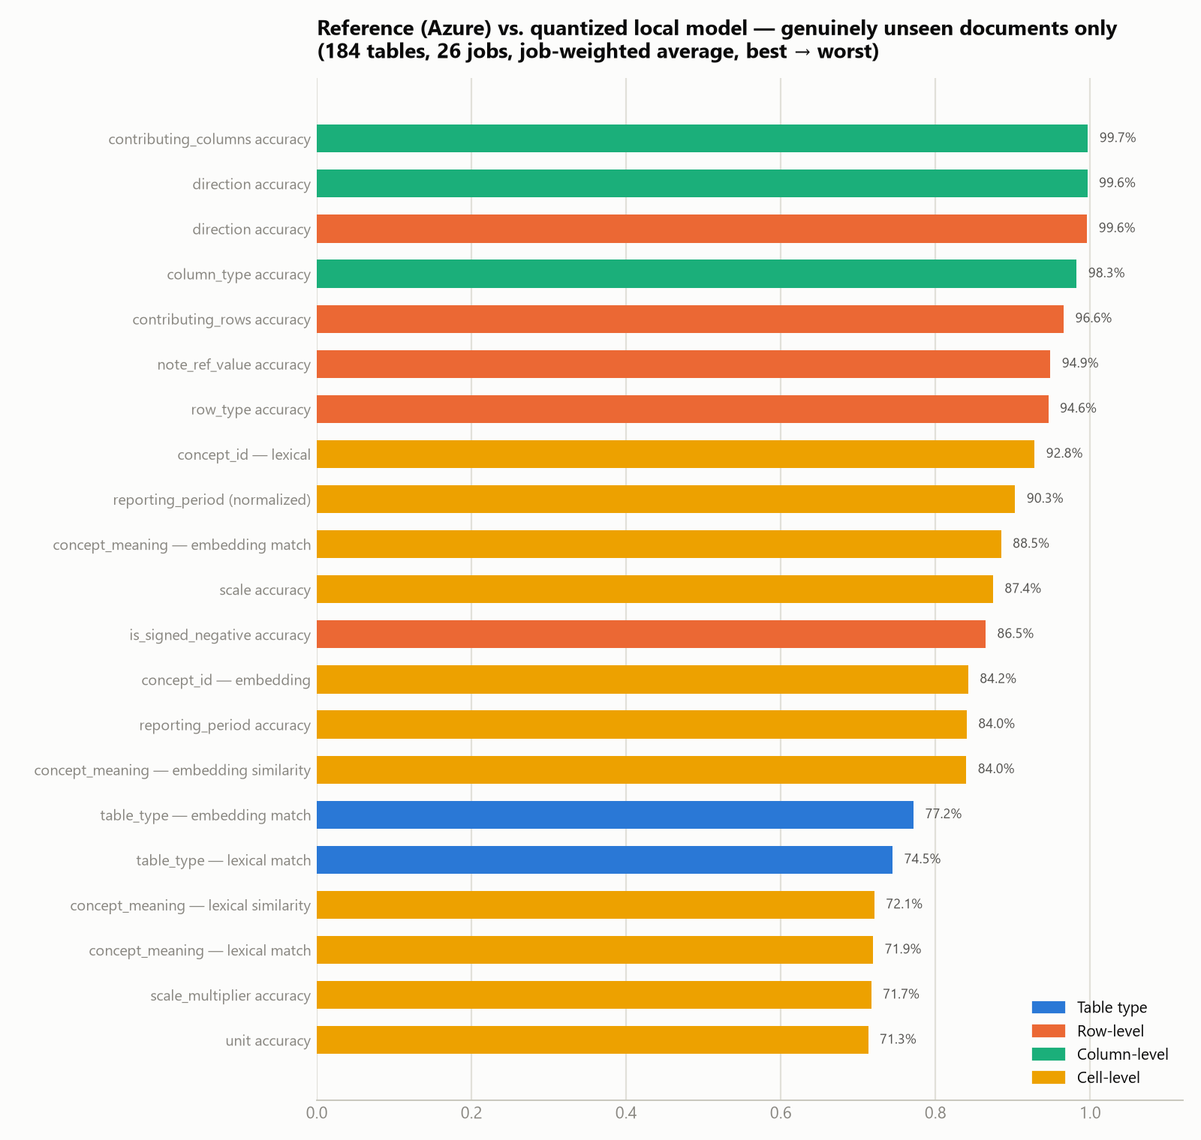
Job-weighted average across 184 compared tables — ranked best to worst, colored by what's being compared:
Rank | Group | Metric | Score
1 | Column | contributing_columns accuracy | 99.7%
2 | Row | direction accuracy | 99.6%
2 | Column | direction accuracy | 99.6%
4 | Column | column_type accuracy | 98.3%
5 | Row | contributing_rows accuracy | 96.6%
6 | Row | note_ref_value accuracy | 94.9%
7 | Row | row_type accuracy | 94.6%
8 | Cell | concept_id — lexical | 92.8%
9 | Cell | reporting_period (normalized) | 90.3%
10 | Cell | concept_meaning — embedding match | 88.5%
11 | Cell | scale accuracy | 87.4%
12 | Row | is_signed_negative accuracy | 86.5%
13 | Cell | concept_id — embedding | 84.2%
14 | Cell | reporting_period accuracy | 84.0%
14 | Cell | concept_meaning — embedding similarity | 84.0%
16 | Table type | Embedding match | 77.2%
17 | Table type | Lexical match | 74.5%
18 | Cell | concept_meaning — lexical similarity | 72.1%
19 | Cell | concept_meaning — lexical match | 71.9%
20 | Cell | scale_multiplier accuracy | 71.7%
21 | Cell | unit accuracy | 71.3%

Reading this: the same pattern the full mixed corpus showed holds up on documents the model never trained on — structural fields (contributing_columns, direction, column_type, row_type) all sit at 94.6–99.7%, while the two soft spots remain `table_type` classification (74–77%) and free-text semantic fields (concept_meaning, unit, scale_multiplier — 71–72%). Nothing here suggests the model's strengths on the mixed corpus were inflated by memorized documents.

4. Structural accuracy distribution
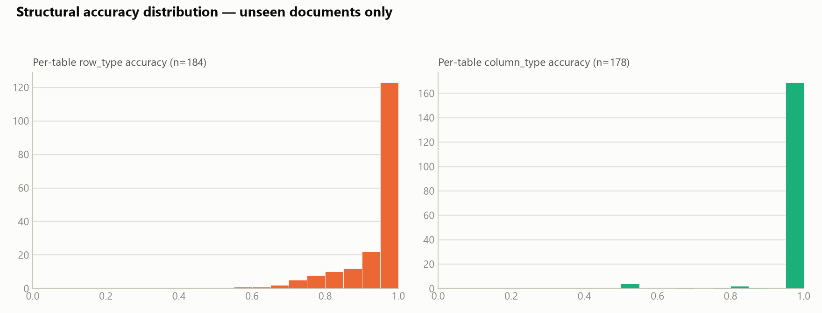
Both row_type and column_type accuracy are heavily concentrated at 1.0, same as the full corpus — most unseen tables are labeled perfectly or nearly perfectly at the structural level.

5. Cell-level concept tagging
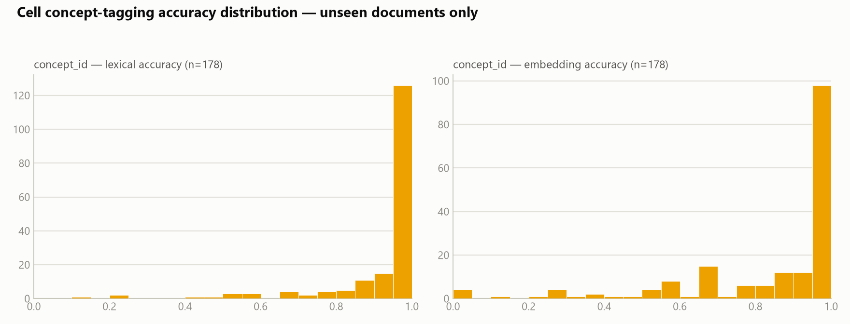
concept_id (n=178 tables with at least one concept-bearing cell) shows most tables scoring at or near 1.0, with a left tail on the embedding metric similar in shape to the full-corpus distribution.

6. Does restricting to purely unseen documents change the picture?
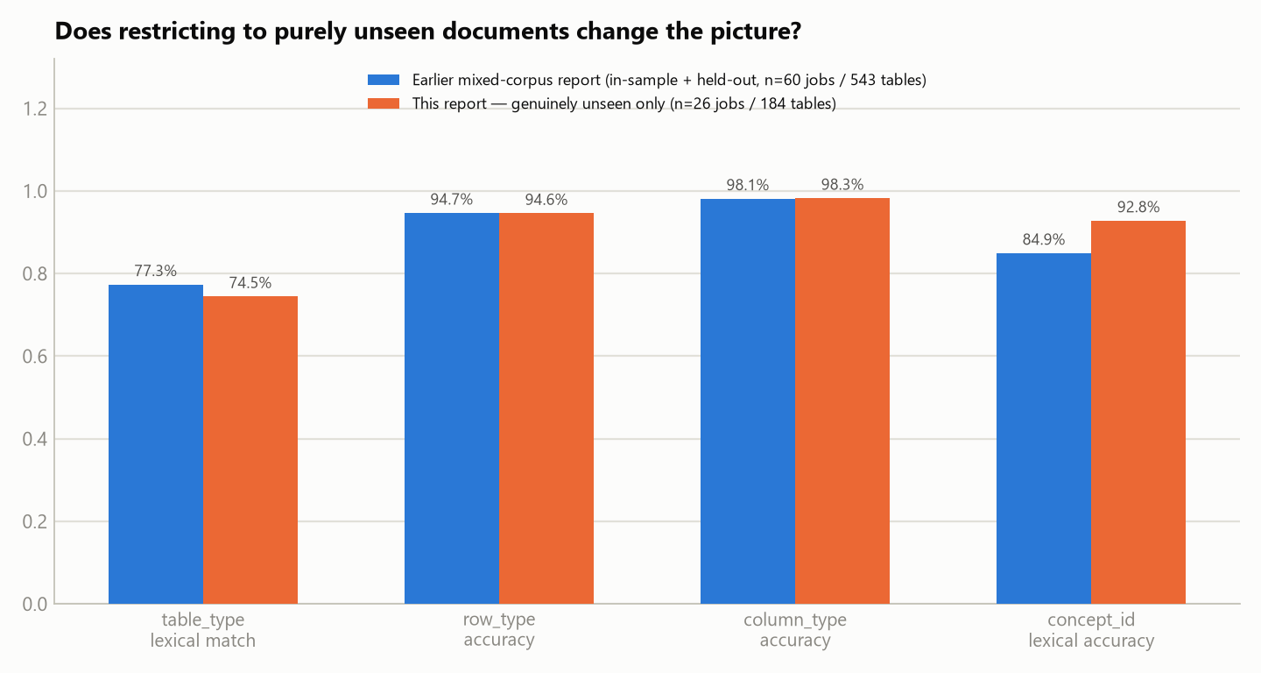
Metric | Earlier mixed report (60 jobs / 543 tables) | This report — unseen only (26 jobs / 184 tables) | Gap
table_type lexical match | 77.3% | 74.5% | −2.9 pp
row_type accuracy | 94.7% | 94.6% | −0.1 pp
column_type accuracy | 98.1% | 98.3% | +0.1 pp
concept_id lexical accuracy | 84.9% | 92.8% | +7.9 pp

Structural typing shows essentially no gap — row_type and column_type land within ±0.1 point of the blended in-sample+held-out corpus, reinforcing that the model learned the general structural task rather than memorizing specific documents. table_type is modestly lower on unseen-only data (−2.9pp), consistent with some memorization advantage on that open-vocabulary field. concept_id lexical accuracy is *higher* here — as flagged in the 2026-07-24 report's held-out check, this is almost certainly a sampling artifact (this 184-table subset happens to contain a different mix of concept-bearing cells than the full 543-table corpus), not evidence the model does better on unseen data; it should not be read as a real advantage.

7. Where the model performs well — and where it struggles

7.1 Best-scoring unseen documents
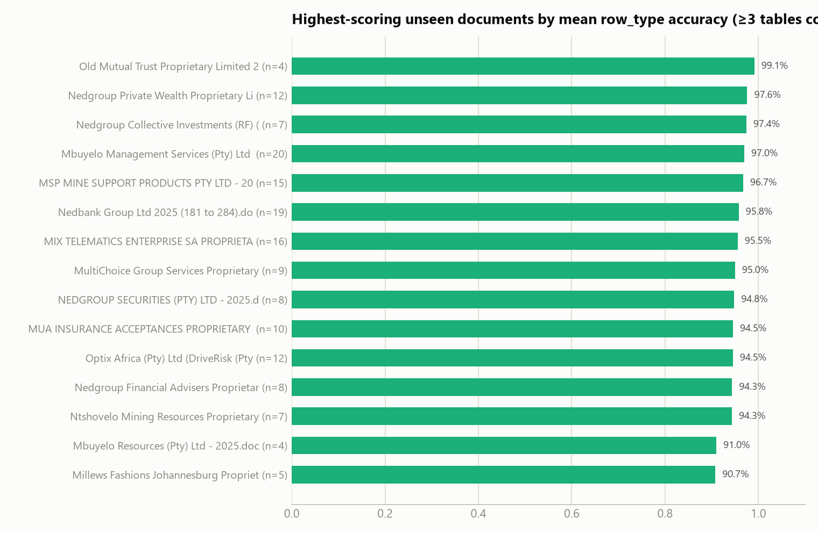
Documents with ≥3 tables compared, to rule out lucky small samples: the top scorer (Old Mutual Trust Proprietary Limited) reaches 99.1% mean row_type accuracy, and several others clear 95%.

7.2 Largest unseen tables handled with a perfect clean sweep
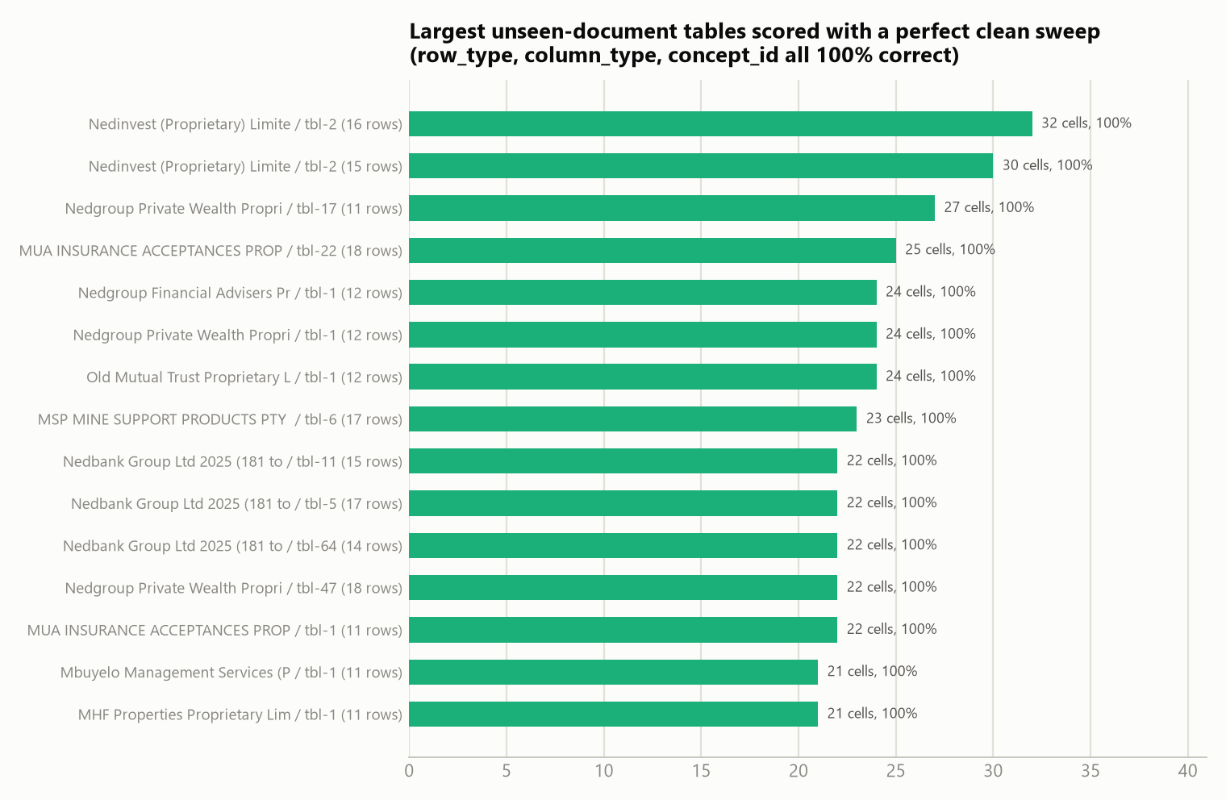
The top performer (Nedinvest, tbl-2, 16 rows / 32 compared cells) scores 100% on row_type, column_type, *and* concept_id simultaneously — the same evidence as the full-corpus report that the model isn't just pattern-matching small tables, even restricted to documents it never trained on.

7.3 Does table complexity actually hurt accuracy on unseen documents?
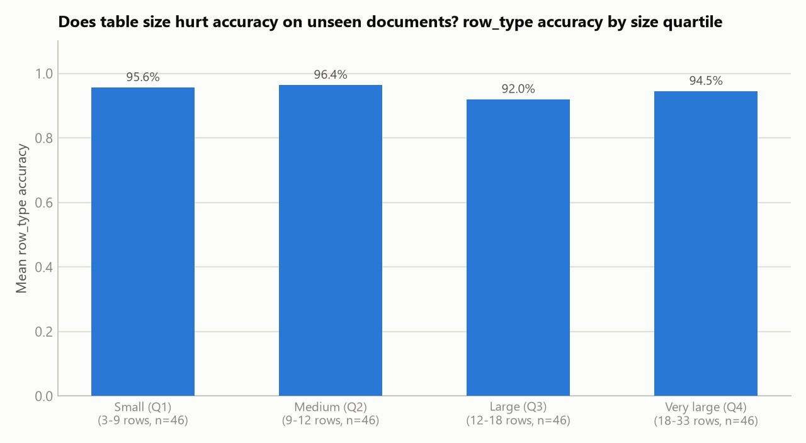
Splitting the 184 unseen tables into size quartiles by row count: accuracy moves from 95.6% (Q1, smallest) → 96.4% (Q2) → 92.0% (Q3) → 94.5% (Q4, largest) — a mild, non-monotonic wobble of a few points rather than the steadier decline seen on the full mixed corpus. With only 46 tables per quartile here, this is too small a sample to call a real complexity effect one way or the other; it does not show the largest unseen tables being the worst-handled ones.

7.4 Lowest-scoring unseen documents
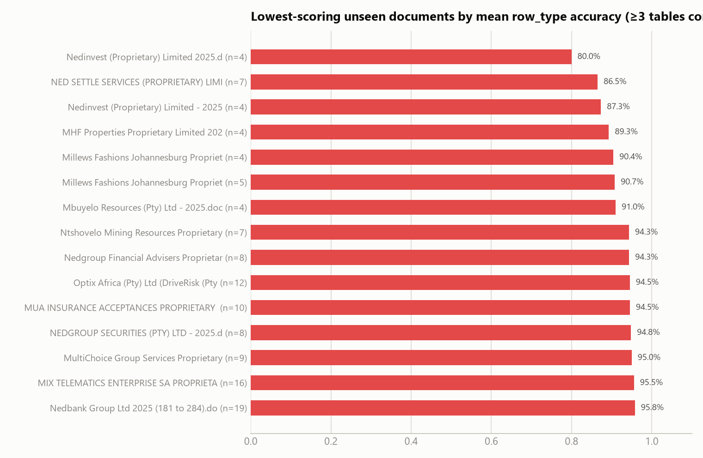

7.5 Lowest-scoring individual unseen tables
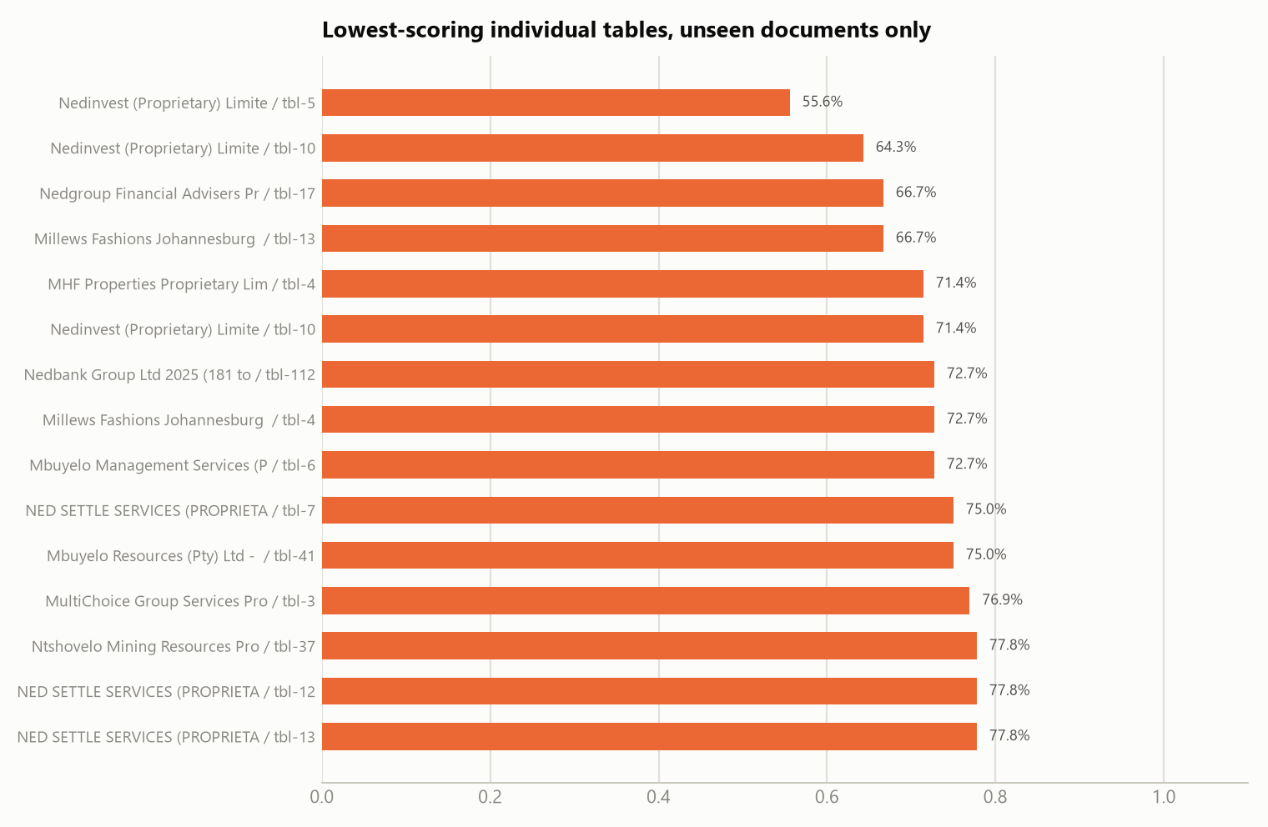
The same pattern as the full-corpus report shows up here: most of the weakest documents (Nedinvest, Millews Fashions, MHF Properties) have only 4–5 compared tables, so one or two mis-typed rows swing the document average by 15–40 points — these are noisy small-sample signals, not necessarily systematically hard documents. With only 24 unique documents in this set, the "worst" and "best" document lists in §7.1/7.4 overlap almost entirely (the full ranking, not two disjoint groups) — read both as one continuum, not two separate populations.

8. Inference performance
Jobs with successful inference + comparison | 26
Total inference wall-clock time | 4,886 s ≈ 1.36 hours
Mean / median time per job | 188 s / 162 s
Tables attempted (manifest) | 186
Inference errors | 2 (1.1% error rate)

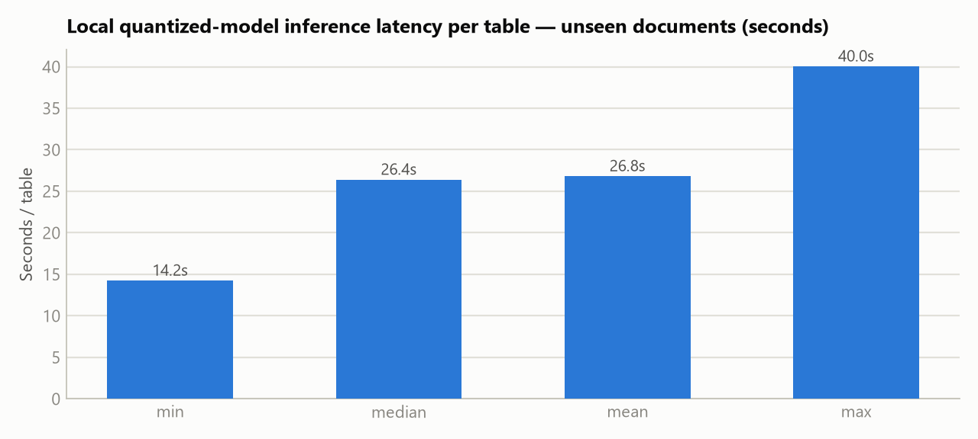
Median latency of 26.4 seconds per table (mean 26.8s), in line with the 2026-07-24 report's full-corpus figures (median 27.2s, mean 31.3s) — this subset's latency is not meaningfully different from the blended corpus, so the cost-per-table and capacity figures in that report's §9 apply unchanged here; they are not repeated in this report.

9. Notes and caveats
- This is the same 26-job held-out subset from the 2026-07-24 report, not newly collected data. It was re-compared on 2026-07-27; the resulting numbers match the earlier held-out bucket to within rounding (e.g. row_type_accuracy 94.59% then vs. 94.59% now), confirming the comparison pipeline is stable and this report's numbers are consistent with the earlier finding.
- This measures agreement with the training teacher, not ground truth. The "reference" in every comparison is the original Azure-model-generated label — the same labels the model was fine-tuned to reproduce. High agreement confirms distillation + quantization fidelity; it does not independently confirm the Azure labels themselves were correct.
- Metrics are job-weighted averages, not simple means-of-means. A direct table-level ("micro") recomputation of the 6 fields available at that granularity matches the job-weighted figures to within 0.2 point, confirming the weighting doesn't distort the headline numbers.
- Small-sample documents dominate the best/worst lists. With only 24 unique documents total, most have 4–10 compared tables; treat document-level rankings as a starting point for spot-checking, not a precise severity ranking.
- `concept_id`'s apparent held-out advantage (§6) is a sampling artifact, not a generalization finding — carried forward from the same caveat in the 2026-07-24 report.
6. Full raw statistics are in report_assets/eval_stats_unseen.json; regenerate with report_assets/analyze_eval_unseen.py and report_assets/eval_chart_gen_unseen.py. For the full deployment cost/capacity analysis, see §9 of Evaluation_and_Metrics_Report.docx (2026-07-24) — that analysis is a property of the T4 deployment, not of which document subset is evaluated, and is unchanged here.

