Manaeva Daria 24401020121

Global Earthquake-Tsunami Risk Assessment Dataset

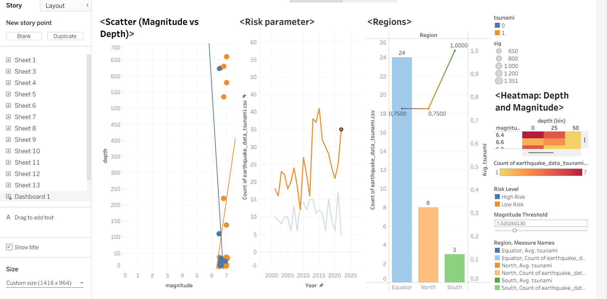

This dashboard provides a comprehensive analysis of earthquake data, focusing on the relationships between magnitude, depth, location, and tsunami risks. It is divided into four main visualizations and a control panel.

Here is a breakdown of each section:

1. Scatter Plot: Magnitude vs. Depth (Far Left)

Purpose: Shows the correlation between how strong an earthquake is (Magnitude) and how deep underground it occurred (Depth).

Key Insight: Most data points are clustered at the bottom (0-100 depth), indicating that most significant earthquakes happen near the surface.

Color Coding: The dots are colored by Tsunami occurrence (Blue = No Tsunami, Orange = Tsunami). You can see orange dots mixed in, particularly in the shallow depth clusters, suggesting shallow quakes are more likely to cause tsunamis.

2. Line Chart: Risk Parameter (Middle Left)

Purpose: Tracks the frequency of earthquakes over time (Years 2000–2025).

Key Insight: It separates data into High Risk (Grey/Blue line) and Low Risk (Orange line).

The Orange line (Low Risk) fluctuates significantly, spiking around 2011, 2015, and 2022.

The Grey line (High Risk) stays relatively low and stable, indicating that high-risk events are less frequent but consistent.

3. Bar & Line Chart: Regions (Middle Right)

Purpose: Compares earthquake counts and tsunami probabilities across three geographic regions: Equator, North, and South.

Bars (Count): The Equator region has the highest frequency of earthquakes (24 events), followed by North (8) and South (3).

Line (Avg. Tsunami): This is the most critical insight. While the South has the fewest earthquakes (3), the green line shoots up to 1.000 (100%). This implies that every earthquake recorded in the "South" region triggered a tsunami.

4. Heatmap: Depth and Magnitude (Far Right)

Purpose: A density map showing where the most earthquakes occur.

Key Insight: The darkest red block is at Magnitude 6.4 and Depth 0-25. This confirms that moderate, shallow earthquakes are the most common type in this dataset. As magnitude increases or depth increases, the blocks turn yellow (fewer events).

5. Controls & Filters (Right Sidebar)

Magnitude Threshold: There is a slider set to roughly 7.02. This allows the user to filter the entire dashboard to only show earthquakes above a certain strength.

Legends: Clarify that Blue/Orange colors often represent Tsunami (0/1) or Risk Level (High/Low).

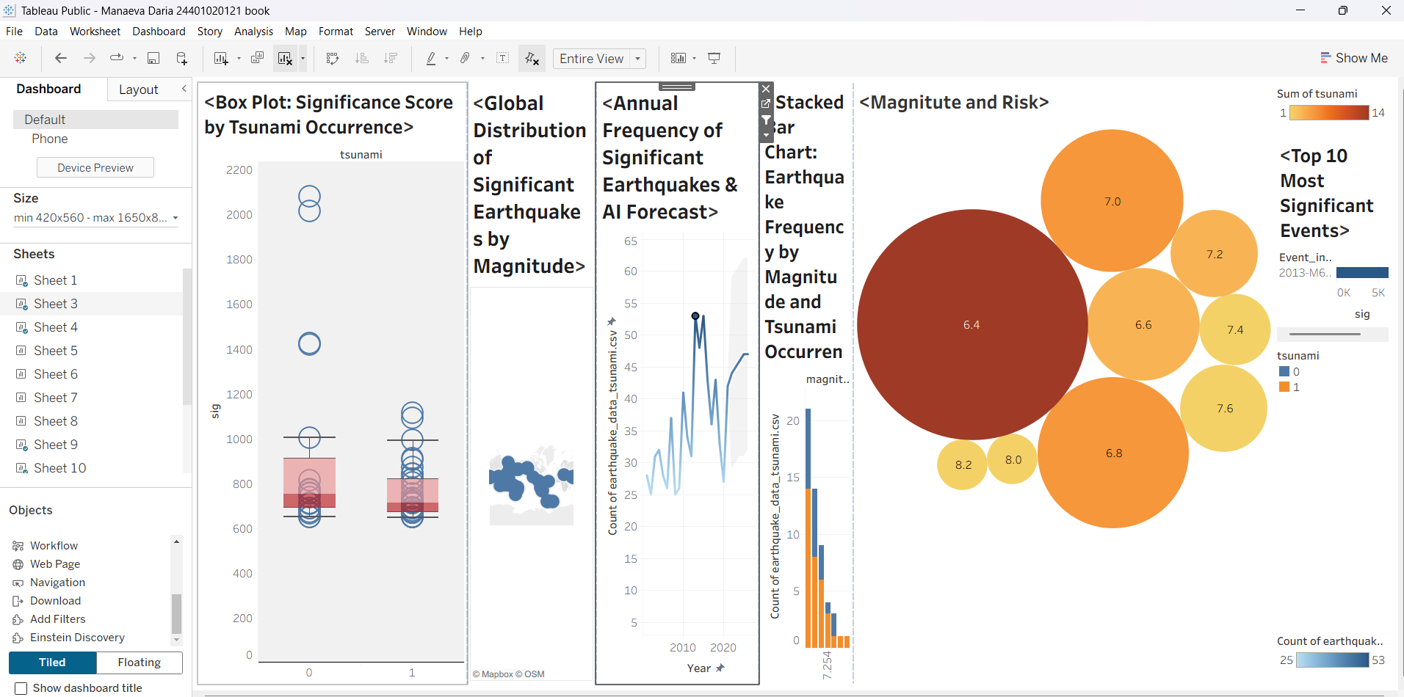

The dashboard is arranged horizontally and features six distinct visualizations that tell a story about seismic activity, magnitude, and associated risks.

Here is a breakdown of the charts from left to right:

Box Plot: Significance Score by Tsunami Occurrence

This chart compares the "Significance Score" (sig) of earthquakes. It uses box plots and scatter points to show the distribution of scores for events that caused a tsunami (1) versus those that did not (0).

Global Distribution of Significant Earthquakes by Magnitude

A geographic map visualization focusing on the "Ring of Fire" in the Pacific Ocean. It shows the density and location of significant seismic events.

Annual Frequency of Significant Earthquakes & AI Forecast

A line chart tracking the count of earthquakes over time (years). It includes a shaded area at the end, likely representing an AI-generated forecast for future seismic activity.

Stacked Bar Chart: Earthquake Frequency by Magnitude and Tsunami Occurrence

A vertical bar chart showing the frequency of earthquakes grouped by magnitude. The bars are stacked with two colors (blue and orange) to distinguish between events that caused tsunamis and those that didn't.

Magnitude and Risk

A packed bubble chart. Each bubble represents a magnitude range (e.g., 6.4, 7.0). The size of the bubble likely represents frequency, while the color intensity (from light yellow to dark red) represents the "Sum of tsunami," indicating which magnitudes carry the highest tsunami risk.

Top 10 Most Significant Events

(Far right, partially visible) A horizontal bar chart ranking the top 10 specific earthquake events based on their significance score (sig), labeled by Year and Magnitude.

Interface Details:

The left sidebar shows the Dashboard and Layout panes, listing the available sheets (Sheet 1, Sheet 3, etc.) and objects. This indicates the user is currently in the process of designing or reviewing the dashboard.

Annual Frequency of Significant Earthquakes & AI Forecast
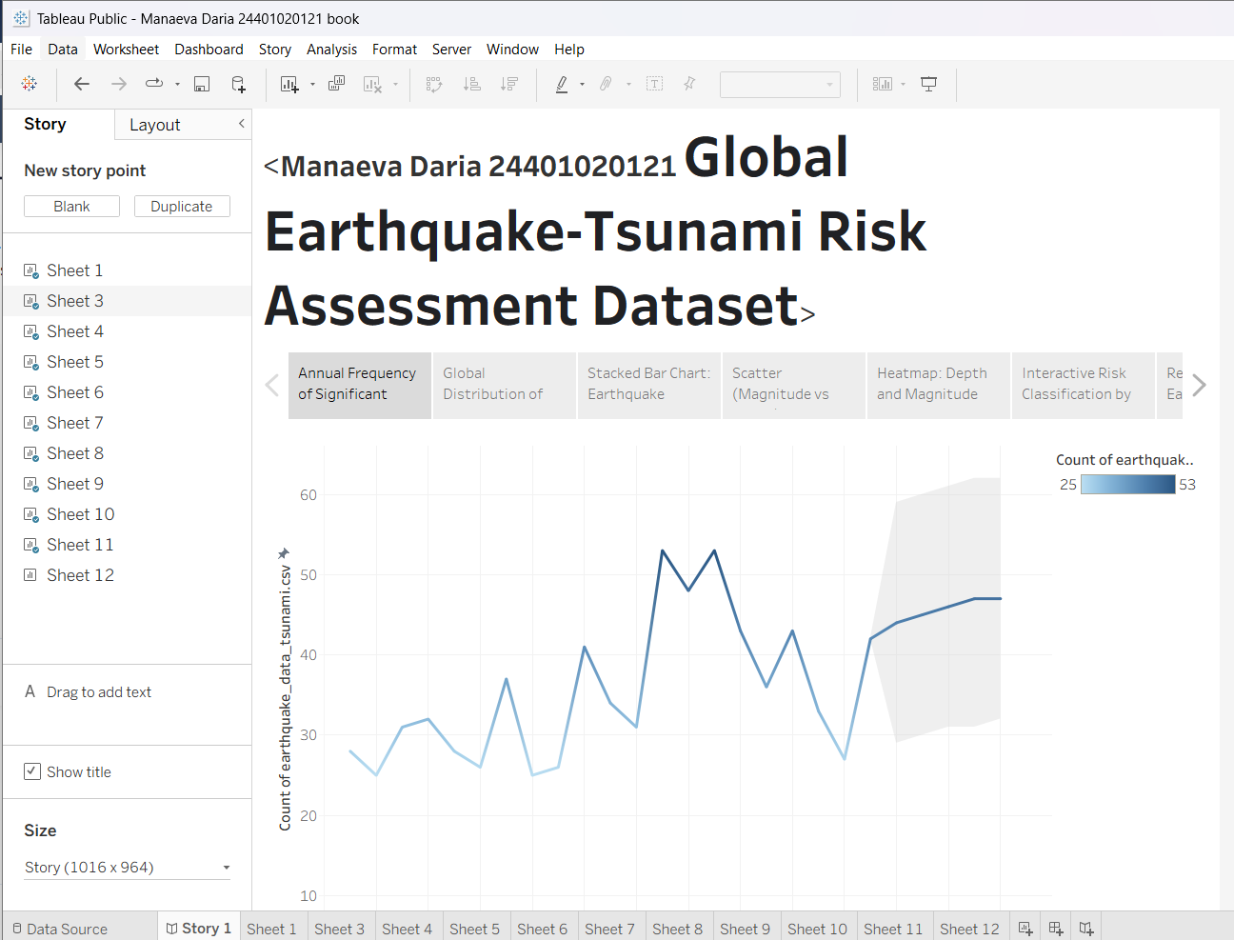
The visualization features a line chart that tracks the count of significant earthquakes over time. It displays historical data from 2001 to 2021, followed by a shaded gray area extending to 2027. This shaded region represents an AI-generated forecast, predicting a general upward trend in the frequency of earthquakes for the coming years. The left sidebar lists the data fields used, such as "Year," "magnitude," and "tsunami."
Global Distribution of Significant Earthquakes by Magnitude 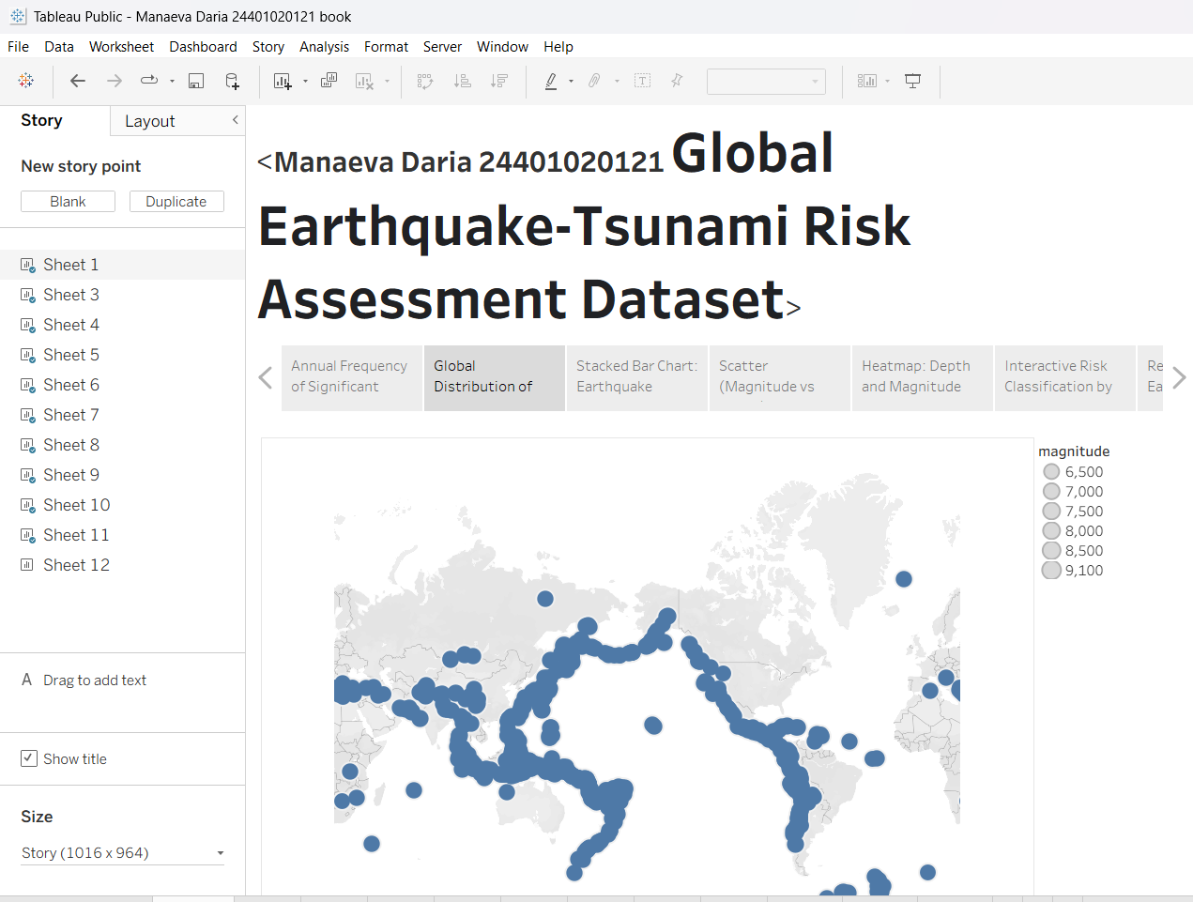
The chart plots earthquake locations on a world map using blue circles, where the size of each circle corresponds to the magnitude of the event (as shown in the legend on the right, ranging from 6,500 to 9,100, likely representing magnitudes 6.5 to 9.1). The distribution clearly highlights tectonic plate boundaries, with a dense concentration of earthquakes along the "Ring of Fire" in the Pacific Ocean.

Stacked Bar Chart: Earthquake Frequency by Magnitude and Tsunami Occurrence
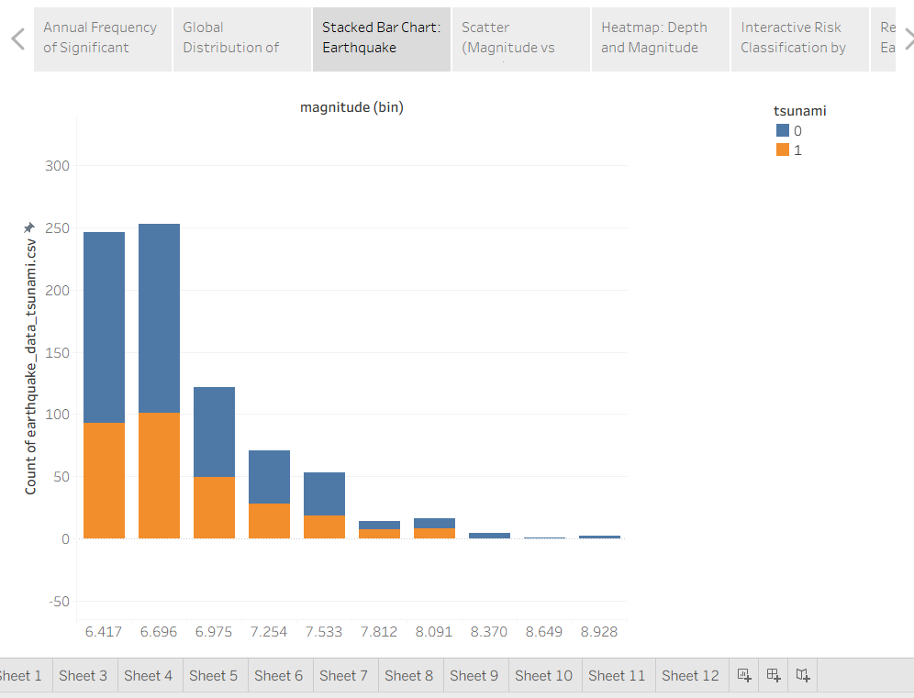
The chart visualizes the frequency of earthquakes grouped by magnitude bins (x-axis), ranging from approximately 6.4 to 8.9. The bars are stacked with two colors (blue and orange) to represent tsunami occurrence, allowing the viewer to see the ratio of earthquakes that caused tsunamis versus those that did not within each magnitude range. The data indicates that lower-magnitude earthquakes (around 6.4–6.7) are far more frequent than high-magnitude events.

Scatter (Magnitude vs Depth)
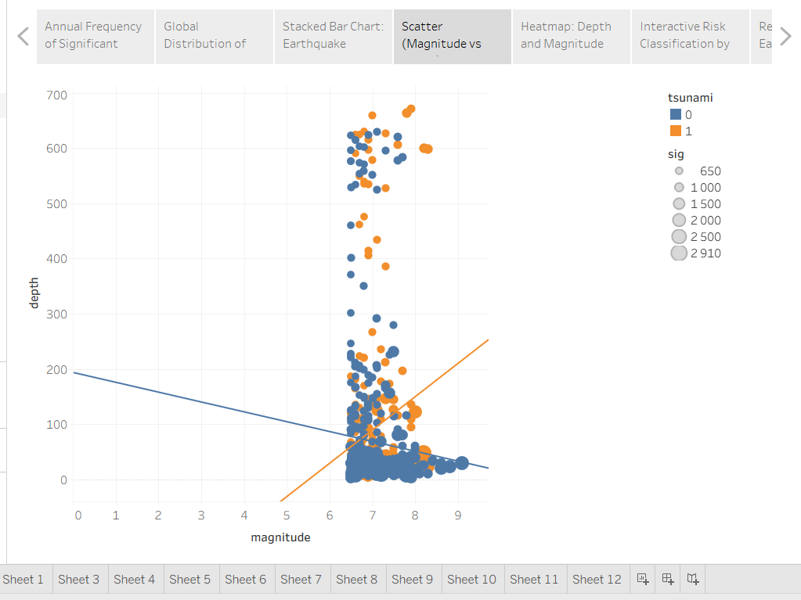
The scatter plot starts with magnitude values around 5 on the x-axis and depth at 0 km on the y-axis, with the majority of data points concentrated in the lower-right portion of the chart where shallow earthquakes (0-100 km depth) with magnitudes between 6 and 8 are clustered.

Heatmap: Depth and Magnitude
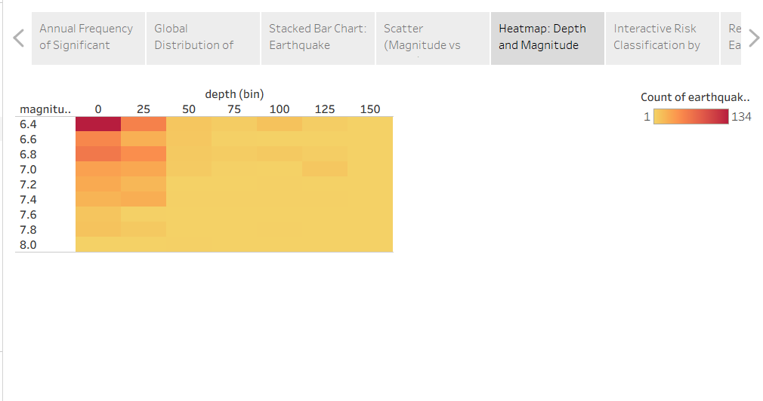The visualization maps the frequency of earthquakes based on two variables:
Y-Axis (Rows): Earthquake Magnitude (ranging from 6.4 to 8.0).
X-Axis (Columns): Earthquake Depth (ranging from 0 to 150).
The color intensity represents the count of earthquakes (CNT), where dark red/orange indicates a high frequency and yellow indicates a low frequency. The chart shows that the most frequent earthquakes in this dataset are shallow (depth 0-25) and of lower magnitude (around 6.4).

Interactive Risk Classification by Magnitude Threshold
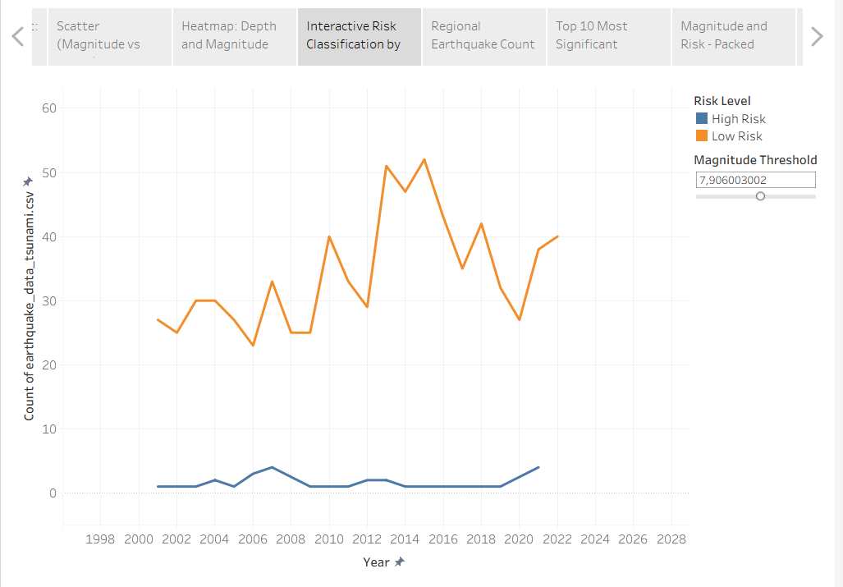
The visualization tracks the frequency of earthquakes over time (from roughly 2001 to 2022) and categorizes them into two groups based on a "Risk Level":
Orange Line (Low Risk): Represents a significantly higher count of earthquakes, fluctuating between approximately 15 and 45 events per year.
Blue Line (High Risk): Represents a much lower frequency, generally staying below 15 events per year.
On the right side, there is a parameter control labeled "Magnitude Threshold" (set to roughly 7.12), which suggests that the classification of "High" vs. "Low" risk is dynamically determined by the magnitude of the earthquake.

Regional Earthquake Count and Average Tsunami - Dual-Axis Combination Chart
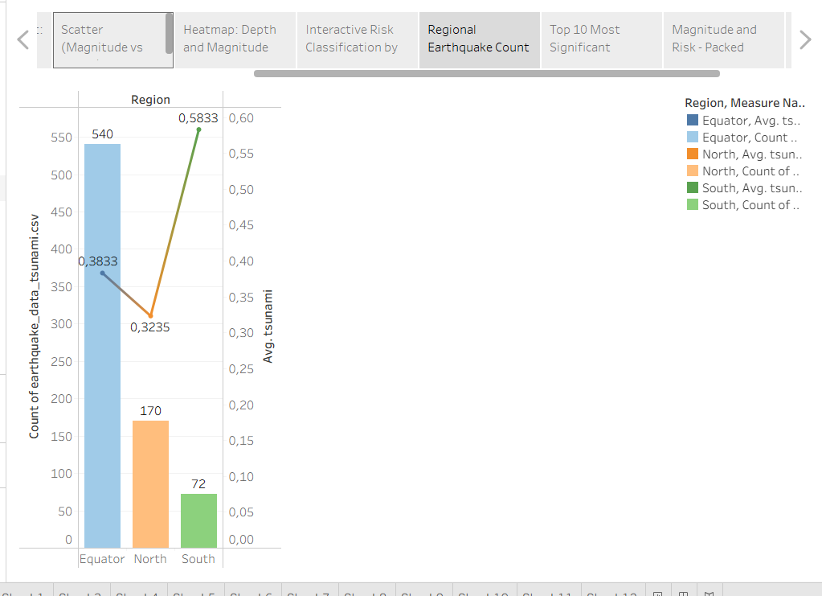
It uses a dual-axis chart (combining bars and lines) to compare earthquake statistics across three geographic categories: Equator, North, and South.
Bars (Left Axis): Represent the total count of earthquakes. The Equator region has the highest frequency (540), followed by North (170) and South (72).
Lines (Right Axis): Represent the average tsunami value. Interestingly, the South region has the highest average (0.5833) despite having the lowest number of earthquakes, while the North region has the lowest average (0.3235).

Top 10 Most Significant Events: Horizontal Bar Chart with Color Gradient
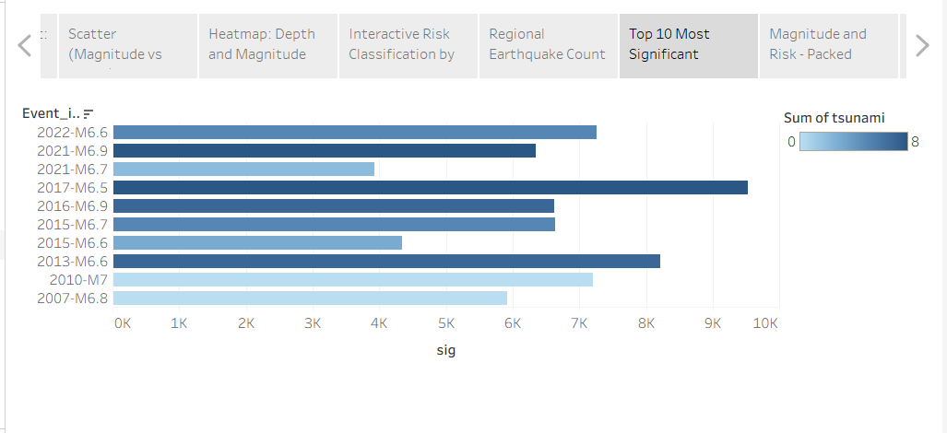
X-Axis: Represents the Significance score (sig) of the events.
Y-Axis: Lists specific earthquake events identified by Year and Magnitude (e.g., "2017-M6.5").
Bar Length: Indicates the total significance, with the event 2017-M6.5 having the longest bar (highest significance, reaching near 9500).
Color: The bars are shaded based on the sum of tsunami occurrences (SUM(tsunami)), where darker blue indicates a higher tsunami impact or frequency associated with that event.

Magnitude and Risk - Packed Bubble Chart

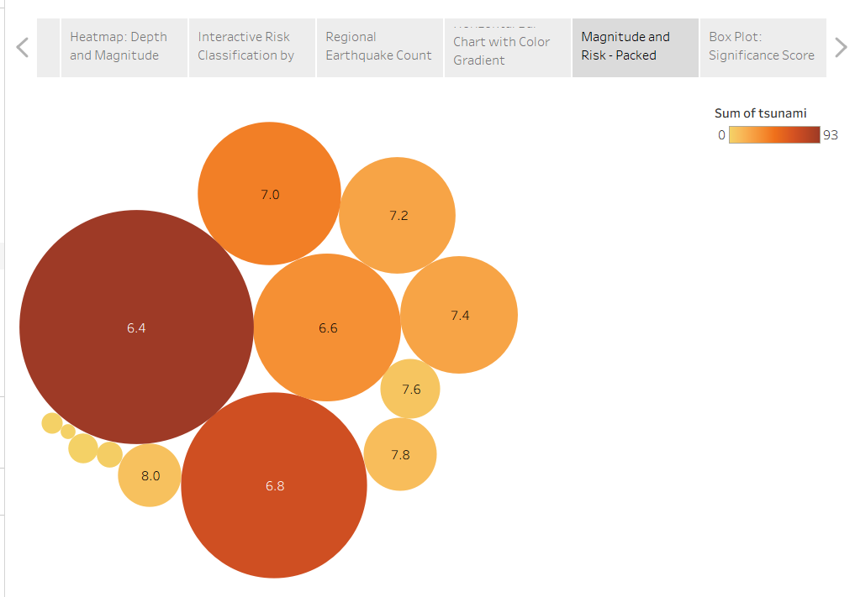
It uses a packed bubble chart to display earthquake data.
Bubbles: Each circle represents a specific magnitude bin (labeled inside, e.g., 6.4, 7.0, 8.0).
Size: The size of the bubble corresponds to the count of earthquakes. The largest bubble is 6.4, indicating that earthquakes of this magnitude are the most frequent in the dataset. The bubble for 8.0 is very small, showing that high-magnitude earthquakes are rare.
Color: The color represents the sum of tsunamis (SUM(tsunami)). Darker red/brown indicates a higher number of tsunamis. The 6.4 and 6.8 bubbles are the darkest, suggesting they are associated with the highest total number of tsunamis, likely because these events happen so often.

Box Plot: Significance Score by Tsunami Occurrence
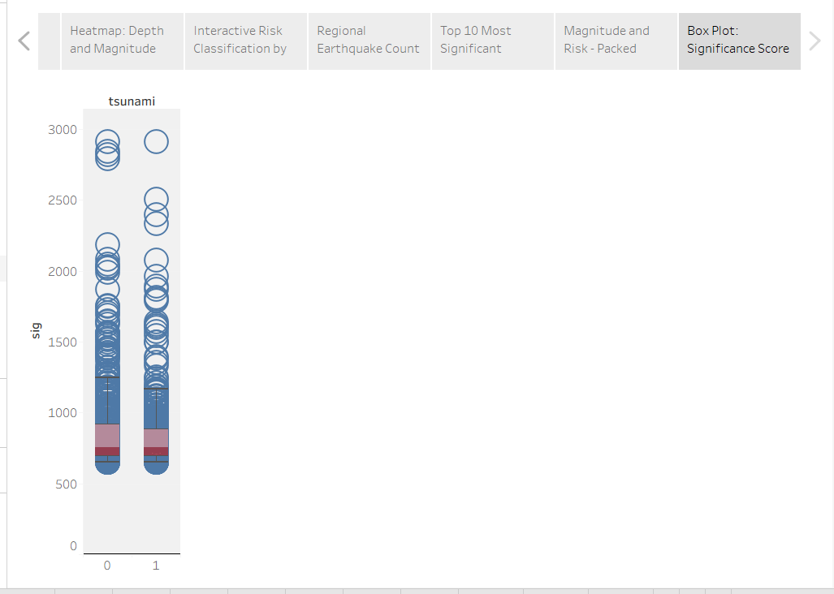
The visualization compares earthquake significance scores against tsunami occurrence using a combination of a box plot and a scatter plot (jitter plot):
X-Axis: Represents tsunami occurrence, categorized as 0 (no tsunami) and 1 (tsunami occurred).
Y-Axis: Represents the significance score (sig), ranging from 0 to 3000.
Key Observations:
The data points (blue circles) are heavily clustered at the bottom, indicating that most earthquakes have a low significance score (roughly below 1000).
The reddish/purple boxes at the bottom represent the interquartile range for these lower scores.
There are significant outliers stretching all the way up to 3000 for both categories, showing that while rare, some earthquakes have extremely high significance scores regardless of whether they triggered a tsunami.

Seismic Depth & Magnitude Explorer
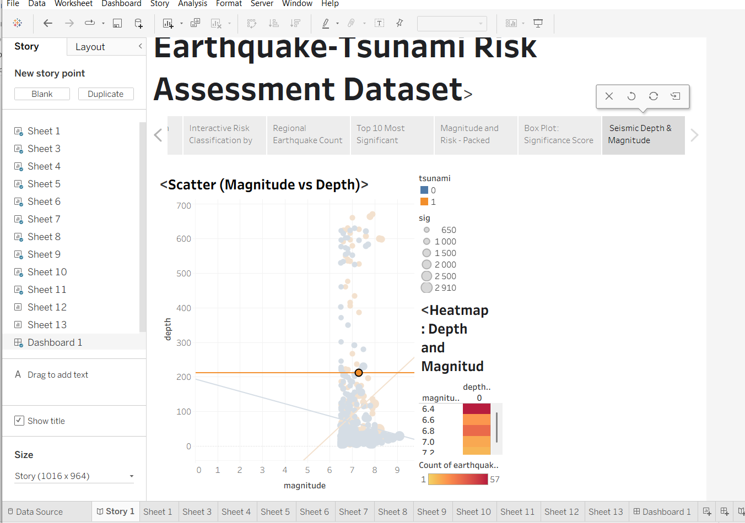
A focused analytical view that examines the relationship between earthquake magnitude and focal depth. The scatter plot maps individual seismic events, color-coded by tsunami occurrence, to reveal outlier patterns. Paired with a heatmap that visualizes event density, this dashboard clearly demonstrates that the vast majority of seismic activity clusters at shallow depths with moderate magnitudes, while deep-focus or ultra-high-magnitude events remain rare.

