Software Requirements
Specification

for

The Colour Palette Manager

Prepared by Manaeva Daria

April 24 2026

Colour Palette Manager
Design Patterns, Architecture & Implementation
Colour Palette Manager
Design Patterns, Architecture & Implementation
Colour Palette Manager
Design Patterns, Architecture & Implementation

1. Introduction

1.1 Project Overview
The Colour Palette Manager is a desktop application built with Java Swing and MySQL that allows graphic designers, illustrators, and developers to create, organise, and reuse collections of colours. A palette is a named set of colour swatches, each stored with its HEX value, RGB components, an optional display label, and a sort position. All palettes and their colours are persisted in a MySQL relational database, ensuring they survive application restarts and can be shared across installations.

The application provides an interactive graphical interface where users can browse saved palettes in a sidebar, view and edit the swatches of the currently selected palette in a central editor, add new colours by typing a HEX code or using the built-in colour picker, and remove individual colours with a single right-click. An integrated drawing canvas allows users to paint with any palette colour as the active brush, and an undo/redo system (powered by the Command pattern) covers both palette edits and canvas strokes.

1.2 Scope
- Full description of the five-pattern architecture: Singleton, Adapter, Facade, Observer, Command.
- Database schema for the two MySQL tables and the Spring JDBC access strategy.
- Package and class structure with role descriptions.
- Key interaction sequences — adding a colour, undoing an action, picking a colour from the canvas.
- Non-functional characteristics: performance targets, testability, and maintainability considerations.

2. System Overview

2.1 Core Features
Palette Management | Create, rename, tag, and delete named colour palettes stored in MySQL.
Colour CRUD | Add colours by HEX input (with live preview) or via the Swing JColorChooser. Delete colours with right-click.
HEX / RGB / HSL Display | Every colour swatch shows its HEX code; a tooltip displays RGB and HSL values via the ColorAdapter.
Undo / Redo | All palette edits and canvas strokes are wrapped in Commands. Ctrl+Z / Ctrl+Y navigate the undo and redo stacks.
Drawing Canvas | Mouse-driven freehand painting with variable brush size. Left-click on a swatch sets the active brush colour. Right-click on the canvas picks the colour under the cursor.
Observer-driven UI | Any change to palette data automatically refreshes the sidebar, editor panel, and status bar — no manual repaint calls in the UI code.

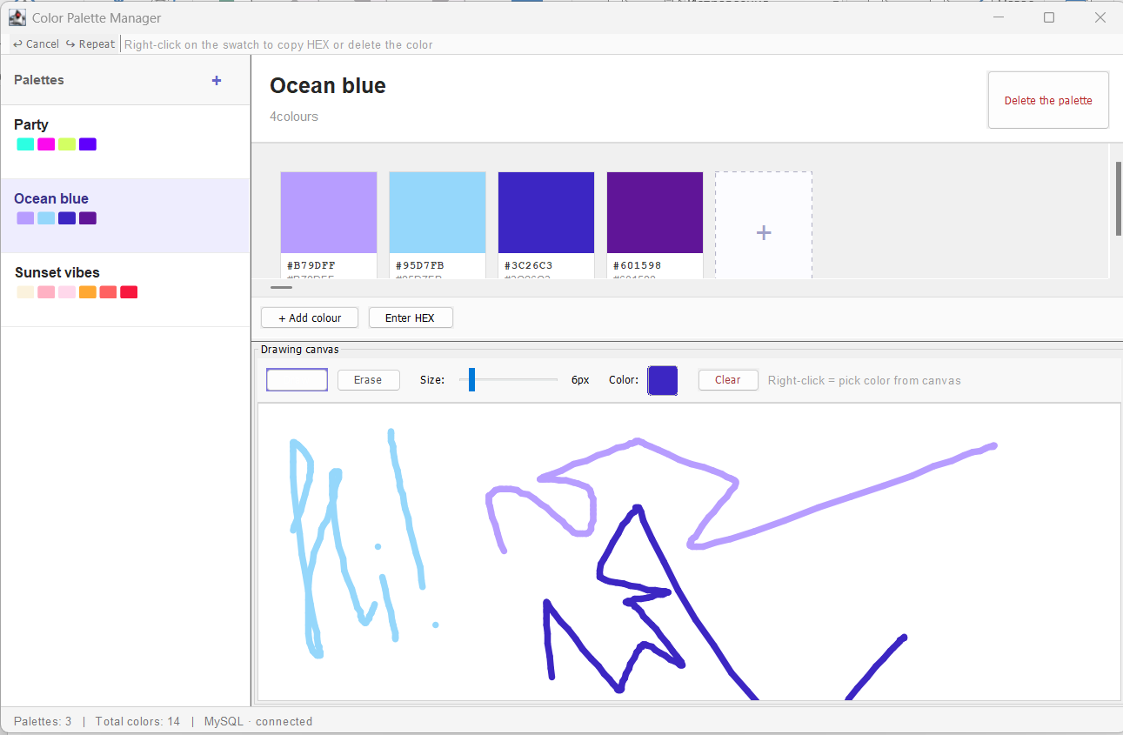

3. System Architecture

3.1 Layered Architecture
The application is divided into five logical layers. Each layer depends only on the layer below it — the UI never talks directly to the database, and the database layer has no knowledge of Swing.

Layer | Package(s) | Responsibility
UI (View) | ui | Swing panels and dialogs. Observes data via PaletteObserver. Sends actions through CommandManager.
Canvas | canvas | DrawingCanvas JPanel, CanvasToolbar, Stroke data class.
Facade / Service | facade | PaletteFacade: the single entry point for all data operations. Manages observers.
Adapter | adapter | ColorAdapter: translates between HEX, RGB, and HSL formats.
Command | command | Command interface, CommandManager, and all concrete command classes.
Observer | observer | PaletteObserver interface implemented by all UI panels.
DAO | dao | PaletteDAO and ColorDAO: all SQL isolated here.
Model | model | Palette and ColorModel POJOs — no Swing, no SQL.
DB | db | DatabaseConnection Singleton — one JDBC connection for the application lifetime.

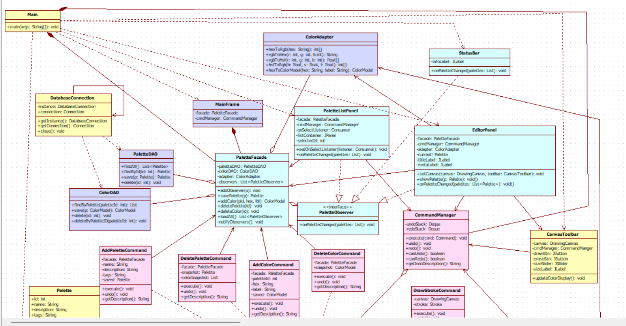
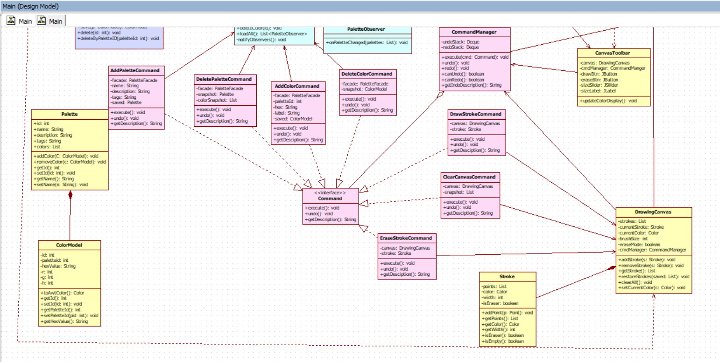

3.2 Package Structure
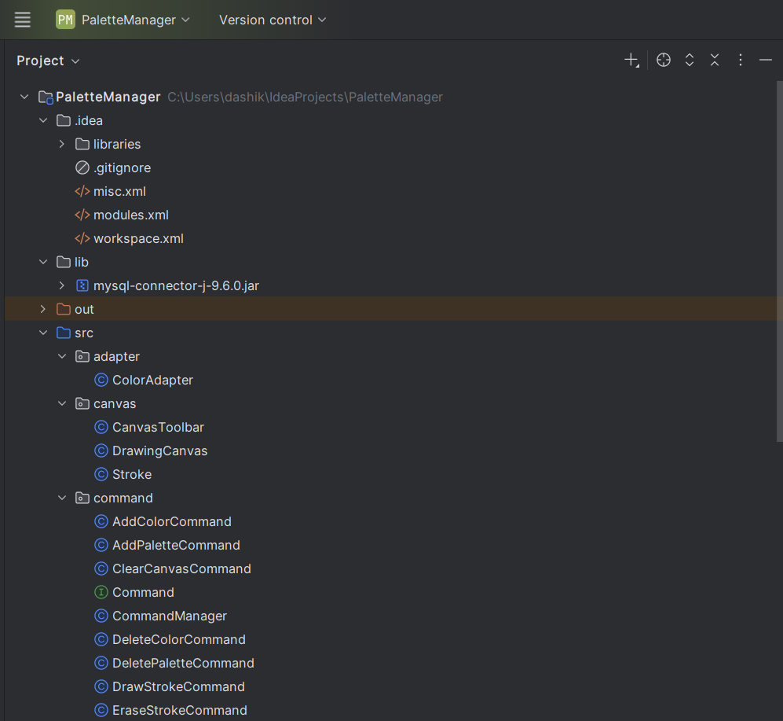
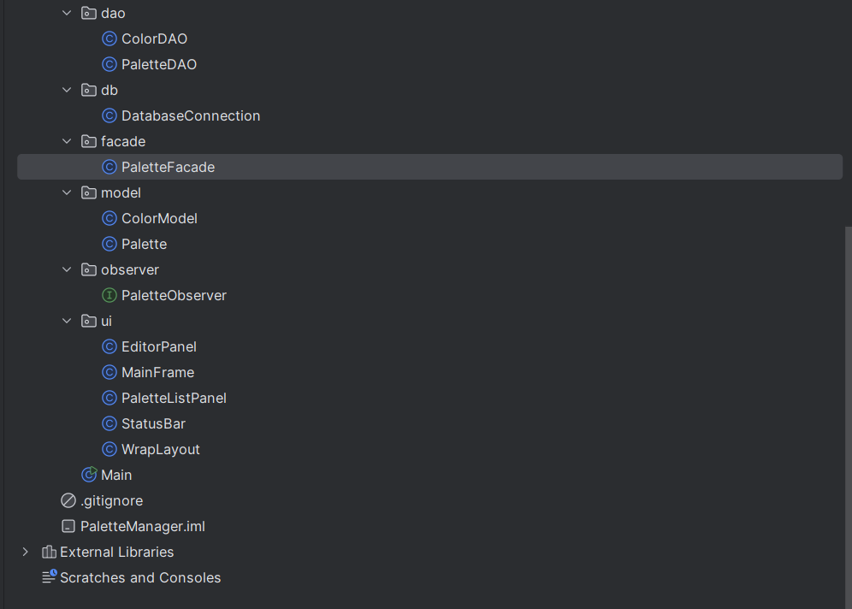

4. Design Patterns
Five design patterns are applied throughout the project. Each section below states the pattern's intent, the specific problem it solves in this application, the classes involved, and the concrete mechanism used.

4.1 Singleton — DatabaseConnection

Intent
Ensure that a class has only one instance and provide a global access point to it.

Problem Solved
Opening a new JDBC connection for every database query is expensive (tens of milliseconds per connection on a typical MySQL server) and quickly exhausts the server's connection limit. The application needs one shared connection that is created on first use and reused throughout the application lifetime.
Every DAO class obtains its connection by calling DatabaseConnection.getInstance().getConnection(). Neither DAO knows or cares whether the connection was just created or is being reused — that is entirely encapsulated inside DatabaseConnection.

The synchronized keyword on getInstance() prevents two threads from simultaneously finding instance == null and both creating a new object. After the first call the condition is false and synchronisation overhead disappears.
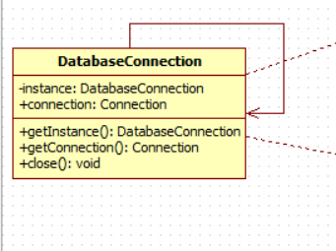

4.2 Adapter — ColorAdapter

Intent
Convert the interface of a class into another interface that clients expect. Allow classes with incompatible interfaces to work together.

Problem Solved
The application works with three incompatible colour representations that cannot be used interchangeably:
- HEX strings ("#FF6B6B") — used for database storage, user input, and display labels.
- RGB integer triples [255, 107, 107] — used by java.awt.Color and Swing's colour chooser.
- HSL float triples [0.0°, 100%, 71%] — used by the tooltip display and colour harmony math.

Without an adapter, conversion code would be duplicated across the Facade, dialogs, and the canvas, each implementing the formulas slightly differently and creating maintenance risk.
PaletteFacade delegates all colour conversion to ColorAdapter. The UI layer never contains conversion logic — it calls facade.getRgbString(hex) or facade.getHslString(hex), both of which forward to the adapter.
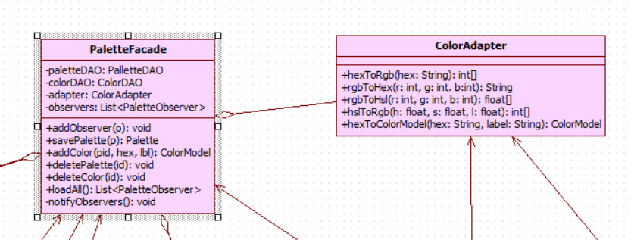

4.3 Facade — PaletteFacade

Intent
Provide a simplified interface to a complex subsystem. Hide the interactions between multiple sub-components behind a single, easy-to-use class.

Problem Solved
Without a facade, every Swing panel would need to:
- Call PaletteDAO for palette-level operations.
- Call ColorDAO for colour-level operations.
- Invoke ColorAdapter to convert HEX before saving.
- Remember to call notifyObservers() after every mutation.
- Know the correct order of these calls (e.g. assign palette ID before saving a colour).

This produces tight coupling between UI and data-access code, making changes to either layer require touching many unrelated classes.
PaletteFacade is also the Observer publisher. It holds a List<PaletteObserver> and calls onPaletteChanged(loadAll()) after every mutation. All Swing panels register as observers in MainFrame.initUI() — the facade never references any Swing class directly.
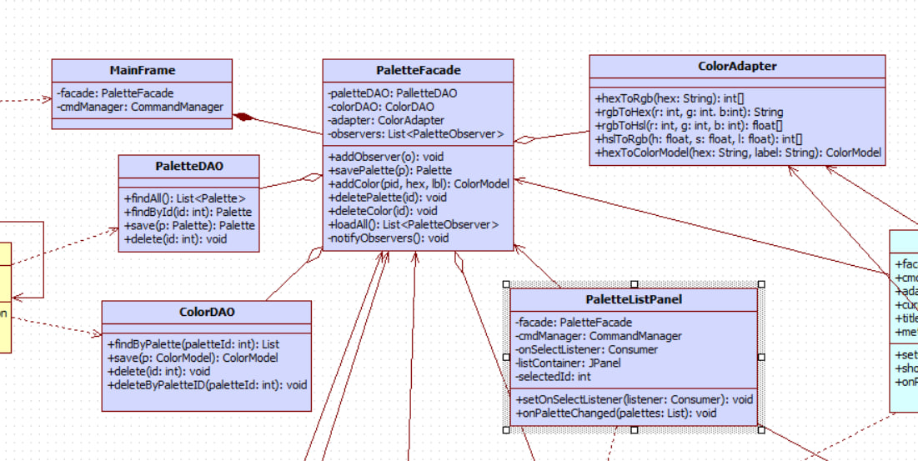

4.4 Observer — PaletteObserver

Intent
Define a one-to-many dependency between objects so that when one object changes state, all dependents are notified and updated automatically.

Problem Solved
When a colour is added to a palette, three separate UI components must update simultaneously: the sidebar must redraw the mini-swatches for that palette, the editor panel must add the new swatch card, and the status bar must increment its colour count. Without Observer, the facade (or commands) would need direct references to every UI component, creating hard coupling between the data layer and Swing.
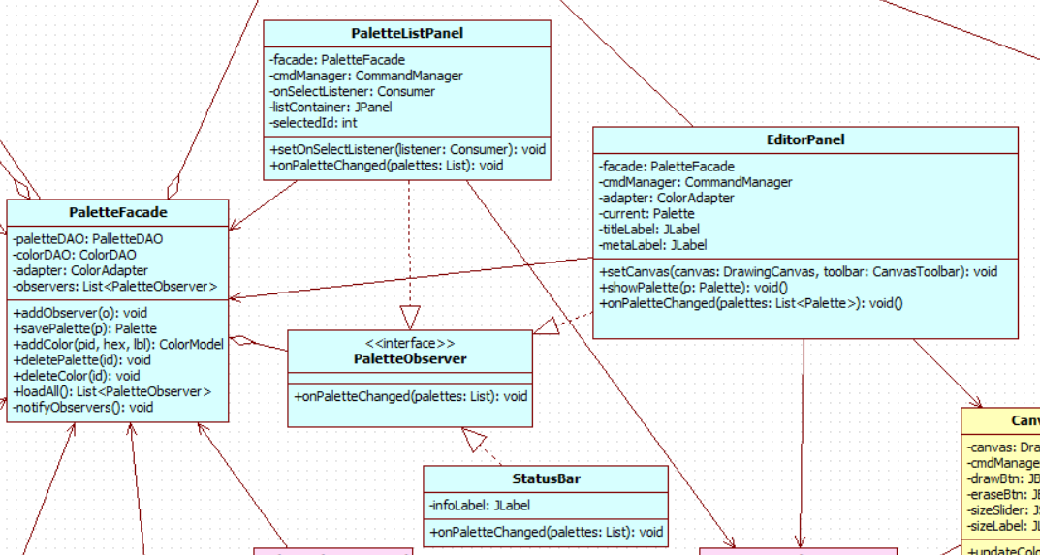

4.5 Command — CommandManager

Intent
Encapsulate a request as an object, allowing parameterisation, queuing, and reversible operations. Undo and redo are the primary motivation.

Problem Solved
Users expect Ctrl+Z to work for both palette edits (add a colour, delete a palette) and canvas operations (draw a stroke, erase, clear). Without the Command pattern, undo logic for each action would be scattered across different panels and handlers — impossible to maintain consistently.
Commands are O(1) for undo because they store the exact object that was created or removed by execute() — no database re-query is needed on undo.
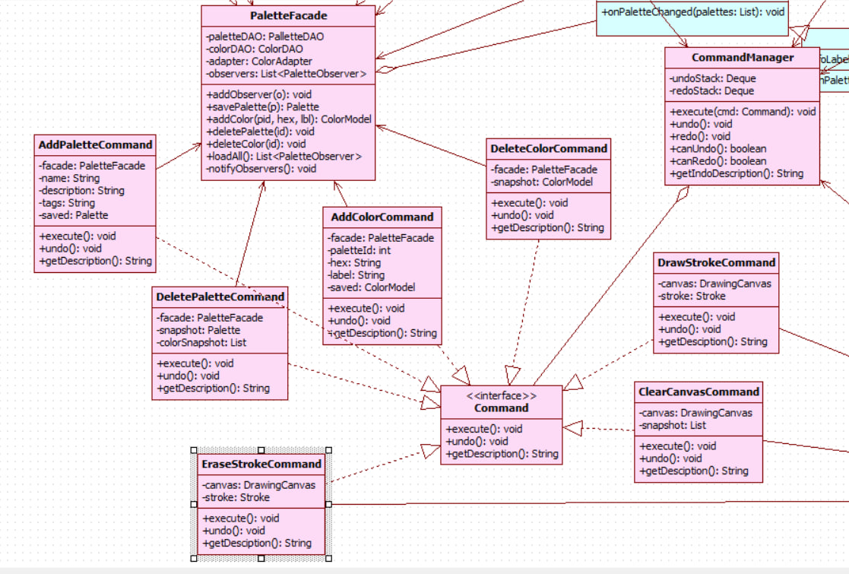

5. Database Design

5.1 Schema Overview
The MySQL database contains two tables: palettes and colors. The colors table has a foreign key to palettes with ON DELETE CASCADE, so deleting a palette automatically removes all its colours — no application-level cleanup required.

5.2 Tables: palettes and colors
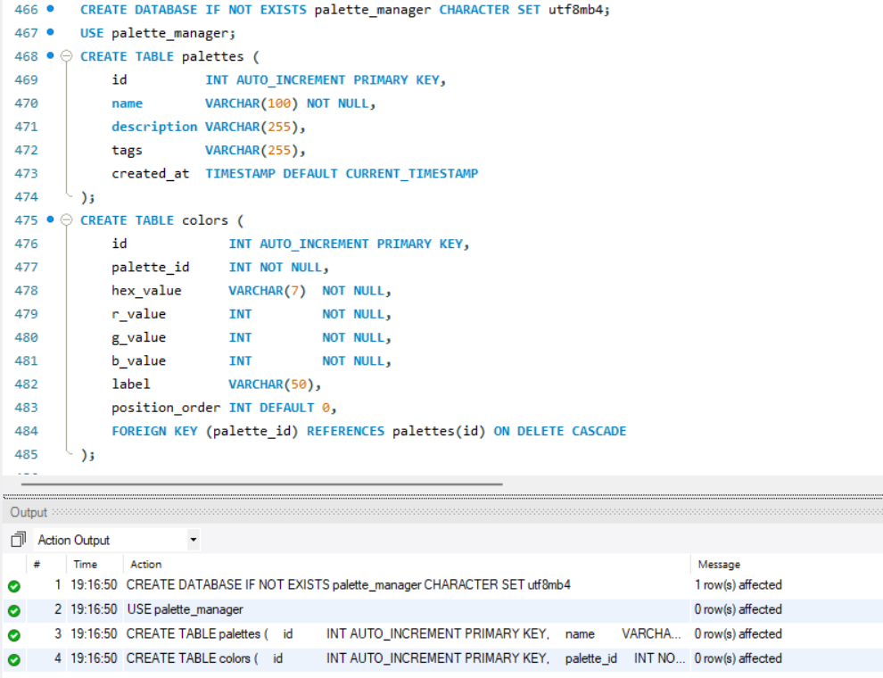

5.3 DAO Access Strategy
All SQL is confined to PaletteDAO and ColorDAO. Both use PreparedStatement for every query — no string concatenation, no SQL injection risk. DatabaseConnection.getInstance().getConnection() is called once per method to obtain the shared connection. ResultSets are processed inside the same try-with-resources block that created the statement.

PaletteFacade.loadAll() calls PaletteDAO.findAll() to get all palettes, then for each palette calls ColorDAO.findByPaletteId() to populate the colour list. This N+1 pattern is acceptable for typical palette counts (tens, not millions); a JOIN-based query can be substituted in PaletteDAO if performance becomes a concern at scale.

6. Intended Audience
Intended audience:
Java developers who will maintain, extend, or integrate the palette manager into a larger system. Familiarity with Swing and JDBC is assumed.
Software architects and engineering students who want to see five design patterns — Singleton, Adapter, Facade, Observer, and Command — applied together in a real project rather than in isolated textbook examples.
Graphic designers and power users who want to understand how their palette data is structured, stored, and retrieved.
Technical reviewers assessing the quality of the architecture, documentation, and pattern usage for academic or professional evaluation.

7. System Features
Palette creation and management Users create a new palette by entering a name and optional tags. Palettes are listed in the sidebar sorted by creation time. Any palette can be selected, renamed, or deleted. Deleting a palette removes all its colours automatically via a database cascade.
Colour addition — two methods A colour can be added by typing a HEX value directly into a text field, which shows a live preview rectangle that updates on every keystroke. Alternatively, the built-in Swing colour picker provides RGB and HSV sliders for visual selection. Both methods store the colour's HEX value and pre-parsed RGB components in the database.
Colour display and format conversion Each colour appears as a rectangular swatch showing its HEX code and display label. Hovering over a swatch shows a tooltip with the colour in all three formats: HEX, RGB, and HSL. The conversion is handled by the Adapter and requires no extra user action.
Colour deletion with undo Right-clicking a swatch opens a context menu with a delete option. The deletion is wrapped in a Command, so Ctrl+Z immediately restores the colour with its original HEX value and label.
Drawing canvas The canvas occupies the lower portion of the main window. Left-clicking and dragging draws a freehand stroke in the active colour. The toolbar above the canvas provides a Draw/Erase toggle, a brush size slider, a display of the current active colour, and a Clear button. Erase mode paints in white using a wider brush.
Colour picking from canvas Right-clicking anywhere on the canvas reads the pixel colour at that position, converts it to HEX using the Adapter, and sets it as the active brush colour. The matching swatch in the editor panel is highlighted with a coloured border to confirm the selection.
Undo and redo for all actions Every user action — adding a colour, deleting a colour, creating a palette, deleting a palette, drawing a stroke, erasing, and clearing the canvas — is wrapped in a Command object and managed by CommandManager. The toolbar Undo and Redo buttons navigate the full action history. Undo descriptions are shown as button tooltips so the user always knows what will be reversed.
Persistent data storage All palette and colour data is stored in two MySQL tables. The application reads all palettes and their colours on startup. No data is held only in memory — every change is written to the database immediately so that closing the window never causes data loss.

8. Conclusion
The Colour Palette Manager demonstrates how a focused set of design patterns can make a moderately complex desktop application clean, extensible, and easy to reason about. Each pattern addresses a concrete problem: Singleton prevents resource waste, Adapter eliminates scattered conversion code, Facade decouples UI from data access, Observer removes all explicit update calls from the data layer, and Command makes every user action reversible at zero cost to the calling code.

The result is a codebase where the boundaries between layers are sharp and well-defined. A developer who has never seen this project before can locate where palette data is stored (DAO), where conversion happens (Adapter), where the UI is notified (Facade), and where undo is managed (CommandManager) without reading more than a handful of classes. This clarity is the primary benefit of disciplined pattern usage, and it is what makes the application a viable foundation for future features such as colour harmony generation, palette export, remote synchronisation, or a web-based front end.

