**NAME**: Navigator For Visually Impaired Person

**AIM**: Around 12 million Indians are visually impaired due to untreated refractive error, according to the WHO. Many visually impaired persons come from deprived backgrounds and reside in tier 4 cities and rural areas without access to spectacles. However, they are unaware that this is curable. This navigation system aims to help blind people to navigate around safely. To find the obstacle links, the user does not need to move the white cane around. As a result, a person can go around without using a cane and continuously hear from speakers about potential hazards.

The primary goal of a navigator for visually impaired individuals is to increase their mobility and independence, allowing them to travel more freely and confidently in their daily lives. By providing guidance and support, a navigator can help individuals with visual impairments to overcome barriers and access new opportunities, such as traveling to new places or exploring unfamiliar environments.

**SCOPE**: The scope of the navigator for a visually impaired project would typically involve developing a device or application that can help visually impaired individuals navigate their surroundings more easily and safely. This could include features such as:

1. GPS and mapping technology: To track the user's location and provide turn-by-turn directions to their destination, the device would need to use GPS.
2. Voice and audio cues: the device would need to provide audio cues to guide the user along their route, such as "turn left in 50 meters".
3. Obstacle detection: The device may have sensors that identify obstructions in the user's route, such as walls, steps, or ground-level items, and issue alerts or directions to avoid them.
4. Object recognition: The device may make use of computer vision technology to identify landmarks, buildings, signs, or other items in the user's environment and deliver details about them via audio cues.
5. Integration with other devices: the device or application could be designed to work with other devices that visually impaired individuals may use, such as braille readers, hearing aids, or smartphones.

**ILLUSTRATION**:

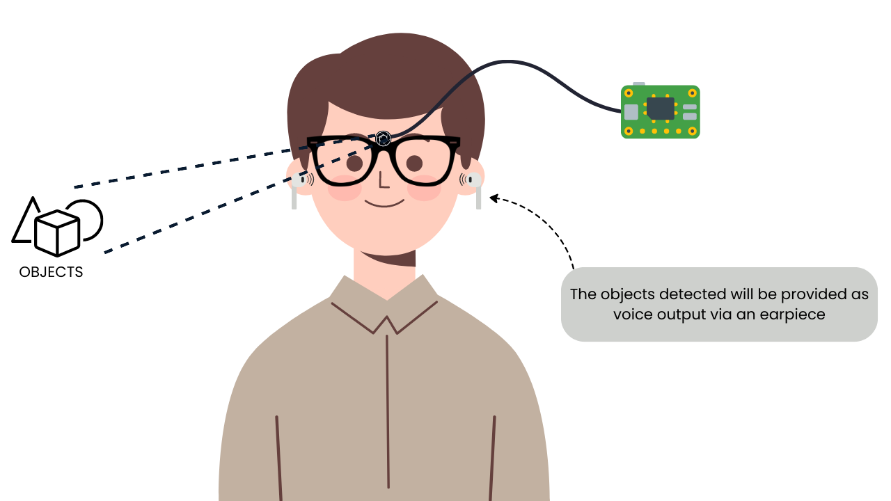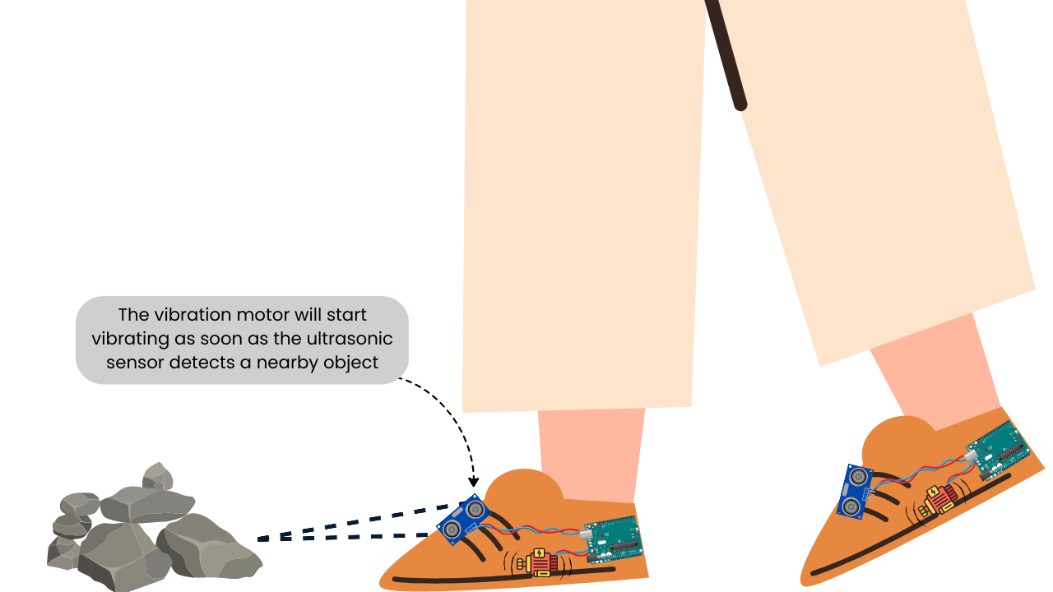**APPLICATIONS**: It can be used for providing a set of useful features such as,

* Light Detection
* Color Detection
* Object Recognition
* Banknote Recognition
* Optical Character Recognition

**REFERENCES**:

1. Nishajith. A, Nivedha. J, Shilpa.S.Nair, Prof.Mohammed Shaffi. J, “Review paper on- Smart Cap-Wearable Visual Guidance System For Blind”, Proceedings of the International Conference on Inventive Research in Computing Applications (ICIRCA 2018) IEEE Xplore Compliant Part Number: CFP18N67-ART; ISBN:978-1-5386-2456-2.
2. Arjun Pardasani, Prithviraj N Indi, Sashwata Banerjee, Aditya Kamal, “Review paper on-Smart Assistive Navigation Devices for Visually Impaired People”,2019 IEEE 4th International Conference on Computer and Communication Systems.
3. Joe Louis Paul I, B.-J.; Kim, Sasirekha S, Mohanavalli S, Jayashree C, Moohana Priya P, Monika K, “Review paper on Smart Eye for Visually Impaired-An aid to help the blind people”, Second International Conference on Computational Intelligence in Data Science (ICCIDS-2019).
4. N.Loganathan, K.Lakshmi, N.Chandrasekaran, S.R.Cibisakaravarthi, R.Hari Priyanga, K.HarshaVarthini, “Review paper on- Smart Stick For Blind People”, 2020 6th International Conference On Advance Computing & Communication System (ICACCS).