Bluetooth: Technology, Applications and Compatibility
1.0 Introduction.
This technical paper seeks to explore at an introductory level the key features of Bluetooth Technology. We shall examine the Bluetooth Special Interest Group (SIG) and its key role in maintaining specifications of the protocol, profiles, testing and qualification, interoperability and compatibility. It will then consider the sort of applications and products being derived.
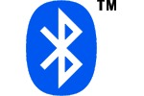
Figure 1: Bluetooth Logo.
Perhaps as early as the 10th Century, when Harald Blåtand (Bluetooth) was King of Denmark. Whilst Nordic states were warring, he managed to unite Denmark and part of Norway into a single kingdom. His name has become synonymous with a standard aimed at unifying the worlds of telecommunications and computing.
The Bluetooth brand is now recognized worldwide on products with short range wireless communication capabilities. The brand is a label that is not a single company technology but is shared by many members of the Bluetooth SIG. The brand is applied to devices implementing the Bluetooth technology, even if it says little about the way the technology works.

2.0 The Technology.
Fundamentally Bluetooth operates within the Industrial, Scientific and Medical (ISM) band at 2.4 GHz. It is a short-range wireless communication standard defined as cable replacement for a Personal Area Network (PAN).
A cable replacement standard has been defined because cables limit mobility of the consumer; they are cumbersome to carry around, are easily lost or broken. Often connectors are prone to difficult to diagnose failures; or are proprietary. To counteract these limitations Bluetooth is designed to be light and portable. It can be embedded to take the riggers of physical knocks and shocks. It includes standards and protocols to make it mobile, robust, reliable and not limited to one manufacturer. The operating band also fits the goals of Bluetooth, imposing requirements as a cable replacement. The cost needs to be comparable with cable. Reductions can be achieved by operating in the licence free 2.4 GHz ISM band, keeping backward compatibility wherever possible lowers the cost of ownership by avoiding upgrades and having a relaxed radio specification enables single chip integrated circuit solutions. It also needs to be as reliable and resilient as cable and cope with errors and degradation caused by interference. For mobile devices it must be compact, light weight, low power and easy to use.

2.1 Frequency Hopping.
We have addressed the reasons for the Bluetooth without delving into the ‘nuts and bolts’ of the technology to discover how it operates. For the majority of countries the ISM band used by Bluetooth is available from 2.40-2.4835 GHz, although some countries impose restrictions. In this band Bluetooth uses Frequency Hopping Spread Spectrum (FHSS) techniques in order to improve its immunity from interference.
In unrestricted countries the radios hop in pseudo random sequences around all available channels, this equates to 79 RF channels with a channel spacing of 1 MHz. Starting at a base frequency of 2402 MHz then the frequency of the channels, f, can be expressed as:
f =2402 + n MHz
where, n is the channel number with an integer value in the range of 0 to 78. In restricted countries a limited frequency hopping schemes with just 23 channels is used and is catered for in the Bluetooth specification. Both hopping schemes have a 1 MHz channel spacing making it possible to design a simple radio interface whereby the baseband only has to specify a channel number and the radio multiplies this up to the appropriate frequency offset.
In this FHSS scheme there are 1600 hops per second, which is a hop every 625 µs. Part of this hop timing is taken up by the guard time of 220 µs allowing the synthesizer time to settle. The frequency hopping implements time division multiplexing as shown in Figure 2. The basis of the scheme has the Master device transmitting in the first 625 µs slot, k, and here the Slave receives. In the next slot k = 1 the Slave is permitted to transmit and the master listens.
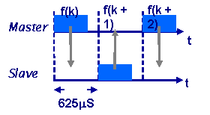
Figure 2: Frequency Hopping, master and slave interact on corresponding slots.
The radio must be able to retune and stabilize on a new frequency within tight time constraints. This is pushed further when establishing a connection; the hop rate can be shortened to every 312.5 µs. As the radios are constantly hopping to different radio channels, this ensures that packets affected by interference on one channel can be retransmitted on a different frequency channel. To further enhance resilience both ARQ (Automatic Repeat reQuest) and FEC (Forward Error Correction) form part of the specification.

2.2 The Bluetooth SIG and Specifications.
If the success of Bluetooth is measured by its initial interest alone then its prominence has already been assured. Before products were on sale, hundreds of companies joined the Bluetooth Special Interest Group (SIG) and the Bluetooth brand became recognized worldwide. With membership of the SIG nearing 2500 members it is only right to look at how the SIG works to promote, shape and define the specification and position Bluetooth in the market place.
In 1994, Ericsson Mobile Communications began to examine alternatives to cables linking accessories with their mobile phones. This study produced the initial specification for wireless technology, with the Bluetooth SIG founded in February 1998 by the core promoters Ericsson Mobile Communications AB., Intel Corp., IBM Corp., Toshiba Corp. and Nokia Mobile Phones.
The core promoters announced the global SIG in May 1998 and invited other companies to join as Bluetooth adopters. In July 1999 the core promoters published version 1.0 of the specification and further enlarged the core promoter group in December 1998 with the inclusion of Microsoft, Lucent (now Agere), 3Com. and Motorola.
The Bluetooth specifications are open specifications for wireless communications that are free to download and use; however to use it royalty free you do have to join the SIG. By joining the group you sign up to an adopter’s agreement sharing any patents essential for implementing Bluetooth. The specifications define minimum functionality allowing devices from different companies to communicate. They provide the following:
- Protocol definitions for interoperability
- Host controller interface
- Bearer services for higher layer protocols
- Profiles
- Qualification
- Production test
- Brand book

2.2.1 The Protocol Stack.
The Bluetooth specifications define not only a radio system but cover the underlying structure. The Core Specification contains a software protocol stack similar to the more familiar Open Systems Interconnect (OSI) standard reference model for communication protocol stacks. It permits applications to discover devices, the services they offer and permission to use these services. The stack is a sequence of layers with features crossing single or multiple layered boundaries. Figure 3 outlines the stack with each block corresponding to a Core Specification chapter. Other remaining chapters relate to compliance requirements, test modes and test control interface.
If we ascend the stack, we first come across the fundamental component, the radio. The radio modulates and demodulates data for transmitting and receiving over the air. The operating band of the radio is divided into 1 MHz spaced channels with a chosen modulation scheme of Gaussian Frequency Shift Keying (GFSK). Each channel is specified to signal at 1mega symbols per second, equivalent to 1 Mb/s. Above the radio are the Baseband and Link Controller, they are responsible for controlling the physical links via the radio, assembling the packets and controlling the frequency hopping.
Progressing through the layers, the Link Manager (LM) controls and configures links to other devices. The Host Controller Interface (HCI) is above the LM layer and is probably one of the most important layers to consider as a designer. It handles communication between host and the module. The standard defines the HCI command packets that the host uses to control the module, the event packets used by the host to inform lower protocol layers of changes, the data packets for voice and data traffic between host and module and the transport layer used by the HCI packets. The transport layer can be USB (H2), RS232 (H3), UART (4) or a robust proprietary standard such as BCSP (BlueCore Serial Protocol).
The Logical Link Control and Adaptation (L2CAP) is a multiplexer, adapting data from higher layers and converting between different packet sizes. The next 4 layers could be loosely grouped as communication interfaces. These are RFCOMM (Radio Frequency COMMunication port) which provides an RS232 like serial interface. Wireless Application Protocol (WAP) and OBject EXchange (OBEX) are responsible for providing interfaces to other Communications Protocols. The final member of this rough grouping is the Telephony Control protocol Specification (TCS) providing telephony services. Service Discovery Protocol (SDP) lets devices discover the services available on another Bluetooth device.
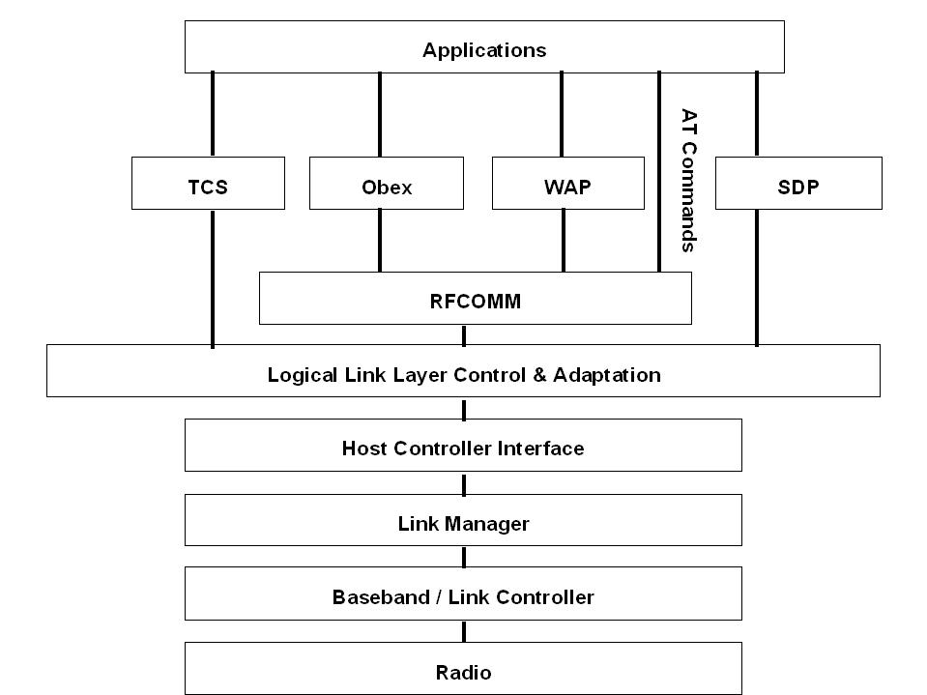
Figure 3: The Bluetooth Protocol Stack
The application layer is probably obvious, but the standard provides Profiles laying out rules for how applications use the protocol stack, ensuring interoperability at application level.
2.2.2 Master and Slave Operation.
Bluetooth devices exist in small ad-hoc network configuration with the ability to operate as either master or the slave; the specification also allows a mechanism for master and slave to switch their roles. The configurations can be single point, which is the simplest configuration with one master and one slave. Multipoint, called a Piconet, based on up to 7 slaves clustered around a single Master. And a third type called a Scatternet, this is a group of Piconets effectively hubbed via a single Bluetooth device acting as a master in one Piconet and a slave in the other Piconet. The Scatternet permits either larger coverage areas or number of devices than a single Piconet can offer. Figure 4 outlines the different master and slave topologies permitted for networks in the standard.
The role of the master is to control the available bandwidth between the slaves, it calculates and allocates how often to communicate with each slave and locks them into the appropriate frequency hopping sequence. In addition to hop sequence control, the master is responsible for transmit control by dividing the network into a series of time slots amongst the net members, as part of a Time Division Multiplexing (TDM) scheme. These time slots can consist of data and potentially additional voice traffic.
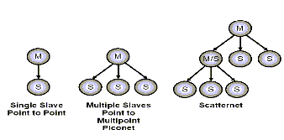
Figure 4: Point to point, Piconet and Scatternet.

2.2.3 Voice and Data Links.
Bluetooth carries communication traffic over two types of air interface links defined as Asynchronous ConnectionLess (ACL) or Synchronous Connection Oriented (SCO). During a connection the links carry voice and data traffic in the time slots and are categorized as either time critical, as used for voice and audio, or high speed non-time critical data with a mechanism for acknowledgement and re-transmission. The first link established between master and slave is the ACL link and carries high speed data that is insensitive to time.
Once an ACL has been established a SCO link can be created on top of the ACL link. The SCO link is circuit switched; it has symmetric synchronous services and has slot reservation at fixed intervals, making it suitable for time critical data such as voice. The specification restricts the number of SCO links that a master can support to three. Summarizing the two types of links:
ACL
- Packet constructed of a 72 bit access code, a 54 bit packet header, a 16 bit CRC and Payload data
- Largest data packet is DH5 giving 723.2 Kb/s as highest data rate in one direction.
- Non time critical data
- Asynchronous
- Packet switched
- Polling access
SCO
- Same access code and header as ACL packets
- ARQ (Automatic Repeat reQuest) and SEQ (SEQuence) flags redundant since flow control and re-transmissions do not apply
- Cyclic Redundancy Code (CRC) field is absent
- Payload fixed at 30 bytes, with source data of 10, 20 or 30 bytes
- Circuit switched
- Symmetric synchronous services
- Slot reservation at fixed intervals

2.2.4 Power: Classes, Control and Saving.
This section is a grouping of elements influencing various forms of power control. The specification highlights three device power classes possible for Bluetooth radios that are related to the power range of the transmitter:
- Class 1 is 100mW and up to about 100m range
- Class 2 is 2.5mW and up to about 20m range
- Class 3 is 1mW and up to about 10m range
The second form of power control is on the receiver side of a Bluetooth device. To enable all classes to communicate in a Piconet without damage to the RF front ends of the lower power classes, a method for controlling Class 1 device transmitter power is required.
The last form of power control relates to the power consumption. The Hold, Sniff and Park modes are power saving modes set out in the specification aiming to preserve battery consumption. The Hold mode is typically used when a master is establishing a link with a new device and requires the other slaves to temporarily halt their transmissions. The Sniff mode puts slaves into a low duty cycle mode of operation but is still an active member of the Piconet and the master can only transmit after a ‘sniff’ interval. In Park mode slaves enters a low duty cycle mode of operation and are no longer an active members of the Piconet.

3.0 Applications and Profiles.
Undeniably the ideal candidate for the first wave of applications will inevitably be based on mobile cellular technology, but what other applications can be realised using Bluetooth technology? The short-range connections of data and voice could mean the emergence of applications suitable for:
- Access points allowing mobile devices connection to services e.g. telephone network (PSTN) or LAN services.
- Mobile phone link to Laptop PCs
- Mobile phone connections to wireless headsets
- PDA, palmtop and desktop PC inter accessibility for file and data synchronisation.
The Bluetooth core specification describes the protocol, but the Profiles document enhances this by setting out a number of profiles for applications and defining the way a number of services operate e.g. a file transfer profile defines how devices exchange data files. The profile document aids applications development, describing implementation schemes and highlights parts of the core Bluetooth protocol supporting the profile. A wireless headset for a mobile phone is an application example using the profiles. It uses the Headset profile as its core specification.

3.1 Connections – How are they made?
As applications need to connect to one another it is probably appropriate to introduce how devices connect to each other. In its simplest form the devices needing to connect proceed as follows:
- The master enters inquiry mode and sends out an inquiry to discover devices available to connect to.
- Potential slaves make themselves discoverable by entering inquiry scan mode and listen for an inquiry from a master.
- On receiving an inquiry, the slave responds to the master with a Frequency Hop Synchronisation packet (FHS). The FHS contains information that is needed to create a connection to the device; this information includes its Bluetooth address and class of device.
- The master collects the FHS information from each device discovered. To connect to one of these devices the master goes into page mode and will page the device using the corresponding Bluetooth address.
- The slave being paged by a master will need to be in page scan mode to be able to connect to a master.

4.0 Compatibility.
Compatibility covers various issues, whether it is compatibility with other Bluetooth devices, the specification or other systems that share the same frequency band. We will examine some of these aspects here.

4.1 Interference.
Bluetooth is subject to interference from two types of emitters, as well as environmental problems. The emitters break down to intentional emitters and accidental emitters. Intentional emitters occupy the ISM band and are systems based on IEEE 802.11b (Wi-Fi), Home RF, DECT variants, proprietary systems and of course other Bluetooth devices. Accidental emitters include microwave ovens and lighting. The third source of interference could be the environment, signals can fade due to distance or being blocked by walls, furniture and human bodies; device positioning could be critical.
How is the affect of these forms of interference minimised? With respect to the intentional emitters, Bluetooth has a clear advantage over systems based on Direct Sequence Spread Spectrum (DSSS) systems such as IEEE802.11b as it is based on a FHSS system. What makes the DSSS poor in comparison is that transmission power is often low in any specified band. The FHSS signal may have high enough power in its narrower band to effectively ‘punch through’ the parts of the wider band occupied by the DSSS system. Otherwise, if there is strong interference from the DSSS system on Bluetooth, its ability to hop utilises the rest of the band more effectively.
HomeRF is another FHSS system and you could be lucky that both systems could hop around and miss each other. But HomeRF with greater data rates has larger channel sizes and therefore Bluetooth has a greater chance of hitting these on a hop.
Against other intentional emitters and accidental emitters the techniques for co-existence with IEEE 802.11b and HomeRF are just as applicable i.e. the ability to hop away from offending channels and retry are Bluetooth’s natural defence.

4.2 Interoperability, Testing and Qualification.
In the interests of interoperability the Bluetooth SIG has provided a qualification process that is a series of tests examining a device’s functionality and verifies that it conforms to the Bluetooth specification and associated profiles. By passing the qualification process, the manufacturer is granted a free license to use the Bluetooth patents in the product and the Bluetooth brand on their products. One of the more fruitful options open to Bluetooth manufacturers is the regularly scheduled ‘Unplug Fests’. These are scheduled meetings of the Bluetooth technical community, where products are tested against each other for interoperability.
The Bluetooth specification allows inter device communications to be secure through the use of encrypted links that can be turned on and off as required. Link keys are shared between required devices and to be interoperable in this encrypted process, devices must possess the correct link keys.

5.0 Conclusion.
This was an overview of Bluetooth giving insight to the key features and potential challenges of the technology. The technology occupies the 2.4 GHz ISM band sharing the bandwidth with potential competing standards. It defines a Personal Area Network (PAN) whereas others advocate a Wide Area Network (WAN) approach. It is best positioned as a short-range wireless standard designed with the same cost goals and similar or greater reliability and performance as the cable it replaces. Based on a frequency agile FHSS scheme it leverages hopping to avoid interference and it was not intended as a replacement for wireless LAN in a WAN scenario, because as yet it does not fully specify a hand over mechanism.
The importance of the Bluetooth SIG and how its specifications aid development of applications was highlighted, especially through the profiles, and their interoperability is assured through the qualification process. A flavour of the applications was explored through the functionality and where particular attention must be paid to the protocol stack for system segmentation. The latest specifications including the profiles are available from the Bluetooth SIG website. Reading specifications can seem a little ‘one dimensional’ but read in conjunction with a good book, whilst using a development tool from one of the Bluetooth silicon vendors, then the jigsaw pieces to really start to fit.
In conclusion, if we allow PCs a cornucopia of competing, serial cable standards hanging from them surely there must be room for differing wireless standards to co-exist to cover various functionalities.

References
- J. Bray and C.F. Sturman, “Bluetooth: Connect Without Cables”, Prentice Hall.
- SHEPHERD, R.: ‘Bluetooth wireless technology in the home’, Electronics & Communications Engineering Journal, October, 2001, pp. 195–203.
- PHILLIPS, M.: ‘Reducing the cost of Bluetooth systems’, Electronics & Communications Engineering Journal, October, 2001, pp. 204–208.
- BRAY, J., and STURMAN, C. F.: ‘Bluetooth–Connect Without Cables’, Prentice Hall PTR, 2001.
- MILLAR, B. A., BISDIKIAN, C.: ‘Bluetooth Revealed: The Insider’s Guide to an Open Specification for Global Wireless Communications’, Prentice Hall PTR, 2000.

