Temperature_Analysis
Mandar
2025-06-25
rm(list = ls())
knitr::opts_chunk$set(cache = TRUE, cache.lazy = FALSE, warning = FALSE,
message = FALSE,echo = TRUE, dpi = 300,
fig.width = 15, fig.height = 10)

Reading the data from the directory
## Daily data
data <- readRDS(file = "/Users/mandarphatak/Climate-Analysis/DWD_Folder/Data_DWD/Hamburg_Fuhlsbüttel.rds")
data <- data |> dplyr::filter(date < "2025-01-01")
library(tidyverse)
library(SPEI)
library(drought)
library(extRemes)
library(heatwaveR)

data tranformation :- We select the te
## Tavg Tmax Tmin prec
## Min. : 6.794 Min. :10.88 Min. :2.556 Min. : 392.3
## 1st Qu.: 8.352 1st Qu.:12.08 1st Qu.:4.593 1st Qu.: 681.2
## Median : 9.140 Median :12.92 Median :5.099 Median : 742.9
## Mean : 9.060 Mean :12.91 Mean :5.137 Mean : 759.4
## 3rd Qu.: 9.739 3rd Qu.:13.59 3rd Qu.:5.891 3rd Qu.: 831.2
## Max. :11.180 Max. :15.07 Max. :7.161 Max. :1071.8
## rel_hum
## Min. :69.43
## 1st Qu.:78.50
## Median :80.03
## Mean :79.77
## 3rd Qu.:81.24
## Max. :84.81

Focusing on Temperature data

Data Over View :- We perform the following data manipulation for desired data overview

Temperature Variation
annual_temperature_tbl_long$Temperature_Type <- factor(
annual_temperature_tbl_long$Temperature_Type,
levels = c("Tmax", "Tavg", "Tmin"))
trends_tbl <- annual_temperature_tbl_long %>%
group_by(Temperature_Type) %>%
summarize(trend = coef(lm(Temperature ~ year))[2]) %>%
ungroup()
trends_tbl <- trends_tbl %>%
mutate(
label = case_when(
Temperature_Type == "Tmax" ~ paste0("Maximum Temperature (Trend: +", round(trend, 4), "°C/year)"),
Temperature_Type == "Tavg" ~ paste0("Average Temperature (Trend: +", round(trend, 4), "°C/year)"),
Temperature_Type == "Tmin" ~ paste0("Minimum Temperature (Trend: +", round(trend, 4), "°C/year)")
),
color = case_when(
Temperature_Type == "Tmax" ~ "#ff1744",
Temperature_Type == "Tavg" ~ "#fc8d59",
Temperature_Type == "Tmin" ~ "#4575b4"
),
y = case_when( # adjust based on your plot’s Y-axis ranges
Temperature_Type == "Tmax" ~ 15,
Temperature_Type == "Tavg" ~ 10.55,
Temperature_Type == "Tmin" ~ 6.5
),
x = 1938 # horizontal position of the labels
)

Overview of Temperature Variation 1936-2024
ggplot(annual_temperature_tbl_long, aes(x = year, y = Temperature, colour = Temperature_Type)) +
geom_line(linewidth = 1) +
geom_point(aes(fill = Temperature_Type), shape = 21, size = 4, stroke = 1, colour = "white") +
# Add separate trend lines for each temperature type
geom_smooth(aes(group = Temperature_Type), method = "lm", se = FALSE, linewidth = 1,
show.legend = FALSE, color = "black") +
geom_text(
data = trends_tbl,
aes(x = x, y = y, label = label, color = Temperature_Type),
fontface = "bold", hjust = 0, size = 7, show.legend = FALSE
) +
# Fixed color scales with intuitive temperature colors
scale_color_manual(
values = c("Tmax" = "#ff1744", # Hot red for maximum
"Tavg" = "#fc8d59", # Orange for average
"Tmin" = "#4575b4"), # Cool blue for minimum
labels = c("Tmax" = "Maximum Temperature",
"Tavg" = "Average Temperature",
"Tmin" = "Minimum Temperature"),
name = "Temperature Type"
) +
scale_fill_manual(
values = c("Tmax" = "#ff1744", # Same colors for consistency
"Tavg" = "#fc8d59",
"Tmin" = "#4575b4"),
guide = "none" # Hide fill legend since color legend shows the same info
) +
scale_x_continuous(breaks = c(seq(1936, 2024, 10), 2024),
expand = c(0.02, 0.02),
limits = c(1936, 2024)) +
scale_y_continuous(
limits = c(1, 16),
breaks = seq(1, 16, by = 2),
labels = function(x) paste0(format(x, nsmall = 0), "°C"),
expand = c(0, 0)
) +
labs(
title = "Temperature Variation (1936-2025)",
subtitle = "Hamburg Fuhlsbüttel",
x = "",
y = "Temperature (°C)"
) +
theme_minimal() +
theme(
plot.title.position = "plot",
plot.title = element_text(hjust = 0, face = "bold", colour = "black", size = 30, margin = margin(b = 20)),
plot.subtitle = element_text(hjust = 0, face = "bold", colour = "black", size = 30, margin = margin(b = 10)),
axis.line = element_line(color = "black", linewidth = 1),
axis.title = element_text(face = "bold", color = "black", size = 22),
axis.ticks = element_blank(),
panel.grid.minor = element_blank(),
panel.grid.major = element_line(linewidth = 0.5),
axis.text.x = element_text(angle = 45, hjust = 1, face = "bold", color = "black", size = 20),
axis.text.y = element_text(face = "bold", color = "black", size = 20),
legend.text = element_text(size = 18, face = "bold"),
legend.title = element_text(size = 18, face = "bold"),
legend.position = "bottom", # Better positioning for temperature legend
panel.background = element_blank(),
plot.background = element_blank()
) +
guides(color = "none", fill = "none")
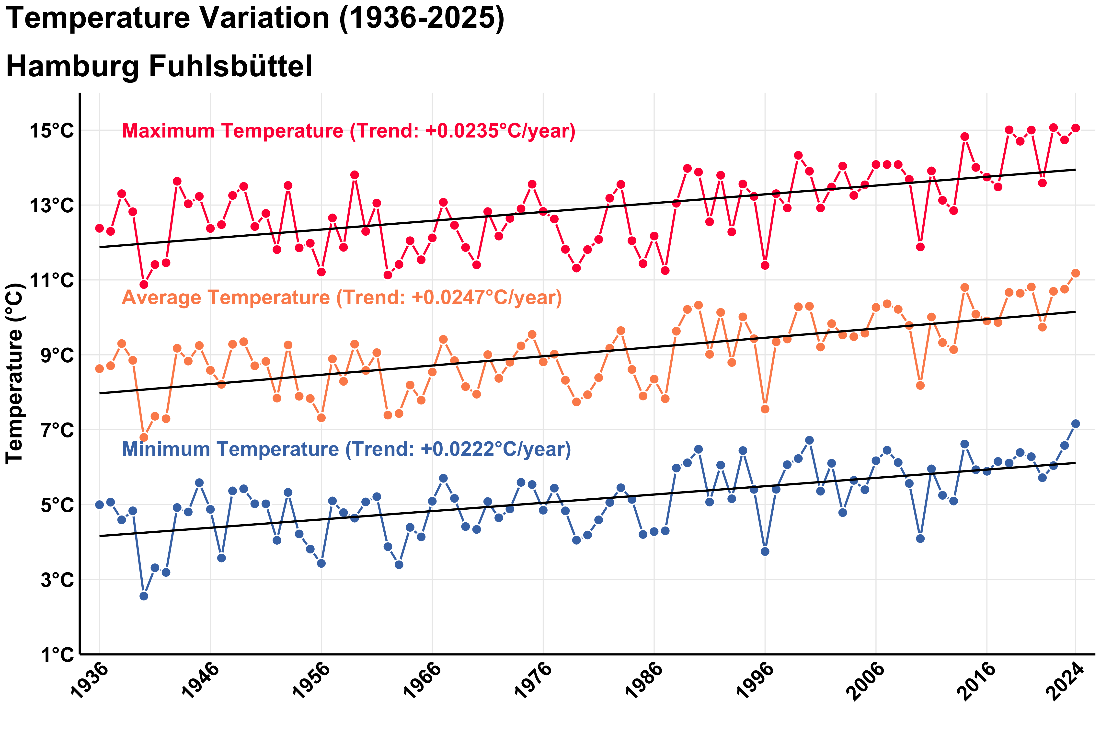 ### Decadal Changes in Temperature
annual_temperature_tbl_long <- annual_temperature_tbl_long |>
mutate(decade_group = case_when(
year >= 1936 & year <= 1939 ~ "1936–1939",
year >= 1940 & year <= 1949 ~ "1940–1949",
year >= 1950 & year <= 1959 ~ "1950–1959",
year >= 1960 & year <= 1969 ~ "1960–1969",
year >= 1970 & year <= 1979 ~ "1970–1979",
year >= 1980 & year <= 1989 ~ "1980–1989",
year >= 1990 & year <= 1999 ~ "1990–1999",
year >= 2000 & year <= 2009 ~ "2000–2009",
year >= 2010 & year <= 2019 ~ "2010–2019",
year >= 2020 & year <= 2024 ~ "2020–2024",
TRUE ~ NA_character_
))
decadal_summary_tbl <- annual_temperature_tbl_long %>%
group_by(decade_group, Temperature_Type) %>%
summarise(decadal_mean = mean(Temperature, na.rm = TRUE), .groups = "drop")
library(ggplot2)
ggplot(decadal_summary_tbl, aes(x = decade_group, y = decadal_mean, fill = Temperature_Type)) +
geom_bar(stat = "identity", position = "dodge", color = "black") +
scale_fill_manual(
values = c("Tmax" = "#ff1744", "Tavg" = "#fc8d59", "Tmin" = "#4575b4"),
name = "Temperature Type",
labels = c("Tmax" = "Maximum", "Tavg" = "Average", "Tmin" = "Minimum")
) +
labs(
title = "Decadal Mean Temperature (1936–2024)",
subtitle = "Hamburg Fuhlsbüttel",
x = "Decade",
y = "Mean Temperature (°C)"
) +
theme_minimal(base_size = 16) +
theme(
plot.title = element_text(face = "bold", size = 24),
plot.subtitle = element_text(size = 20),
axis.text.x = element_text(angle = 45, hjust = 1, face = "bold"),
axis.text.y = element_text(face = "bold"),
legend.title = element_text(face = "bold"),
legend.text = element_text(face = "bold")
)
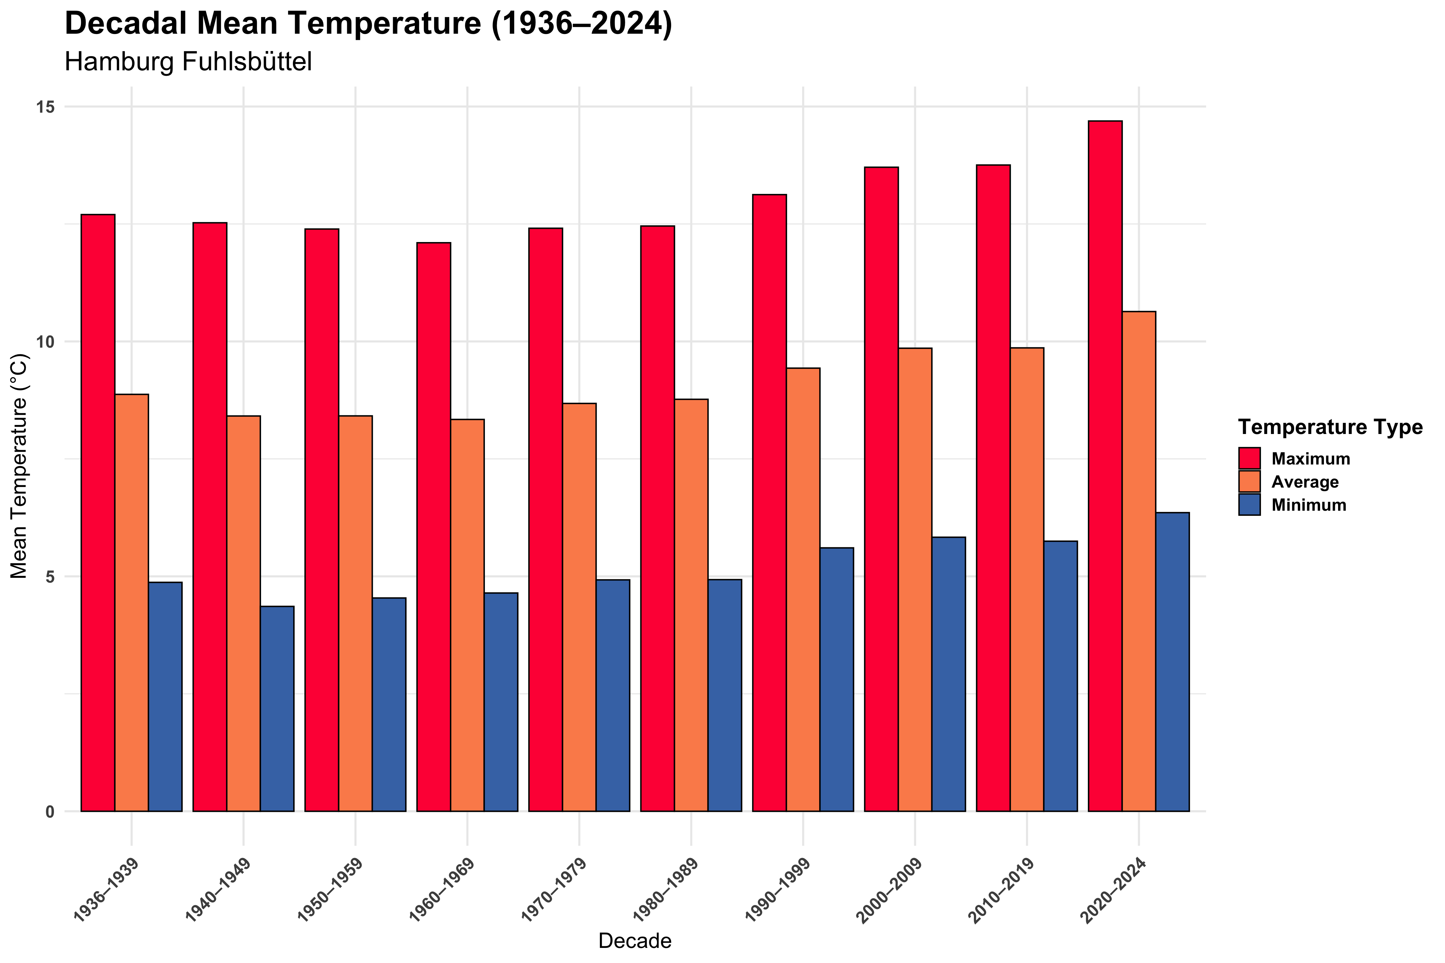 ## Variation in Temperature across decade
decadal_diff_tbl <- decadal_summary_tbl %>%
arrange(Temperature_Type, decade_group) %>%
group_by(Temperature_Type) %>%
mutate(
change_from_prev = decadal_mean - lag(decadal_mean),
percent_change = 100 * change_from_prev / lag(decadal_mean)
) %>%
ungroup()
ggplot(decadal_summary_tbl, aes(x = decade_group, y = decadal_mean, group = Temperature_Type, color = Temperature_Type)) +
geom_line(linewidth = 1.5) +
geom_point(size = 4) +
scale_color_manual(
values = c("Tmax" = "#ff1744", "Tavg" = "#fc8d59", "Tmin" = "#4575b4"),
name = "Temperature Type",
labels = c("Tmax" = "Maximum", "Tavg" = "Average", "Tmin" = "Minimum")
) +
labs(
title = "Decadal Temperature Trends (1936–2024)",
subtitle = "Hamburg Fuhlsbüttel",
x = "",
y = "Mean Temperature (°C)"
) +
theme_minimal(base_size = 16) +
theme(
plot.title = element_text(face = "bold", size = 24),
plot.subtitle = element_text(size = 20),
axis.text.x = element_text(angle = 45, hjust = 1, face = "bold"),
axis.text.y = element_text(face = "bold"),
legend.title = element_text(face = "bold"),
legend.text = element_text(face = "bold")
)
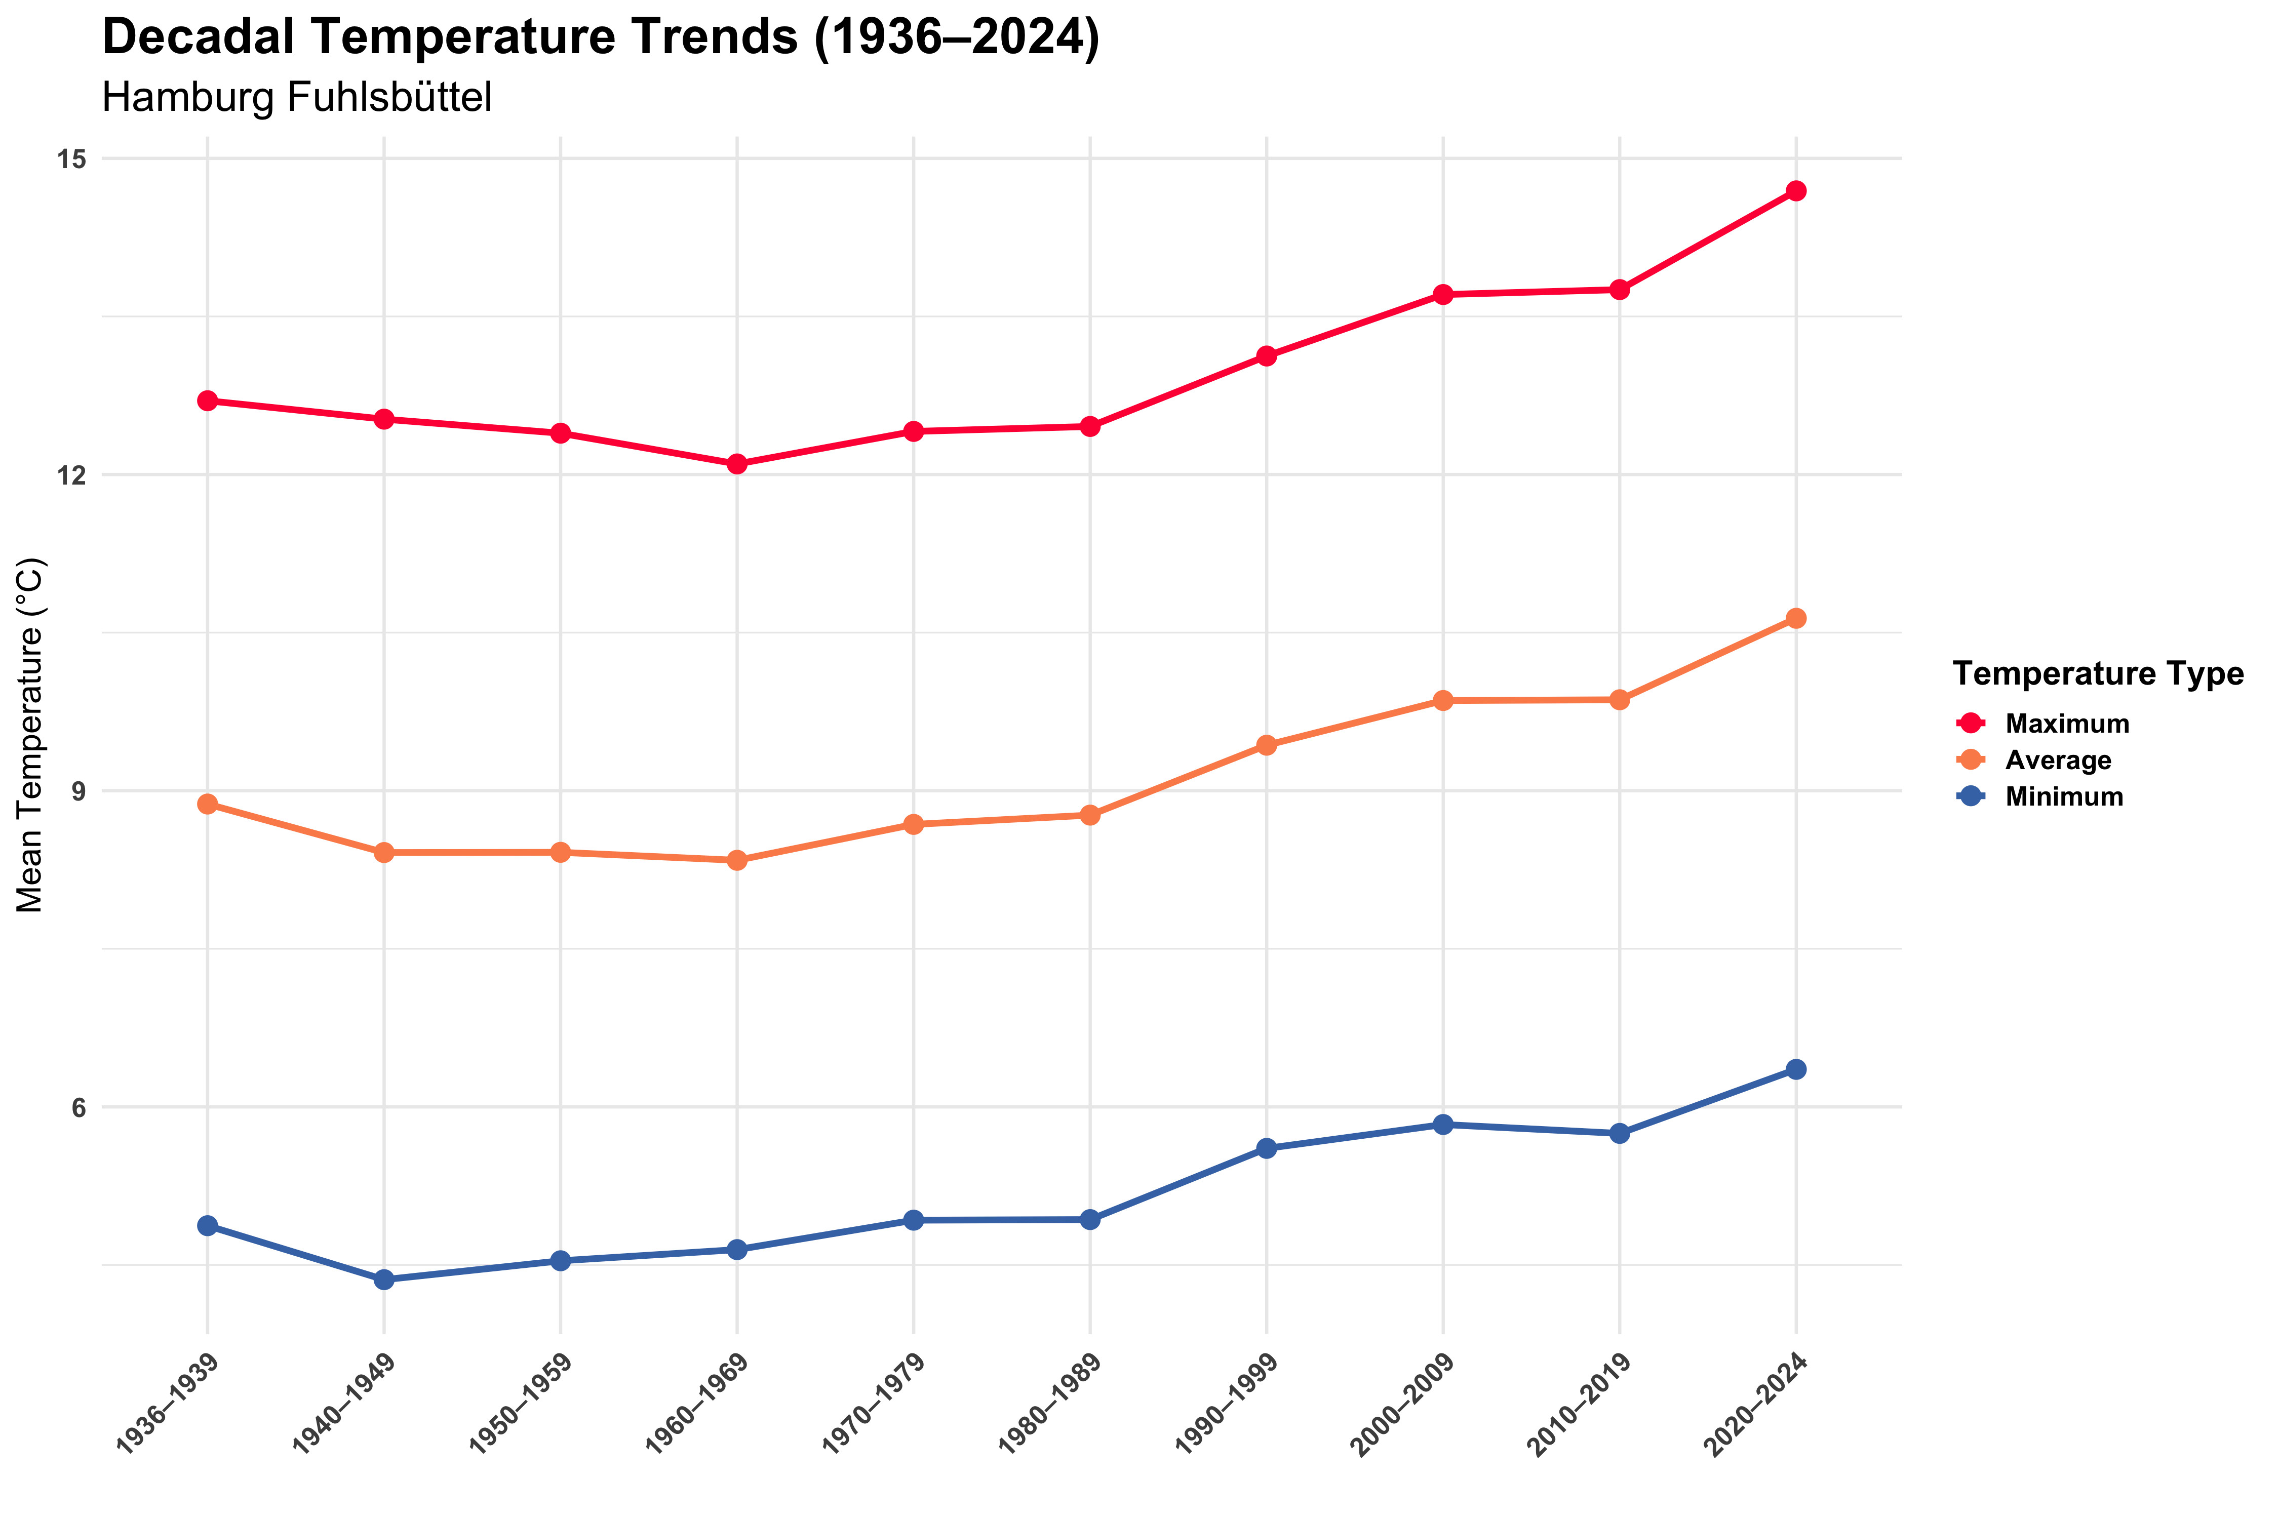

Incremental changes in Temperature across Decades
decadal_diff_tbl <- decadal_summary_tbl %>%
arrange(Temperature_Type, decade_group) %>%
group_by(Temperature_Type) %>%
mutate(decadal_diff = decadal_mean - lag(decadal_mean)) %>%
filter(!is.na(decadal_diff)) %>%
ungroup()
ggplot(decadal_diff_tbl, aes(x = decade_group, y = decadal_diff, fill = Temperature_Type)) +
geom_col(position = position_dodge(width = 0.7), width = 0.6) +
geom_label(aes(label = round(decadal_diff, 2)),
position = position_dodge(width = 0.7),
size = 4.5, fontface = "bold",
show.legend = FALSE) +
# geom_text(aes(label = round(decadal_diff, 2)),
# position = position_dodge(width = 0.7),
# vjust = ifelse(decadal_diff_tbl$decadal_diff >= 0, -0.3, 1.3),
# size = 5, fontface = "bold") +
scale_fill_manual(
values = c("Tmax" = "#ff1744", "Tavg" = "#fc8d59", "Tmin" = "#4575b4"),
name = "Temperature Type",
labels = c("Tmax" = "Maximum", "Tavg" = "Average", "Tmin" = "Minimum")
) +
labs(
title = "Decadal Changes in Temperature at Hamburg-Fuhlsbüttel",
subtitle = "Average, Minimum, and Maximum Temperatures – Change from Previous Decade (°C)"
) +
theme_minimal(base_size = 16) +
theme(
plot.title = element_text(face = "bold", size = 24),
plot.subtitle = element_text(size = 20),
axis.text.x = element_text(angle = 30, hjust = 1),
axis.text.y = element_text(face = "bold"),
legend.title = element_text(face = "bold"),
legend.text = element_text(face = "bold")
)
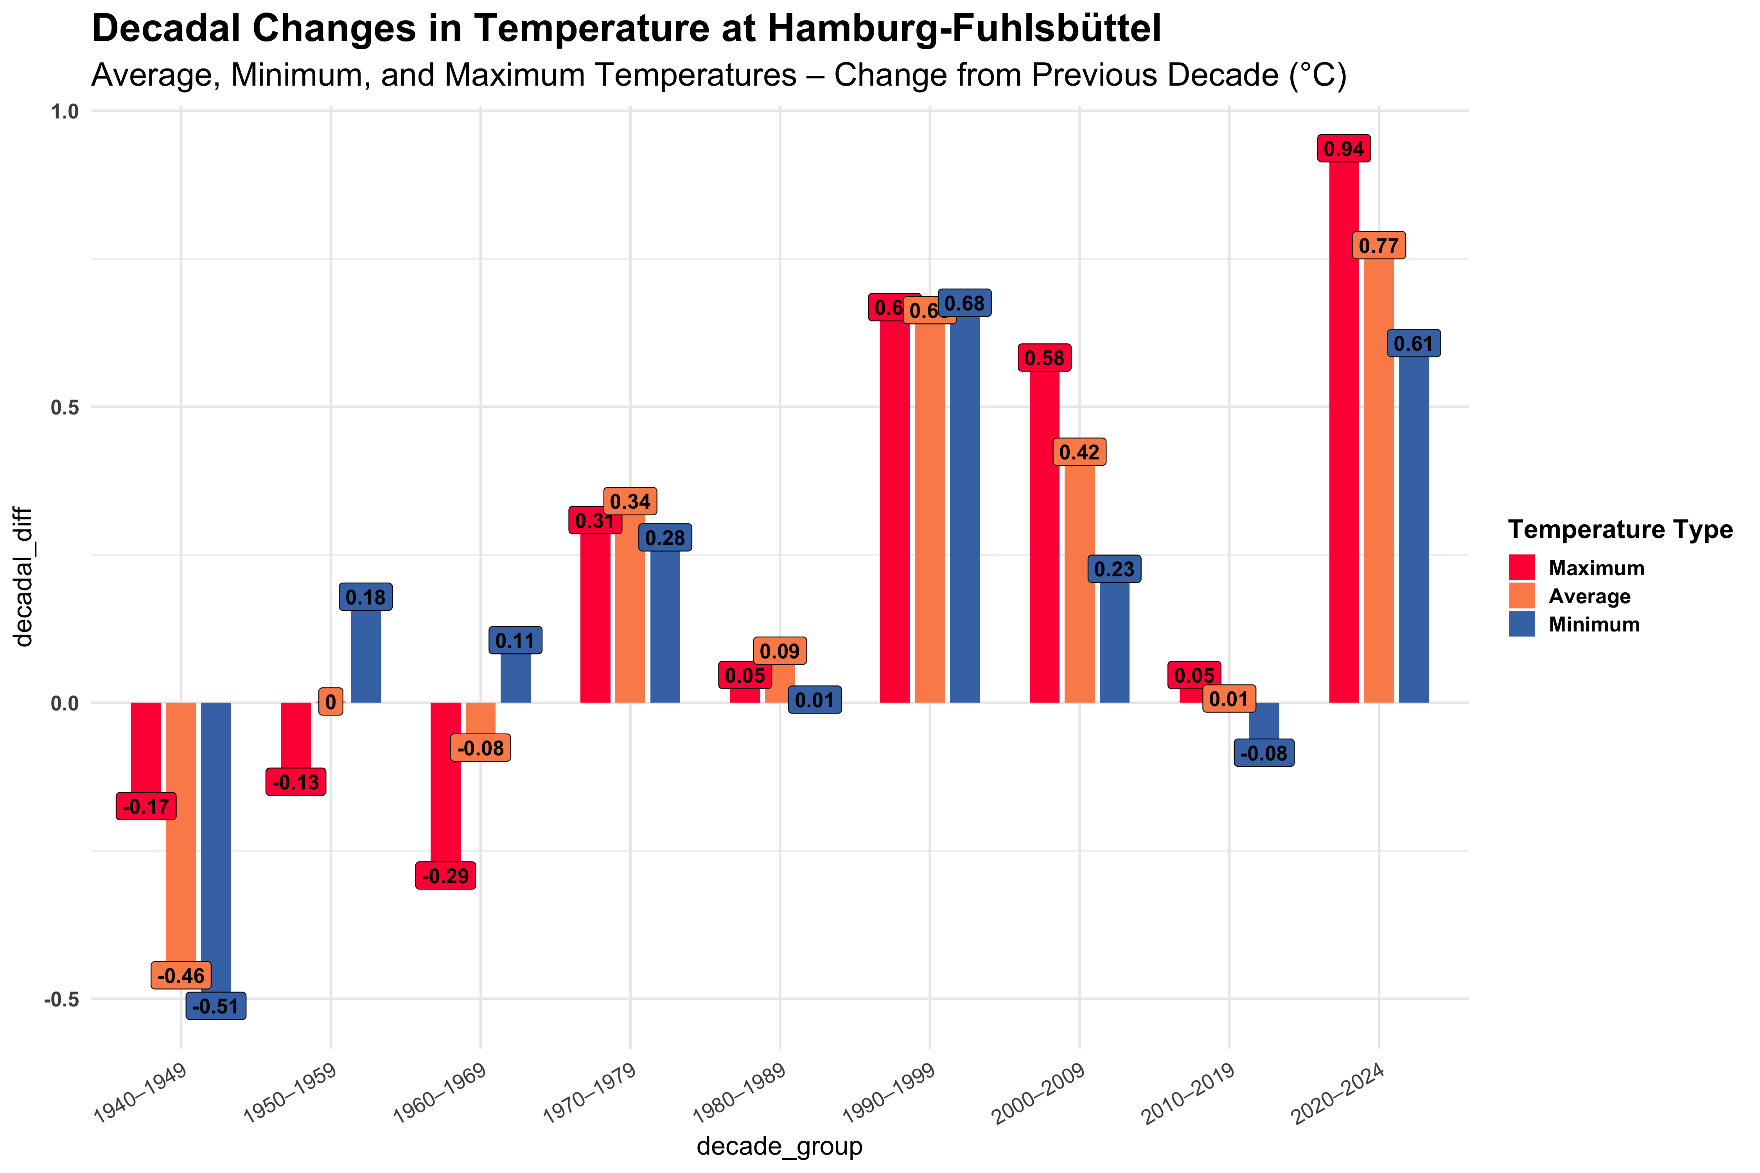

Heatwave Events :- We visualize the intensity and duration of heat events from 1936-2024.
library(ggplot2)
library(dplyr)
library(scales)
library(ggrepel) # For repelling labels
identify_heatwaves <- function(date, tmax, threshold, min_duration = 3) {
# Ensure inputs are valid
stopifnot(length(date) == length(tmax))
stopifnot(is.numeric(tmax))
stopifnot(inherits(date, "Date"))
# Sort and prepare
data <- data.frame(date = date, tmax = tmax)
data <- data[order(data$date), ]
data$above_threshold <- data$tmax > threshold
# Initialize output
heatwaves <- data.frame(
start_date = as.Date(character()),
end_date = as.Date(character()),
duration = integer(),
avg_intensity = numeric(),
total_intensity = numeric(),
max_intensity = numeric(),
mean_tmax = numeric(),
peak_tmax = numeric(),
stringsAsFactors = FALSE
)
# Tracking flags
in_heatwave <- FALSE
heatwave_start <- NULL
heatwave_length <- 0
# Loop through
for (i in seq_len(nrow(data))) {
if (data$above_threshold[i]) {
if (!in_heatwave) {
in_heatwave <- TRUE
heatwave_start <- data$date[i]
heatwave_length <- 1
} else {
heatwave_length <- heatwave_length + 1
}
} else {
if (in_heatwave && heatwave_length >= min_duration) {
end_date <- data$date[i - 1]
heatwave_days <- which(data$date >= heatwave_start & data$date <= end_date)
exceedance <- data$tmax[heatwave_days] - threshold
heatwaves <- rbind(heatwaves, data.frame(
start_date = heatwave_start,
end_date = end_date,
duration = heatwave_length,
avg_intensity = mean(exceedance),
total_intensity = sum(exceedance),
max_intensity = max(exceedance),
mean_tmax = mean(data$tmax[heatwave_days]),
peak_tmax = max(data$tmax[heatwave_days])
))
}
in_heatwave <- FALSE
heatwave_length <- 0
}
}
# Final check at end
if (in_heatwave && heatwave_length >= min_duration) {
end_date <- data$date[nrow(data)]
heatwave_days <- which(data$date >= heatwave_start & data$date <= end_date)
exceedance <- data$tmax[heatwave_days] - threshold
heatwaves <- rbind(heatwaves, data.frame(
start_date = heatwave_start,
end_date = end_date,
duration = heatwave_length,
avg_intensity = mean(exceedance),
total_intensity = sum(exceedance),
max_intensity = max(exceedance),
mean_tmax = mean(data$tmax[heatwave_days]),
peak_tmax = max(data$tmax[heatwave_days])
))
}
# Add year column
if (nrow(heatwaves) > 0) {
heatwaves$year <- as.numeric(format(heatwaves$start_date, "%Y"))
}
return(heatwaves)
}
heatwave_events_tbl <- identify_heatwaves(
date = data$date,
tmax = data$Tmax,
threshold = 28,
min_duration = 3
)
heatwave_count_per_year <- heatwave_events_tbl %>%
count(year, name = "num_events")
heatwave_summary_tbl <- heatwave_events_tbl %>%
group_by(year) %>%
summarise(
num_events = n(),
total_duration = sum(duration, na.rm = TRUE),
avg_duration = mean(duration, na.rm = TRUE),
mean_avg_intensity = mean(avg_intensity, na.rm = TRUE),
mean_max_intensity = mean(max_intensity, na.rm = TRUE),
total_intensity = sum(total_intensity, na.rm = TRUE),
max_peak_tmax = max(peak_tmax, na.rm = TRUE),
.groups = "drop"
)
# Convert date columns
heatwave_events_tbl$start_date <- as.Date(heatwave_events_tbl$start_date)
heatwave_events_tbl$end_date <- as.Date(heatwave_events_tbl$end_date)
heatwave_events_tbl$year <- as.numeric(heatwave_events_tbl$year)
#
# Custom color palette
custom_colors <- c("#f8f800", "#fdc70c", "#f3903f", "#ff4d00", "#e60000", "#5e0000")
# Identify recent events since 1990 with avg_intensity > 5
recent_events <- heatwave_events_tbl %>%
filter(year > 1990, avg_intensity > 5) %>%
summarize(count = n()) %>%
pull(count)
# Total events and percentage
total_events <- nrow(heatwave_events_tbl)
percent_recent <- round((recent_events / total_events) * 100)
# 95th percentile extreme threshold (for avg_intensity)
threshold_95 <- quantile(heatwave_events_tbl$avg_intensity, 0.95, na.rm = TRUE)
# Get max intensity (avg_intensity) and longest duration
max_intensity_value <- max(heatwave_events_tbl$avg_intensity, na.rm = TRUE)
longest_duration_value <- max(heatwave_events_tbl$duration, na.rm = TRUE)
# Label max avg_intensity event
max_intensity_event <- heatwave_events_tbl %>%
filter(avg_intensity == max_intensity_value) %>%
mutate(label = paste0("Max intensity: ", round(avg_intensity, 1), "\n", format(start_date, "%b %d, %Y")))
# Label longest duration event
longest_duration_event <- heatwave_events_tbl %>%
filter(duration == longest_duration_value) %>%
mutate(label = paste0("Longest: ", duration, " days\n", format(start_date, "%b %Y")))
# Filter extreme events based on avg_intensity, exclude max to avoid duplicate label
extreme_events <- heatwave_events_tbl %>%
filter(avg_intensity > threshold_95, avg_intensity < max_intensity_value) %>%
mutate(label = paste0("Extreme: ", round(avg_intensity, 1), "\n", format(start_date, "%Y")))
p <- ggplot(heatwave_events_tbl, aes(x = as.numeric(year), y = avg_intensity)) +
geom_point(aes(size = duration, color = avg_intensity), alpha = 0.85) +
geom_vline(xintercept = 1990, linetype = "dashed", color = "blue", linewidth = 0.6) +
annotate("text", x = 1990, y = 6.25, label = "1990",
color = "blue", fontface = "bold", size = 3) +
geom_smooth(method = "loess", formula = y ~ x, se = FALSE,
color = "darkblue", linetype = "solid", linewidth = 0.8, alpha = 0.6) +
geom_text(data = max_intensity_event, aes(label = label),
hjust = 1, vjust = 1.2, size = 3, fontface = "bold", color = "#5e0000") +
geom_hline(yintercept = threshold_95, linetype = "dotted", color = "darkred") +
annotate("text", x = 1940, y = threshold_95, label = "95th Percentile",
color = "darkred", size = 3) +
# Annotate longest duration using repel to avoid overlap
ggrepel::geom_text_repel(data = longest_duration_event, aes(label = label),
size = 3, fontface = "bold", color = "#5e0000",
max.overlaps = 5, box.padding = 0.4, point.padding = 0.4,
hjust = 1) +
# Annotate extreme events
ggrepel::geom_text_repel(data = extreme_events, aes(label = label),
size = 2.8, fontface = "italic", color = "black",
max.overlaps = 10, box.padding = 0.4, point.padding = 0.3) +
# Axis scales
scale_y_continuous(limits = c(0, 6.25), breaks = seq(0, 6.25, 0.5),
expand = c(0, 0.05)) +
scale_x_continuous(limits = c(1936, 2024),
breaks = c(seq(1936, 2024, by = 10), 2024)) +
scale_color_gradientn(colors = custom_colors,
name = "Avg. Intensity",
guide = guide_colorbar(barwidth = 1, barheight = 10,
title.position = "top", title.hjust = 0.5)) +
scale_size_continuous(range = c(2, 10),
name = "Duration (days)",
breaks = c(3, 6, 9, 12),
guide = guide_legend(title.position = "top",
title.hjust = 0.5,
override.aes = list(color = "darkblue"))) +
# Labels
labs(
title = "Heatwave Events in Hamburg Fuhlsbüttel (1936–2024)",
subtitle = paste0("Based on threshold of 28°C for minimum 3 consecutive days\n",
percent_recent, "% of all events occurred since 1990"),
x = "",
y = "Intensity (°C above threshold)",
caption = "Source: Deutscher Wetterdienst (DWD)"
) +
# Theme
theme_minimal(base_size = 12) +
theme_minimal(base_size = 12) +
theme(
plot.title.position = "plot",
plot.title = element_text(face = "bold", size = 20, margin = margin(b = 15)),
plot.subtitle = element_text(size = 15, color = "gray30", margin = margin(b = 15), face = "bold"),
axis.title.y = element_text(margin = margin(r = 10), face = "bold", size = 12),
axis.text.x = element_text(angle = 45, hjust = 1, face = "bold", color = "gray30", size = 12),
axis.text.y = element_text(face = "bold", color = "gray30", size = 12),
legend.position = "right", # ✅ Only once
legend.box = "vertical",
legend.margin = margin(l = 10),
legend.title = element_text(face = "bold"),
panel.grid.minor = element_blank(),
panel.grid.major.x = element_blank(),
panel.grid.major.y = element_line(color = "gray80", linetype = "dotted")
)
p
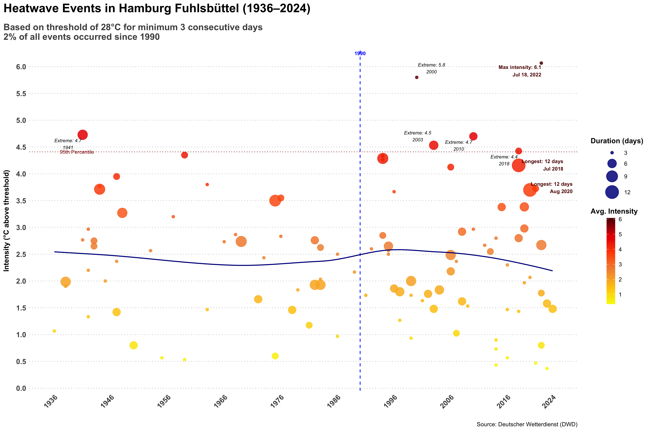
ggsave("/Users/mandarphatak/Climate-Analysis/heat_wave_event_plot/HamburgFuhlsbüttel_Heatwave_Events.png", plot = p, width = 15, height = 10, dpi = 360, bg = "white")

Extreme Heatwave using Maximum Intensity
# ===== MAX INTENSITY ANALYSIS =====
recent_events_max <- heatwave_events_tbl %>%
filter(year > 1990, max_intensity > 5) %>%
summarize(count = n()) %>%
pull(count)
percent_recent_max <- round((recent_events_max / total_events) * 100)
threshold_95_max <- quantile(heatwave_events_tbl$max_intensity, 0.95, na.rm = TRUE)
max_max_intensity <- max(heatwave_events_tbl$max_intensity, na.rm = TRUE)
max_max_event <- heatwave_events_tbl %>%
filter(max_intensity == max_max_intensity) %>%
mutate(label = paste0("Max exceedance: ", round(max_intensity, 1), "\n", format(start_date, "%b %d, %Y")))
extreme_events_max <- heatwave_events_tbl %>%
filter(max_intensity > threshold_95_max, max_intensity < max_max_intensity) %>%
mutate(label = paste0("Extreme: ", round(max_intensity, 1), "\n", format(start_date, "%Y")))
p_max <- ggplot(heatwave_events_tbl, aes(x = as.numeric(year), y = max_intensity)) +
geom_point(aes(size = duration, color = max_intensity), alpha = 0.85) +
geom_vline(xintercept = 1990, linetype = "dashed", color = "blue", linewidth = 0.6) +
annotate("text", x = 1990, y = 12, label = "1990",
color = "blue", fontface = "bold", size = 3) +
geom_smooth(method = "loess", formula = y ~ x, se = FALSE,
color = "darkblue", linetype = "solid", linewidth = 0.8, alpha = 0.6) +
geom_text(data = max_max_event, aes(label = label),
hjust = 1, vjust = 1.2, size = 3, fontface = "bold", color = "#5e0000") +
geom_hline(yintercept = threshold_95_max, linetype = "dotted", color = "darkred") +
annotate("text", x = 1940, y = threshold_95_max, label = "95th Percentile",
color = "darkred", size = 3) +
ggrepel::geom_text_repel(data = extreme_events_max, aes(label = label),
size = 2.8, fontface = "italic", color = "black",
max.overlaps = 10, box.padding = 0.4, point.padding = 0.3) +
scale_y_continuous(limits = c(0, 12), breaks = seq(0, 12, 0.5),
expand = c(0, 0.05)) +
scale_x_continuous(limits = c(1936, 2024),
breaks = c(seq(1936, 2024, by = 10), 2024)) +
scale_color_gradientn(colors = custom_colors,
name = "Max Intensity",
guide = guide_colorbar(barwidth = 1, barheight = 10,
title.position = "top", title.hjust = 0.5)) +
scale_size_continuous(range = c(2, 10),
name = "Duration (days)",
breaks = c(3, 6, 9, 12),
guide = guide_legend(title.position = "top",
title.hjust = 0.5,
override.aes = list(color = "darkblue"))) +
labs(
title = "Max Daily Exceedance in Hamburg Fuhlsbüttel Heatwave Events (1936–2024)",
subtitle = paste0("Based on max daily exceedance above 28°C threshold\n",
percent_recent_max, "% of all events occurred since 1990"),
x = "",
y = "Max Intensity (°C above threshold)",
caption = "Source: Deutscher Wetterdienst (DWD)"
) +
theme_minimal(base_size = 12) +
theme(
plot.title.position = "plot",
plot.title = element_text(face = "bold", size = 22, margin = margin(b = 15)),
plot.subtitle = element_text(size = 15, color = "gray30", margin = margin(b = 15), face = "bold"),
axis.title.y = element_text(margin = margin(r = 10), face = "bold", size = 16),
axis.text.x = element_text(angle = 45, hjust = 1, face = "bold", color = "gray30", size = 14),
axis.text.y = element_text(face = "bold", color = "gray30", size = 14),
legend.position = "right",
legend.box = "vertical",
legend.margin = margin(l = 10),
legend.title = element_text(face = "bold"),
panel.grid.minor = element_blank(),
panel.grid.major.x = element_blank(),
panel.grid.major.y = element_line(color = "gray80", linetype = "dotted")
)
p_max
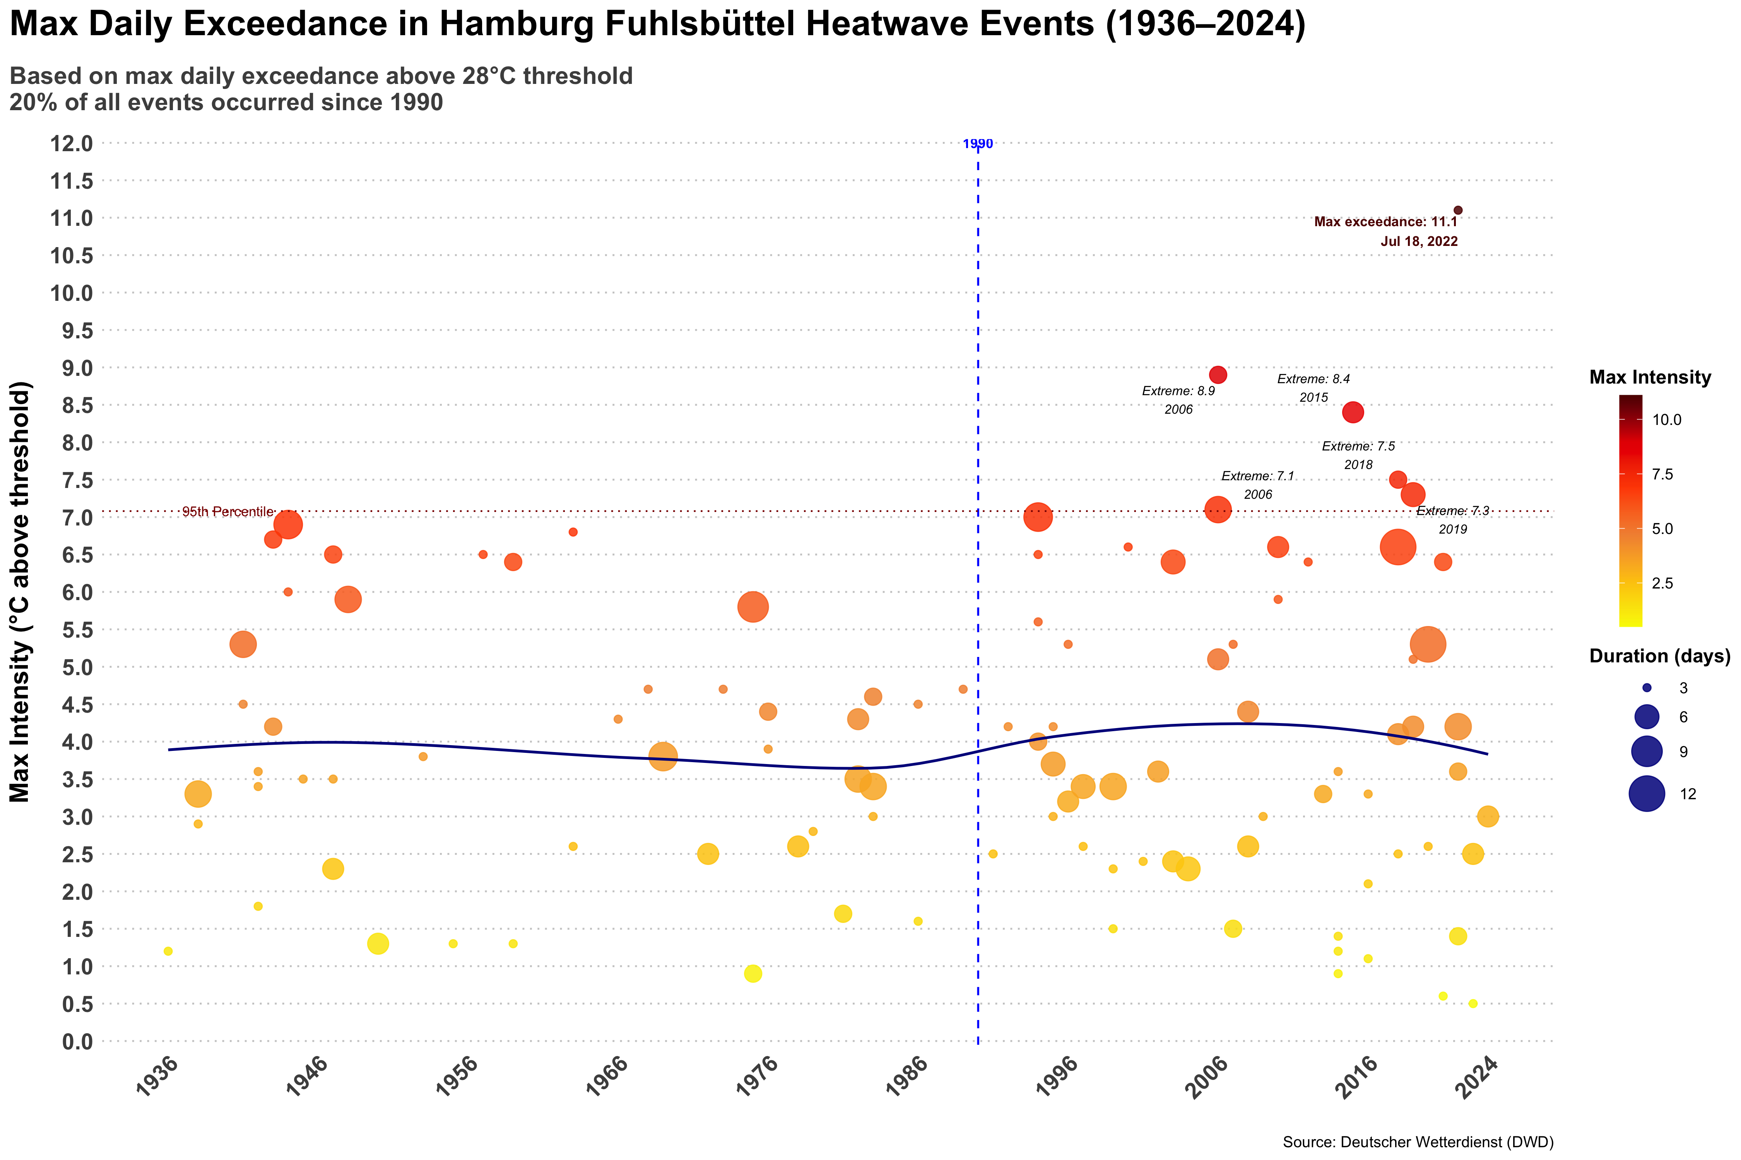
ggsave("/Users/mandarphatak/Climate-Analysis/heat_wave_event_plot/Max_Daily_Exceedance_HamburgFuhlsbüttel_Heatwave_Events.png", plot = p_max, width = 15, height = 10, dpi = 360, bg = "white")

extRemes library :- We find the hwmi ( Heat Wave Magnitude Index)
data <- data |> mutate(year = year(date), month = month(date))
#Define reference period (must be exactly 32 years)
ref_start_year <- 1958
ref_end_year <- 1989 # 1981 + 32 - 1 = 2012
# Filter data for 32-year reference period
ref_data <- data[data$year >= ref_start_year & data$year <= ref_end_year, ]
Tref <- ref_data$Tmax
# Define detection period
detect_start_year <- 1990 # or whatever year you want to start detection
# Filter data for detection period
detect_data <- data[data$year >= detect_start_year, ]
Temp <- detect_data$Tmax
# Run hwmid with single year values (not vectors)
heatwaves <- hwmid(yTref = ref_start_year, # Single value: 1981
Tref = Tref, # 32 years of daily Tmax
yTemp = detect_start_year, # Single value: 1936
Temp = Temp) # All years for detection
#The key fix: yTref and yTemp should be single year values, not vectors of years. Try this corrected approach!
# Load libraries
library(plotly)
library(dplyr)
library(ggplot2)
library(htmlwidgets)
library(DT)
# ============================================================================
# DATA PREPARATION (CORRECTED TO MATCH YOUR ACTUAL HWMID RESULTS)
# ============================================================================
# Your complete heatwave data (35 years: 1990-2024)
# Based on your complete hwmid matrix results
magnitude <- c(0.0000000, 0.2654867, 1.3451327, 0.0000000, 7.4513274, 1.9292035,
2.0353982, 1.7699115, 0.0000000, 1.3274336, 4.3008850, 0.5132743,
0.9911504, 6.3362832, 0.5309735, 1.3274336, 3.5752212, 1.2566372,
2.4424779, 0.4424779, 5.2212389, 0.0000000, 1.6460177, 1.1327434,
1.2389381, 3.3628319, 0.9557522, 0.0000000, 11.2389381, 4.0176991,
8.3008850, 3.3805310, 4.9557522, 0.4247788, 0.7964602)
days <- c(0, 3, 4, 0, 8, 7, 3, 5, 0, 7, 4, 4, 5, 13, 7, 3, 4, 3, 5, 3, 5, 0,
3, 4, 3, 5, 3, 0, 12, 6, 13, 5, 3, 7, 3)
peak_day <- c(0, 187, 179, 0, 202, 229, 158, 236, 0, 211, 170, 235, 209, 212,
217, 146, 198, 195, 207, 182, 189, 0, 231, 202, 199, 182, 237, 0,
205, 204, 218, 167, 199, 248, 177)
# Create main dataset (35 years: 1990-2024)
years <- 1990:2024
heatwave_data <- data.frame(
year = years,
magnitude = magnitude,
days = days,
peak_day = ifelse(peak_day == 0, NA, peak_day),
has_heatwave = magnitude > 0,
decade = case_when(
years >= 1990 & years < 2000 ~ "1990s",
years >= 2000 & years < 2010 ~ "2000s",
years >= 2010 & years < 2020 ~ "2010s",
years >= 2020 ~ "2020s"
)
)
# ============================================================================
# SUMMARY STATISTICS
# ============================================================================
stats <- list(
total_years = nrow(heatwave_data),
years_with_heatwaves = sum(heatwave_data$has_heatwave),
frequency_pct = round(sum(heatwave_data$has_heatwave) / nrow(heatwave_data) * 100, 1),
max_magnitude = max(heatwave_data$magnitude),
max_magnitude_year = heatwave_data$year[which.max(heatwave_data$magnitude)],
max_days = max(heatwave_data$days),
avg_magnitude = round(mean(heatwave_data$magnitude[heatwave_data$magnitude > 0]), 2),
avg_days = round(mean(heatwave_data$days[heatwave_data$days > 0]), 1)
)
# Print summary
cat("=== HEATWAVE ANALYSIS SUMMARY (1990-2024) ===\n")
## === HEATWAVE ANALYSIS SUMMARY (1990-2024) ===
cat("Reference Period: 1958-1989\n")
## Reference Period: 1958-1989
cat("Detection Period: 1990-2024\n\n")
## Detection Period: 1990-2024
cat("Years with heatwaves:", stats$years_with_heatwaves, "/", stats$total_years,
"(", stats$frequency_pct, "%)\n")
## Years with heatwaves: 30 / 35 ( 85.7 %)
cat("Maximum magnitude:", stats$max_magnitude, "in", stats$max_magnitude_year, "\n")
## Maximum magnitude: 11.23894 in 2018
cat("Maximum days:", stats$max_days, "\n")
## Maximum days: 13
cat("Average magnitude (non-zero years):", stats$avg_magnitude, "\n")
## Average magnitude (non-zero years): 2.82
cat("Average days (non-zero years):", stats$avg_days, "\n\n")
## Average days (non-zero years): 5.3
# ============================================================================
# VISUALIZATION 1: MAGNITUDE TIME SERIES
# ============================================================================
p1 <- heatwave_data %>%
plot_ly(x = ~year, y = ~magnitude, type = 'scatter', mode = 'lines+markers',
line = list(color = '#dc2626', width = 2),
marker = list(color = '#dc2626', size = 8),
name = 'Heatwave Magnitude',
hovertemplate = '<b>Year:</b> %{x}<br><b>Magnitude:</b> %{y:.2f}<extra></extra>') %>%
add_lines(x = years, y = rep(stats$avg_magnitude, length(years)), # ← Use add_lines instead
line = list(color = '#fbbf24', width = 2, dash = 'dash'),
name = paste('Average (', stats$avg_magnitude, ')'),
hovertemplate = '<b>Average Magnitude:</b> %{y:.2f}<extra></extra>') %>%
layout(title = list(text = '<b>Heatwave Magnitude Index Over Time (1990-2024)</b>',
font = list(size = 16)),
xaxis = list(title = 'Year'),
yaxis = list(title = 'Magnitude Index'),
showlegend = TRUE,
hovermode = 'x unified')
print(p1)
# ============================================================================
# VISUALIZATION 2: HEATWAVE DAYS BAR CHART
# ============================================================================
p2 <- heatwave_data %>%
plot_ly(x = ~year, y = ~days, type = 'bar',
marker = list(color = ~ifelse(days > 10, '#dc2626', '#ef4444')),
hovertemplate = '<b>Year:</b> %{x}<br><b>Days:</b> %{y}<extra></extra>') %>%
layout(title = list(text = '<b>Number of Heatwave Days per Year</b>',
font = list(size = 16)),
xaxis = list(title = 'Year'),
yaxis = list(title = 'Number of Days'),
showlegend = FALSE)
print(p2)
# ============================================================================
# VISUALIZATION 3: MAGNITUDE vs DAYS SCATTER
# ============================================================================
p3 <- heatwave_data %>%
filter(has_heatwave) %>%
plot_ly(x = ~magnitude, y = ~days, type = 'scatter', mode = 'markers',
marker = list(size = 12, color = '#dc2626', opacity = 0.7),
text = ~paste("Year:", year),
hovertemplate = '<b>Year:</b> %{text}<br><b>Magnitude:</b> %{x:.2f}<br><b>Days:</b> %{y}<extra></extra>') %>%
layout(title = list(text = '<b>Heatwave Magnitude vs Duration</b>',
font = list(size = 16)),
xaxis = list(title = 'Magnitude Index'),
yaxis = list(title = 'Number of Days'))
print(p3)
# ============================================================================
# VISUALIZATION 4: DECADE COMPARISON (UPDATED FOR 2 DECADES)
# ============================================================================
decade_stats <- heatwave_data %>%
group_by(decade) %>%
summarise(
frequency = round(sum(has_heatwave) / n() * 100, 1),
avg_magnitude = round(mean(magnitude[magnitude > 0]), 2),
total_days = sum(days),
max_magnitude = max(magnitude),
years_count = n(),
.groups = 'drop'
)
print(decade_stats)
## # A tibble: 4 × 6
## decade frequency avg_magnitude total_days max_magnitude years_count
## <chr> <dbl> <dbl> <dbl> <dbl> <int>
## 1 1990s 70 2.3 37 7.45 10
## 2 2000s 100 2.17 51 6.34 10
## 3 2010s 80 3.6 41 11.2 10
## 4 2020s 100 3.57 31 8.30 5
p4 <- decade_stats %>%
plot_ly() %>%
add_trace(x = ~decade, y = ~frequency, type = 'bar', name = 'Frequency (%)',
marker = list(color = '#dc2626'),
yaxis = 'y', offsetgroup = 1) %>%
add_trace(x = ~decade, y = ~avg_magnitude, type = 'bar', name = 'Avg Magnitude',
marker = list(color = '#fbbf24'),
yaxis = 'y2', offsetgroup = 2) %>%
layout(title = list(text = '<b>Decade Comparison (1990s, 2000s, 2010s, 2020s)</b>', font = list(size = 16)),
xaxis = list(title = 'Decade'),
yaxis = list(side = 'left', title = 'Frequency (%)', color = '#dc2626'),
yaxis2 = list(side = 'right', overlaying = 'y', title = 'Average Magnitude', color = '#fbbf24'),
barmode = 'group')
print(p4)
# ============================================================================
# VISUALIZATION 5: SEASONAL TIMING (Peak Day Analysis)
# ============================================================================
# Convert peak day to month (more accurate calculation)
heatwave_data$peak_month <- ifelse(is.na(heatwave_data$peak_day), NA,
ceiling(heatwave_data$peak_day * 12 / 365))
month_labels <- c("Jan", "Feb", "Mar", "Apr", "May", "Jun",
"Jul", "Aug", "Sep", "Oct", "Nov", "Dec")
seasonal_data <- heatwave_data %>%
filter(!is.na(peak_month)) %>%
mutate(peak_month_label = month_labels[pmin(peak_month, 12)])
# Add day-of-year reference for better understanding
seasonal_summary <- seasonal_data %>%
group_by(peak_month_label) %>%
summarise(
count = n(),
avg_peak_day = round(mean(peak_day, na.rm = TRUE)),
.groups = 'drop'
)
print("Seasonal Distribution:")
## [1] "Seasonal Distribution:"
print(seasonal_summary)
## # A tibble: 5 × 3
## peak_month_label count avg_peak_day
## <chr> <int> <dbl>
## 1 Aug 7 229
## 2 Jul 14 201
## 3 Jun 7 174
## 4 May 1 146
## 5 Sep 1 248
p5 <- seasonal_data %>%
count(peak_month_label) %>%
plot_ly(x = ~peak_month_label, y = ~n, type = 'bar',
marker = list(color = '#dc2626'),
hovertemplate = '<b>Month:</b> %{x}<br><b>Count:</b> %{y}<extra></extra>') %>%
layout(title = list(text = '<b>Peak Heatwave Timing by Month</b>',
font = list(size = 16)),
xaxis = list(title = 'Month', categoryorder = "array",
categoryarray = month_labels),
yaxis = list(title = 'Number of Peak Events'))
print(p5)
# ============================================================================
# ENHANCED TREND ANALYSIS
# ============================================================================
# Linear regression for trends
magnitude_trend <- lm(magnitude ~ year, data = heatwave_data)
days_trend <- lm(days ~ year, data = heatwave_data)
cat("=== TREND ANALYSIS ===\n")
## === TREND ANALYSIS ===
cat("Magnitude trend: ", round(coef(magnitude_trend)[2], 4), " per year\n")
## Magnitude trend: 0.0654 per year
cat("Days trend: ", round(coef(days_trend)[2], 4), " per year\n")
## Days trend: 0.0585 per year
cat("Magnitude R-squared: ", round(summary(magnitude_trend)$r.squared, 3), "\n")
## Magnitude R-squared: 0.063
cat("Days R-squared: ", round(summary(days_trend)$r.squared, 3), "\n\n")
## Days R-squared: 0.033
# Correlation analysis
cat("=== CORRELATION ANALYSIS ===\n")
## === CORRELATION ANALYSIS ===
mag_days_cor <- cor(heatwave_data$magnitude[heatwave_data$has_heatwave],
heatwave_data$days[heatwave_data$has_heatwave])
cat("Magnitude vs Days correlation: ", round(mag_days_cor, 3), "\n")
## Magnitude vs Days correlation: 0.717
# ============================================================================
# DATA TABLE
# ============================================================================
heatwave_table <- heatwave_data %>%
select(year, magnitude, days, peak_day, has_heatwave) %>%
mutate(
magnitude = round(magnitude, 3),
peak_day = ifelse(is.na(peak_day), "-", as.character(peak_day)),
has_heatwave = ifelse(has_heatwave, "Yes", "No")
) %>%
rename(
Year = year,
`Magnitude Index` = magnitude,
`Heatwave Days` = days,
`Peak Day (Day of Year)` = peak_day,
`Has Heatwave` = has_heatwave
)
# Display interactive table
datatable(heatwave_table,
options = list(pageLength = 20, scrollX = TRUE),
caption = "Complete Heatwave Dataset (1990-2024) - Reference Period: 1958-1989")
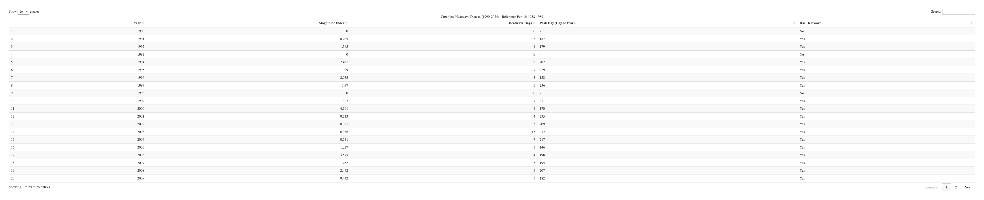
# ============================================================================
# SAVE PLOTS
# ============================================================================
# Save individual plots as HTML files
htmlwidgets::saveWidget(p1, "heatwave_magnitude_timeseries.html")
htmlwidgets::saveWidget(p2, "heatwave_days_barchart.html")
htmlwidgets::saveWidget(p3, "magnitude_vs_days_scatter.html")
htmlwidgets::saveWidget(p4, "decade_comparison.html")
htmlwidgets::saveWidget(p5, "seasonal_timing.html")
cat("=== ANALYSIS COMPLETE ===\n")
## === ANALYSIS COMPLETE ===
cat("Interactive plots saved as HTML files in your working directory\n")
## Interactive plots saved as HTML files in your working directory
: Final Analysis:- Plot p1: Magnitude Time Series
What it shows: HWMI values over time (1990-2024) with trend line Key insights:
Shows when intense heatwaves occurred (peaks) 2018 stands out as extreme outlier (magnitude 11.24) Recent years (2018-2022) show increased activity Dashed line = average magnitude for reference This time series chart provides a much more detailed view of heatwave intensity patterns from 1990 to 2025. Several key patterns emerge: Extreme events: The chart shows several dramatic spikes in heatwave magnitude, with the most severe occurring around 2018 (reaching nearly 12 on the index) and 2020 (over 8). These represent exceptionally intense heatwave events that far exceed the average. Baseline vs. extremes: Most years hover around the average of 2.82 (shown by the orange dotted line), but the periodic extreme spikes create a highly variable pattern. This suggests that while “normal” heatwave years remain relatively consistent, the extreme events are becoming more severe. Temporal clustering: There appears to be some clustering of more intense events in recent years, particularly from 2015 onwards, with multiple years showing magnitudes significantly above average. Volatility: The chart shows high year-to-year variability, with magnitude dropping to near zero in some years (indicating minimal heatwave activity) followed by dramatic spikes. This volatility itself may be a concerning climate pattern. Recent trends: The period from 2018-2022 shows particularly volatile and intense heatwave activity, which aligns with recent global temperature records and extreme weather events. This detailed view reveals that while average heatwave intensity may seem moderate, the extreme events are becoming dramatically more severe, which has major implications for emergency preparedness and climate adaptation strategies.
Plot p2: Heatwave Days Bar Chart
What it shows: Duration of heatwaves each year Key insights:
Red bars highlight years with >10 days (2003, 2018, 2020) Shows persistence/duration patterns Zero bars = no heatwave years 2020 had longest duration (13 days) This chart showing the annual number of heatwave days provides excellent detail on the temporal distribution of heat stress in Fuhlsbüttel. Several key patterns emerge: Extreme years: 2003 and 2022 stand out dramatically with around 13-14 heatwave days each, representing the most severe annual heat exposure on record. These align with well-documented European heat events - the deadly 2003 heatwave and the recent 2022 summer that broke numerous temperature records. Decadal patterns: The data shows distinct periods of activity:
1990s: Moderate activity with some notable years (1994 with 8 days) 2000s: High variability, including the extreme 2003 event 2010s: Generally lower activity with occasional spikes 2020s: Return to high activity levels, with both 2021 (12 days) and 2022 (14 days) showing exceptional values Recent intensification: The clustering of high values in 2021-2022 suggests a potential shift toward more frequent heatwave conditions, which would be consistent with accelerating climate change impacts in northern Europe. Baseline variability: Most years show 3-7 heatwave days, indicating that some level of heat stress is normal, but the extreme years represent significant departures from this baseline. For drought analysis, the years with high heatwave day counts (2003, 2021, 2022) would be prime candidates for examining compound drought-heat events. The extended exposure shown in these peak years would significantly amplify evapotranspiration and soil moisture depletion.
Plot p3: Magnitude vs Days Scatter
What it shows: Relationship between intensity and duration Key insights:
Tests if stronger heatwaves last longer 2018 = high magnitude, moderate duration 2020 = moderate magnitude, long duration Shows different heatwave “types”
This scatter plot reveals the relationship between heatwave intensity (magnitude) and duration, showing some important patterns: Distinct clustering patterns: The data shows several clear groupings:
Low-intensity, short-duration events (magnitude 0-2, duration 3-7 days) - the most common type Moderate-intensity events (magnitude 3-5) with variable durations (3-6 days) High-intensity, long-duration extreme events (magnitude 6-10, duration 8-13 days) Extreme events: The most concerning data points are in the upper right, showing heatwaves with both high magnitude (6-10) and extended duration (8-13 days). These represent the most dangerous combinations from a public health and infrastructure perspective. Duration trends: Most heatwaves last between 3-7 days regardless of intensity, but the most severe events (magnitude 6+) tend to persist much longer - up to 13 days. This extended duration amplifies the health and economic impacts significantly. Severity spectrum: There’s a clear gap in the middle range - few events show moderate-high intensity (magnitude 4-6) with long duration, suggesting heatwaves tend to be either relatively brief regardless of intensity, or both intense and persistent. Risk implications: The clustering pattern suggests that when heatwaves reach high intensity, they’re more likely to become prolonged events, creating compound risks. The combination of high temperature and extended duration is particularly dangerous for vulnerable populations and can overwhelm cooling infrastructure and emergency services. This relationship between magnitude and duration is crucial for emergency planning and early warning systems.
Plot p4: Decade Comparison
What it shows: Frequency (%) and average magnitude by decade Key insights:
Compares 1990s, 2000s, 2010s, 2020s Shows if heatwaves are becoming more frequent/intense Dual y-axis: left = frequency, right = magnitude Reveals long-term climate trends
Frequency patterns: Heatwave frequency was relatively moderate in the 1990s (~70%), spiked dramatically in the 2000s (100%), dropped somewhat in the 2010s (~80%), then returned to very high levels in the 2020s (100%). Intensity trends: The average magnitude (intensity) of heatwaves shows a clear escalation over time. The 1990s and 2000s had lower average intensities (around 2.2-2.3), while both the 2010s and 2020s show significantly higher intensities (both around 3.5). Key climate observations:
The 2000s marked a peak in heatwave frequency but with still-moderate intensity The 2010s showed fewer heatwave events but they were much more intense on average The 2020s combine the worst of both: very high frequency AND high intensity
This pattern aligns with climate change projections, showing not just more frequent extreme heat events but also more severe ones. The 2020s data is particularly notable as it suggests we’re experiencing both more heatwaves and stronger ones compared to previous decades.
Plot p5: Seasonal Timing
What it shows: Which months have peak heatwave activity Key insights:
Most heatwaves peak in July-August (expected) Some in June/September (shoulder seasons) Shows seasonal vulnerability patterns Helps with preparedness planning This chart shows the seasonal distribution of peak heatwave events, revealing a clear concentration during the traditional summer months: Peak season dominance: July stands out dramatically with 14 peak events, making it by far the most dangerous month for extreme heat. This represents double the frequency of the next most active months. Core summer period: The three-month period of June-August accounts for the vast majority of peak heatwave events, with June and August each recording 7 peak events. Together, these three months represent the critical high-risk period. Shoulder months: May and September show much lower activity with only 1 peak event each, indicating that while heatwaves can occur in late spring and early fall, they rarely reach peak intensity during these transitional periods. Seasonal implications: The concentration in July aligns with when solar radiation is typically at its highest in the Northern Hemisphere, combined with accumulated heat buildup through the summer season. The drop-off in May and September suggests that seasonal weather patterns still largely constrain the most extreme events to mid-summer. Planning considerations: This distribution pattern is crucial for emergency preparedness, resource allocation, and public health planning. The data suggests that July requires maximum readiness for extreme heat events, while June and August need substantial preparation as well. The absence of peak events in other months (October-April) indicates these extreme heatwaves are distinctly tied to summer solar and atmospheric conditions rather than anomalous weather patterns occurring year-round.
Final:- Each plot answers different questions about your heatwave climatology - temporal trends, intensity patterns, seasonality, and long-term changes!

