Ticket Service Homework

A ticket service management for theater.

Implementation of a simple ticket service that facilitates the discovery, temporary hold, and final reservation of seats within a high-demand performance venue.

This application is developed using Spring Boot, Spring JDBC, Spring RESTful web services, Maven, HSQLDB.

**Assumptions**

1. Theatre has sitting arrangement based on levels.
2. Seat provided based on availability.
3. User can choose levels (Orchestra, Mezzanine, Balcony[we can increase level by avoiding multiple changes]). Seats are assigned in each level as first come first serve bases.
4. Hold time for the seats is 2 minute which can be updatable. If the user doesn't reserve the seats before 2 minute, then the holds are removed and user has to send a request again to hold the seats.There is no guarantee of same seat number.
5. Get notification of expiration of seat hold.
6. Seat numbers is assigned for the user
7. User can hold and reserve the seats at multiple levels

**Building Project**

1. Clone this project
2. Git clone
3. Kindly make sure JAVA_HOME environment variable is configured and maven bin directory is added to PATH environment variable. Run the following commands
4. Cd ticket-service
5. Run command mvn clean install
6. Go to target folder by ‘cd target’
7. To run the program use ‘Java -jar ticket-service.jar’ command.

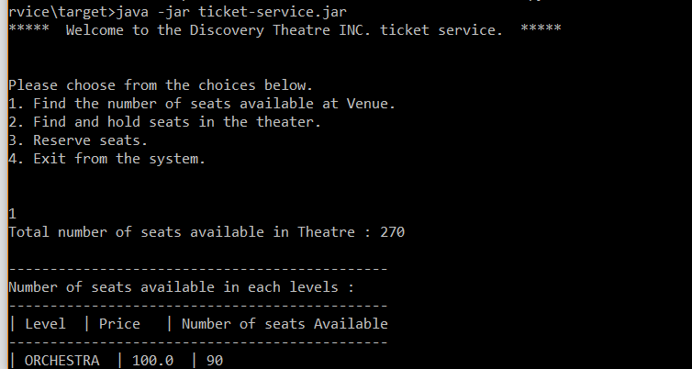

**Output**

1. Find number of seats available within the venue, optionally sell by levels.

Note: available seats are seats that are neither held nor reserved.

Total seats available in all venue:

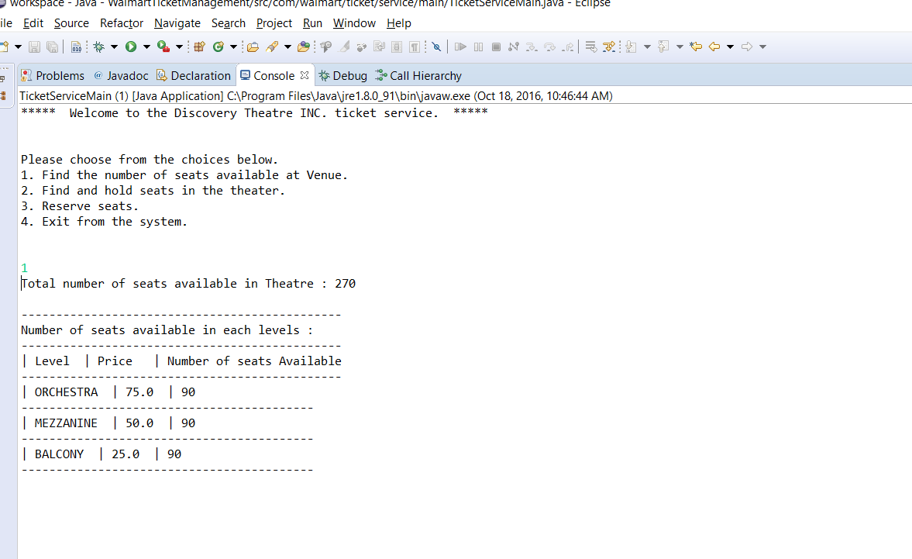

1. Find and hold best available seats on behalf of a customer, potentially limited to specific levels

Note: each ticket hold should expire within a set number of seconds.

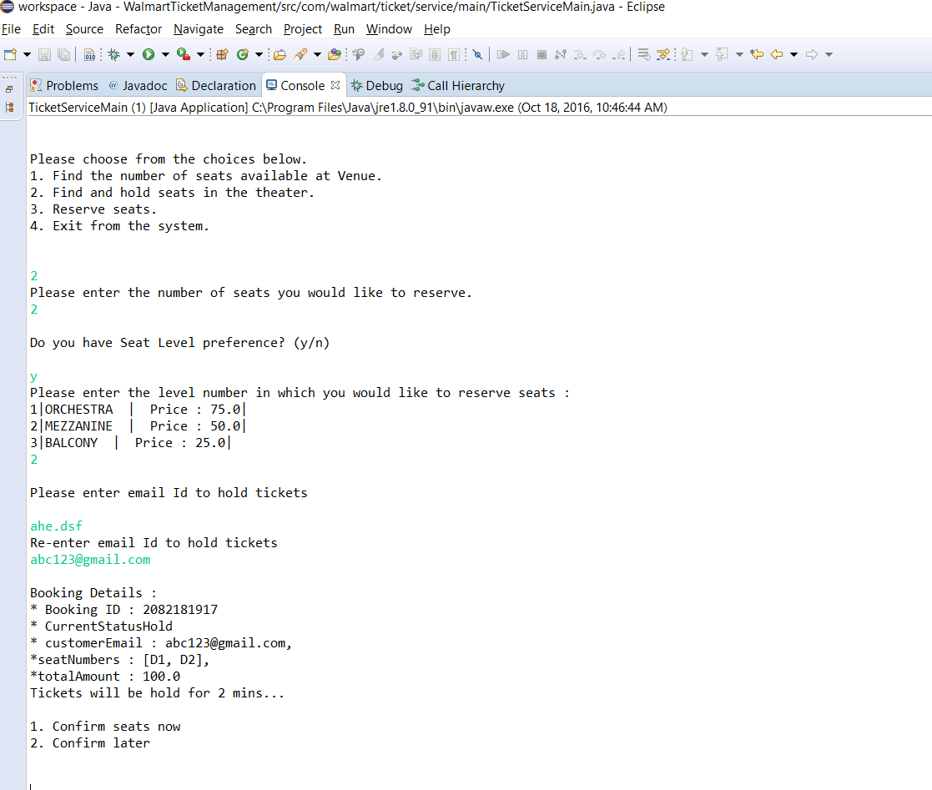

1. If you hold for more than 2 minutes, you will get notification.

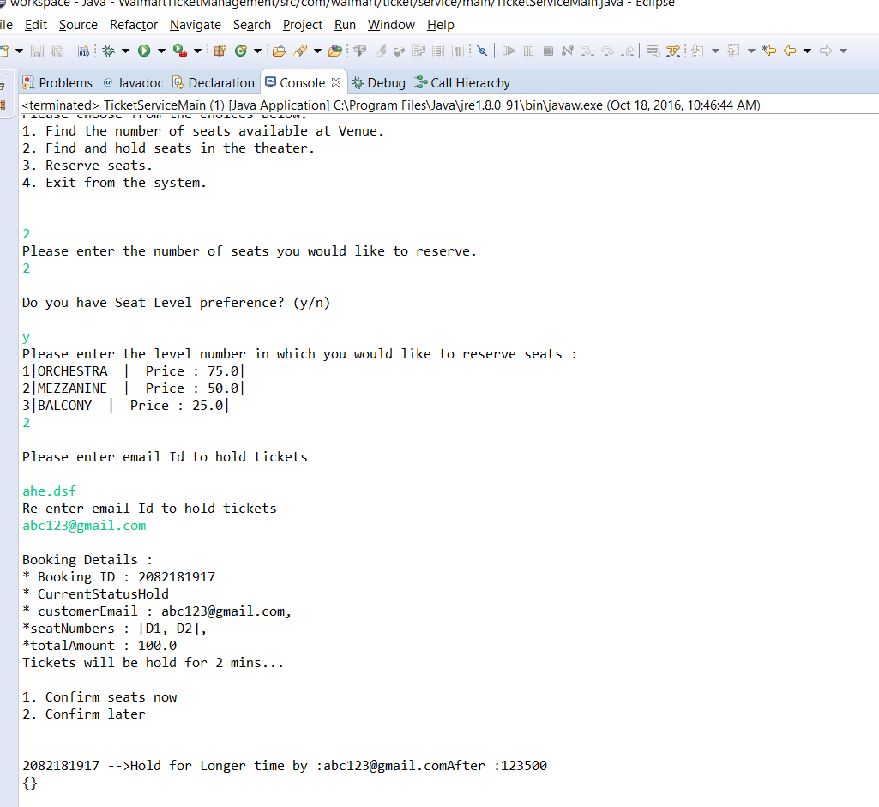

1. Reserve seats are where customer is hold seats reserve seats are based on customer’s email id and Booking id.

Note: If booking id and email id matched then only ticket will confirm

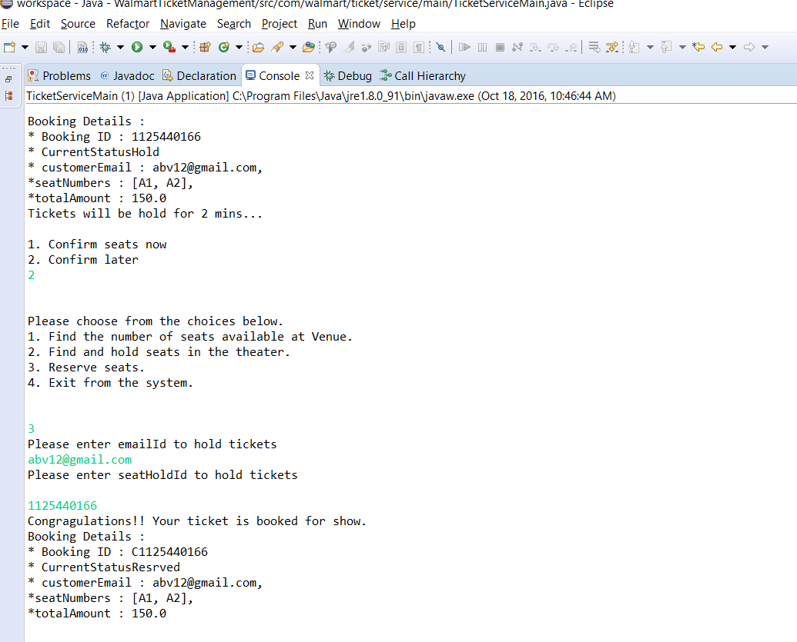

### **Flowchart Diagram for Ticket service homework**

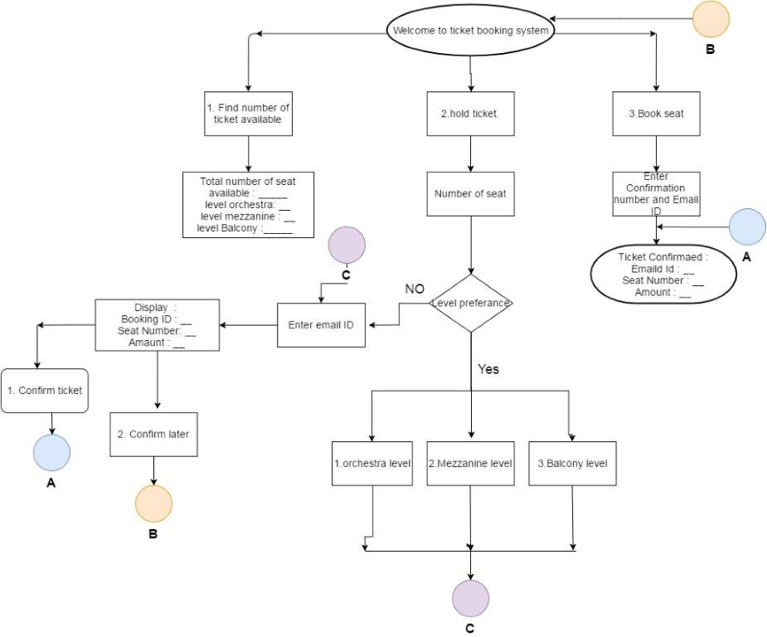

**Class Diagram**

