Project Demonstration

Project Title: Optimizing User, Group, and Role Management with Access Control and Workflows
Team ID: LTVIP2026TMIDS71782
Team Size: 4
Team Leader: Ujjwala Priyadarshini Manda– Project Coordination, Application access, access control list, Flow
Configuration
Team Member: Rupa Sri Yelisetti–Users & Groups
Team Member: Ramakrishna Vinayak Arigela– Roles & Table Creation
Team Member: Samudrala S S N V Ranga Durga Mahathi– Assign users to group & Assign roles to user
Demonstration Steps:

- 1. Created users.
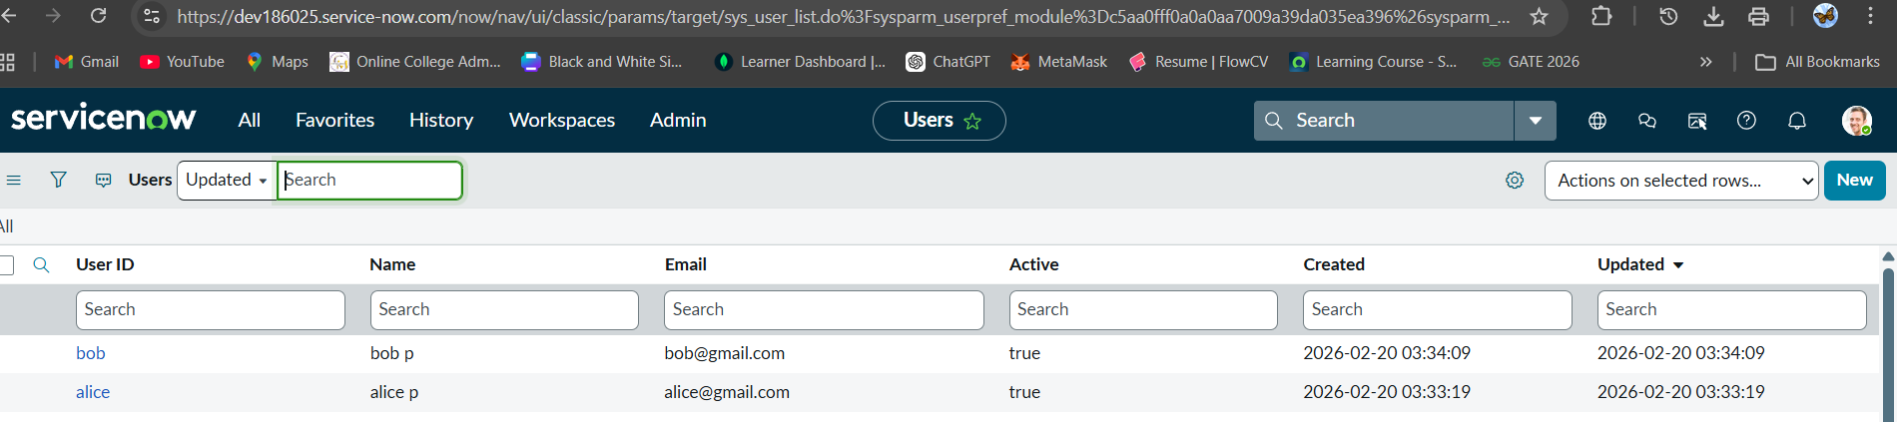
2. Created groups
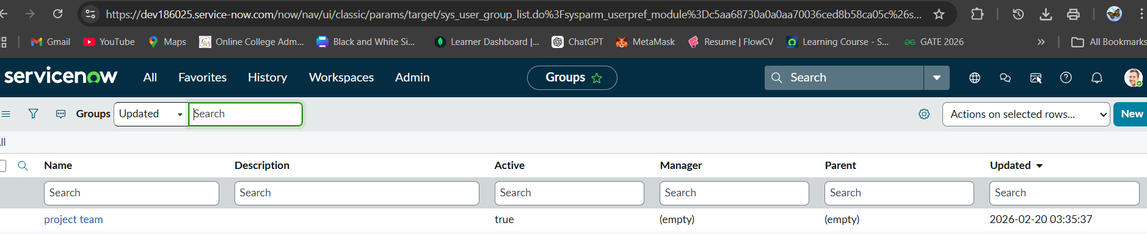

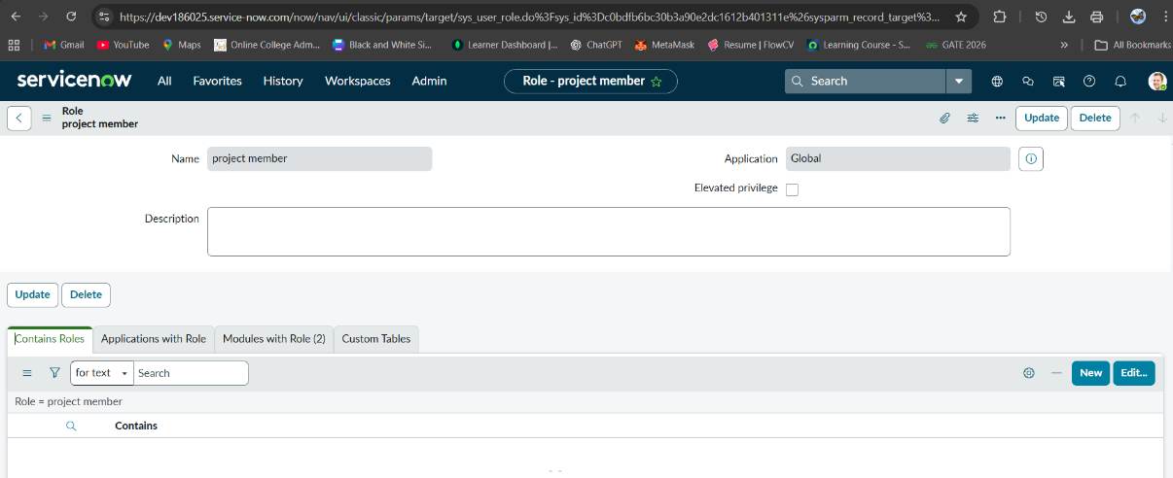
3.created roles
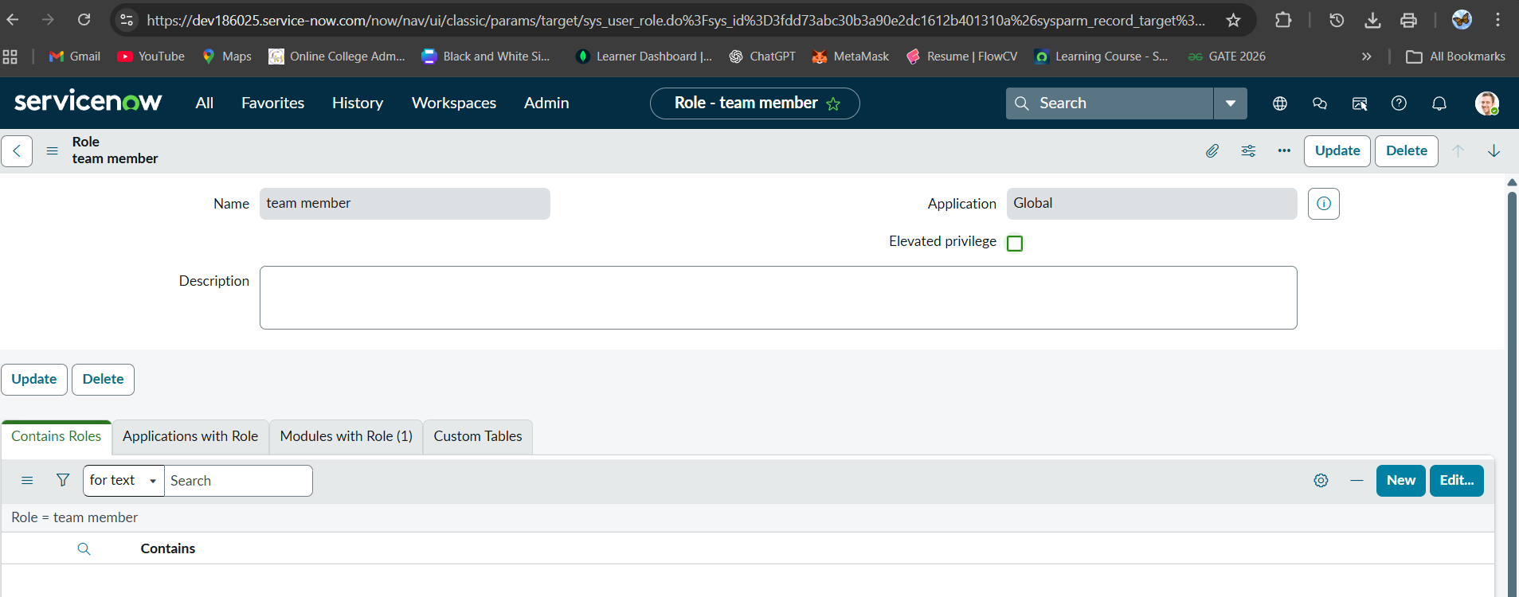
4.created Tables
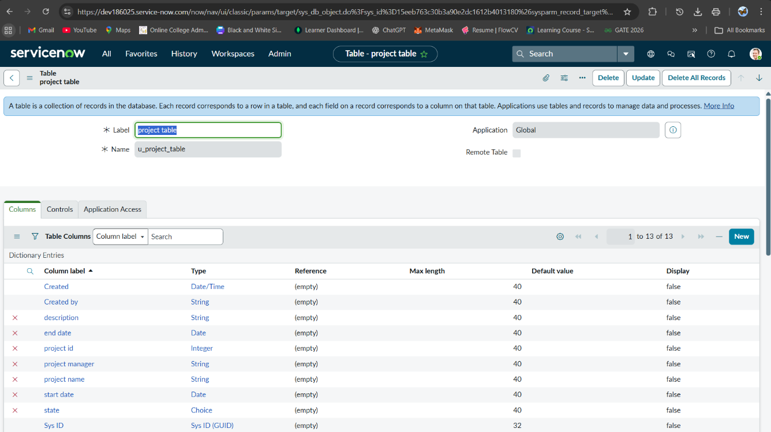

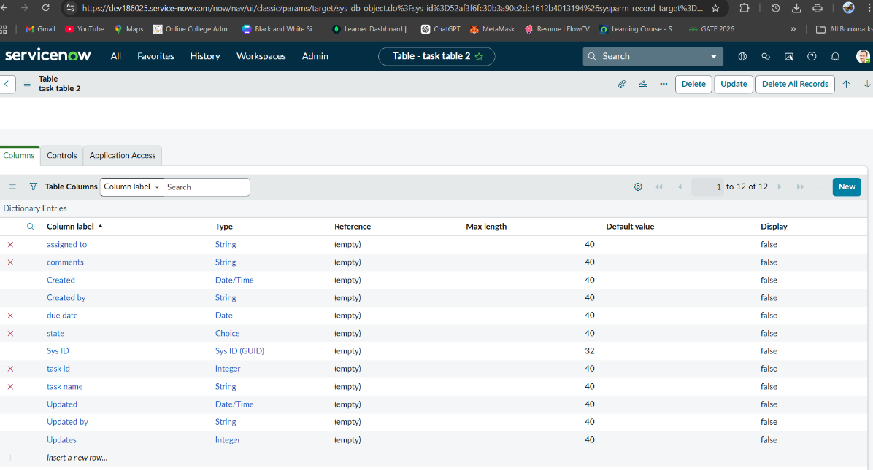
5. Assign users to groups
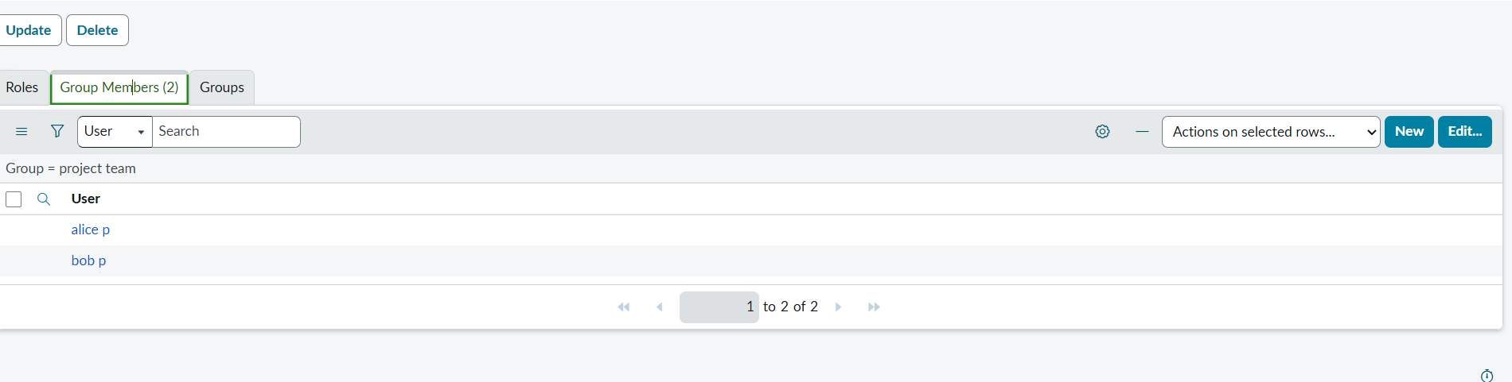
6. Assign roles to users
Assign roles to alice user
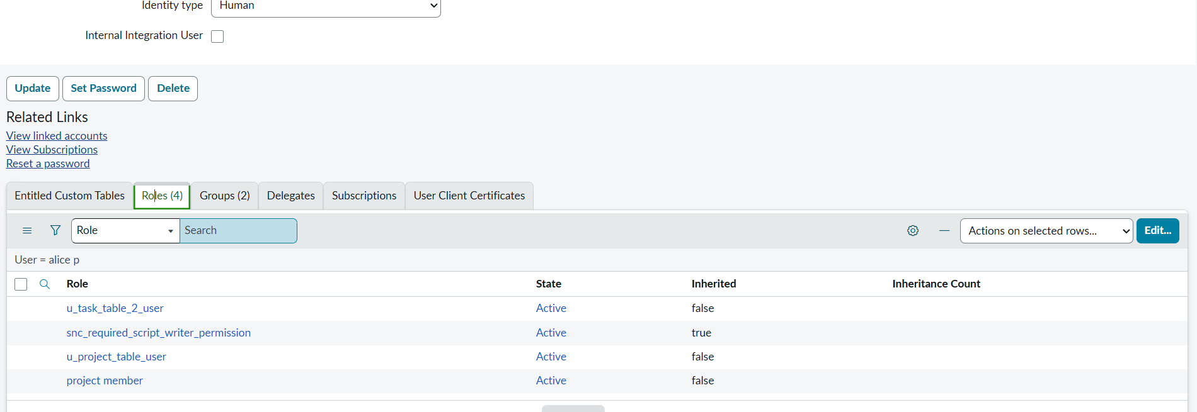
Assign roles to bob user
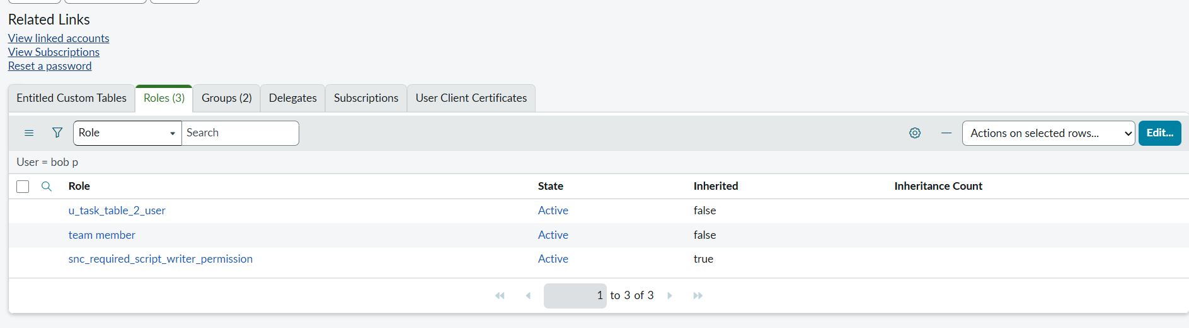
7. Assign table access to application
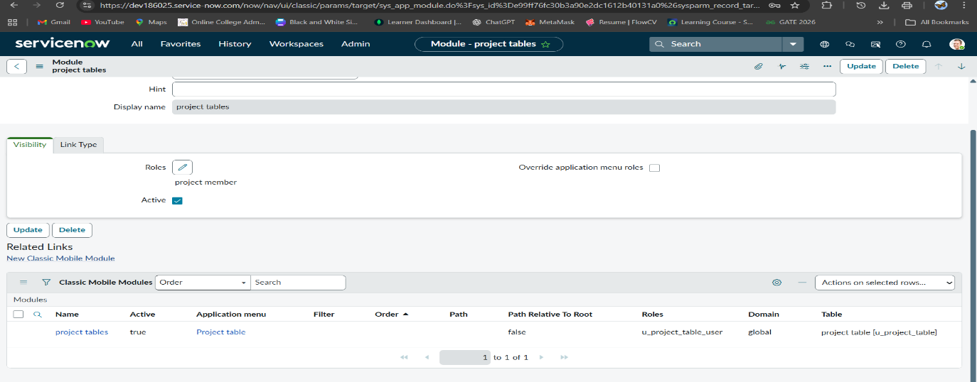
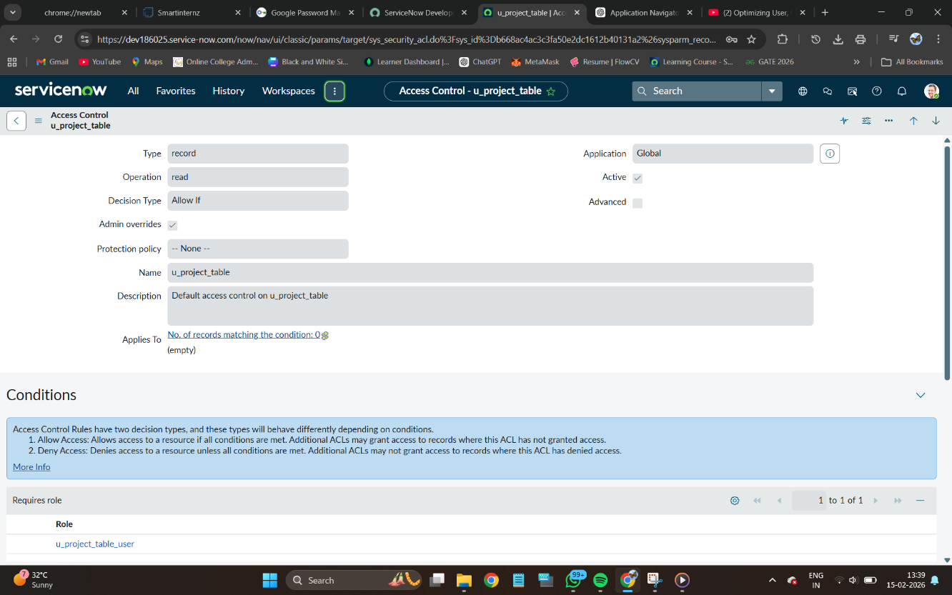
8. Create ACL

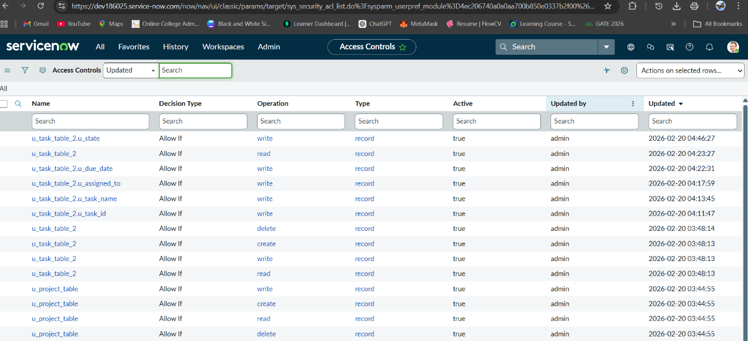

9. Flow

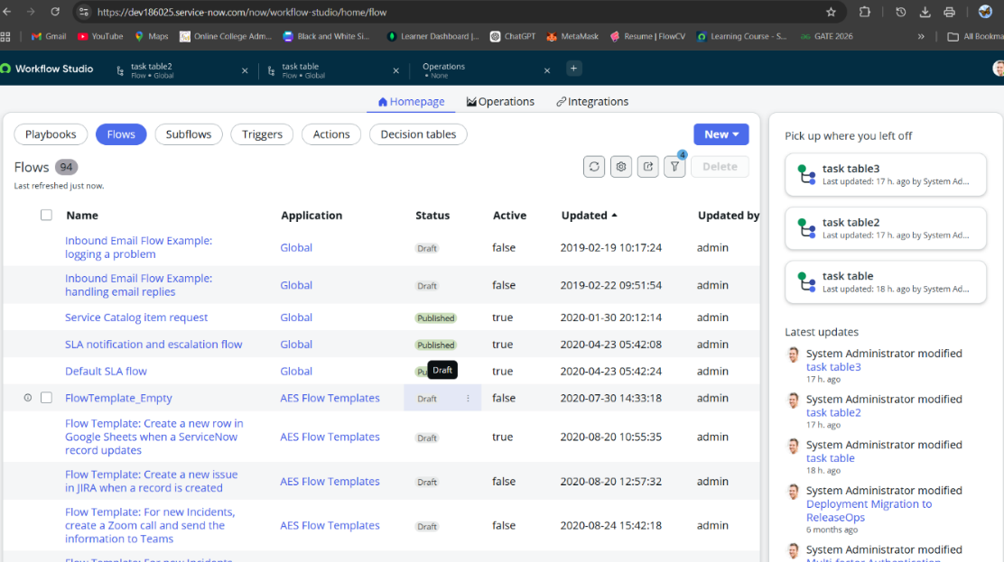

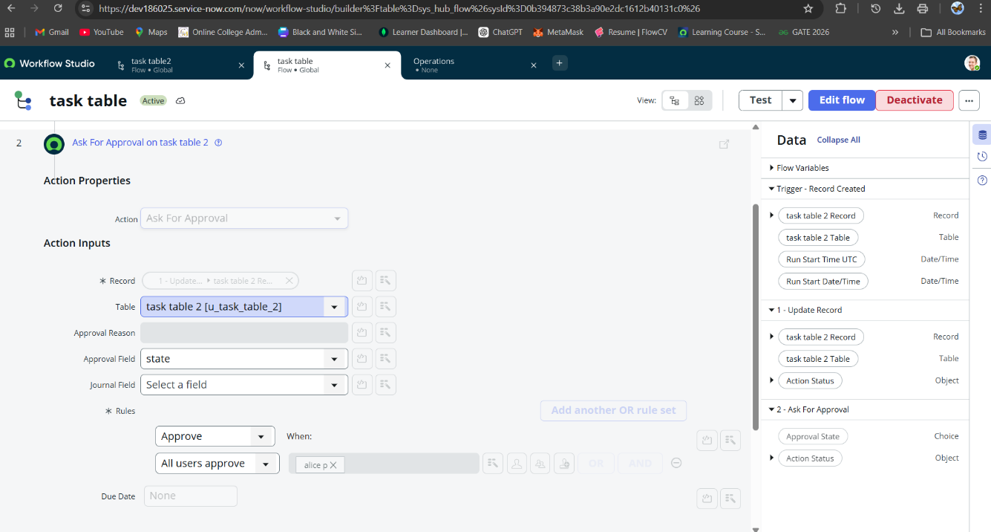
10.Asking for approval

11. Approved
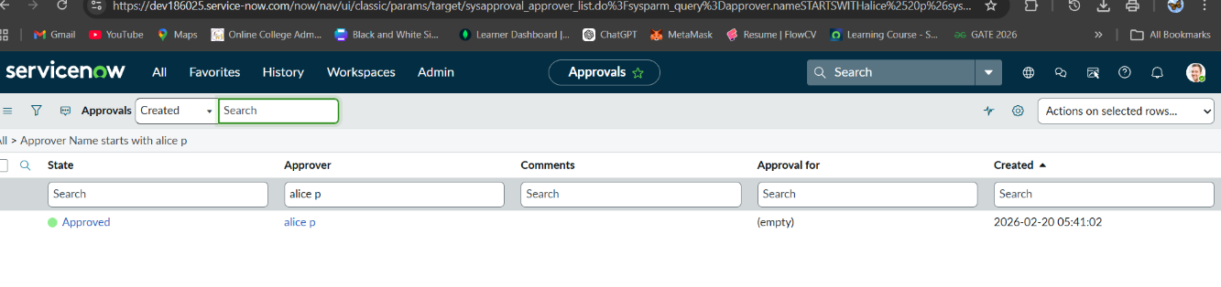

Result:
The system successfully implements structured user, group, and role management with secure access control.
Automated workflows streamline role assignments and approval processes, reducing manual effort.
Role-based ACLs ensure data security and prevent unauthorized access.
Overall, the solution improves efficiency, accountability, and scalability within the organization.

