The following are considered to build the solution:

1. AdventureWorks2017 Database is considered.

From the following tables data is sourced

a. [Sales].[SalesOrderDetail]

b. [Production].[Product]

c. [Sales].[SalesOrderHeader]

Source Query:

Select

sum([UnitPrice]*OrderQty) as TotalSales,

sum(OrderQty) OrderQty,datepart(yy,slot.[OrderDate]) [Year],

ISNULL(prodtab.Color,'NoColor') [Color]

from [Sales].[SalesOrderDetail] SLO

join [Production].[Product] ProdTab on SLO.ProductID=Prodtab.ProductID

join [Sales].[SalesOrderHeader] SLOT on slo.SalesOrderid=slot.SalesOrderID

--join [Sales].[SalesTerritory] SLT on SLOT.TerritoryID = SLT.TerritoryID

Group by datepart(yy,slot.[OrderDate]),prodtab.Color

order by year

2. Target table creation on AdventureWorksDW2017

CREATE TABLE [dbo].[FactSalesTable_NZD_Currency](

[TotalSales] [decimal](25,2) NULL,

[Year] [smallint] NULL,

[Color] [nvarchar](25) NULL,

[OrderQty] [decimal](25,2) NULL,

[TotalSAlesByNewZealand] [decimal](25,2) NULL

) ON [PRIMARY]

GO

3. The exchange rate file is downloaded from https://exchangeratesapi.io/ and saved on local system

Exchange Rate File : eurofxref.csv

4. The exchange file is read and the data is loaded into AdventureWorksDW2017.dbo.ExchangeRate table

CREATE TABLE [dbo].[ExchangeRate](

[NZD] [decimal](25, 2) NULL

) ON [PRIMARY]

5. The target table FactSalesTable_NZD_Currency will be loaded and the column TotalSAlesByNewZealand will be null.

6. The target table is then updated to populate TotalSAlesByNewZealand field.

UPDATE [dbo].[FactSalesTable_NZD_Currency]

SET TotalSAlesByNewZealand=[OrderQty]*[dbo].[ExchangeRate].NZD

FROM [dbo].[ExchangeRate]

JOIN [FactSalesTable_NZD_Currency]

ON 1=1

Here the exchange NZD currency exchange rate is 1.80 as of the date the file was downloaded.

Cosideration: If we can register to the exchange rate api, directly the exchange rates can be sourced from the url https://exchangeratesapi.io/

Testing :

Considered product color as "Black" and for Year 2011:

Query executed on Adventures2017 and the result set is saved in excel.

Select

--sum([UnitPrice]*OrderQty) as TotalSales,

OrderQty,datepart(yy,slot.[OrderDate]) [Year],

ISNULL(prodtab.Color,'NoColor') [Color]

from [Sales].[SalesOrderDetail] SLO

join [Production].[Product] ProdTab on SLO.ProductID=Prodtab.ProductID

join [Sales].[SalesOrderHeader] SLOT on slo.SalesOrderid=slot.SalesOrderID

--join [Sales].[SalesTerritory] SLT on SLOT.TerritoryID = SLT.TerritoryID

where prodtab.Color='Black' and datepart(yy,slot.[OrderDate])=2011

--Group by datepart(yy,slot.[OrderDate]),prodtab.Color

--order by year



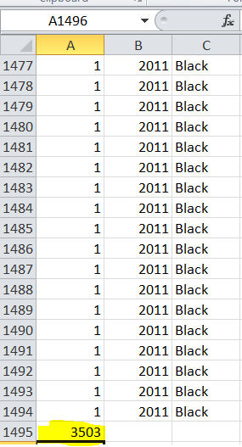

When the excel and table are compared the orderqty matches

