STEP 1: CREATE AND VISUALIZE THE GRAPH
import networkx as nx
import matplotlib.pyplot as plt
G = nx.Graph()

edges = {
('Shivani', 'Advika'),
('Shivani', 'Vivan'),
('Advika', 'Vivan'),
('Advika', 'Myra'),
('Vivan', 'Myra'),
('Myra', 'Shivansh')
}

G.add_edges_from(edges)
plt.figure(figsize=(6, 4))
nx.draw(G, with_labels=True, node_color='lightblue', node_size=1500, font_size=10)
plt.title("Sample Graph")
plt.show()
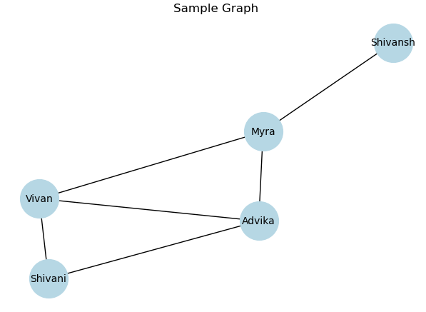

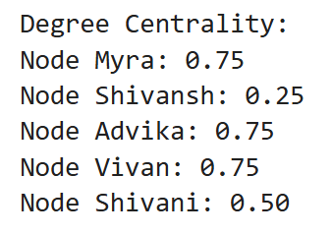
STEP 2: DEGREE CENTRALITY
deg_centrality = nx.degree_centrality(G)

print("Degree Centrality:")
for node, cent in deg_centrality.items():
print(f"Node {node}: {cent:.2f}")

STEP 3: BETWEENNESS CENTRALITY

bet_centrality = nx.betweenness_centrality(G)
print("\nBetweenness Centrality:")
for node, cent in bet_centrality.items():
print(f"Node {node}: {cent:.2f}")
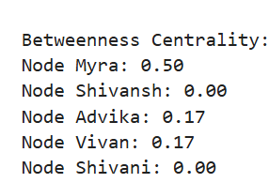

STEP 4: CLOSENESS CENTRALITY
close_centrality = nx.closeness_centrality(G)
print("\nCloseness Centrality:")
for node, cent in close_centrality.items():
print(f"Node {node}: {cent:.2f}")
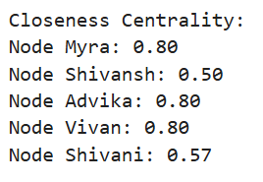

STEP 5: GRAPH CENTERS( ECCENTRICITY)

eccentricity = nx.eccentricity(G)
min_ecc = min(eccentricity.values())
centers = [node for node, ecc in eccentricity.items() if ecc == min_ecc]
print("\nEccentricity of Nodes:")
for node, ecc in eccentricity.items():
print(f"Node {node}: {ecc}")
print(f"\nGraph Centers (Min Eccentricity = {min_ecc}): {centers}")
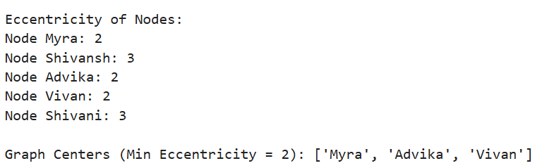

DG=G.to_directed()
recip=nx.reciprocity(DG)
print(f"Reciprocity of the directed Graph:{recip:.2f}")

clustering=nx.clustering(G)
print(f"Clustering Cofficient:")
for node,coeff in clustering.items():
print(f"Node {node}:{coeff:.2f}")

