Networkx
Matplotlib
pandas
G = nx.Graph()

edges = [
('Shivani', 'Advika'),
('Advika', 'Vivan'),
('Vivan', 'Myra'),
('Myra', 'Vansh'),
('Vansh','Aman'),
('Advika','Aman'),
('Shivani','Riya'),
('Riya','arsh')
]

G.add_edges_from(edges)

plt.figure(figsize=(6, 4))
nx.draw(
G,
with_labels=True,
node_color='lightblue',
node_size=1500,
edge_color='gray',
font_size=10
)
plt.title("Social Network Graph")
plt.show()
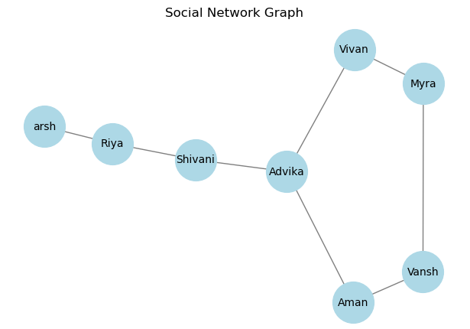
3.Shortest Path
#Shortest Path from Shivani to Vansh
path=nx.shortest_path(G, source='Shivani',target='Vansh')
print("Shortest path from Shivani to Vansh:",path)

4.Network Density
density=nx.density(G)
print("Network Density:",round(density,2))

5.Egocentric Networks (Ego Networks)
#Create ego network for Advika
ego=nx.ego_graph(G,'Advika')
pos=nx.spring_layout(ego)
nx.draw(ego,pos,with_labels=True, node_color='orange',node_size=1700, edge_color='black')
plt.title("Advika's Ego Network")
plt.show()
