import pandas as pd
import networkx as nx
import matplotlib.pyplot as plt
%pip install seaborn
import seaborn as sns
sns.set_theme(style="whitegrid")
print("Libraries imported successfully")

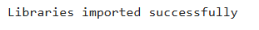
emails=pd.DataFrame({
"Sender":[
"CEO","CEO","CEO","HR","HR","Finance","Finance","Manager","Manager","Manager",
"Developer1","Developer2","Developer3","Research","Sales","Sales","Sales"
],
"Receiver":[
"HR","Finance","Manager","Manager","Developer1","CEO","Sales",
"Developer1","Developer2","Research","Developer3","Developer3","Research",
"CEO","CEO","Manager","Finance"
]
})
print("Email Dataset")
print(emails)
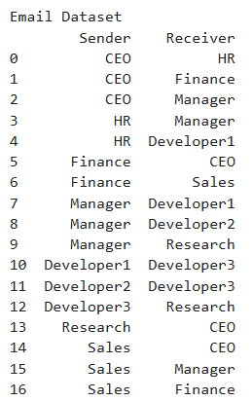

#Edge List Representation
print("Edge List\n")
for i, row in emails.iterrows():
print(row["Sender"], "--->", row["Receiver"])
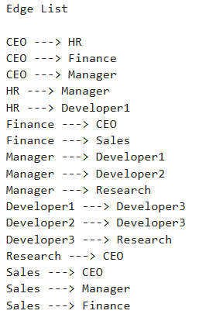

#Create Graph
G=nx.from_pandas_edgelist(
emails, source="Sender", target="Receiver", create_using=nx.DiGraph())
print("Employees:")
print(list(G.nodes()))
print("Connections")
print(list(G.edges()))
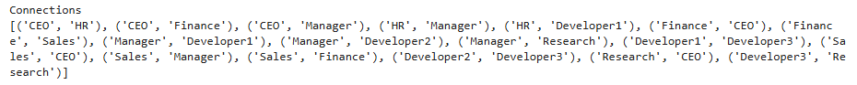
matrix=nx.to_pandas_adjacency(G, dtype=int)
print("=====Adjacency Matrix=====")
print(matrix)
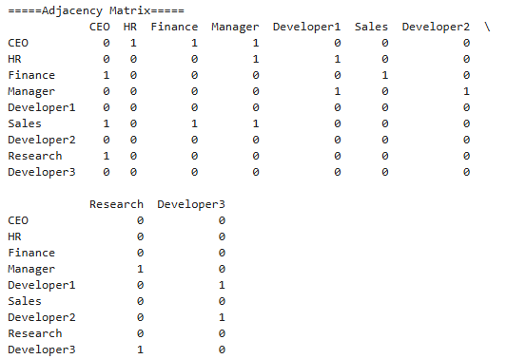

# Interactive Adjacency Matrix using Plotly
import plotly.express as px

fig = px.imshow(
matrix,
text_auto=True,
color_continuous_scale="Blues",
labels={
"x": "Receiver",
"y": "Sender",
"color": "Email Connection"
},
title="Interactive Corporate Email Adjacency Matrix"
)

fig.update_layout(width=800, height=700)

fig.show(renderer="browser")
fig.show()

#Sociogram
import networkx as nx
import plotly.graph_objects as go

#positions of nodes
pos=nx.kamada_kawai_layout(G)

#Edges
edge_x=[]
edge_y=[]

for a,b in G.edges():
x1,y1=pos[a]
x2,y2=pos[b]
edge_x +=[x1,x2,None]
edge_y +=[y1,y2,None]

edges=go.Scatter(
x=edge_x,
y=edge_y,
mode='lines',
line=dict(color='gray',width=2),
hoverinfo='none'
)

#Nodes
node_x=[]
node_y=[]
info=[]

for n in G.nodes():
x,y=pos[n]
node_x.append(x)
node_y.append(y)
info.append(
f"{n}<br>"
f"Out-degree:{G.out_degree(n)}<br>"
f"In-degree:{G.in_degree(n)}<br>"
f"Received:{G.in_degree(n)}"
)

nodes=go.Scatter(
x=node_x,
y=node_y,
mode="markers+text",
text=list(G.nodes()),
textposition="top center",
hovertext=info,
hoverinfo="text",
marker=dict(
size=35,
color=node_x,
colorscale="Viridis"
)
)

fig=go.Figure([edges,nodes])

fig.update_layout(
title="Corporate Email Network",
showlegend=False,
width=900,
height=700,
plot_bgcolor="white",
xaxis_visible=False,
yaxis_visible=False
)

fig.show(renderer="browser")

