Aim: Structural, Automorphic and Regular equivalence
import numpy as np
import pandas as pd
%pip install seaborn
import seaborn as sns
import networkx as nx
import matplotlib.pyplot as plt

#Create a simple graph to analyze equivalence
G= nx.DiGraph()
edges=[
("Alice","Manager"),
("Bob","Manager"),
("Charlie","Manager"),
("Manager","HR"),
("Manager","Finance"),
("HR","CEO"),
("Finance","CEO")
]

G.add_edges_from(edges)

plt.figure(figsize=(8,6))
pos= nx.spring_layout(G, seed=42)
nx.draw(G,pos,with_labels=True, node_color='orange', node_size=2000,arrows=True)
plt.title("Corporate Communication Network")
plt.show()

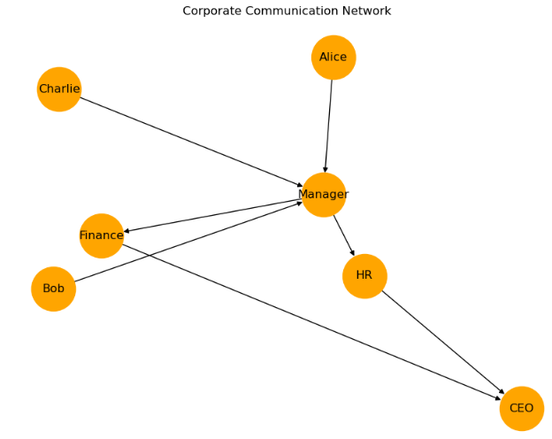
# Aim: Structural, Automorphic and Regular Equivalence
# Case Study: Movie Actors Collaboration Network
import numpy as np
import pandas as pd
%pip install seaborn
import seaborn as sns
import networkx as nx
import matplotlib.pyplot as plt

#Create a simple graph to analyze equivalence
G= nx.DiGraph()
edges=[
("Aamir","Madhavan"),
("Aamir","Sharman"),
("Kareena","Madhavan"),
("Kareena","Sharman"),
("Madhavan","Boman"),
("Sharman","Boman")
]

G.add_edges_from(edges)

plt.figure(figsize=(8,6))
pos= nx.spring_layout(G, seed=42)
nx.draw(G,pos,with_labels=True,node_color='lightgreen',node_size=3000,arrows=True)
plt.title("Movie Actors Collaboration Network")
plt.show()

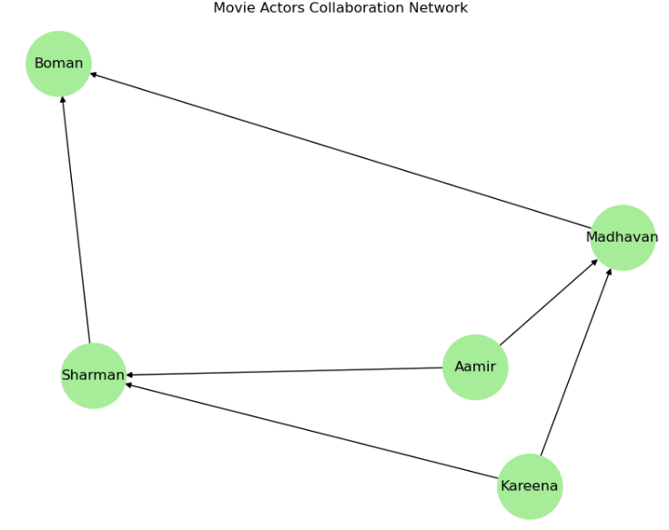
from itertools import combinations

def structurally_equivalent(G):
struct_eq=[]
for u,v in combinations(G.nodes(),2):
if (set(G.successors(u))==set(G.successors(v))) and (set(G.predecessors(u))==set(G.predecessors(v))):
struct_eq.append((u,v))
return struct_eq
print("Structurally Equivalent Pairs:")
print(structurally_equivalent(G))

#Automorphic Equivalence
def automorphically_equivalent(G):
auto_eq=[]
for u, v in combinations(G.nodes(),2):
mapping={u:v,v:u}
for node in G.nodes():
if node not in mapping:
mapping[node]=node
G_swapped=nx.relabel_nodes(G,mapping)
if nx.is_isomorphic(G,G_swapped):
auto_eq.append((u,v))
return auto_eq

print("Automorphically Equivalent Pairs:")
print(automorphically_equivalent(G))

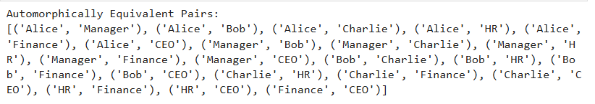

#Regular Equivalence
roles={}
for node in G.nodes():
preds=set(G.predecessors(node))
succs=set(G.successors(node))

if preds==set() and succs=={"Manager"}:
roles[node]="Employee"
elif preds=={"Alice","Bob","Charlie"}:
roles[node]="Manager"
elif preds=={"Manager"} and 'CEO' in set(G.successors("HR")).union(G.successors("Finance")):
roles[node]="Department"
elif preds=={"HR","Finance"}:
roles[node]="CEO"
else:
roles[node]="Other"

#view regular equivalence classes
import pandas as pd
role_df=pd.DataFrame.from_dict(roles, orient='index',columns=['Role'])
role_df

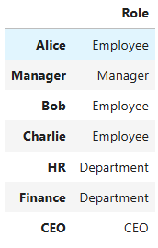

#Structural Equivalence
from itertools import combinations

def structurally_equivalent(G):
struct_eq=[]
for u,v in combinations(G.nodes(),2):
if (set(G.successors(u))==set(G.successors(v))) and (set(G.predecessors(u))==set(G.predecessors(v))):
struct_eq.append((u,v))
return struct_eq

print("Structurally Equivalent Pairs:")
print(structurally_equivalent(G))

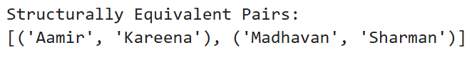

# Automorphic Equivalence
def automorphically_equivalent(G):
auto_eq=[]
for u, v in combinations(G.nodes(),2):
mapping={u:v,v:u}
for node in G.nodes():
if node not in mapping:
mapping[node]=node
G_swapped=nx.relabel_nodes(G,mapping)
if nx.is_isomorphic(G,G_swapped):
auto_eq.append((u,v))
return auto_eq

print("Automorphically Equivalent Pairs:")
print(automorphically_equivalent(G))

#Regular Equivalence
roles={}
for node in G.nodes():
preds=set(G.predecessors(node))
succs=set(G.successors(node))

if preds==set():
roles[node]="Main Actor"
elif len(preds)>=2:
roles[node]="Supporting Actor"
else:
roles[node]="Other"

#view regular equivalence classes
import pandas as pd
role_df=pd.DataFrame.from_dict(roles,orient='index',columns=['Role'])
role_df

