Dice rolls

dice_rolls = []

for i in range(10):
roll = rnd.randint(1,6) # slumpmässigt tal mellan 1 och 6
dice_rolls.append(roll) # lägg till i listan

print(dice_rolls)

import random as rnd

dice_rools = [rnd.randint(1,6) for w in range(1,11)]

dice_rools

a)
dice_rolls = [rnd.randint(1,6) for i in range(10)]
dice_rolls.sort() # sorterar den i stigande ordning
print(dice_rolls)

b)
dice_rolls = [rnd.randint(1,6) for i in range(10)]
dice_rolls.sort(reverse=True) # sorterar den i fallande ordning

print(dice_rolls)

c)
_max = max(dice_rolls)
_min = min(dice_rolls)

print(f"max {_max}")
print(f"min {_min}")

d)
average_value = sum(dice_rolls) / len(dice_rolls)

print(average_value)

e)

import statistics

median_value = statistics.median(dice_rolls)

print(median_value)

f)
unique_values = []

for x in dice_rolls:
if x not in unique_values:
unique_values.append(x)

print(unique_values)

g)
unique_values = set(dice_rolls) # set() returnerar unika värden.

print(unique_values)

Food menu

food = ["vegetarian lasagne", "spaghetti", "fish", "soup", "pancakes"]

weekdays = ["Monday","Tuesday","Wednesday", "Thursday","Friday"]

head_1 = "Day"

head_2 = "Food"

print(f"{head_1:<12}{head_2}")
print(f"{'-'*9}{'-'*9}")
for meal, _day in zip(food, weekdays):
print(f"{_day:<12}{meal}")

utan zip funktionen

weekdays = ["Monday", "Tuesday", "Wednesday", "Thursday", "Friday"]

dishes = ["vegetarian lasagne", "spaghetti", "fish", "soup", "pancakes"]

head_1 = "Day"

head_2 = "Food"

print(f"{head_1:<10} {head_2:<10}")

print("----------------------")

for i in range(len(weekdays)):
print(f"{weekdays[i]:<10} {dishes[i]:<10}")

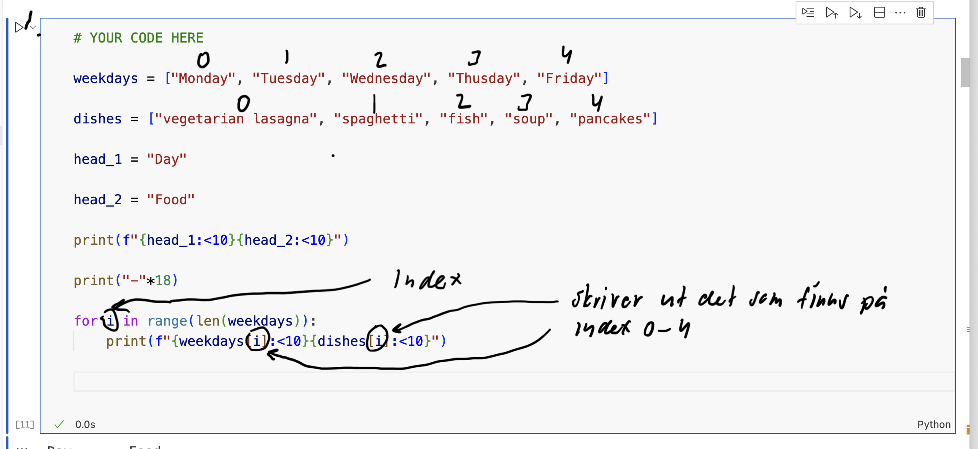

Squares

squard_numbers = [x**2 for x in range(-10, 11)]

print(squard_numbers)

import matplotlib.pyplot as plt

plt.plot(squard_numbers)

Chessboard

char_list = ['A','B','C','D','E','F','G','H']

combo_list = [char_m + "1" for char_m in char_list]

combo_list

b)
letters = ['A','B','C','D','E','F','G','H']

chessboard = []

for i in range(1,9):
row = []
for letter in letters:
row.append(letter + str(i))
chessboard.append(row)

chessboard

for row in chessboard:
print(row)

c)
# # YOUR CODE HERE

tuple_columns = ("A","B","C","D","E","F","G","H")

tuple_rows = (1,2,3,4,5,6,7,8)

tuple_board = tuple(tuple((col, row) for col in tuple_columns) for row in tuple_rows)

for row in tuple_board:
print(row)

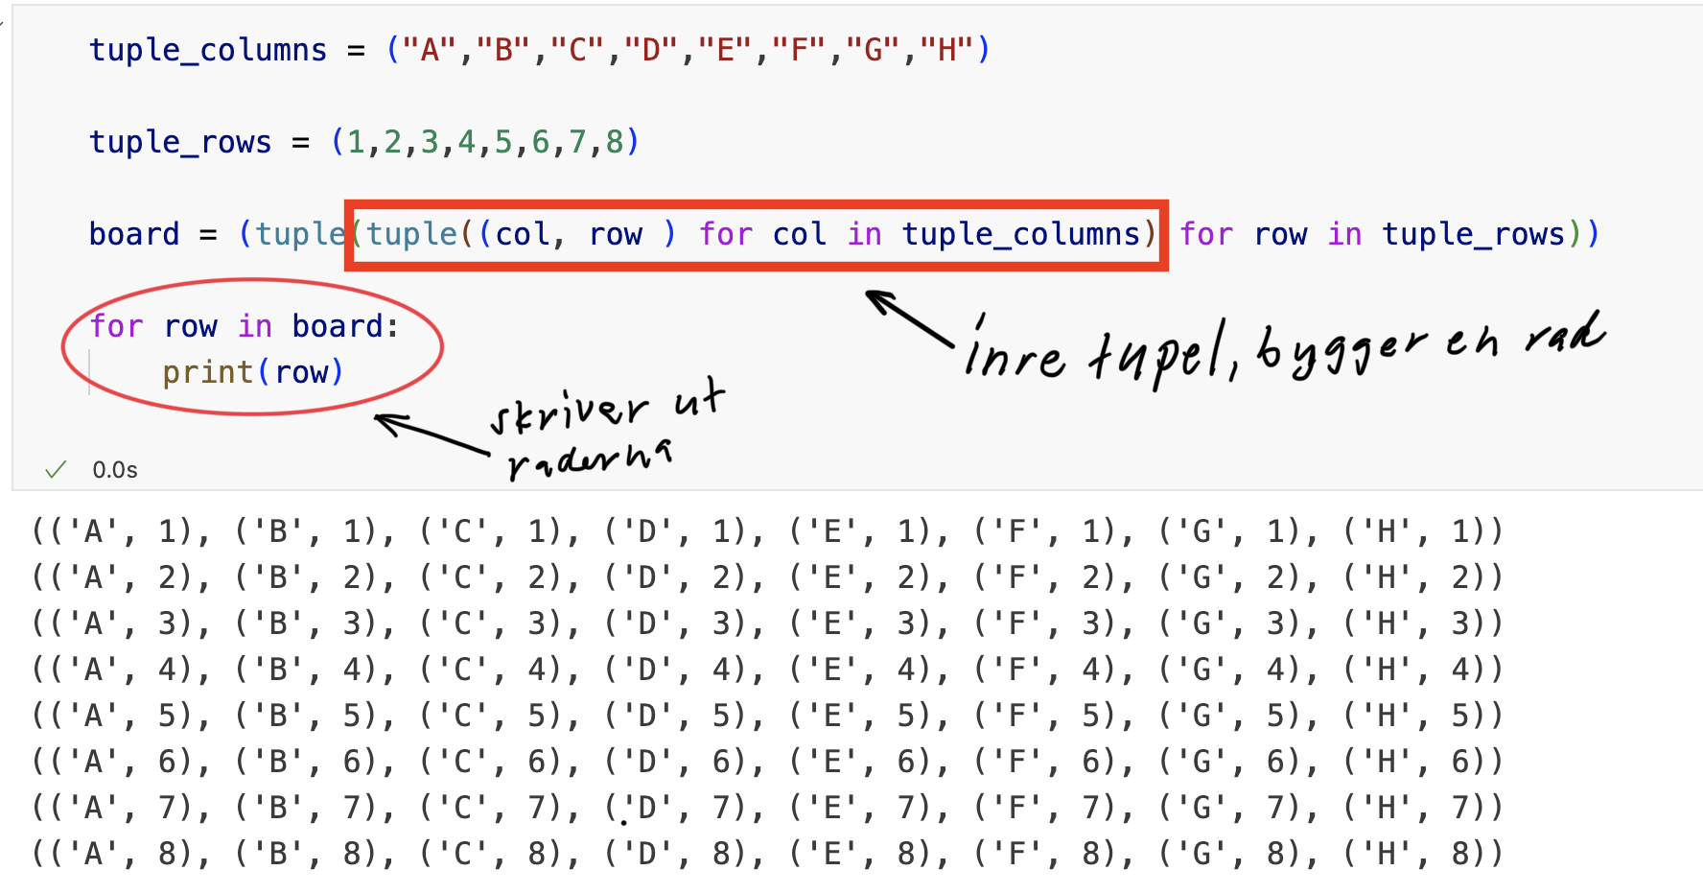

Dice rolls convergence

import random as rnd

count_six = 0

for i in range(100):
dice_eyes = rnd.randint(1,6)
if dice_eyes == 6:
count_six += 1

print(count_six)

b)
count_six = 0

list_of_dice_rolls = [10,100,1000,10000,100000,1000000]

count_six = []

probabilities = []

for rolls in list_of_dice_rolls:
six_count = 0
for i in range(rolls):
dice = rnd.randint(1,6)

if dice == 6:
six_count +=1
count_six.append(six_count)
probabilities.append(six_count / rolls)

print(count_six)
print(probabilities)

Monte Carlo simulation

a)

