**Plan for the interface**

This project is scraping Coursera website and annotating reviews to different courses. To ease others to understand our project and search for annotation, below is our plan to create an interface.

1. We will have multiple search functionalities. There will be one text field where user can input any name of the course and then all the annotated reviews related to particular keyword will be displayed e.g. if user searches for “data science”, all the course which have data science keyword will be displayed with the comments associated with that in a tabular format.

These will be fields displayed as an example

|  |  |  |
| --- | --- | --- |
| Name of course | Comments | Annotation |
| Data science | This course is very difficult | Difficulty |

1. Validations on above text field will be in JavaScript where user should not be able to input any special characters, he will be shown an alert message that “Special characters are not allowed”.
2. Another validation will be that user should not be able to click on search button if there is no text in search text box. User will be displayed alert message ” Please input search text”.
3. There will be a dropdown with inputs (Content, Course delivery, Difficulty, Workload, Usefulness), user can select any annotation, and then reviews which have been annotated as “Yes” will be displayed.

Choose an item.

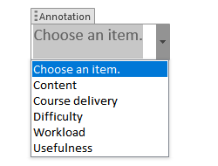

1. If user does not select any item and click on Search button, he will be shown an alert message indicating “Please select an annotation”.
2. There will be a search button, when clicking that button all the results will be displayed.
3. We will be using HTML and Javascript as front end and python as backend.
4. All the data will be queried from SQLite database.
5. Additional information we will be displaying will be count of annotated text.
6. We will display graphical information about the distribution of the count of annotated text for each annotation if time permits.