Jadavpur University

Department of Computer Science and Engineering

Computer Networks Laboratory (BCSE-III)

Assignment 5: Packet Tracer and Traffic Analysis with Wireshark
Live Packet Capture, Protocol Stack Dissection, ARP Resolution, ICMP Diagnostics, HTTP/TCP Session Flow, Ethernet OUI Identification, and Hierarchy Profiling
Student Name: | Mandeep Shaw | Roll Number: | 302510501002
Section: | A1 | Course: | BCSE-III Computer Networks Lab
Date of Submission: | November 2026 | Tools Used: | Wireshark v4.2.2, Dumpcap, ping, Firefox

1. Overview and Objectives
Network protocol analysis and deep packet inspection (DPI) are fundamental techniques for network diagnostic debugging, performance profiling, cybersecurity audits, and empirical verification of protocol specifications. Wireshark is an industry-standard cross-platform packet capture and network protocol analysis suite built on top of the libpcap and dumpcap capture architectures.
Wireshark partitions captured network traffic into three interconnected interactive inspection panes:
- Packet List Panel: Displays a chronological summary of each captured frame with columns for packet index number, relative or absolute timestamp, source and destination network/hardware addresses, transport/application protocol identification, length in octets, and protocol-specific summary metadata.
- Packet Details Panel: Presents an expandable hierarchical tree dissecting the protocol stack layer-by-layer (Frame → Ethernet II → IPv4/IPv6 → TCP/UDP/ICMP → Application layer protocols such as HTTP, DNS, or mDNS).
- Packet Bytes Panel: Displays the raw byte buffer of the selected packet in traditional hex dump format (16 octets per row in hexadecimal) alongside corresponding ASCII character encodings, with bidirectional selection synchronization linked to the details tree.

2. Question 1: ICMP and ARP Traffic Analysis
"Generate some ICMP traffic by using the Ping command line tool to check the connectivity of a neighbouring machine (or router). Note the results in Wireshark. The initial ARP request broadcast from your PC determines the physical MAC address of the network IP Address, and the ARP reply from the neighboring system. After the ARP request, the pings (ICMP echo request and replies) can be seen."

2.1 Experimental Methodology
To examine the interaction between link-layer address resolution and network-layer reachability testing:
- The local machine was configured on the local subnet with IP address 10.223.117.129 and MAC address ce:7e:13:24:96:68.
- A live packet capture was initiated in Wireshark on the active network interface.
- The ping utility was executed from the terminal targeting a neighbouring machine at IP 10.223.117.59:
$ ping -c 4 10.223.117.59
- Wireshark display filters arp and icmp were applied respectively to isolate address resolution and ICMP signaling.

2.2 Address Resolution Protocol (ARP) Analysis
Before an IP datagram can be transmitted over a local Ethernet/802.3 broadcast domain, the host's operating system consults its internal ARP cache. Because no entry initially exists for target IP 10.223.117.59, an ARP Request frame is broadcast to the Layer-2 broadcast address ff:ff:ff:ff:ff:ff.
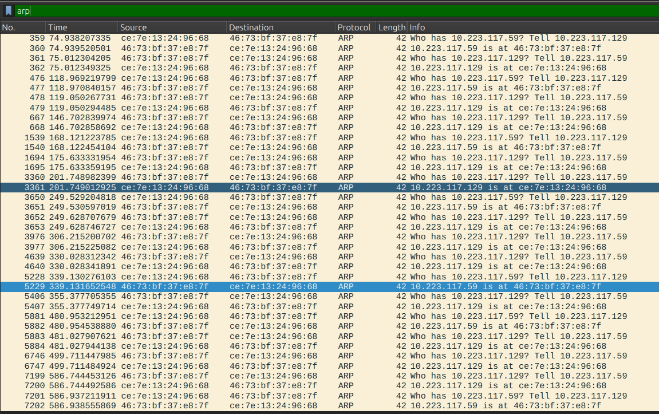
Figure 1: Wireshark packet capture filtered by 'arp', capturing ARP request broadcasts and corresponding unicast replies.
Dissection of Address Resolution:
- ARP Request (Packet No. 5228):
  - Source MAC: ce:7e:13:24:96:68 (Transmitting PC)
  - Destination MAC: ff:ff:ff:ff:ff:ff (Ethernet Broadcast)
  - Sender IP: 10.223.117.129 → Target IP: 10.223.117.59
  - Info: Who has 10.223.117.59? Tell 10.223.117.129
- ARP Reply (Packet No. 5229):
  - Source MAC: 46:73:bf:37:e8:7f (Neighbouring Target System)
  - Destination MAC: ce:7e:13:24:96:68 (Unicast reply to transmitting PC)
  - Sender IP: 10.223.117.59 → Target IP: 10.223.117.129
  - Info: 10.223.117.59 is at 46:73:bf:37:e8:7f

2.3 Internet Control Message Protocol (ICMP) Echo Sequence
With the destination MAC address cached, the diagnostic ping packets are transmitted. The display filter icmp captures four consecutive Echo Request and Echo Reply pairs.
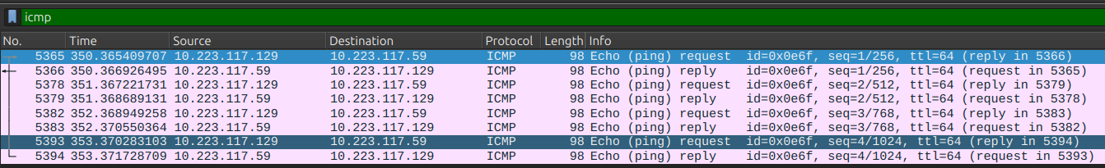
Figure 2: Wireshark packet capture filtered by 'icmp', showing alternating ICMP Echo Requests (Type 8) and Echo Replies (Type 0).
No. | Time (s) | Source IP | Destination IP | Type / Code | Len | ICMP Details
5365 | 350.365409 | 10.223.117.129 | 10.223.117.59 | Type 8, Code 0 | 98 | Echo request, id=0x0e6f, seq=1/256, ttl=64
5366 | 350.366926 | 10.223.117.59 | 10.223.117.129 | Type 0, Code 0 | 98 | Echo reply, id=0x0e6f, seq=1/256, ttl=64
5378 | 351.367221 | 10.223.117.129 | 10.223.117.59 | Type 8, Code 0 | 98 | Echo request, id=0x0e6f, seq=2/512, ttl=64
5379 | 351.368689 | 10.223.117.59 | 10.223.117.129 | Type 0, Code 0 | 98 | Echo reply, id=0x0e6f, seq=2/512, ttl=64
5382 | 352.368949 | 10.223.117.129 | 10.223.117.59 | Type 8, Code 0 | 98 | Echo request, id=0x0e6f, seq=3/768, ttl=64
5383 | 352.370550 | 10.223.117.59 | 10.223.117.129 | Type 0, Code 0 | 98 | Echo reply, id=0x0e6f, seq=3/768, ttl=64
5393 | 353.370283 | 10.223.117.129 | 10.223.117.59 | Type 8, Code 0 | 98 | Echo request, id=0x0e6f, seq=4/1024, ttl=64
5394 | 353.371728 | 10.223.117.59 | 10.223.117.129 | Type 0, Code 0 | 98 | Echo reply, id=0x0e6f, seq=4/1024, ttl=64
Measured Round-Trip Time (RTT):
For sequence 1 (Packets 5365 and 5366):
RTT = T_reply - T_request = 350.366926495 s - 350.365409707 s = 0.001516788 s ≈ 1.517 ms
The identifier 0x0e6f (decimal 3695) uniquely identifies the Linux ping process instance.

3. Question 2: Web Traffic Analysis
"Generate some web traffic and:
a. Find the list of different protocols that appear in the protocol column in the unfiltered packet-listing window.
b. How long did it take from when the HTTP GET message was sent until the HTTP OK reply was received? (in Time-of-day format).
c. What is the Internet address of the website? What is the Internet address of your computer?
d. Search back through your capture, and find an HTTP packet containing a GET command. Click on the packet in the Packet List Panel. Then expand the HTTP layer in the Packet Details Panel.
e. Find out the value of the Host from the Packet Details Panel, within the GET command."

3.1 Part 2a: Protocol Diversity in Unfiltered Packet Listing
A web browser was launched to generate HTTP/HTTPS traffic. The unfiltered packet listing captures multiple interleaved protocols across the TCP/IP stack.
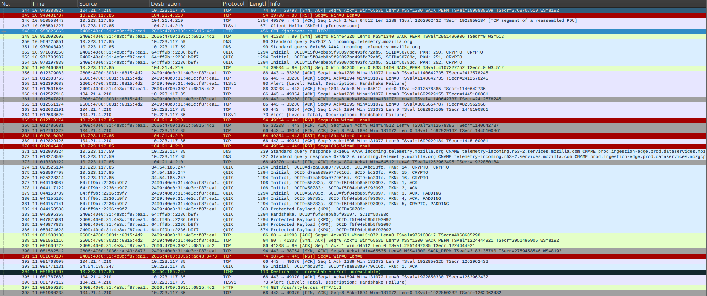
Figure 3: Unfiltered packet capture displaying concurrent interleaved protocols during web browsing.
Observed Protocols in the Protocol Column:
- TCP (Transmission Control Protocol): Manages reliable connection setup (SYN, SYN-ACK, ACK), payload delivery, and connection teardown (FIN, RST).
- TLSv1 / TLSv1.2 (Transport Layer Security): Encrypted session establishment, cipher suite negotiation, and protected application records.
- HTTP (Hypertext Transfer Protocol): Cleartext web requests (e.g., GET /js/theme.js HTTP/1.1) and responses.
- DNS (Domain Name System): Name resolution queries and responses over UDP port 53.
- QUIC (Quick UDP Internet Connections): Modern multiplexed transport protocol operating on top of UDP port 443 (HTTP/3).
- ICMP (Internet Control Message Protocol): Error signaling such as Destination unreachable (Port unreachable).

3.2 Parts 2b & 2c: HTTP Response Time (RTT) and IP Addresses
To measure the response time, the time display was switched to Time-of-day format via View → Time Display Format → Time-of-day, and the display filter http was applied.
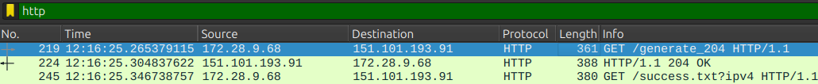
Figure 4: HTTP GET request (Packet 219) and HTTP 204 OK response (Packet 224) displayed in Time-of-day format.
Extracted Packet Timestamps:
- HTTP GET Request (Packet No. 219):
  - Timestamp: 12:16:25.265379115
  - Source IP (Client Machine): 172.28.9.68
  - Destination IP (Web Server): 151.101.193.91
  - Request Line: GET /generate_204 HTTP/1.1
- HTTP OK Reply (Packet No. 224):
  - Timestamp: 12:16:25.304837622
  - Source IP (Web Server): 151.101.193.91
  - Destination IP (Client Machine): 172.28.9.68
  - Status: HTTP/1.1 204 OK
Response Time Calculation:
ΔT = 12:16:25.304837622 - 12:16:25.265379115 = 0.039458507 seconds ≈ 39.46 ms
Identified Internet Addresses:
• Internet Address of Website (Server): 151.101.193.91 (Fastly CDN edge node)
• Internet Address of Computer (Client): 172.28.9.68 (Local private IPv4 address on wlp1s0)

3.3 Parts 2d & 2e: Dissecting HTTP GET and Host Parameter
Selecting Packet 219 in the Packet List Panel and expanding the Hypertext Transfer Protocol layer in the Packet Details Panel reveals the HTTP headers.
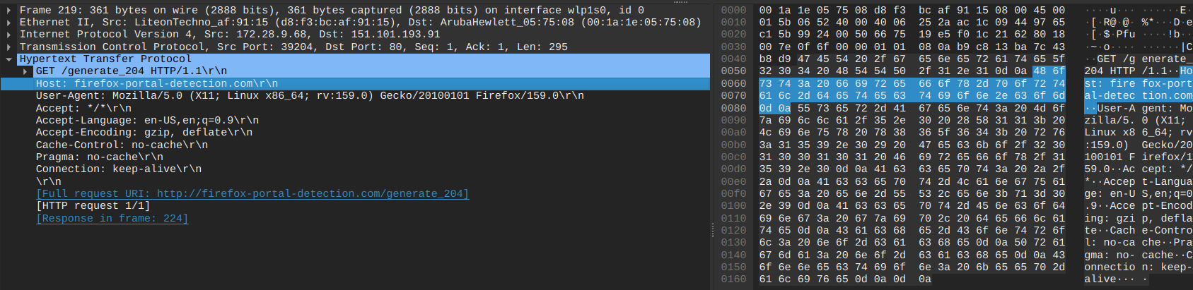
Figure 5: Expanded HTTP layer in Details Panel for Packet 219, highlighting the Host parameter and raw bytes.
Header Parameters:
- Request Method: GET
- Request URI: /generate_204
- Request Version: HTTP/1.1
- Host Header: firefox-portal-detection.com
- Full Header Line: Host: firefox-portal-detection.com
- User-Agent: Mozilla/5.0 (X11; Linux x86_64; rv:159.0) Gecko/20100101 Firefox/159.0
- Connection: keep-alive
Answer for 2e: The value of the Host parameter from the Packet Details Panel is firefox-portal-detection.com.

4. Question 3: Hex and ASCII Byte Representations
"Highlight the Hex and ASCII representations of the packet in the Packet Bytes Panel."
When Host: firefox-portal-detection.com is clicked in the middle Details Panel, Wireshark dynamically highlights the corresponding raw slice in the Packet Bytes Panel (offsets 0x005e to 0x0080), as shown in Figure 5 above.
- Highlighted Hexadecimal Stream:
48 6f 73 74 3a 20 66 69 72 65 66 6f 78 2d 70 6f 72 74 61 6c 2d 64 65 74 65 63 74 69 6f 6e 2e 63 6f 6d 0d 0a
- Highlighted ASCII Stream:
Host: firefox-portal-detection.com..
The trailing .. in the ASCII pane corresponds to non-printable control octets 0x0d (Carriage Return, ) and 0x0a (Line Feed, ), terminating the HTTP header per RFC 2616.

5. Question 4: First 4 Bytes Hex Value of Host Parameter
"Find out the first 4 bytes of the Hex value of the Host parameter from the Packet Bytes Panel."
Examining the first four highlighted bytes of the Host parameter:
Byte Position | Hexadecimal | Binary | Decimal | ASCII Character
1st Byte | 48 | 01001000 | 72 | 'H'
2nd Byte | 6f | 01101111 | 111 | 'o'
3rd Byte | 73 | 01110011 | 115 | 's'
4th Byte | 74 | 01110100 | 116 | 't'
Answer: The first 4 bytes of the Hex value of the Host parameter are 48 6f 73 74, which directly decodes to the ASCII word Host.

6. Question 5: Protocol Filtering and Following Network Flows
"Filter packets with http, TCP, DNS and other protocols.
a. Find out what those packets contain by following one of the conversations (also called network flows), select one of the packets and press the right mouse button..click on follow."

6.1 Protocol Display Filters
Wireshark provides boolean filtering expressions to selectively display traffic streams:
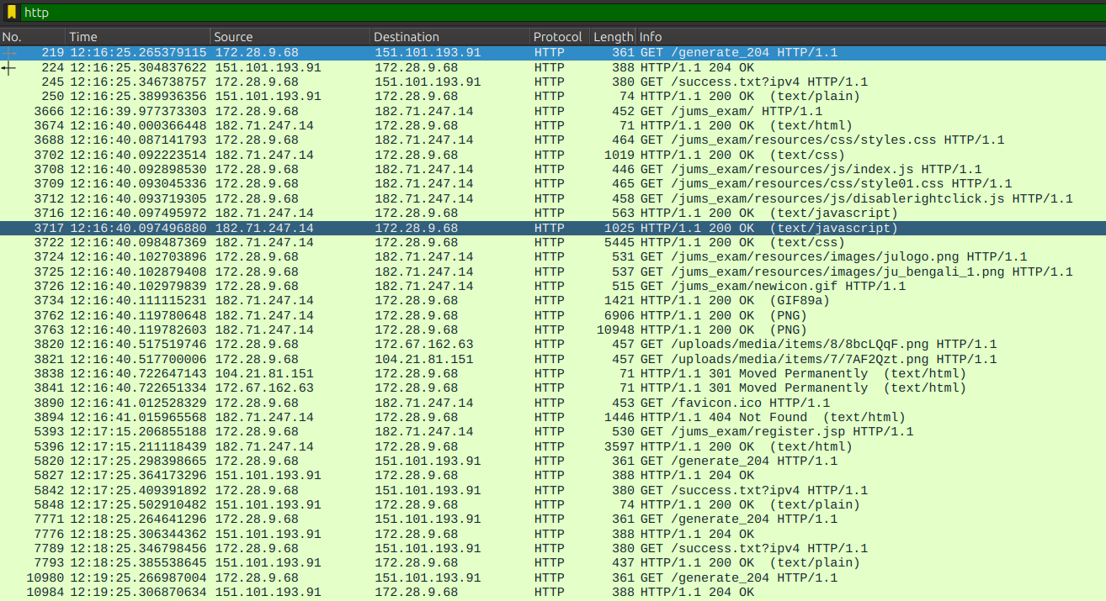  Figure 6a: HTTP display filter (http). | 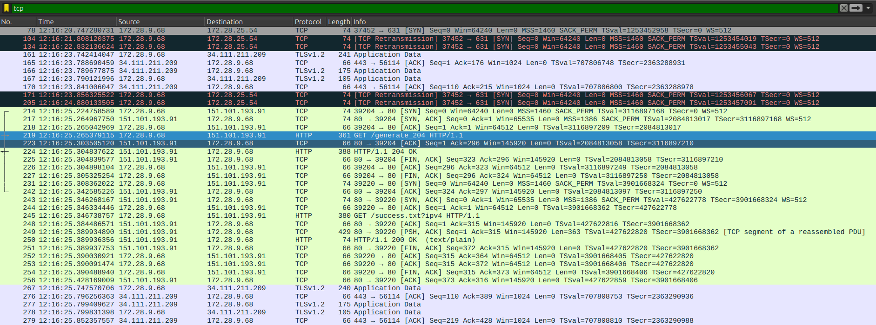  Figure 6b: TCP display filter (tcp).
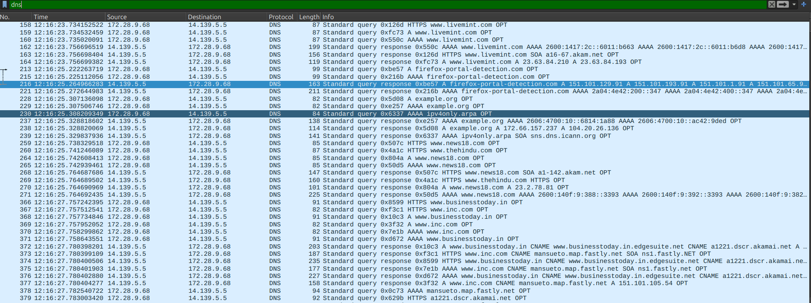  Figure 6c: DNS display filter (dns). | 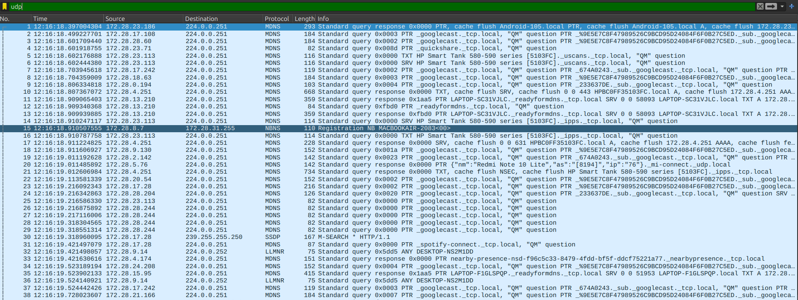  Figure 6d: UDP display filter (udp).

6.2 Part 5a: Following UDP Stream (Conversation Reassembly)
Selecting a packet and navigating to Right Click → Follow → UDP Stream reassembles the fragmented payload bytes, strips lower protocol headers, and presents the unencapsulated application data in UTF-8.
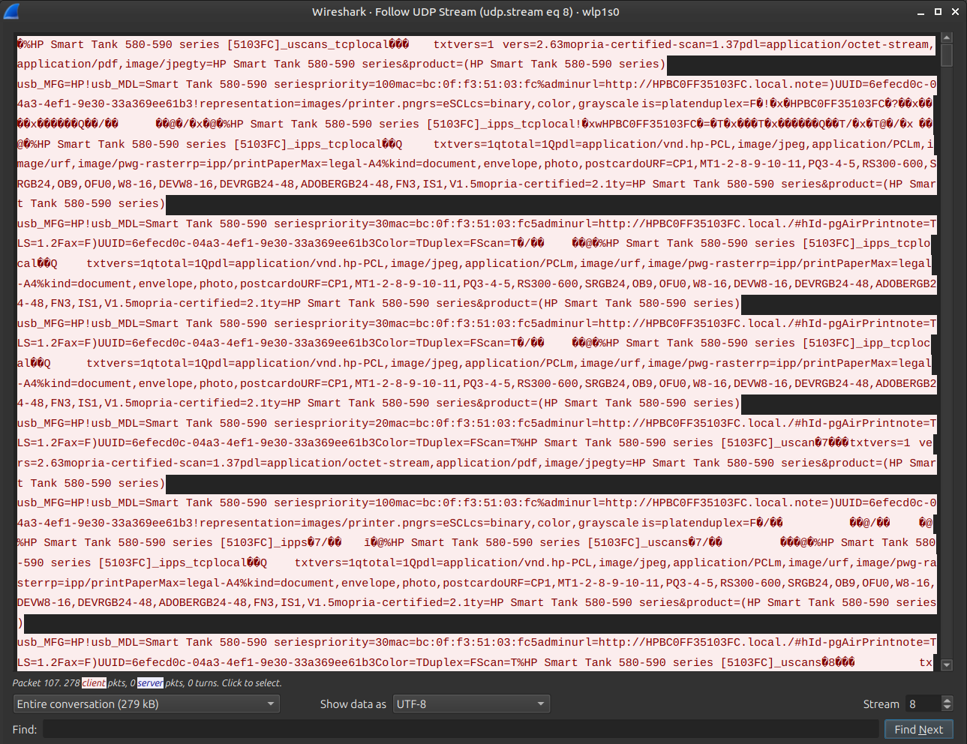
Figure 7: Wireshark stream reconstruction dialog for UDP Stream 8 (udp.stream eq 8) capturing mDNS service discovery announcements.
Analysis of Reassembled Stream 8 Payload:
The stream captures Multicast DNS (mDNS) announcements broadcast over UDP port 5353 by an office printer:
- Device Name: HP Smart Tank 580-590 series [5103FC]
- Hostname: HPBC0FF35103FC.local.
- Hardware MAC: bc:0f:f3:51:03:fc
- Advertised Service Descriptors:
  - _uscans._tcp.local (eSCL network scanning)
  - _ipps._tcp.local (Secure IPP printing)
  - _ipp._tcp.local (Standard IPP printing)
- Configuration Attributes: Admin URL: http://HPBC0FF35103FC.local./#hId-pgAirPrint, UUID: 6efecd0c-04a3-4ef1-9e30-33a369ee61b3, Color=T, Duplex=F, Scan=T.
- Supported PDLs: application/octet-stream, application/pdf, image/jpeg, application/vnd.hp-PCL, image/urf.

7. Question 6: Server HTTP Response and Ethernet Layer Inspection
"Search through your capture, and find an HTTP packet coming back from the server (TCP Source Port == 80). Expand the Ethernet layer in the Packet Details Panel."
The display filter http and tcp.srcport == 80 was applied. Packet No. 224 was selected and the Ethernet II layer was expanded.
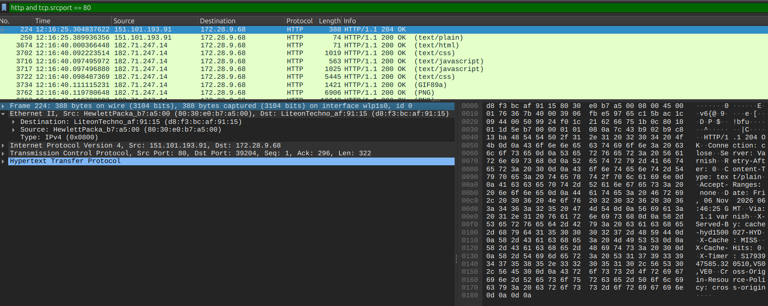
Figure 8: Packet 224 matching 'http and tcp.srcport == 80' with expanded Ethernet II layer.
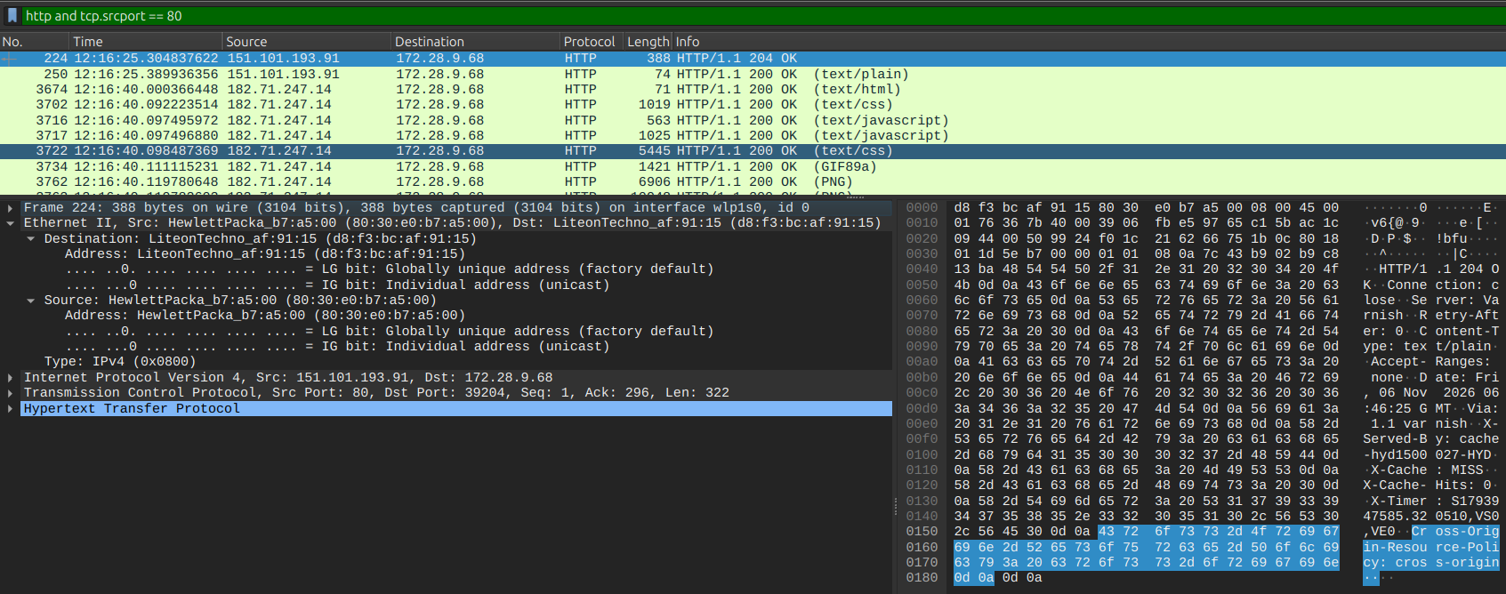
Figure 9: Detailed bit-level inspection of Destination and Source addresses in the Ethernet II header.
Ethernet II Header Dissection:
- Destination MAC Address (PC): LiteonTechno_af:91:15 (d8:f3:bc:af:91:15)
  - LG bit = 0: Globally unique address (factory default IEEE assigned)
  - IG bit = 0: Individual address (unicast frame)
- Source MAC Address (Sending Node): HewlettPacka_b7:a5:00 (80:30:e0:b7:a5:00)
  - LG bit = 0: Globally unique address (factory default IEEE assigned)
  - IG bit = 0: Individual address (unicast frame)
- EtherType: IPv4 (0x0800)

8. Question 7: NIC Manufacturers of PC and Server
"What are the manufacturers of your PC’s Network Interface Card (NIC), and the servers NIC?"
Referring to the expanded Ethernet II header in Figures 8 and 9:
- PC's Network Interface Card (NIC):
  - MAC Address: d8:f3:bc:af:91:15
  - Manufacturer: Lite-On Technology Corp. (LiteonTechno) — corresponds to the laptop's internal wireless adapter (wlp1s0).
- Server's / Gateway's Network Interface Card (NIC):
  - MAC Address: 80:30:e0:b7:a5:00
  - Manufacturer: Hewlett Packard (HewlettPacka)
Key Networking Principle (Hop-by-Hop MAC Rewriting):
Layer-2 MAC addresses never cross IP router boundaries. The web server (151.101.193.91) is located on a remote Fastly CDN datacenter across the Internet. Intermediate routers rewrite the Layer-2 Ethernet frame at every hop. Therefore, the Source MAC (80:30:e0:b7:a5:00) belongs to the local default gateway router / wireless access point (manufactured by Hewlett Packard), rather than the physical NIC of the remote web server.

9. Question 8: Organizationally Unique Identifiers (OUIs)
"What are the Hex values (shown in the raw bytes panel) of the two NICS Manufacturers OUIs?"
An Organizationally Unique Identifier (OUI) comprises the first 24 bits (3 bytes) of a standard 48-bit IEEE 802 MAC address, assigned to hardware vendors by the IEEE Registration Authority.
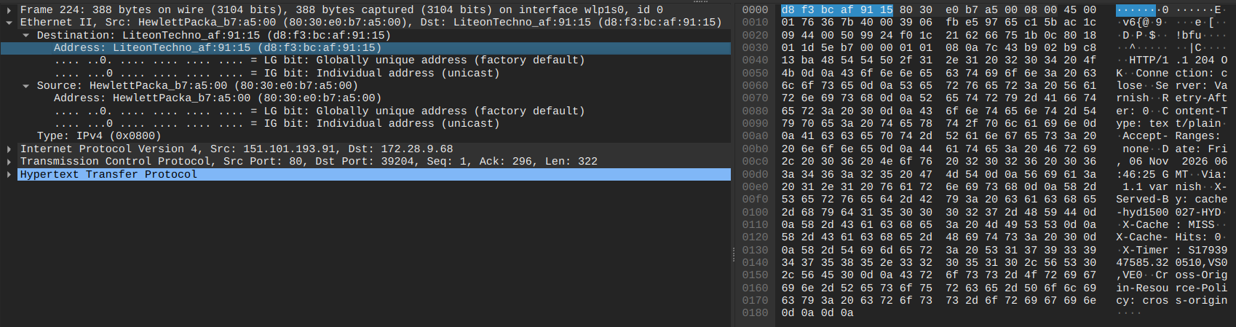  Figure 10a: PC NIC MAC 'd8 f3 bc af 91 15' highlighted in raw bytes. | 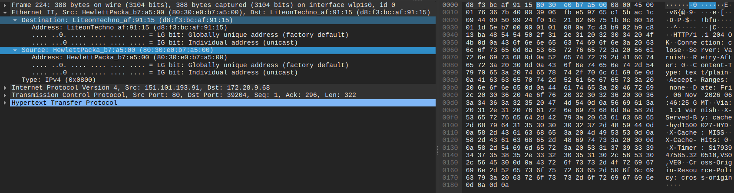  Figure 10b: Gateway NIC MAC '80 30 e0 b7 a5 00' highlighted in raw bytes.
Node Role | Full MAC Address | OUI (Hex Value) | OUI Bytes | Manufacturer Identity
PC Client NIC | d8:f3:bc:af:91:15 | d8:f3:bc | 0xd8, 0xf3, 0xbc | Lite-On Technology Corp.
Gateway / Server NIC | 80:30:e0:b7:a5:00 | 80:30:e0 | 0x80, 0x30, 0xe0 | Hewlett Packard Enterprise
Answers:
• Hex value of PC NIC Manufacturer OUI: d8:f3:bc (or d8 f3 bc)
• Hex value of Gateway / Server NIC Manufacturer OUI: 80:30:e0 (or 80 30 e0)

10. Question 9: Protocol Hierarchy Statistics
"Find the following statistics:
a. What percentage of packets in your capture are TCP, and give an example of the higher level protocol which uses TCP?
b. What percentage of packets in your capture are UDP, and give an example of the higher level protocol which uses UDP?"
Navigating to Statistics → Protocol Hierarchy generates an aggregated breakdown of all 94,876 captured packets (totaling 59,833,276 bytes).
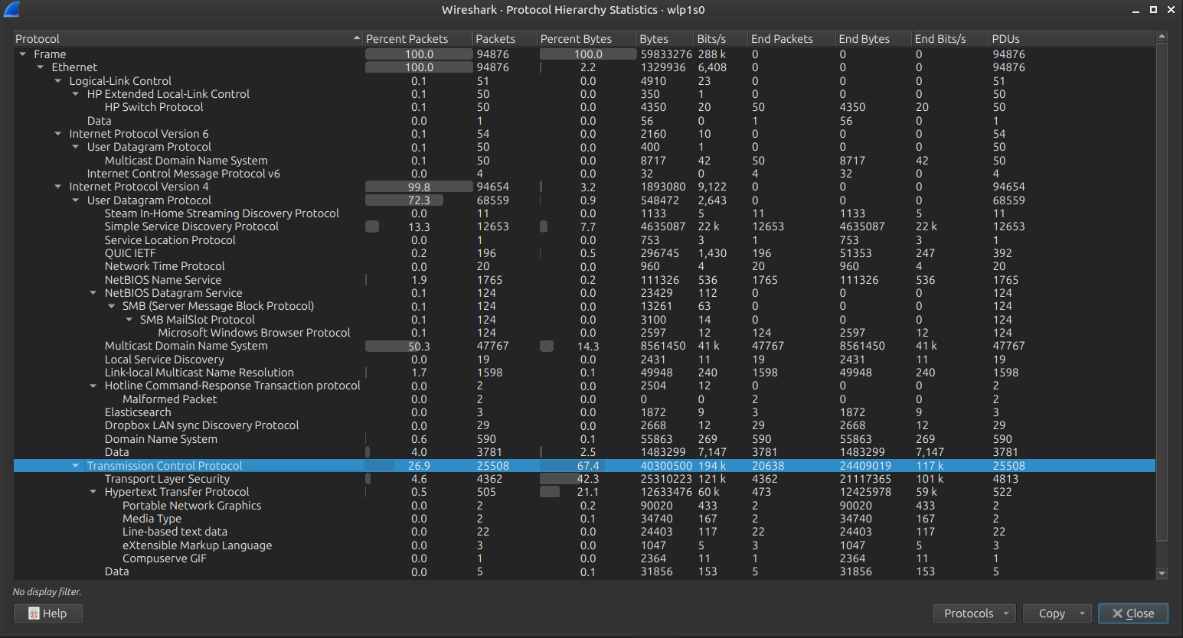  Figure 11a: Protocol Hierarchy highlighting TCP (26.9% packets, 67.4% bytes). | 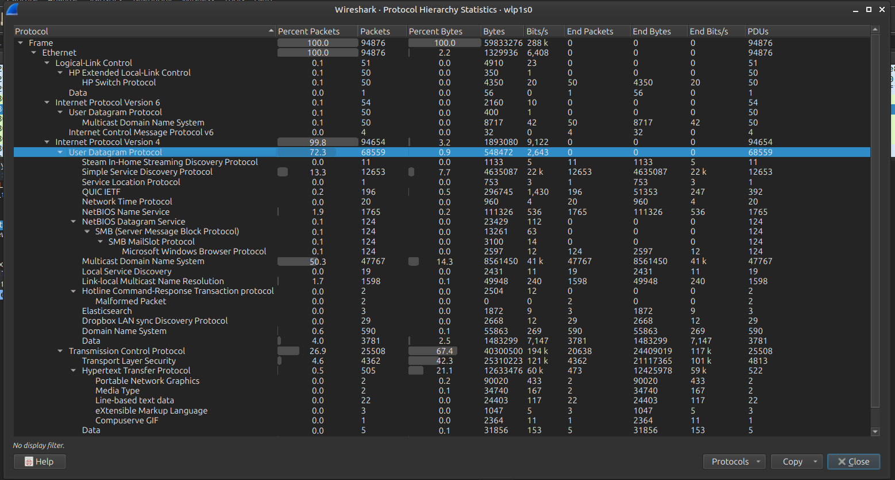  Figure 11b: Protocol Hierarchy highlighting UDP (72.3% packets, 0.9% bytes).
Statistical Summary:
- Part a: Transmission Control Protocol (TCP):
  - Packet Percentage: 26.9% (25,508 packets out of 94,876)
  - Byte Volume: 40,300,500 bytes (67.4% of all captured bytes)
  - Higher-Level Protocols Using TCP:
    - TLS (Transport Layer Security): 4,362 packets (4.6%)
    - HTTP (Hypertext Transfer Protocol): 505 packets (0.5%)
    - Subordinate web payloads: PNG images, XML files, CSS stylesheets
- Part b: User Datagram Protocol (UDP):
  - Packet Percentage: 72.3% (68,559 packets out of 94,876)
  - Byte Volume: 548,472 bytes (0.9% of all captured bytes)
  - Higher-Level Protocols Using UDP:
    - mDNS (Multicast DNS): 47,767 packets (50.3%)
    - SSDP (Simple Service Discovery): 12,653 packets (13.3%)
    - NetBIOS Name Service (NBNS): 1,765 packets (1.9%)
    - LLMNR (Link-Local Multicast Name Resolution): 1,598 packets (1.7%)
    - DNS (Domain Name System): 590 packets (0.6%)
    - QUIC IETF: 196 packets (0.2%)
    - NTP (Network Time Protocol): 20 packets (<0.1%)
Protocol | Packets | % of Packets | Bytes | % of Bytes | Avg Size | Primary Role in Trace
UDP | 68,559 | 72.3% | 548,472 | 0.9% | ≈ 8 B | High-frequency lightweight multicast discovery and beaconing.
TCP | 25,508 | 26.9% | 40,300,500 | 67.4% | ≈ 1580 B | Heavyweight reliable web browsing, TLS, and media transfers.
Other / LLC | 809 | 0.8% | 18,984,304 | 31.7% | — | Link-layer control, IPv6, HP switch protocols.

11. Question 10: Traffic Flow Graph Analysis
"Find the traffic flow Select the Statistics->Flow Graph menu option. Choose General Flow and Network Source options, and click the OK button."
The Flow Graph renders a two-dimensional ladder diagram plotting temporal packet exchanges between network endpoints along vertical timeline axes.

11.1 General Flow Graph (All Flows, Network Addresses)
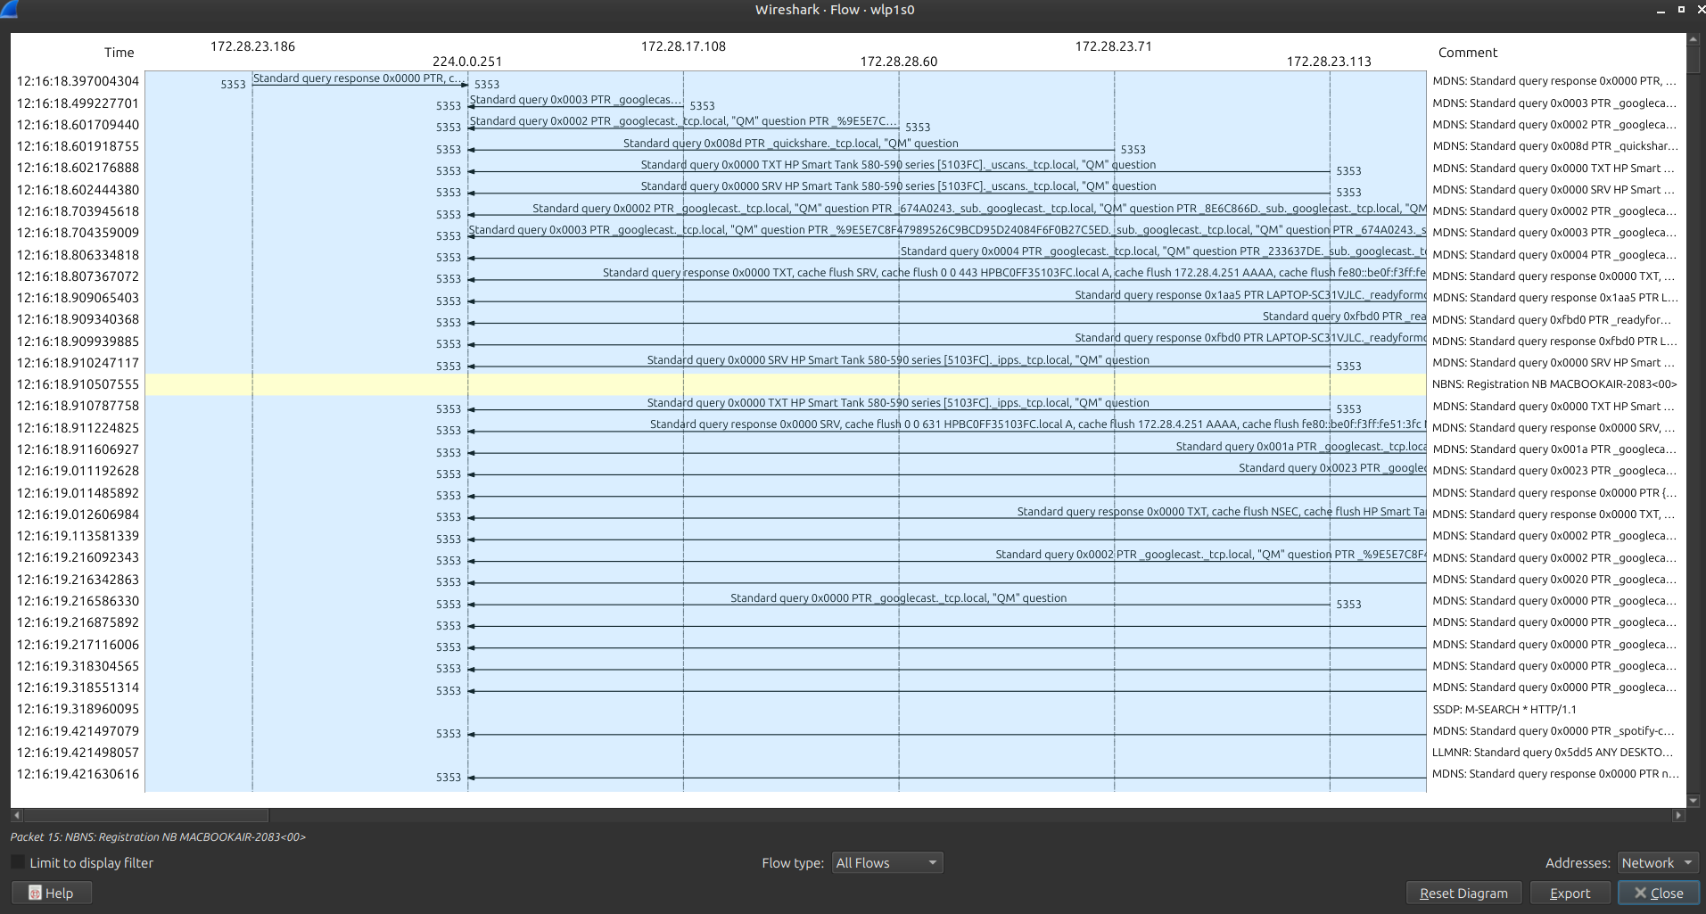
Figure 12: Wireshark General Flow Graph (All Flows, Network Addresses) showing multicast discovery traffic.
Multiple local IP endpoints (172.28.23.186, 172.28.17.108, 172.28.28.60, 172.28.23.71, 172.28.23.113) interact with the mDNS multicast IP 224.0.0.251, showing active zero-configuration host and service discovery across the campus subnet.

11.2 TCP Flow Graph (TCP Connection Lifecycle)
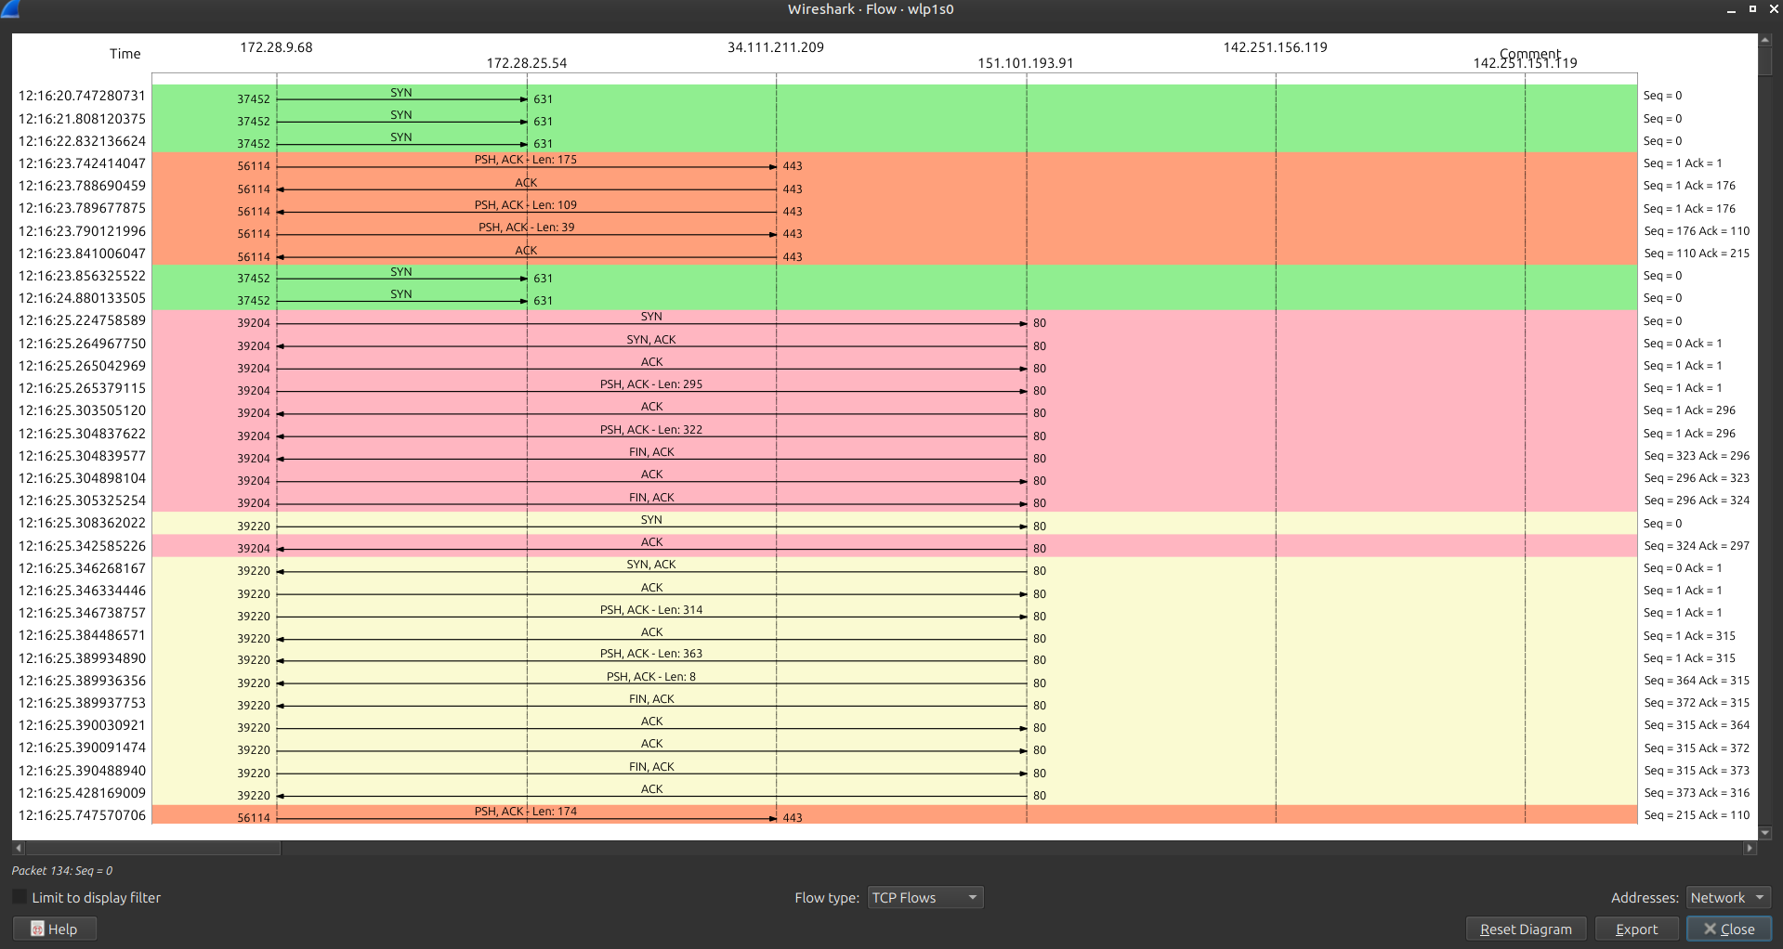
Figure 13: Wireshark TCP Flow Graph showing complete connection lifecycle (Handshake → Data Transfer → Teardown).
Detailed Lifecycle Phases:
- Phase 1: Three-Way Handshake (Establishment):
  - Client → Server: SYN (port 39204 → 80, Seq=0)
  - Server → Client: SYN, ACK (port 80 → 39204, Seq=0, Ack=1)
  - Client → Server: ACK (port 39204 → 80, Seq=1, Ack=1)
- Phase 2: HTTP Transaction (Data Exchange):
  - Client → Server: PSH, ACK - Len: 295 (HTTP GET request)
  - Server → Client: ACK (acknowledging request receipt)
  - Server → Client: PSH, ACK - Len: 322 (HTTP 204 OK response)
- Phase 3: Connection Teardown (Four-Way Termination):
  - Server → Client: FIN, ACK (Server initiates close, Seq=323, Ack=296)
  - Client → Server: ACK (Client acknowledges close, Seq=296, Ack=323)
  - Client → Server: FIN, ACK (Client initiates close, Seq=296, Ack=324)
  - Server → Client: ACK (Server completes termination, Seq=324, Ack=297)

12. Conclusion and Key Learnings
- Layer Encapsulation: Confirmed how application data (HTTP/DNS) is encapsulated inside transport headers (TCP/UDP), which are nested inside network packets (IPv4), and wrapped in data link frames (Ethernet II).
- ARP and Link-Layer Dynamics: Address resolution via ARP broadcasts is indispensable for mapping logical IP addresses to 48-bit physical MAC addresses on shared broadcast domains.
- Hop-by-Hop MAC Rewriting: Wireshark inspection reinforced the fundamental principle that MAC addresses do not survive IP routing boundaries; the source MAC of an inbound Internet packet identifies the local default router rather than the remote server.
- Transport Trade-offs: Evidenced a clear division between TCP (used for reliable, bulky HTTP/TLS data transfer accounting for 67.4% of total bytes) and UDP (used for lightweight, high-frequency multicast device discovery and name resolution accounting for 72.3% of total packets).
- Conversational Reassembly: Following TCP/UDP streams removes protocol encapsulation overhead, enabling complete inspection of application-layer payloads and REST transactions.

