* Installation Requirements-
* Install java sdk(java_ee_sdk)
* Install Eclipse IDE(eclipse-jee-mars)
* Install apache-tomcat
* Install mysql
* Need to create a dynamic web project in eclipse IDE
* Jars to include in project-
* For Java Mail: activation.jar and mail.jar.
* For tomcat Server- servlet-api.jar.
* For Jfreechart- jcommon.jar and jfreechart.jar
* SQL Database-
* Create database with name happiness_index_database.
* SQL Tables-
* Create a table with name: employee_info and columns: id, name, email and team as below-

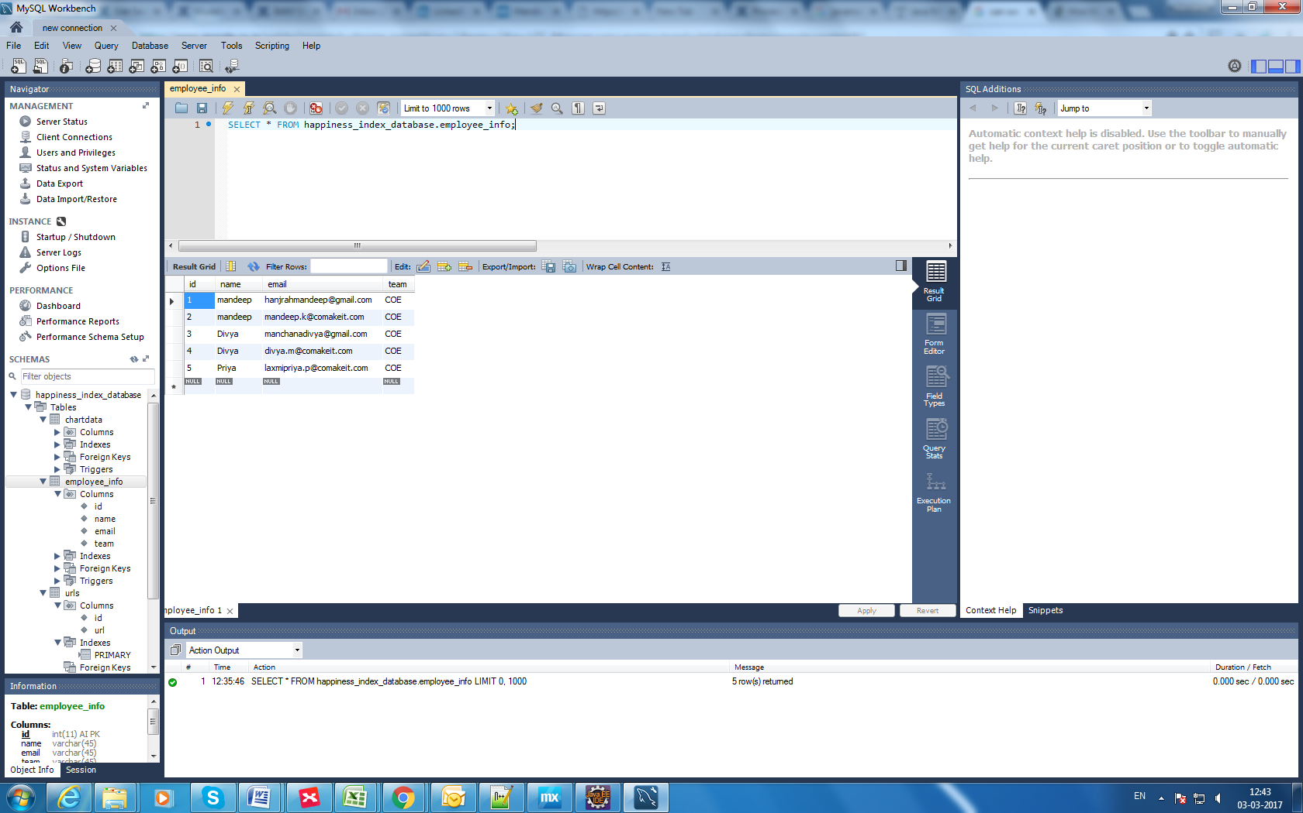

* Create a table with name: urls and columns: id, url and give input to url column as <http://localhost:8080/HappinessIndex/Url_parameter_servlet> as below-

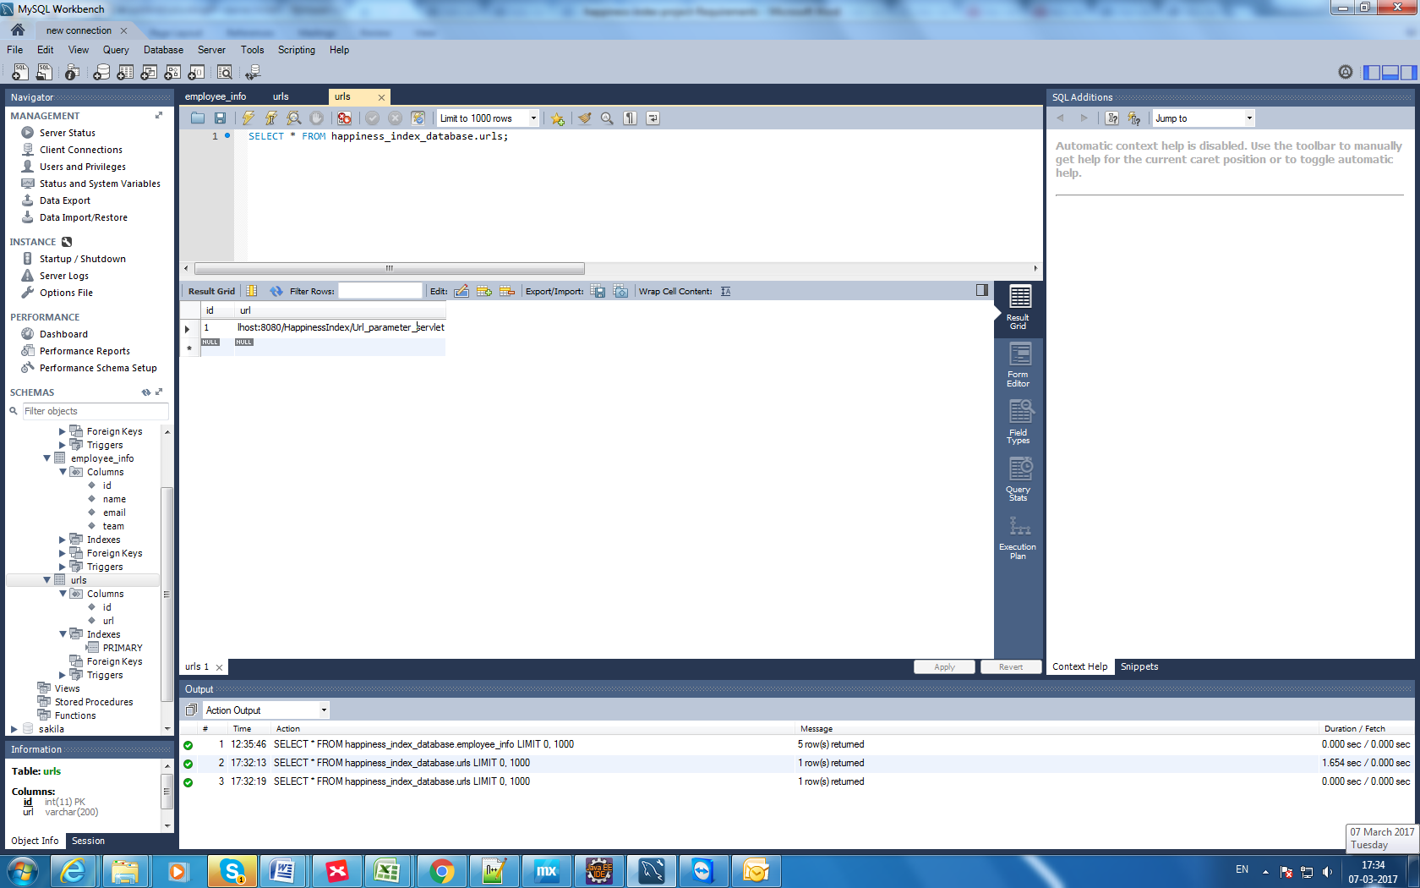

* Create a table with name: chartdata and columns: id, email, date, response and team as below:

