

‘Breast Cancer Prediction’ using classification models

Progress Report

Group Members:   
Deep Singh 251122489  
Mandeep Singh 251122474  
Sanket Salunke 25110239

Table of Contents

I. INTRODUCTION 1

II. PROBLEM DEFINITION AND MOTIVATION 1

*A.* *Problem Definition* 1

*B.* *Motivation* 1

III. RELATED WORK 1

IV. METHODOLOGY 1

*A.* *Understanding Business Problem* 1

*B.* *Problem Formalization* 1

*C.* *Requirement Analysis* 2

*D.* *Exploratory Data Analysis* 2

*1.* *Target Value Analysis* 3

2. *Visualizations* 3

*E.* *Data Preprocessing:* 4

V. PROJECT STATUS 5

VI. EXPECTED DELIVERABLES OF PROJECT OUTCOMES 5

VII. REFERENCES 6

**Figures**

Figure 1 Workflow 1

Figure 2 2

Figure 3 2

Figure 4 - Target value Analysis 3

Figure 5 Univariate Analysis – Box plot 3

Figure 6 Correlation Matrix - using Heatmap 3

Figure 7 Univariate Analysis - Histogram 4

Figure 8 Bivariate Analysis - Histogram and Scatterplot 4

Figure 9 4

Figure 10 5

Figure 11 5

Figure 12 Conversion of Categorical Data 5

Figure 13 Feature Scaling (Range 0-1) 5

**Tables**

Table 1 Dataset Description …………………………………………………………………………………………………… 2

Table 2 Project Status …….……………………………………………………………………………... ……………………. 5

# INTRODUCTION

Breast cancer is the most common cancer among Canadian women (excluding non-melanoma skin cancers). It is the second leading cause of death from cancer in Canadian women [1]. More than 80% of deaths due to cancerous cells occurs in underdeveloped and developing countries. Cancer in an essence is a group of diseases, causing an abnormal growth of body cells which lead to development in malign cells, also termed as cancerous cells. As per some statistics of Canadian government, breast cancer accounts for 13 to 25% of overall deaths due to cancer. Its estimated that in year 2019, around 30,000 cases were diagnosed with breast cancer and 5000 in severe cases.

# PROBLEM DEFINITION AND MOTIVATION

## *Problem Definition*

Presently there are many ML models, which can be used to for predictions. However, the accuracy of these models is relatively low. Under these circumstances, the chances for false predictions become certainly high. Since, these predictions affect the life of individuals, the error introduced in predication models can be fatal. The goal of this project is to access ML models and detect the cancerous cells with a higher degree of accuracy.

## *Motivation*

The early diagnosis of Breast cancer can improve the prognosis and chance of survival significantly, as it can promote timely clinical treatment to patients. Accurate classification of benign tumors can assist medical practitioner in devising correct course of treatment. Machine learning (ML) algorithms are widely employed in pattern classification and forecast modelling, because of its unique advantages in critical features detection from complex datasets.

# RELATED WORK

Feature selection, in machine learning is the process of selecting a subset of the most relevant features from a number of other available feature subsets. Choosing relevant attributes is an integral part of prediction algorithms in machine learning as it plays an important role in creating a more accurate predictive model.

There are various benefits to applying the attribute selection methods such as:

1. It is more effective and faster in training the machine learning model.
2. It decreases the complexity of a model and makes it easier to interpret.
3. It improves the accuracy of an algorithm if the right subset is chosen.
4. It reduces overfitting.

Some features may have a complex interrelation between them making it difficult to select the best subset of features. Different approaches have been proposed in this project for breast cancer diagnosis [1-5]. Usually, there are three types of feature selection methods which are: filter, wrapper, and embedded methods.

# METHODOLOGY

This project will be built on Python programming language. Python platform has an extensive list of libraries and tools for building an ML project. There are number of predefined libraries, which will be employed in various stages of project, from exploratory data analysis, modelling and optimization.

Below figure will gives the brief idea of project’s workflow:

Figure 1 Workflow

Each activity is discussed as under:

## *Understanding Business Problem*

The data sample can be analyzed by ML algorithm to detect the presence of malign cell. Using different models, we will be predicting whether a person is diagnosed with cancer or not.

## *Problem Formalization*

Classification and data mining methods are an effective way to classify data. Especially in medical field, where those methods are widely used in diagnosis and analysis to make decisions.

In this case, based on the features like radius, texture, perimeter, area etc. given in the data set, model should predict whether it is malignant or benign where malignant means infectious and benign is not harmful. Both Supervised and Unsupervised techniques can be employed to obtain the outcomes. With python library Scikit-Learn (sklearn), different ML algorithms like Logistic regression, KNN, Decision tree, SVM can be used.

## *Requirement Analysis*

The dataset chosen to address this problem is obtained from Kaggle repository under the heading of Breast Cancer Wisconsin (Diagnostic) Data Set. The dataset is owned by University of Wisconsin, available to students and researchers under open source license. There are 32 features in data set, including

TABLE 1 DATASET DESCRIPTION

|  |  |  |
| --- | --- | --- |
|  | Feature Name | Feature Description |
|  | ID number |  |
|  | Diagnosis | M = Malign  B = Benign |

remaining features are based on real-valued features from images of cell nucleus, for example:

|  |  |  |
| --- | --- | --- |
|  | Radius | mean of distances from center to points on the perimeter |
|  | Texture | standard deviation of gray-scale values |
|  | Perimeter |  |
|  | Area |  |
|  | Smoothness | local variation in radius lengths |
|  | Compactness | perimeter^2 / area - 1.0 |
|  | Concavity | severity of concave portions of the contour |
|  | Concave points | number of concave portions of the contour |
|  | Symmetry |  |
|  | Fractal Dimension | "coastline approximation" - 1 |

## *Exploratory Data Analysis*

In order to summarize main characteristics of dataset EDA techniques are used. During the initial data analysis certain parameters were interrogated, viz.

1. Presence of Outliers
2. Presence of non-normal
3. Association between features
4. Pattern in data sets.

For this several analysis techniques/tools are employed, viz. Box Plot, Histogram and Scatterplot

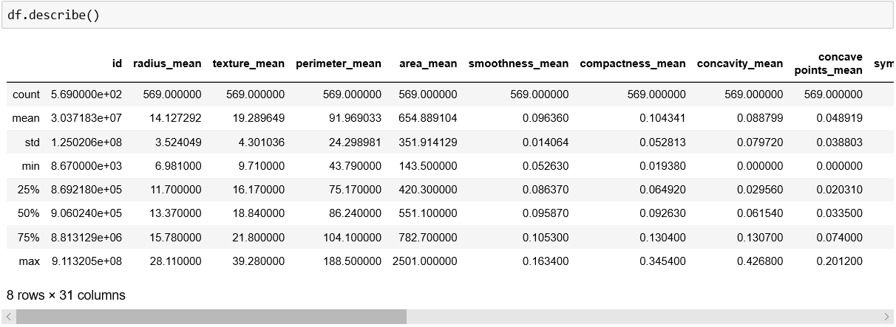

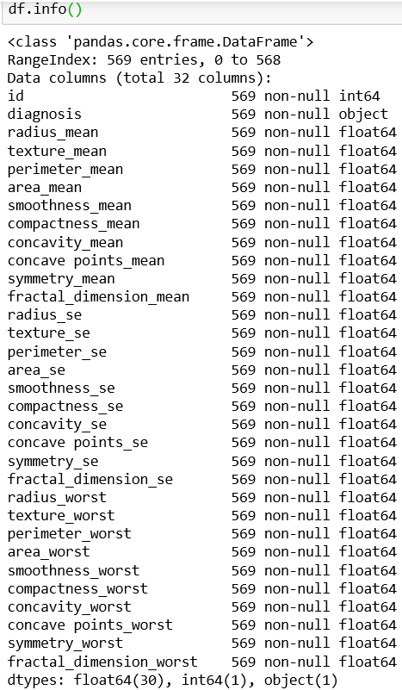

Figure 2

Inferences Figure 2:

* Dataset comprises of 569 observations and 32 features
* All data are in float format except for ‘id’ which is in integer format
* No variable column has missing value

Figure 3

Inferences Figure 3:

* Mean value for all features is greater than median value (50%)
* Noticeable difference between 75% and max value for all features, this indicates presence of outliers in data set.

### *Target Value Analysis*

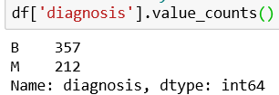

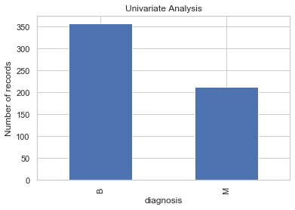

Figure 4 - Target value Analysis

Inferences Figure 4

* Target/dependent feature is categorical in nature with two possible outcomes
* With 357 Benign and 212 Malign outcomes
* Dataset has 60 to 40 ratio for outcomes, which is a balanced ratio.

### Visualizations

1. Correlation Matrix
2. Univariate Analysis (Single Variable)
3. 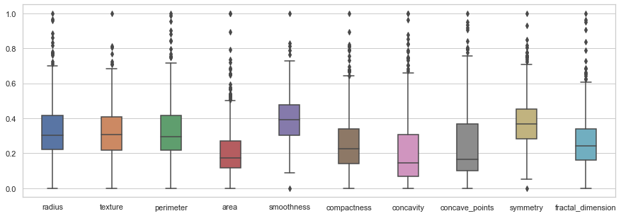Bivariate Analysis (Correlations)

Figure 5 Univariate Analysis – Box plot

1. Correlation Matrix – is done to inspect relation between varriables

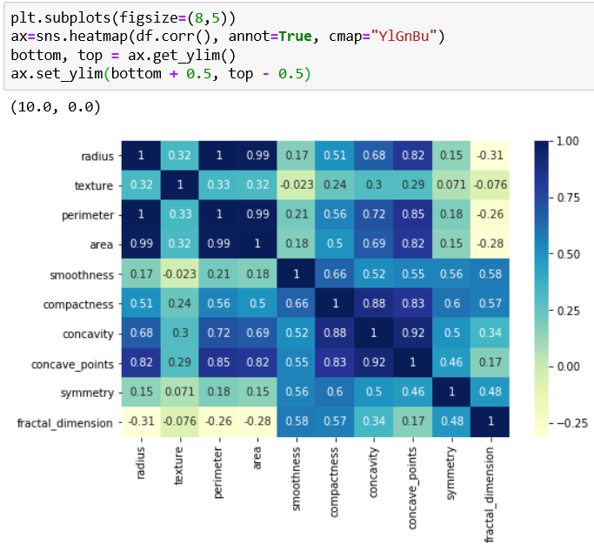

Figure 6 Correlation Matrix - using Heatmap

Inferences Figure 5

* Group 1: (Radius, perimeter, area, concavity and concave_points) have strong positive correlation
* Group 2: (Texture, smoothness, symmetry, fractal_dimension) have relatively low or negative correlation to Group 1 features

1. *Univariate analysis* – is done by performing frequency counts of different features.

Inferences Figure 6:

* Presence of outliers is in 4th quadrant, and rarely in 3rd and 1st as in case of smoothness and symmetry

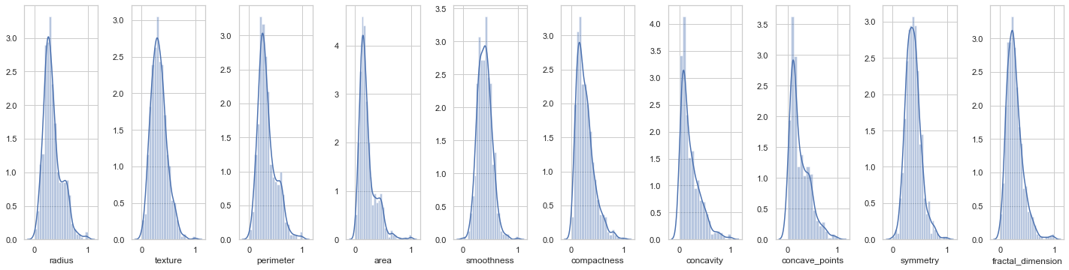Figure 7 Univariate Analysis - Histogram

Inferences Figure 7:

* Texture, smoothness and symmetry are normally distributed
* Remaining variables are skewed

1. *Bivariate analysis* is done to identify association between different features. Plot analysis between (Radius, diagnosis) and (texture, diagnosis) indicates the reason for skewness of radius and normal distribution of texture.

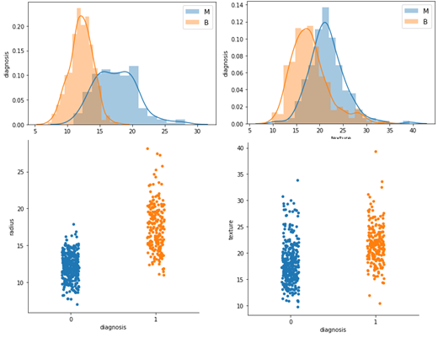

Figure 8 Bivariate Analysis - Histogram and Scatterplot

## *Data Preprocessing:*

Before starting Data preprocessing, the data quality must be inquired on parameters like:

1. Completeness (Cases of missing data): Presence of any NaN value can heavily impact the decision-making ability. There can be various methods to tackle empty or non-null values in dataset, like replacing empty values with mean, median or zero values. In our case the data consistency implies that no such operation is needed.

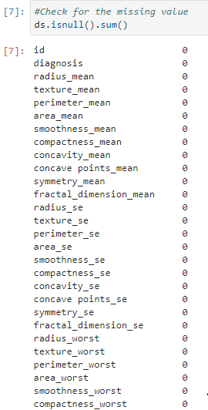

Figure 9

1. *Data Constraints***:**  i.e. on basis of Data Types (values of particular type) in a column, data range

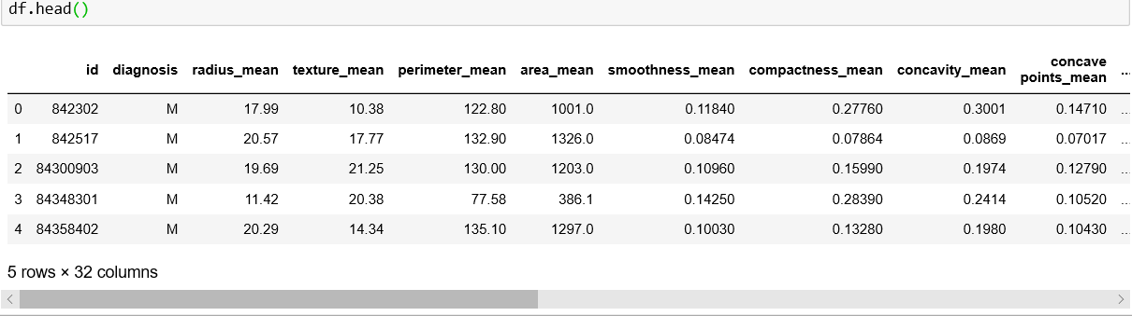Figure 10

Figure 11

1. *Presence/Conversion of Categorical Data***:** Since most ML model work with numerical values, it is imperative to convert data to suitable forms. To ensure this the categorical feature: diagnosis is mapped to 0s and 1s for benign and malignant.

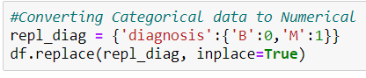

Figure 12 Conversion of Categorical Data

Data preprocessing: includes cleaning, instance selection, normalization, transformation, feature extraction and selection. Dataset doesn’t require cleaning, instance selection or transformation as there is no corrupt or missing data. However, there is a requirement for scaling/normalization of data as certain feature are in range of 0-1, while other like area and perimeter are in order of 0-1000.



Figure 13 Feature Scaling (Range 0-1)

# PROJECT STATUS

|  |  |  |
| --- | --- | --- |
| **S.N** | **Objectives** | **Status** |
|  | Problem definition | Completed |
|  | Problem formalization | Completed |
|  | Requirement analysis/data Collection | Completed |
|  | Exploratory Data Analysis | Completed |
|  | Data Preprocessing | Completed |
|  | Identification and Implementation of appropriate models | Due |
|  | Acquiring Results (Models score for evaluation) | Due |
|  | Optimizing the best model to improve the performance | Due |
|  | Final observation | Due |

Table 2

# EXPECTED DELIVERABLES OF PROJECT OUTCOMES

1. ML model score of different models
2. Processed dataset.
3. Project Report including Observations

# REFERENCES

1. M. F. Akay, “Support vector machines combined with feature selection for breast cancer diagnosis,” *Expert Systems with Applications*, vol. 36, no. 2, pp. 3240–3247, 2009.
2. Y. Sun, C. F. Babbs, and E. J. Delp, “A comparison of feature selection methods for the etection of breast cancers in mammograms: adaptive sequential floating search vs. genetic algorithm,” in *Proceedings of the 2005 IEEE Engineering in Medicine and Biology 27th Annual Conference*, pp. 6532–6535, Shanghai, China, September 2005.
3. B. Zheng, S. W. Yoon, and S. S. Lam, “Breast cancer diagnosis based on feature extraction using a hybrid of K-means and support vector machine algorithms,” *Expert Systems with Applications*, vol. 41, no. 4, pp. 1476–1482, 2014.
4. E. Aličković and A. Subasi, “Breast cancer diagnosis using GA feature selection and Rotation Forest,” *Neural Computing and Applications*, vol. 28, no. 4, pp. 753–763, 2017.
5. M. Banaie, H. Soltanian-Zadeh, H.-R. Saligheh-Rad, and M. Gity, “Spatiotemporal features of DCE-MRI for breast cancer diagnosis,” *Computer Methods and Programs in Biomedicine*, vol. 155, pp. 153–164, 2018.