PROJECT DOCUMENTATION
Online Retail Sales Dashboard
A Power BI Business Intelligence Project Analyzing UK E-Commerce Transaction Data
Prepared by: [Your Name]
Date: August 2026
Tool Used: Microsoft Power BI

Table of Contents
1. Executive Summary
2. Project Objectives
3. Dataset Description
4. Methodology
5. Dashboard Overview & Analysis
6. Key Insights & Findings
7. Business Recommendations
8. Tools & Technologies Used
9. Conclusion
10. Future Enhancements
11. Author & Contact

1. Executive Summary
This document presents the complete project documentation for the Online Retail Sales Dashboard, a business intelligence solution developed in Microsoft Power BI. The project analyzes over 536,000 e-commerce transactions from a UK-based online gift and homeware retailer, covering the period from December 2010 to December 2011.
The objective of this project was to transform raw, unstructured transactional data into a clear, interactive dashboard that enables stakeholders to monitor revenue performance, identify high-value customers, and evaluate international market opportunities for business expansion. The final deliverable consists of four interconnected dashboard pages covering revenue trends, country-wise performance, customer analysis, and a global demand map.

2. Project Objectives
The key objectives defined for this project were:
- Analyze historical sales data to identify monthly revenue trends and seasonal patterns.
- Determine the highest revenue-generating countries outside the United Kingdom to support market expansion decisions.
- Identify top customers by revenue contribution to support customer retention and loyalty strategies.
- Visualize global product demand geographically to highlight potential expansion targets.
- Deliver an interactive, self-service Power BI dashboard that allows stakeholders to filter and explore the data without technical expertise.

3. Dataset Description
The analysis is based on the publicly available UCI Online Retail Dataset, which records all transactions occurring for a UK-based, registered non-store online retail business.
Metric | Value
Total Records | 536,641 transactions
Date Range | December 1, 2010 – December 9, 2011
Unique Invoices | 25,900
Unique Customers | 4,373
Countries Covered | 38
Total Revenue (calculated) | ~£9.7 Million

3.1 Data Fields
- InvoiceNo: Unique identifier assigned to each transaction/invoice
- StockCode: Unique product/item code
- Description: Name of the product
- Quantity: Number of units sold per line item
- InvoiceDate: Date and time the transaction was generated
- UnitPrice: Price per unit of product, in GBP (£)
- CustomerID: Unique identifier assigned to each customer
- Country: Country where the customer resides

4. Methodology
The project followed a structured analytics workflow, from raw data to a decision-ready dashboard:
- Data Collection: Sourced the raw transactional CSV dataset.
- Data Cleaning: Checked for missing Customer IDs, removed duplicate records, and handled negative quantities associated with product returns/cancellations.
- Data Modeling: Structured the dataset within Power BI and created calculated columns and DAX measures (e.g., Revenue = Quantity × Unit Price, Month-over-Month Growth %).
- Dashboard Design: Designed four dedicated report pages, each answering a specific business question, using KPI cards, combo charts, column charts, and a filled map visual.
- Interactivity: Added slicers and filters (e.g., month selector) to allow dynamic, self-service exploration of the data.
- Validation: Cross-verified KPI totals and chart values against manual aggregations of the source data to ensure accuracy.

5. Dashboard Overview & Analysis
The dashboard consists of four report pages, each described in detail below along with the corresponding visualization.

5.1 Page 1 — Monthly Revenue Trend (2011)
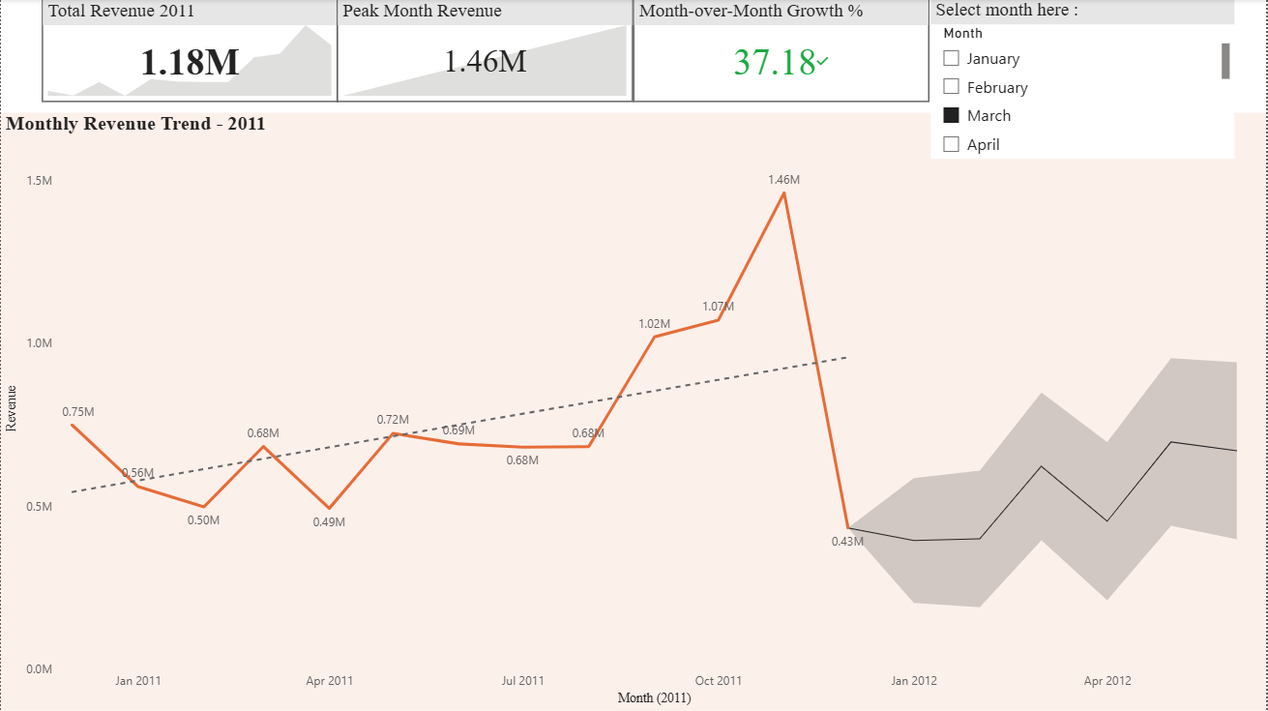
This page tracks monthly revenue performance across 2011 using a combination of KPI cards and a trend line chart with a forecast band.
- Total Revenue 2011: £1.18M
- Peak Month Revenue: £1.46M, recorded in October 2011
- Month-over-Month Growth: 37.18%
Revenue remained relatively stable through the first three quarters of the year, ranging between £0.49M and £0.72M per month, before rising sharply from August onward and peaking in October — most likely driven by pre-holiday-season bulk ordering. A dashed trend line and a shaded forecast band project a moderate, fluctuating revenue pattern into early 2012. A month slicer allows users to filter the report interactively.

5.2 Page 2 — Top 10 Countries by Revenue (Excl. UK)
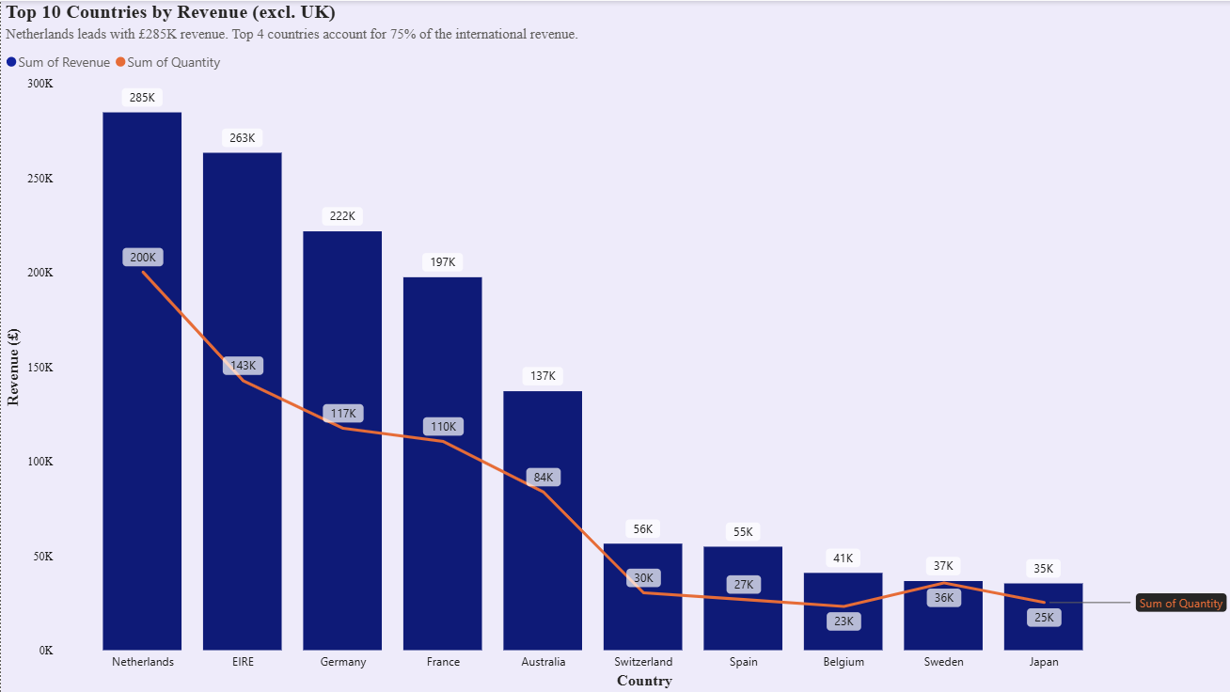
This page ranks the top 10 international markets (excluding the UK, the retailer's home market) using a combo chart of revenue (columns) and order quantity (line).
- Top Market: Netherlands, with £285K in revenue
- Following Markets: EIRE (£263K), Germany (£222K), and France (£197K)
- Market Concentration: The top 4 countries account for 75% of total international revenue
This concentration indicates that international demand is not evenly distributed but is instead centered in a small set of Western European markets, which represent the strongest candidates for focused marketing and logistics investment.

5.3 Page 3 — Top 10 Customers by Revenue
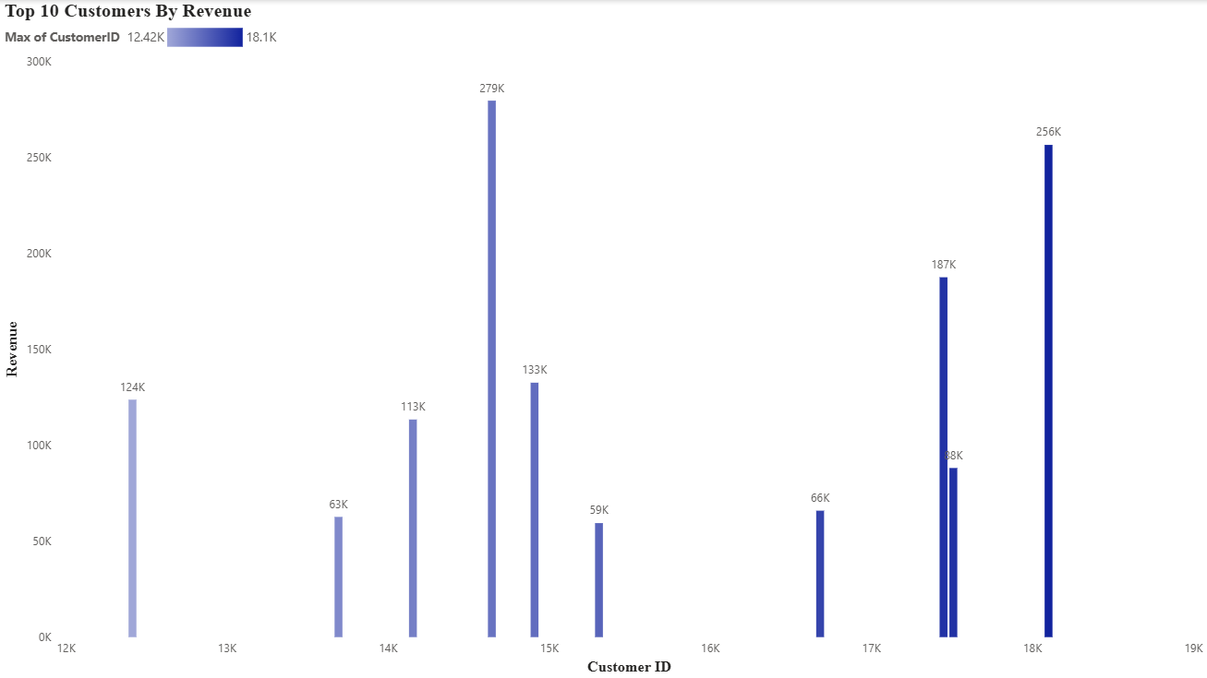
This page identifies the ten highest-value customers by total revenue contribution, using a column chart color-coded by Customer ID.
- Highest-Value Customer: Contributed approximately £279K in total revenue
- Other Leading Customers: Additional customers contributed £256K, £187K, and £133K respectively
The chart reveals a highly concentrated customer base: out of 4,373 total customers, a small subset — likely wholesale or bulk-purchasing accounts — is responsible for a disproportionate share of total revenue. This insight supports the case for a dedicated key-account or loyalty retention program targeting these top customers.

5.4 Page 4 — Global Product Demand by Country (Expansion Opportunities)
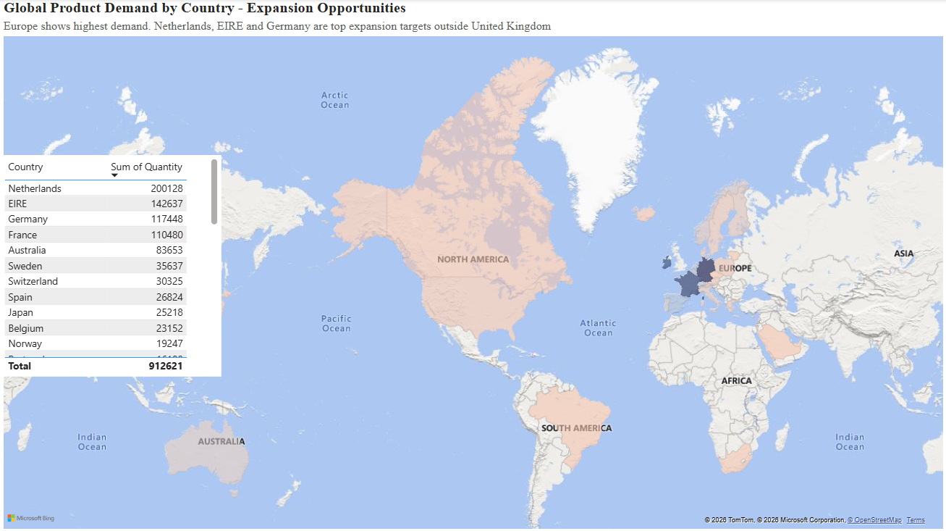
This page uses a filled world map alongside a ranked table to visualize total product quantity ordered by country, highlighting geographic demand concentration.
- Total International Quantity Ordered: 912,621 units
- Top Expansion Targets: Netherlands (200,128 units), EIRE (142,637 units), and Germany (117,448 units)
Europe shows by far the highest demand outside the UK, reinforcing the findings from the country revenue analysis. Netherlands, EIRE, and Germany are confirmed as the top three markets to prioritize for expansion, warehousing, or targeted advertising investment.

6. Key Insights & Findings
- Revenue grew consistently through 2011, with an exceptional October peak, most likely linked to seasonal/holiday bulk ordering.
- International sales are concentrated in Western Europe, with the Netherlands, Ireland, and Germany together representing the majority of revenue and demand outside the UK.
- The customer base is highly concentrated: a small number of high-value customers drive a disproportionate share of total revenue, indicating reliance on key accounts.
- The alignment between the top revenue-generating countries (Page 2) and the top demand countries (Page 4) validates the Netherlands, EIRE, and Germany as consistent, high-confidence expansion targets.

7. Business Recommendations
- Prioritize inventory planning and marketing budget toward the Netherlands, EIRE, and Germany, given their consistent lead in both revenue and demand.
- Develop a key-account management or loyalty program for the top 10 customers to reduce the risk of revenue concentration and improve retention.
- Plan inventory and staffing ahead of Q4 to capture the recurring seasonal revenue spike observed in October.
- Investigate the drivers behind the sharp revenue decline after October to distinguish between seasonality and data completeness for the following year.

8. Tools & Technologies Used
- Microsoft Power BI: Dashboard design, data modeling, DAX measures, and interactive visuals
- Power Query: Data cleaning and transformation
- Dataset Source: UCI Machine Learning Repository — Online Retail Dataset

9. Conclusion
The Online Retail Sales Dashboard successfully converts a large, raw transactional dataset into an interactive business intelligence tool that surfaces actionable insights across revenue performance, customer value, and international market opportunity. The findings consistently point to a small set of high-value customers and a concentrated group of European markets as the primary drivers of growth, giving stakeholders clear, data-backed direction for retention and expansion strategy.

10. Future Enhancements
- Add RFM (Recency, Frequency, Monetary) segmentation to classify customers by loyalty tier.
- Incorporate product-level profitability and returns analysis, using the negative-quantity records that represent cancellations/returns.
- Build a cohort analysis to track customer retention trends over time.
- Automate data refresh via Power BI Service with a scheduled cloud gateway connection.

11. Author & Contact
- Name: [Your Name]
- Email: your.email@example.com
- LinkedIn: linkedin.com/in/yourprofile
- GitHub: github.com/yourusername

