NEXORA TECHNOLOGIES
Sales Analysis & Business Intelligence
Project Documentation Report
Prepared using Python, Pandas, NumPy, Matplotlib and Seaborn
Source: Sales_Analysis_Python_Project.ipynb
Total Sales | Total Profit | Total Orders | Customers
₹15.29 Cr | −₹17.25 L | 805 | 397

Table of Contents
1. Executive Summary 3
1.1 Project Overview 3
1.2 Business Context 3
1.3 Project Objective 3
1.4 Tools & Analytical Approach 4
1.5 Key Outcomes Summary 4
2. Dataset Information 5
2.1 Dataset Overview 5
2.2 Source Datasets 5
2.3 Dataset Size Summary 6
2.4 Dataset Relationships 6
3. Data Preparation & Cleaning 7
3.1 Data Quality Assessment 7
3.2 Cleaning Steps Applied 7
3.3 Data Transformation & Integration 8
4. Insights & Findings 9
4.1 Overall Business KPIs 9
4.2 Sales Trend Analysis 9
4.3 Category-wise Sales & Revenue Contribution 10
4.4 Product Performance 11
4.5 Customer Analysis 12
4.6 Geographic Analysis 13
4.7 Customer Acquisition 15
4.8 Profitability Analysis 15
4.9 Correlation Analysis 16
4.10 Outlier Analysis 16
5. Business Recommendations 18
6. Conclusion 19

1. Executive Summary

1.1 Project Overview
The Sales Analysis and Business Intelligence project is a Python-based data analytics project designed to evaluate the sales performance, profitability, customer behaviour, product performance, geographic contribution, and customer acquisition patterns of Nexora Technologies, an e-commerce electronics retailer.
The project uses transactional e-commerce data collected across four interconnected datasets: Customers, Orders, Order Items, and Products. These datasets were cleaned, standardized, transformed, and integrated to create a single consolidated analytical dataset for business analysis.
The primary purpose of the project is to convert raw, inconsistent transactional data into meaningful business insight that can support data-driven decision-making. The analysis focuses not only on revenue generation but also on profitability, customer value, product contribution, market performance, and areas where business performance can be improved.

1.2 Business Context
In an e-commerce environment, monitoring sales alone is not sufficient to evaluate business performance. A business may generate high revenue while simultaneously experiencing low or negative profitability due to product costs, pricing decisions, or discounting behaviour. This is precisely the pattern observed in Nexora Technologies' data: total sales exceed ₹152.9 million, yet the business runs an overall loss.
This project therefore evaluates multiple dimensions of business performance, including:
- Overall sales and profit performance
- Monthly sales trends and peak sales periods
- Product and category-level performance
- High-performing and underperforming products
- Category-level profitability and loss drivers
- Customer revenue contribution and value segmentation
- Repeat versus one-time customer behaviour
- City-wise sales and customer distribution
- Customer acquisition trends
- Relationship between quantity, sales, and profit
- Unusual or high-value sales transactions

1.3 Project Objective
The main objective of this project is to perform an end-to-end analysis of e-commerce transaction data using Python, and to generate actionable business recommendations. Specific objectives include:
- Assess overall sales, order, customer, and profitability performance.
- Identify monthly sales trends and determine the peak sales period.
- Analyze sales contribution across product categories.
- Identify top-performing and bottom-performing products by sales.
- Evaluate category-level profitability and identify loss-making categories.
- Identify high-value customers and segment the customer base by spend.
- Analyze repeat versus one-time customer behaviour.
- Evaluate city-wise sales and customer distribution.
- Analyze customer signup trends to understand acquisition patterns.
- Examine the relationship between quantity, sales, and profit.
- Detect unusually large or extreme sales transactions.
- Translate analytical findings into practical business recommendations.

1.4 Tools & Analytical Approach
Tool | Role in the Project
Python | Core programming language for the analysis
Pandas | Data cleaning, transformation, and integration
NumPy | Numerical computation and derived metrics
Matplotlib / Seaborn | Data visualization and charting

Workflow: Raw Data → Data Quality Checks → Cleaning & Standardization → Data Transformation → Dataset Integration → KPI Analysis → Product / Customer / Geographic Analysis → Advanced EDA → Business Recommendations.

1.5 Key Outcomes Summary
Metric | Value
Total Sales | ₹152,903,055.50
Total Profit | −₹1,725,258.50 (loss)
Overall Profit Margin | −1.13%
Total Orders | 805
Total Customers | 397
Peak Sales Month | January (₹21,113,937)
Repeat Customer Rate | 60.7% (241 of 397)
Most Profitable Category | Tablet (+7.00% margin)
Largest Loss-Making Category | Smartphone (−9.20% margin)
Top City by Sales | Delhi (₹43,114,449.50)

2. Dataset Information

2.1 Dataset Overview
The analysis is based on four interconnected raw datasets representing different aspects of Nexora Technologies' e-commerce operations: customer information, order information, order-level product transactions, and product information.
The datasets were initially provided in raw form and contained duplicate records, missing values, inconsistent naming conventions, mixed date formats, and inconsistent categorical values. These issues were identified during an initial data-quality assessment and addressed during the data-preparation stage described in Section 3.

2.2 Source Datasets
2.2.1 Customers Dataset
Raw size: 520 rows × 4 columns. Contains customer identification, name, city, and signup-date information.
Column | Description | Role
customer_id | Unique identifier assigned to each customer | Primary Key
customer_name | Name associated with the customer | Customer Attribute
city | Customer's city / location | Geographic Attribute
signup_date | Date on which the customer registered | Acquisition Attribute
2.2.2 Orders Dataset
Raw size: 1,240 rows × 4 columns. Contains order-level identification, timing, and payment information.
Column | Description | Role
order_id | Unique identifier for an order | Primary Key
customer_id | Identifier of the customer who placed the order | Foreign Key
order_date | Date on which the order was placed | Time Attribute
payment_method | Payment method used for the order | Transaction Attribute
2.2.3 Order Items Dataset
Raw size: 2,050 rows × 5 columns. Provides transaction-level detail for each product included in an order.
Column | Description | Role
order_item_id | Unique identifier for an order-item record | Primary Key
order_id | Identifier of the associated order | Foreign Key
product_id | Identifier of the purchased product | Foreign Key
quantity | Number of units purchased | Transaction Metric
unit_price | Selling price per unit | Financial Metric

2.2.4 Products Dataset
Raw size: 90 rows × 4 columns. Contains product identification, naming, category, and base cost.
Column | Description | Role
product_id | Unique identifier for a product | Primary Key
product_name | Name of the product | Product Attribute
category | Product category | Product Classification
base_price | Base / cost price of the product | Cost Metric

2.3 Dataset Size Summary
Dataset | Rows | Columns | Primary Purpose
Customers | 520 | 4 | Customer information
Orders | 1,240 | 4 | Order information
Order Items | 2,050 | 5 | Transaction-level product detail
Products | 90 | 4 | Product & pricing information
Integrated Analytical Dataset (sales) | 1,359 | 20 | End-to-end business analysis

2.4 Dataset Relationships
The four datasets are connected through common identifiers, forming the following logical data model:
Customers →(customer_id)→ Orders →(order_id)→ Order Items →(product_id)→ Products
A customer can place multiple orders; a single order can contain multiple order-item records; and a product can appear across multiple order-item transactions. These relationships were implemented in pandas through validated one-to-many and many-to-one merges (see Section 3.3).

3. Data Preparation & Cleaning

3.1 Data Quality Assessment
Each of the four raw datasets was profiled for duplicate rows and missing values before any cleaning was applied.
Dataset | Duplicate Rows Found | Rows After De-duplication
Customers | 20 | 500
Orders | 40 | 1,200
Order Items | 50 | 2,000
Products | 10 | 80

Beyond duplication, the assessment identified inconsistent city spellings and casing, mixed date formats across signup and order dates, inconsistently labelled payment methods, inconsistent product-category naming, and missing values in customer name, city, product base price, order-item quantity, and unit price.

3.2 Cleaning Steps Applied
Customers
Issue City values inconsistently cased and spelled — e.g. "DELHI", "delhi", "Delhi", "Bengaluru", "Bengalore".
Fix Values were lower-cased, mapped through a canonical lookup (bengaluru/bengalore → Bangalore, delhi → Delhi, mumbai → Mumbai), then title-cased.
Issue Missing customer_name and city values.
Fix Filled with "Unknown" so records remain usable rather than being dropped.
Orders
Issue order_date mixed between DD/MM/YYYY and YYYY-MM-DD formats.
Fix Parsed using pd.to_datetime(format="mixed", errors="coerce") — 0 unparseable dates remained after conversion.
Issue payment_method inconsistently labelled — "Cash on Delivery", "COD", "cash", "Upi", "upi".
Fix Normalized casing and merged synonyms into 5 clean categories: Upi (313), Credit Card (309), Cash (303), Unknown (141), Debit Card (134).
Products
Issue Category naming variants — "Smart Phone"/"Smartphone", "Accessory"/"Accessories", inconsistent casing.
Fix Normalized casing and merged synonyms into 4 categories: Smartphone, Accessories, Tablet, Laptop.
Issue Missing base_price for several products.
Fix Imputed using the category-level median price, preserving category cost structure rather than a flat global average.

Order Items
Issue Invalid rows with zero or negative quantity.
Fix Removed, then remaining missing quantities imputed with the column median (rounded).
Issue Missing unit_price on many line items.
Fix Backfilled from each product's cleaned base_price via a product-to-price mapping.

Final validation confirmed 0 duplicate rows and 0 missing values across all four cleaned tables before integration.

3.3 Data Transformation & Integration
Date parts (year, month, month name, quarter) were derived from signup_date and order_date. The cleaned tables were then merged into a single analytical dataset:
orders ⋈ order_items (inner, one-to-many) ⋈ customers (left, many-to-one) ⋈ products (left, many-to-one) → sales (1,359 rows)
Derived Field | Formula
sales_amount | quantity × unit_price
profit | (unit_price − base_price) × quantity
profit_margin | profit ÷ sales_amount × 100

4. Insights & Findings

4.1 Overall Business KPIs
After cleaning, transforming, and integrating the datasets, key performance indicators were calculated to understand overall business performance.
KPI | Value
Total Sales | ₹152,903,055.50
Total Profit | −₹1,725,258.50
Total Orders | 805
Total Customers | 397
Overall Profit Margin | −1.13%
Average Basket Size | ≈4.19 units per order

Despite substantial revenue, the business is running a net loss overall — the central tension this report investigates through category, product, and customer-level analysis below.

4.2 Sales Trend Analysis
Monthly sales were aggregated using order_date and plotted to observe fluctuations in revenue across the analysis period.
Finding Sales performance varied meaningfully month to month rather than remaining constant. January was the strongest month, with sales of approximately ₹21,113,937 — the clear peak across the period analyzed.
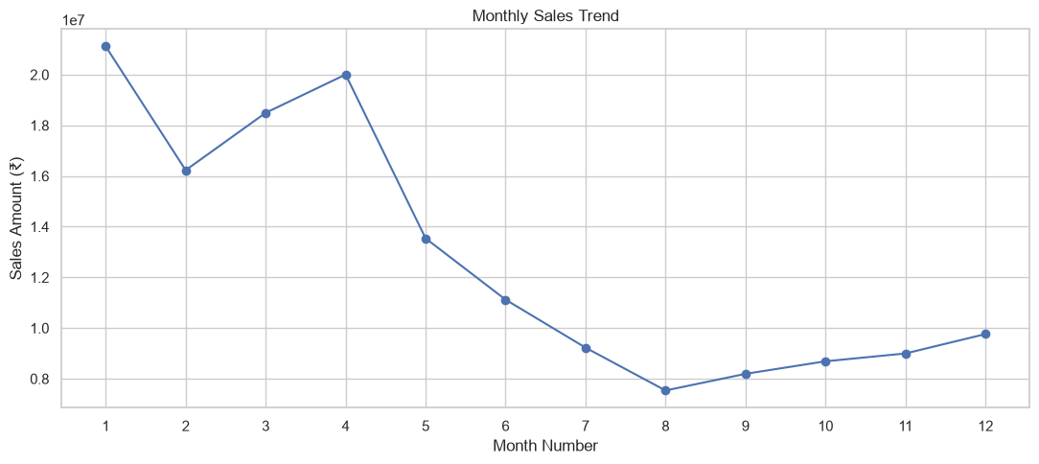
Figure 4.1 — Monthly Sales Trend
Insight The variation in monthly sales indicates the presence of seasonal or time-based purchasing patterns that can inform forecasting and inventory planning.
Recommendation Investigate what drove the January peak — product mix, promotions, or demand timing — and test replicating those conditions in lower-performing months.

4.3 Category-wise Sales & Revenue Contribution
Total sales and revenue share were compared across the four product categories: Smartphone, Accessories, Tablet, and Laptop.
Finding Smartphone generated the highest revenue at ₹51,643,695 (33.8% of total sales), followed by Accessories (₹37,639,203, 24.6%), Tablet (₹34,944,107, 22.9%), and Laptop (₹28,676,050.50, 18.8%).
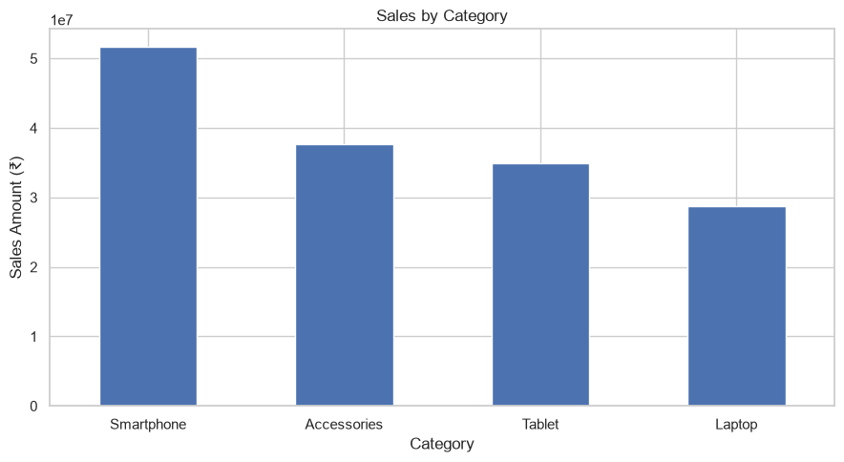
Figure 4.2 — Sales by Category
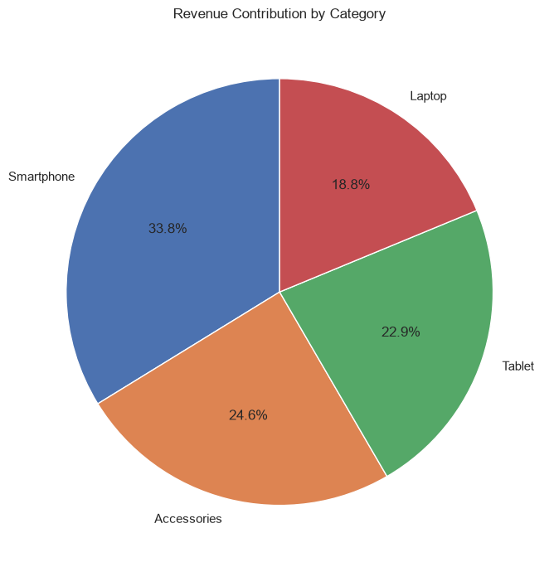
Figure 4.3 — Revenue Contribution by Category
Insight Revenue concentration in Smartphone signals its importance to top-line performance — but as Section 4.8 shows, this category is also the largest source of loss, so revenue leadership does not equal profitability leadership.
Recommendation Continue supporting high-revenue categories while evaluating pricing and cost structure for categories where revenue share and profit share diverge.

4.4 Product Performance
Finding — Top 10 Products Dell Inspiron led individual product sales at ₹16,378,302.50, closely followed by Laptop Bag (₹16,359,507.50) and Wireless Mouse (₹15,422,146.00).
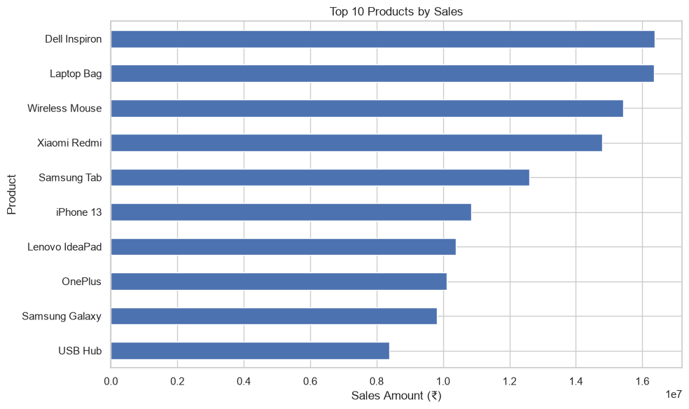
Figure 4.4 — Top 10 Products by Sales
Finding — Bottom 10 Products MacBook Air recorded the lowest sales at just ₹1,278,303.00, trailed by iPad Air (₹5,412,059.00) and HP Pavilion (₹5,508,235.50).
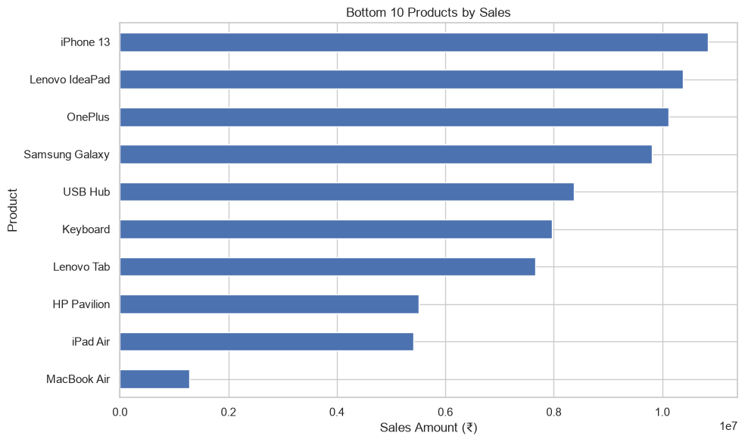
Figure 4.5 — Bottom 10 Products by Sales
Insight A small group of products drives a disproportionate share of revenue. Low sales alone does not indicate a loss-making product — profitability depends on the gap between selling price and base cost, examined in Section 4.8.
Recommendation Prioritize inventory and promotion for top-performing products; review pricing, positioning, or bundling for consistently low-performing ones such as MacBook Air.

4.5 Customer Analysis
Finding — Top 10 Customers Customer C0142 was the highest-value customer with ₹1,403,565.50 in lifetime purchases, followed by C0218 (₹1,381,521.00) and C0233 (₹1,307,125.00).
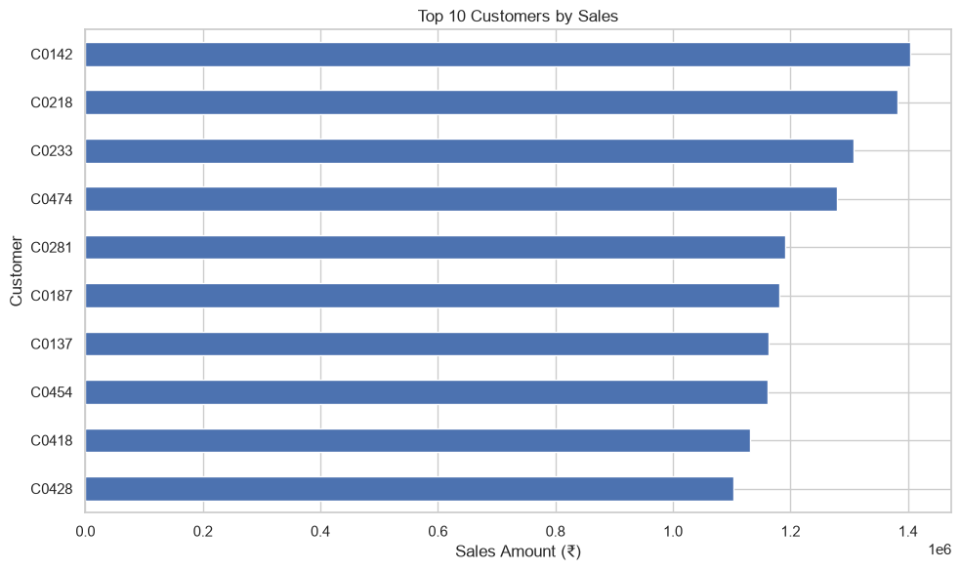
Figure 4.6 — Top 10 Customers by Sales
Finding — Customer Segmentation Customers were segmented into three near-equal spend tertiles: Low Value (133), Medium Value (132), and High Value (132).
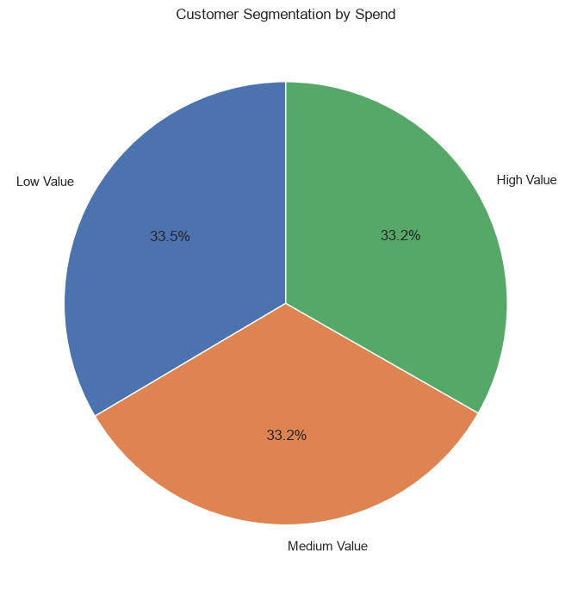
Figure 4.7 — Customer Segmentation by Spend

Finding — Repeat vs One-Time Customers 241 customers (60.7%) placed more than one order, while 156 customers (39.3%) placed only one — a healthy repeat-purchase base.
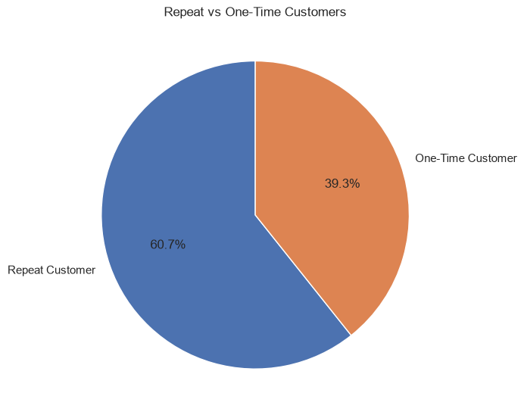
Figure 4.8 — Repeat vs One-Time Customers
Insight A 60.7% repeat rate indicates meaningful customer loyalty already exists. The near-equal value tertiles suggest spend is fairly distributed rather than concentrated in a tiny elite group of customers.
Recommendation Grow the repeat-purchase base further through loyalty programs, personalized offers, and targeted retention campaigns aimed at one-time customers.

4.6 Geographic Analysis
Finding — Sales by City Delhi leads all cities with ₹43,114,449.50 in sales, followed by Mumbai (₹24,584,164.50) and Hyderabad (₹20,911,148.00).
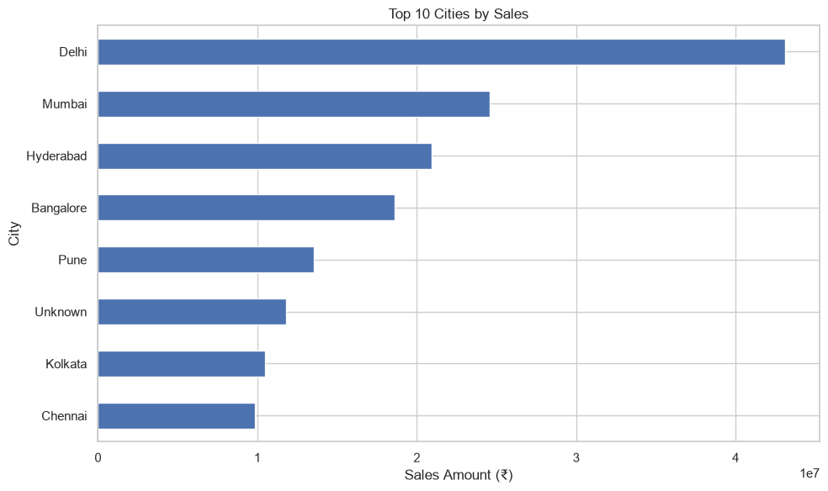
Figure 4.9 — Top Cities by Sales

Finding — Customer Distribution by City Delhi also holds the largest customer base with 131 unique customers, followed by Mumbai (86) and Bangalore (69).
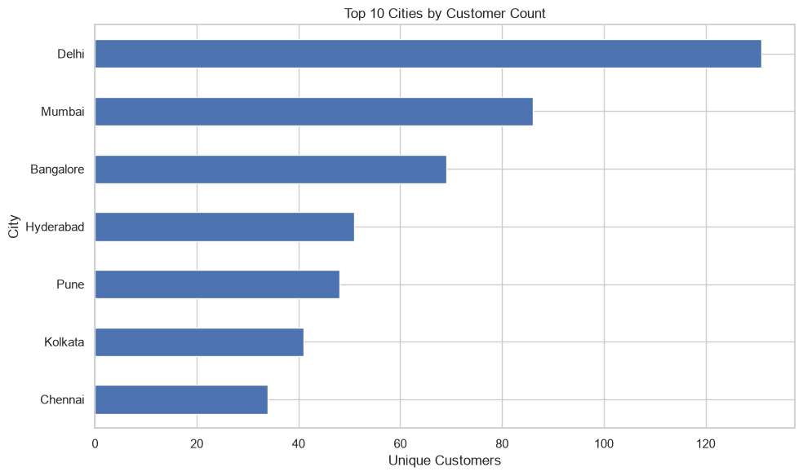
Figure 4.10 — Top Cities by Customer Count
Insight Revenue and customer concentration are strongly aligned in the top three metros, indicating that geographic strategy should be led by these markets while monitoring smaller cities for emerging opportunity.
Recommendation Prioritize marketing spend and inventory allocation toward Delhi, Mumbai, and Hyderabad, while piloting targeted campaigns in lower-penetration cities.

4.7 Customer Acquisition
Monthly new-customer signups were tracked from January 2023 through June 2025 to understand acquisition trends over time.
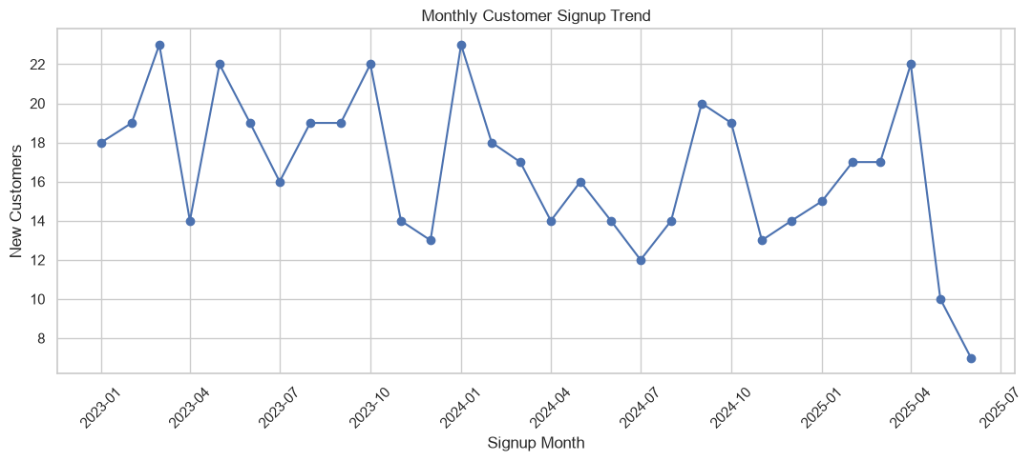
Figure 4.11 — Monthly Customer Signup Trend
Insight Signups fluctuate month to month without a single dominant trend, suggesting acquisition has been broadly steady rather than driven by one major campaign.
Recommendation Identify and replicate whatever drove the strongest signup months, and investigate months with comparatively weak acquisition.

4.8 Profitability Analysis
Finding — Sales vs Profit Plotting sales amount against profit shows that higher-value transactions do not consistently translate into higher profit — several high-sales transactions still register a loss.
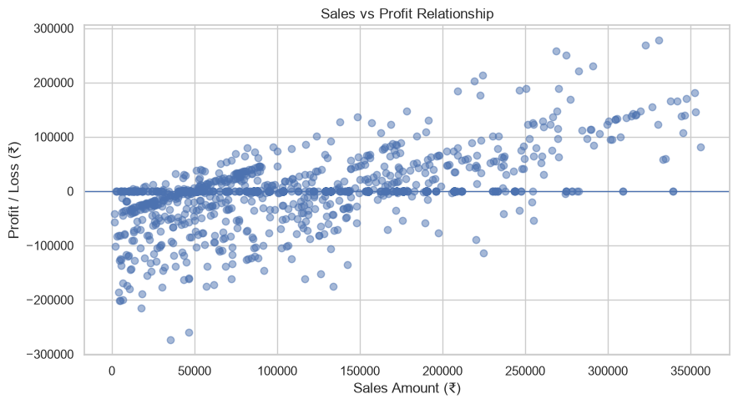
Figure 4.12 — Sales vs Profit Relationship
Finding — Category-Level Margin Tablet is the most profitable category at +7.00% margin (+₹2,445,401 profit), followed by Accessories at +4.00% (+₹1,505,393). Laptop runs a −3.23% margin (−₹925,331.50), and Smartphone is the largest loss driver at −9.20% margin (−₹4,750,721) despite leading on revenue.
Category | Total Sales | Total Profit | Margin
Tablet | ₹34,944,107.00 | +₹2,445,401.00 | +7.00%
Accessories | ₹37,639,203.00 | +₹1,505,393.00 | +4.00%
Laptop | ₹28,676,050.50 | −₹925,331.50 | −3.23%
Smartphone | ₹51,643,695.00 | −₹4,750,721.00 | −9.20%

Insight Category profitability is inverted relative to revenue: the category driving the most sales (Smartphone) is also the biggest loss-maker, while the smallest-revenue category (Tablet) is the most profitable. Revenue leadership and profitability leadership are not the same thing at Nexora.
Recommendation Prioritize a pricing and cost review for Smartphone before pursuing further volume growth in that category; protect and consider scaling Tablet and Accessories.

4.9 Correlation Analysis
A correlation matrix was used to examine the linear relationship between quantity and sales_amount.
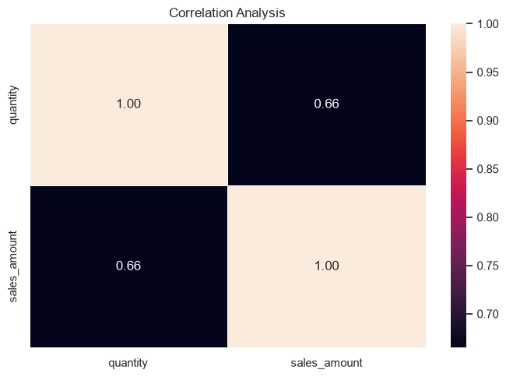
Figure 4.13 — Correlation Heatmap (quantity vs sales_amount)
Finding Quantity and sales_amount show a moderate positive correlation of r = 0.66 — order value is influenced by, but not fully explained by, the number of units purchased.
Insight Because the correlation is moderate rather than strong, factors such as unit price and product mix also play a significant role in driving sales amount, alongside quantity.
Recommendation Use correlation as a supporting signal only; combine it with product- and category-level analysis before drawing conclusions about what drives order value.

4.10 Outlier Analysis
A boxplot of sales_amount was used to detect unusually high-value transactions using the interquartile range (IQR) convention.
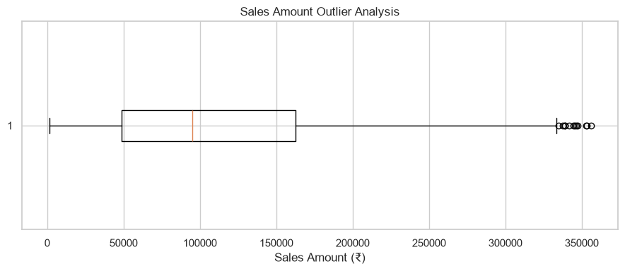
Figure 4.14 — Sales Amount Outlier Analysis
Finding The distribution is right-skewed, with a number of high-value transactions extending well beyond the typical range.
Insight These high-value transactions may be genuine bulk or premium-product purchases rather than data errors, and can meaningfully influence total revenue figures.
Recommendation Review extreme transactions individually before excluding them from any future analysis; retain genuine high-value orders as they represent real business activity.
5. Business Recommendations
REC.01 Prioritize profitable growth
Revenue is high but overall profit is negative — focus on margin improvement, not sales volume alone.
REC.02 Fix Smartphone economics first
Smartphone drives −9.20% margin at 33.8% revenue share. Audit selling price, base cost, and discounting on this category before anything else.
REC.03 Protect and scale Tablet & Accessories
These are the only two categories with positive margin (+7.00% and +4.00%). Safeguard availability and evaluate opportunities to scale them sustainably.
REC.04 Improve customer retention
60.7% repeat rate is a solid base — grow it further with loyalty initiatives, personalized offers, and product recommendations.
REC.05 Optimize inventory by demand
Use monthly and product-level sales patterns — especially the January peak — to prioritize stock for high-demand products.
REC.06 Localize geographic strategy
Delhi, Mumbai, and Hyderabad together drive the majority of revenue — concentrate marketing and inventory investment accordingly.
REC.07 Increase basket size
With ≈4.19 units per order, test bundles and cross-selling — especially pairing loss-making Smartphones with profitable Accessories.
REC.08 Replicate acquisition wins
Study the signup months with the strongest new-customer growth and replicate whatever drove them; investigate weak months too.

6. Conclusion
Strong revenue does not automatically translate into profit.
This analysis combined data cleaning, integration, KPI reporting, sales-trend analysis, product and category profitability, customer behaviour, geographic performance, acquisition trends, and advanced EDA on Nexora Technologies' transaction data.
The largest opportunity lies in improving pricing and cost economics for Smartphone and Laptop — the two loss-making categories — while retaining high-value, repeat customers and scaling Tablet and Accessories, the two categories already proven profitable.

NEXORA TECHNOLOGIES · SALES ANALYSIS & BUSINESS INTELLIGENCE

