Urban Crust Sales Analysis
1. INTRODUCTION
The Urban Crust Sales Analysis project evaluates transactional sales data to extract meaningful operational and business intelligence for the brand. Analyzing sales data enables Urban Crust to identify top sales drivers, understand consumer purchasing habits, streamline inventory management, and optimize pricing structures. SQL (Structured Query Language) serves as the primary analytical tool to query database tables, aggregate transactions, perform multi-table joins, analyze product categories, and uncover peak operational periods for Urban Crust.
2. DATASET DESCRIPTION
The project utilizes relational sales data for Urban Crust stored in four distinct tables within the MySQL database.
TABLE NAME | DESCRIPTION | IMPORTANT COLUMNS
orders | Contains record of customer order instances including date and time details. | order_id (Primary Key), date, time
order_details | Stores line-item details fro each order, linking specific pizzas to quantity purchased. | order_details (Primary Key), order_id (Foreign Key), pizza_id (Foreign Key), quantity
pizzas | Stores SKU-level pricing and size variations for each pizza. | pizza_id (Primary Key), pizza_type_id (Foreign Key), size, price
pizza_types | Contains catalog-level details regarding pizza names, categories and ingredients. | pizza_type_id (Primary Key), name, category, ingredients

- Dataset Size: orders (21,350 rows), order_details (48,620 rows), pizzas (96 rows), pizza_types (32 rows).
- Relationships: orders joins to order_details via order_id. order_details joins to pizzas via pizza_id. pizzas joins to pizza_types via pizza_type_id.

3. PROJECT OBJECTIVE
The key analytical objectives executed in SQL for Urban Crust include:
- Sales & Revenue: Calculate total revenue, total orders placed, total pizzas sold, and average pizzas per order.
- Product & Pricing: Identify highest-priced pizza SKUs, most popular pizza sizes, top 5 ordered pizzas by quantity, and top 5 pizzas by revenue.
- Category Analysis: Measure category-wise quantity sold, revenue contribution percentage, and category average prices.
- Operational Patterns: Identify hourly distribution of orders and pinpoint peak store ordering hours for Urban Crust operations.
4. SQL ANALYSIS / KEY INSIGHTS
A. Sales & Revenue Insights
- Total Revenue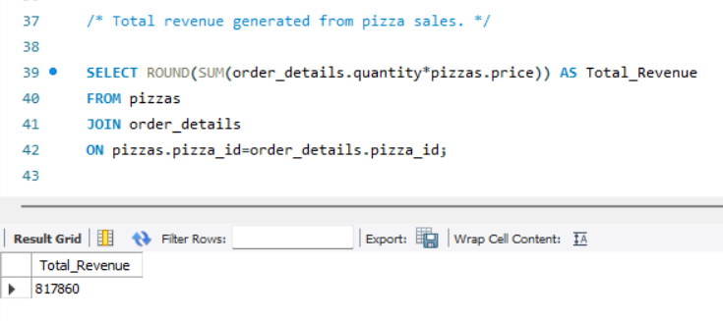
- Total Orders & Volume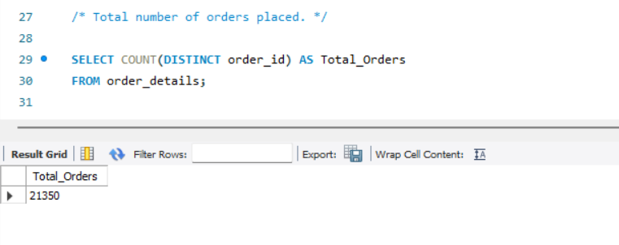
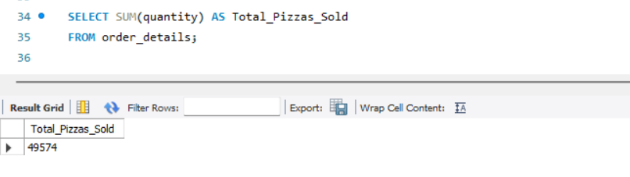
- Top 3 most ordered pizza types based on revenue.
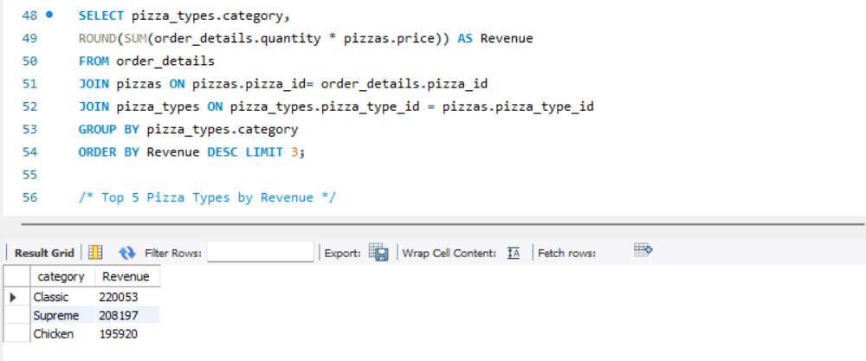

- Top 5 Pizza Types by Revenue
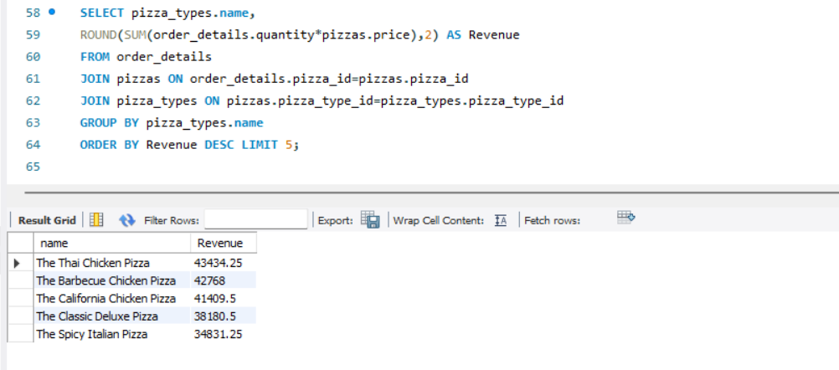

- Revenue Contribution (%) by Category
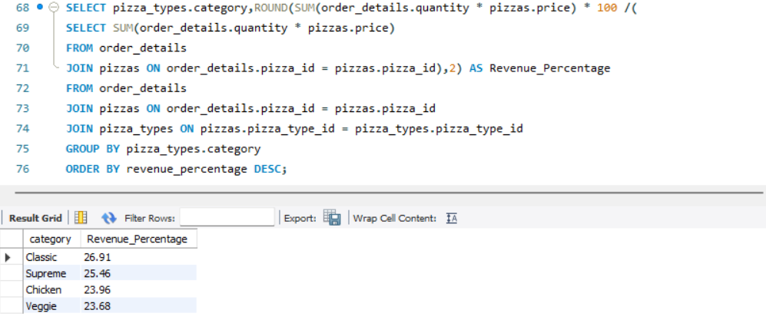

- Monthly Revenue
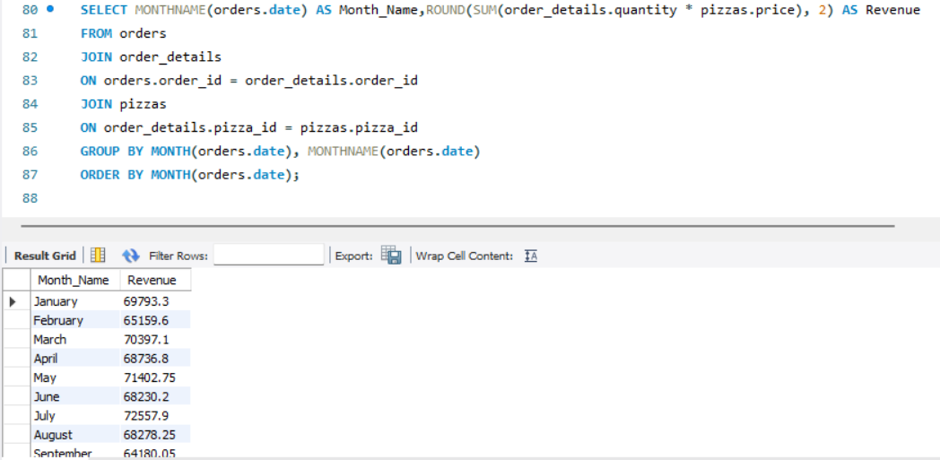

B. Product Insights
- Highest-Priced Pizza
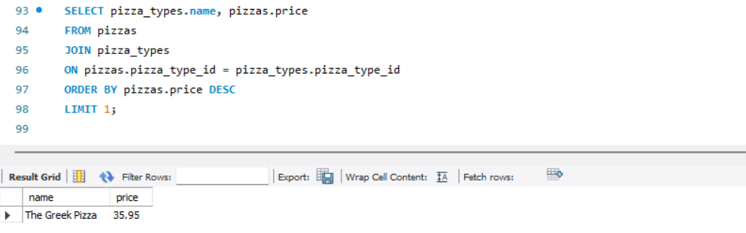

- Most Common Pizza Size Ordered
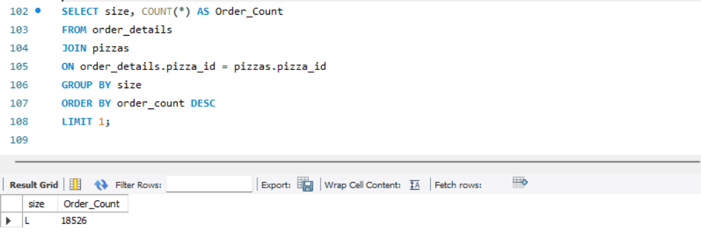

- Top 5 Most Ordered Pizza Types Along with Their Quantities
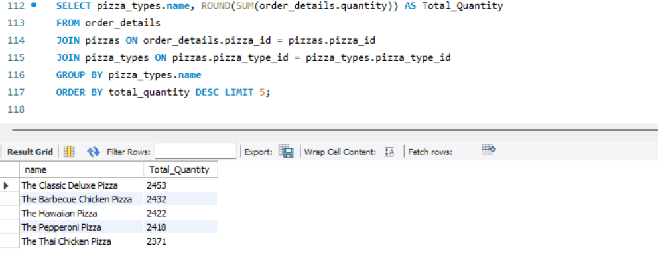

C. Category Insights
- Category-wise Ordered Quantity
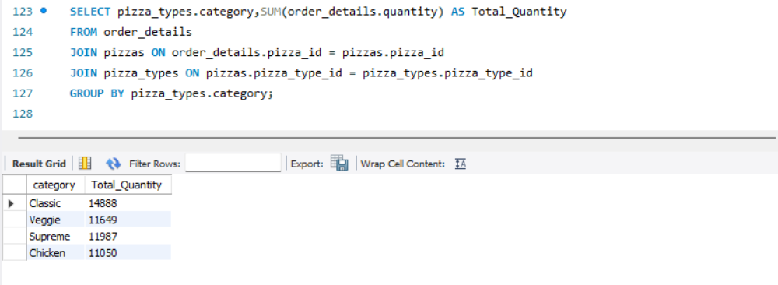

- Category-wise Distribution of Pizzas
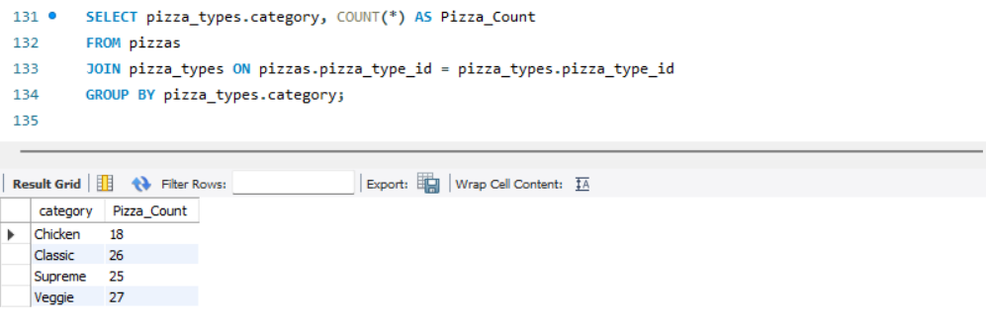

- Most Ordered Pizza Category
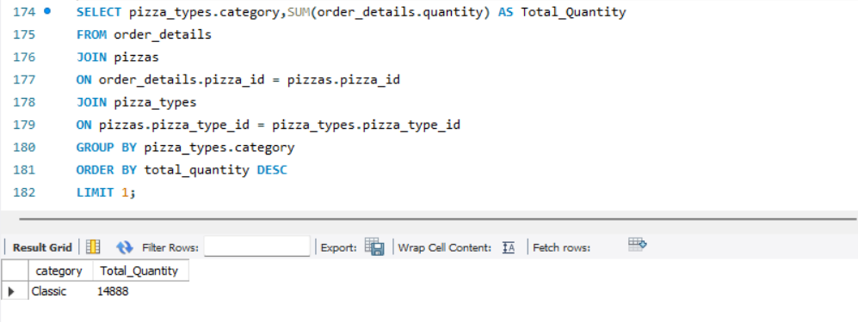

- Average Price by Category
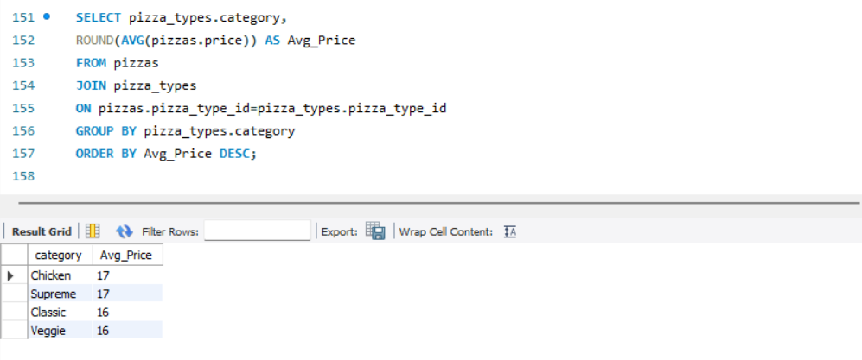
D. Time & Order Pattern Insights
- Distribution of Orders by Hour of the Day
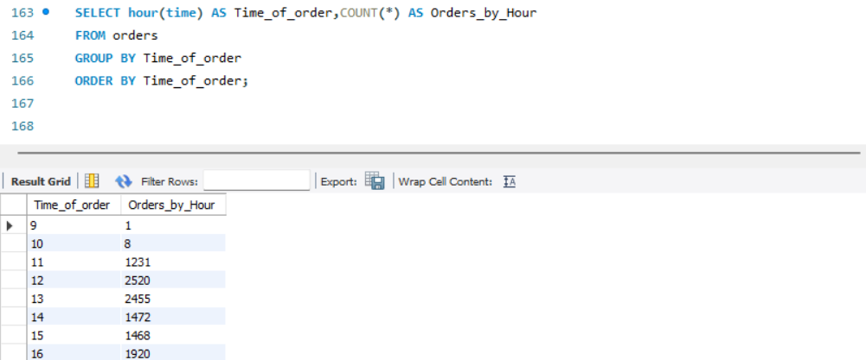


- Average Number of Pizzas Ordered per Day
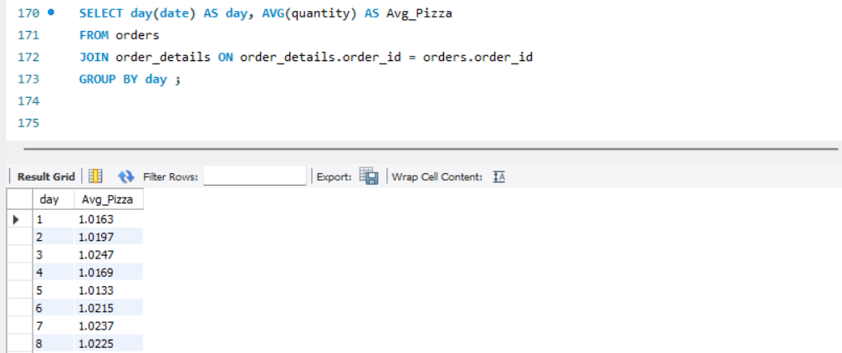
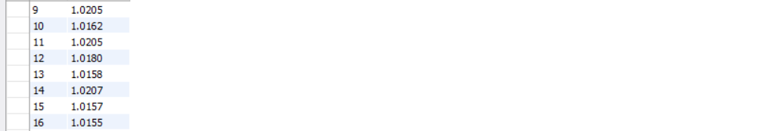
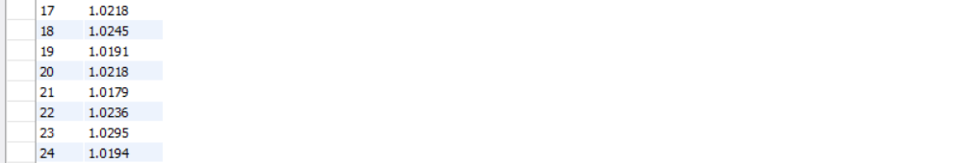
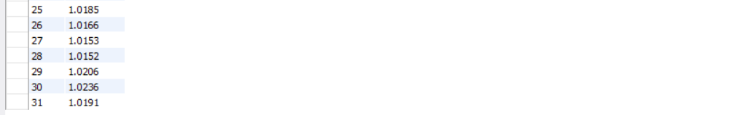

- Orders by Day of Week
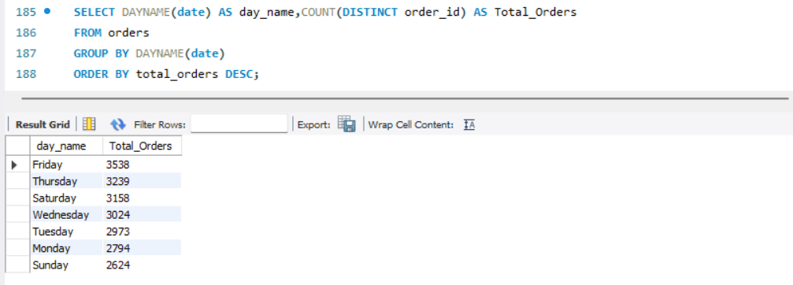

- Peak Hours of Store
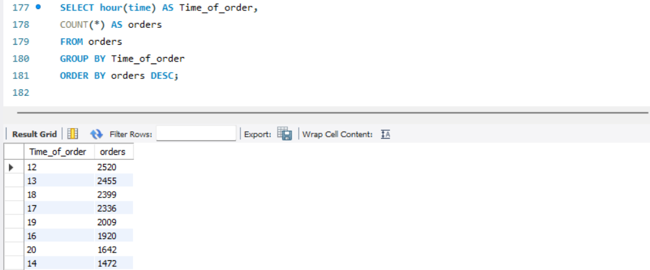


5. BUSINESS INSIGHTS / RECOMMENDATIONS
- Promotions & Menu Strategy: Focus promotional efforts on top-revenue drivers at Urban Crust, such as The Thai Chicken Pizza and The Barbecue Chicken Pizza. Introduce bundle deals pairing popular Large-size pizzas with sides or beverages.
- Low-Performing Size Optimization: Re-evaluate inventory costs for XXL and XL sizes due to negligible demand (XXL represents only 28 total sales across the period). Rationalizing these sizes can simplify supply chain management for Urban Crust.
- Staffing & Operational Efficiency: Optimize store staffing levels at Urban Crust outlets during peak order windows (12:00 PM – 1:00 PM and 5:00 PM – 7:00 PM). Ensure prep tasks are completed prior to 12 PM to prevent kitchen bottlenecks.

6. CONCLUSION
The analysis evaluated 21,350 customer orders and 49,574 pizza sales across four relational tables for Urban Crust. Key findings highlight that large-size pizzas drive sales volume and the Classic/Chicken categories generate substantial revenue for the brand. Utilizing SQL for aggregations and joins allowed multi-table data extraction to reveal clear operational peaks and product performance for Urban Crust. These insights enable data-driven decision-making regarding staffing, inventory control, and targeted menu promotions.

7. TOOLS & TECHNOLOGIES
- Database Engine: MySQL Server
- SQL Querying Tools: MySQL Workbench
- Data Processing Language: SQL (DDL & DML queries, Joins, Aggregations, Window Functions)
- Dataset: Urban Crust Relational Pizza Sales Dataset (orders, order_details, pizzas, pizza_types)

Key Takeaways
- Urban Crust generated total sales revenue of $817,860.05 across 21,350 unique customer orders.
- Large (L) size pizzas are the customer favourite, accounting for 18,956 units sold.
- The Thai Chicken Pizza generated the highest individual item revenue ($43,434.25).
- The Classic pizza category generated both the highest volume (14,888 units) and highest total revenue ($220,053.10).
- Peak order volume at Urban Crust occurs during lunch (12 PM – 1 PM) and dinner (5 PM – 7 PM) hours.

