Software Technology

by Damric Dobric / Andreas Pech

*Image Classification With Spatial Pooler*

Mandeep Singh (1228409)

Mandeepsingh.sherry@gmail.com

***Abstract--* This paper presents an emerging machine learning algorithm Hierarchical Temporal Memory (HTM) which is using Spatial pooler for learning and classifying visual data. The SP models how neurons learn feedforward connections and form efficient representations of the input. It converts arbitrary binary input patterns into sparse distributed representations (SDRs), using a combination of competitive Hebbian learning rules and homeostatic excitability control, and we also describe a key parameters of the SP.**

***Keywords: Hierarchical Temporal Memory, spatial pooler, sparse distributed representations****.*

1. **INTRODUCTION**

The HTM (Hierarchical Temporal Memory) spatial

pooler incorporates several computational principles of the cortex. It relies on competitive Hebbian learning, homeostatic excitability control, topology of connections in sensory cortices, and activity-dependent structural plasticity. The HTM spatial pooler is designed to achieve a set of computational properties that support computations with SDRs (Sparse Distributed Representations)**[1]**. These properties include (1) preserving topology of the input space by mapping similar inputs to similar outputs, (2) continuously adapting to changing statistics of the input stream, (3) forming fixed sparsity representations, (4) being robust to noise, and (5) being fault tolerant. As an integral component of HTM, the outputs of the SP can be easily recognized by downstream neurons and contribute to improved performance in an end-to-end HTM system.

The related works in this area of forecasting that have used in Machine Learning (ML) or statistical modelling, the emphasis here is to enable the reader to understand on some of the various ML or statistical techniques actively in use in the times past and till this present moment.

1. **METHODOLOGY**

The SP is a core component of HTM networks (Figure 1). In an end-to-end HTM system, the SP transforms input patterns into SDRs in a continuous online fashion. The HTM temporal memory learns temporal sequences of these SDRs and makes predictions for future inputs. A single layer in an HTM network is structured as a set of mini-columns, each with a set of cells (Figure 2). The HTM neuron model incorporates dendritic properties of pyramidal cells in neocortex, where proximal and distal dendritic segments on HTM neurons have different functions (Figure 3). Patterns detected on proximal dendrites lead to action potentials and define the classic receptive field of the neuron. Patterns recognized by a neuron’s distal synapses act as predictions by depolarizing the cell without directly causing an action potential.

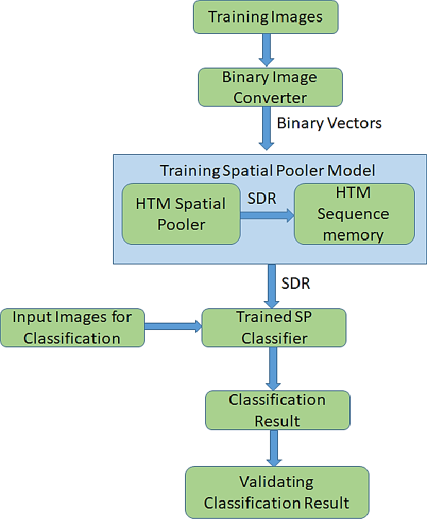

Figure 1. Flow chart of Image classification model

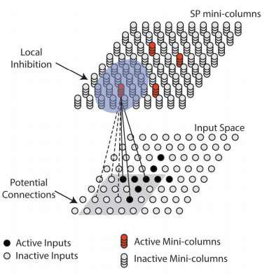

Figure 2. The illustration of spatial pooling.[3]

The HTM spatial pooler converts inputs (bottom) to SDRs (top). Each SP mini-column **[2]** forms synaptic connections to a subset of the input space (gray square, potential connections). A local inhibition mechanism ensures that a small fraction of the SP mini-columns that receive most of the inputs are active within the local inhibition radius (shaded blue circle). Synaptic permanences are adjusted according to the Hebbian rule: for each active SP mini-column, active inputs (black lines) are reinforced and inactive inputs (dashed lines) are punished.

**3. Mathematical Formulation [3]**

In HTM, spatial pooling is performed using the notion of SDRs followed by competitive Hebbian learning rules, a Homeostatic excitability control, and an overlapping mechanism for deriving candidate or winner SDR patterns via inhibition. SDRs are formed by activating or deactivating a set of potential synapses or connecting neural links. These synapses are grouped into a set of mini-columns and are spread out in a [hypercube](https://www.sciencedirect.com/topics/computer-science/hypercube) based on a set of [predefined rules.](https://www.sciencedirect.com/topics/computer-science/predefined-rule)

**Initialize connections:**

Consider a group of mini-columns with a set of potential connecting logical synapses or neurons; these potential connections may be initialized accordingly as:

∏i = {j | I (Xj ; Xic, γ) and Zij < p}

where,

*j* = HTM neuron location indexin the mini-column.

*i* = mini-column index.

*xj* = location of the *j*th input neuron (synapses) inthe input space.

*xci* = location centre of potential neurons (synapses)of *i*th mini-column in a hypercube of input space. *γ* = edge length of *xj*.

*ρ* = fraction of inputs within the hypercube of input

space that are potential connections.

*Zij* = represents a uniformly distributed random number between 0 and 1.

*I* = an indicator function.

**Permanence Activation Rule:**

A set of connected synapses are described by a binary matrix.

W, which is formulated by conditioning the synapses to a permanence activation rule as:

Wij =

where,

*Dij* = independent and identically distributed (i.i.d)dendrite synaptic permanence values from the *j*th input to the *i*th mini-column,

*θ*c = synaptic permanence threshold

Dij =

Where a natural topology exists, neighbourhood mini-columns may be inhibited in accordance to the relation given , otherwise a global inhibition parameter is simply used.

Ni = { j | ║Yi -Yj║ < }

where,

*y*i = is the *i*th HTM-SP mini-column,

*y*j = is the *j*th HTM-SP mini-column,

*i,j* = mini-column indexes.

**Computing Overlap:**

For creating associations with input patterns, feed-forward inputs to each of the generative spatial mini-columns are computed using a matching technique called the overlap. The overlap is computed as:

Oi = bi

Where,

bi = is a positive boost factor for exciting each HTM-SP mini-column.

zj = input [pattern vector](https://www.sciencedirect.com/topics/computer-science/pattern-vector) seen by the generative HTM neuron

**SP mini- column Activation rule:**

SP mini-column becomes active if the feedforward input is above a stimulus threshold θstim and is among the top s percent of its neighbourhood,

ai =

Where,

s = target activation density (sparsity).

Z = a percentile function.

*θstim* = a stimulus threshold.

Finally, boost updating in HTM-SP follows the homeostatic excitability control mechanism comparable to that observed in [cortical neurons.](https://www.sciencedirect.com/topics/computer-science/cortical-neuron) Boosting is accomplished in HTM-SP using the following model equations.

______________________

T

< > = 1/ | Ni |

bi =

where, ai = time averaged activation over the last T SDR inputs,

*T* = an integer number denoting the number ofMonte Carlo trials to obtain a reasonable activation estimate, ait = the current activity of the *i*th mini-column at time step *t*.

*β* = apositive parameter that controls the strengthof the adaptation effect.

As mentioned in, such calculations have been used in previous models of homeostatic synaptic plasticity.

**4. Code for Testing Algorithm**

**Step 1: Project Structure**

In this project we have different libraries**[5]**, classes with different specifications.

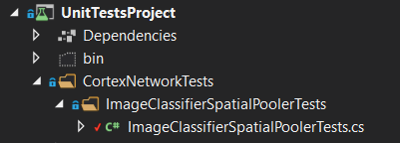

Figure 3: UnitTestProject

In the UnitTestProject we have main unit test method in ImageClassificationSpatialPoolerTest.cs which gives the information about Implementation of this project.

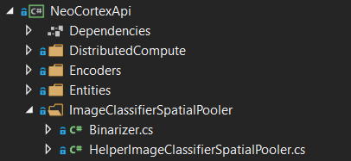

Figure 4: Helping classes

Helping classes like Binarizer.cs and HelperImageClassificationSpatialPooler.cs have methods defined which are used in UnitTestProject class.

**Step 2: Defining input and output parameters of Images.**

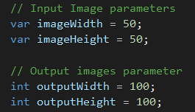

Figure 5: input and output parameters of Images.

**Step 3: Setting input space dimensions and Column space dimensions.**



Figure 6: input space dimensions

**Step 4: Setting the parameters of Potential connection.**



Figure 7: parameters of Potential connection**.**

**Step 5: TrainingImagePath is the image path contains images file name.**



Figure 8: Training Image Path

**Step 6: Training Data**

1. In ReadImageData method reads the data

of training image in binary form.

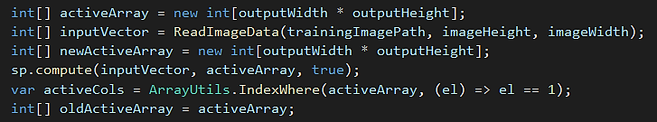

Figure 9: Training Process

1. So, Input vector having the data of images in binary form.
2. Compute function contains input vector which has input patterns that shows a large number of data, grouped together into a common output representation that is active array.
3. Active column represent the activation of mini column, which have active input =1.
4. Training Images as below Figure 10.

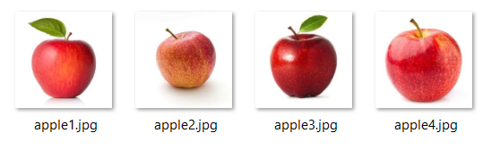

Figure 10: Training Data images containing different types of apples [9] [10] [11] [12]

**Step 7:** **GetHammingDistance** **[6]**

This method used to compare, the reference array which we have to compare with array which is given.

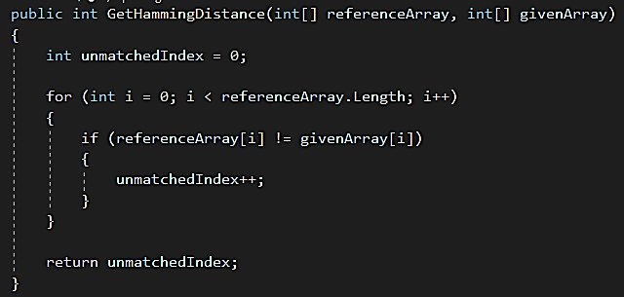

Figure 11: Hamming Distance Function

**Step 8: Deciding Model Trained or not:**

The GetHammingDistance method is in the loop, this is how the model of common receptive field is learned from the input. In this loop, defined new active array always gives value to old active array till then model is not trained.

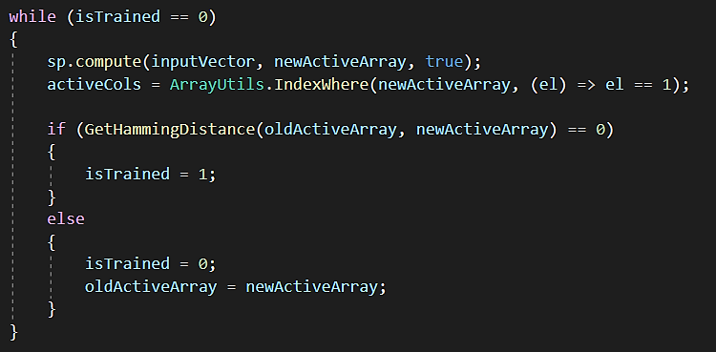

Figure 12: Training Model

**Step 9: Input Images for Classification Prediction**

1. Prediction **[7]** follows the same procedure as training with same compute function.

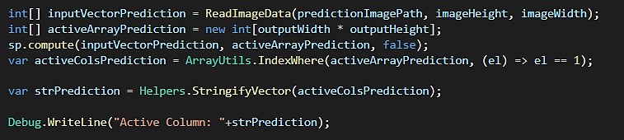

Figure 13: Prediction Process

1. Prediction Images **[8]**

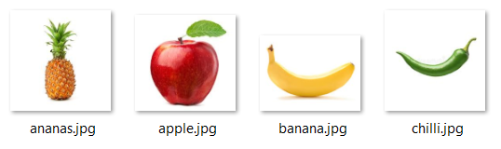

Figure 14: Input images for Prediction [13] [14] [15] [16]

**Step 10: Converting Prediction Images into Binary**

1. Reading Data from binary images to identify the prediction and active column

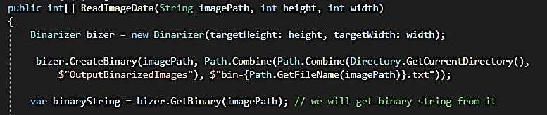

Figure 15: Binary Conversion

1. It returns binarized image in integer array and creates file of binarized Image

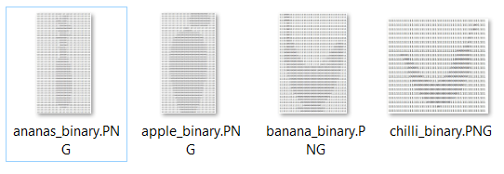

Figure 16: Binary Images

**Step 11: Computing Prediction Percentage**

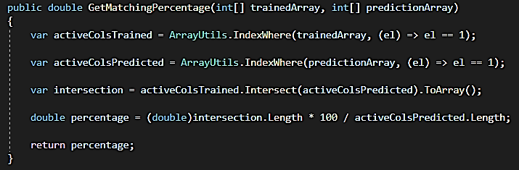

Figure 17: Computing Prediction Percentage

GetMatchingPercentage method compares the active column of trained Images and active column of Prediction Images. Percentage of Intersection of these active columns gives us a result.



Figure 18: Percentage Matching

Our Model is trained for Apple because we are giving different Images of Apple Only. So, it gives more percentage prediction towards Apple image rather than other images.

The Prediction percentage can be calculated by



If the Percentage Prediction is more than or equal to 90%, then it is apple and if it is less than 90% then it is not an apple.

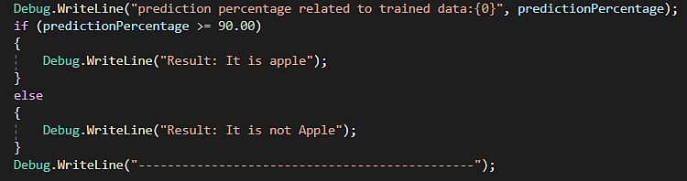

Figure 19: Classification Result

**Step 12: Output of Classification Prediction**

If we give an image of ananas then the prediction percentage related to trained data is less than 90%, so it is telling us it is not an apple.

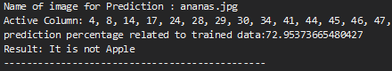

Figure 20: Output for Ananas

If we give an image of an apple then the prediction percentage related to trained data is more than or equal to 90% , so it is telling us it is Apple.

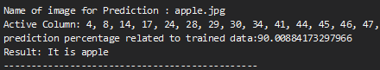

Figure 21: Output for Apple

If we give a image of banana then the prediction percentage related to trained data is less than 90%, so it is telling us it is not Apple.

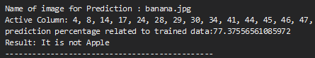

Figure 22: Output for Banana

If we give an image of Chilli then the prediction percentage related to trained data is less than 90% , so it is telling us it is not Apple.

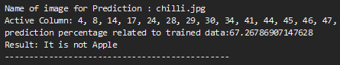

Figure 23: Output for Chilli

**5. Testing Approach**

**Scope of the Testing:** SP Model is been trained using four different types of apple images as explained in following steps (1 to 4). Then 4 different images like Banana, Ananas, Apple and Chilli are given as an input to SP model for classification as explained in step 5. Expected result is for Apple, model should give more than 90 % as Prediction Percentage related to trained data i.e. Classifying it as an Apple and on the other hand , for Banana, Chilli and Ananas model should give less than 90 % Prediction Percentage related to trained data i.e. classifying it as not an Apple. The result of this test is depicted in table below Table 1.

* 1. **Training image**

Training is using four different types of Apples as shown in figure fig. 4.1.Considering **apple2.png** for further explanation.

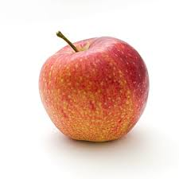

Figure 24: apple2.png [10]

* 1. **Converting input image into binary image**



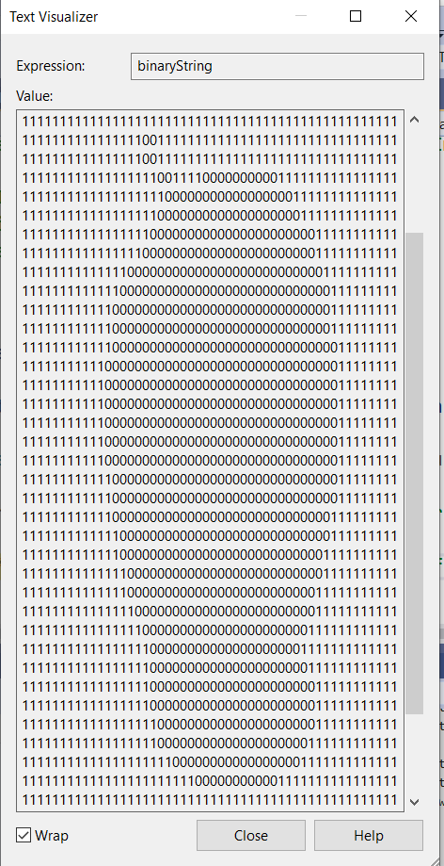

Figure 25: Binary image of apple2.png

* 1. **Generating active column**



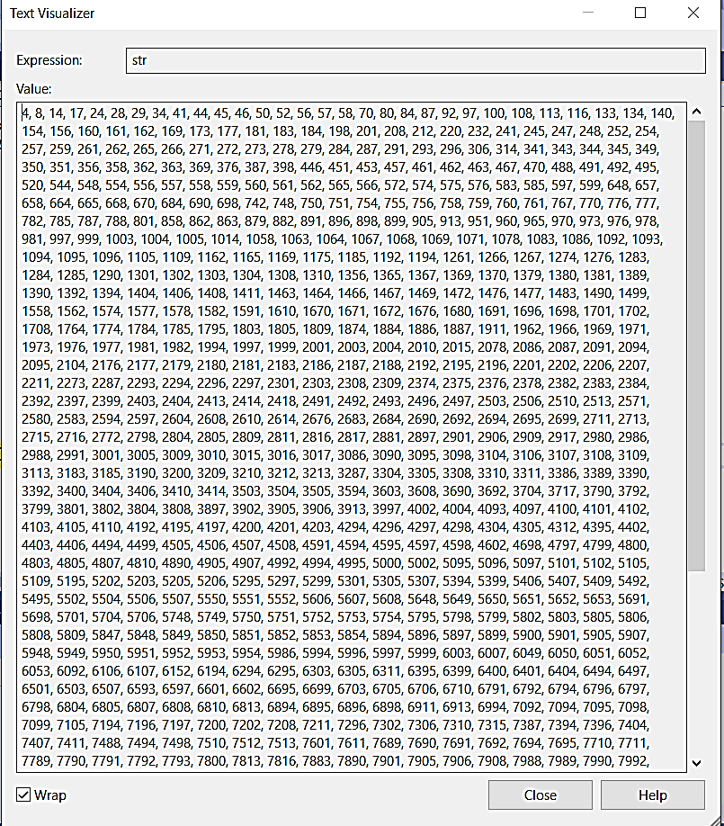

Figure 26: Active Column of apple2.png

* 1. **Training completed**

When Hamming Distance is zero that indicate modal is trained



* 1. **Giving input images for classification**

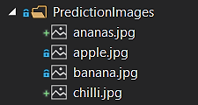

Figure 27: Input images for classification

* 1. **Image Classification Prediction**

Further testing is done using more images for classification e.g. Ananas, Apple, banana, Chilli. In order to classify whether input image is apple or anything other than apple. Model is classifying input image as an Apple if Prediction percentage is more than 90% and not an apple otherwise. Table 1 summarizes corresponding Binary Image, Active column, Prediction percentage, and classification result for each given input image like Ananas, Apple, Banana and Chilli.Result for each input image is depicted as below in Table 1.

Table 1: Summary of prediction for images

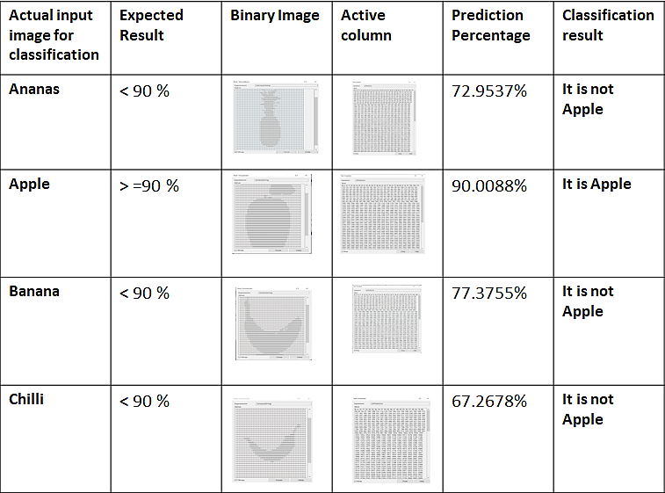

**6. Result**

For evaluating a classifier quality and accuracy, we are using Confusion Matrix [17]. A confusion matrix is a summary of prediction results on a classification problem, in which number of correct and incorrect predictions are summarized with count values and broken down by each class. For constructing Confusion matrix for above 4 input images as shown in Figure 14, Above test case has been executed for 10 times and getting following result (10 Test run) .Table 2 explains Prediction result for each input image e.g. Apple, Ananas Banana ,Chilli.

Table 2: Result of 10 Test Runs

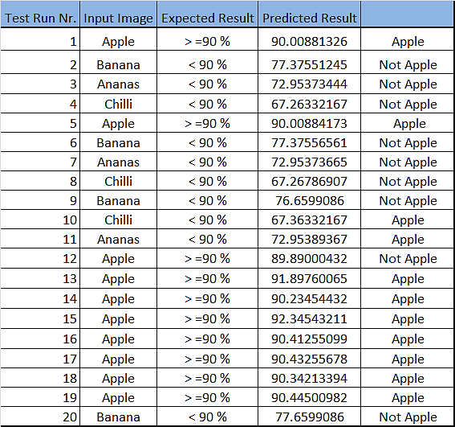

Based on above 10 test runs result, Confusion matrix has prepared as shown below, Table 3 summarizes result of 10 test runs as shown in Table 2. First row indicates result for total 10 Apple images. For 10 actual Apple images, SP model correctly classify it as an Apple 9 times and fail to classify correctly 1 time. Second row indicates, For total 10 not-Apple images including Ananas, Banana and Chilli, SP model classifies all 10 correctly as Not-Apple.

Table 3: Confusion Matrix [17]

|  |  |  |  |  |
| --- | --- | --- | --- | --- |
|  |  | Predicted Classification Result |  |  |
| Actual Images for Prediction |  | **Apple** | **Not Apple** | **Total** |
| **Apple** | 9 | 1 | 10 |
| **Not Apple** | 0 | 10 | 10 |
| **Total** | **9** | **11** | **20** |

From this Confusion matrix, Accuracy of Classification can be determined. Classification accuracy is the ratio of correct predictions to total predictions made as follows,

Accuracy = (Total Predicted Apple + total Predicted Not Apple) *100

Total Predictions made

Accuracy = (9 + 10) *100 = 95 %

20

We are getting Classification accuracy 95 % based on 10 test runs.

**7. Conclusion:**

In this paper, we followed testing approach by training SP model with 4 different types of Apples as a training dataset and testing classification capability of SP model based on 4 images including apple and non-apple images as testing dataset. It is observed that for apple image, SP model is predicting maximum percentage (> 90 %) and for non- apple images it predict comparatively less percentage. It is noticed that for images looking more like apple (Training data) has comparatively more prediction percentage e.g. ananas has more prediction Percentage than chilli.

From above results, we can conclude that SP model has Classification accuracy of 95% when 10 test runs are been carried out.

**References:**

[1] Kirtay, Murat, Lorenzo Vannucci, Ugo Albanese, Alessandro Ambrosano, Egidio Falotico, and Cecilia Laschi. "Spatial pooling as feature selection method for object recognition." In *ESANN*. 2018.

[2] Osegi, E. N. "Using the hierarchical temporal memory spatial pooler for short-term forecasting of electrical load time series." *Applied Computing and Informatics* (2018).

[3] W. Zhuo, Z. Cao, Y. Qin, Z. Yu and Y. Xiao, "Image classification using HTM cortical learning algorithms," Proceedings of the 21st International Conference on Pattern Recognition (ICPR2012), Tsukuba, 2012, pp. 2452-2455.

[4] http://nupic.docs.numenta.org/0.6.0/

spatial-pooler.html

[5] D. Dobric, “NeoCortexApi,” 2019. [Online]. Available:https://github.com/ddobric/neocortexapi/.

[6] https://github.com/UniversityOfApplied

SciencesFrankfurt/se-cloud-2019-2020/blob/Mandeep_Singh/Source/HTM/UnitTestsProject/CortexNetworkTests/ImageClassifierSpatialPoolerTests/ImageClassifierSpatialPoolerTests.cs

[7] https://docs.microsoft.com/en-

us/dotnet/machine-learning/tutorials/image-classification

[8] Mattsson, Olov. "Fruit recognition by hierarchical temporal memory." (2011).

[9] https://www.istockphoto.com/de/foto/

roter-apfel-mit-blatt-gm683494078-125451195

[10] https://www.pexels.com/photo/healthy-

apple-fruits-natural-102104/

[11] https://www.istockphoto.com/de/foto/

roter-apfel-mit-blatt-isoliert-auf-wei%C3%9Fem-hintergrund-gm185262648-19966694

[12] https://i5.walmartimages.ca/images/

Enlarge/094/514/6000200094514.jpg

[13] https://d2lnr5mha7bycj.cloudfront.net/

product-image/file/large_fda9f2e7-b6f4-4fc6-bc27-355eece8b1fd.jpg

[14] https://image.shutterstock.com/

image-photo/red-apple-on-white-background-600w-158989157.jpg

[15] https://encrypted-tbn0.gstatic.com/

images?q=tbn%3AANd9GcRXe6A1vQhf-ZiW-zZ0o7W204cR_mRR80G52Mh_Wj5

7tmEe2OIL&usqp=CAU

[16] https://image.shutterstock.com/

image-vector/realistic-green-hot-natural-chili-260nw-1027834957.jpg

[17] Arora, R., 2012. Comparative analysis of classification algorithms on different datasets using WEKA. *International Journal of Computer Applications*, *54*(13).