Measuring Automotive Module Sleep Current During Product Development with a 2KΩ Shunt Resistor and SPST Switch

David T. Ashley ([dashley@gmail.com](mailto:dashley@gmail.com))

# Introduction / Overview

Automotive modules are typically constantly powered, and enter a low-power mode (often called “sleep”) to minimize battery drain when the vehicle is idle. In normal operation, current draw is likely to several hundred milliamperes or more; in sleep, current is likely to be 100-500 microamperes (a current range approaching a million to one).

Supplying normal operational current while preserving the ability to measure the very small sleep current is a technical challenge. This document describes one solution involving the use of a 2KΩ resistor (the shunt), an SPST switch, and a digital multimeter.

# Design Requirements

In order for the described solution to work, it is required that the module whose sleep current is being measured (the module under test) has the following characteristics:

* (Req. ) It is possible to control when the module enters and exits sleep mode. (This is typically done using network traffic and directly-connected inputs.)
* (Req. ) The module does not have an overly sensitive LVI circuit that will cause a reset or wakeup when S1 is opened to measure current and the supply voltage drops by approximately 1 volt.

The described solution is also designed to meet these requirements:

* (Req. 3) The solution must be able to measure sleep current with ±5% accuracy, but hopefully with ±1% accuracy.
* (Req. 4) The current measurement must not create excessive voltage drop across the measurement device. (An excessive voltage drop might trigger LVI circuits, and also substantially affect the sleep current.)
* (Req. 5) Testing mistakes or a module exiting sleep mode unexpectedly must not cause hardware damage.

A typical mechanical microammeter (low-current galvanometer), such as that shown in Figure 1, does not meet (Requirement 5) because an unexpected current increase (a testing mistake or the module unexpectedly exiting sleep) will destroy the meter.

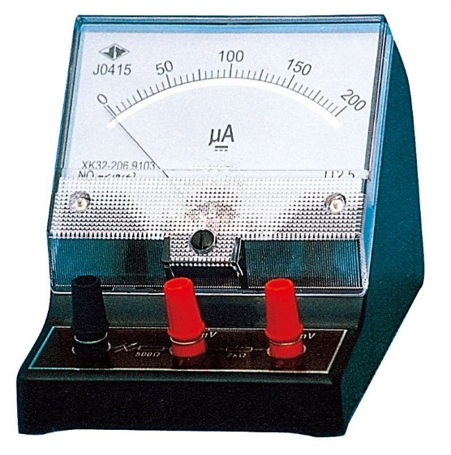

Figure : Typical Low-Current Galvanometer

# The Proposed Solution

## Schematic Diagram

Figure 2 provides a schematic diagram of the proposed solution.

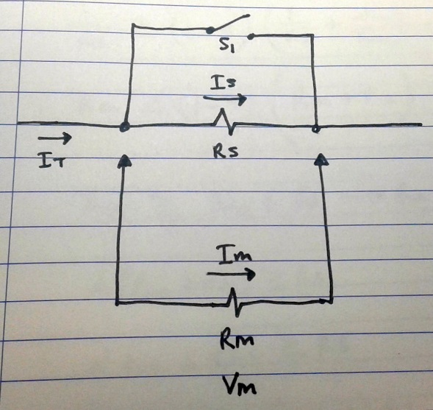

Figure : Schematic Diagram of Proposed Solution

The components and variables are:

* S1, an SPST switch. S1 is kept closed to operate the module under test normally and to place it into sleep mode. Once in sleep mode, S1 is opened to measure sleep current.
* RS, the shunt resistor used to measure current (and the value of the shunt resistor, in ohms).
* IS, the current flowing through RS.
* RM, the modeled resistance of the voltmeter used to measure the voltage across RS.
* IM, the current flowing through RM.
* VM, the voltage across RM.
* IT, the total current flowing through the module under test.
* For analysis, ISLEEP is used to denote the approximate typical current flowing through the module under test while it is in sleep mode.
* For analysis (see §3.4), the variable α is used to represent permissible measurement error. α is dimensionless and represents ΔV/V or ΔI/I. For example, α = 0.01 would represent a permissible error of 1%.

## Physical Packaging

Need to include a proposed physical packaging. Would anticipate a project box with two banana jacks and a switch externally exposed, plus the 2KΩ resistor internal.

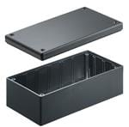

Figure : Recommended Physical Packaging of Proposed Solution

## Operation

To use the proposed device, the following steps apply:

* S1 should be closed. (With S1 closed, the module under test can draw normal operational current.)
* The module under test should be placed into sleep mode.
* S1 should be opened. (This will introduce a small voltage drop to the module under test, and allow the measurement of ISLEEP by measuring VM, the voltage across shunt resistor RS. The voltage measured should be 2mV of measured voltage per 1µA of sleep current.)
* VM should be measured.
* ISLEEP should be calculated. (Divide the measured number of millivolts by 2 to get the sleep current, in microamps.)

## Analysis of (Requirement 3): Accuracy

Measuring the voltage across the current shunt RS using a voltmeter affects the voltage, because some current flows through the voltmeter. Although a typical digital voltmeter has a high input impedance (10MΩ is typical), the error should be analyzed.

RS would ideally be chosen to give an easy-to-calculate relationship between VM and ISLEEP.

There are three obvious approaches to selecting RS:

1. Select RS for an easily-calculated relationship between ISLEEP and VM, make an assumption about minimum RM, and ensure that RS and RM are compatible in that the desired measurement error α is not exceeded.
2. Assume a specific RM and choose RS so as to preserve the easily-calculated relationship between ISLEEP and VM.
3. Use a less-than-easy method to calculate ISLEEP from VM.

Method (1) is the laziest method, and the only one explored. We need to determine the necessary relationship between RS and RM to have the desired accuracy of α = 0.01 = 1%.

The accuracy requirement directly implies that:

 ()

 ()

 ()

 ()

 ()

 (6)

For example, if RS = 2KΩ is chosen and an accuracy of α = 0.01 = 1%, (6) implies that RM ≥ 99 RS = 198KΩ; and just about any modern digital voltmeter has RM >> 198KΩ.

## Analysis of (Requirement 4): Voltage Drop

A low voltage drop due to measurement is desirable, as:

* It is unlikely to affect ISLEEP substantially.
* It reduces the probability that opening S1 will trigger LVI detection circuits in the module under test.

A suitable target for VS is 1 volt.

With RS = 2KΩ and ISLEEP ≤ 500µA, the voltage drop target is met.

If opening S1 causes an LVI trip, it would be possible to add an output capacitor (between the output and ground) to limit the voltage slew rate.

## Analysis of (Requirement 5): No Possible Hardware Damage

### RS Power Dissipation

One possibility for damage is to destroy RS by causing too much power dissipation.

The maximum current flows through RS when the output is shorted to ground. The maximum voltage anticipated to be used for testing is 24 volts.

A general rule of thumb is to dissipate no more than one half the rated power in a resistor. For 1/4-watt resistors, this implies dissipating no more than 1/8-watt per resistor.

 ()

 ()

 ()

This implies that if RS=2KΩ is chosen, the power dissipation will be too great.

With RS=2KΩ, the power dissipated will be

 ()

To decrease maximum power dissipation per resistor to about 1/8 watt, it would be necessary to spread power evenly over at least two ¼-watt resistors. The most obvious way to do this would be two 1KΩ resistors in series.

With power spread evenly over two or more ¼-watt resistors, it should be impossible to destroy RS using 24 volts or less.

### Voltmeter Damage

The voltmeter used to measure is protected against damage because no voltage beyond power supply voltage (typically 24V maximum) can appear as VM (typically not enough to damage a modern DVM, even when configured for measurement of millivolts).

### Module Under Test Damage

The module under test is protected against damage because an attempt to exit a low-power mode with RS in series will behave as a “brown out” or “very bad power connection”. No automotive module I’m aware of would be damaged by this (although the module would not operate normally).