Stated, Shipped, Violated, Repaired
A Case Study of One Absence Invariant in an Agent-Facing Analyzer
Mike Andersen
August 2026

Abstract
An analysis tool that returns no findings may have completed successfully, stopped before completion, run with reduced capability, or never run. Human developers often distinguish these states through editor context, but an autonomous coding agent may receive only the tool’s text output. This paper presents a case study of a shipped PowerShell analyzer that explicitly represented these conditions in several result vocabularies, yet still violated the underlying absence invariant in operation. The failure occurred in a secondary reader that measured the analyzer from its lifecycle logs. When the configured data root was unavailable, the reader silently substituted a temporary directory, found no records there, and rendered that result as evidence that the signal had never been captured. The rendering logic was locally correct; the claim was false because provenance had been lost upstream.
The defect was identified by contrasting the directory the reader searched with the directory in which lifecycle records actually existed. The repair retained fallback behavior but introduced a resolution-provenance seam and a distinct unresolvable state. The shipped reader was then executed in both fallback-root and known-root conditions: the fallback run declined to claim absence, while the known-root run read three lifecycle files containing six records and derived the expected rule states. A historical pre-fix/post-fix check also recorded nine of twelve selected tests failing against the old reader and none failing against the repaired reader, although that result was not rerun for this manuscript and is therefore treated as supporting rather than primary evidence.
The contribution is the documented lifecycle of one invariant: stated, shipped, violated operationally, detected by differential evidence, repaired, and re-measured. The paper does not evaluate whether the analyzer improves the quality of agent-written code.
Keywords: autonomous coding agents; static analysis; observability; provenance; differential testing; PowerShell; silent failure

1. Introduction
An autonomous coding agent edits a file, invokes an analyzer, and receives no findings. That result is not self-explanatory. At least four conditions can produce the same apparent silence:
- The analyzer completed and found no defects.
- The analyzer started but did not finish.
- The analyzer completed with reduced capability.
- The analyzer never ran.
A developer working in an editor may distinguish these conditions through a spinner, status bar, extension notification, or crash dialog. An agent that receives only text from a tool has no equivalent side channel. If every non-finding condition is represented by the same empty result, the consumer can treat “not checked” as “checked and clean.”
This paper examines that problem in a shipped PowerShell analyzer used inside an autonomous editing loop. The system had already invested in explicit failure states. Its agent-facing hook distinguished clean analysis, incomplete analysis, degraded analysis, and unavailable analysis. Its efficacy ledger distinguished a missing log from a log containing no events. Its human-review workflow included an explicit unsure verdict. These mechanisms separately embodied the same design intent: a result that was not measured should not be rendered as a measured zero.
The case is interesting because the invariant was nevertheless false in operation. A reader of the analyzer’s lifecycle records resolved its data directory through a helper that silently substituted a temporary fallback when the expected environment variable was absent. The reader searched that fallback, found no lifecycle records, and entered a branch documented as meaning that the signal had never been captured. The conclusion was about the observed system, but the evidence established only that the reader had found nothing in the directory it happened to search.
The defect therefore did not sit in the rendering code where the invariant was written. It sat upstream, at the point where the measurement path was bound to its data source. Code review of the result vocabulary did not reveal it. Existing tests did not reveal it. It was discovered by contrasting the reader’s claim with the filesystem state the claim purported to describe.
This paper makes three bounded contributions:
- A case-study contribution: a complete account of one absence invariant from statement and separate implementation through operational violation, differential detection, repair, and re-measurement.
- An engineering contribution: a provenance-carrying resolution seam and an explicit unresolvable state that preserve fallback behavior while preventing a reader from converting uncertainty about its input into a claim of absence.
- A validation contribution: a controlled comparison of fallback-root and known-root executions, supported by historical pre-fix/post-fix test evidence whose limitations are stated explicitly.
The paper does not claim that explicit failure states are new, that provenance is a new concept, or that differential testing is a new method. These ideas are established in verification, distributed-systems observability, provenance standards, argumentation, and software testing [1]-[8]. The contribution is their composition and operationalization in one agent-facing analyzer, together with evidence showing how a locally correct invariant failed when an upstream resolution step erased information.
The paper also does not answer whether the analyzer improves the code written by an autonomous agent. No controlled authoring corpus, scoring rubric, sample size, or independent scorer exists for that question. The evaluation here is limited to the failure mechanism and its repair.
Artifact availability. The public case-study artifact is the Claude PowerShell LSP repository, version 1.29.0; the provenance repair merged in commit 7c2f1fa. The companion Evidence and Revision Audit Supplement contains the source paths, line anchors, measurements, and limitations.

2. System Context

2.1 Agent-facing analysis path
The case-study system is a plugin that analyzes PowerShell files after an agent edits them. A PostToolUse hook starts or reuses PowerShell Editor Services over standard input and output, receives diagnostics, and renders those diagnostics back to the agent as text. The plugin consumes the editor-services implementation; it does not implement its own analysis or navigation provider.
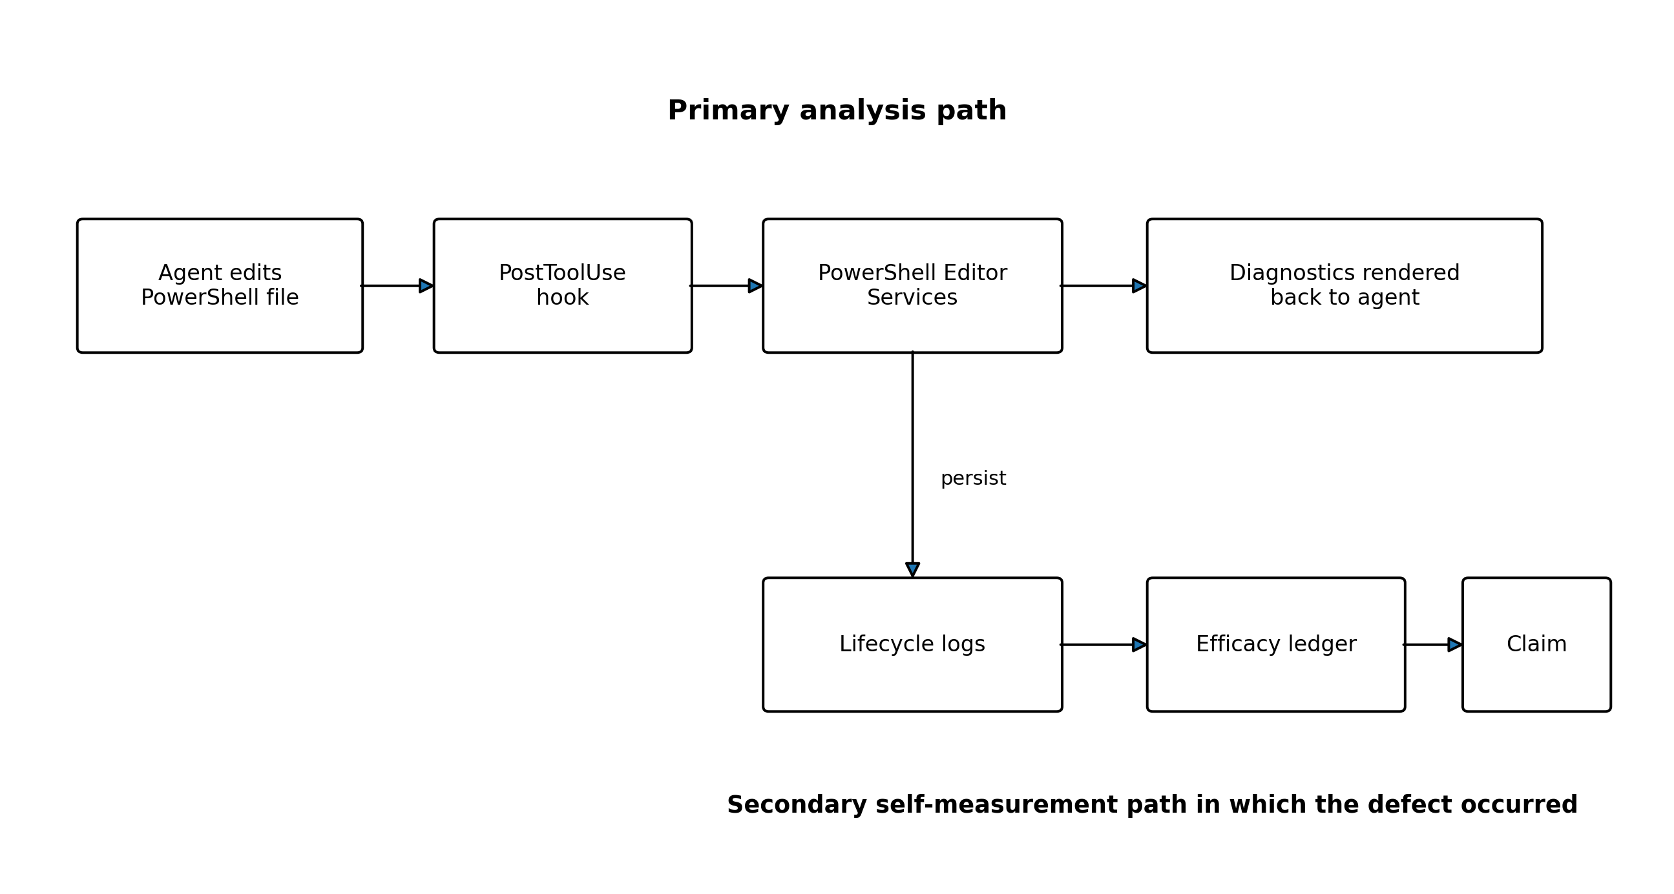
Figure 1. The analyzer’s primary path and the secondary self-measurement path.
The distinction between the two paths in Figure 1 is central. The primary path analyzes edited source files. The secondary path reads lifecycle logs produced by that primary path and calculates per-rule efficacy information. The defect documented here occurred in the secondary reader, not in the analyzer’s protocol transport or diagnostic engine.
The plugin is designed not to block editing. Even when the analyzer is unavailable, the hook exits successfully so that an analysis failure does not become an editing failure. That fail-open editing behavior is reasonable, but it makes the quality of the status channel especially important: the turn can complete successfully while its analysis information is incomplete.

2.2 Four non-finding states
The agent-facing result vocabulary distinguishes four states:
State | Meaning | Agent-visible behavior
ok | Analysis completed with the intended capability | No status banner on the normal warm path
incomplete | Analysis did not complete | Non-empty banner stating that the edit was not checked
degraded | Parser-only analysis completed without the full lint rules | Non-empty banner describing the reduced capability
unavailable | The analyzer could not start or was unavailable for the session | Non-empty banner stating that diagnostics are off
This vocabulary implements a practical rule already familiar from verification and decision systems: an indeterminate result should be represented explicitly rather than collapsed into a successful result [1], [4], [5].

2.3 The secondary reader
The efficacy ledger reads persisted lifecycle records and renders per-rule state. Before the repair, its core result vocabulary had three meanings:
Ledger state | Meaning
absent | No lifecycle log was found; the source comment described this as the signal never having been captured
no-events | A lifecycle log exists, but the rule has no lifecycle event in it
derived | A numeric result was derived from counted events
The source stated the intended invariant directly: a ledger over nothing and a ledger of zeros must not look the same. The rendering function honored that invariant locally. It had no path that converted an unmeasured rate into a numeric zero.
The failure arose because the function’s input did not carry enough information to justify the absent state.

3. The Absence Invariant

3.1 Separate result vocabularies
Three separately implemented vocabularies expressed related forms of uncertainty for different consumers:
Consumer | Vocabulary | Relevant non-answer
Autonomous agent | ok, incomplete, degraded, unavailable | incomplete, degraded, or unavailable, depending on the failure
Efficacy-ledger reader | absent, no-events, derived; later unresolvable | unresolvable after the repair
Human dogfood reviewer | useful, false-positive, noisy, bad-fix, unsure | unsure
They were implemented at different sites and for different consumers rather than through one shared state machine. The paper therefore does not claim a unified architecture. Their convergence is instead an observation: each vocabulary needed a value that prevented an unknown or unavailable result from being silently interpreted as a known favorable result.

3.2 Design property and operational property
The case depends on distinguishing two claims:
- Design property: the ledger’s rendering logic does not convert an unmeasured result into numeric zero.
- Operational property: the reader does not render a claim of absence when its own input resolution is uncertain.
The design property held. The operational property did not.
This distinction explains why inspection of Get-LifecycleRates did not reveal the failure. Its state transitions were consistent with its inputs. The defect was that the input summarized only whether files were found, not whether the reader had searched the intended location.
The companion audit supplement separates evidence support from claim status: a claim may be measured and refuted at the same time. This is consistent with assurance-case practice, which represents supporting evidence and potential defeaters separately [6]. The main paper applies the scheme only to its central claims.

4. Operational Violation

4.1 Silent fallback resolution
The original root resolver returned the configured plugin data directory when the CLAUDE_PLUGIN_DATA environment variable was set. When it was unset, the resolver silently returned a temporary directory:
function Get-PluginDataRoot {
$root = $env:CLAUDE_PLUGIN_DATA
if ([string]::IsNullOrWhiteSpace($root)) {
$root = Join-Path ([System.IO.Path]::GetTempPath()) 'powershell-lsp-data'
}
return $root
}
The fallback existed so that out-of-band invocations such as tests would not fail merely because the plugin environment was absent. The problem was not the existence of the fallback. The problem was that the returned string did not say whether it represented the configured data root or a substitute.
The ledger then searched the returned root for lifecycle files. An empty search result set Present to false, which made the absent branch reachable. That branch was documented as a claim that the signal had never been captured. Under a substituted root, however, the evidence supported only this narrower statement: the reader found no lifecycle record under the location it searched.

4.2 Differential evidence
The failure was established by comparing the two relevant filesystem locations:
Observation | Real plugin data root | Temporary fallback root
Lifecycle files | 3 | 0
Lifecycle-file sizes | 827, 418, and 1,208 bytes | Not applicable
Environment in bare shell | Expected variable not set | Fallback selected
The fallback directory existed and contained an unrelated log, but no lifecycle files. The real data root contained three lifecycle files. Before the repair, a bare-shell ledger run searched the fallback and reported the signal as never captured.
The contrast is stronger than a source-code argument. The reader’s own output was the object in doubt, so reading that output could not establish its correctness. The filesystem differential showed that the world contained records while the reader’s selected observation point did not.
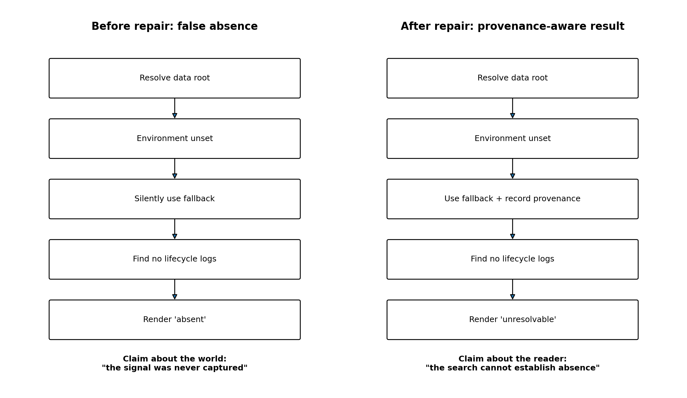
Figure 2. The false-absence path and the provenance-aware path introduced by the repair.

4.3 Where the invariant failed
The failure chain can be represented as:
- The analyzer produced lifecycle records.
- The efficacy reader resolved a data root.
- Resolution silently substituted a fallback.
- The reader searched the fallback and found no records.
- The renderer correctly mapped “no records found” to absent.
- The published result was interpreted as a claim about the analyzer’s history.
Steps 4 through 6 behaved consistently with the information supplied to them. The information loss occurred at Step 3. The invariant was written near the renderer, but the step that defeated it sat several files upstream.
A survey of resolution behavior found four silent fallback resolvers using three different fallback directories, two sites that refused rather than substituted, and one site that already implemented the needed known-root predicate locally. This distribution is consistent with a missing shared seam, although it does not prove that every site shared one causal origin. The repair therefore addressed the shared information contract and was applied to the two readers known to publish absence claims.

5. Repair

5.1 Resolution provenance
The repair introduced a sibling resolver, Get-PluginDataRootResolution, that returns the resolved root together with whether the root is known and how it was resolved. A companion predicate, Test-PluginDataRootKnown, is derived from that result rather than independently reimplementing the logic.
Conceptually, the returned object has the form:
{
Root: <resolved path>,
Known: <true or false>,
Provenance: <environment or fallback mechanism>
}
The original Get-PluginDataRoot behavior was retained byte-for-byte. Existing out-of-band callers could continue to receive a fallback path. Consumers that publish claims about the presence or absence of data could now ask whether the path was authoritative.

5.2 A fourth ledger state
The ledger gained a fourth result state:
State | Interpretation
absent | The reader searched a known root and found no lifecycle log
no-events | A lifecycle log exists, but the rule has no event
derived | A value was derived from recorded events
unresolvable | The reader found no log under a substituted root and therefore cannot distinguish true absence from an unsuccessful observation
RootKnown defaults to true for backward compatibility. This is deliberately fail-open with respect to provenance: a caller that omits the new argument retains the pre-repair semantics. The choice avoided silently changing existing callers, but it does not make the repository provenance-safe by default. The two readers that publish absence claims were changed to pass the resolution state explicitly, and the safety claim in this paper is bounded to those readers.

5.3 Stronger invariant
The original invariant constrained the rendering result:
A ledger over nothing and a ledger of zeros must not look the same.
The repair establishes a stronger operational invariant:
A reader must not render a claim about the observed system when the reader’s own input resolution was a substitution.
The stronger invariant reaches the upstream condition that defeated the original. It is implemented at the two readers found to violate it, not enforced mechanically across the entire repository. Because the compatibility default remains fail-open, another consumer that omits the provenance argument could reintroduce the same class of failure.

6. Evaluation
The evaluation asks whether the documented failure can be established and whether the repair changes the reader’s behavior in the predicted direction without disturbing the known-root path.

6.1 RQ1: Did the pre-repair reader publish false absence?
Result: Yes, for the observed bare-shell condition.
Three lifecycle files existed under the real plugin data root. The environment variable naming that root was unset in a bare shell. The resolver selected the temporary fallback, where no lifecycle files existed. The pre-repair reader mapped that empty search to absent, whose own source documentation described the signal as never captured.
This establishes the operational violation for one machine and one captured state. It does not establish the frequency of the defect in field use.

6.2 RQ2: Does the repaired reader distinguish an unknown root from known absence?
Result: Yes.
The shipped reader was run read-only under two conditions that differed in whether CLAUDE_PLUGIN_DATA was set.
Condition | Resolution reported | Records read | Rendered outcome
Bare shell; variable unset | fallback:temp; data root not known | 0 | Every rate column rendered unresolvable
Environment set to real root | env:CLAUDE_PLUGIN_DATA; data root known | 3 files / 6 records | Three rules derived; remaining rules rendered no-events
The token absent appeared in neither run. In the fallback case, the reader named the directory and resolution mechanism and declined to make an absence claim. In the known-root case, it read the available records and produced derived and known-empty states.

6.3 RQ3: Was the known-root path preserved?
Result: Supported for the observed run.
The repair did not change the original path-returning helper. The known-root execution continued to read the real lifecycle corpus and derive rule states. As Section 5.2 explains, the RootKnown compatibility default preserves unmodified callers rather than making them provenance-safe; the two publishing readers opt into provenance-aware resolution explicitly.
This is evidence of preserved behavior for the exercised reader path. It is not a complete repository-wide regression study.

6.4 RQ4: Did the repair satisfy a pre-fix/post-fix falsification check?
Historical supporting result: A recorded calibration check placed the same post-fix test file into pre-fix and post-fix worktrees. Nine of twelve selected tests failed against the pre-fix reader and none failed against the repaired reader. The check was designed to exit non-zero if it could not prove that the two trees represented the expected versions or if the pre-fix run did not turn red.
This result has two limitations:
- It was carried from the calibration build’s record and was not rerun for this manuscript.
- The criterion was enforced at the run level. Three tests passed in both directions and were not individually treated as failures of the criterion.
The result therefore supports the repair but is not the primary evidence. A publication-grade replication should preserve the exact invocation, identify every selected test, and require the expected transition on a per-test basis where that is the stated criterion.

6.5 Test-suite discrepancy
Two recorded builds reported different full-suite verdicts on the repository: one reported 1,395 passes and one failure out of 1,396 tests, while a later build reported 2,245 passes and no failures. The totals are not directly comparable because one guard enumerates a directory whose contents differed between runs. The verdict difference remains unexplained because the invocation producing the earlier failure was not preserved.
Nothing in the available record establishes whether that failure was among the twelve selected falsification tests. The two results are therefore not combined. This uncertainty limits the weight assigned to the historical test record but does not alter the reproduced filesystem differential or the observed post-repair root-state behavior.

6.6 What was not evaluated
This paper does not evaluate whether the analyzer causes an autonomous agent to write better PowerShell. No task corpus, quality rubric, experimental arms, sample size, or designated scorer exists. A future efficacy study should be preregistered before data collection, including a commitment to publish a null or negative result. The measurement path documented here should be treated as an instrument that required calibration before such a study could be credible.
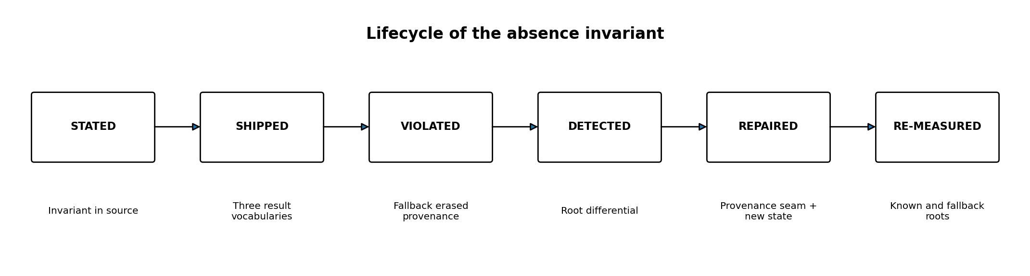
Figure 3. The complete lifecycle documented by the case study.

7. Design Implications
The implications below are hypotheses and engineering recommendations derived from one system. Several restate established ideas in a specific agent-facing setting rather than introduce new principles.

7.1 Make non-answers explicit and non-empty
A result vocabulary should include a value for indeterminate or unavailable analysis. Verification competitions use an explicit UNKNOWN outcome, and argumentation frameworks represent abstention as a first-class state [4], [5]. Agent-facing tools need the same discipline because silence is otherwise shared by success and failure.
A useful status should communicate both that analysis did not produce a normal result and what the consumer can do next. A token that exists internally but renders as empty does not preserve the distinction for an agent.

7.2 Carry provenance with resolved values
A resolved path is not only a string. It also has a derivation: environment configuration, default, search, migration, or fallback. Provenance standards treat the history that produced a value as information a consumer may need to assess its reliability [3]. The case study shows a concrete consequence of discarding that history: a downstream reader can publish a stronger claim than its input licenses.
For resolvers whose outputs feed metrics, compliance checks, evidence reports, or absence claims, the resolution object should carry at least:
- the resolved value;
- whether it is authoritative for the requested purpose;
- and the mechanism that produced it.

7.3 Require a reachable failing direction
A passing status can be meaningless when the condition that should make it fail is unreachable. Vacuity detection formalizes this concern in verification [1]. The corresponding engineering practice is to show that a gate can go red for the intended reason before treating its green state as evidence.
For the present repair, the check should fail against the old reader, pass against the repaired reader, and reject an execution in which the old version does not go red. Section 6.4 records the remaining limitation in how that criterion was enforced.

7.4 Calibrate self-measurement paths before using their outputs
A tool that reads its own logs is a measurement instrument. Its results depend on capture, storage, discovery, parsing, attribution, and rendering. A correct final calculation cannot compensate for an unobserved failure earlier in that chain.
The case suggests a practical ordering rule: before publishing efficacy figures, verify that the reader can distinguish at least these conditions:
- known input with events;
- known input with no relevant events;
- authoritative input with no records;
- substituted or unknown input;
- incomplete parsing or attribution.
This rule is motivated here by one implementation. The paper does not claim that the broader requirement is novel or that this case establishes its prevalence.

7.5 Test the observation boundary, not only the renderer
The original rendering function was correct given its inputs. A unit test confined to that function could therefore pass indefinitely while the operational claim remained false. Tests for evidence-producing software should include the boundary at which the observation source is selected.
For this class of reader, a meaningful test varies the source condition itself: configured root, substituted root, missing directory, present empty directory, and present directory with records. The output is then checked against the claim each condition licenses.

8. Threats to Validity
Single system and single developer. The case concerns one plugin, one language ecosystem, one primary developer, and one machine for the reproduced filesystem state. It establishes a mechanism, not a frequency distribution.
Self-authored evidence. The system author also classified the evidence and wrote the paper. The public repository and companion audit supplement provide the file paths, source anchors, and measured outputs needed to inspect the central claims, but they do not create independent assessment.
Historical evidence not fully reproducible. The 9-of-12 pre-fix result and the earlier one-failure full-suite result were preserved as build records rather than rerun from a complete invocation archive. Their limitations are retained in the evaluation rather than resolved by inference.
Repair scope. The provenance-aware contract was applied to two readers known to publish absence claims. The underlying fallback resolver remains for compatibility, and no repository-wide mechanism requires every future consumer to inspect provenance.
Detection bias. The defect was found during a survey that was looking for something else. Because the reader’s own output was misleading, existing tests and ordinary review did not surface it. Similar defects may remain precisely because the instrument affected by them cannot reliably report them.
Literature coverage. The source survey retrieved thirteen open-access items through general web search and direct fetches. It did not query ACM Digital Library, IEEE Xplore, Scopus, or Web of Science; follow citation graphs; or search non-English literature. Claims about novelty are therefore bounded to the retrieved set.
No downstream-harm measurement. The paper argues that silent analysis failure can become silent reasoning failure, but it does not present a deployed incident or controlled experiment showing harm to generated code. That consequence remains a motivated hypothesis.

9. Related Work

9.1 Vacuity and non-triggering checks
Vacuity detection addresses verification results that are technically true for degenerate reasons, such as a response property holding because requests never occur [1]. The present case applies the same discipline operationally: a passing or favorable state should not be trusted until the failure condition it purports to exclude has been shown reachable. The historical pre-fix/post-fix gate is an instance of that practice, although its run-level enforcement should be strengthened.

9.2 Differential observability and gray failure
Gray-failure research describes disagreement between what a system observer reports and what an application experiences [2]. This case narrows that structure to a reader that publishes a claim about an analyzer’s history. The reader observed an empty fallback directory and reported a conclusion about the real capture environment. The repair does not eliminate the observation gap; it makes the uncertainty visible to the consumer.

9.3 Provenance
The W3C PROV model defines provenance as information about how data or an entity was produced so that consumers can assess qualities such as reliability and trustworthiness [3]. The resolution-provenance seam is a small implementation of that general principle. Its specific contribution is to carry whether a returned directory is configured or substituted into the code that decides whether absence may be claimed.

9.4 Explicit unknown and abstention states
Software-verification competitions require an explicit unknown verdict for cases in which a tool cannot decide or terminates unsuccessfully [4]. Argumentation frameworks similarly treat undecided or abstaining outcomes as first-class states [5]. The result vocabularies in the case-study system operationalize that principle for an agent, an efficacy reader, and a human reviewer.

9.5 Differential and controlled-replay testing
Differential testing compares outputs from comparable executions to identify candidate defects [7]. More recent work on silent failures in agent traces uses controlled replay and an outcome flip as contrastive evidence [8]. The present case uses two related contrasts: the initial comparison between the reader’s claim and the directory state it claimed about, and the controlled post-repair execution under known-root and fallback-root conditions.

9.6 Silent failure in agent systems
Recent work describes agent-runtime failures whose signals are swallowed, diluted, or converted into plausible narratives, and tool-call failures in which an operation succeeds syntactically while violating the intended state transition [9], [10]. The analyzer case differs in mechanism but shares the consumer-facing shape: the agent can receive a normal-looking result with no marker that the expected checking process did not occur as assumed.

9.7 Unsound static analysis and absence of evidence
Practical static analyzers often make deliberate unsoundness tradeoffs, so a clean result does not establish the underlying property universally [11]. The present work concerns runtime execution states rather than designed-in analysis unsoundness, but both caution against reading a clean result more strongly than the tool’s evidence permits. The statistical distinction between absence of evidence and evidence of absence states the broader epistemic issue directly [12].

10. Conclusion
A shipped analyzer stated an invariant that a ledger over nothing must not resemble a ledger of zeros. The invariant was implemented correctly in the ledger’s result vocabulary and echoed by separate result vocabularies elsewhere in the system. It was nevertheless false in operation because an upstream resolver silently substituted a fallback directory and discarded the provenance needed to interpret an empty search.
The defect was established by contrasting the reader’s selected root with the directory in which lifecycle records actually existed. The repair retained fallback behavior while making it legible, carried resolution provenance to the publishing reader, and added an unresolvable state for cases in which the search could not justify a claim of absence. When rerun under fallback-root and known-root conditions, the shipped reader declined to claim absence in the former and derived the recorded states in the latter.
The case demonstrates a narrow but important engineering lesson: invariants about evidence cannot be enforced only where evidence is rendered. They must reach upstream to the point where the observation source is selected and qualified. A locally truthful vocabulary can still publish a false operational claim when its inputs have lost the information needed to interpret them.

References
[1] R. Armoni, L. Fix, A. Flaisher, O. Grumberg, N. Piterman, A. Tiemeyer, and M. Y. Vardi, “Enhanced Vacuity Detection in Linear Temporal Logic,” in Proceedings of the 15th International Conference on Computer Aided Verification (CAV 2003), LNCS 2725, pp. 368-380, Springer, 2003, doi:10.1007/978-3-540-45069-6_35.
[2] P. Huang, C. Guo, L. Zhou, J. R. Lorch, Y. Dang, M. Chintalapati, and R. Yao, “Gray Failure: The Achilles’ Heel of Cloud-Scale Systems,” Proceedings of HotOS ’17, 2017, doi:10.1145/3102980.3103005.
[3] L. Moreau and P. Missier, eds., PROV-DM: The PROV Data Model, W3C Recommendation, 30 April 2013.
[4] 5th International Competition on Software Verification (SV-COMP 2016), “Competition Rules,” held at TACAS 2016, Eindhoven, Netherlands, 2016.
[5] M. Caminada and Y. Wu, “On the Justification Status of Arguments,” BNAIC, 2010.
[6] U. Gohar, A. Hunter, R. Lutz, and M. Cohen, “CoDefeater: Using LLMs to Find Defeaters in Assurance Cases,” arXiv:2407.13717v2, 2024.
[7] W. M. McKeeman, “Differential Testing for Software,” Digital Technical Journal, vol. 10, no. 1, 1998.
[8] S. Lin, H. Wang, K. W. Kwok, D. Guo, M. Nale, S. Fleming, and A. M. K. Cheng, “REFLECT: Intervention-Supported Error Attribution for Silent Failures in LLM Agent Traces,” arXiv:2606.09071, 2026. The source survey reviewed the abstract listing only.
[9] X. Wu, “When Errors Become Narratives: A Longitudinal Taxonomy of Silent Failures in a Production LLM Agent Runtime,” arXiv:2606.14589, 2026. The source survey reviewed the abstract listing only.
[10] S. Reddy, S. Challaram, and S. Basu, “Reason Less, Verify More: Deterministic Gates Recover a Silent Policy-Violation Failure Mode in Tool-Using LLM Agents,” arXiv:2607.07405, 2026. The source survey reviewed the abstract listing only.
[11] B. Livshits, M. Sridharan, Y. Smaragdakis, M. Lhotak, J. N. Amaral, B.-Y. E. Chang, S. Z. Guyer, U. P. Khedker, A. Moller, and D. Vardoulakis, “In Defense of Soundiness: A Manifesto,” Communications of the ACM, vol. 58, no. 2, 2015.
[12] D. G. Altman and J. M. Bland, “Absence of Evidence Is Not Evidence of Absence,” BMJ, vol. 311, p. 485, 1995, doi:10.1136/bmj.311.7003.485.

Appendix A. Evidence Summary
The companion Evidence and Revision Audit Supplement, distributed with this manuscript, contains the larger claim ledger and source anchors. The table below retains only the claims required to evaluate this manuscript.
Claim | Evidence in the source record | Status and limitation
The agent-facing analyzer has four result states | Source reads of the status resolver and banner renderer | Directly supported for the current source; total reachability of every token is not measured end to end
The ledger distinguishes absent, no-events, derived, and unresolvable | Source reads of Get-LifecycleRates and rendering sites | Directly supported for the repaired implementation
The real root contained lifecycle data while the fallback did not | Three lifecycle files in the real root; none in the fallback | Measured on one machine and one captured state
The repaired reader distinguishes fallback and known roots | Read-only executions in both conditions | Measured for the shipped reader and observed corpus
Historical selected-test falsification | 9/12 red pre-fix; 0/12 red post-fix | Supporting record only; not rerun, and gate was run-level
Repository-wide absence-provenance coverage | Repair applied at two readers | Not established tree-wide
Analyzer improves agent-written code | No experiment exists | Open and outside this paper

