**Algorithms for Data Guided Business Intelligence**

# Home Work

# Topic 2, Part 2

# By Rohit Mandge

Unity ID: ***RNMANDGE***

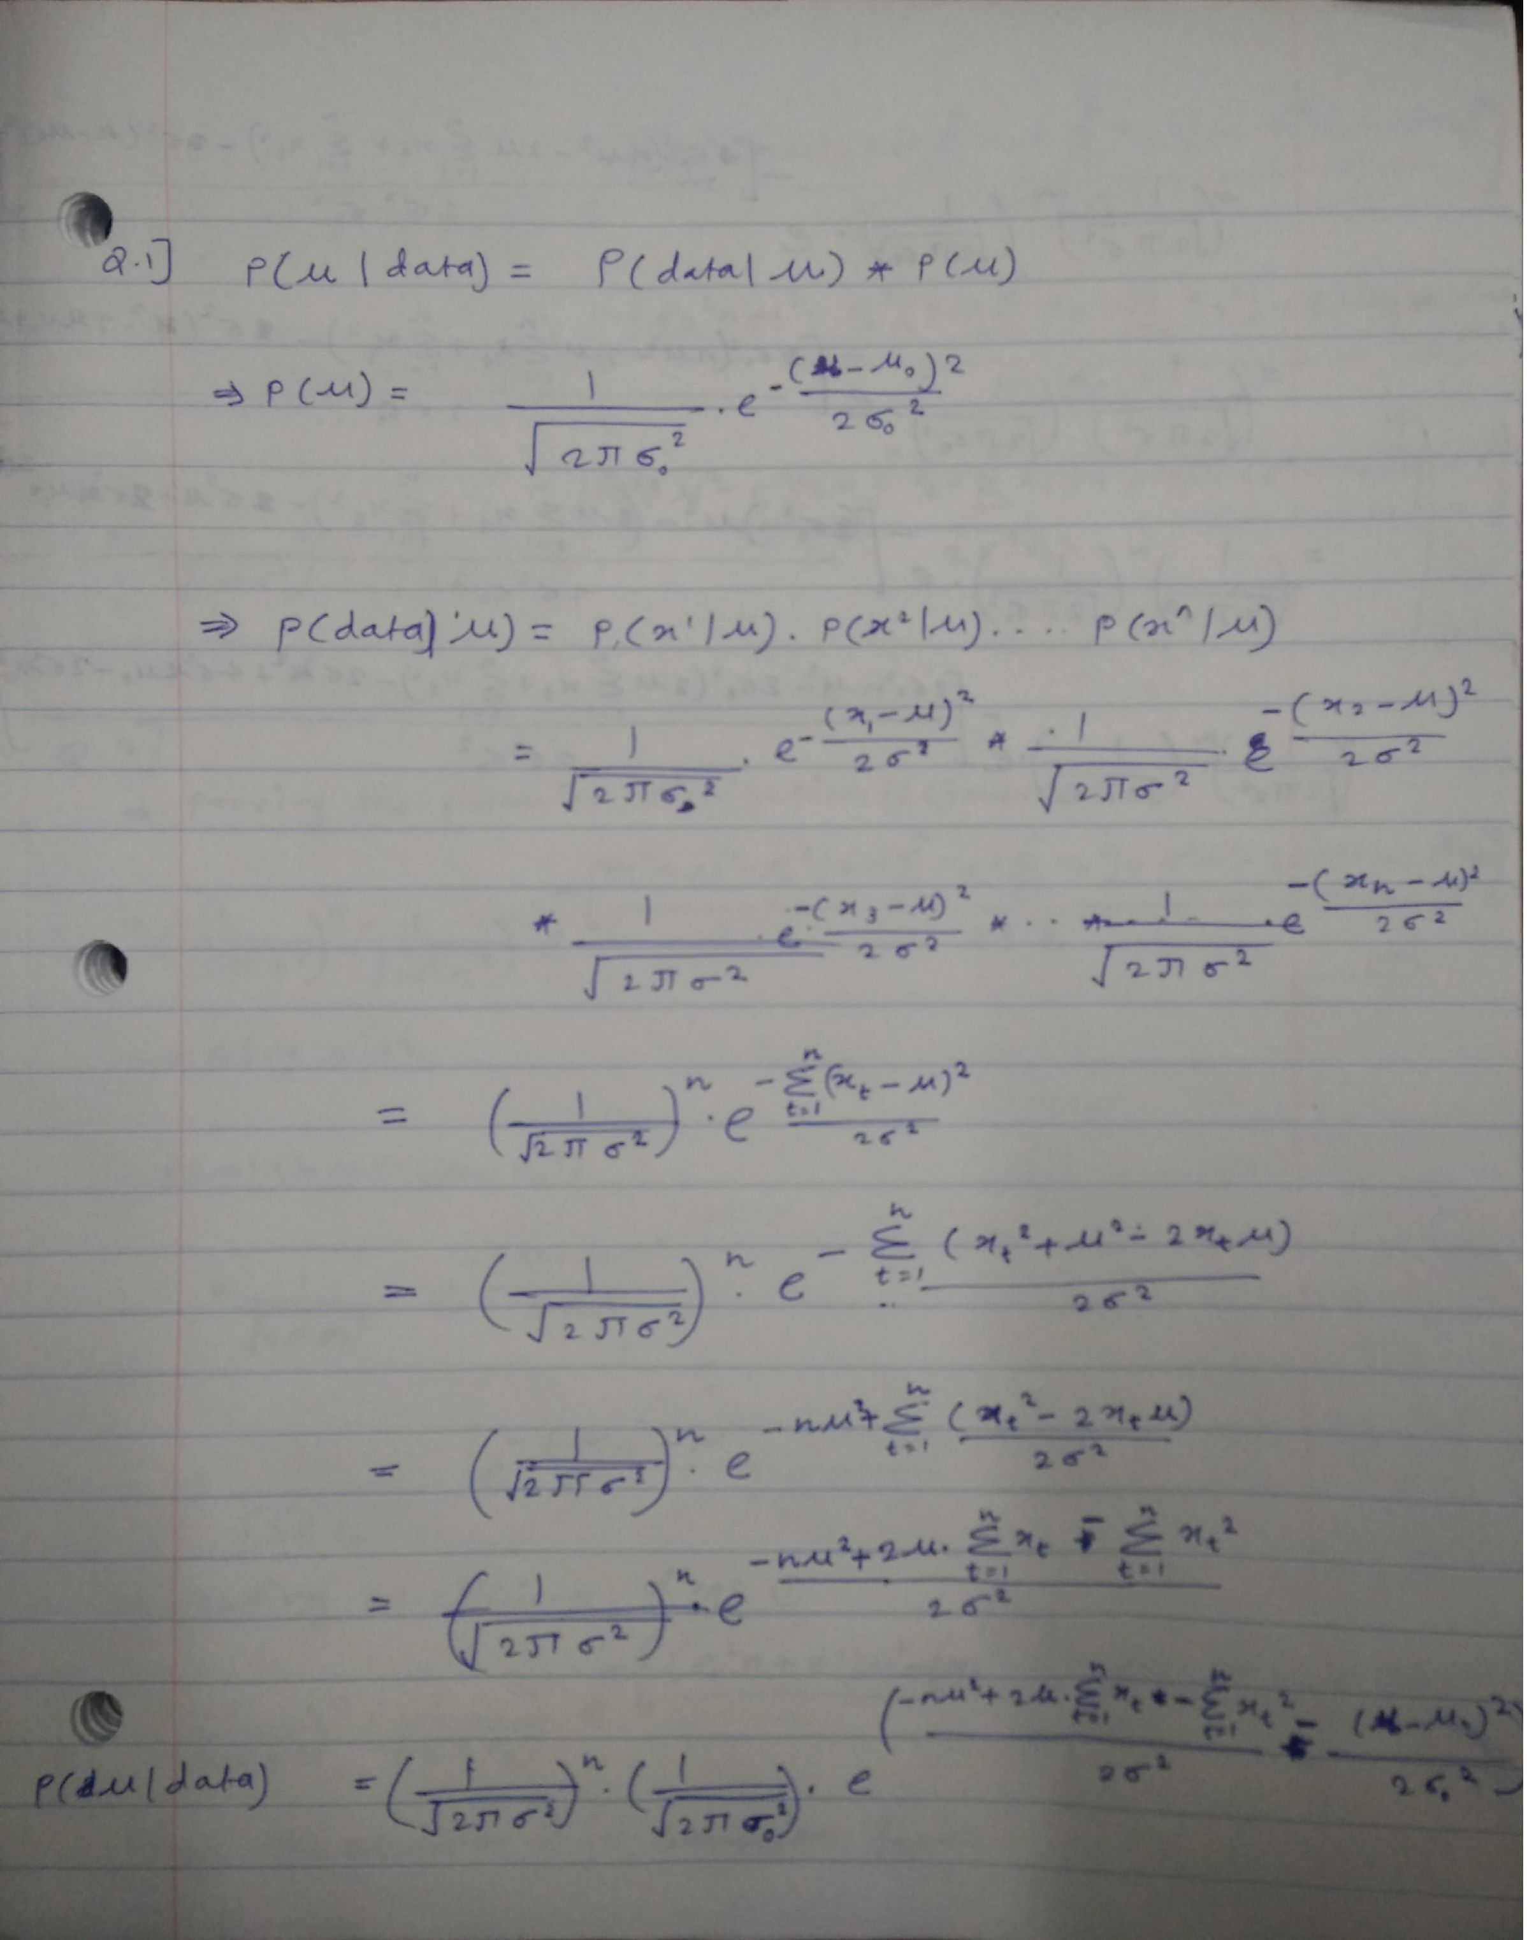

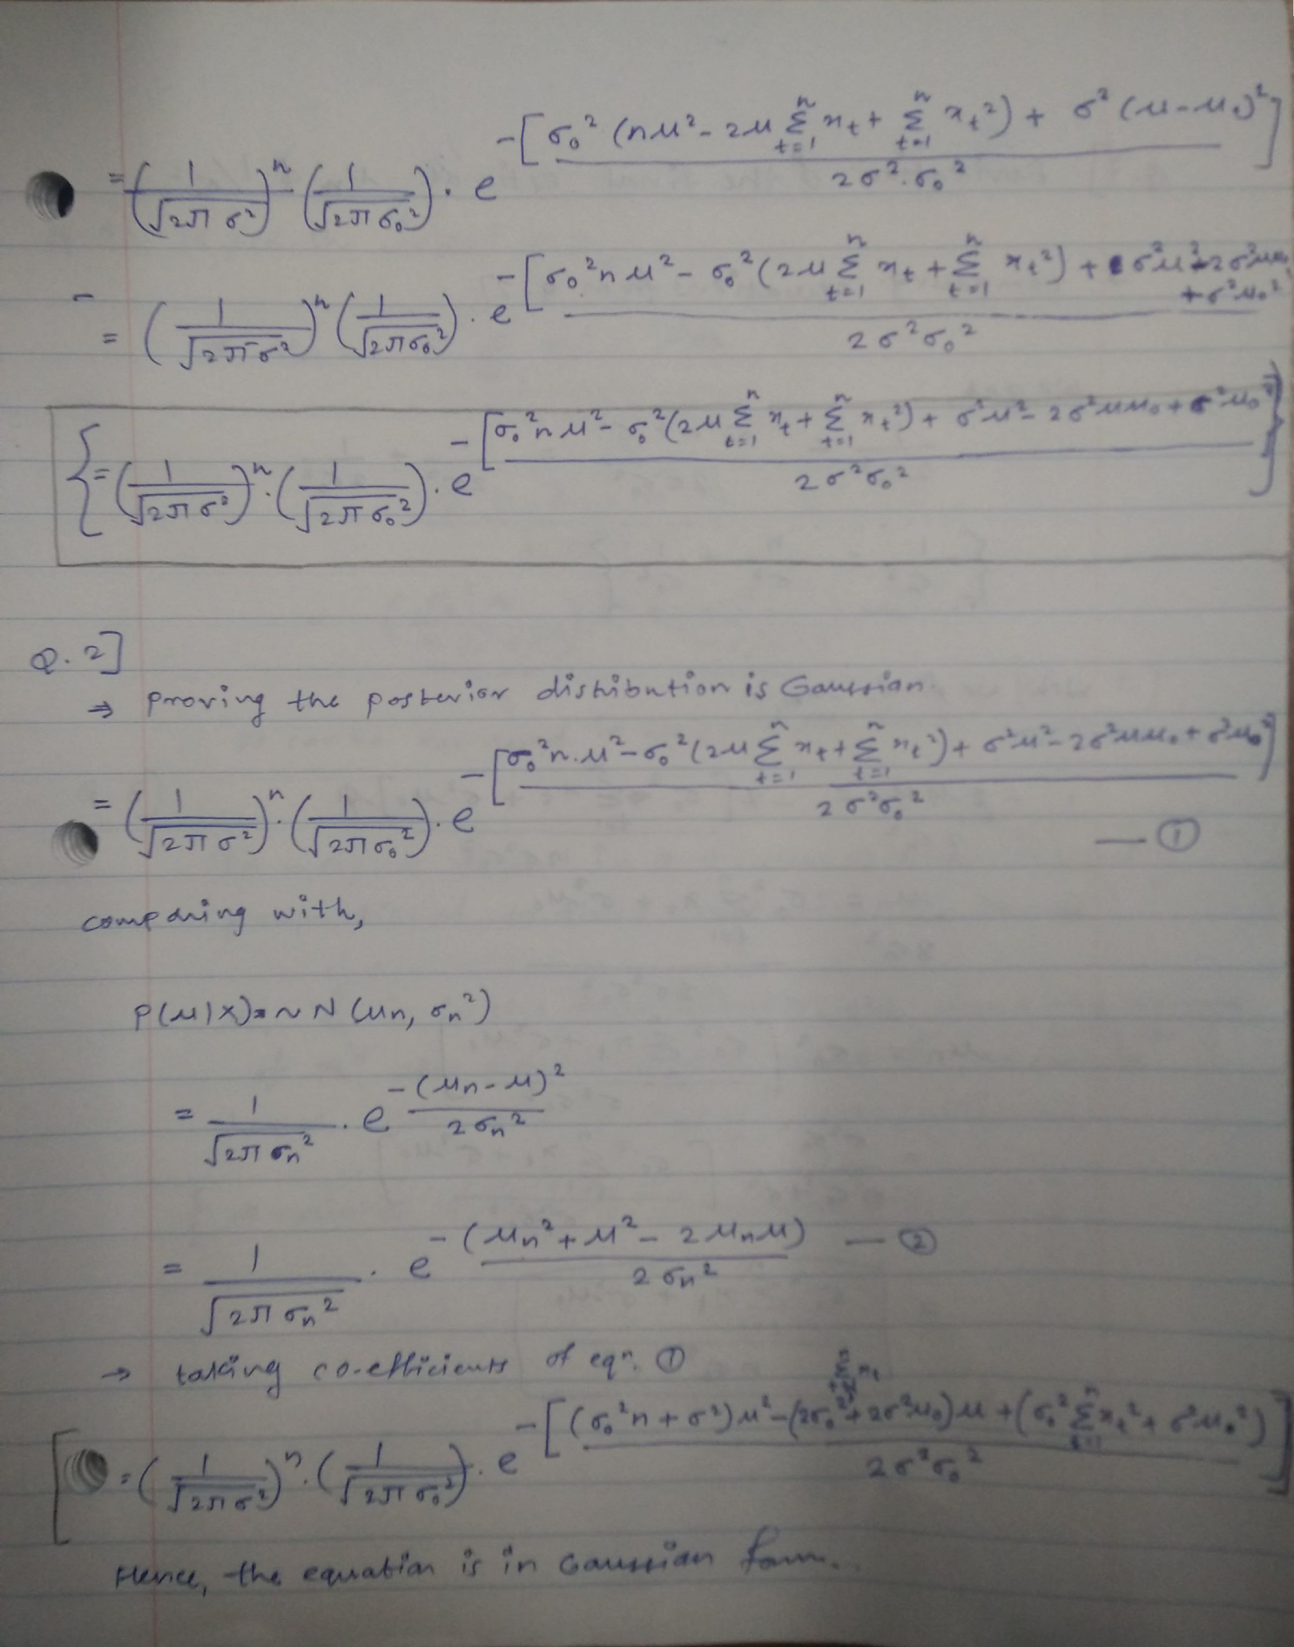

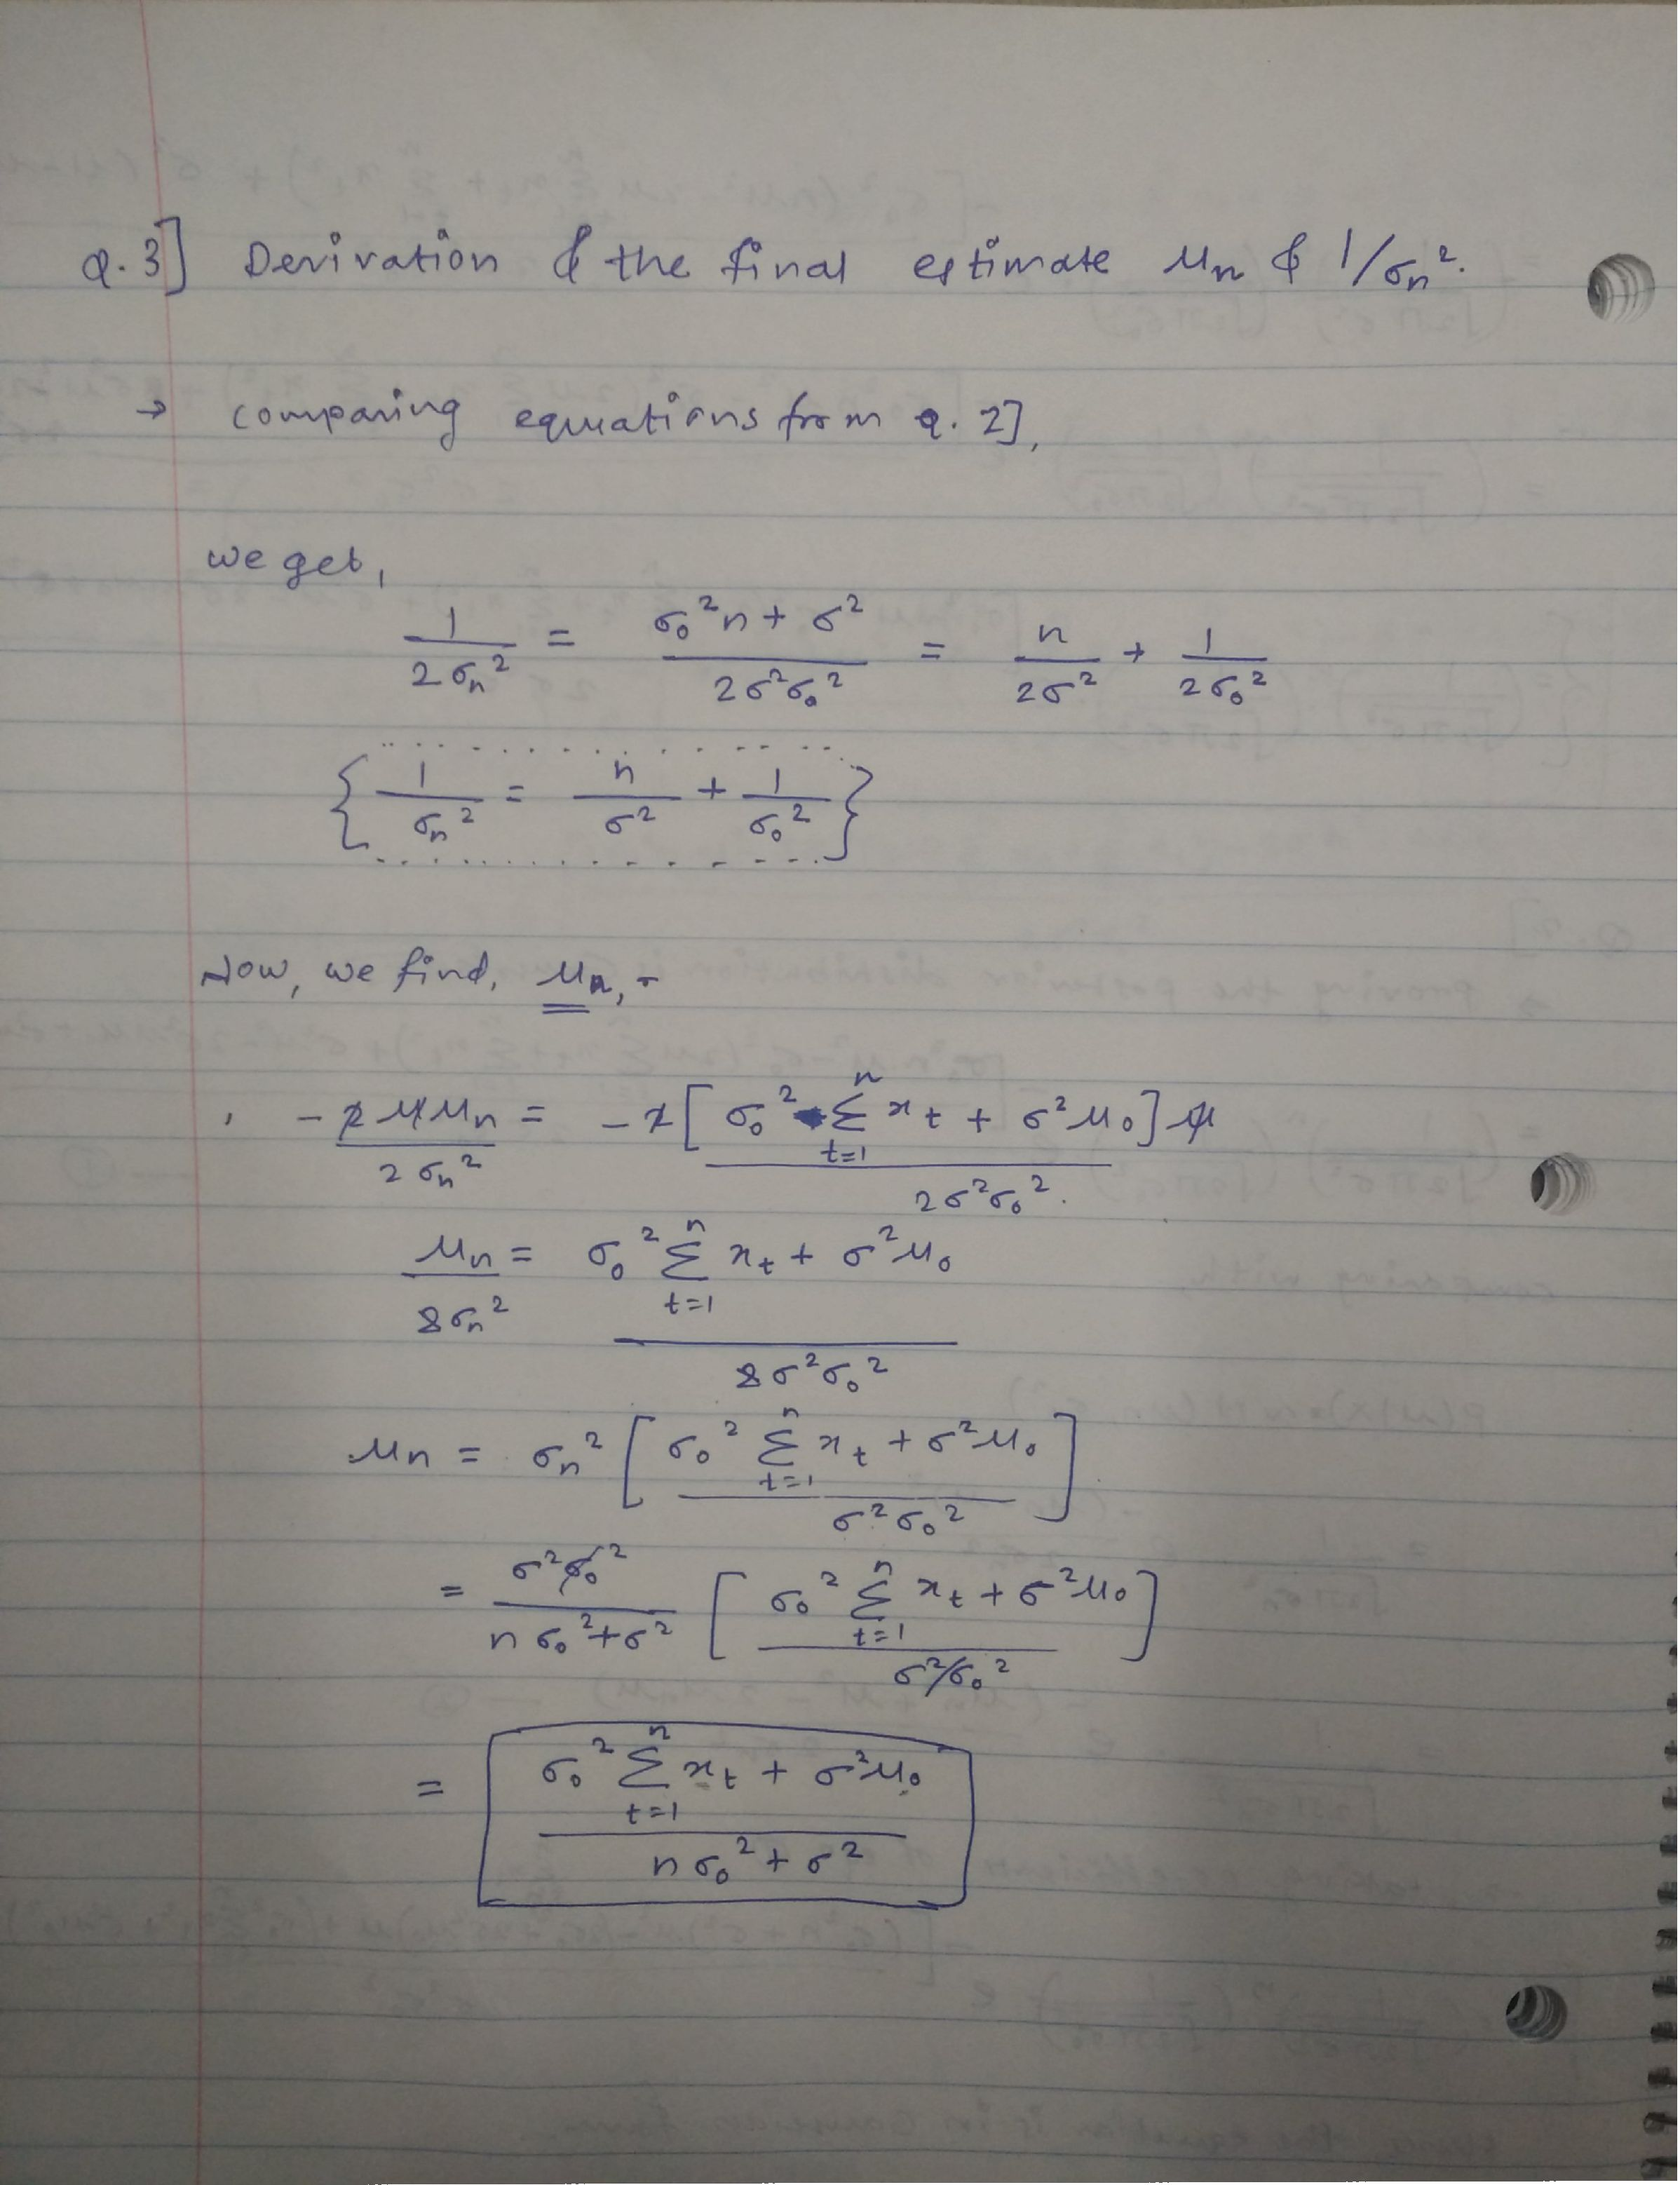

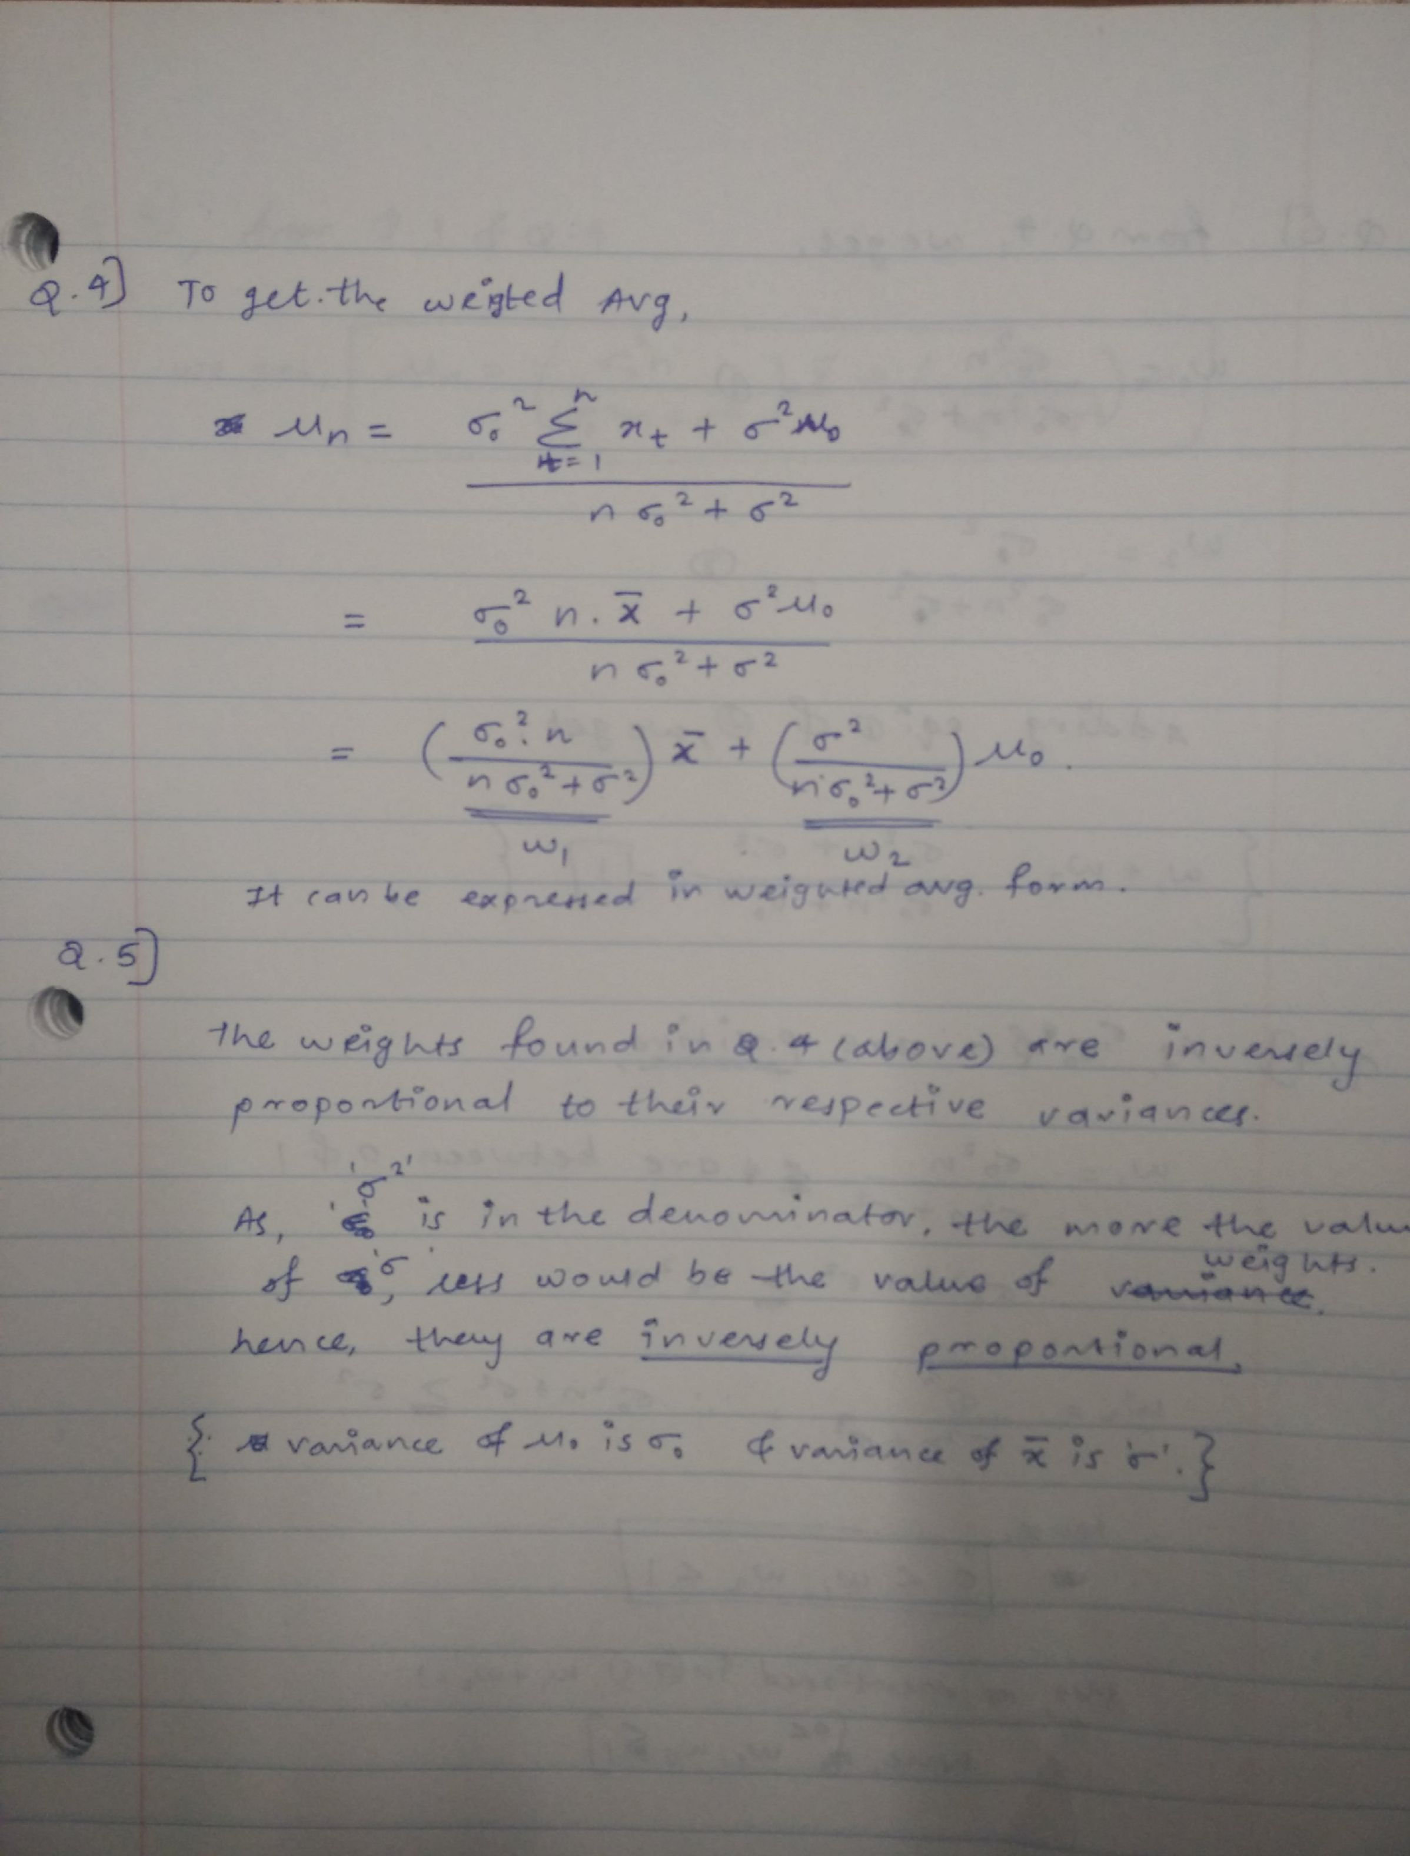

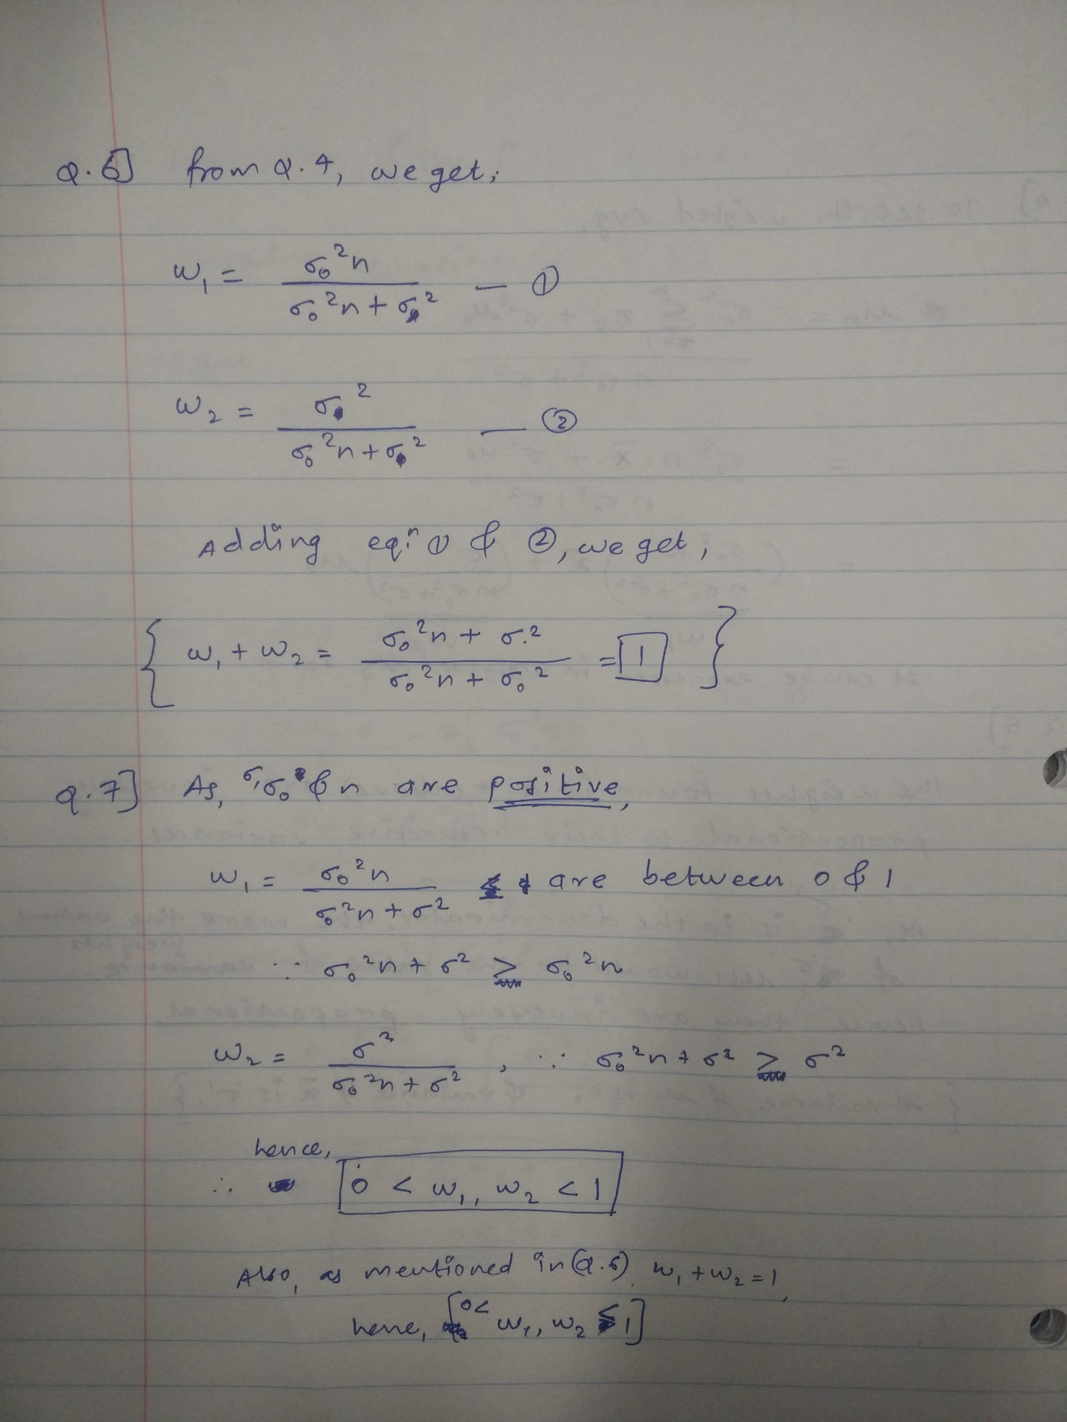

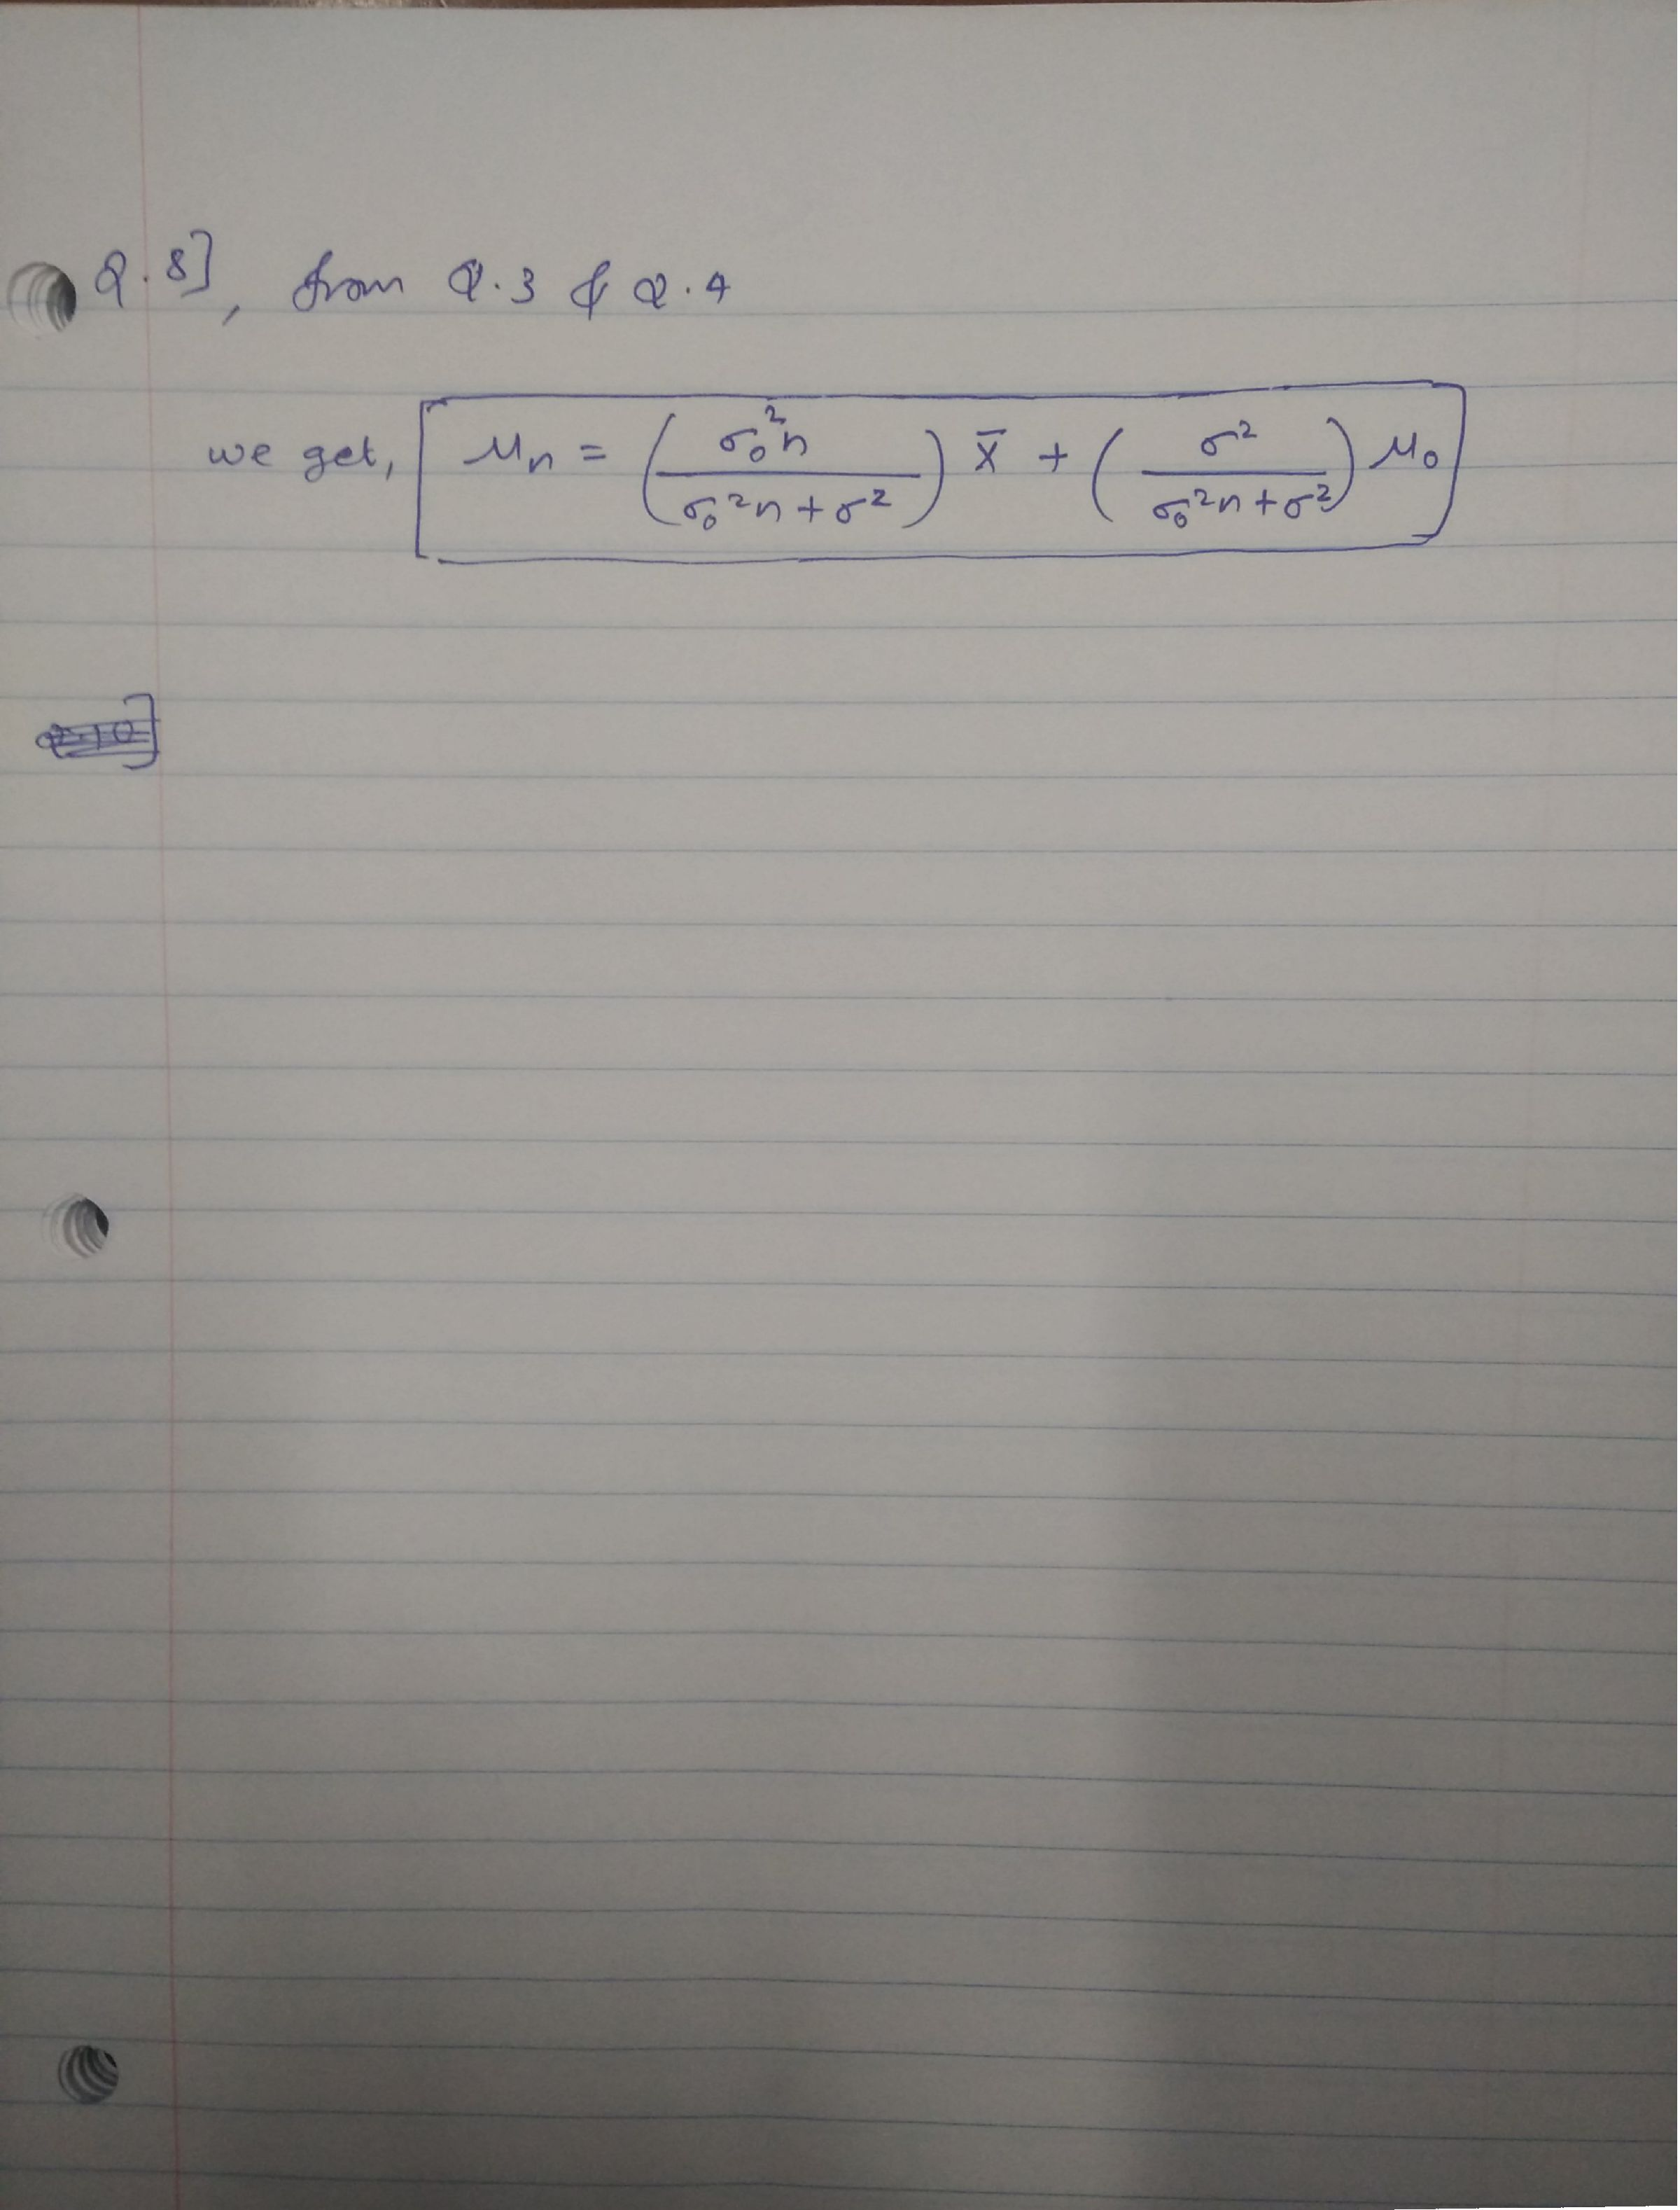

Q.10)

vectorPrior <- rnorm(20, mean = 4, sd = 0.8)

vectorPrior <- sort(vectorPrior)

densityPrior <- dnorm(vectorPrior, mean = 4, sd = 0.8)

vectorLikelihood <- rnorm(20, mean = 6, sd = 1.5)

vectorLikelihood <- sort(vectorLikelihood)

densityLikelihood <- dnorm(vectorLikelihood, mean = 6, sd = 1.5)

vectorPost <- rnorm(20, mean = 5.7, sd = 0.3093236)

vectorPost <- sort(vectorPost)

densityPost <- dnorm(vectorPost, mean = 5.7, sd = 0.3093236)

plot(vectorLikelihood, densityLikelihood, type = "l", col="green", xlim=c(1,10), ylim = c(0,3), xlab="Vector", ylab="Density")

par(new=TRUE)

plot(vectorPost, densityPost, type = "l", col="blue", xlim=c(1,10), ylim = c(0,3), xlab="Vector", ylab="Density")

par(new=TRUE)

plot(vectorPrior, densityPrior, type = "l", col="red", xlim=c(1,10), ylim = c(0,3), xlab="Vector", ylab="Density")

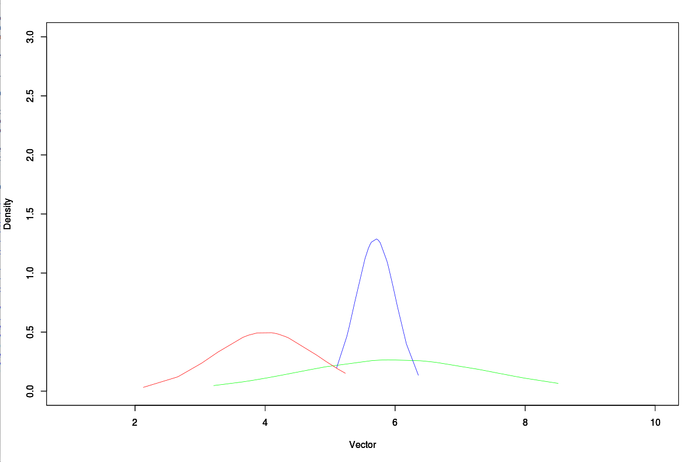**The values we get are mean = 5.7 and variance = (0.3)^2**