1. **DATABASE**

create database mahasiswa;

create table mahasiswa (NIM serial primary key not null, namaMahasiswa varchar (200) not null, JK char (1) not null);

insert into mahasiswa (NIM, namaMahasiswa, JK) values ('6543', 'Adriansyah', 'L'), ('7654', 'Nara Yunita', 'P'), ('8765', 'Farrel Abdillah', 'L'), ('9876', 'Juan Akbar', 'L'), ('0987', 'Mayasari', 'P');

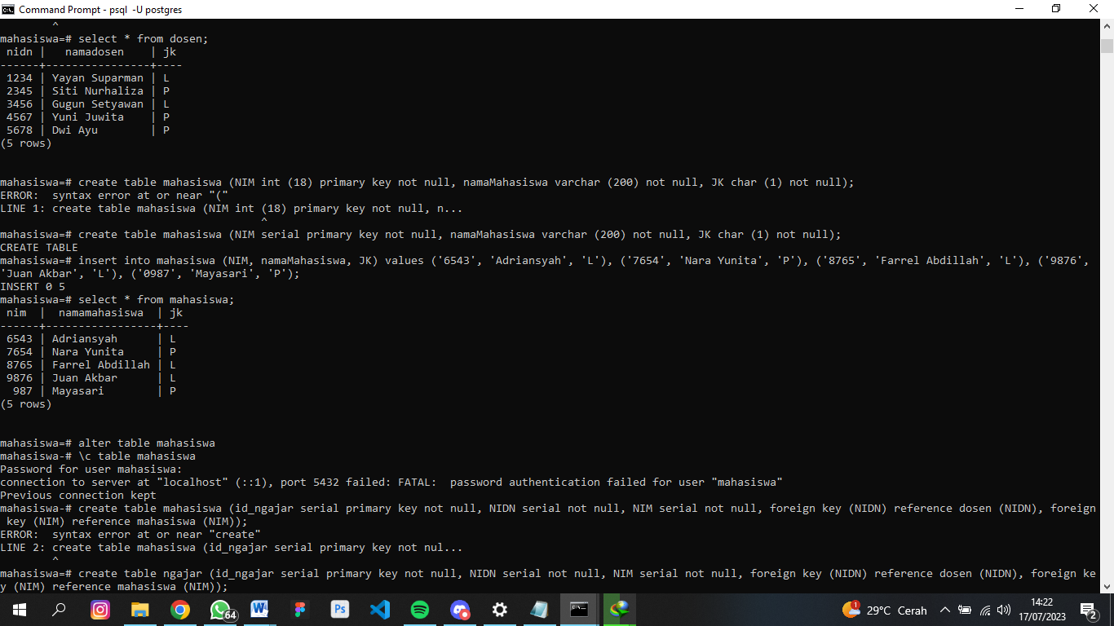

create table dosen (NIDN serial PRIMARY KEY NOT NULL, namaDosen varchar (200) NOT NULL, JK char (1) NOT NULL);

insert into dosen (NIDN, namaDosen, JK) values ('1234', 'Yayan Suparman', 'L'), ('2345', 'Siti Nurhaliza', 'P'), ('3456', 'Gugun Setyawan', 'L'), ('4567', 'Yuni Juwita', 'P'), ('5678', 'Dwi Ayu', 'P');

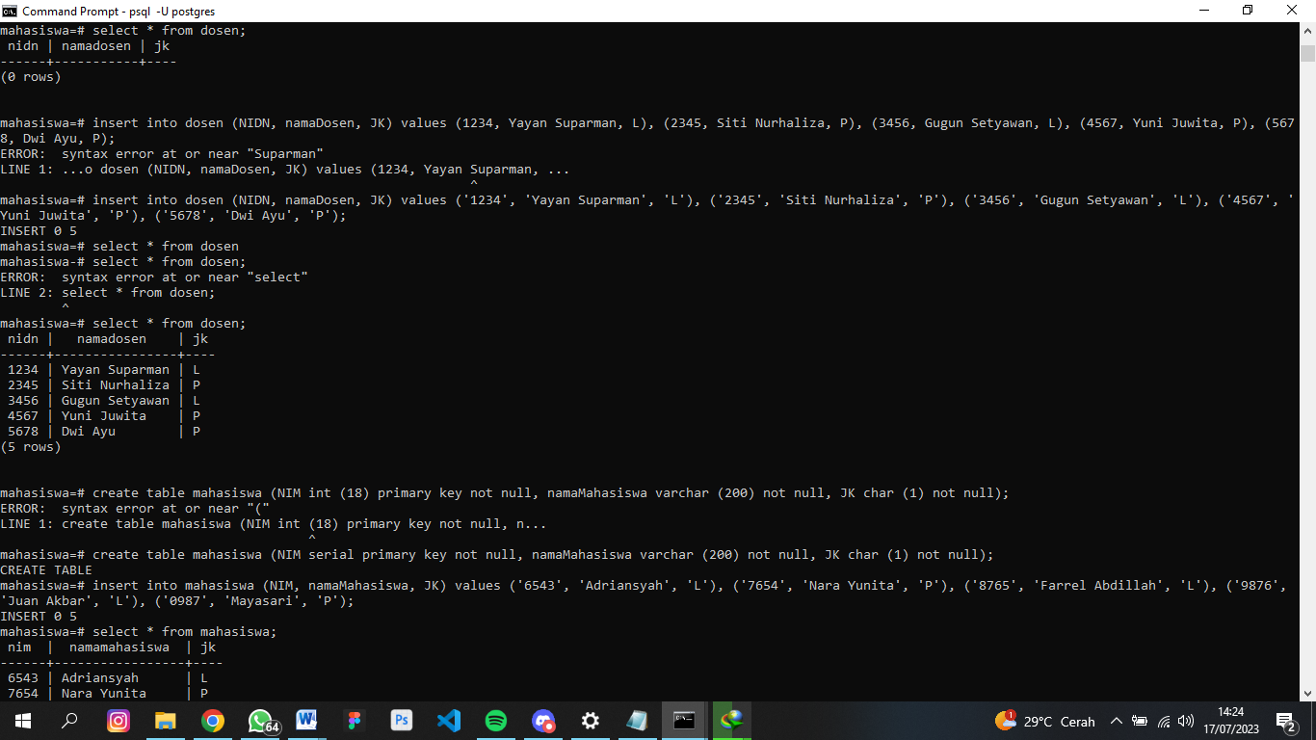

create table ngajar (id_ngajar serial primary key not null, NIDN serial not null, NIM serial not null, foreign key (NIDN) references dosen (NIDN), foreign key (NIM) references mahasiswa (NIM));

insert into ngajar (id_ngajar, NIDN, NIM) values ('1029', '1234', '0987'), ('2938', '2345', '9876'), ('3847', '3456', '8765'), ('4756', '4567', '7654'), ('5665', '5678', '6543');

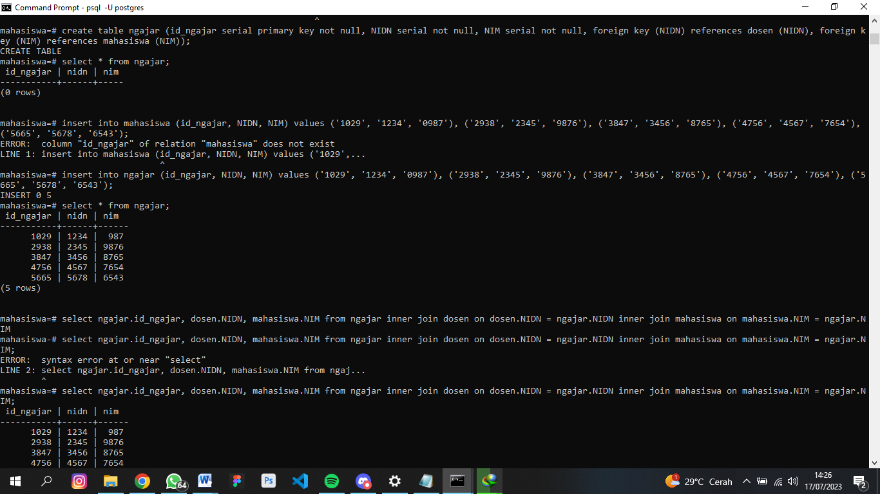

select ngajar.id_ngajar, dosen.namaDosen, mahasiswa.namaMahasiswa from ngajar inner join dosen on dosen.NIDN = ngajar.NIDN inner join mahasiswa on mahasiswa.NIM = ngajar.NIM;

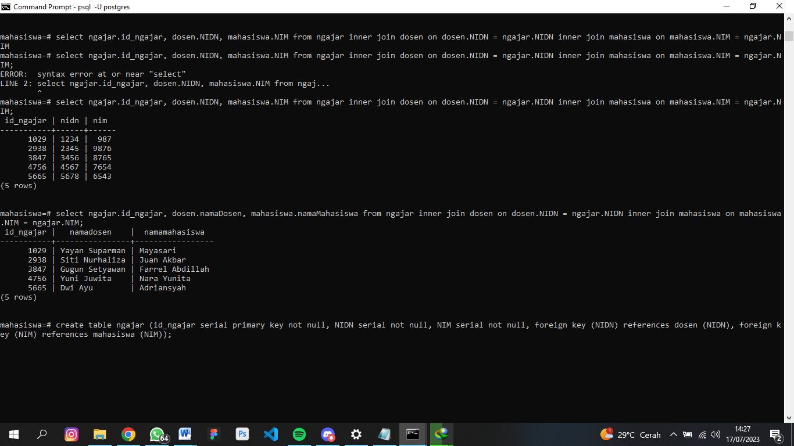

1. **CRUD**

1.Create

*CREATE DATABASE MAHASISWA;

*CREATE TABLE DOSEN;

* INSERT INTO dosen (NIDN, namaDosen, JK) values ('1234', 'Yayan Suparman', 'L'), ('2345', 'Siti Nurhaliza', 'P'), ('3456', 'Gugun Setyawan', 'L'), ('4567', 'Yuni Juwita', 'P'), ('5678', 'Dwi Ayu', 'P');

2. Read

*SELECT * FROM dosen;

*SELECT namaDosen FROM dosen;

3. Update

* UPDATE mahasiswa SET namaMahasiswa = 'Farrel Bramasta' WHERE NIM = '8765';

4.Delete

*DELETE FROM dosen WHERE NIDN = ‘22’;

1. **RELATION**

create table ngajar (id_ngajar serial primary key not null, NIDN serial not null, NIM serial not null, foreign key (NIDN) references dosen (NIDN), foreign key (NIM) references mahasiswa (NIM));

insert into ngajar (id_ngajar, NIDN, NIM) values ('1029', '1234', '0987'), ('2938', '2345', '9876'), ('3847', '3456', '8765'), ('4756', '4567', '7654'), ('5665', '5678', '6543');



select ngajar.id_ngajar, dosen.namaDosen, mahasiswa.namaMahasiswa from ngajar inner join dosen on dosen.NIDN = ngajar.NIDN inner join mahasiswa on mahasiswa.NIM = ngajar.NIM;



\d ngajar;

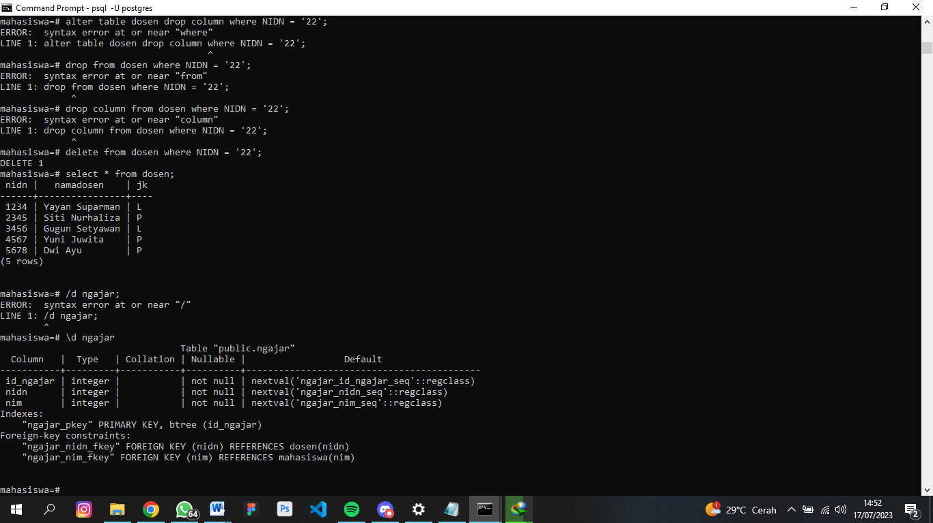

1. **HTTP CODE**

404 – Not Found (pages / data yang dicari tidak ditemukan)

302 – Found (data / page yang dicari ditemukan)

403 – Forbidden (dilarang / tidak dapat diakses)

505 – HTTP Version Not Supported (server tidak mendukung versi anda / kudet)

202 – Everythings is ok (web bekerja dengan semestinya / lancar)

1. **Collection**

