Case Study: Outland Adventures

Reports

Report 1: Equipment Sales vs Rentals
This report counts the number of orders based on whether the customer bought equipment, rented it, or had a mix of both. The point of the report is to see how customers are actually using the equipment options. If most orders are rentals instead of purchases, Blythe and Jim might reconsider how much equipment they keep available for sale.
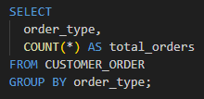

Report 2: Trip Booking by Location
This report shows how many bookings each trip location has received. Looking at the number of bookings for each region helps show which destinations customers are choosing more often. If one location has noticeably fewer bookings, it could mean demand is lower there and the company may need to adjust their trip planning or marketing.
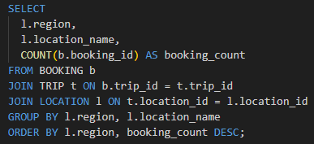

Report 3: Inventory Older Than Five Years
This report lists inventory items that were added to the system more than five years ago. Since outdoor gear gets used a lot on trips, older equipment might not be in the best condition anymore. This report helps identify gear that may need to be replaced or removed so customers have reliable equipment.
