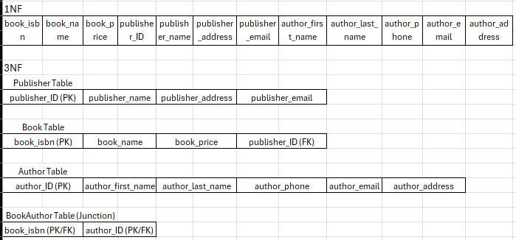

Assumptions:
- A publisher can publish many books.
- Each book has one publisher.
- Author_ID was added to uniquely identify authors.
- One book can have many authors.
- One author can have many books.

