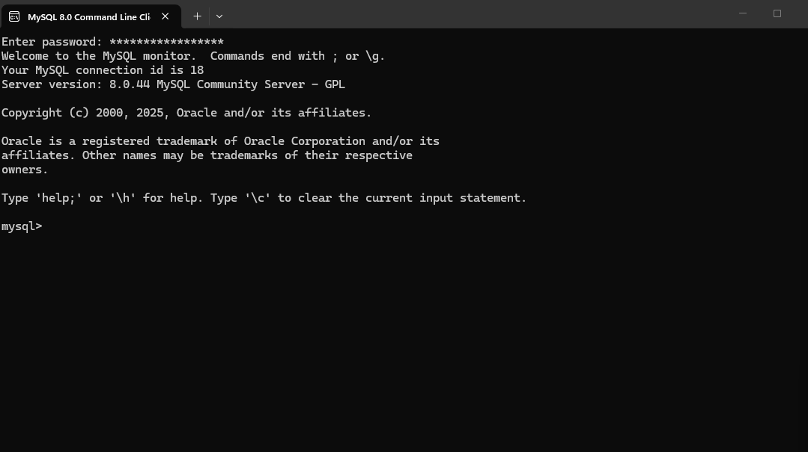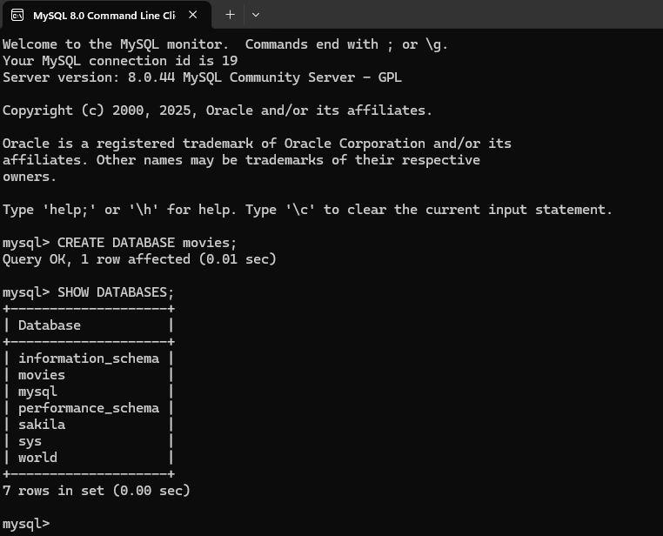
Function 1: CONCAT()
When you’d use it:
To merge multiple text fields into a single display value (reports, exports, readable output).
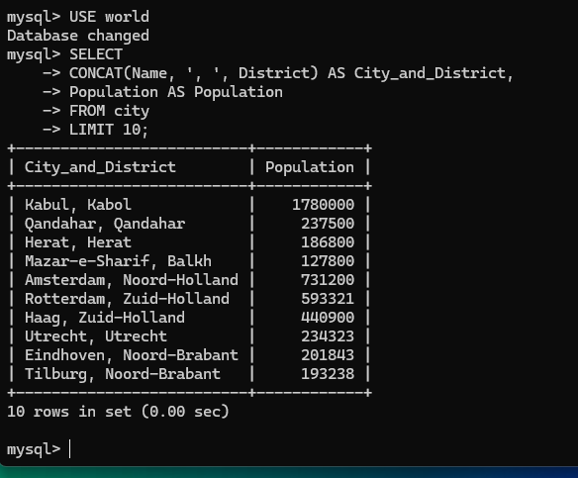

Function2: IFNULL()
When you’d use it:
To replace NULL values with a default so reports don’t show blanks.
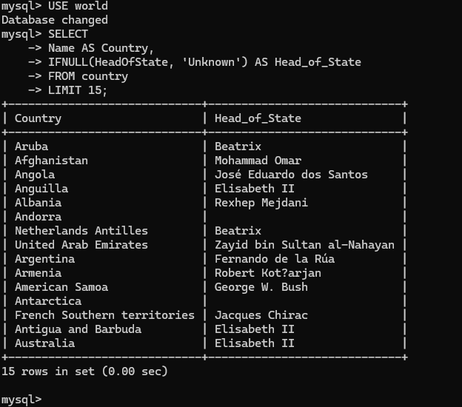

Function 3: COUNT()
When you’d use it:
To aggregate data and answer questions like “how many records are there?”
