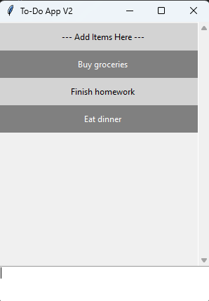
When I ran the original program, my dumb brain did exactly what the program said which was “Add items here.” I literally clicked that text box thinking I would be able to type something there (which you can’t). I also was able to delete the “add items here” box if I wanted to since the program seemed to be treating that box as an item in the to do list. Because of that, I absolutely had to change a few things to make sure the program made sense not just to me but to anyone else who ran it.
Figure 1 Original program

Besides the changes requested from the assignment, I also did the following:
- Prevented the instructions from being deleted. (It will always show at the very top)
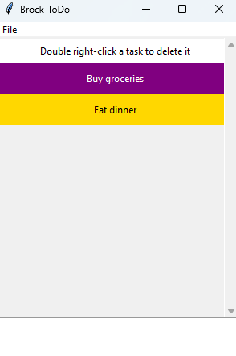
- Coded the placeholder (“add tasks below”) in different stages depending on where it is based on user input. (If no tasks, “Add tasks below” shows. If tasks are in the list, “Add tasks below” goes away until the list is empty again.) This prevents the placeholder from becoming another task in the list.
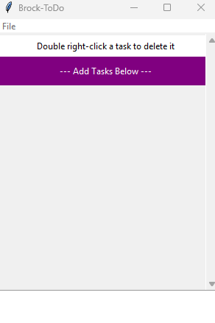
- I may have been wrong for this considering the instructions said to change left click to a simple right click, but I also took away the pop up for deletion conformation. I realized deleting A LOT of items in the list was very annoying when you had to click confirmation every time. My solution to this was to have the user double right click when they want to delete an item. Doing it this way eliminates that annoyance while also keeping the confirmation (and the right click).
Figure 3 Start of program
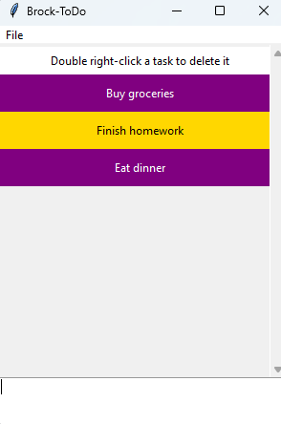
Figure 4 With items added

Figure 2 With an item deleted

