Screenshot 1:
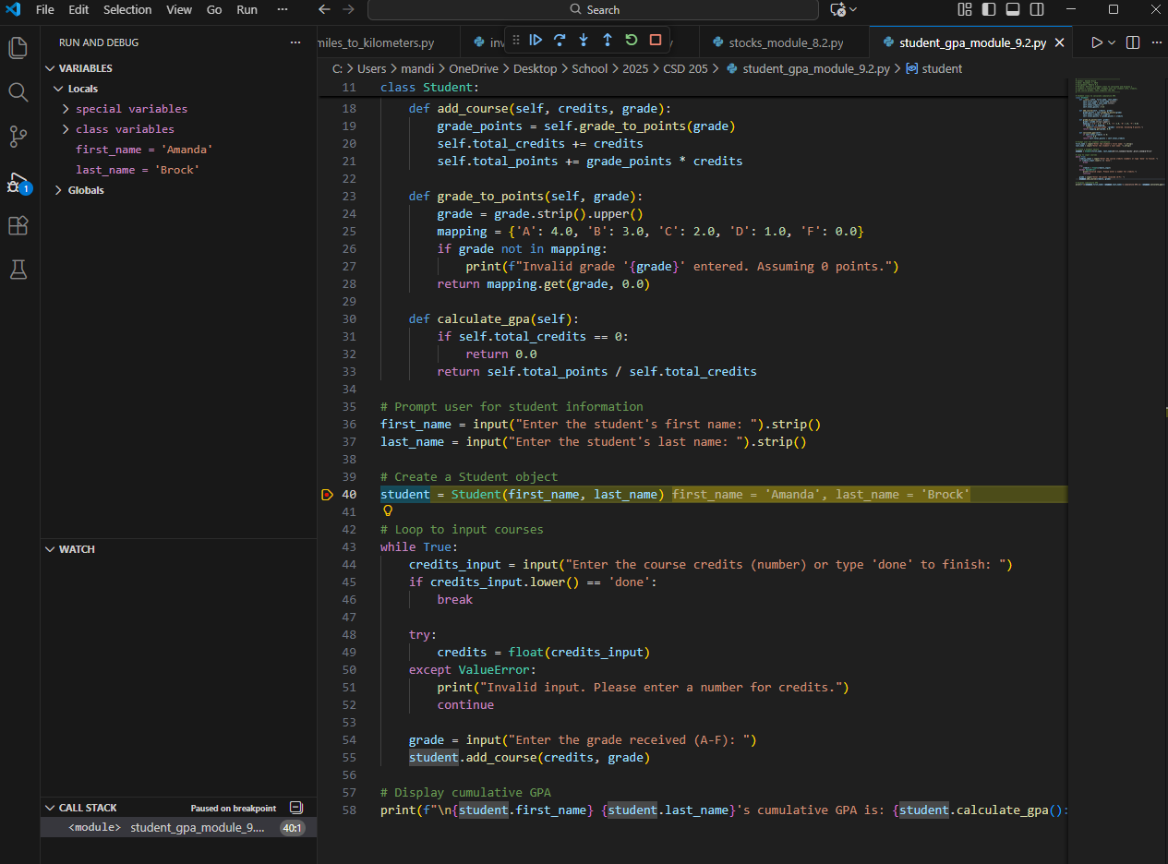
Figure 1: Breakpoint hit during debugging
Screenshot 2:
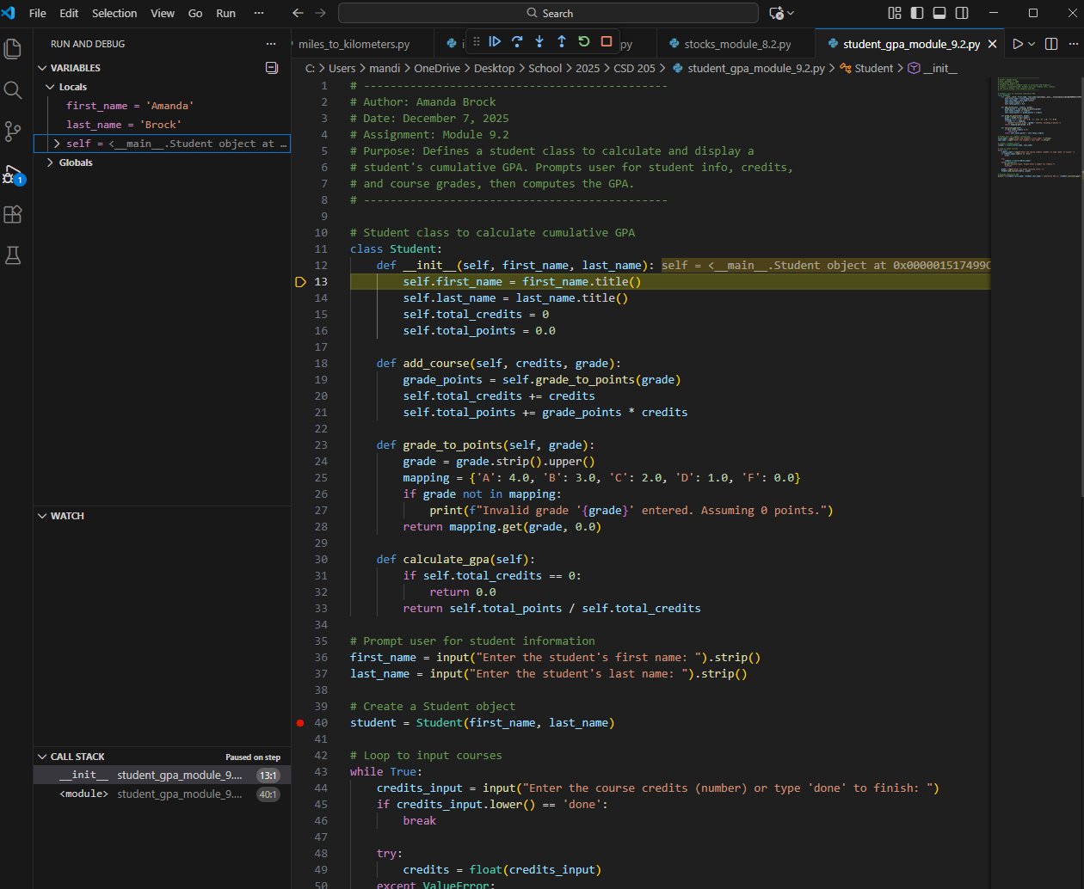
Figure 2: Stepped into init function
Screenshot 3:
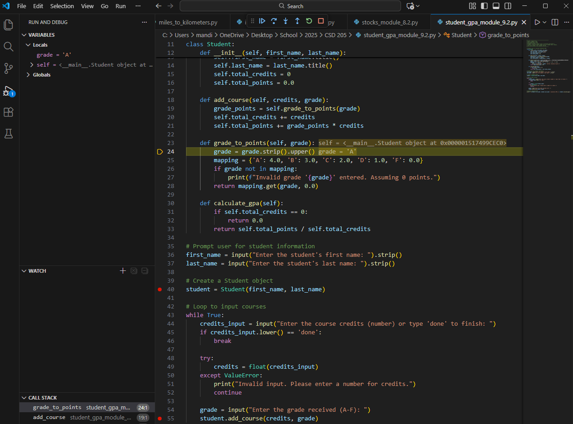
Figure 3: Stepped into add_course and grade_to_points while debugging

