Project: Todo Application Functional Testing
Course: CSD-380 DevOps
Description: Functional test plan for the Todo web application based on the Todo Business Requirements.
Date: 2026/09/03
To complete the test case plan, fill out the information for Project, Course, Description and Date in the header below.

TABLE OF CONTENTS
Website Access and Todo List Display 2
Create a Todo Item and Validate Blank Entry 2
Edit a Todo Item and Validate Blank Edit 3
Delete a Todo Item and Invalid URL Handling 4
Mobile and Tablet Views 5

Test 1 | Website Access and Todo List Display
 | Test Objective: Verify that users can access the Todo application through the required URL and view the list of todo task items. | Developer: Brady Heinz  Date tested: __________________ | Peer tester: Amanda Brock  Date tested: 9/5/26
Step | Action | Expected results: | Developer pass/fail | Tester pass/fail  + Screenshot
1 | Open a web browser. | The browser opens successfully. | ________ | Yes  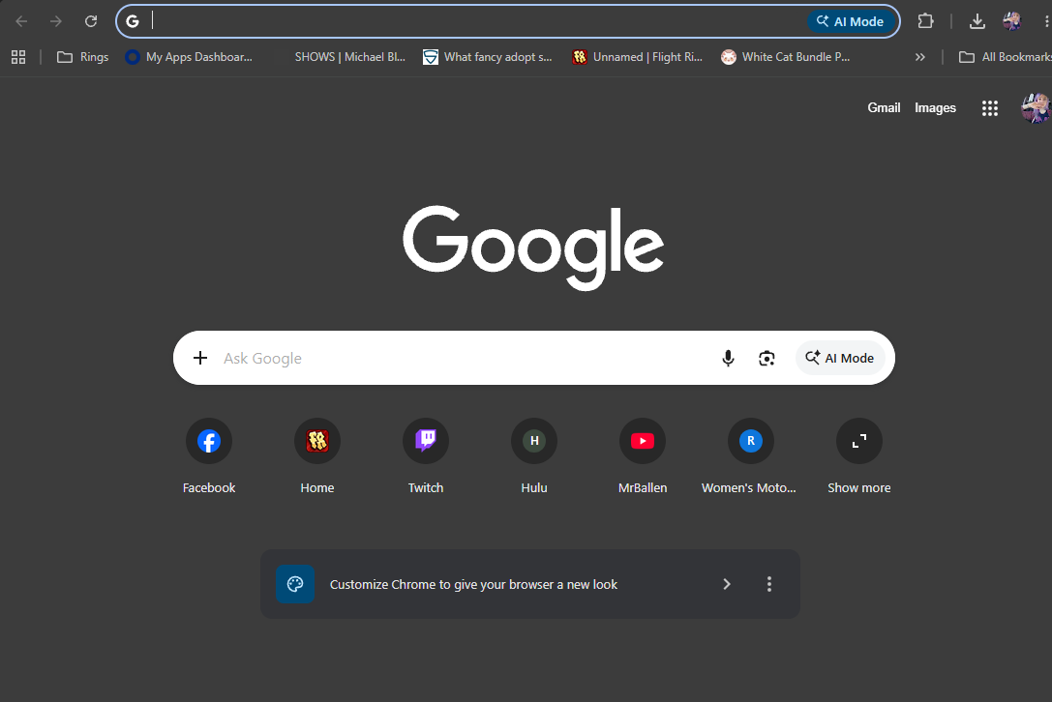
2 | Visit https://buwebdev.github.io/todo/. | The Todo website loads without errors. | ________ | Yes  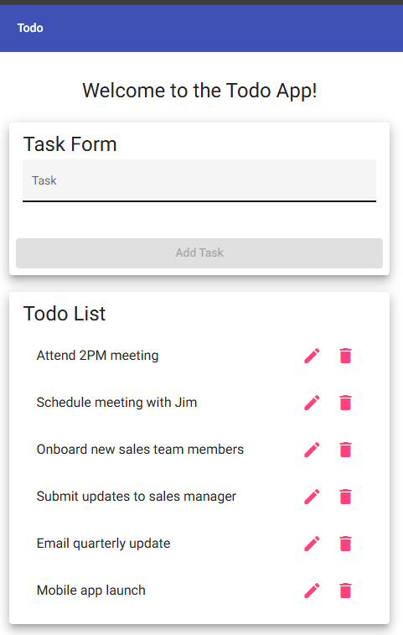
3 | Confirm the Todo list is visible on the page. | Existing todo task items are displayed. | ________ | Yes  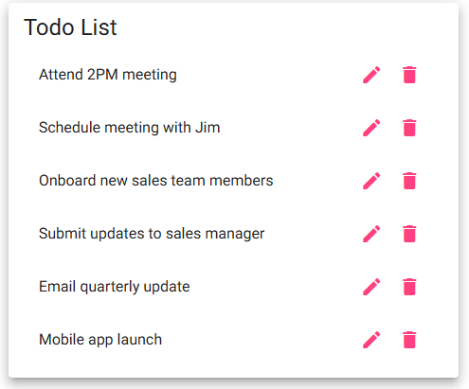
4 | Refresh the browser window. | The page reloads correctly. | ________ | Yes
5 | Confirm the Todo list is still displayed after refreshing. | The Todo task list remains available and usable. | ________ | Yes
Comments | Requirements covered: viewing todo items and accessing the application through the standard URL.  Peer tester comments: The website loaded correctly and the Todo list displayed without any issues. After refreshing the page, the list was still available and usable. All steps in this test passed as expected.

Test 2 | Create a Todo Item and Validate Blank Entry
 | Test Objective: Verify that users can create a new todo task and cannot submit a blank task. | Developer: Brady Heinz  Date tested: __________________ | Peer tester: Amanda Brock  Date tested: 9/5/26
Step | Action | Expected results: | Developer pass/fail | Tester pass/fail  + Screenshot
1 | Open the Todo website. | The Todo page loads correctly. | ________ | Yes
2 | Enter "Complete CSD-380 assignment" in the new todo field. | The text appears in the task field. | ________ | Yes  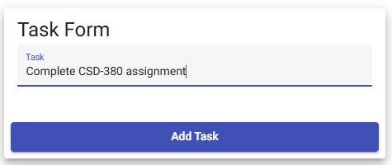
3 | Submit the new todo item. | The new task is added to the Todo list. | ________ | Yes  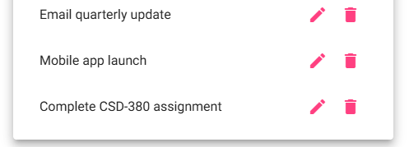
4 | Leave the new todo field empty and attempt to submit it. | The application prevents the blank task from being submitted. | ________ | Yes  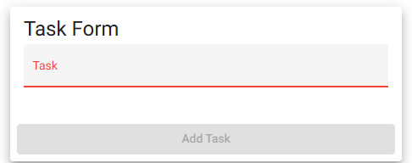
5 | Review the Todo list. | No blank task appears in the list. | ________ | Yes  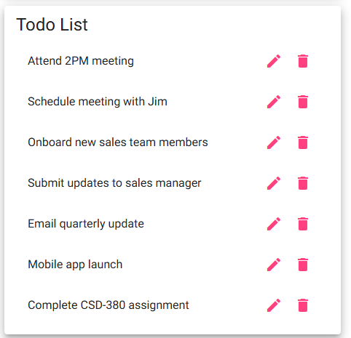
Comments | Requirements covered: creating todo items and preventing blank todo entries.  Peer tester comments: A new task was added successfully and appeared in the Todo list. The application also prevented a blank task from being submitted. All steps passed and the task form worked as expected.

Test 3 | Edit a Todo Item and Validate Blank Edit
 | Test Objective: Verify that users can edit an existing todo task and cannot save an edited task with an empty value. | Developer: Brady Heinz  Date tested: __________________ | Peer tester: Amanda Brock  Date tested: 9/5/26
Step | Action | Expected results: | Developer pass/fail | Tester pass/fail  + Screenshot
1 | Select an existing todo task and choose the Edit option. | The edit form opens for the selected task. | ________ | Yes  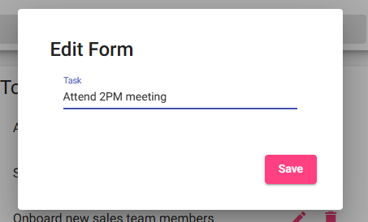
2 | Change the task description to "Finish Todo Test Plan." | The updated text appears in the edit field. | ________ | Yes  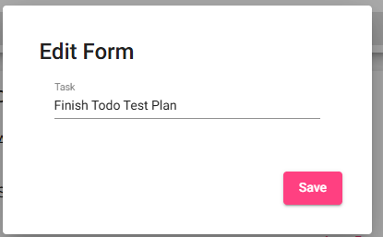
3 | Save the edited task. | The Todo list displays the updated task description. | ________ | Yes  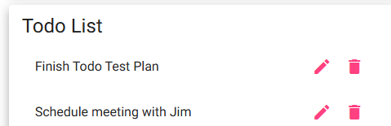
4 | Edit the task again, remove all text, and attempt to save. | The application prevents the empty edit from being submitted. | ________ | No  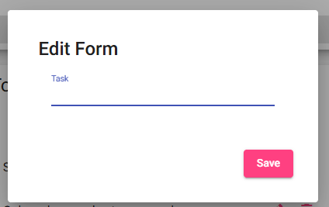
5 | Return to the Todo list. | The task retains a valid description and no blank task is displayed. | ________ | No  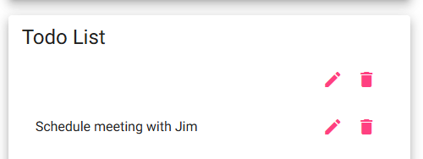__
Comments | Requirements covered: editing todo items and preventing blank values when editing.  Peer tester comments: The task could be edited and saved with the updated description as expected. However, the application allowed the task to be saved after all text was removed, which created a blank item in the list. The edit form should prevent empty values from being saved.

Test 4 | Delete a Todo Item and Invalid URL Handling
 | Test Objective: Verify that users can delete a todo item and that invalid URLs display the application custom 404 error page. | Developer: Brady Heinz  Date tested: __________________ | Peer tester: Amanda Brock  Date tested: 9/5/26
Step | Action | Expected results: | Developer pass/fail | Tester pass/fail  + Screenshot
1 | Create or identify a todo task that can be deleted. | The task is visible in the Todo list. | ________ | Yes  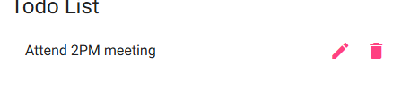
2 | Select the Delete option for the task. | The selected task is removed from the Todo list. | ________ | Yes  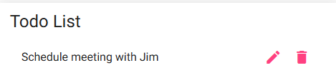
3 | Refresh the Todo page. | The deleted task does not return. | ________ | No  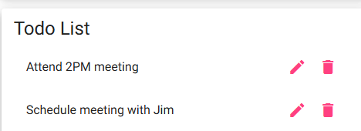
4 | Enter an invalid Todo URL, such as https://buwebdev.github.io/todo/invalidpage. | The invalid URL is processed by the website. | ________ | Yes  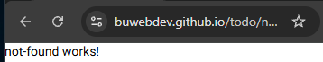
5 | Review the displayed error page. | A custom 404 error page is displayed to the user. | ________ | Yes
Comments | Requirements covered: deleting todo items and displaying a custom 404 page for invalid application URLs.  Peer tester comments: The task was removed from the Todo list successfully when the delete option was selected. However, the deleted task returned after the page was refreshed, so the deletion did not persist. The invalid URL test worked correctly and displayed the custom 404 page.

Test 5 | Mobile and Tablet Views
 | Test Objective: Verify that the Todo application provides usable views for both mobile and tablet devices. | Developer: Brady Heinz  Date tested: __________________ | Peer tester: Amanda Brock  Date tested: 9/5/26
Step | Action | Expected results: | Developer pass/fail | Tester pass/fail  + Screenshot
1 | Open the Todo website using a desktop browser. | The website displays normally. | ________ | Yes  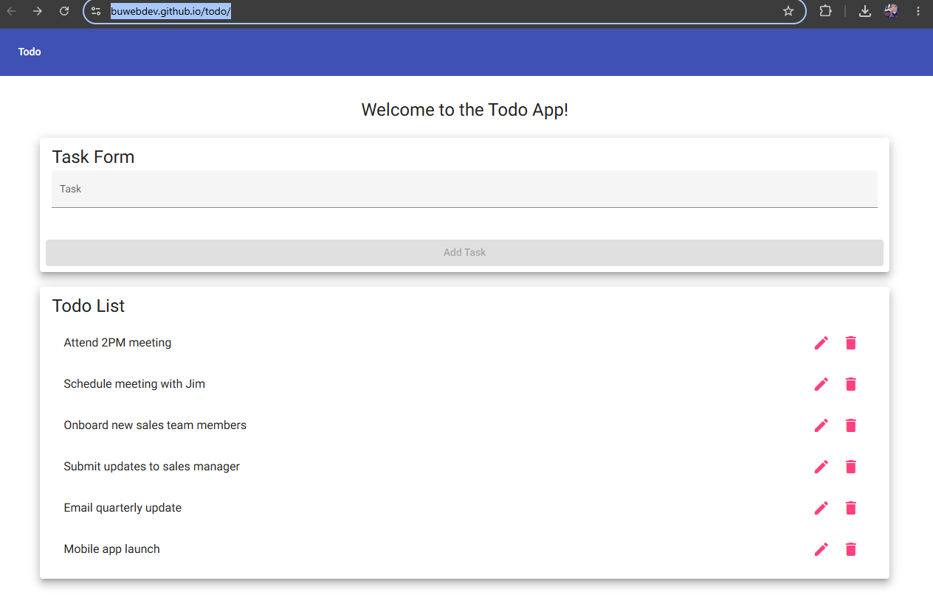
2 | Use the browser responsive design mode and select a mobile screen size. | The page adjusts to a mobile-friendly layout. | ________ | Yes  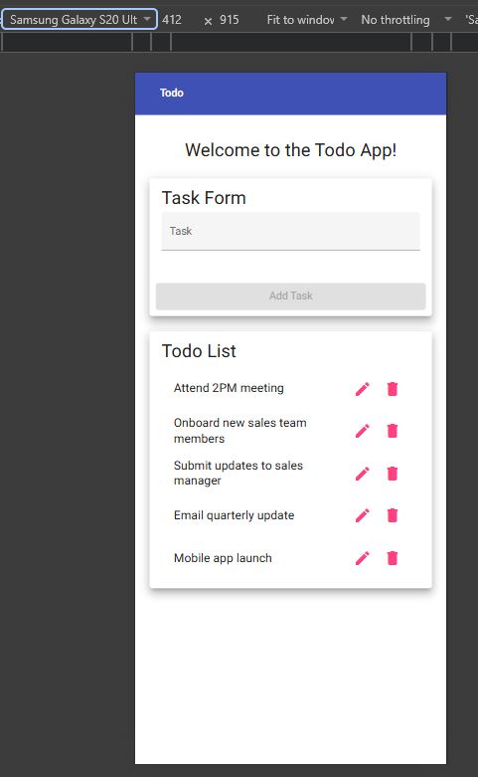
3 | Confirm the Todo list and controls can be viewed and used at the mobile size. | Content is readable and controls remain accessible. | ________ | Yes  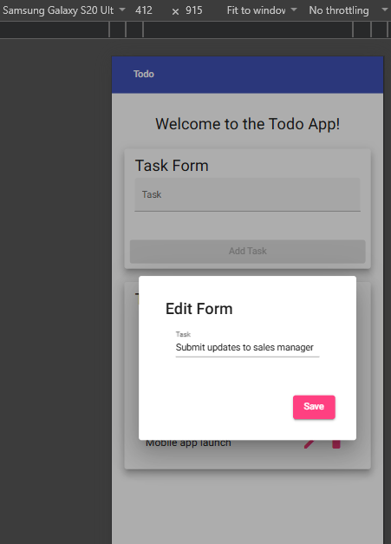
4 | Change the responsive display to a tablet screen size. | The page adjusts to a tablet-friendly layout. | ________ | Yes  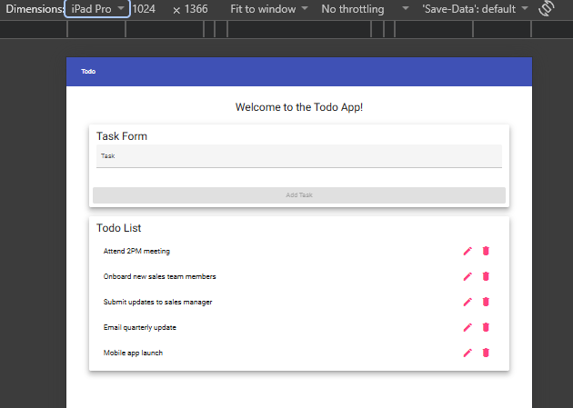
5 | Confirm the Todo list and controls can be viewed and used at the tablet size. | Content is readable and controls remain accessible. | ________ | Yes  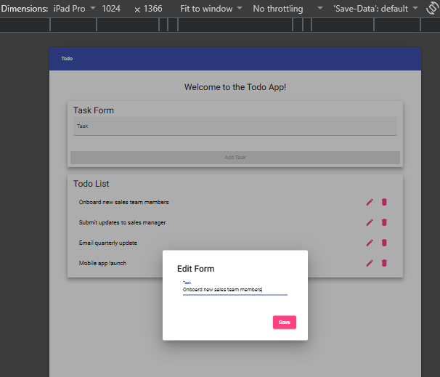
Comments | Requirements covered: mobile and tablet views of the Todo application.  Peer tester comments: The application displayed correctly in both mobile and tablet screen sizes. The Todo list and controls remained readable and accessible in both views. All responsive layout steps passed during testing.

