Retail Fulfillment - Value Stream Map
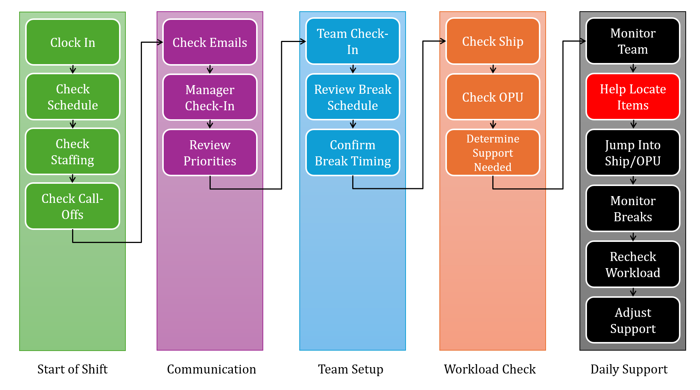
Stage | Estimated Average Flow Time
Start of Shift Setup | ~30-50 minutes
Monitor team/breaks | Ongoing throughout shift
Help locate missing items | ~20-30 minutes per occurrence
Jump into Ship/OPU | Variable based on workload
Recheck workload/adjust support | ~5-10 minutes per check

Estimated Cycle Time: 8.5 hours

One of the biggest delays during a fulfillment shift occurs when an item cannot be located for a customer's order. This is especially common with Style items. The inventory system may show that several of an item are on hand even when the item has not been delivered to the store in months. Team members may spend 20–30 minutes searching the sales floor, backroom, and other possible locations before determining that the item cannot be found. RFID devices can help locate Style merchandise, but when they are unavailable or not working properly, the search can take even longer. During this time, the customer's order is not moving forward, and a leader may also have to stop another task to assist with the search.

Lean Waste and Process Issues Identified
Motion: Searching multiple areas for merchandise
Waiting: Customer order stops progressing
Overprocessing: Continuing to search for potentially unavailable inventory
Task interruption: Leader stops another activity to assist

Contributing factors: inaccurate on-hand inventory counts and RFID equipment problems.

Optimizing the Fulfillment Leadership Process
- Eliminating Waste:
  - The largest variable in the current value stream occurs when fulfillment team members cannot locate an item. Extended searches can create excess walking, waiting, and interruptions for both the team member and leaders assisting them.
- Workflow Orchestration:
  - A new fulfillment process allows a team member to request additional help, or "escalate" an item, if it cannot be located within two minutes after checking its home and other obvious locations. The escalation automatically sends an alert to leaders and designated experts, allowing several qualified employees to assist instead of requiring the team member to locate a specific leader.
- Standardization:
  - The two-minute rule creates a consistent escalation point. Rather than each employee deciding individually how long to search, everyone follows the same process. The total time from the beginning of the search until the item is either located or confirmed unavailable could then be compared before and after the change to determine whether the new process reduces overall flow time.

Conclusion
Mapping my typical fulfillment shift helped identify that the largest delay does not occur during the routine tasks at the beginning of the day, but during the repeated support activities that happen throughout the shift. Missing items, specifically Style, can require 20–30 minutes of searching, especially when inventory counts are inaccurate or RFID equipment is not working properly. The new two-minute escalation process is intended to reduce the amount of time one employee spends searching alone and involve additional resources sooner. Comparing missing-item resolution times before and after the change would show whether the new process actually improves the value stream.

