**SYNPOSIS-1**

**ONLINE RESTAURANT MANAGEMENT SYSTEM**

**SUBMITTED TO:**



GURU NANAK DEV UNIVERSITY COLLEGE, JALANDHAR

For the partial fulfillment of the requirement for the award of degree of

“MASTER OF COMPUTER APPLICATIONS”

(2016-2019)

**SUBMITTED TO: SUBMITTED BY:**

Ms. Hiteshi Nitin

(Lect. of Computer Science Block) MCA(TYC) 6th Sem

2016-CSB1215

**Department of Computer Science & Application**

**Guru Nanak Dev University College,**

**Jalandhar**

INDEX

|  |  |  |
| --- | --- | --- |
| **S No.** | **CONTENTS** | **Pg. No.** |
|  |  |  |
| 1. | Introduction | 3 |
| 2. | Technologies Used | 4 |
| 3. | Python | 4-8 |
| 4. | MongoDB | 9-12 |
| 5. | Django | 13-16 |
| 6. | Existing and Proposed System | 17 |
| 7. | Feasibility Study | 18-19 |
|  | a. Economical Feasibility |  |
|  | b. Technical Feasibility |  |
|  | c. Operational Feasibility |  |
| 8. | Requirements during Development | 20-21 |
| 9. | References | 22 |

1. **INTRODUCTION**

The objective to build an **Online Restaurant Management System** project that can efficiently handle and manage various activities of a restaurant and all these activities will be happening under the supervision of the administrator. The businesses in restaurants are now growing constantly.

At the same time, the need for managing its operations and tasks arises. The best way to optimize these activities is growing the business online as well. Today's generation encourages high-tech services especially over the Internet. Hence the project is developed proficiently to help restaurant owners automate their business operations. This project serves the best way of maintaining customer's information and caters their needs.

The project has admin login that controls all the online activities in the system. Admin can check and verify various member details. He can even approve or disapprove table booking requests.

Users have to first create an account into the system by registering themselves. Then he/she can login into the system to avail various services.

The system has a graphical view of tables that user can select or deselect from the available slot in the system. The booking system is such that already booked tables are shown in red color and the available ones in usual color. These bookings can be seen by admin from his account and he may approve or disapprove the request.

The system can be used in restaurants, hotels, and clubs for booking tables. The system can also be used as software to promote various restaurants.

**2. TECHNOLOGIES USED**

**2.1 Python**

Python is an interpreted, high-level, general-purpose programming language. Created by Guido van Rossum and first released in 1991, Python has a design philosophy that emphasizes code readability, notably using significant whitespace. It provides constructs that enable clear programming on both small and large scales. Van Rossum led the language community until stepping down as leader in July 2018.

Python features a dynamic type system and automatic memory management. It supports multiple Programming paradigms, including object-oriented, imperative, functional and procedural, and has a large and comprehensive standard library.

**2.2 MongoDB**

MongoDB is an [open source](https://whatis.techtarget.com/definition/open-source) database management system (DBMS) that uses a document-oriented database model which supports various forms of data. It is one of numerous non-relational [database](https://searchsqlserver.techtarget.com/definition/database) technologies which arose in the mid-2000s under the [NoSQL](https://searchdatamanagement.techtarget.com/definition/NoSQL-Not-Only-SQL) banner for use in big data applications and other processing jobs involving data that doesn't fit well in a rigid relational model. Instead of using [tables](https://whatis.techtarget.com/definition/table) and [rows](https://searchoracle.techtarget.com/definition/row) as in [relational databases](https://searchdatamanagement.techtarget.com/definition/relational-database), the MongoDB architecture is made up of collections and documents.

**2.3 Django**

Django is a high-level Python Web framework that encourages rapid development and clean, pragmatic design. Built by experienced developers, it takes care of much of the hassle of Web development, so you can focus on writing your app without needing to reinvent the wheel. It's free and open source.

**3. Python**

Python is an interpreted, high-level, general-purpose programming language. Created by Guido van Rossum and first released in 1991, Python has a design philosophy that emphasizes code readability, notably using significant whitespace. It provides constructs that enable clear programming on both small and large scales. Van Rossum led the language community until stepping down as leader in July 2018.

Python features a dynamic type system and automatic memory management. It supports multiple Programming paradigms, including object-oriented, imperative, functional and procedural, and has a large and comprehensive standard library.

**3.1 PROMINENT FEATURES:**

Python provides lots of features that are listed below:

* Easy to Learn and Use
* Expressive Language
* Interpreted Language
* Python is a High- Level Language
* Portable
* Free and Open Source
* Object-Oriented Language
* Extensible
* Large Standard Library
* GUI Programming Support
* Integrated
* Dynamically Typed
* Embeddable
  + 1. **Easy to Learn and Use:**
* **Easy to Code:**

Python is very easy to code. Compared to other popular languages like Java and C++, it is easier to code in Python. Anyone can learn [python syntax](https://data-flair.training/blogs/python-syntax-semantics/)in just a few hours. Though sure, mastering Python requires learning about all its advanced concepts and packages and modules. That takes time. Thus, it is programmer-friendly.

* **Easy to Read:**

Being a high-level language, Python code is quite like English. Looking at it, you can tell what the code is supposed to do. Also, since it is dynamically-typed, it mandates indentation. This aids readability.

**3.1.2 Expressive Language:**

Python language is more expressive. The sense of expressive is the code is easily understandable.

**3.1.3 Interpreted Language:**

* If you’re any familiar with languages like C++ or Java, you must first compile it, and then run it. But in Python, there is no need to compile it. Internally, its source code is converted into an immediate form called bytecode. So, all you need to do is to run your Python code without worrying about linking to libraries, and a few other things.
* By interpreted, we mean the source code is executed line by line, and not all at once. Because of this, it is easier to debug your code. Also, interpreting makes it just slightly slower than Java, but that does not matter compared to the benefits it has to offer.

**3.1.4 High Level Language:**

It is a high-level language. This means that as programmers, we don’t need to remember the system architecture. Nor do we need to manage the memory. This makes it more programmer-friendly and is one of the key python features.

**3.1.5 Portable:**

It is platform independent programming language, its code easily run on any platform such as Windows, Linux, Unix, Macintosh etc. Thus, Python is a portable language.

**3.1.6 Free and Open Source:**

* Python is freely available. You can download it from the following link: <https://www.python.org/downloads/>
* It is open-source. This means that its source code is available to the public. You can download it, change it, use it, and distribute it. This is called FLOSS (Free/Liber and Open Source Software). As the Python community, we’re all headed toward one goal- an ever-bettering Python.

**3.1.7 Object-Oriented Language:**

A programming language that can model the real world is said to be object-oriented. It focuses on objects, and combines data and functions. Contrarily, a procedure-oriented language revolves around functions, which are code that can be reused. Python supports both procedure-oriented and object-oriented programming which is one of the key python features. It also supports multiple inheritance, unlike Java. A class is a blueprint for such an object. It is an abstract data type, and holds no values.

|  |
| --- |
| **Basic concepts of OOPs are:** |
| * Object * Class * Inheritance * Polymorphism * Abstraction * Encapsulation |

**3.1.8 Extensible:**

If needed, you can write some of your Python code in other languages like C++. This makes Python an extensible language, meaning that it can be extended to other languages.

**3.1.9 Large Standard Library:**

Python downloads with a large library that you can use so you don’t have to write your own code for every single thing. There are libraries for regular expressions, documentation-generation, unit-testing, web browsers, threading, databases, CGI, email, image manipulation, and a lot of other functionality.

**3.1.10 GUI Programming Support:**

Python supports the GUI programming. You can use Tkinter to create basic GUIs.

**3.1.11 Integrated:**

It can be easily integrated with languages like C, C++, JAVA etc.

**3.1.12 Dynamically Typed:**

Python is dynamically-typed. This means that the type for a value is decided at runtime, not in advance. This is why we don’t need to specify the type of data while declaring it.

**3.1.13 Embeddable:**

It is possible to put code in other languages in our Python source code. However, it is also possible to put our Python code in a source code in a different language like C++. This allows us to integrate scripting capabilities into our program of the other language.

**4. MongoDB**

* MongoDB is an open-source document database and leading NoSQL database.
* MongoDB is written in C++.
* MongoDB is a cross-platform, document oriented database that provides, high performance, high availability, and easy scalability.
* MongoDB works on concept of collection and document.
* MongoDB was designed to work with commodity servers. Now it is used by company of all sizes, across all industry.

**4.1 Database**

Database is a physical container for collections. Each database gets its own set of files on the file system. A single MongoDB server typically has multiple databases.

**4.2 Collection**

Collection is a group of MongoDB documents. It is the equivalent of an RDBMS table. A collection exists within a single database. Collections do not enforce a schema. Documents within a collection can have different fields. Typically, all documents in a collection are of similar or related purpose.

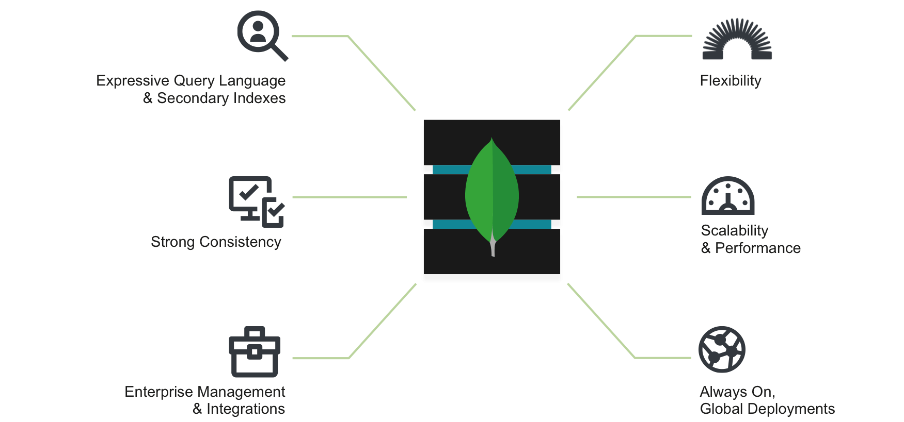

**4.3 Document**

A document is a set of key-value pairs. Documents have dynamic schema. Dynamic schema means that documents in the same collection do not need to have the same set of fields or structure, and common fields in a collection's documents may hold different types of data.

**4.4 Advantages of MongoDB in database development**

MongoDB is one of the top databases available in the market. **MongoDB is a non-relational database** with many advanced features and options. Here are a few of the advantages of using MongoDB.

* **Flexible Database**

We know that MongoDB is a schema-less database. That means we can have any type of data in a separate document. This thing gives us flexibility and a freedom to store data of different types.

* **Scalability**

A great advantage of MongoDB is that it is a horizontally scalable database. When you have to handle a large data, you can distribute it to several machines.

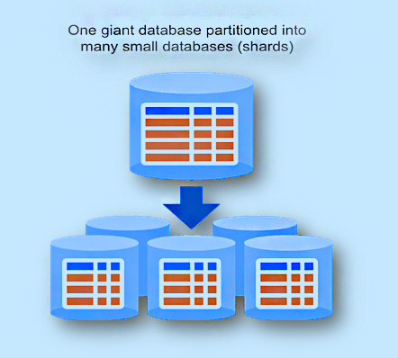

* **Sharding**

We can store a large data by distributing it to several servers connected to the application. If a server cannot handle such a big data, then there will be no failure condition. The term we can use here is “auto-sharding”.

* **High Speed**

MongoDB is a document-oriented database. It is easy to access documents by indexing. Hence, it provides fast query response. The speed of MongoDB is 100 times faster than the relational database.

* **Ad-hoc Query Support**

MongoDB has a very advanced feature for ad hoc queries. This is why we don’t need to worry about fore coming queries coming in the future.

* **Easy Environment Setup**

It is easier to setup MongoDB then RDBMS. It also provides JavaScript client for queries.

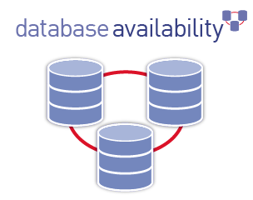

* **Replication**

MongoDB supports Master Slave replication. A master can perform Reads and Writes and a Slave copies data from the master and can only be used for reads or back up (not writes).

* **High Availability**

MongoDB has features like replication and gridFS. These features help to increase data availability in MongoDB. Hence the performance is very high.

**5. Django**

Django is a high-level Python Web framework that encourages rapid development and clean pragmatic design. A Web framework is a set of components that provide a standard way to develop websites fast and easily. It delivers transparent and high-quality code writing, making it important for developers, and equally important for customers. Django’s primary goal is to ease the creation of complex database-driven websites. Some well-known sites that use Django include PBS, Instagram, Disqus, Washington Times, Bit bucket and Mozilla.

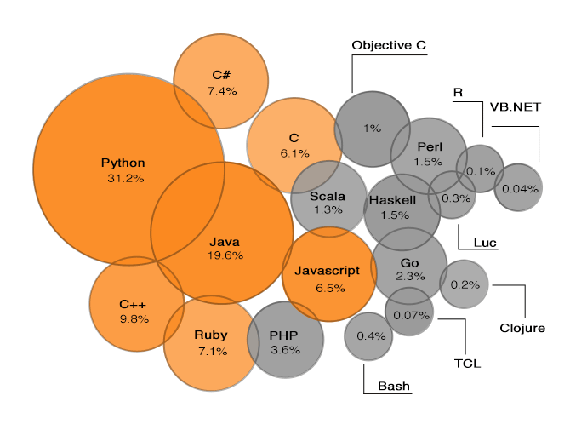

## **5.1 Django – Design Philosophies**

Django comes with the following design philosophies –

* **Loosely Coupled** − Django aims to make each element of its stack independent of the others.
* **Less Coding** − Less code so in turn a quick development.
* **Don't Repeat Yourself (DRY)** − Everything should be developed only in exactly one place instead of repeating it again and again.
* **Fast Development** − Django's philosophy is to do all it can to facilitate hyper-fast development.
* **Clean Design** − Django strictly maintains a clean design throughout its own code and makes it easy to follow best web-development practices.

**5.2 Django works with high-load projects**

Django suits high-load projects perfectly, given that the approach to implementation is done properly. Together with other technologies such as Redis, MongoDB, etc., fast loading pages and quick data processing can be achieved.

Django allows to build projects that have different goals and functionality. There are many applications that exist out there. Here is list of the top popular Django apps below.

### NASA

The National Aeronautics and Space Administration’s official website is a go-to app if you are interested in space. The site features news, pictures, and videos. Django allows the company handle the big number of views and traffic.

### Pinterest

Pinterest allows users to share pictures that showcase their interests. Also, users can follow and share pictures with others as well as content. Pinterest is powered by Django and lets users interact with the platform easily.

### Instagram

You all heard of Instagram. It hosts more than 400 million people and allows them to share photos and videos. Django lets Instagram users browse the app, find and post photos with ease.

### YouTube

We all go to YouTube for fun and serious videos to watch. Initially, YouTube was a PHP-based application. However, the constant need to improve and add new functionality made the company choose Python and Django in particular. The Django framework lets YouTube developers add new features and make upgrades effortlessly.

### DropBox

Dropbox is powered by Python and lets users manage their files effectively. Familiar to all kinds of devices, Dropbox uses the Django framework to enable file storage, synchronization, and sharing.

### Reddit

Reddit is known as the place to search for information and entertainment based on different categories. All posts and links generated by users are promoted to the top via voting. Due to the Django framework, Reddit’s users can enjoy its capabilities and functionality.

## **5.3 Advantages of Django**

Here are few advantages of using Django which can be listed out here –

* **Object-Relational Mapping (ORM) Support** − Django provides a bridge between the data model and the database engine, and supports a large set of database systems including MySQL, Oracle, Postgres, etc. Django also supports NoSQL database through Django-nonrel fork. For now, the only NoSQL databases supported are MongoDB and google app engine.
* **Multilingual Support** − Django supports multilingual websites through its built-in internationalization system. So you can develop your website, which would support multiple languages.
* **Framework Support** − Django has built-in support for Ajax, RSS, Caching and various other frameworks.
* **Administration GUI** − Django provides a nice ready-to-use user interface for administrative activities.
* **Development Environment** − Django comes with a lightweight web server to facilitate end-to-end application development and testing.

**6.** **EXISTING AND PURPOSED SYSTEM**

**6.1 EXISTING SYSTEM:**

Some of the existing systems still require customers to search through print and visual media for Restaurants. Customers need to find for restaurant using conventional methods and appear for table booking and food purchase on a specified date at a specified location. Restaurants owner’s need to advertise the restaurant. This approach is tedious and requires much effort and resources.

The existing system is a manual system of limitations like accuracy, expense, low speed and efficiency and unformatted outputs. In the existing system, all data processing is done manually. All the files and record books are replaced by the software system. When there are a lot of issues such as retrieval and storage of the information, then keeping track of them becomes a tedious task. By implementing a computerized system, the limitation in the present system will be reduced. Manpower can be reduced to a greater extent and efficiency and accuracy can be increased to manifold. More over consumption of time can be reduced to far greater extend by the implementation of the proposed system.

**6.2 PROPROSED SYSTEM:**

The proposed system is a web based application which allows Customers and Restaurant Owner’s to register their details. Customers can browse through the restaurant details that are posted and can apply for the table booking or food delivery online. The Restaurant Owner can browse through the posted orders and give suitable reply to customers.

In the proposed system, we propose to computerize the above-mentioned activities. In the existing system, all data processing is done manually. The main points focused in our proposed system are:

* User friendly interface
* Fast access to database
* Less error prone
* More storage capacity
* Search facility
* Friendly look and feel

**7.** **FEASIBILITY STUDY**

**7.1 PURPOSE:**

The feasibility analysis is designed to determine whether or not, given the project environment, a project will be successful (in virtually any interpretation of that word). A feasibility analysis may be conducted for a project with an emphasis on financial viability, environmental integrity, cultural acceptability, or political practicability. It is a determination as to the likelihood of success and a description of how that determination was achieved.

**7.2 TYPES OF FEASIBILITY:**

There are various measures of feasibility that helps to decide whether a particular project is feasible or not. These measures include:

* Technical Feasibility
* Operational Feasibility
* Economical and financial feasibility

**7.2.1 TECHNICAL FEASIBILITY:**

The technical issues raised during the technical feasibility analysis are:

* Does the necessary technology exist to do what is suggested?
* Does the proposal equipment have the technical capacity to hold the data required to use the new system?
* Will the proposed system & components provide adequate responses to inquiries, regardless of the number or locations of users?
* Can the system be expanded?

**7.2.2 OPERATIONAL FEASIBILITY:**

We have designed front end in HTML, CSS, Js by getting the information from the end user, which help us in designing the GUI according to the end user’s requirements. The end users can easily understand and expand it in the future.

**7.2.3 ECONOMICAL FEASIBILITY:**

It involves estimating cost and benefits that can be tangible and intangible because of confusing between the types of costs it is sometimes very difficult to divide the benefits out weight the cost.

**7.3 HOW FEASIBLE IS OUR SYSTEM**

This was analyzed by comparing the following factors with both the existing system and proposed system.

**Cost:**

The cost required in the proposed system is comparatively less to the existing system.

**Effort:**

Compared to the existing system the proposed system will provide a better working environment in which there will be ease of work and the effort required will be comparatively less than the existing system.

**Time:**

Also the time required generating a report or for doing any other work will be comparatively very less than in the existing system. Record finding and updating will take less time than the existing system.

**Application:**

Feasibility analyses are used to present an approach or a series of alternatives and to offer decision-making guidance based on the climate in which the project will evolve. They often defend a single or primary approach, incorporating extensive forecasts on the project’s development, as well as its evolution after implementation. Because a feasibility analysis may focus on one or many aspects of a project, it may be a very short (one- to two-page) or long (multivolume) document. In any case, it generally begins with an executive summary and a description of the project outputs in their as-built condition.

**8.** **SYSTEM REQUIREMENTS:**

**8.1** **HARDWARE REQUIREMENTS (website):**

The application would be developed in:

* Intel Core(TM)2 dual core and above
* 240 GB HD
* Minimum 2 GB RAM
* Standard USB Keyboard and Mouse
* Window-7 or Above

**8.2 HARDWARE REQUIREMENTS (client side):**

Following Hardware configuration is recommended for end user proper working of the project.

* Minimum Intel Dual Core 1.83 GHz Processor.
* Minimum 1 GB RAM
* Windows 7 and above
* 180 GB Hard Disk Storage Space
* Stand Keyboard and Mouse

**8.3 SOFTWARE REQUIREMENTS:**

**8.3.1 SOFTWARE REQUIREMENTS(website):**

* Operating System: Windows 7 or Above
* Front End Programming: - HTML, HTML5, CSS, CSS3, BOOTSTRAP
* Back End Database: -MongoDB

**8.3.2 SOFTWARE REQUIREMENTS (client side):**

* Operating System: Windows 7 or Above
* Visual Studio Code
* Internet Connection or LAN availability for accessing the Online Restaurant Management System

**9. REFRENCES:**

* **Books:**
* Django: Web Development with Python (Samuel Dauzon, Aidas Bendoraitis)
* Learning Python Application Development (Ninad Sathaye)
* **Website:**
* [www.w3schools.com](http://www.w3schools.com)
* [www.docs.djangoproject.com](http://www.docs.djangoproject.com)
* [www.realpython.com](http://www.realpython.com)