1. Introduction to CAP Theorem
The CAP theorem states that in a distributed data store, you can only achieve two out of the following three guarantees:
- Consistency (C): Every read receives the most recent write or an error.
- Availability (A): Every request receives a response, without guarantee that it contains the most recent write.
- Partition Tolerance (P): The system continues to operate despite arbitrary partitioning due to network failures.
2. Explaining Each Guarantee
- Consistency: Ensures that all nodes see the same data at the same time. In a consistent system, a read will always return the most recent write.
- Availability: Ensures that every request (read or write) receives a response, even if it's not the most recent data.
- Partition Tolerance: The system continues to function even if there is a network split that prevents some nodes from communicating with others.
3. Trade-offs in CAP Theorem
- CA (Consistency + Availability, no Partition Tolerance): Systems that prioritize consistency and availability but may fail during network partitions. Example: Traditional relational databases
- CP (Consistency + Partition Tolerance, no Availability): Systems that maintain consistency and partition tolerance but may sacrifice availability. Example: Distributed databases like HBase.
- AP (Availability + Partition Tolerance, no Consistency): Systems that prioritize availability and partition tolerance but may sacrifice consistency. Example: NoSQL databases like Cassandra and Couchbase.
4. Real-world Applications
- CA Systems: Used in environments where network partitions are rare, and consistency and availability are crucial.
- CP Systems: Suitable for financial applications where consistency is critical, and partitions can be tolerated with downtime.
- AP Systems: Ideal for web applications where availability is critical, and eventual consistency is acceptable.

5. Importance of CAP Theorem
Understanding CAP helps in designing systems that align with business requirements and constraints. It guides architects to make informed decisions based on the trade-offs suitable for their specific use case.
Venn Diagram of CAP Theorem
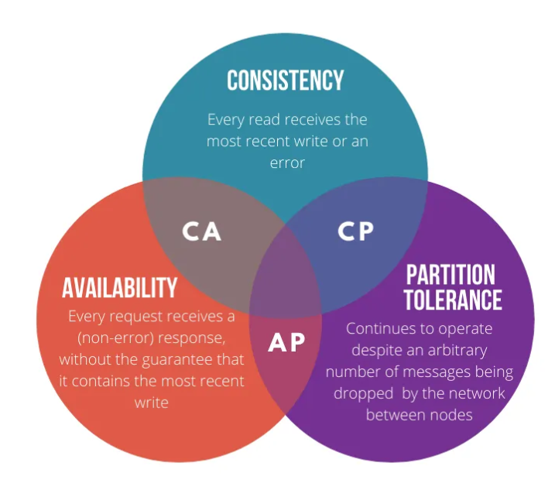
Here is a simplified Venn diagram to illustrate the CAP theorem:
- CP: Consistency and Partition Tolerance (sacrificing Availability)
- CA: Consistency and Availability (sacrificing Partition Tolerance)
- AP: Availability and Partition Tolerance (sacrificing Consistency)
Real-world applications
When designing a distributed system, engineers need to consider the trade-offs between consistency, availability, and partition tolerance. The choice of which properties to prioritize depends on the specific requirements of the application.
For example, a banking system would likely prioritize consistency over availability. This ensures that all transactions are recorded accurately and that there are no inconsistencies in the data. On the other hand, a social media platform might prioritize availability over consistency. Even if some users see slightly outdated information during a network partition, it is more important that the system remains available for everyone to use.

PACELC theorem
Another way to think about the trade-offs between consistency and availability is the PACELC theorem, which extends the CAP theorem by adding a fourth letter: E for Else. The PACELC theorem states that in any distributed system, one must choose between consistency (C) and latency (L) either when there is a partition (P) or when the system is running normally (E).
This means that even when there is no network failure, the system still must balance the trade-off between consistency and latency. For example, if a system chooses to be always consistent, it might have to sacrifice latency by waiting for all nodes to agree on the latest state of the data. Conversely, if a system chooses to have low latency, it might have to sacrifice consistency by returning stale or conflicting data.
Some examples of how different applications apply the PACELC theorem are:
- A search engine might choose to be PA/EL, meaning that it prioritizes availability over consistency both during a partition and under normal operation. This allows the search engine to return results quickly, even if they are not always up to date or accurate.
- A stock trading platform might choose to be PC/EC, meaning that it prioritizes consistency over availability both during a partition and under normal operation. This ensures that all trades are executed correctly and that there are no discrepancies in the prices or quantities of the stocks.
- A messaging app might choose to be PA/EC, meaning that it prioritizes availability over consistency during a partition, but consistency over availability under normal operation. This allows the app to continue sending and receiving messages, even if some of them are delayed or out of order due to network issues, but also guarantees that the messages are eventually delivered and synchronized across all devices.
Consistency :
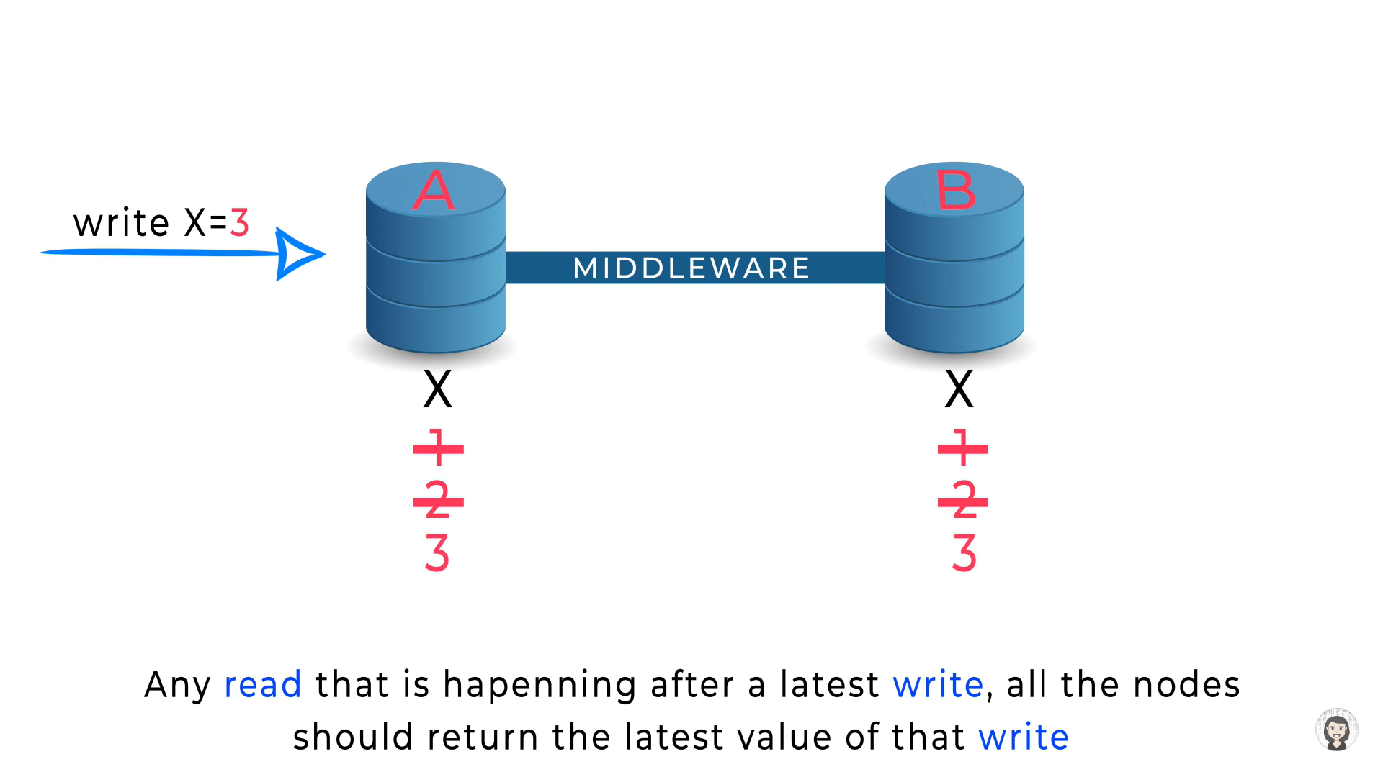
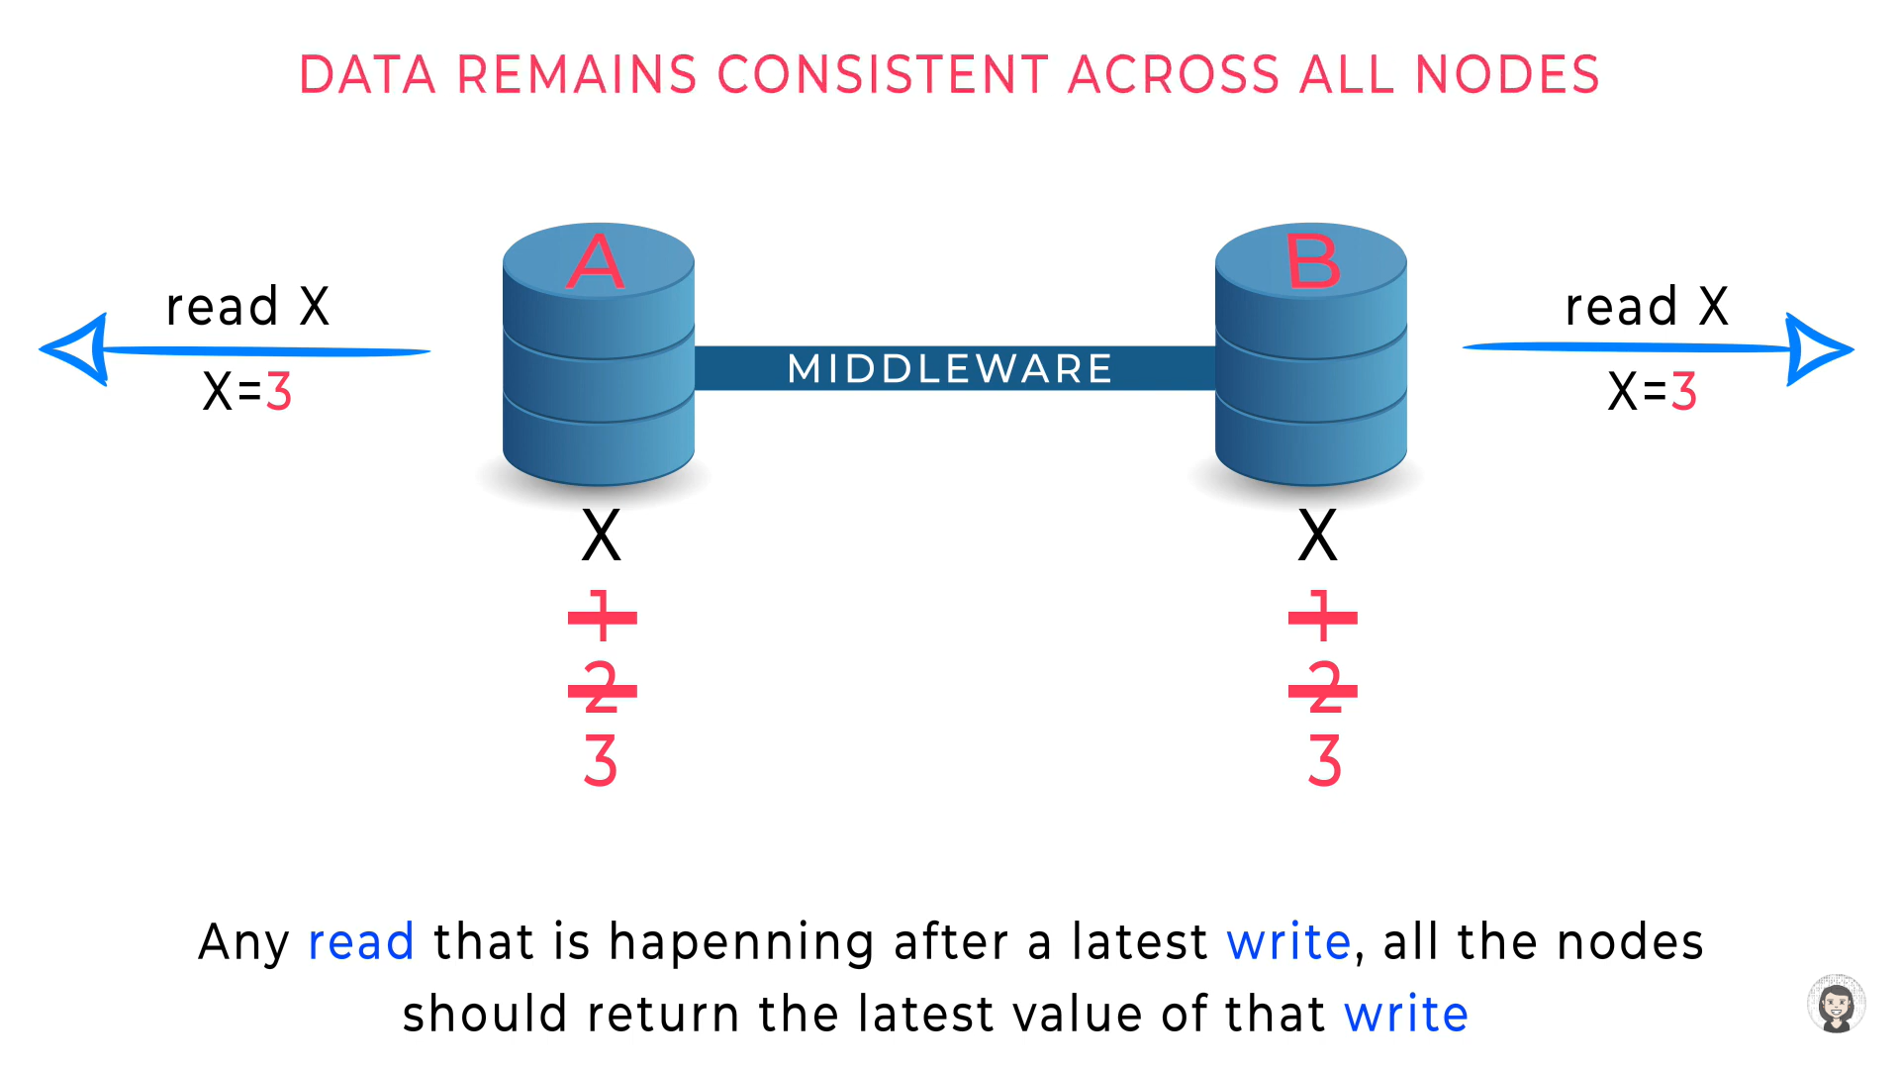

Availability:
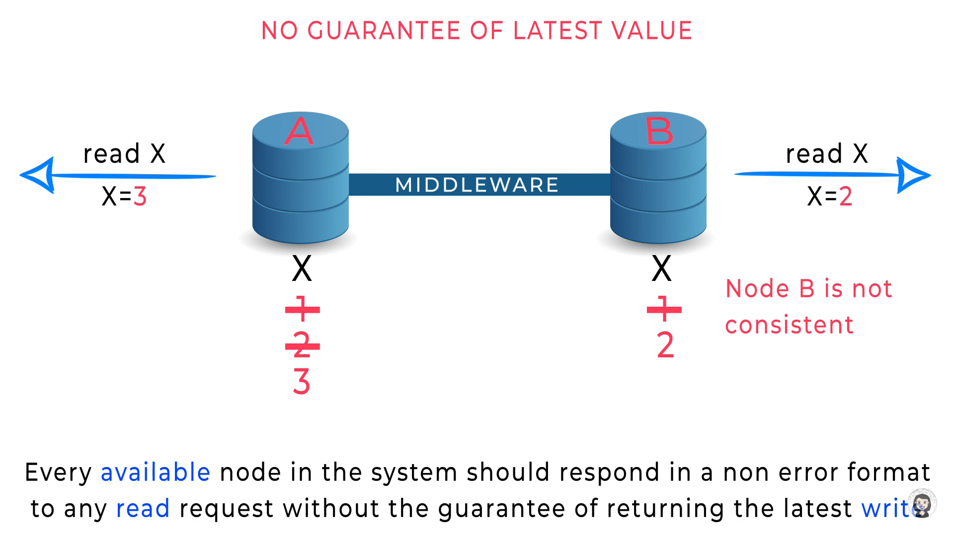

Partition:
