Collections Framework
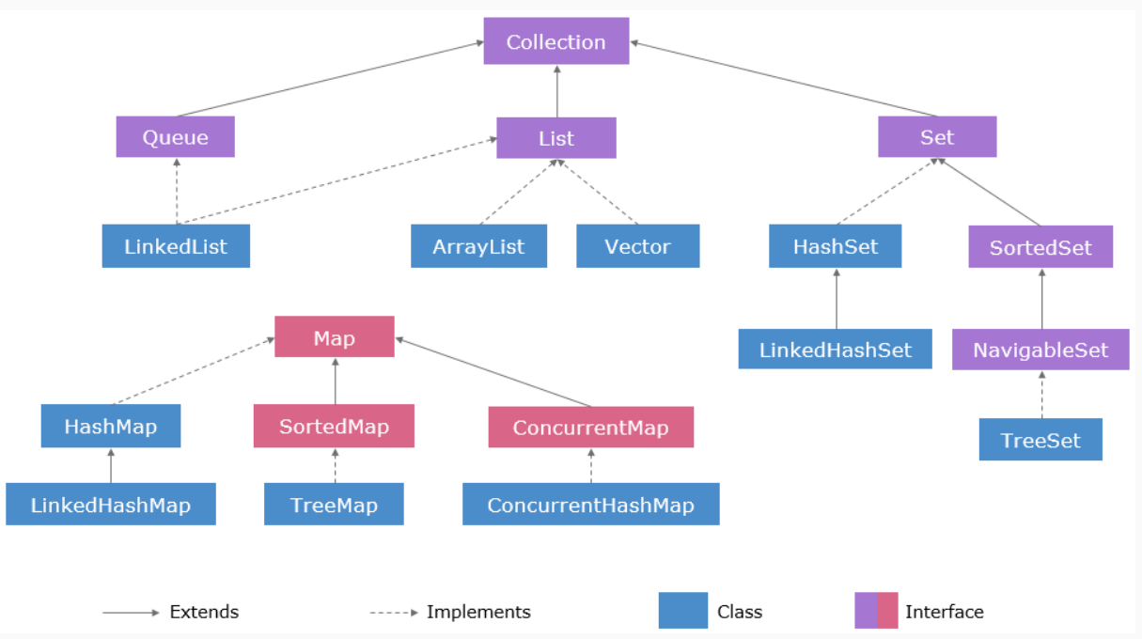
Why List is used over Array?
- List can grow dynamically whereas Array cannot. In list, elements can be inserted and deleted frequently, whereas Arrays are much better suited for frequent access of elements. List occupies much more memory as every node defined the List has its own memory set whereas Arrays are memory-efficient data structure.

- Interface Collections<E> extends Iterable<E>{
// All below methods will be supported by all child class Collection.
boolean add( E paramE);
boolean remove(Object paramObject);
int size();
Boolean isEmpty();
Void clear();
boolean contains(Object paramObject);
boolean containsAll(Collection<?> paramCollection);
boolean addAll(Collection<? Extends E> paramCollection);
boolean removeAll(Collection<?> paramCollection);
boolean retainAll(Collection<?> paramCollection);
}
- Interface Set<E> extends Collection<E> // to store unique elements
- Interface List<E> extends Collection<E>{ // to store list of elements
// Additional methods of list along with Collections method
// Any implementation of the List interface will maintain the insertion order. If A is inserted first and then B, A will be in an index before B. In List, position matters the most.
E get(int paramInt);
E set(int paramInt, E paramE);
Int indexOf(Object paramE);
Int LastIndexOf(Object paramE);
ListIterator<E> listIterator();
ListIterator<E> listIterator(int paramInt);
List<E> subList(int paramInt1, int paramInt2);
}
- Interface Map<K, V> {// to store unique key and value pairs
int size();
boolean isEmpty();
boolean containsKey(Object paramObject);
boolean containsValue(Object paramObject);
V get(Object Key);
V put(K key, V value);
V remove(Object key);
void putAll(Map<? Extends K, ? extends V> paramMap);
void clear();
Set<K> keyset();
Collection<V> values();
Set<Entry<K,V>> entrySet();
boolean equals(Object paramObject);
int hashCode();
public static abstract interface Entry<K, V>{
K getKey();
V getValue();
V setValue(V paramV);
boolean equals(Object paramObject);
int hashCode();
}
}
- Interface SortedMap<K, V> extends Map<K, V>{
//Elements are stored in natural sorted order or if comparator passed then it’ll sort according to comparator
Comparator<? Super K> comparator():
SortedMap<K, V> submap(K fromKey, K toKey);
SortedMap<K, V> headMap(K toKey);
SortedMap<K, V> tailMap(K fromKey);
K firstKey();
K lastKey()
}
- Interface NavigableMap<K, V> extends SortedMap<K, V>
- Class HashMap implements Map{
//unsorted, unordered
// key’s hashcode() is used
}
- Class HashTable implements Map{
//Synchronized – Thread Safe – version of HashMap
// unsorted, unordered
// key’s hashCode() is used
//HashMap allows a key with null value. Hashtable doesn’t
}
- Class LinkedHashMap implements Map{
// insertion order is maintained
// slower insertion and deletion
// faster iteration
}
- Class TreeMap implements Map, NavigableMap{
//sorted order is maintained
// implements NavigableMap
}
- Class ArrayList implements List<E>, RandomAccess{
//Insertion and deletion are slower compared to LinkedList.
// It is not thread Safe. Multiple thread accessing the list may cause an issue.
}
- Class Vector implements List<E>, RandomAccess{
//Vectors are thread safe – Synchronized Methods
}
- Class LinkedList implements List<E>, Queue{
//Elements are doubly linked – forward and backward – to one another
// Ideal choice to implement stack or queue
// Iteration is slower than ArrayList
//Fast Insertion and Deletion
// Implements Queue interface also. So, supports methods like peek(), poll() and remove()
}
- Interface SortedSet<E> extends Set<E>{
// keep the elements sorted in its natural ordering
SortedSet<E> subSet(E fromElement, E toElement);
SortedSet<E> headSet(E toElement);
SortedSet<E> tailSet(E fromElement);
E first();
E last();
}
- Interface NavigableSet<E> extends SortedSet<E>{
// Sorted set which contains method for easy access of elements
E lower(E e);
E floor(E e);
E ceiling(E e);
E higher(E e);
E pollFirst();
E pollLast();
}
- Class HashSet implements Set{
//unordered, unsorted – iterates in random order
//uses hashCode()
}
- Class LinkedHashSet implements Set{
// Order of Insertion : A, X, B ; Order of storing : A, X, B
//unsorted
//uses hashCode()
}
- Class TreeSet implements Set, NavigableSet {
//Naturally sort elements
//implements NavigableSet which is sortedSet
}
- Interface Queue<E> extends Collection<E>{
// Queue is used when processing required on each element. Elements arranged in order of processing

//Insert the specified element into this queue
//Throws exception in case of failure
boolean add(E paramE);

//Insert the specified element into this queue
//Returns false in case of failure
boolean offer(E paramE);
//Retrieve and removes the head of this queue.
//Throws Exception if Queue is Empty
E remove();
//Retrieve and removes the head of this queue.
//return null if Queue is Empty
E poll();
E elements();
// It’ll return the elements but not remove it
E peek();
}
- Interface Deque<E> extends Queue<E>{
// Queue with processing at both ends ….
Void addFirst(E e);
Void addLast(E e);
Boolean offerFirst(E e);
Boolean offerLast(E e);
E removeFirst();
E removeLast();
E pollFirst();
E pollLast();
E getFirst();
E getLast();
E peekFirst();
E peekLast();
Boolean removeFirstOccurrence(Object o);
Boolean removeLastOccurrence(Object o);
}
- Interface BlockingQueue<E> extends Queue<E>{
//A Queue that additionally supports an operation that wait for
// the queue to become non-empty when retrieving an
//element, and wait for space to become available in the queue when
//storing an element.
}
- Class PriorityQueue implements Queue{
//Sorted – natural order
}
- Class ArrayDeque implements Deque{
//Doubled ended queue
}
- Class ArrayBlockingQueue implements BlockingQueue{
//uses Array – Optionally-bounded
}
- Class LinkedBlockingQueue implements BlockingQueue{
//uses Linked list – optionally-bounded
//Linked queues typically have higher throughput than array-based queues
//less predictable performance in most concurrent applications.
}

//Collections can only hold objects - not primitives.
List<Integer> integers = new ArrayList<Integer>();
//code like below is permitted because of auto-boxing
Integer.add(5); //new Integer(5)
//5 is auto-boxed into Integer object and stored in ArrayList

- What are the static methods present in the Collections class?
- Collection is an interface whereas Collections is a class.
- static int binarySearch(List, key) -> Cab be used only on sorted list
- static int binarySearch(List, key, Comparator)
- static void reverse(List) -> Reverse the order of elements in a List.
- Static Comparator reverseOrder(); -> Return a Comparator that sorts the reverse of the collection current sort sequence.
- Static void sort(List)
- Static void sort(List, Comparator)
- How HashMap works internally?
- Map<String, Integer> m = new HashMap<>();
Above code will create an array of buckets of size 16 (total 16 buckets) initially. Each bucket is a node or linkedList.
m.put(“abc”, 1); -> first hash of the key (“abc”) is calculated which will generate hashCode (suppose 111112) which then put in a formula index = hash & (n-1) to calculate the index number. This index number, suppose 4, will store the key, value, hashcode in array of buckets.
Since each bucket is a linkedList, so this bucket will store 4 information in this linkedList or node, 1. Hashcode, 2. Key, 3. Value, 4. Next (the address of next node only when hash collision happened, null if no next node).
m.put(“acb”, 3); -> Suppose hashcode collision happened i.e. same hashcode generated same as above. So, same index number will also be generated i.e. index = 4. Since, already one linkedList is present at index 4, one more linkedList will be created at the same index. So, the above next will hold the address of this linkedList (i.e hashcode) and point to this linkedList. And this linkedList’s next will store null.
m.put(null, 4); -> If null key is provided then the value will be stored at 0th index of bucket and both hashCode and Key will store null value i.e. 0
m.put(“abc”, 5); -> For duplicate key with different value, no additional linkedList will be created. Only the last value will update the previous value.
Based on the loadFactor and threshold size, the table size that is array of buckets will be doubled. E.g. if loadFactor is 0.75 and threshold is 12, it means after 75% bucket is occupied or after 12 indexes are filled then the array of buckets will be doubled from 16 to 32 and this will go on and on.
- How hashSet works internally?
- hashSet internally calls hashMap. When hashSet object is created, then according to the parameter passed, 4 constructors defined will be called.
- Public hashSet(){
map = new HashMap<>(); //default constructor will be called if no param is passed.
}
- Public hashSet(int capacity){
map = new HashMap<>(); //parameterized constructor will be called if capacity is mentioned.
}
- Public hashSet(int capacity, float lf){ // here lf is loadFactor which says after how much size occupancy, a new array bucket will be created.
map = new HashMap<>(); //parameterized constructor will be called if capacity is mentioned.
}
- Public hashSet(Collection E) {
map = new HashMap<>();
}
Set<Integer> m = new HashSet<>();
m.add(“Tom”);
//Constructor 1 will be called and new HashMap() object will be created. When add method is called, it’ll internally call below method which further call map to put value
public Boolean add(E e) {
return map.put(e, PRESENT)==null; // <Tom, PRESENT>
}
// Dummy value to associate with an Object in the backing Map
private static final Object PRESENT = new Object();
- Difference between ConcurrentHashMap and HashMap?
Ans. ConcurrentHashMap is thread-safe and each segment (i.e. each bucket in an array of 16 bucket) acquires lock during write operation. Hence, when one thread has acquired lock other thread cannot access it until the previous thread releases the lock. So, at a time only one thread can write in that segment. But the other thread can acquire other bucket segment and do modification parallelly. So, ConcurrentHashMap is fast, thread-safe.
Map<String, Integer> m = new ConcurrentHashMap<String, Integer>();
m.put("abc", 1);
m.put(null, 5); //null values are not allowed. Runtime exception will be thrown
m.put("23", 4);
m.put("abcd", 1);
m.put("", 1);
System.out.println(m);
- How to make HashMap synchronized?
Ans. Map<String, Integer> m = new HashMap<String, Integer>();
m.put("abc", 1);
m.put("", 5);
m.put("23", 4);
m.put("abcd", 1);
// create synchronizedMap
Map<String, Integer> m1 = Collections.synchronizedMap(m);
31. Why to Override equals(Object) and hashCode() method?
Ans. When we call map.put(g1, “CSE”); it will hash to some bucket location and when we call map.put(g2, “IT”);, it will generates same hashcode value (same as g1) and replace first value by second value because while iterating over same bucket it found a k such that k.equals(g2) is true, means searching key already exist. So, it replaces old value of that key by new value.
Case 2 : Overriding only the equals(Object) method
If we only override equals(Object) method, when we call map.put(g1, “CSE”); it will hash to some bucket location and when we call map.put(g2, “IT”); it will hash to some other bucket location because of different hashcode value as hashCode() method has not been overridden.
