Lamda
Based on the number of arguments a Lambda Expression passes, there are three styles of writing Lambda Expressions:
- Zero Parameter Lambda Expression: A Lambda Expression containing no arguments.
  - () -> System.out.println("No Arguments passed in this Lambda Expression")

- One Parameter Lambda Expression: A Lambda Expression containing one argument.
  - //For single parameter () is optional and declaration of type is optional
  - /*
  - * Note:
  - * For body consisting only 1 statement, {} is not necessary and
  - * Return keyword must not be used for returning values!
  - */
  - num -> num+100
  - //If the data type of the single argument has to be declared, then the use of () is compulsory!!!!
  - /**
  - * Note:
  - * For body consisting more than 1 statements, {} is needed
  - * Return keyword is required to be used if any value is to be returned
  - */
  - (double rate) -> { rate = rate*100;
  - System.out.println("One argument passed: " +rate);
  - }

- Multiple Parameter Lambda Expression: A Lambda Expression containing two or more arguments.
  - //For multiple arguments, declaration is optional only when all arguments are of same type
  - //Also the use of () is mandatory when declaring multiple arguments!!!
  - (num1, num2, num3) -> System.out.println("Multiple arguments passed: " +num1+","+num2+","+num3)

  - (int num1, int num2, String result) -> {
  - if(x+y > 100)
  - result="Pass";
  - else
  - result="Fail";
  - return result;
  - }

In Java, Lambda Expressions are of the "target type" defined by Functional Interfaces. In simple words, they need to follow the definition of an abstract method defined inside the Functional Interface. Let us understand this with an example:
- @FunctionalInterface
- interface Operation{
- //Abstract Functional Method providing definition of lambda expression
- public double calculations(double num1,double num2);
- }

- //Defining a lambda expression of type Operation
- Operation doAdd = (double x, double y)-> x+y;

Here, Lambda Expression has to follow the type defined in the interface. In the given example, the abstract method has
- A Return Type of double
- Two Arguments of double Type
Therefore, we cannot create the following Lambda Expression as it does not follow the definition of the Abstract Method:
- //Three input parameters cannot be passed
- Operation sub = (double x, double y , double z)-> (x+y-z)+"Hello"; //String cannot be returned in place of double

Hence, Lambda Expressions are a type of Functional Interface, where they follow the definition of the Abstract Functional Method of the interface.
Functional Interfaces can be classified into two types:
- User-Defined Functional Interface: These are the Functional Interfaces that are defined by the programmer.
  - //User Defined Lambda Expression
  - @FunctionalInterface
  - interface Operation{
  - public double calculations(double num1,double num2);
  - }

- Built-In Functional Interface: In order to reduce the frequent usage of User-Defined Functional Interfaces, Java provides a series of inbuilt functional interfaces. A lambda expression can be of any of these types. Some of them being:
  - Function – It represents a function that takes a single input parameter and returns a single value/object. For example:
    - Function<Long, Long> addNum = (value) -> value + 10;
  - Predicate – It represents a function that takes a single value/object as a parameter, and returns true or false. For example:
    - Predicate<Integer> checkAge = (age) -> age > 18;
  - Supplier – It represents a function that produces a value/an object without taking any input parameter. For example:
    - Supplier<Integer> generateRandom = ()-> new Integer((int) (Math.random() * 100));
  - Consumer – It represents a function that consumes or processes a value/an object without returning anything. For example:
    - Consumer<String> printValue = (name)-> System.out.println(name);
Method Reference is an alternative to Lambda Expression. It is effective at situations where Lambda Expression is calling an existing method.
Syntax:
- ClassName::methodName // The "::" operator is used for Method Referencing
Let’s consider the code given below:
- List<String> strArr = List.of("Tyson", "Kai", "Max", "Ray", "Daichi");//List.of() returns immutable list of String with mentioned values
- strArr.forEach(s -> System.out.println(s)); //Printing List Using Lambda Expression
Here, we have a Lambda Expression which helps us display the contents of the above-mentioned List. But what if we had a simpler solution to this Lambda Expression? Let's check the alternate code given below:
- strArr.forEach(System.out::println); //Printing List Using Method Reference
Here, we can observe that both the code snippets work the same. Both of them execute the same logic. We can conclude that the second code is a concise and succinct version of the first code.
Method Reference helps in reducing lines of code, where Lambda Expression is calling an existing method. But it is not applicable in cases where we need to pass Arguments. This is because the feature of passing arguments is not supported by Method Reference.
Let's take a deeper look into Lambda Expressions as we observe the difference between Collections.sort() and list.sort().

Let us consider the following List of String:
List<String> nameList = Arrays.asList("Rachael","Ross","Monica","Chandler","Joey","Phoebe");
This list can be sorted in two ways:
- Collections.sort(List<T> list): This method sorts elements in the given list in the ascending order, according to the natural order of the elements of the list. This method belongs to the class Collections and takes the List to be sorted
- list.sort(Comparator<? super E> c): This method sorts elements in the given list according to the order mentioned by a Comparator. This method belongs to the interface List and takes a Lambda Expression for the customized sorting of the list. Hence, by this method we can sort a list not only on the basis of natural order, but also by our own custom format for sorting. We can now sort list based on length of each element, first character of each element etc.
So, we can observe how versatile sorting with list.sort() is in comparison to sorting with Collections.sort().

Note: Comparator is a Built-In Functional Interface, which is used in ordering a given collection. It orders the collection using the Lambda function provided to it.
For inducing ordering while sorting using Collections class, another overloaded method, sort(List<T> list, Comparator<? super T> c) can be used.
public static void main(String[] args) {
List<String> nameList = Arrays.asList("Rachael","Ross","Monica",
"Chandler","Joey","Phoebe");
//Cloning the nameList for the demo
List<String> clonedNameList1 = new ArrayList<String>(nameList);
List<String> clonedNameList2 = new ArrayList<String>(nameList);
List<String> clonedNameList3 = new ArrayList<String>(nameList);
/**
* Sorting Using Collections.sort():
**/
System.out.println("Sorting done by Collections.sort(): ");
Collections.sort(nameList);
System.out.println(nameList);
System.out.println();
/**
* Sorting Using list.sort() #1 : Sorting using Natural Order
**/
//Lambda Expression for sorting the list in Natural Order
Comparator<String> criteria = (str1, str2) -> str1.compareTo(str2);
System.out.println("Sorting done by list.sort() in Natural Order: ");
clonedNameList1.sort(criteria);
System.out.println(clonedNameList1);
System.out.println();

/**
* Sorting Using list.sort() #2 : Sorting on the basis of Length of Elements
**/

//Lambda Expression for sorting the list on the basis of Length:
System.out.println("Sorting done by list.sort() on the basis of Length: ");
clonedNameList2.sort((str1, str2) -> str1.length() - str2.length());
System.out.println(clonedNameList2);
System.out.println();

/**
* Sorting Using list.sort() #3 : Sorting on the basis of First Character of Elements
**/
//Lambda Expression for sorting the list on the basis of First Character
System.out.println("Sorting done by list.sort() on the basis of First Character: ");
clonedNameList3.sort((str1, str2) -> str1.charAt(0) - str2.charAt(0));
System.out.println(clonedNameList3);
}
Let's take a closer look at the Built-In Functional Interfaces provided by Java, and see how they work.
Different types of Built-In Functional Interfaces:
- Function<T1,T2>: Function takes only a single argument of type T1 and returns a value of type T2.
- Predicate<T>: Predicate takes only a single argument of type T and always returns a Boolean value.
- BiPredicate<T1,T2>: BiPredicate takes two arguments, each of type T1 and T2, and returns a Boolean value.
- Consumer<T>: Consumer consumes/takes only a single argument of type T, does operation/processing on it, and does not return any value.
- Supplier<T>: Supplier takes no arguments, and supplies/returns a value of type T.

Stream
Now, let's take a look at the different methods to create Built-In Streams in Java.
- Creating a Stream from a Collection using stream() method. For example:
  - List<String> castList = List.of("Sam","Dean","Castiel","Crowley");
  - Stream<String> supernatural = castList.stream();

- Creating a Stream from an Array using stream() method. For example:
  - Integer[] array = {672, 340, 999};
  - Stream<Integer> stream = Arrays.stream(array);

- Creating a Stream directly using of() method. For example:
  - Creating a Stream directly for Integers:
    - Stream<Integer> stream = Stream.of(672, 340, 999);
  - Creating a Stream directly for Objects of User-Defined Classes:
    - //User Defined Class Employee
    - class Employee{
    - private String name;
    - private Double salary;
    - public Employee(String name, Double salary) {
    - super();
    - this.name = name;
    - this.salary = salary;
    - }
    - }

    - //Creating a Stream for objects of Class Employee
    - Stream<Employee> empStream = Stream.of( new Employee("Tom",5699.5),
    - new Employee("Jack",7629.2),new Employee("Jane",5289.8));
The different operations that can be done on Streams are:
- forEach() : This method is used to traverse each element of the stream. It is used mainly to display the elements in a Stream. For example:
  - List<String> placesToVisit= new ArrayList<String>();
  - placesToVisit.add("Chicago");
  - placesToVisit.add("Venice");
  - placesToVisit.add("Tokyo");
  - placesToVisit.add("San Francisco");
  - placesToVisit.add("Kyoto");
  - placesToVisit.add("Abu Dhabi");

  - placesToVisit.forEach(place -> System.out.println("Trip to " + place));

- map() : This method is used to return a new stream based on operations done on an existing stream. For example:
  - List<String> placesToVisit= new ArrayList<String>();
  - placesToVisit.add("Chicago");
  - placesToVisit.add("Venice");
  - placesToVisit.add("Tokyo");
  - placesToVisit.add("San Francisco");
  - placesToVisit.add("Kyoto");
  - placesToVisit.add("Abu Dhabi");

  - placesToVisit.stream().map(place -> place.toUpperCase()).forEach(place -> System.out.println(place));

- filter() : This method is used to return a new filtered stream based on conditions given for filtering. For example:
  - List<String> placesToVisit= new ArrayList<String>();
  - placesToVisit.add("Chicago");
  - placesToVisit.add("Venice");
  - placesToVisit.add("Tokyo");
  - placesToVisit.add("San Francisco");
  - placesToVisit.add("Kyoto");
  - placesToVisit.add("Abu Dhabi");

  - placesToVisit.stream().filter(place -> place.length() == 5).forEach(x -> System.out.println(x));

- sorted() : This method is used to sort the elements in a Stream. Argument for this method is optional. For Example:
  - //No Argument passed in sorted()
  - List<String> placesToVisit= new ArrayList<String>();
  - placesToVisit.add("Chicago");
  - placesToVisit.add("Venice");
  - placesToVisit.add("Tokyo");
  - placesToVisit.add("San Francisco");
  - placesToVisit.add("Kyoto");
  - placesToVisit.add("Abu Dhabi");

  - placesToVisit.stream().sorted().forEach(x -> System.out.println(x));
  - //Lambda Expression passed as Argument in sorted()
  - List<String> placesToVisit= new ArrayList<String>();
  - placesToVisit.add("Chicago");
  - placesToVisit.add("Venice");
  - placesToVisit.add("Tokyo");
  - placesToVisit.add("San Francisco");
  - placesToVisit.add("Kyoto");
  - placesToVisit.add("Abu Dhabi");

  - placesToVisit.stream().sorted((str1,str2) -> str1.compareTo(str2)).forEach(x -> System.out.println(x));

- collect() : This method stores the modified stream as a new collection type (it can be list, map etc.), after the stream operation terminates, under a new identifier.
  - List<Integer> number = new ArrayList();
  - number.add(2);
  - number.add(3);
  - number.add(4);
  - number.add(5);

  - //The Modified Stream is stored in "doubled" using collect()
  - List<Integer> doubled = number.stream().map(x->2*x).collect(Collectors.toList());

  - System.out.println(doubled);

Let us consider the following code, where we apply the different operations of Stream individually:
- List<String> placesToVisit= new ArrayList<String>();
- placesToVisit.add("Chicago");
- placesToVisit.add("Venice");
- placesToVisit.add("Tokyo");
- placesToVisit.add("San Francisco");
- placesToVisit.add("Kyoto");
- placesToVisit.add("Abu Dhabi");

- //stream() converts the List into a Stream
- Stream<String> streamPlaces = placesToVisit.stream();

- //filter() applies the appropriate filter conditions to obtain Modified Stream
- Stream<String> filterStream = streamPlaces.filter(place -> place.length() <= 8);

- //map() applies appropriate modification to a given Stream
- Stream<String> mapFilter = filterStream.map(place -> place.toUpperCase());

- //forEach() displays all the content of the Stream in console
- mapFilter.forEach(x -> System.out.println(x));
This code can also be shortened by chaining all the separate methods together, in the same order:
- List<String> placesToVisit= new ArrayList<String>();
- placesToVisit.add("Chicago");
- placesToVisit.add("Venice");
- placesToVisit.add("Tokyo");
- placesToVisit.add("San Francisco");
- placesToVisit.add("Kyoto");
- placesToVisit.add("Abu Dhabi");

- //Chaining Multiple Operations of Streams Together
- placesToVisit.stream() //stream()
- .filter(place -> place.length() <= 8) //filter()
- .map(place -> place.toUpperCase()) //map()
- .forEach(x -> System.out.println(x)); //forEach()
Both the codes, as we can see, give us the same output. Thus, we can observe how the chaining of different operations makes the code for filtering a List compact. And we can use different combinations of operations to obtain unique results.
It is always an efficient coding way to use the order of operations as a filter(), map(), sort(), and forEach() which improves the performance.
Streams follow a pipeline format of execution. All the operations that are chained together form the intermediate operations. The last operation, after which the final result is obtained, forms the terminal operation. All the intermediate operations are executed simultaneously based on the stream and the required conditions.
Operations such as map(), filter(), sorted() comprise the intermediate operations, as these operations look after the filtering, modifying, and ordering aspects of the streams. Also, intermediate operations return a stream after its execution. Whereas, operations such as forEach() and/or collect() comprise the terminal operations, as these operations do not return any stream. Instead, they deliver the final stream by either by displaying them (forEach()) or by storing them in a collection (collect()).
Let us take a closer look at this with the following illustrative example:
- Stream<Integer> intStream = Stream.of(10,2,7,5,6,5,8,11);
Let us consider a Stream of random integers. Our goal is to display a sorted stream consisting of cubes of all even integers in the given stream. We have the following chained stream operations as our solution.
- intStream.filter(n -> { System.out.println("Filtering Current Element: "+n); return n % 2 == 0; })
- .map(n -> { System.out.println("Mapping Current Element: "+n); return n * n * n; })
- .sorted()
- .forEach(n -> System.out.println(n));
Let us take a look at the output before we analyze the pipeline execution of the given example.
- Final stream is:
- Filtering Current Element: 10
- Mapping Current Element: 10
- Filtering Current Element: 2
- Mapping Current Element: 2
- Filtering Current Element: 7
- Filtering Current Element: 5
- Filtering Current Element: 6
- Mapping Current Element: 6
- Filtering Current Element: 5
- Filtering Current Element: 8
- Mapping Current Element: 8
- Filtering Current Element: 11
- 8
- 216
- 512
- 1000
We can observe that the first intermediate operation filter() executes for each element of the stream. After the execution of filter(), the next intermediate operation map() is executed for those elements which pass the filter condition. And after the execution of map(), the last intermediate operation sorted() and terminal operation forEach() is executed, where the filtered and mapped stream elements get sorted and displayed.
But, what if we never invoke the terminal operation (in this case forEach()) after the intermediate operations? Will the elements of the stream still be filtered, mapped, and sorted?
- Stream<Integer> intStream = Stream.of(10,2,7,5,6,5,8,11);

- intStream.filter(n -> { System.out.println("Filtering Current Element: "+n); return n % 2 == 0; })
- .map(n -> { System.out.println("Mapping Current Element: "+n); return n * n * n; })
- .sorted();
And the answer is no.
This is because streams are lazy! Streams are said to be lazy because until the terminal operation is invoked, none of the intermediate operations is executed.
So, there is no terminal operation invoked, the filter operation and the mapping operation will not be executed. As a result, the stream remains unoperated. Hence, missing out on the terminal operation will not throw any error/exception but the chained stream operations will not be executed further leading to a few logical errors in the program.
Let us consider the following scenario:
- Stream<String> streamNames = Stream.of("Deadpool", "Iron Man", "Spiderman", "Captain America", "Punisher", "Black Panther");
- streamNames.filter(name -> name.length()<=10) //Line1
- .sorted()
- .forEach(name -> System.out.println(name));
We have created a Stream of string objects here. On this stream, we are applying a filter() and sorted() operation and displaying the modified stream using forEach(). Now let us try and reuse the same stream streamNames to map the elements of the stream using map() and displaying the modified stream again.
- streamNames.map(name -> name.toUpperCase()) //Line2
- .forEach(name -> System.out.println(name));
But upon doing so, a runtime exception will be thrown. This is because once a stream is operated on it cannot be operated on once more. Imagine streams to be like water pipes. Once the water flows from a pipe, there will be no water left. The same case applies to streams as well. So in the above situation, once the filter() operation ends at Line1, the stream streamNames becomes empty and does not allow any more operation to be invoked on it. And when the same stream is accessed again at Line2, it throws the following exception:
- Exception in thread "main" java.lang.IllegalStateException: stream has already been operated upon or closed
- at java.base/java.util.stream.AbstractPipeline.<init>(AbstractPipeline.java:203)
- at java.base/java.util.stream.ReferencePipeline.<init>(ReferencePipeline.java:94)
- at java.base/java.util.stream.ReferencePipeline$StatelessOp.<init>(ReferencePipeline.java:696)
- at java.base/java.util.stream.ReferencePipeline$3.<init>(ReferencePipeline.java:189)
- at java.base/java.util.stream.ReferencePipeline.map(ReferencePipeline.java:188)
- at com.lambada.StreamDemo.main(StreamDemo.java:21)

Hence, we can observe the non-reusability nature of streams from the above situation.

Properties
Properties files are usually used for
- storing configuration related data
- storing information which can be changed frequently as unlike a Java class file, recompilation is not needed if the information is changed from a properties file
- containing locale-specific data. It internationalizes Java code by making the code locale-dependent.
There are different ways in which you can read a Properties file, like by using the Properties class in java.util package, Java ResourseBundle, or we can use any other third-party library like Apache Commons.
The Apache Commons Configuration is a third-party library that provides classes that can be used to perform certain operations on a ".properties" file. It contains a PropertiesConfiguration class which is used to read a properties file.
org.apache.commons.configuration.PropertiesConfiguration Class:
The org.apache.commons.configuration.PropertiesConfiguration class is a class that loads the values from a properties file.
Configuring and using PropertiesConfiguration class:
Discussed below is the configuration and the usage of the PropertiesConfiguration class.
Configuration:
To configure the PropertiesConfiguration class to load your properties file, we have to use the org.apache.commons.configuration2.builder.fluent.Configurations.Configurations() class to build it as shown below,
- Configurations configurations = new Configurations();
- PropertiesConfiguration config = configurations.properties("configuration.properties");
As you can see, we build an object of PropertiesConfiguration class for the configuration.properties. This object can be used for accessing data from the specified properties file.
Note: If you want to pass the properties name directly as shown above, keep your properties file in the src folder or any of its subfolders. If kept anywhere else, you will have to provide the exact path to the properties file.
Methods:
The PropertiesConfiguration class defines a few methods like:
Iterator<String> getKeys(): This will provide all the keys present in the properties file.
- Iterator<String> keys = config.getKeys();
Object getProperty(String key): This provides the corresponding value present in the properties file pertaining to the key passed. If the key value passed is not present in the properties file, it returns null.
- System.out.println("Value for server.port=" + config.getProperty("server.port"));
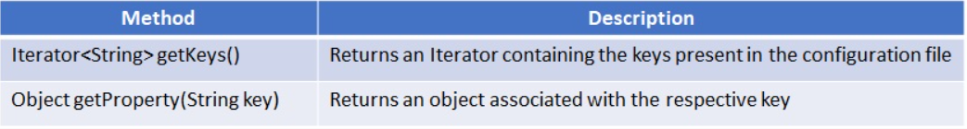
Here, we will mostly deal with reading the properties from a .properties file.

LOGGING
Logging is the process of tracking the execution of the program where,
- Any event that is to the interest of the programmer or administrator can be logged.
- Relevant messages can be recorded in the event of exceptions and errors.
Apache Commons Logging is a logging utility that is Java-based and provides the implementation of loggers and also supports the different Logging APIs.
Log4j is written in Java and is open source. It provides mechanisms to directly log information to a variety of destinations such as database, file, console, etc. It also logs information in various formatting styles such as HTML, XML, Log, etc.
Logging using Log4J can be configured in many ways. In this course, we will be using the properties file.
For configuring Log4j2, we must first know what all it comprises of. Log4j2 has 3 components,
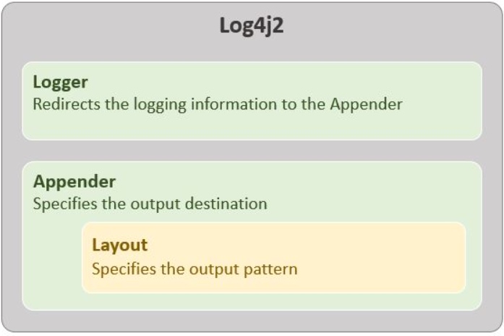
- Appender – Specifies where the logging output should be stored. It can be the console, an external file, any database, etc.
- Layout– Specifies in what format should the information be logged. It can be a simple layout which logs the level followed by the message, or we can specify a pattern for it to follow, etc.
Logger – Accepts all the information to be logged and redirects it to an appropriate Appender.
The properties file is a normal file in which the data is stored in a key-value pair as you saw in the previous module. When we use it to configure Log4J2, it looks as shown below,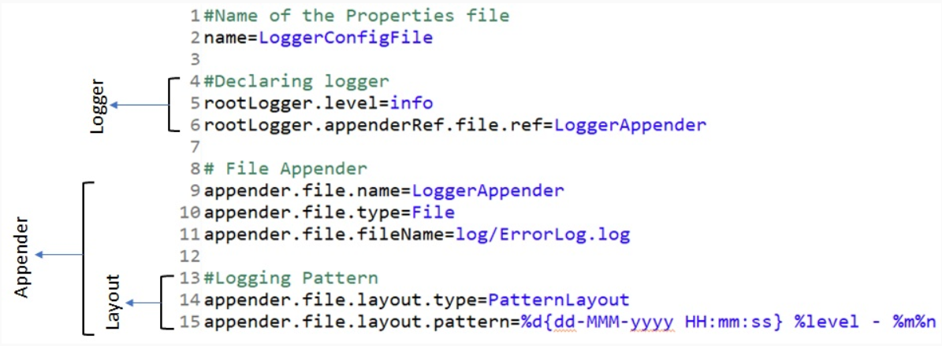
In the Logger component, we are first declaring the Logging Level we want to use, i.e., in this case, INFO. Logging Levels are like the indicators of the severity of each log (We will discuss the Logging Levels on the next page). In the next line, we are configuring the Logger to use the Appender component having the name LoggerAppender.
In the Appender component, we are first declaring the name of the Appender, in this case, LoggerAppender. This links the Logger output to the exact Appender component (This connects line 6 to the appender we want to use). Next, we declare the destination where the logged data should be placed. It can be the console, an external file or an HTML layout also. In this case, we are using an external file to log all the data. The next line declares the name and location the external file is located. It can be an absolute path, or as shown above a relative path. Here we are declaring that the external file with the name ErrorLog.log will be present in the log folder in the project. (Note: If the external file is not found in the mentioned location, then the logger will create a new file in the mentioned location)
Last, but not the least, in the Layout component, we first declare the type of layout we want to use (whether it is SimpleLayout, HTMLLayout, PatternLayout), in this case, a PatternLayout. A PatternLayout is a layout where we configure the pattern of the logging information on our own. Next line we are declaring the pattern to be used. The pattern we want the information to be logged is,
<<$timestamp>> <<$LoggingLevel>> <<$Message>>
where,
- timestamp is given by, %d{dd-MMM-yyyy HH:mm:ss}
- Logging level is given by, %level
- Message is given by, %m
The configurations used in the above properties file is one of the basic configurations. You can change it to suit your needs and project requirements.
Note:
- The name of the properties file must be log4j2.properties for the logger to detect it.
- The log4j2.properties file should be placed directly in the src folder or any of its subfolders. If placed anywhere else, it will not be detected automatically by the Logger.

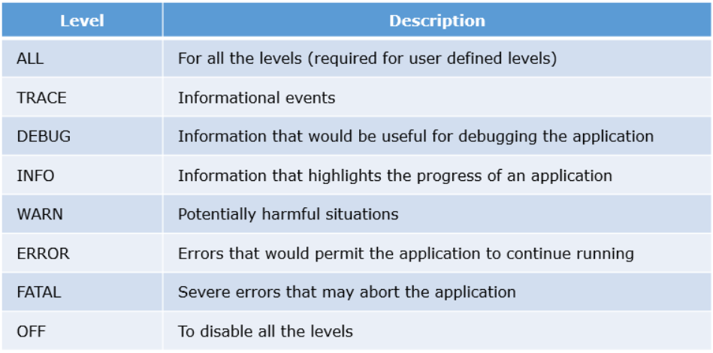
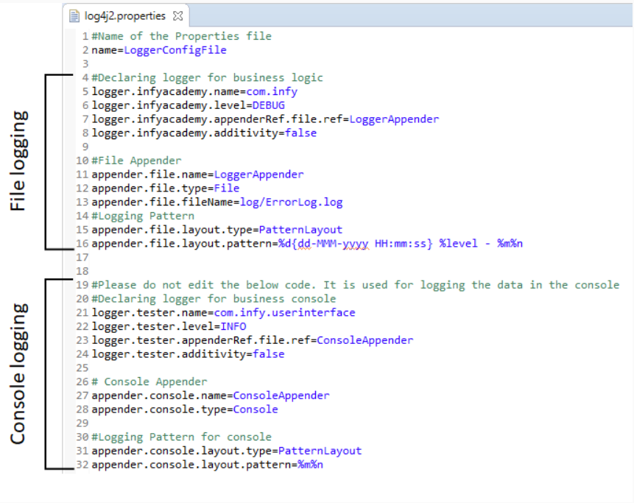
Here are a few solutions to avoid logging multiple times,
- Any exceptions handled in individual classes (Service & DAO) should be rethrown and propagated to the calling environment (main method in Tester) and logging should be done only in the calling environment (main method).
- Log only exceptions that are thrown by its own class (use if condition to check as below) but rethrow exceptions of all the other classes from the catch block as shown below.

Modular Programming
Modular Programming brings in the following features to the mix:
- Module Descriptor: With the introduction of modules in Java, each modular Java project now needs a Module Descriptor file. This file is named as module-info.java and is located in the root directory of the respective module. The Module Descriptor, as the name suggests, defines the packages that are exposed (can be exported) and the packages that are required by the module to function. For example:
  - module com.xyz.calculator{

  - //Sample Module Descriptor (Empty)
  - }
- Exports and Requires: For a Java module to export/expose packages for external use or import packages from other modules, proper declarations are needed to be done in the Module Descriptor file of the module. And these declarations are handled by the keywords exports and requires. Exports is used to declare the packages that are meant to be exposed. Whereas, Requires is used to declare the packages (from other modules) that are needed by the respective module. For example:
  - module com.xyz.calculator{
  - //Export and Requires Declaration:
  - exports com.xyz.calculator;
  - requires com.xyz.service;

  - }

- Circular Dependencies Not Allowed: Java Modules do not allow to have circular dependencies between modules. In simpler words, if a module X requires another module Y then the reverse (Y requiring X) is not allowed. It is expected that the module dependency must by acyclic.
- Split Packages Not Allowed: Split Packaging is referred to the phenomenon of exporting the same package(s) from two different modules. It signifies that the content of the respective package is divided into multiple modules.
- Multi Java Version Modules: With the introduction of modules from Java 9, it is now possible to create JAR files for Java modules written in different versions of Java. To be simply put, we can create JAR files for modules written in Java 8, 9, 10 or 11 within the same JAR file.
MAVEN
Maven helps the developers by supporting a feature called - dependency management. This happens to be one of the most significant features in application development. The dependencies that are needed for each project should be added in the POM along with their groupId, artifactId and version details.
Dependencies refer to the artifacts/jars/libraries that the application uses. Maven is capable of locating the required artifacts in the repository.
What is a repository?
Repository in Maven is referred to as Artifactory for the following reasons:
- It is the source where artifacts required for building the projects are located
- It is the target where artifacts generated out of build process are deployed
Whenever a Maven command is triggered on a project, Maven reads pom.xml and then contacts the repository to resolve dependencies.
Maven mainly has 3 types of repositories:
- Local: refers to the location/folder in the developer's machine where the copy of dependencies gets downloaded and stored.
- Remote: this repository is usually a location that is remote to the developer's machine.
- Central: is the public website/repository given by Maven. It has all the most commonly used libraries for project builds.
Maven not only pulls immediate dependencies automatically but also the necessary transitive dependencies.
Maven downloads the initial set of dependencies and support artifacts required for the project from remote repositories and stores them in a local machine. A local repository is a place located in the local machine where these artifacts (eg: jars) are available for future use. Maven uses the local repository for resolving the dependencies required by various projects.
All the Maven projects will have a configuration file called pom.xml which contains the details about all the required dependencies for a project.
pom.xml is the central configuration file of the Maven application.
What is POM?
- Project Object Model is the most important, logical unit of work in any Maven project
- It is basically an XML configuration file named pom.xml with the information about the project and the necessary configurations.
- pom.xml contains the list of all the dependencies needed for the application
A Maven project's pom.xml has the following sections:
- Project Information: Mandatory section which contains the project co-ordinates to uniquely identify the project.
- Dependencies: Optional section which refers to the libraries/artifacts/jars needed for the application.
- Build Plugin: Optional section which refers to the plugin configurations needed for the application.
- Build Profile: It is an optional section. This section usually has the various configuration settings using which the build can be customized for different environments - production, test, development, etc.
groupId: This element normally has a group name or organization name which owns the project
artifactId: This element gives information about the name of the application. eg: infycart
version : This element reveals the version of the distribution unit (jar/war/ear).
- SNAPSHOT is the general convention used to mention that the project is in active development phase. eg: infycart-0.0.1 - SNAPSHOT.jar
- RELEASE is the convention used to mention that the build of the project is the base-lined, stable version. eg: Spring Context - 4.3.14.RELEASE.jar
packaging: This element decides the type of the distribution unit. eg: jar/war/ear etc.
Maven is a build automation tool used to manage any Java-based project and we do not have to mention each and every configuration detail.

JDBC
Data Persistence means for an application to persist and retrieve information from the non-volatile storage. Data is to be stored and retrieved from the central location. In order to achieve this, it is necessary to persist data in a common repository (like a database). The way of persisting the data into a common repository is called Data persistence.
The term Data persistence:
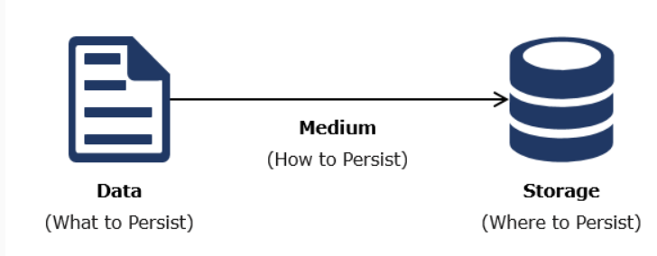
The persistence phenomenon contains three core components- Data, Medium, Storage. It is also necessary to know what to persist, how to persist and where to persist.
Medium is the thing that is used to transfer the data from source to destination. The data is transferred between source and destination in a serialized manner. To transfer the data efficiently in a serial manner, the mechanism used is called Serialization. Serialization is the method of converting all the data/objects to byte stream (0’s and 1’s) to transfer the data to the specified storage or repository.
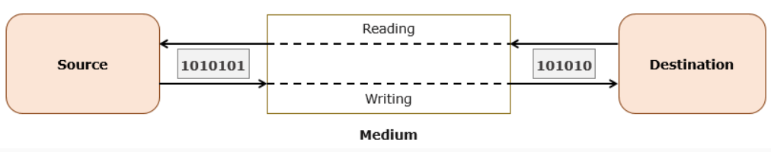
Serialization is one of the methods used to transfer the data efficiently between the source and destination. If we take the database as the destination, all the data will be transferred in the form of a byte stream in the medium between the source and database. The process of converting back from byte stream to data/object is called as Deserialization.
Java Database Connectivity or JDBC, is a Java API which is used to connect to a database and run queries on them. This API is consisted in the standard edition of Java (JavaSE), and requires JDBC drivers for database connection. The JDBC API can access tabular data from any relational database.
The JDBC API can be handy in managing database using Java programs or/and performing the following operations:
- Connecting programs to the databases
- Running queries and/or updating the data in the database
- Obtaining results from the database after query execution.

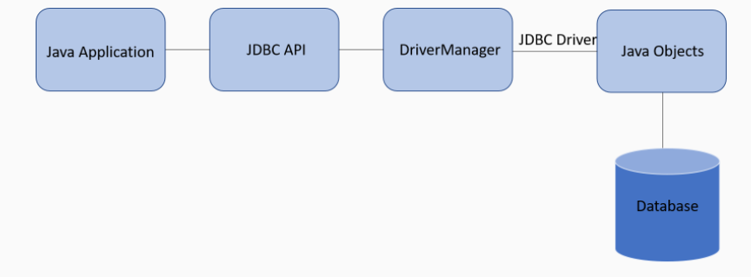
A driver is a software component that connects two dissimilar environments. For example, if you want to connect a web camera with your desktop, you need a Webcam Driver. The Webcam Driver is used to connect your desktop and Webcam is to transfer the data between them. Similarly, since a Java application and the database server are two completely heterogeneous environments, we need a JDBC driver to connect them.

Modular JDK
Shortcoming of JDK prior Modular Programming:
- Before the introduction of Modules in Java 9, the JDK was a monolithic library containing all the packages. It was imported in all the applications in the form of "rt.jar", which had a size of around 60 MB. And this made Java applications difficult to operate in small devices which had limited memory.

- The "weak encapsulation" problem was also prevalent in the JDK as well. Before Java 9, the JDK library consisted of all packages bundled up together. And some of those packages/APIs were only meant for internal uses only. But due to the issue of weaker encapsulation, they could be accessed/modified by users.
- The "missing dependency" problem was also prevalent in the form of "JAR Hell". JAR Hell refers to the problems encountered during loading classes from JARs into classpath. In layman's term, If a project had a dependency on JAR A which had a dependency on JAR B, a run-time error would occur if JAR B was not present in the classpath of the project.
Changes Introduced With Modular JDK:
- To overcome the above limitations of JDK, "Project Jigsaw" was set up to "modularise" the existing JDK. This was made possible with the introduction of modules in Java 9. Hence, the Java Platform Module System (JPMS) was created.
- The main focus of Project Jigsaw for JPMS was to split the monolithic JDK into smaller modules and completely remove the rt.jar file.
- JAVA 9 divides the platform into set of platform modules, which could be further classified into:
  - Standard Modules: Modules that are used by Developers. These start with name "java.*". (Eg.: java.lang.module)
  - Non-Standard Modules: Modules that are intended for Internal uses only. These start with name "jdk.*". (Eg.: jdk.compiler)
- JMOD is the new file format which replaces the previous JAR file format. The Java Modules are shipped in this format.
Features of Modular JDK:
- The platform modules can be listed using the "java --list-modules" command, and modules can be inspected individually with "java --describe-module <module name>" command.
- Modular KDK also provides the following tools:
  - jdeps - used to identify JAR and module dependencies
  - jlink - used to create custom runtime by combining application and JDK modules
  - jmod - used to create JMOD files which is a new format for packaging modules
- Backward compatibility: With the introduction of modules in Java 9, the issue of backward compatibility for projects using Java 8 and below are also answered by Modular JDK. This was done by introducing two unique types of modules:
  - Unnamed module: When we create a java project without module-info.java file and do not give an explicit module name, that project will be part of an unnamed module which by default exports all its packages and can read all other unnamed module present in classpath of the project. All java project created before java 9 will be seen as unnamed module from java 9 onwards and can be executed in newer version.
  - Automatic module: Newer java project with module-info.java expect third party libraries in a form of module. Since third party vendors may not have updated their jars as modules, so since java 9, all jar files found in module path of the project will be converted into a module and their name is derived from jar file name. These converted modules are known as automatic module. This kind of module exports all its packages to outside world.
DOCKER
Docker is tool developed to make the job of developing applications easy and ship them into containers which can then be easily deployed anywhere. If the above line was a little too vague let us try to understand how and where to use docker in a simpler way.
Let's assume that you have created a simple java application which connects to the MySQL database, it also uses logging and properties. You were able to do this because of the following reasons,
- Java has been installed in your system
- You have dependencies in your system that can be used to connect to the MySQL database
- You also have dependencies that you can add to your project to enable the use of properties file and also logging
But when you export the same application in your friend’s system and try to run it, the application might not execute because of various reasons like,
- Java might not have been installed in your friend’s system
- They might not have all the dependencies required for the application
To avoid these issues, you can use docker to create a container which will include all the dependencies that you have used along with the application. Once the container is created you can run it on your friend’s system using docker. Since the application now has all the dependencies required, it should run without any issues.
Security
Encryption/Decryption: To simplify the definition, it is a process where developers can use an algorithm to convert plain data into scrambled data based on a unique key, and only applications with this unique key can decrypt/descramble the scrambled data and get the original value back. Below are a few simplified pictorial representations of how encryption/decryption works.
Even if there is a data leak it will extremely hard for anyone to retrieve the original data back without the unique key. But it is still a possibility that both the data and the unique key can be leaked allowing hackers to get the original data back. So, most developers prefer using hashing instead of encryption algorithms
Hashing: It is the similar to encryption, where the original data is scrambled/modified using an algorithm but the only difference is that, once the data is hashed/scrambled it cannot be retrieved i.e., unlike encryption, there is no unique key that can be used to retrieve the original data. Even if the data is leaked, any third-party users will not be able to retrieve information from the hashed data.
Threads
Each program in execution is a process. A thread is the smallest unit of a process, which can be independently executed by the operating system.
Every Java program creates at least one thread for each execution [ as main() executes as thread ]. Additional threads created depends on the processor. Programmers can create customized threads for their own applications.
Thread implementation in Java can be achieved in two ways:
1. Extending the java.lang.Thread class
2. Implementing the java.lang.Runnable Interface
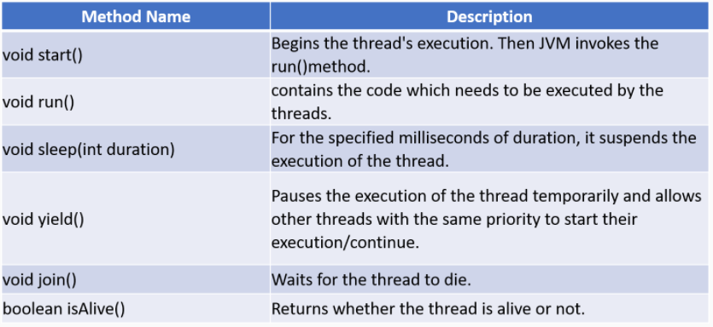
Note: The operating system is responsible for scheduling threads for execution.
Whenever a thread is created to perform its task, it goes through different states between the time it is created and when it completes.
During its life cycle, a thread can move to the following different states:
- New- When a thread a created
- Runnable –When start () is executed on the thread
- Running- When a thread is scheduled by the Operating system
- Non-Runnable(Sleeping, Waiting, Blocked) -When thread execution is waiting for Shared Resource or blocked by IO operation
- Dead -When thread execution is completed or terminated
A thread is said to be alive if it is in the Runnable, Running, and Non-Runnable states
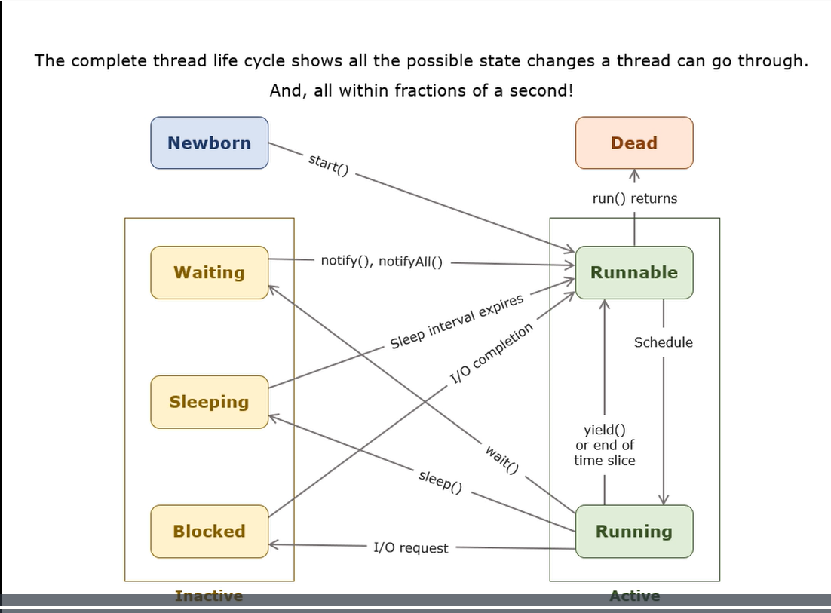
Now that you have seen how threads can be created, have a look at the following overloaded constructors of the Thread class:
Method Name | Description
Thread() | It creates a thread object.
Thread(String name) | Creates a thread with the name being passed as an argument.
Thread(Runnable target) | Creates a thread using the Runnable instance passed as an argument.
Thread(Runnable target, String name) | Creates a thread using the passed Runnable instance and the same is referred to in the name being mentioned.
Thread(ThreadGroup group, Runnable target) | Creates a thread using the passed Runnable instance that belongs to the given thread group.
Thread(ThreadGroup group, Runnable target, String name) | Creates a thread in the given name out of the Runnable interface instance being passed which belongs to the thread group that is given.

Note: The Thread class implements the Runnable Interface
Thread groups can be created using the following constructors:
Constructor | Description
ThreadGroup(String name) | With the given name it creates a new thread group.
ThreadGroup(ThreadGroup parent, String name) | Under the given parent group, it creates a thread group with the name given.

Creating a group for download threads:
- ThreadGroup downloadTG = new ThreadGroup("DownloadThreads");
- Thread downloadThread1 = new Thread(downloadTG, "Download Thread 1");
- Thread downloadThread2 = new Thread(downloadTG, "Download Thread 2");
- Thread downloadThread3 = new Thread(downloadTG, "Download Thread 3");

Some useful methods of ThreadGroup are:
Method | Description
int activeCount() | In the current group, the number of threads running will be returned.
void destroy() | The thread group and all its subgroups will be destroyed.
ThreadGroup getParent() | The parent group of this group will be returned.
void list() | In the standard console, it prints information about this group.
int activeGroupCount() | Returns the number of active groups in this thread group.
String getName() | The group name will be returned.
void interrupt() | All threads of this group will be Interrupted.

A Daemon thread is a thread that runs in the background and serves other threads.
A program won't wait for a daemon thread to complete execution.
A Daemon thread can be created by calling the setDaemon(true) method before calling its start() method. And we can check if a given thread is Daemon thread using the isDaemon() method.
Garbage Collector is one of the examples of a Daemon thread in Java.

Executing multiple threads simultaneously(multithreading) will improve CPU utilization time but also might create issues with shared resources.
There are some resources that need to be accessed by multiple threads. Since threads share the memory of their parent process and they can access as shared resources.
In multithreading, when threads are dependent on a shared resource, they might end up using the resource simultaneously in an interleaved fashion even though they are executing independently. Eventually, the shared resources can be corrupted.
Let us take a scenario to understand the Banking application in which we assume the transaction use-case. Consider a customer who wants to withdraw 1000 from his account which has accountBalance as 1000.
By mistake, the customer requested twice for withdrawal, and hence two threads (thread-1 and thread-2) are created and moved to a runnable state. As the sequence of execution thread-1 was created first and it moves to running state. thread -1 execution starts and account resource is accessed by it.
As per the general logic of withdrawal, the below operation will be performed for thread-1.
- if(accoutBalance >= amountWithdrawal) {
- //Network problem for thread-1
- accoutBalance = accoutBalance - amountWithdrawal;
- }
After checking the condition for accountBalance, because of network issues, thread-1 execution is paused and it goes into a non-runnable state. As amountWithdrawal is not subtracted, still accountBalance will remain 1000. Assume in the meanwhile thread-2 also starts its execution and performs balance checking and withdrawal operation on the account resource and also updates the account balance to 0. Once thread-2 completes its task it will be moved to a dead state.
Once the thread-1 resumes its execution, as it already checked for balance, it tries to withdraw and updates the accountBalance -1000 as shown below-
- accountBalance = accountBalance - amountWithdrawal
- accountBalance = 0 - 1000;
- accountBalance = -1000
Hence Multi-Threading with Shared Resource can lead to resource corruption.
To avoid shared resource corruption, only one thread should access the shared resource at a time, i.e., sequential access for the shared resource is required. Synchronization can be used to ensure this. Every object has a built-in mutually exclusive lock mechanism called monitor. It can be used to achieve synchronization among threads. At the time, only one thread can acquire the monitor on an object.
In Java, locking a resource to a thread until the job finishes can also be achieved by using the synchronized keyword.
In the Banking Application scenario, the below code for withdrawal is synchronized
- synchronized(account){
- if(accoutBalance >= amountWithdrawal) {
- // network problem for thread 1
- accoutBalance = accoutBalance - amountWithdrawal;

- }
- }
Assume if the resource is used by thread-1, then the resource locked for other threads. Once thread-1 finishes the execution, the occupied resource is released and can be accessed by any other threads. The same is explained in the below scenario that synchronized block cannot be accessed by more than one thread at the same time.
Methods or code blocks that can be accessed by one thread at a time should be marked as synchronized. Such methods or blocks becomes thread-safe.
Synchronized method | Synchronized block
public synchronized void perform (Double data) {  // Check data  // perform operation  } |  | public void perform (Double data) {  synchronized(this) {  // Check data  // Perform operation  }  }
In a synchronized context, threads execute sequentially. In such a scenario, a thread in a synchronized context may find itself dependent on the operations of another thread, this calls for a way for the synchronized threads to communicate with each other. Such a mechanism of interaction is termed as Inter-thread communication.
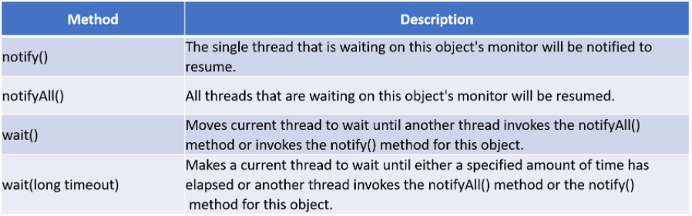
These methods can be called from within a synchronized context only.
The above methods can be used in inter-thread communication as follows:
- If a thread needs to wait for an object's state to change while executing a synchronized method, it may call wait ()
- The thread calling wait () will release the lock on the particular object and will wait for a notification
- It will wait till it is notified by another thread holding the lock on the same object
- If there are multiple threads waiting on the same object, the notify() method will notify any one among them. All the waiting threads can be notified using notifyAll()
- The code for synchronization should be written carefully to prevent a dead-lock situation

The Limitation of Synchronous Programming
In situations where we need an extensive amount of either File IO operations or HTTP Micro-services or Database operations, synchronous programming is time consuming and disadvantageous. Now, you must be asking what Synchronous Programming is in the first place? Well, it is a type of programming model where only one main thread is used for operation. And in above situation, this main thread is blocked whenever an IO operation or HTTP request is encountered. This main thread has to wait until those operations are completed to resume. This synchronicity is disadvantageous as it wastes processing time (as CPU cycles) during the blocked state. And hence it limits the capacity to scale IO operations.

What is Asynchronous Programming?
Asynchronous Programming is simply a method of programming, in which multiple IO operations or HTTP requests can be handled separately, without waiting for their responses by blocking the main thread. And with the advent of Asynchronous Programming, a new paradigm of programming is also introduced, known as Reactive Programming. This programming method helps in managing Asynchronous Programming by efficiently managing the multiple working threads. And this is achieved due to its extensive library of functions for merging, filtering, transforming and combining data from the various threads of operations.
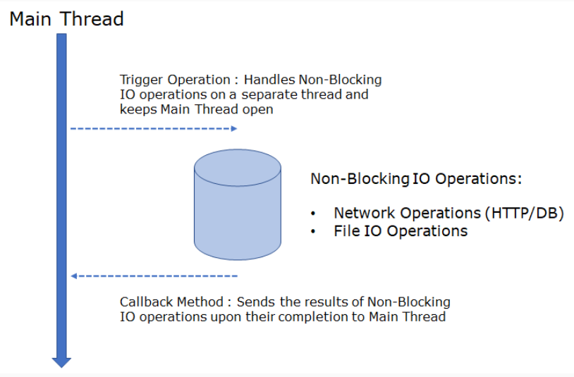
Basically, in non-blocking IO operations the main threads trigger the IO operation in a separate thread. By doing so, the main thread is available for further activities. And when the IO operations are finally completed the output is sent to the main thread using "callback" methods.

Let us look at the following example:
- for (Integer id : traineeIdList) {
- CompletableFuture.supplyAsync(() -> getEmployeeById(id)) //Here CompletableFuture is used to trigger the IO operation in a seperate thread
- .thenApplyAsync(employee -> getScore(employee)) //The different activities to be done in the IO operation is chained together
- .thenApplyAsync(score -> calculatePercent(score)) //This is done by applying a chain of Callback methods
- .thenAcceptAsync(percent -> sendMessage(percent)); //Here thenApplyAsync() and thenAcceptAsync() are the callback methods
- }
CompletableFuture is a feature of Java used for performing asynchronous (non-blocking) tasks and trigger its dependent sub-tasks which may also be asynchronous as well. Essentially, it helps in running the asynchronous task in a separate thread (that is, other than main thread), which is destroyed once the task is complete. And if the task has a returnable data required by the main thread, the data can be sent back to main thread by a callback method. And this is done using a feature known as "ExecutorService".
Before the advent of Asynchronous Programming, IO operations and HTTP Microservices were done using Synchronous Programming. In this, the needed operations, also known as callables were created using the feature known as Future. So, the IO operations were done on a separate thread, but due to the synchronous nature kept the main thread waiting until the output from the callables were received. So, for larger data and IO operations, this became cumbersome.
Let's take a look at the above situation with a small example:
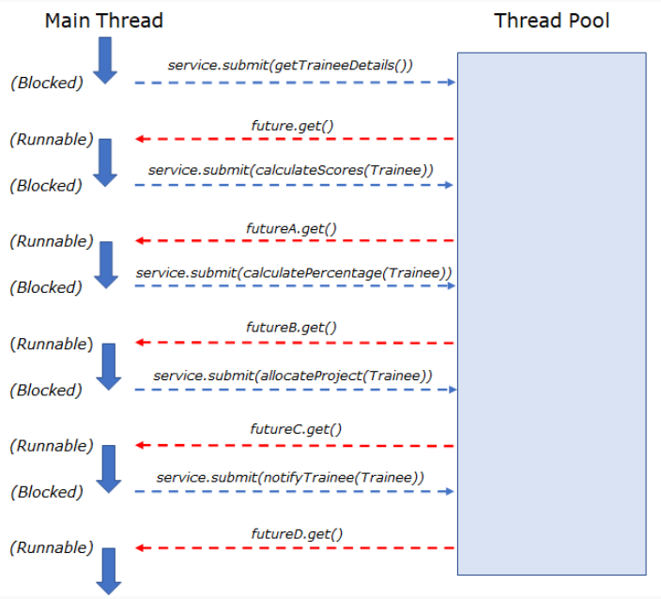
But what if we have not one, but many Trainee objects to perform the same tasks for? It will be really time taking if the Future callables halt the main thread for every individual task. And so, we need CompletableFuture in the place of Future for Asynchronous completion of the tasks.
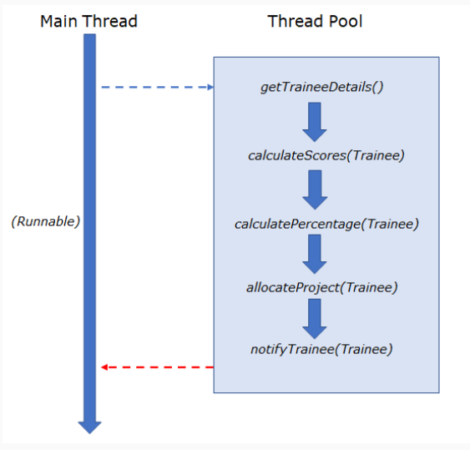
Thus, we can observe how the File IO Operations, HTTP micro-services and Database operations can be handled easily by Asynchronous Programming, without blocking the main thread using CompletableFuture.
Need for Concurrency API:
Working with the Thread class can be very tedious and error-prone, as an application contains a lot of threads. While developing an application, the developer needs to take care of the following aspects while using threads:
- Creating and supervising several threads
- Synchronizing them
- Handling their communication
- Organizing their results
All of the above takes a lot of effort without contributing to business functionality.

What we require is a convenient way to manage threads and separate it from the business logic.

How can we achieve this?

The high-level Concurrency API provided by Java can help us develop concurrent applications conveniently.
- It reduces the programmer's effort and improves maintainability.
- It increases performance and reliability
The API is located in java.util.concurrent package and contains many useful classes, interfaces, and enum TimeUnit for handling concurrent programming. Java 11 has introduced a new method, long convert(java.time.Duration) in the TimeUnit enum which converts given time duration to that unit.
Why Thread Pool?
We can create objects of Thread class or implement the Runnable interface to achieve multi-threading. Then why do we need thread pools?
The answer boils down to a few basic facts.
- A new thread is created for each concurrent task. The time required to manage the thread life-cycle gets added to the execution time.
- A new thread gets added for each task execution which leads to multiple thread creation in memory. A lot of memory is allocated to these threads, which increases the overhead.
The solution to the above problems is Thread Pool.

Thread pools overcome the problems in the following ways:
- A pool of worker threads is created at the beginning.
- A fixed number of threads can be used that reduces the time required for managing the thread life-cycle and also reduces the memory resources which are limited.
- Whenever the number of threads in the pool is less than the tasks flowing in, a queue is maintained. Once the worker thread finishes its execution, the next available task gets executed from the queue.
There are different types of executors available.
- SingleThreadExecutor: Only one worker thread is available in this thread pool executor. It is used for sequential execution of tasks.
  - ExecutorService executorService = Executors.newSingleThreadExecutor();

- FixedThreadPool: In this thread pool executor only, a fixed number of threads are available. If the number of tasks is more than the number of threads, they are stored in a Queue. Once any thread has completed execution, they can execute the next task on the Queue.
  - ExecutorService executorService = Executors.newFixedThreadPool(4);

- CachedThreadPool: This thread pool executor is not bounded by a fixed number of threads. If all the threads are engaged in task execution then a new thread is created in the pool whenever there is a new task assigned. As soon as any of the previously created threads becomes free, that thread will execute the new tasks. If a thread is idle for sixty seconds, it is terminated and removed from the pool.
  - ExecutorService executorService = Executors.newCachedThreadPool();
An Executor initiates and controls the execution of threads and thus improves the program maintenance.
The execute() method of java.util.concurrent.Executor interface :
Method | Description
void execute(Runnable command) | Executes the given Runnable object's run method.

The java.util.concurrent.ExecutorService interface extends Executor. Some of the methods below are provided by ExecutorService:
Method | Description
boolean awaitTermination(long timeout, TimeUnit unit) | Blocks until all tasks have been completed after a shutdown request or the timeout occurs, or the current thread is interrupted, whichever occurs first.
void shutdown() | Shuts down the tasks already submitted in an orderly manner, but no new tasks are accepted.
List<Runnable> shutdownNow() | It returns a list of tasks waiting for execution. Attempts to stop all actively performing tasks also stops the processing of waiting tasks.
boolean isTerminated() | If all tasks have been completed after shutdown then it returns true.
boolean isShutDown() | Returns true if the executor is shut.

Look at the different problems associated with the creation of threads for new tasks often.
Problem | Solution | Description
You must create a new thread for each concurrent task | Thread Pool | A pool of worker threads that are created at the beginning
The time spent in the creation and destruction of threads exceeds the time spent on the tasks |  | As the fixed / expandable number of threads is maintained, the time lost in the creation/destruction of threads is reduced and the memory resources are also limited
Each thread has a large amount of memory, which creates an overhead.
When the no. of threads created exceeds the amount the system can handle without performance degradation, it becomes difficult to maintain stability |  | Maintains a queue whenever there are more active tasks than threads. Fixed thread pools help applications degrade gracefully in the above case, and stay up and running always

All transactions are performed from AccountTransaction class, where threads are created for performing the transactions.
- public class AccountTransaction {

- public static void main(String[] args) {
- DateTimeFormatter customFormatter = DateTimeFormatter.ofPattern("dd/MM/yyyy HH:mm:ss");
- Account account = new Account(1000);
- System.out.println("Start Time: " + customFormatter.format(LocalDateTime.now())); // Time before transaction starts
- ExecutorService executorService = Executors.newSingleThreadExecutor(); // Creates a pool with single worker thread

- executorService.execute(new DepositThread(account, 500)); // Executes run() in DepositThread
- executorService.execute(new WithdrawThread(account, 1200)); // Executes run() in WithdrawThread

- executorService.shutdown(); // Waits for current tasks to end, then shuts down
- while (!executorService.isTerminated()) {
- } // Checking if shutdown is complete
- System.out.println("End Time: " + customFormatter.format(LocalDateTime.now())); // Time after transaction ends
- }

- }
Once the transaction begins, the timestamp for the start time is printed. Then a thread pool with a single worker thread is created by the newSingleThreadExecutor() method. The thread first executes the deposit transaction as it is the task submitted first. Since, there is only a single thread, the second transaction, i.e. withdraw will have to wait, until the first task execution is completed. After completion of the deposit transaction, the thread will be free to execute the next transaction. Withdrawal will take place after deposition. Finally, the shutdown method() is invoked for an orderly shutdown. Once, the shutdown is complete, the Timestamp for end time is printed.
Output:
- Start Time: 01/10/2020 14:57:03
- Balance after deposit: 1500.0
- Balance after withdrawal: 300.0
- End Time: 01/10/2020 14:57:07

For the same ProsperBank application, if a thread pool with a larger size is used, the result will vary.
The AccountTransaction class will be modified to create a thread pool of size 2, by invoking the newFixedThreadPool(thread Threads) method.
- public class AccountTransaction {

- public static void main(String[] args) {
- DateTimeFormatter customFormatter = DateTimeFormatter.ofPattern("dd/MM/yyyy HH:mm:ss");
- Account account = new Account(1000);
- System.out.println("Start Time: " + customFormatter.format(LocalDateTime.now()));
- ExecutorService executorService = Executors.newFixedThreadPool(2); // Creates a pool with 2 threads

- executorService.execute(new DepositThread(account, 500)); // Executes run() in DepositThread
- executorService.execute(new WithdrawThread(account, 1200)); // Executes run() in WithdrawThread

- executorService.shutdown(); // Waits for currently running tasks to finish then shuts down
- while (!executorService.isTerminated()) {
- } // Checking if shutdown is complete
- System.out.println("End Time: " + customFormatter.format(LocalDateTime.now()));
- }

- }
A thread pool with two worker threads is created, and they work independently of each other. So, both, the deposit and withdrawal methods will be executed concurrently. This will give a different result as withdrawal method is executed before, where balance is not enough, after which the deposit method completes its execution.
Output:
- Start Time: 01/10/2020 15:04:14
- Not enough balance
- Balance after deposit: 1500.0
- End Time: 01/10/2020 15:04:16

There is a requirement to acknowledge whether the transaction has been completed. For this, we need to receive confirmation after the task executed.
To achieve the above requirement we can use the Callable interface (java.util.concurrent.Callable<V>). It is similar to Runnable with an additional ability to return the object or throw an exception if something goes wrong.
The Callable interface has only one method - call(). This method represents a task that needs to be completed by a thread before returning any value.
When a callable thread finishes execution, it returns a Future object.
A Future object represents the value that will be returned by a thread when it completes its execution. This value can be retrieved by invoking the get() method of the Future object which in turn returns the result. For any errors, the calling thread will be blocked.
Fixed ThreadPool
import java.util.concurrent.ExecutorService;
import java.util.concurrent.Executors;

class UploadResult implements Runnable {
private String taskName;

public UploadResult(String name) {
taskName = name;
}

@Override
public void run() {
System.out.println(Thread.currentThread().getName() + " (Start) " + taskName);
// Code for uploading result: Dummy implementation
try {
Thread.sleep(2000);
} catch (InterruptedException e) {
System.out.println(e.getMessage());
}
System.out.println(Thread.currentThread().getName() + " (End) " + taskName);
}
}

class ThreadPoolTester {
public static void main(String[] args) {
ExecutorService exServicePool = Executors.newFixedThreadPool(2); // Creating a thread Pool of size 2
int noOfUploadTasks = 3; // Assuming we have 3 UploadResult task which needs to be processed
for (int i = 1; i <= noOfUploadTasks; i++) {
UploadResult uploadRunnable = new UploadResult("UploadResult:" + i);
exServicePool.execute(uploadRunnable);
}
exServicePool.shutdown();
while (!exServicePool.isTerminated()) {
} // Checking if shutdown is complete
System.out.println("Finished all threads");
}
}

A Future object is a value that a callable thread will return in the future. Future object's get() method will give the result value if it is ready, otherwise, it blocks the calling thread.
It also has methods to check whether the calculation is complete, wait until it is finished, etc.
Methods | Description
V get() | It waits to complete the execution and then gets the result.
boolean isCancelled() | If it is able to cancel before it gets completed normally then returns true.
boolean cancel(boolean mayInterruptIfRunning ) | Tries to cancel task execution.
boolean isDone() | Checks if the task is completed or not.
V get(long timeout, TimeUnit unit) | Waits till the given time and then gets the result, if available.

The Future object returned from a callable thread can be retrieved by using these methods of ExecutorService:
Method | Description
<T> Future<T> submit(Callable<T> task) | Submits a value-returning task for execution. It returns a future that has the results of the task pending.
<T> List<Future<T>>invokeAll(Collection<? extends Callable<T>> tasks) | Performs all the Callable tasks as a collection and returns a list of Futures objects holding their results and status when all tasks are completed.
T invokeAny(Collection<? extends Callable<T>>tasks) | Performs the given tasks, and returns the result of one that has successfully completed, if any (i.e. without throwing an exception).

Here's how we can check whether an upload has been successful or not:
- UploadResult uploadCallable = new UploadResult();
- ExecutorService exService=Executors.newSingleThreadExecutor();
- Future<Boolean> future = exService.submit(uploadCallable);
- try {
- System.out.println("Upload successful: " + future.get());//Getting value from Future object
- } catch (InterruptedException e) {
- e.printStackTrace();
- } catch (ExecutionException e) {
- e.printStackTrace();
- }
import java.util.concurrent.Callable;
import java.util.concurrent.ExecutionException;
import java.util.concurrent.ExecutorService;
import java.util.concurrent.Executors;
import java.util.concurrent.Future;

class UploadResult implements Callable<Boolean> {
private String taskName;

public UploadResult(String name) {
taskName = name;
}

@Override
public Boolean call() throws Exception {
System.out.println(Thread.currentThread().getName() + " (Start) " + taskName);
// Code for uploading result: Dummy implementation
Boolean retValue = null;
try {
Thread.sleep(2000);
// code to Upload result
// Set retValue to true
retValue = Boolean.TRUE;
} catch (Exception e) {
System.out.println(e.getMessage());
// Set retValue to false
retValue = Boolean.FALSE;
}
System.out.println(Thread.currentThread().getName() + " (End) " + taskName);
return retValue;
}
}

class RunTaskService {
public static void main(String[] args) {
ExecutorService exService = Executors.newSingleThreadExecutor();
UploadResult uploadCallable = new UploadResult("Batch 1");
Future<Boolean> future = exService.submit(uploadCallable);
try {
System.out.println("Upload completed: " + future.get());
} catch (Exception e) {
System.out.println(e.getMessage());
}
exService.shutdown();
}
}

Here are some methods in the Lock interface:
Method | Description
void lock() | Waits until the lock is acquired.
boolean tryLock() | At the time of calling if it is free then the lock is acquired and it returns true, it will not wait to get the lock. It returns false if the lock is currently used by a different thread.
boolean tryLock(long time, TimeUnit unit) | Gets the lock if it is free in the given time of waiting and the current thread is not interrupted.
void unlock() | The lock will be released.

ReentrantLock implements a Lock interface.
It has an additional constructor where fairness policy (longest waiting thread to acquire lock first) can be set to true.
- ReentrantLock(boolean fair)
ReentrantLock can be repeatedly entered by the thread that currently holds the lock.

The following code is used for using a lock:
- Lock lockob = new ReentrantLock();
- lockob.lock();
- // Critical code section
- lockob.unlock();

import java.util.concurrent.*;
import java.util.concurrent.locks.ReentrantLock;

class UploadResultWithLock implements Runnable {
private ReentrantLock lock;
private int resultCount;

public UploadResultWithLock(ReentrantLock lock) {
this.lock = lock;
}

@Override
public void run() {
System.out.println(Thread.currentThread().getName() + " (Start) - Results uploaded: " + resultCount);
// Code for uploading result: Dummy implementation
try {
lock.lock();
Thread.sleep(2000);
resultCount++;
} catch (InterruptedException e) {
System.out.println(e.getMessage());
} finally {
lock.unlock();
}
System.out.println(Thread.currentThread().getName() + " (End) - Results Uploaded: " + resultCount);
}
}

class Tester {
public static void main(String[] args) {
ExecutorService exServicePool = Executors.newFixedThreadPool(2); // Creating a thread Pool of size 2
int noOfUploadsTask = 3; // Assuming we have 3 UploadResult tasks which need to be processed
ReentrantLock lock = new ReentrantLock(); // The lock to be used
UploadResultWithLock uploadRunnable = new UploadResultWithLock(lock);
for (int i = 1; i <= noOfUploadsTask; i++) {
exServicePool.execute(uploadRunnable);
}
exServicePool.shutdown();
while (!exServicePool.isTerminated()) {
}
System.out.println("Finished all threads");
}
}

