Goals:
Enable building production ready applications quickly.
Provide common non-functional features:
- Embedded servers
- Metrics
- Health checks
- Externalized configuration
What Spring Boot is NOT!
- ZERO code generation
- Neither an application server nor a Web server. It provides integrated servers like Jetty, TOMCAT, etc.
Features
- Quick Starter Projects with Auto Configuration.
- Web (“spring-boot-starter-web” dependencies add Spring MVC, Spring Core, Validation Framework and Logging framework)
- JPA (“spring-boot-starter-data-jpa” dependencies add hibernate framework and auto configure it.
- Embedded Servers – Tomcat, Jetty or Undertow.
- Production-ready features
- Metrics and health checks (To monitor applications)
- Externalized configuration (Dev env, Prod env, etc.)
@SpringBootApplication add Application.context, enable auto-configuration, enable component scan (It will automatically scan all class level dependencies and register it as Component and register class as Bean)
Spring MVC Framework provides decoupled way of developing web applications. With simple concepts like Dispatcher Servlet, ModelAndView and ViewResolver, it makes it easy to develop web applications.

Instead, a technique called Dependency Injection (DI) is used. It is a technique in which the responsibility of creating, assembling and wiring the dependencies of a dependent class is externalized to the external framework or library called dependency injection (DI) frameworks. Now the control over the construction, wiring and assembly of an object no longer resides with the dependent classes themselves. This reversal of responsibilities is sometimes also known as Inversion of Control (IoC). Dependency injection framework are also called as IoC containers.
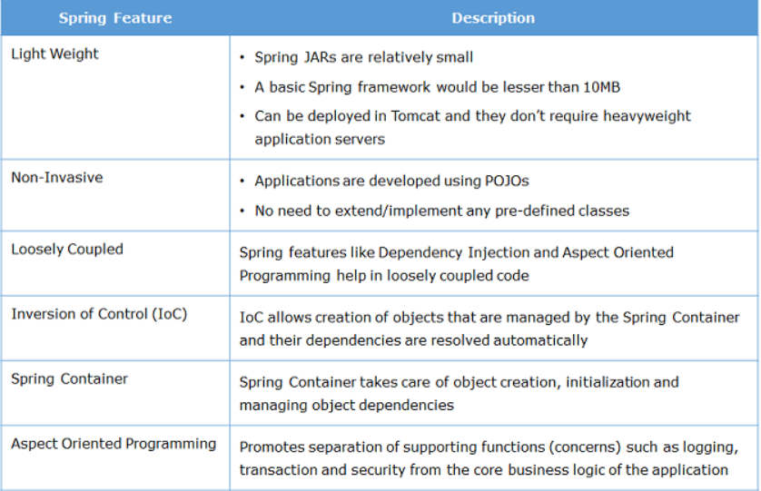

The Spring Core Container has the following modules:
- Core: This is the key module of Spring Framework which provides fundamental support on which all other modules of the framework are dependent.
- Bean: This module provide basic Spring IoC container called BeanFactory.
- Context: This module provides Spring IoC container called ApplicationContext which extends the features of BeanFactory container and provides additional features for enterprise application development.
- Spring Expression Language (SpEL): This module is used for querying/manipulating object value.
In the Spring framework, the interface ApplicationContext represents the IoC container. The Spring container is responsible for instantiating, configuring and assembling objects known as beans, as well as managing their life cycles.

- @Configuration : The Java configuration class is marked with this annotation. This annotation identifies this as a configuration class, and it’s expected to contain details on beans that are to be created in the Spring application context.
- @Bean : This annotation is used to declare a bean. The methods of configuration class that creates an instance of the desired bean are annotated with this annotation. These methods are called by Spring container during bootstrap and the values returned by these methods are treated as Spring beans. By default, only one bean instance is created for a bean definition by the Spring Container, and that instance is used by the container for the whole application lifetime.

You know that Properties file can be read using Properties class but Spring provides Environment class to directly access the values from properties file. The Environment object can be obtained from ApplicationContext as follows:
- Environment environment = applicationContext.getEnvironment();

Using Environment, property value can be fetched using getProperty() method as follows:
- environment.getProperty("SUCCESS");

Some of the best practices that should be followed in Java-Annotation based configuration are:
- Use specialized stereotypes and NOT generic stereotype
As you have seen previously, @Component is a 'generic' stereotype for any Spring-managed bean or component. We also derive @Service, @Repository and @Controller from @Component, which are 'specialized' stereotypes used for classes implementing Service, Persistence and Controller layers respectively.
@Component can be used interchangeably with any of the above derived specific stereotypes and there will not be any significant issue or complication to the application. However, it is a best practice to use the specific stereotypes for their respective layer implementations (which is @Service for Service Layer, @Repository for Persistence Layer and @Controller for Controller Layer).
- Annotate ONLY classes and NOT interfaces
We should always annotate only the classes (and/or it's methods) and not the interface which it implements as Java does not allow the implementing classes to inherit the interfaces which are annotated. Hence, it is a good practice to avoid annotating the interfaces.
By default, Spring IoC container creates only one bean instance (singleton scope), and that instance is used by the container for the whole application lifetime. So w1 and w2 refers to same object. Also equals() method is not overridden, it uses the references for equality check. So, this is the correct option.
Spring container will perform dependency injection using the Java Reflection API. It will search for the class which implements CustomerLoginRepository interface and injects its object. The dependencies which are injected using @Autowired should be available to Spring container when the dependent bean object is created. If the container does not find a bean for auto-wiring, it will throw NoSuchBeanDefinitionException exception.
The @Autowired annotation can also be used on setter methods. This is called as Setter Injection.
The @Autowired annotation can also be used on constructor. This is called as Constructor Injection.
The @SpringBootApplication annotation indicates that it is a configuration class and also triggers auto-configuration and component scanning. It is a combination of the following annotations with their default attributes:
- @EnableAutoConfiguration – This annotation enables auto-configuration for Spring Boot application which automatically configures your application based on the dependencies that you have added.
- @ComponentScan – This enables Spring bean dependency injection feature by using @Autowired annotation. All application components which are annotated with @Component, @Service, @Repository or @Controller are automatically registered as Spring Beans. These beans can be injected by using @Autowired annotation.
- @Configuration – This enables Java based configurations for Spring boot application.

Spring Boot uses Apache Commons Logging for logging. It provides default configurations for using Java Util Logging, Log4j2, and Logback as logging implementation. If Spring Boot starters are used then Logback is used for logging by default.
By default, it logs messages in console at ERROR, WARN, and INFO levels. You can easily configure logging levels, logging format, and log file location by setting logging related properties in application.properties file.
You know that enterprise applications are developed using multiple layers. While the functionalities of each layer are different, there are few functionalities which are common to all layers such as logging, security, transaction management, etc. These functionalities are called as cross-cutting concerns.
Advantages of AOP
- It ensures that cross cutting concerns are kept separate from the core business logic.
- It allows to create a more loosely coupled application wherein you can change the cross-cutting concerns code without affecting the business code.
Spring framework provides AOP support by default. But it leverages the use of AspectJ, which is one of the most popular AOP frameworks. AspectJ provides an easy way for implementing AOP with the help of annotations.
- Aspect is a class that implements the cross-cutting concerns. To declare a class as an aspect it should be annotated with the @Aspect annotation. It should be applied to the class which is annotated with @Component annotation or with derivatives of it.
- Join point is a specific point in the application such as method execution, exception handling, changing object variable values, etc. during its execution. In Spring AOP a join point is always the execution of a method.
- Advice is a method of the aspect class that provides the implementation for the cross-cutting concern. It gets executed at the selected join point(s). The following table shows the different types of advice along with the execution point they have
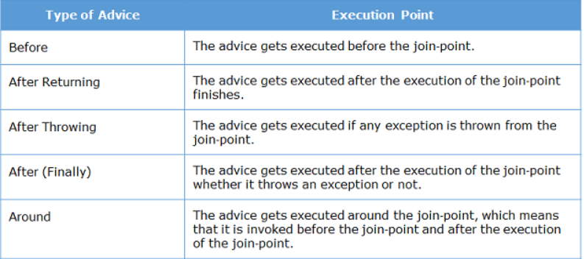
- Pointcut represents an expression used to identify join points. It evaluates to the method name before or after which the advice needs to be executed.
So far you have learnt that advice is a method which implements cross-cutting concern. But one question remains unanswered. How to tell which method of the bean advice needs to be executed? This is where pointcut expressions comes to the rescue.
It is used to determine exactly for which methods of Spring beans advice needs to be applied. It has the following syntax:
- execution(<modifiers> <return-type> <fully qualified class name>.<method-name>(parameters))
where,
- execution is called as pointcut designator. It tells Spring that join point is the execution of the matching method.
- <modifiers> determines the access specifier of the matching method. It could either be public, protected, or private. It is not mandatory.
- <return-type> determines the return type of the method in order for a join point to be matched. It is mandatory. If the return type doesn't matter wildcard * is used.
- <fully qualified class name> specifies the fully qualified name of the class which has methods on the execution of which advice gets executed. It is optional. You can also use * wildcard as name or part of a name.
- <method-name> specifies the name of the method on the execution of which advice gets executed. It is mandatory. You can also use * wildcard as name or part of a name.
- parameters are used for matching parameters. To skip parameter filtering, use two dots .. as parameters.
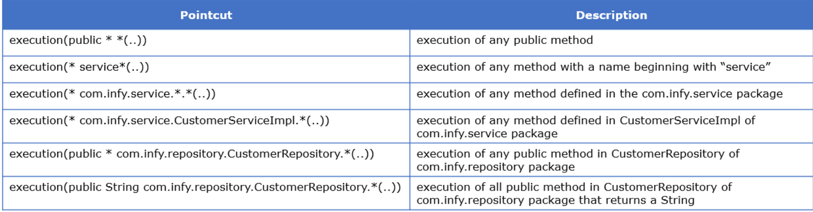
Before advice
This advice is invoked before the actual method call. It is declared using @Before annotation. The following is an example of this advice:
- @Before("execution(* com.infy.service.*Impl.*(..))")
- public void before() throws InfyBankException {
- LOGGER.info("Before advice called.");
- }
This advice is executed before execution of methods of classes present in com.infy.service package and whose name ends with Impl.
After Advice
This advice is executed after the execution of the actual method, even if it throws exception during execution. It is commonly used for resource cleanup such as temporary files or closing database connections. It is declared using @After annotation. The following is an example of this advice :
- @After("execution(* com.infy.service.*Impl.*(..))")
- public void after() throws InfyBankException {
- LOGGER.info("After advice called.");
- }
This advice is executed after execution of methods of classes present in com.infy.service package and whose name ends with Impl.
After Returning Advice
This advice gets executed after joinpoint finishes its execution. If the target method throws an exception the advice is not executed. It is declared using @AfterReturning annotation. The following is an example of this advice that is executed after methods of classes whose name ends with Impl in com.infy.service package finishes its execution:
- @AfterReturning("execution(* com.infy.service.*Impl.*(..))")
- public void afterReturning() throws InfyBankException {
- LOGGER.info("After returning advice called.");
- }
You can also access the value returned by the joinpoint by defining returning attribute of @AfterReturning annotation as follows:
- @AfterReturning(value = "execution(* com.infy.service.*Impl.*(..)),returning = "returnvalue"")
- public void afterReturning(String returnvalue) throws InfyBankException {
- LOGGER.info("After returning advice called.");
- }
In above code snippet, the value of the returning attribute is returnvalue which matches with the name of the advice method argument.
After Throwing Advice
This advice gets executed after an exception is thrown from target method. It is defined using @AfterThrowing annotation. The following is an example of this advice that gets executed when exceptions are thrown from methods of all the classes of com.infy.service package whose name ends with Impl. So, it is marked with @AfterThrowing annotation as follows:
- @AfterThrowing(pointcut = "execution(* com.infy.service.*Impl.*(..))", throwing = "exception")
- public void afterThrowing(InfyBankException exception) throws InfyBankException {
- LOGGER.error(exception.getMessage(), exception);
- }
- @AfterThrowing annotation has following two attributes:
  - pointcut attribute is pointcut expression which defines when advice is executed.
  - throwing attribute is used to access the exception thrown from target method inside the advice method. It’s must match with the name of Exception argument passed to advice method.
Around advice
This advice gets executed around the join point i.e. before and after the execution of the target method. It is declared using @Around annotation. The following is an example of this advice:
- @Around("execution(* com.infy.service.*Impl.*(..))")
- public void aroundAdvice(ProceedingJoinPoint proceedingJoinPoint) throws Throwable {
- LOGGER.info("Before proceeding part of the Around advice.");
- proceedingJoinPoint.proceed();
- LOGGER.info("After proceeding part of the Around advice.");
- }
In above code snippet aroundAdvice method accepts an instance of ProceedingJoinPoint as parameter. It extends the JoinPoint interface, and it can only be used in the Around advice. The proceed() method invokes the joinpoint.
The most important places, rather classes where Spring Boot features must not be added are the classes implementing the business logic. One of the biggest examples of this are the validation classes. Introducing Spring Boot framework here is unwanted and may lead to unnecessary complications.
The following test class tests the authenticateCustomer() method of CustomerLoginServiceImpl class:
- @SpringBootTest
- public class DemoSpringBootCoreApplicationTests {

- @Autowired
- CustomerLoginService customerLoginService;

- @Test
- public void authenticateCustomerTestValidCredentials() throws InfyBankException {
- CustomerLoginDTO customer = new CustomerLoginDTO();
- customer.setLoginName("monica");
- customer.setPassword("monica123");
- String actual = customerLoginService.authenticateCustomer(customer);
- Assertions.assertEquals("SUCCESS", actual);
- }

- @Test
- public void authenticateCustomerTestInValidCredentials() throws InfyBankException {
- CustomerLoginDTO customer = new CustomerLoginDTO();
- customer.setLoginName("monica");
- customer.setPassword("monica13");
- InfyBankException exception=Assertions.assertThrows(InfyBankException.class,()->customerLoginService.authenticateCustomer(customer));
- Assertions.assertEquals("Service.WRONG_CREDENTIALS", exception.getMessage());
- }
- }
In the above test class, following annotation is used:
- @SpringBootTest - This annotation loads ApplicationContext using SpringApplication so that all the Spring Boot features will be available to the tests.
Creating and using mock objects with Mockito
Mockito provides following annotations for creating and using mock objects:
1. @Mock - This annotation creates the mock object of annotated field. For example, CustomerServiceImpl class has a dependency on CustomerRepository, so CustomerRepository needs to be mocked i.e. a dummy object of CustomerRepository is required. This can be done using @Mock annotation as follows:
- @Mock
- CustomerLoginRepository customerLoginRepository;
2. @InjectMocks - This annotation creates object of annotated field and inject mocked dependencies. For example, the object of CustomerServiceImpl class needs the mocked object of CustomerRepository class, so this can be done using @InjectMocks annotation as follows:
- @InjectMocks
- CustomerLoginService customerLoginService = new CustomerLoginServiceImpl();
So, you have created the mock objects. Now you will learn how to add behavior to methods of mock objects.
Configuring Behavior of Mock Object
To add behavior of mock object, Mockito provides various methods. One such method is when(). It is a static method defined in org.mockito.Mockito class. It specifies the value returned when a method of mock object is called. For example, the following code snippet tells Mockito that when getCustomerByCustomerId() method of the mock CustomerRepository is called with 1002 as parameter then it should return null:
- Mockito.when(customerRepository.getCustomerByCustomerId(1002)).thenReturn(null);
Sometimes, you need to define behavior for range of values or beforehand unknown values. For this, you can configure mocked methods using matcher methods as follows:
- Mockito.when(customerRepository.getCustomerByCustomerId(anyInt())).thenReturn(null);
In the above code snippet, anyInt() is a matcher method which returns any Integer value. So, whenever any Integer value is passed to getCustomerByCustomerId() method of the mock CustomerRepository, it will return null value. Some other matcher methods are as follows:
- anyBoolean() - It returns any boolean or Boolean value.
- anyInt() - It returns any integer or Integer value.
- anyFloat() - It returns any float or Float value.
- anyDouble() - It returns any double or Double value.
- anyLong() - It returns any long or Long value.
- any() - It returns any Object.
You must take care of the following points while using Mockito:
- The private and static methods cannot be mocked.
- Do not use matcher methods as values returned by a method. For return value, use exact values.
- If a method has multiple arguments, then you must provide all arguments either by matchers or by exact values.
- The matcher methods cannot be used outside of verification or stubbing.
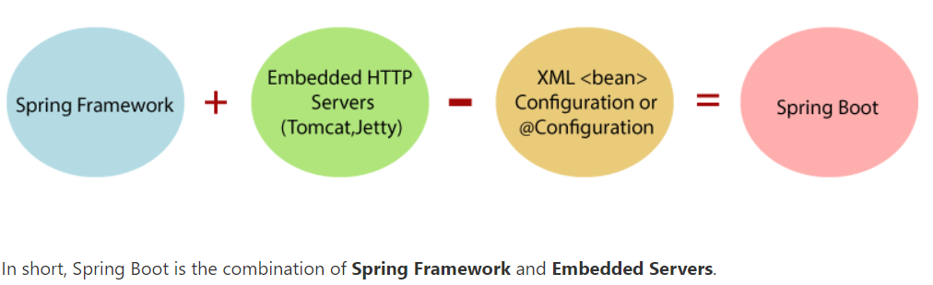
Why should we use Spring Boot Framework?
We should use Spring Boot Framework because:
- The dependency injection approach is used in Spring Boot.
- It contains powerful database transaction management capabilities.
- It simplifies integration with other Java frameworks like JPA/Hibernate ORM, Struts, etc.
- It reduces the cost and development time of the application.
Along with the Spring Boot Framework, many other Spring sister projects help to build applications addressing modern business needs. There are the following Spring sister projects are as follows:
- Spring Data: It simplifies data access from the relational and NoSQL databases.
- Spring Batch: It provides powerful batch processing.
- Spring Security: It is a security framework that provides robust security to applications.
- Spring Social: It supports integration with social networking like LinkedIn.
- Spring Integration: It is an implementation of Enterprise Integration Patterns. It facilitates integration with other enterprise applications using lightweight messaging and declarative adapters.

Advantages of Spring Boot
- It creates stand-alone Spring applications that can be started using Java -jar.
- It tests web applications easily with the help of different Embedded HTTP servers such as Tomcat, Jetty, etc. We don't need to deploy WAR files.
- It provides opinionated 'starter' POMs to simplify our Maven configuration.
- It provides production-ready features such as metrics, health checks, and externalized configuration.
- There is no requirement for XML configuration.
- It offers a CLI tool for developing and testing the Spring Boot application.
- It offers the number of plug-ins.
- It also minimizes writing multiple boilerplate codes (the code that has to be included in many places with little or no alteration), XML configuration, and annotations.
- It increases productivity and reduces development time.

Limitations of Spring Boot
Spring Boot can use dependencies that are not going to be used in the application. These dependencies increase the size of the application.

Goals of Spring Boot
The main goal of Spring Boot is to reduce development, unit test, and integration test time.
- Provides Opinionated Development approach
- Avoids defining more Annotation Configuration
- Avoids writing lots of import statements
- Avoids XML Configuration.
By providing or avoiding the above points, Spring Boot Framework reduces Development time, Developer Effort, and increases productivity.

Spring Boot: Spring Boot is a module of Spring Framework. It allows us to build a stand-alone application with minimal or zero configurations. It is better to use if we want to develop a simple Spring-based application or RESTful services.
The primary comparison between Spring and Spring Boot are discussed below:
Spring | Spring Boot
Spring Framework is a widely used Java EE framework for building applications. | Spring Boot Framework is widely used to develop REST APIs.
It aims to simplify Java EE development that makes developers more productive. | It aims to shorten the code length and provide the easiest way to develop Web Applications.
The primary feature of the Spring Framework is dependency injection. | The primary feature of Spring Boot is Autoconfiguration. It automatically configures the classes based on the requirement.
It helps to make things simpler by allowing us to develop loosely coupled applications. | It helps to create a stand-alone application with less configuration.
The developer writes a lot of code (boilerplate code) to do the minimal task. | It reduces boilerplate code.
To test the Spring project, we need to set up the sever explicitly. | Spring Boot offers embedded server such as Jetty and Tomcat, etc.
It does not provide support for an in-memory database. | It offers several plugins for working with an embedded and in-memory database such as H2.
Developers manually define dependencies for the Spring project in pom.xml. | Spring Boot comes with the concept of starter in pom.xml file that internally takes care of downloading the dependencies JARs based on Spring Boot Requirement.

Spring Boot vs. Spring MVC
Spring Boot: Spring Boot makes it easy to quickly bootstrap and start developing a Spring-based application. It avoids a lot of boilerplate code. It hides a lot of complexity behind the scene so that the developer can quickly get started and develop Spring-based applications easily.
Spring MVC: Spring MVC is a Web MVC Framework for building web applications. It contains a lot of configuration files for various capabilities. It is an HTTP oriented web application development framework.
Spring Boot and Spring MVC exist for different purposes. The primary comparison between Spring Boot and Spring MVC are discussed below:
Spring Boot | Spring MVC
Spring Boot is a module of Spring for packaging the Spring-based application with sensible defaults. | Spring MVC is a model view controller-based web framework under the Spring framework.
It provides default configurations to build Spring-powered framework. | It provides ready to use features for building a web application.
There is no need to build configuration manually. | It requires build configuration manually.
There is no requirement for a deployment descriptor. | A Deployment descriptor is required.
It avoids boilerplate code and wraps dependencies together in a single unit. | It specifies each dependency separately.
It reduces development time and increases productivity. | It takes more time to achieve the same.
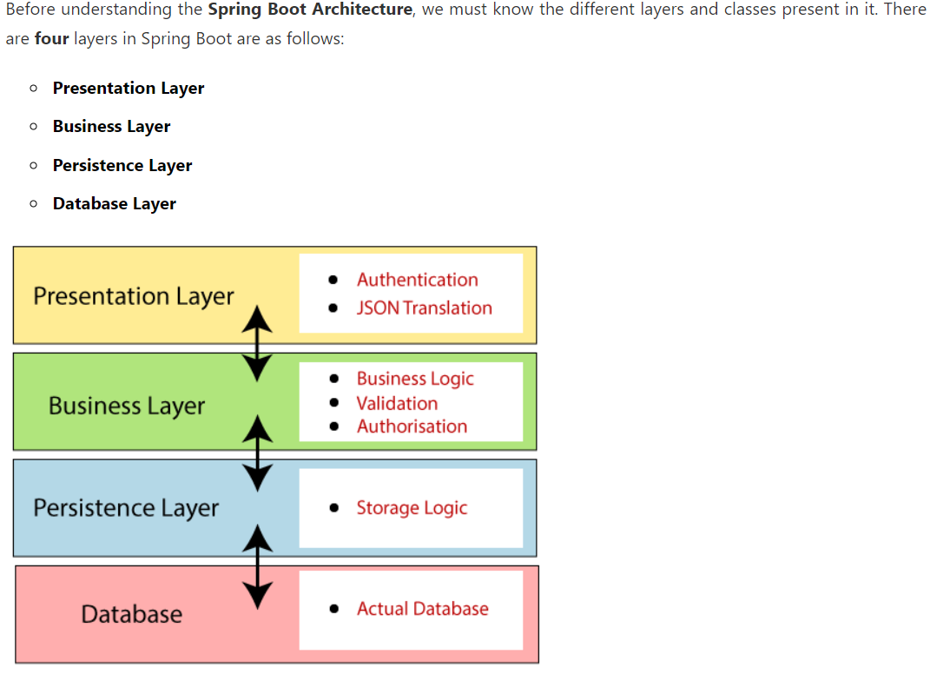
- Now we have validator classes, view classes, and utility classes.
- Spring Boot uses all the modules of Spring-like Spring MVC, Spring Data, etc. The architecture of Spring Boot is the same as the architecture of Spring MVC, except one thing: there is no need for DAO and DAOImpl classes in Spring boot.
- Creates a data access layer and performs CRUD operation.
- The client makes the HTTP requests (PUT or GET).
- The request goes to the controller, and the controller maps that request and handles it. After that, it calls the service logic if required.
- In the service layer, all the business logic performs. It performs the logic on the data that is mapped to JPA with model classes.
- A JSP page is returned to the user if no error occurred.
