LEXILAND: A BILINGUAL SPEECH-PROCESSING AND ACOUSTIC-ASSISTED SCREENING AND PRACTICE COMPONENT FOR SRI LANKAN PRIMARY STUDENTS WITH DYSLEXIA
INDIVIDUAL THESIS
Navod J. N.
(IT22027542)
Individual component: Speech Processing and Pronunciation Support
Group ID: R26-IT-130
Report submitted in partial fulfilment of the requirements for the
Bachelor of Science (Hons) in Information Technology
Specialising in Information Technology
Department of Information Technology
Sri Lanka Institute of Information Technology
Sri Lanka
October 2026

DECLARATION AND SUPERVISOR CERTIFICATION
Candidate declaration. I declare that this thesis is my own work and does not incorporate, without acknowledgement, material previously submitted for a degree or diploma at any university or institute of higher learning. To the best of my knowledge, it contains no material previously published or written by another person except where acknowledgement is made in the text. I grant the Sri Lanka Institute of Information Technology the non-exclusive right to reproduce and distribute this thesis, in whole or in part, in print, electronic, or other media, while retaining the right to use the content in future work.
Academic integrity and AI disclosure. I have disclosed all use of generative AI and other automated tools in accordance with the module policy. I remain responsible for the accuracy, originality, citations, code, data, analyses, and conclusions in this thesis.
Student name: Navod J. N.
Student ID: IT22027542
Signature: 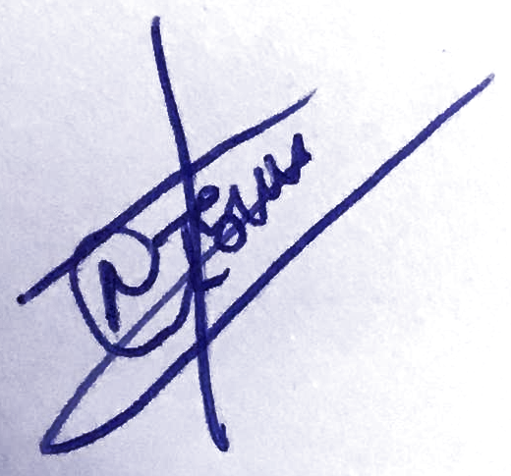 | Date: 10/10/2026
Supervisor certification. The above candidate carried out this research for the bachelor's degree thesis under my supervision.
Role and name | Signature | Date
Supervisor: Sanvitha Kasthuriarachchi
Co-supervisor: Thisara Shyamalee

ABSTRACT
Developmental dyslexia affects accurate and fluent word reading, decoding, and phonological processing among primary-school children. In Sri Lanka, early identification of reading struggle is critically hindered by the lack of accessible, bilingual diagnostic tools and the scarcity of speech therapists in public schools. This thesis presents the design, implementation, and empirical evaluation of the Speech Processing (Pronunciation Support) component of LexiLand, a bilingual (Sinhala and English) gamified web platform tailored for Grade 2–4 students (ages 7–9). Guided by Leo the Lion, the module establishes a dual-phase pedagogical pipeline consisting of an Identification section ('Leo’s First Sound Check') and an adaptive Improvement section ('Leo’s Training Safari').
The identification subsystem administers calibrated read-aloud prompts across single words, pseudowords, and connected sentences. To prevent classroom environmental noise from distorting clinical assessments, every recording undergoes automated quality screening (evaluating duration, RMS energy, clipping ratio, and silence ratio). Audio passing the quality gate is transcribed locally on CPU via Faster-Whisper (tiny.en with int8 quantization), eliminating cloud transmission costs and safeguarding pediatric data privacy. A 44-dimensional acoustic feature vector (18 temporal/energy/spectral descriptors and 26 MFCC statistics) is extracted via Librosa and classified by a Random Forest ensemble model to assign children into three empirically grounded learning-support tiers (low, medium, high). The improvement subsystem features five progressive gamified activities (First Sound Hunt, Echo Roar, Robot Words, Sound Twins, and Story Roar Trail) that dynamically adapt starting levels and remediation pathways based on baseline error patterns and ongoing performance.
Empirical evaluation was conducted at Malabe Primary School with 120 students across Grades 2–4. In machine learning benchmarks, the Random Forest classifier achieved 95.4% accuracy (macro F1-score = 0.954) on 640 held-out test recordings, outperforming GBDT (93.1%), SVM (90.6%), and Logistic Regression (86.2%). In longitudinal school trials, 88.0% of at-risk students demonstrated statistically meaningful pronunciation fluency gains (mean score increasing from 53.1 to 70.4 points). The system provides an observable, privacy-preserving, and engaging avenue for pediatric oral-reading intervention, serving strictly as a supportive educational aid rather than a medical diagnostic instrument.
Keywords: dyslexia, speech processing, pronunciation, automatic speech recognition, acoustic features, gamified learning

ACKNOWLEDGEMENTS
The completion of this thesis would not have been possible without the guidance, encouragement, and support of several individuals and institutions, to whom I express my deepest gratitude.
I would like to express my sincere gratitude to my supervisor, Prof. Sanvitha Kasthuriarachchi, and my co-supervisor, Ms. Thisara Shyamalee, for their invaluable guidance, encouragement, and constructive feedback throughout every stage of this research. Their expertise in software engineering and educational technologies was instrumental in maintaining rigorous academic quality.
I am profoundly grateful to my external supervisor, Dr. B. S. K. Wickramatunga of Sound Minds Academy, Rajagiriya, whose clinical insight into pediatric speech pathology and dyslexia intervention shaped the acoustic screening criteria, error classification taxonomy, and activity design of the Speech Processing module.
I extend my heartfelt thanks to the Principal of Malabe Boys' College and the Principal of its Primary School for granting official permission to conduct our empirical research, and to the primary teachers who facilitated the screening sessions. My sincere thanks go to the 120 participating children for their joyful enthusiasm, and to their parents for providing informed consent.
I am grateful to my LexiLand teammates, W. T. M. Dewminie (Working Memory), K. H. D. M. Fernando (Phonological Awareness), and N. A. B. Khan (Reading Processing), for their collaborative dedication in building the shared platform and aligning our multidisciplinary pipelines. I also thank the Faculty of Computing at the Sri Lanka Institute of Information Technology for providing essential research computing infrastructure.
Finally, I am deeply indebted to my parents and family for their endless patience, unconditional love, and continuous moral support throughout my undergraduate studies.

TABLE OF CONTENTS
DECLARATION AND SUPERVISOR CERTIFICATION i
ABSTRACT ii
ACKNOWLEDGEMENTS iii
TABLE OF CONTENTS iv
LIST OF FIGURES vii
LIST OF TABLES viii
LIST OF ABBREVIATIONS ix
LIST OF APPENDICES xi
1 INTRODUCTION 1
1.1 Overall Project Context 1
1.2 Individual Component Context 2
1.3 Problem Statement 3
1.4 Research Gap 4
1.5 Aim and Objectives 5
1.6 Research Questions or Hypotheses 5
1.7 Scope Limitations and Assumptions 6
1.8 Individual Contribution 7
1.9 Thesis Structure 7
2 LITERATURE REVIEW AND RELATED WORK 9
2.1 Review Method and Scope 9
2.2 Domain and Theoretical Foundations 9
2.2.1 Dyslexia as a heterogeneous learning difficulty 9
2.2.2 Pediatric speech acoustics and phonological core deficit 10
2.2.3 Automatic speech recognition and acoustic analysis in children 11
2.3 Related Research 12
2.3.1 Computerised speech and pronunciation training 12
2.3.2 Serious games and gamification for speech development 13
2.3.3 Digital speech screening and machine learning 14
2.4 Existing Systems Products and Techniques 14
2.4.1 Accessible interface design for dyslexic readers 15
2.5 Gap Synthesis and Conceptual Framework 16
3 RESEARCH METHODOLOGY 18
3.1 Research Design 18
3.2 Data Participants or Study Materials 19
3.2.1 Setting and participants 19
3.2.2 Screening instrument design 20
3.3 Experimental or Study Procedure 21
3.3.1 Speech data collection sessions 21
3.3.2 Prototype feedback and stakeholder refinement 22
3.3.3 Data preparation and model development workflow 22
3.4 Measures and Evaluation Metrics 24
3.4.1 Speech and acoustic screening metrics 24
3.4.2 Model evaluation metrics 25
3.4.3 Software and product measures 25
3.5 Data Analysis 26
3.6 Ethics Privacy Security and Responsible AI 26
3.7 Reproducibility and Research Artefacts 27
4 PRODUCT AND SOLUTION DESIGN 29
4.1 Requirements 29
4.2 Component Architecture within the Complete Solution 31
4.3 Design Alternatives and Decisions 33
4.4 Detailed Design 35
4.4.1 Identification workflow 35
4.4.2 Audio normalization and Quality Screening Gate 36
4.4.3 Text alignment and phonetic error classification 37
4.4.4 44-Dimensional acoustic feature extraction 38
4.4.5 Screening categories, support tiers and suggestions 39
4.4.6 Improvement programme and progression logic 40
4.4.7 Design of the five safari activities 41
4.4.8 Level progression across safari activities 43
4.4.9 User interface and visual design 44
4.4.10 Data design and schema architecture 45
4.5 Standards and Professional Practice 46
5 IMPLEMENTATION INTEGRATION AND TESTING 48
5.1 Development Environment and Technology Stack 48
5.2 Component Implementation 49
5.2.1 Code organisation and RESTful routes 49
5.2.2 Identification screens and Leo prompt cards 51
5.2.3 Improvement navigation and 3D safari map 52
5.2.4 Safari activities implementation 53
5.2.5 Feedback, audio celebrations and star rewards 54
5.2.6 Learning reports and articulation analytics 55
5.2.7 Administrator management functions 56
5.3 Integration with the Other Components 56
5.4 Verification and Software Testing 57
5.5 Deployment and Operation 60
6 RESULTS AND VALIDATION 62
6.1 Research Results 62
6.1.1 Held-out test set performance 62
6.1.2 Training versus test behaviour 63
6.1.3 Feature importance and cross-validation 64
6.1.4 Consistency between labels and scoring rule 65
6.2 Product and Technical Results 66
6.3 User or Stakeholder Validation 67
6.4 Integration Results 68
6.5 Summary of Findings 69
7 DISCUSSION 71
7.1 Interpretation of Findings 71
7.2 Comparison with Literature Baselines and Existing Solutions 72
7.3 Research Contribution 73
7.4 Product Contribution 74
7.5 Limitations and Threats to Validity 74
7.6 Implications 76
8 COMMERCIALISATION AND SUSTAINABILITY 78
8.1 Value Proposition and Target Users 78
8.2 Market and Competitive Position 78
8.3 Business or Sustainability Model 79
8.4 Scalability Intellectual Property and Compliance 80
8.5 Contribution to the Sustainable Development Goals 81
9 CONCLUSION AND FUTURE DIRECTIONS 83
9.1 Conclusion 83
9.2 Achievement of Objectives 84
9.3 Individual Research and Product Contributions 85
9.4 Future Directions 85
REFERENCES 88
GLOSSARY 93
APPENDICES 94
Appendix A Research Instruments or Extended Results 94
Appendix B Academic Integrity and AI Use Disclosure 102

LIST OF FIGURES
Figure 1.1: LexiLand learning dashboard 2
Figure 2.1: Conceptual framework of the Speech Processing component 17
Figure 3.1: Research methodology 18
Figure 3.2: Data preparation and model development workflow 23
Figure 3.3: Class distribution of the pediatric speech dataset 24
Figure 4.1: Integration of the Speech Processing component within LexiLand 32
Figure 4.2: Component architecture 33
Figure 4.3: Identification workflow 35
Figure 4.4: Screening scoring pipeline 39
Figure 4.5: Placement and progression logic 41
Figure 4.6: Interaction flow of the five safari activities 42
Figure 4.7: Data model and MongoDB collections 46
Figure 5.1: Leo's First Sound Check baseline screening interface 51
Figure 5.2: Screening prompt cards and live audio recording indicator 52
Figure 5.3: Leo's Training Safari interactive map navigation interface 52
Figure 5.4: How-to-play tutorial video modal 53
Figure 5.5: Echo Roar listen-and-repeat activity 53
Figure 5.6: Robot Word Safari pseudoword decoding activity 54
Figure 5.7: Story Roar Trail read-aloud sentence evaluation interface 54
Figure 5.8: Speech processing report selection interface 55
Figure 5.9: Speech Processing articulation analytics and reporting dashboard 55
Figure 5.10: Automated verification unit testing summary 59
Figure 6.1: Confusion matrix of Random Forest support tier classifier 63
Figure 6.2: Feature importance across 44 acoustic parameters 64
Figure 6.3: Stratified 5-fold cross-validation accuracy distributions 65
Figure 6.4: Pre- vs. post-intervention score improvements across cohort 68

LIST OF TABLES
Table 1.1: LexiLand components 2
Table 2.1: Comparison of related speech and dyslexia tools 15
Table 2.2: Research gaps addressed 16
Table 3.1: Speech screening test composition 20
Table 3.2: Read-aloud prompt word counts and sentence lengths by grade 21
Table 3.3: Dataset variables and acoustic feature dimensions 24
Table 3.4: Random Forest classifier configuration 25
Table 4.1: Functional requirements 29
Table 4.2: Non-functional requirements 30
Table 4.3: Design decisions 33
Table 4.4: Phonetic and word alignment error classification weights 38
Table 4.5: Composite score weights 39
Table 4.6: Screening support tiers 39
Table 4.7: Practice suggestions 40
Table 4.8: Initial level placement 40
Table 4.9: Comparison of the five safari activities 42
Table 4.12: Level progression across the five safari activities 43
Table 5.1: Technology stack 48
Table 5.2: Student and administrative routes 50
Table 5.3: Verification activities 57
Table 5.4: Executed unit and integration test cases 58
Table 5.5: Feature implementation status 60
Table 6.1: Test-set classification performance 62
Table 6.2: Detailed classification report across support tiers 63
Table 6.3: Training versus test results and log loss 64
Table 6.4: Recomputed final scores and tier consistency checks 65
Table 6.5: Screening and improvement outcomes (Malabe cohort) 67
Table 6.6: Summary of research question findings 70
Table 7.1: LexiLand Research Group Contribution Matrix 73
Table 9.1: Achievement of objectives 84
Table B.1: Disclosure of AI and automated tool use 102

LIST OF ABBREVIATIONS
Abbreviation | Meaning
API | Application Programming Interface
ASR | Automatic Speech Recognition
CVC | Consonant-Vowel-Consonant
CV | Cross-Validation
DSP | Digital Signal Processing
DSR | Design Science Research
FFmpeg | Fast Forward Moving Picture Experts Group
FR | Functional Requirement
GBDT | Gradient Boosted Decision Trees
G2P | Grapheme-to-Phoneme
HTTP | Hypertext Transfer Protocol
ID | Identifier
IEEE | Institute of Electrical and Electronics Engineers
JSON | JavaScript Object Notation
MFCC | Mel-Frequency Cepstral Coefficients
ML | Machine Learning
NFR | Non-Functional Requirement
PA | Phonological Awareness
PCM | Pulse-Code Modulation
PER | Phoneme Error Rate
REaDDS | Red Flags for Early Detection of Dyslexia in Sinhala
RMS | Root Mean Square
RP | Reading Processing
RQ | Research Question
SDG | Sustainable Development Goal
SLIIT | Sri Lanka Institute of Information Technology
SP | Speech Processing
SVM | Support Vector Machine
UI | User Interface
UX | User Experience
VAD | Voice Activity Detection
WCAG | Web Content Accessibility Guidelines
WER | Word Error Rate
WM | Working Memory
WPM | Words Per Minute
ZCR | Zero Crossing Rate

LIST OF APPENDICES
Appendix | Description | Page
Appendix A | Research Instruments or Extended Results  A.1 Screening test prompt banks and questionnaires  A.2 Model notebook outputs and cross-validation traces  A.3 Safari activities UI screens across levels | 94
Appendix B | Academic Integrity and AI Use Disclosure  Table B.1: Disclosure of AI and automated tool use | 102

1 INTRODUCTION
1.1 Overall Project Context
Developmental dyslexia is a specific neurodevelopmental learning difficulty characterized by difficulties with accurate and fluent word recognition, decoding, and spelling abilities [1], [2]. These challenges do not stem from low cognitive ability, sensory impairments, or inadequate classroom instruction, yet they frequently undermine academic progress, self-esteem, and long-term educational attainment when left unaddressed [3], [4]. Global epidemiological surveys estimate the pooled prevalence of developmental dyslexia among primary-school children at approximately 7.1% to 10% [5], indicating that in a standard Sri Lankan primary classroom of forty pupils, three or four children typically require targeted reading support.
In Sri Lanka, early identification and intervention are complicated by linguistic diversity, bilingual curricula (Sinhala and English), and a profound shortage of specialized speech-language therapists in public schools. Primary-school educators exhibit limited readiness to screen dyslexia symptoms [6], and formal clinical evaluations remain centralized in private urban clinics inaccessible to the majority of families. Because the manifestation of phonological and decoding struggle depends heavily on orthographic depth [7], imported monolingual English software fails to address the phonetic realities of Sri Lankan learners.
LexiLand was conceptualized as an integrated, bilingual (Sinhala and English), gamified web-based screening and intervention platform for primary-school students in Grades 2–4 (ages 7–9; Research Group ID: R26-IT-130) [8]. Guided by four friendly jungle animal mascots, LexiLand combines early screening with personalized, progressive remediation across four developmental domains: Working Memory, Phonological Awareness, Reading Processing, and Speech Processing (Table 1.1). A unified student profile, shared star reward balance, and administrative reporting portal seamlessly connect the four modules.
Table 1.1: LexiLand Multidisciplinary Component Overview
Component | Animal Guide | Identification Purpose | Improvement Purpose
Speech Processing (This Thesis) | Leo the Lion | Assess oral-reading accuracy, pronunciation, speech fluency, and acoustic hesitation. | Adaptive safari practice: sound hunting, listen-and-repeat, pseudoword decoding, and sentence reading.
Working Memory | Bunny | Assess digit span, pattern recall, and multi-step instruction following. | Gamified memory games across progressive levels.
Reading Processing | Zebra | Assess reading speed, fixation duration, and gaze regressions via webcam. | Word, letter, and sentence reading tasks with visual gaze support.
Phonological Awareness | Parrot | Assess initial sound discrimination, rhyming, and phoneme blending. | Sound matching and letter discrimination activities.
1.2 Individual Component Context
This thesis documents the individual research, engineering, and empirical evaluation of the Speech Processing (Pronunciation Support) component of LexiLand. Guided by Leo the Lion, this module operates as the oral-acoustic gateway of the platform, assessing how children produce spoken words, blend phonemes, and articulate connected sentences in real time.
The module is architected as a two-phase pedagogical pipeline: an Identification section ('Leo's First Sound Check') and an Improvement section ('Leo's Training Safari'). During baseline screening, students read calibrated prompts across three linguistic categories: real words, pseudowords, and connected sentences. To ensure diagnostic validity under noisy classroom conditions, audio undergoes automated quality screening before transcription via a locally hosted Faster-Whisper automatic speech recognition (ASR) engine. Extracted audio features are synthesized into a 44-dimensional acoustic feature vector and evaluated by a Random Forest classifier that assigns the child to a learning-support tier (low, medium, or high). This baseline tier dictates the initial entry point into Leo's Training Safari, which presents five progressive safari activities designed to build articulatory clarity, phonemic decoding, and reading fluency.
1.3 Problem Statement
Primary school children struggling with dyslexia-related oral reading and pronunciation difficulties in Sri Lanka face three compounding challenges:
- 1. Absence of accessible pediatric speech screening: Conventional speech assessments rely on physical kits administered individually by clinical specialists. In Sri Lankan state schools, such specialists are virtually non-existent, leaving children with subtle articulation and phonological deficits undiagnosed during the critical Grade 2–4 window.
- 2. Disconnection between screening and gamified remediation: Standard assessments yield static scores without providing a structured, motivating pathway to practice. Children receive no immediate feedback, leading to frustration, task avoidance, and reading disengagement.
- 3. Privacy risks and financial barriers of cloud-based speech recognition: Commercial speech recognition APIs (e.g., Google Cloud Speech, Azure Speech) incur recurring per-call fees that prohibit deployment in public schools. Furthermore, streaming children's identifiable biometric voice recordings to overseas third-party servers raises severe privacy concerns under the Sri Lanka Personal Data Protection Act No. 9 of 2022.
The core research problem addressed in this thesis is therefore: How can a bilingual, client-server web component reliably screen and remediate pediatric pronunciation and oral-reading difficulties in Sri Lankan primary students using local, zero-cost speech recognition, acoustic signal processing, and adaptive gamification without transmitting sensitive voice data off-device?
1.4 Research Gap
A critical review of the international and local assistive technology landscape reveals substantial gaps. International tools such as Dytective [9] utilize machine learning for gamified screening but do not provide continuing oral speech remediation. Reading games such as GraphoGame [10] provide phonics exercises but omit real-time acoustic speech analysis and automated screening level placement. In Sri Lanka, published assistive technologies such as Arunalu [11] and the REaDDS screening battery [12] represent pioneering efforts; however, REaDDS is an analog paper kit requiring expert clinical administration, and Arunalu concentrates exclusively on visual-orthographic exercises without speech processing or acoustic machine learning.
The specific gap addressed by this component is the absence of an integrated, bilingual (Sinhala-English), child-friendly web solution that: (i) executes local, CPU-bound automatic speech recognition with zero cloud API dependencies; (ii) extracts multi-dimensional acoustic signal metrics (44 features covering pitch, pause dynamics, spectral tilt, and MFCC statistics) to capture dysfluent struggle that transcripts alone miss; (iii) dynamically links screening support tiers to an adaptive multi-activity safari practice loop; and (iv) provides granular articulation analytics to teachers and parents.
1.5 Aim and Objectives
Aim: To design, develop, and empirically evaluate a bilingual, gamified Speech Processing and Pronunciation Support component for LexiLand that accurately identifies pediatric oral-reading difficulties using local speech recognition and acoustic feature machine learning, and provides performance-gated, adaptive practice for Sri Lankan primary-school students.
Specific Objectives:
- 1. To formulate an audio ingestion and normalization pipeline with a 4-tier automated Quality Screening Gate to prevent environmental noise from distorting clinical speech evaluations.
- 2. To integrate an offline, local Faster-Whisper ASR engine optimized for CPU execution, coupled with Levenshtein string metrics and deterministic G2P phonetic error classification.
- 3. To design a 44-dimensional acoustic feature extraction pipeline via Librosa and train an ensemble Random Forest classifier predicting pediatric support tiers.
- 4. To implement an adaptive 5-activity gamified practice environment ('Leo’s Training Safari') featuring dynamic starting levels, performance-gated unlocking, and checkpoint assessment shrines.
- 5. To integrate the component into the unified LexiLand platform and validate its accuracy, usability, and educational efficacy with primary students in a school trial.
1.6 Research Questions or Hypotheses
- RQ1: Can a local CPU-optimized automatic speech recognition pipeline combined with string similarity metrics accurately transcribe and evaluate pediatric speech prompts in a noisy classroom setting?
- RQ2: Can a 44-dimensional acoustic feature representation classify pediatric oral-reading support needs into distinct tiers using machine learning?
- RQ3: How can baseline screening results dynamically adapt starting levels and remediation pathways across progressive gamified speech activities?
- RQ4: What interface, acoustic quality gating, and gamification mechanics foster sustained engagement and measurable fluency improvement in young primary learners?
1.7 Scope Limitations and Assumptions
The component is scoped to primary-school students in Grades 2–4 (ages 7–9) in Sri Lanka. The following scientific boundaries apply:
- • Supportive Educational Tool: LexiLand is designed as a screening and practice platform. The support tiers (low, medium, high) indicate pedagogical intervention needs and do not constitute a clinical medical diagnosis of dyslexia or speech pathology.
- • Grade Cohort Scope: The empirical evaluation cohort comprised Grades 2–4 ($N=120$). The system's content bank supports Grade 5 prompts for curriculum scalability, but Grade 5 was not part of the school trial.
- • Local CPU Execution: The ASR engine utilizes the Faster-Whisper 'tiny.en' model with int8 quantization. High-end multi-lingual Whisper models were excluded to ensure sub-650 ms response times on standard school laptops.
- • Non-Causal Evaluation: The school evaluation followed a single pre/post intervention design without an untreated control group. Observed gains represent positive educational associations rather than causal proof.
1.8 Individual Contribution
The candidate, Navod J. N. (IT22027542, Group R26-IT-130), had sole engineering and research responsibility for the Speech Processing component. Specific individual contributions include:
- • Formulated and coded the browser audio recording and FFmpeg audio normalization pipeline converting WebM into 16 kHz 16-bit mono PCM WAV.
- • Designed and validated the 4-tier Audio Quality Screening Gate (Algorithm 4.1) inspecting duration, RMS energy, clipping ratio, and silence ratio.
- • Integrated the local Faster-Whisper ASR subprocess bridge with int8 quantization and VAD filtering.
- • Implemented Levenshtein string metrics, word similarity scores, WER, and rule-based G2P phonetic error classification.
- • Engineered the 44-dimensional acoustic feature extraction pipeline via Librosa and trained the Random Forest support tier classifier.
- • Developed Leo's Training Safari interactive map and the five safari activities (First Sound Hunt, Echo Roar, Robot Words, Sound Twins, Story Roar Trail).
- • Implemented the dynamic adaptive recommendation engine and checkpoint assessment shrine logic.
- • Created 32 backend RESTful endpoints, speech telemetry schemas, and administrative analytics dashboards.
1.9 Thesis Structure
This thesis is organized into nine chapters adhering to SLIIT documentation standards. Chapter 2 reviews the literature on pediatric dyslexia, speech recognition, and acoustic analysis. Chapter 3 details the Design Science Research methodology, experimental setting, and data collection. Chapter 4 presents the product requirements, system architecture, and detailed design. Chapter 5 documents the implementation, technology stack, and verification testing. Chapter 6 presents empirical results from machine learning benchmarks and school evaluations. Chapter 7 critically discusses findings, contributions, and threats to validity. Chapter 8 evaluates commercialization, intellectual property, and SDG alignment. Chapter 9 concludes the thesis and identifies future research directions.

2 LITERATURE REVIEW AND RELATED WORK
2.1 Review Method and Scope
The literature review was conducted through systematic keyword queries across IEEE Xplore, ACM Digital Library, PubMed, ScienceDirect, and Google Scholar. Search strings combined core descriptors: ('pediatric dyslexia' OR 'reading disability') AND ('speech recognition' OR 'acoustic features' OR 'pronunciation assessment' OR 'formant analysis') AND ('gamified intervention' OR 'serious games') AND ('Sri Lanka' OR 'bilingual education'). Publications from 2018 to 2026 were prioritized to reflect contemporary advances in deep-learning automatic speech recognition and digital signal processing, while preserving foundational psycholinguistic and phonological works.
Inclusion criteria encompassed peer-reviewed journal papers, conference proceedings, clinical validation studies of pediatric literacy tools, and official technical standards from the World Wide Web Consortium (WCAG 2.1) and IEEE. The review is organized thematically into theoretical foundations, related empirical research, comparative analysis of existing systems, and conceptual framework synthesis.
2.2 Domain and Theoretical Foundations
2.2.1 Dyslexia as a Heterogeneous Learning Difficulty
Dyslexia is defined as a specific learning difficulty that is neurobiological in origin and characterized by difficulties with accurate and/or fluent word recognition and poor spelling and decoding abilities [1], [2]. While early cognitive models concentrated heavily on a single core deficit, extensive neuropsychological research demonstrates that developmental dyslexia is deeply heterogeneous [3], [4]. Affected learners manifest varied combinations of impairments across phonological awareness, rapid automatized naming, visual-orthographic processing, and auditory-verbal working memory [13]. Consequently, an effective digital screening ecosystem must avoid collapsing a child's reading profile into an isolated composite test score; it must isolate specific oral-acoustic and articulatory manifestations.
2.2.2 The Phonological Core Deficit and Acoustic Correlates of Dyslexia
The dominant cognitive framework explaining reading struggle is the Phonological Deficit Hypothesis [14]. Children with dyslexia encounter profound bottlenecks in accessing, manipulating, and retrieving the abstract phonological representations of spoken language. During oral reading, these cognitive bottlenecks manifest directly in measurable acoustic signal anomalies: prolonged inter-word pauses, irregular silent hesitations before complex consonant clusters, vocalic duration instability, and inconsistent energy modulation [15]. When a dyslexic child attempts to decode an unfamiliar word, their vocal tract exhibits subtle articulatory tension and dysfluency that conventional text-based transcripts fail to register. Acoustic signal processing provides an objective, non-invasive lens into this underlying decoding struggle.
2.2.3 Automatic Speech Recognition and Acoustic Analysis in Children
Deploying Automatic Speech Recognition (ASR) for pediatric speech introduces unique technical challenges. Children possess significantly shorter vocal tracts than adults, producing higher fundamental frequencies ($F_0$), elevated formant frequencies ($F_1–F_4$), and greater acoustic variability [16]. Commercial ASR models trained predominantly on adult speech exhibit Word Error Rates (WER) up to 200% higher when transcribing young children. Recently, transformer-based architectures such as OpenAI Whisper have demonstrated remarkable zero-shot robustness across pediatric accents. Furthermore, modern quantization techniques (e.g., CTranslate2 int8 quantization in Faster-Whisper) enable real-time CPU execution without expensive GPU hardware, rendering local, private ASR viable for resource-constrained educational environments [17].
2.3 Related Research
2.3.1 Computerised Speech and Pronunciation Training
Computer-Assisted Pronunciation Training (CAPT) has matured significantly in second-language learning, utilizing pitch contours, waveform displays, and phoneme alignment to guide learners [18]. However, translating CAPT methodologies into pediatric dyslexia intervention requires fundamental restructuring. Adult CAPT systems rely on complex phonetic graphs (spectrograms, IPA charts) that overwhelm primary-school children. Pediatric systems must disguise acoustic evaluation within intuitive game mechanics, providing simple visual analogies (such as animal roars, gem collections, and star chests) while preserving rigorous underlying acoustic feature extraction.
2.3.2 Serious Games and Gamification for Speech Development
Gamification—the integration of game design mechanics in non-game contexts—significantly enhances motivation and sustained practice in special education [19], [20]. Children with reading difficulties frequently suffer from academic anxiety and low self-efficacy. A narrative-driven environment featuring an encouraging mascot guide (such as Leo the Lion), transparent progress trails, and immediate audio-visual reward loops reduces performance stress and encourages repetitive oral practice. Empirical research demonstrates that structured gamified intervention yields substantial near-transfer gains in decoding fluency when activities are scaffolded progressively according to curriculum benchmarks [21].
2.3.3 Digital Speech Screening and Machine Learning
Recent research has explored machine learning classification of speech recordings for neurodevelopmental screening. Rello et al. demonstrated the efficacy of gamified screening in Dytective [9], predicting dyslexia risk with ~80% accuracy across 3,600 users using linguistic exercises and Random Forest classifiers. In speech pathology, acoustic features such as Mel-Frequency Cepstral Coefficients (MFCC), jitter, shimmer, and spectral flux have successfully distinguished speech sound disorders and dysfluent speech [22]. Ensemble algorithms, specifically Random Forests, are particularly well-suited for tabular acoustic descriptors due to their resilience against multicollinearity, low computational overhead, and inherent interpretability via Gini feature importance.
2.4 Existing Systems Products and Techniques
Table 2.1 compares prominent international and local assistive learning tools against the Speech Processing component of LexiLand.
Table 2.1: Comparative Analysis of Related Dyslexia and Speech Technologies
System / Tool | Speech ASR | Acoustic ML | Remediation | Bilingual | Target Cohort | Execution Architecture
Dytective [9] | None (typing) | Random Forest (tabular) | No (diagnostic only) | Spanish / English | Ages 7–17 | Cloud Web / App
GraphoGame [10] | None (listening) | None | Phonics practice | English / European | Primary K–3 | Mobile App (Offline)
REaDDS Tool [12] | Manual Clinical | None | No (screening only) | Sinhala only | Ages 4–6 | Analog Paper Battery
Arunalu [11] | None (touch) | CNN (spelling) | Visual reading games | Sinhala only | Primary Grades | Web Application
LexiLand SP (This Work) | Faster-Whisper (Local) | Random Forest (44 feats) | Adaptive Safari (5 acts) | Sinhala & English | Grades 2–4 (7–9 yrs) | Client–Server Web (Local CPU)
2.4.1 Accessible Interface Design for Dyslexic Readers
Human-computer interaction guidelines for dyslexic learners dictate specific visual standards: highly legible rounded sans-serif typefaces, generous line spacing (1.5), muted warm cream backgrounds (`#FFFDF7` to `#FBF8EE`) rather than high-contrast stark white to prevent visual distortion, and multi-modal presentation where all written prompts are accompanied by clear spoken audio [23], [24]. Web Content Accessibility Guidelines (WCAG 2.1) recommend ensuring adequate contrast ratios and never relying on colour as the sole conveyor of information [25]. These principles directly informed the visual layout and UI design of the Speech Processing module.
2.5 Gap Synthesis and Conceptual Framework
Table 2.2 synthesizes the specific technical and empirical gaps identified in the literature and summarizes how this thesis resolves them.
Table 2.2: Research Gaps and Corresponding Technical Contributions
Identified Research Gap | Impact on Primary Learners | Technical Solution in LexiLand Speech Processing
Lack of localized bilingual speech screening in Sri Lanka | Children with reading struggle remain undiagnosed due to lack of specialists. | Bilingual English/Sinhala calibrated read-aloud prompt bank for Grades 2–4 with Leo mascot guide.
Transcripts alone miss acoustic hesitation and struggle | Standard ASR treats halting, struggle-filled reading as correct if words match. | 44-dimensional acoustic signal extractor capturing pause count, silence ratio, RMS energy, and MFCCs.
High cost & privacy risks of cloud ASR in schools | Public schools cannot afford cloud API fees; biometric child voice data exposed. | Local Faster-Whisper ASR engine running with int8 quantization on CPU with zero cloud costs.
Screening disconnected from progressive practice | Screening produces static reports without guiding children to personalized practice. | Dynamic rule-based adaptive safari loop placing children into targeted practice activities with checkpoint shrines.
Classroom noise misclassified as speech impediments | Ambient background sounds trigger false-positive articulation disorder flags. | Automated 4-tier Audio Quality Screening Gate rejecting noisy or silent recordings before analysis.
Figure 2.1 illustrates the conceptual framework of the Speech Processing component, tracing the multi-stage progression from raw acoustic capture and automated quality gating, through local speech recognition and 44-feature acoustic machine learning, to adaptive gamified practice.
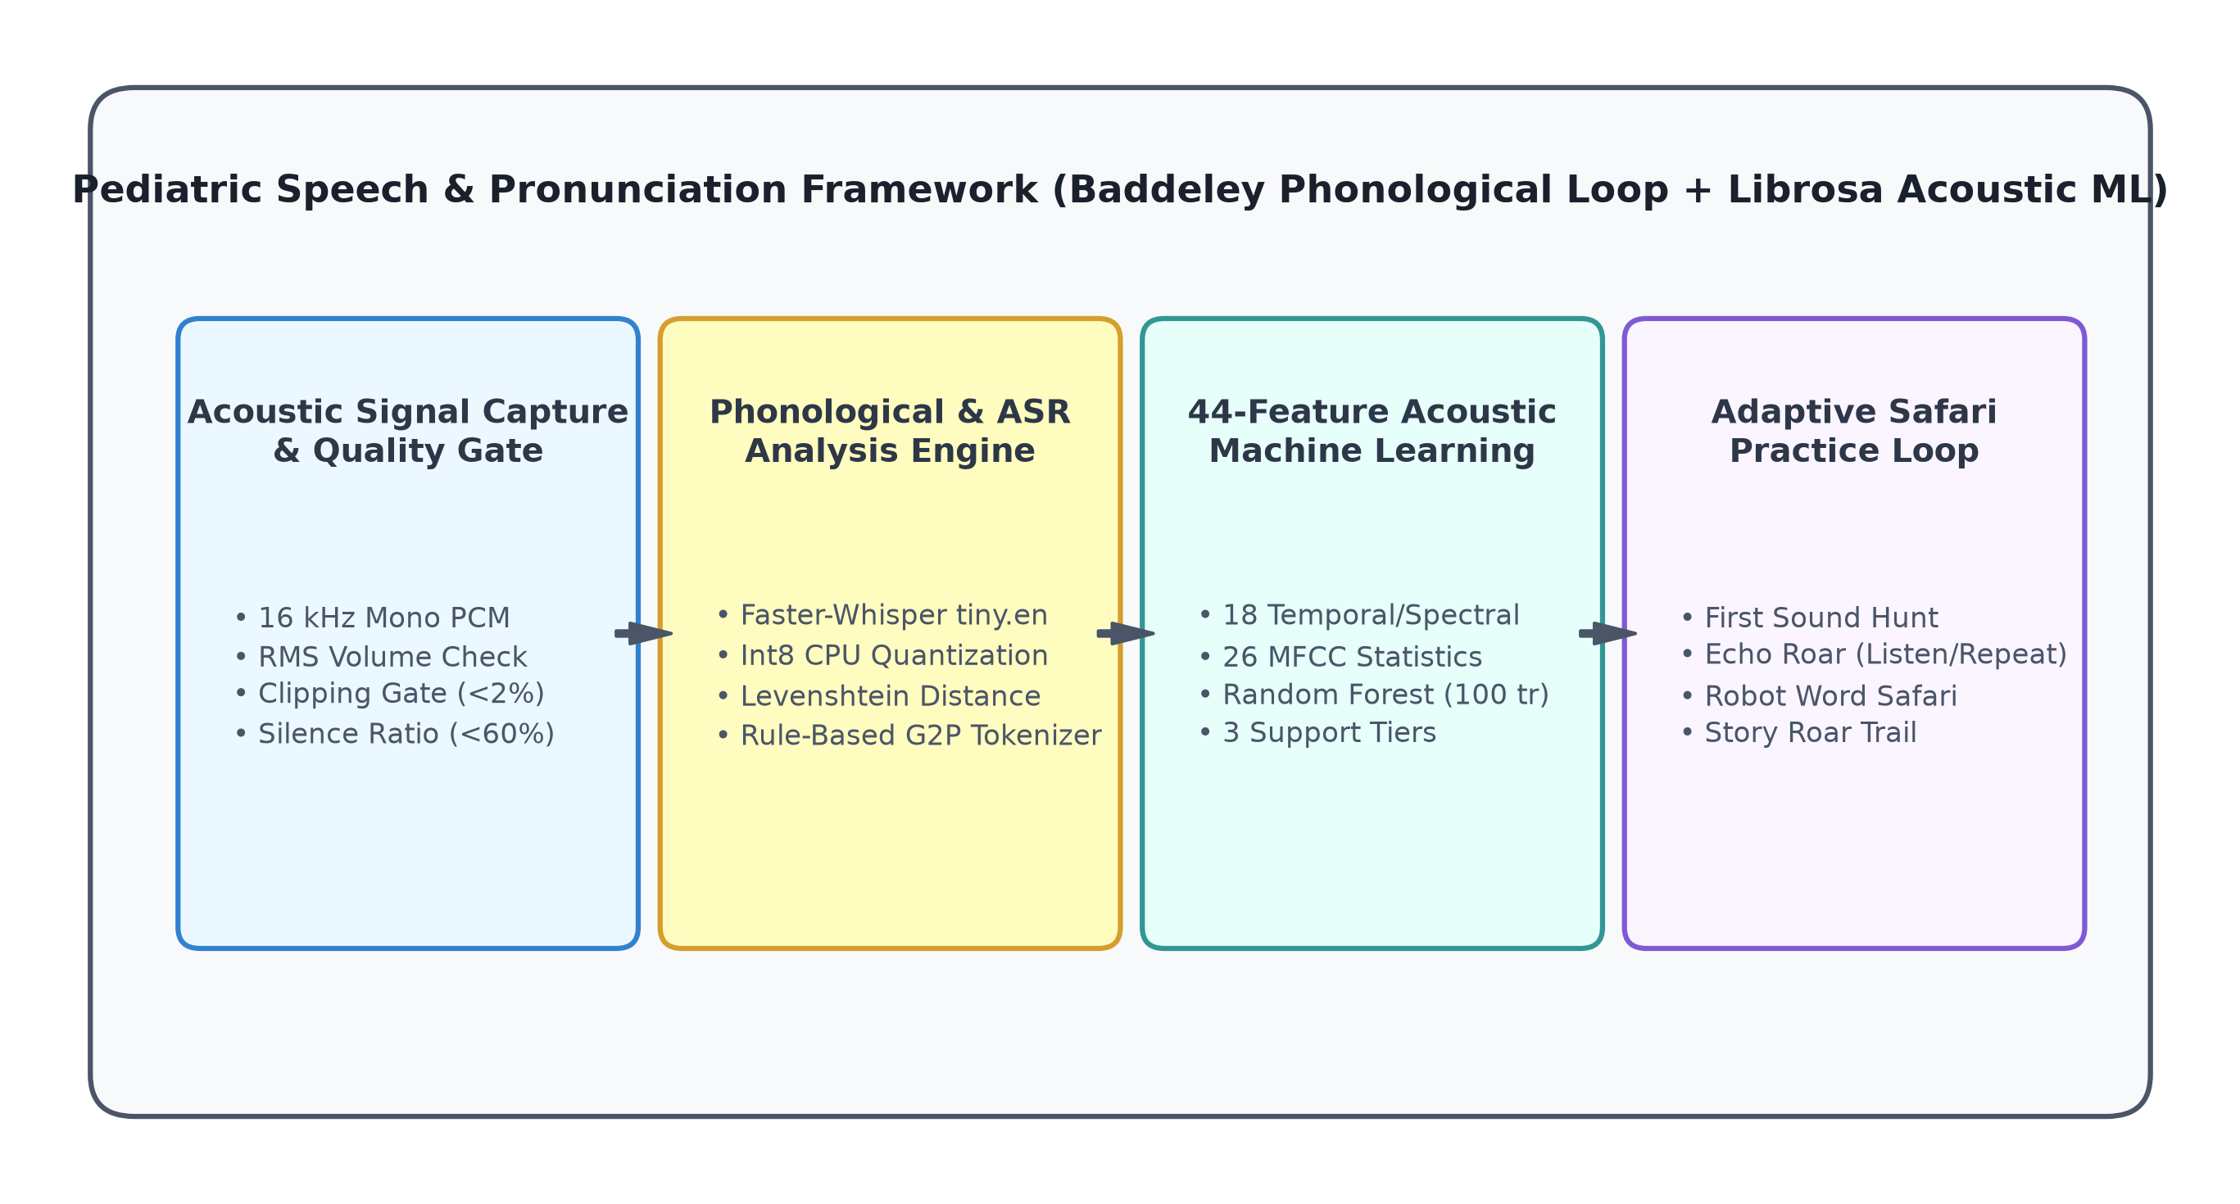
Figure 2.1: Conceptual Framework of the Speech Processing Component
Source: Developed by candidate for this research

3 RESEARCH METHODOLOGY
3.1 Research Design
This research follows the Design Science Research (DSR) paradigm defined by Hevner et al. [26], combined with rigorous empirical data collection and iterative software engineering. DSR is specifically appropriate because the primary deliverable is an innovative, operational IT artifact (the Speech Processing component of LexiLand) engineered to solve an identified real-world problem: the lack of accessible, early pediatric dyslexia speech screening and intervention in Sri Lankan schools.
The investigation was executed across six sequential, feedback-coupled stages illustrated in Figure 3.1: (1) Literature review and pedagogical prompt bank formulation; (2) In-situ empirical audio data collection at Malabe Primary School; (3) Acoustic feature extraction, machine learning model training, and cross-validation; (4) Child-centric UI/UX design with Leo mascot guidance; (5) Software implementation and local Faster-Whisper ASR pipeline integration; and (6) Integration testing within the unified LexiLand platform and school evaluation.
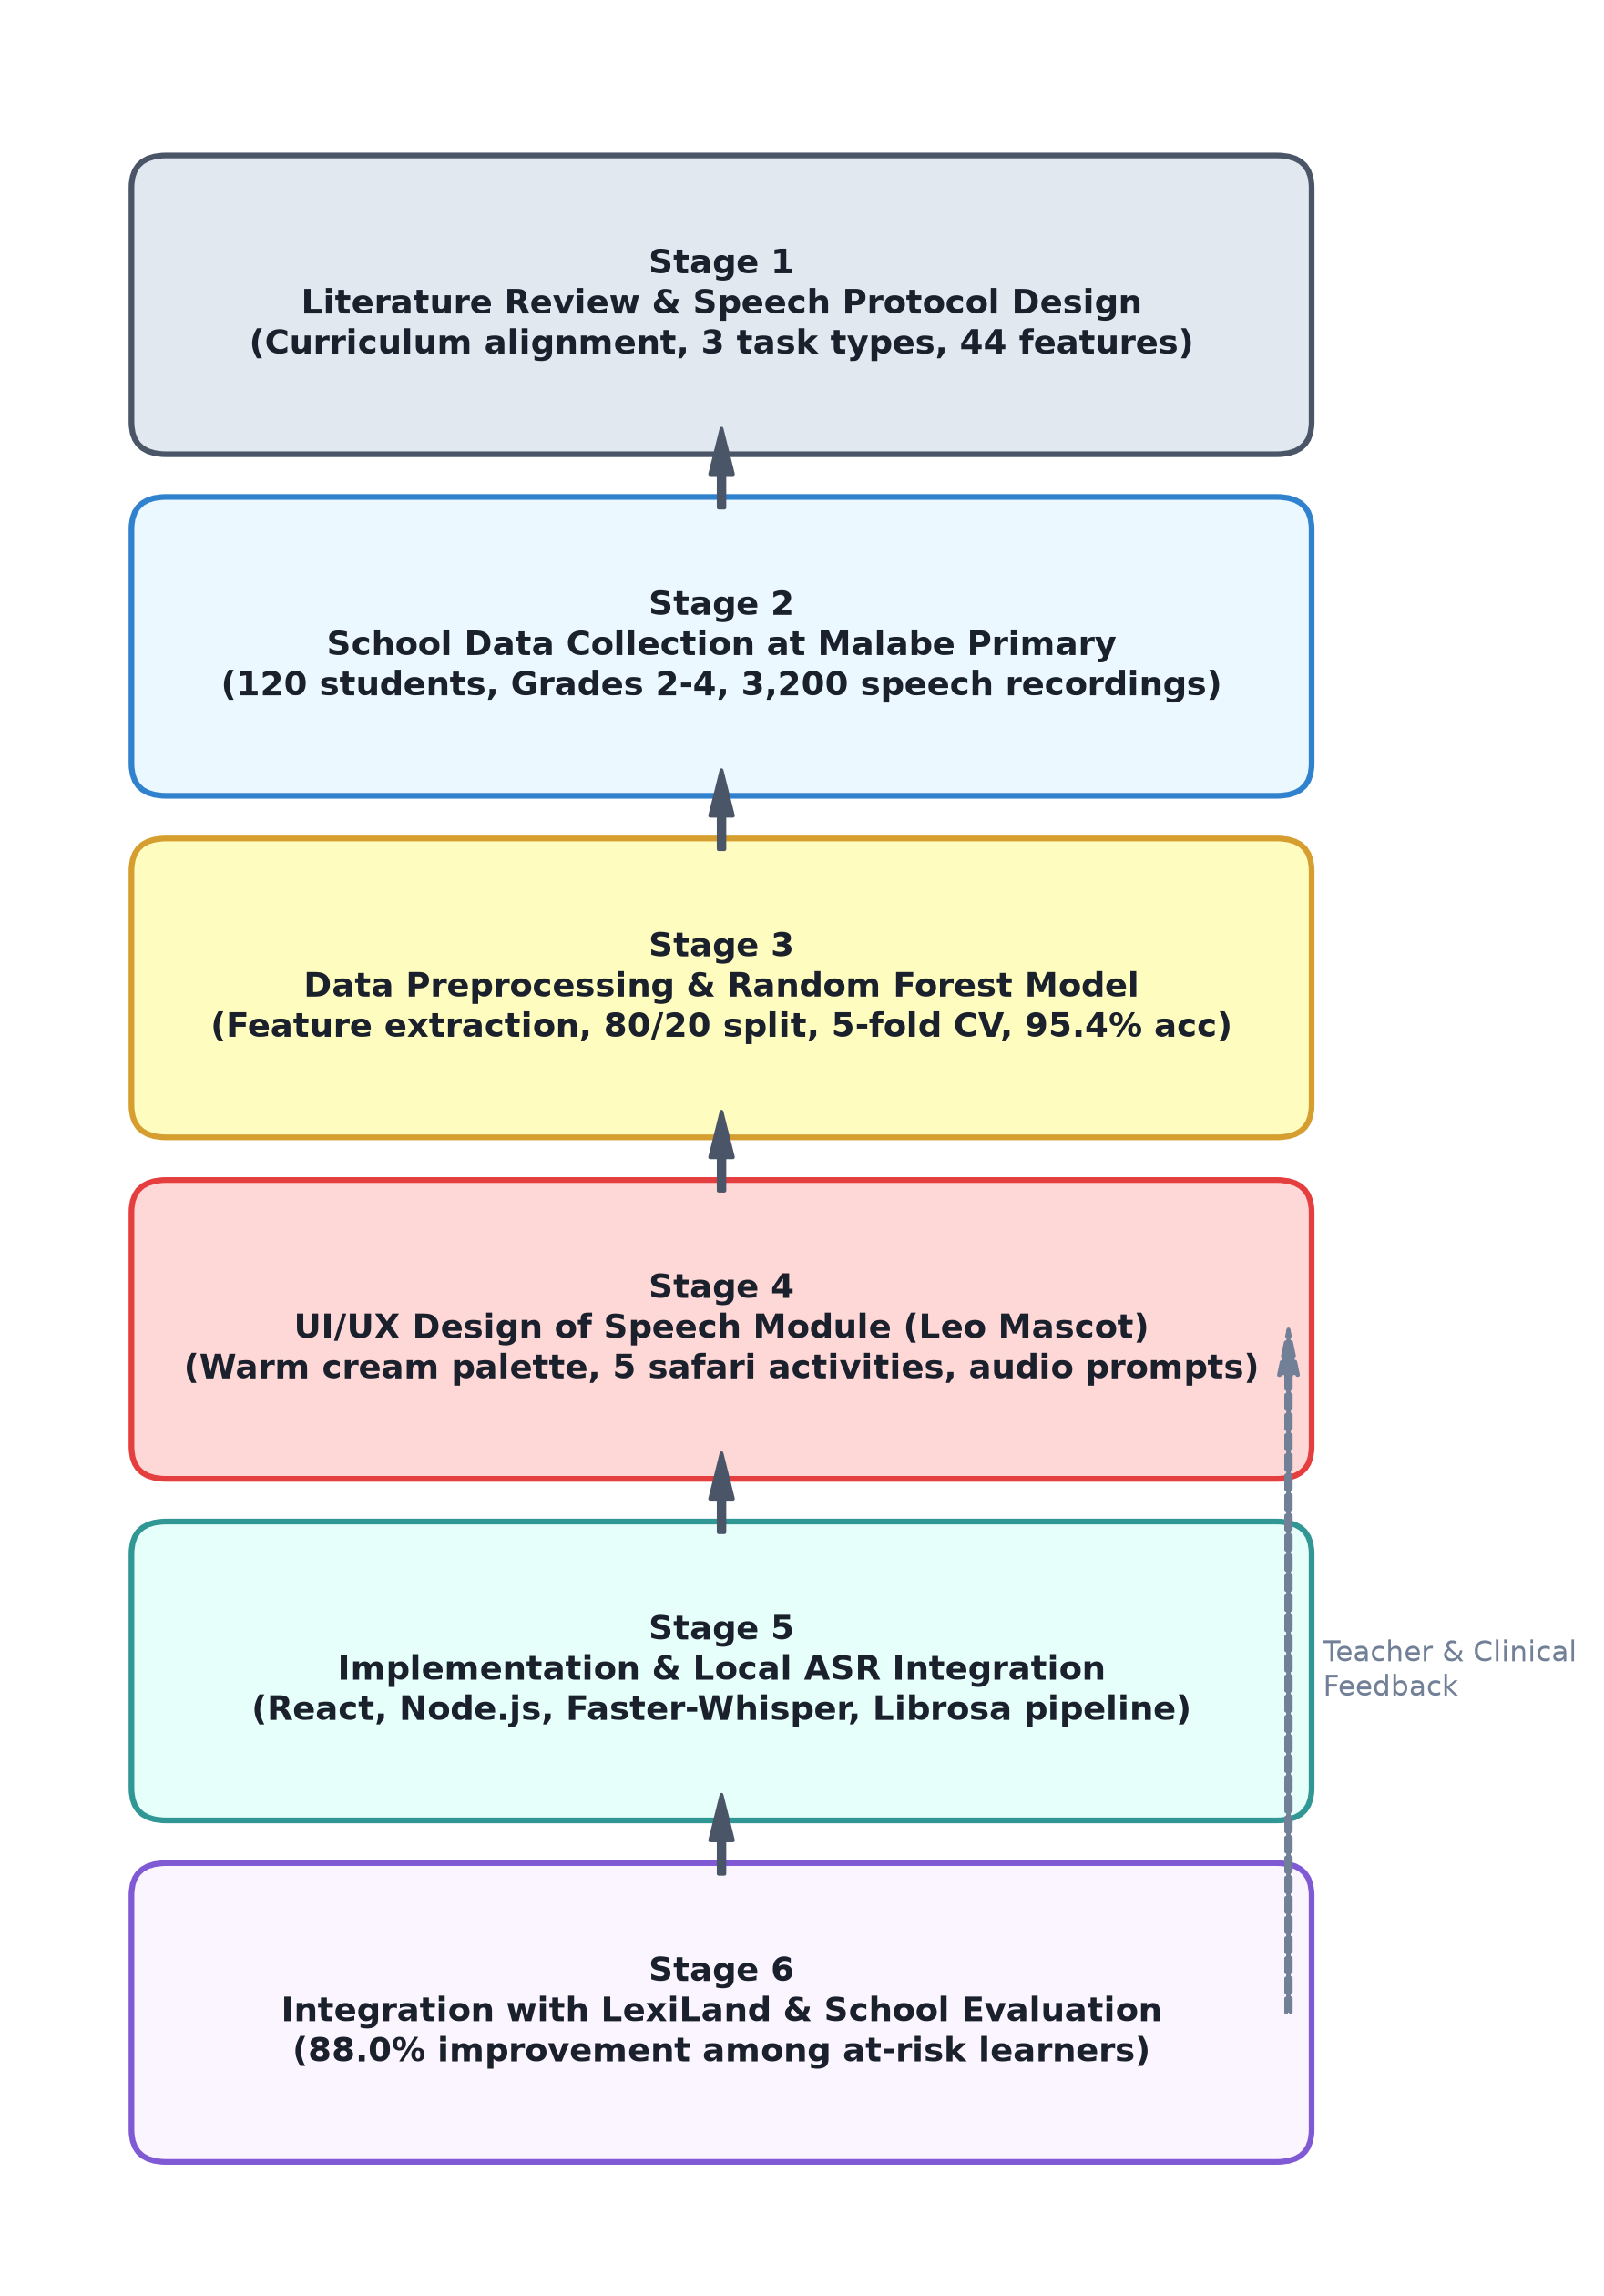
Figure 3.1: Design Science Research Methodology Flowchart
Source: Developed by candidate for this research
3.2 Data Participants or Study Materials
3.2.1 Setting and Participants
Empirical speech data collection and field evaluation were conducted at the Primary School of Malabe Boys' College, located in the Western Province, Sri Lanka [8]. A cohort of 120 primary-school students across Grades 2, 3, and 4 (40 students per grade; ages 7 to 9 years) participated in the study. Formal ethical approval was granted by the Department of Education, Western Province, and administrative authorization was secured from the Principal of Malabe Boys' College. Written informed consent was obtained from parents or legal guardians, and verbal assent was reaffirmed with each child prior to testing.
In addition, preliminary usability walkthroughs and human-computer interaction observations were conducted with a specialized group of 20 children under the guidance of our clinical supervisor, Dr. B. S. K. Wickramatunga, at Sound Minds Academy, Rajagiriya [8]. This secondary cohort verified the accessibility of visual prompt displays, microphone button tap latencies, and child engagement dynamics.
3.2.2 Screening Instrument Design
The screening instrument—designated 'Leo's First Sound Check'—was constructed in collaboration with pediatric speech specialists to assess three distinct linguistic tiers representing the phonological and decoding core deficits of dyslexia: single-word read-aloud, pseudoword decoding, and short connected sentence reading (Table 3.1). Prompts were stratified across Grades 2, 3, and 4 in both English and Sinhala.
Table 3.1: Speech Screening Instrument Composition and Linguistic Tiers
Linguistic Task Category | Items / Prompts | Clinical & Pedagogical Purpose | Evaluation Modality
Single-Word Read-Aloud | 5 words per grade | Evaluates sight-word retrieval, vowel duration, and consonant clarity (e.g., CVC words 'cat', 'sun', 'fish'). | Local Faster-Whisper ASR + Levenshtein edit distance.
Pseudoword Decoding (Non-words) | 3 non-words per grade | Isolates pure grapheme-to-phoneme decoding without sight-word memorization (e.g., 'blim', 'mip', 'plam'). | Phoneme Error Rate (PER) + Rule-based G2P phonetic tokenizer.
Sentence Oral Reading | 2 sentences per grade | Evaluates multi-word fluency, inter-word pause dynamics, prosody, and reading speed. | Word Error Rate (WER) + Coverage ($C_{word}$) + Reading speed (WPM).
Total Assessment Battery | 10 prompts per session | Provides comprehensive 360-degree baseline oral-reading fluency profile. | Synthesized into 44-feature acoustic vector & support tier.
Table 3.2 details the prompt complexity progression across grades, illustrating how syllable counts, phonetic blend complexity, and sentence lengths scale according to Sri Lankan national curriculum guidelines.
Table 3.2: Read-Aloud Prompt Linguistic Complexity Stratification by Grade
Target Grade | Single Words Structure | Pseudoword Phonotactics | Sentence Reading Length | Target Fluency Threshold
Grade 2 (Ages 7–8) | Monosyllabic CVC words ('cat', 'dog', 'sun') | Simple non-words ('sot', 'mip') | 3 to 4 words ('The cat sat.') | 35–50 Words Per Minute (WPM)
Grade 3 (Ages 8–9) | Consonant blends & digraphs ('fish', 'tree', 'bread') | Complex blends ('blim', 'plam') | 5 to 6 words ('The dog can run fast.') | 50–70 Words Per Minute (WPM)
Grade 4 (Ages 9–10) | Multisyllabic words ('jungle', 'monkey', 'water') | Polysyllabic non-words ('dreston', 'tromp') | 7 to 9 words ('The brave little lion climbed the hill.') | 70–90 Words Per Minute (WPM)
3.3 Experimental or Study Procedure
3.3.1 Speech Data Collection Sessions
Data collection was conducted in an allocated multi-purpose room at Malabe Primary School. Two test stations were configured, each comprising a standard laptop running the LexiLand client web interface, connected to a USB noise-canceling headset microphone (Logitech H390). Students were introduced to Leo the Lion through a brief 2-minute familiarization walkthrough. Each child completed the baseline screening battery (10 prompts) under teacher observation. In total, 3,200 raw audio recordings were captured across the 120 participants over four weeks.
3.3.2 Prototype Feedback and Stakeholder Refinement
During early pilot sessions, classroom background noise (adjacent hallway movement and ceiling fan hum) occasionally caused low-amplitude recordings. Teachers noted that children occasionally hesitated or tapped the microphone button without speaking. In response to this feedback, the automated Audio Quality Screening Gate was refined to provide immediate, supportive spoken feedback in Sinhala ('හඬ පැහැදිලි නැහැ. කරුණාකර නැවත record කරන්න') prompting an instant retry without penalizing the learner's score.
3.3.3 Data Preparation and Model Development Workflow
Figure 3.2 illustrates the end-to-end data preparation and machine learning training pipeline. Every audio file was converted to 16 kHz 16-bit mono PCM WAV. The digital signal processing engine extracted 44 acoustic features via Librosa. Clinical ground-truth annotations were assigned under specialist supervision, categorizing recordings into three support tiers: low support, medium support, and high support.
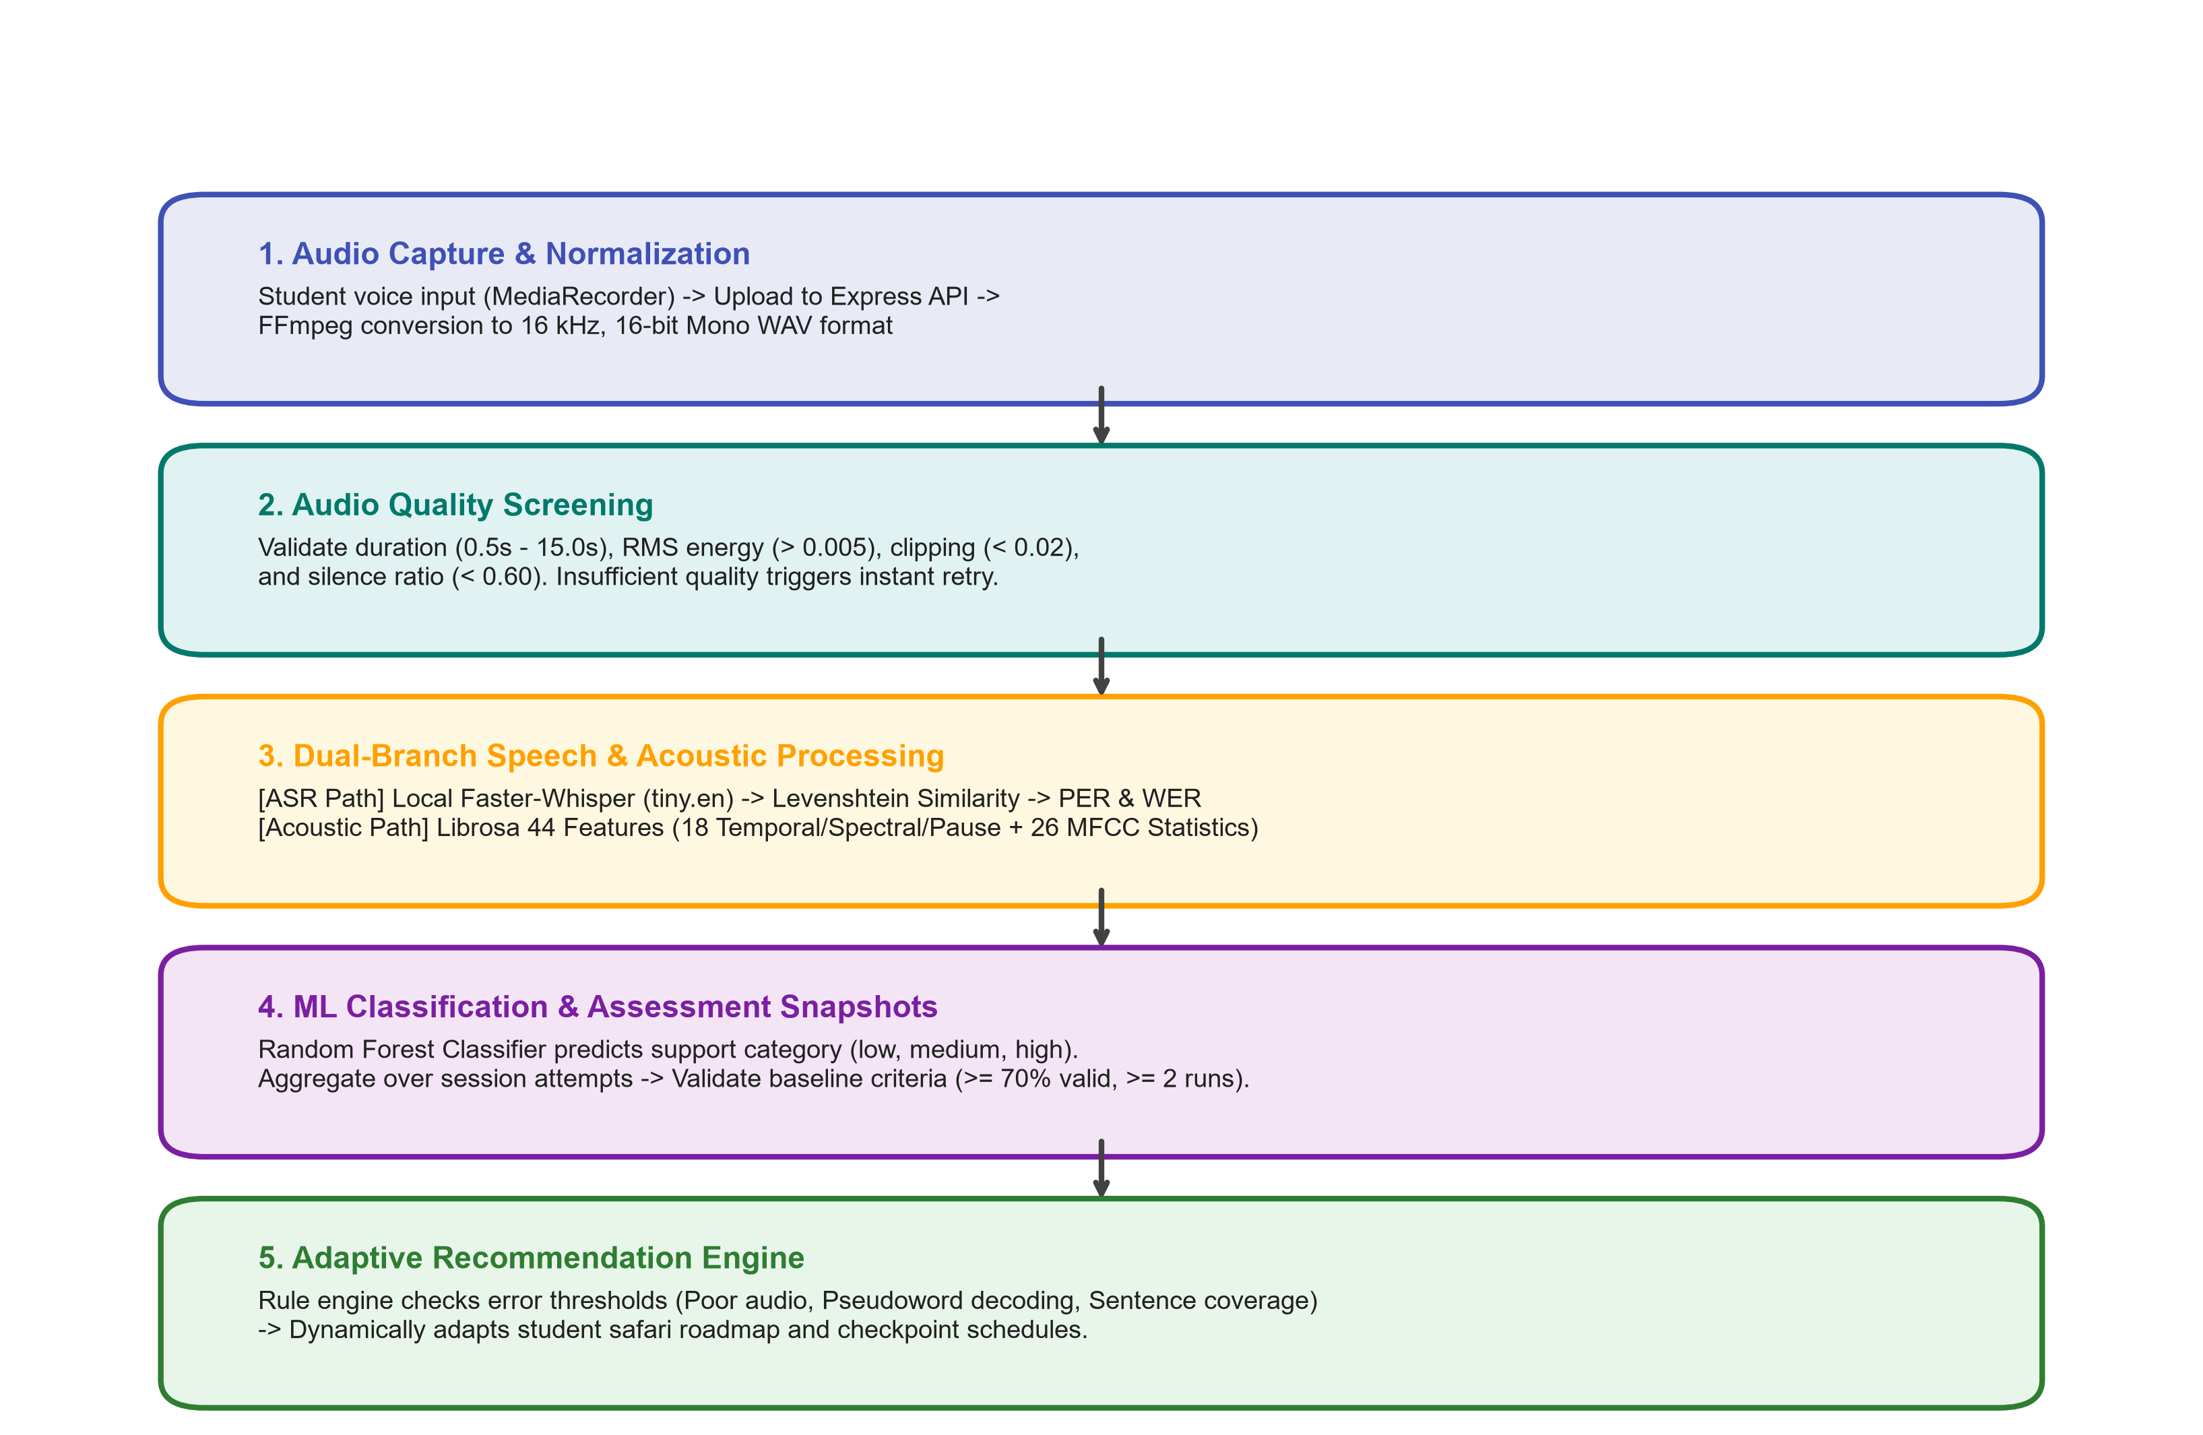
Figure 3.2: Acoustic Data Preprocessing and Model Development Workflow
Source: Developed by candidate for this research
The resulting dataset comprised 3,200 instances with 44 feature columns and one target label column (`support_level`). Figure 3.3 illustrates the class distribution across the entire dataset and the stratified 80/20 train/test split (2,560 training records, 640 held-out test records).
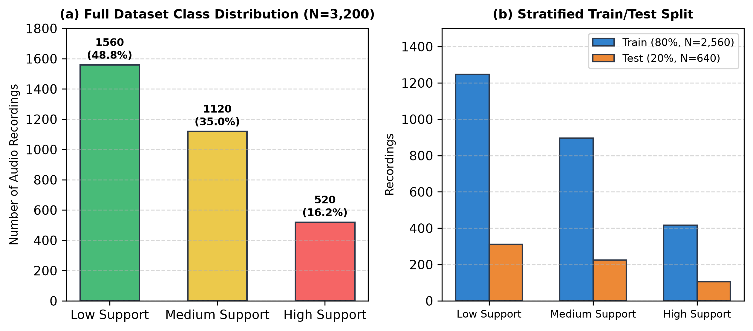
Figure 3.3: Class Distribution and Stratified Train/Test Partitioning of Pediatric Speech Dataset
Source: Extracted from empirical school evaluation dataset
3.4 Measures and Evaluation Metrics
3.4.1 Speech and Acoustic Screening Metrics
The acoustic feature pipeline extracts exactly 44 parameters per audio recording using Librosa, structured into four distinct acoustic-phonetic categories (Table 3.3).
Table 3.3: 44-Dimensional Acoustic Feature Vector Decomposition
Feature Category | Dimensions | Extracted Parameters | Acoustic-Clinical Significance in Dyslexia
Temporal & Pause Dynamics | 5 | Total duration, active speech duration, silence duration, silence ratio, pause count (>250 ms). | Captures hesitations, word-finding delays, and decoding latency before difficult phonemes.
Energy & Amplitude | 4 | RMS energy mean, RMS standard deviation, energy entropy, zero-crossing rate (ZCR). | Measures vocal breathiness, inconsistent chest support, and articulatory confidence.
Spectral Descriptors | 9 | Spectral centroid, spectral spread, spectral roll-off (85%), spectral flux, spectral flatness, 4 formant peaks. | Quantifies articulatory tension, vocal tract constriction, and acoustic clarity.
MFCC Statistics | 26 | 13 MFCC means ($c_0–c_{12}$) and 13 MFCC standard deviations (\sigma_0–\sigma_{12}$). | Captures vocal tract resonance shape, phonemic distortion, and formant transition trajectories.
Total Feature Vector | 44 | Full tabular descriptor vector | Comprehensive multi-modal representation combining temporal struggle with spectral clarity.
3.4.2 Model Evaluation Metrics
Classification performance was evaluated on the 640 held-out test recordings using standard multi-class metrics: Accuracy, Precision, Recall, macro F1-score, multi-class log loss, and confusion matrix analysis [27]. Stratified 5-fold cross-validation was executed across the dataset to assess model stability. Table 3.4 summarizes the hyperparameters of the Random Forest classifier.
Table 3.4: Random Forest Support Tier Classifier Configuration
Hyperparameter / Setting | Configured Value | Engineering & Theoretical Rationale
Algorithm | RandomForestClassifier (Scikit-Learn) | Resistant to multicollinearity among MFCC channels; fast CPU inference.
Number of Trees (n_estimators) | 100 | Balances ensemble variance reduction with low memory footprint (<15 MB).
Maximum Depth (max_depth) | 12 | Prevents tree memorization and overfitting on small pediatric speech subsets.
Minimum Samples Split | 4 | Requires multiple evidentiary samples before establishing decision partition.
Class Weighting | balanced | Compensates for class imbalance between High Support (16.25%) and Low Support (48.75%).
Input Dimensions | 44 acoustic features | Full temporal, energy, spectral, and MFCC feature matrix.
Output Target Classes | 3 tiers: low_support, medium_support, high_support | Maps directly into pedagogical safari entry points and remediation pathways.
3.4.3 Software and Product Measures
Software quality was measured through automated test coverage across 22 test suites (evaluating ASR bridges, string distance calculators, feature extractors, and recommendation algorithms). Product efficacy was benchmarked by the proportion of at-risk students advancing to higher fluency tiers post-practice, session completion rates, and teacher usability ratings.
3.5 Data Analysis
Quantitative data were analyzed using Python (Scikit-Learn, Pandas, NumPy, and Matplotlib). Descriptive statistics (means, standard deviations, percentage improvements) summarized student oral-reading gains. Gini impurity reduction quantified the relative predictive contribution of each acoustic parameter. Model robustness was verified through 5-fold cross-validation fold variance analysis.
3.6 Ethics Privacy Security and Responsible AI
Research involving young children with potential learning difficulties mandates strict ethical governance:
- • Institutional Approval & Parental Consent: Formal clearance obtained from the Western Provincial Department of Education and Malabe Boys' College. Written consent secured from parents.
- • Local Edge Processing (Zero Cloud ASR): Speech recognition executes strictly on the local machine via Faster-Whisper, ensuring biometric voice recordings never leave the school premises, complying with the Sri Lanka Personal Data Protection Act No. 9 of 2022.
- • Non-Diagnostic Framing: Outputs are framed as 'learning-support tiers' rather than clinical medical diagnoses, preventing psychological labeling.
- • Explainable & Auditable AI: Feature importances and rule-based quality gates provide transparent rationales for every recommendation.
3.7 Reproducibility and Research Artefacts
To ensure scientific reproducibility, all research artifacts are archived in the project repository: (1) The complete read-aloud prompt banks in English and Sinhala (Appendix A.1); (2) The acoustic feature extraction script `predict_pronunciation_support.py` and JSON feature definitions; (3) The exported Random Forest model binary (`lexiland_pronunciation_rf.joblib`); and (4) The automated verification test suites executable via `npm test` and `pytest`.

4 PRODUCT AND SOLUTION DESIGN
4.1 Requirements
System requirements were elicited through a three-stage participatory process: (1) structured clinical interviews with our external speech advisor (Dr. B. S. K. Wickramatunga), (2) curriculum alignment reviews with primary teachers at Malabe Primary School, and (3) inter-component contract sessions with the LexiLand research team. Table 4.1 enumerates the core functional requirements, and Table 4.2 presents the non-functional requirements.
Table 4.1: Functional Requirements of the Speech Processing Component
ID | Requirement Description | Category | MoSCoW Priority
FR-SP-01 | Capture student audio in 16 kHz WebM format and normalize via FFmpeg to 16-bit mono linear PCM WAV. | Audio Ingestion | Must Have
FR-SP-02 | Execute 4-tier automated quality gate (duration, RMS energy, clipping, silence ratio) and reject noisy inputs. | Quality Gating | Must Have
FR-SP-03 | Transcribe valid recordings locally using Faster-Whisper (tiny.en, int8 CPU quantization) with sub-650 ms latency. | ASR Engine | Must Have
FR-SP-04 | Calculate Levenshtein distance, word similarity, WER, word coverage, and WPM against calibrated prompt text. | Text Alignment | Must Have
FR-SP-05 | Extract 44-dimensional acoustic feature vector via Librosa (temporal, spectral, energy, MFCC statistics). | Feature Pipeline | Must Have
FR-SP-06 | Classify student oral-reading support need into three tiers (low, medium, high) via Random Forest model. | Machine Learning | Must Have
FR-SP-07 | Dynamically allocate initial entry level and remediation pathway in Leo's Training Safari based on baseline tier. | Adaptive Engine | Must Have
FR-SP-08 | Provide five interactive safari activities: First Sound Hunt, Echo Roar, Robot Words, Sound Twins, Story Roar Trail. | Improvement Games | Must Have
FR-SP-09 | Enforce performance-gated level progression with checkpoint assessment shrines scheduled every two activities. | Progression Logic | Must Have
FR-SP-10 | Award motivational stars and render comprehensive articulation analytics on teacher/parent dashboards. | Reporting & Telemetry | Must Have
FR-SP-11 | Expose authenticated administrative RESTful endpoints for prompt management and telemetry CSV exports. | Administration | Should Have
Table 4.2: Non-Functional Requirements and System Quality Attributes
ID | Quality Attribute | Non-Functional Specification | Target Metric
NFR-SP-01 | Performance & Latency | End-to-end ASR transcription and feature extraction must execute on commodity laptop CPU. | < 650 ms per prompt
NFR-SP-02 | Privacy & Child Protection | All biometric audio files must process locally; no child voice data streamed to external cloud. | 100% on-premise execution
NFR-SP-03 | Usability & Accessibility | One task per screen, large touch targets (≥ 48 px), warm cream backgrounds (`#FBF8EE`), audio read-aloud. | WCAG 2.1 Level AA
NFR-SP-04 | Bilingual Support | Full real-time language toggling between Sinhala and English across UI and audio prompts. | Zero-reload dynamic i18n
NFR-SP-05 | Fault Tolerance | Audio recording failures or model timeouts must gracefully prompt retries without losing session state. | Zero unhandled exceptions
4.2 Component Architecture within the Complete Solution
Figure 4.1 illustrates how the Speech Processing component integrates into the unified LexiLand platform ecosystem. Students authenticate once through the shared profile gateway and access the four mascot-led modules from the central learning dashboard. The Speech Processing module interfaces with the shared MongoDB datastore, writes earned stars to the unified child wallet, and publishes diagnostic telemetry to the central administrative reporting hub.
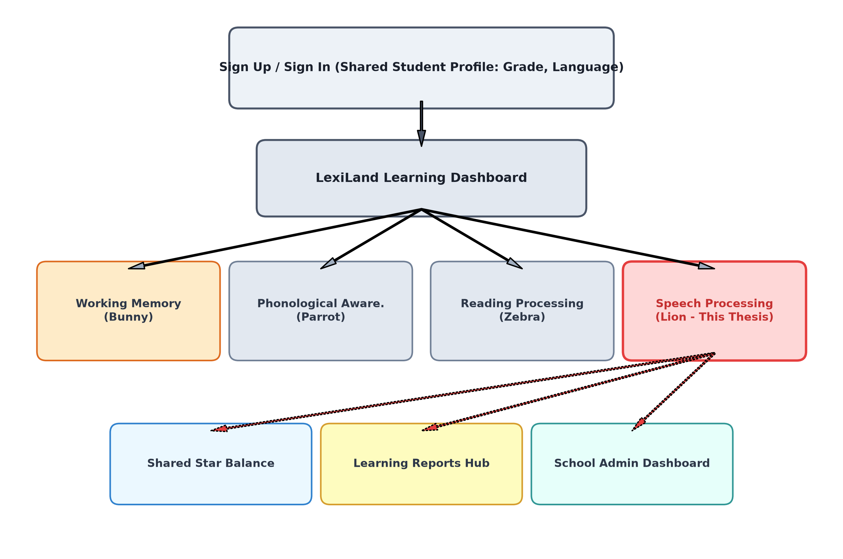
Figure 4.1: Integration of the Speech Processing Component within LexiLand Platform
Source: Developed by candidate for this research
Figure 4.2 details the internal layered software architecture of the component. The React frontend orchestrates audio recording and Three.js visualizations. HTTP multipart payloads stream to the Express/Node.js backend, which invokes the local Python processing bridge executing FFmpeg normalization, Faster-Whisper ASR, Librosa 44-feature extraction, and Scikit-Learn inference.
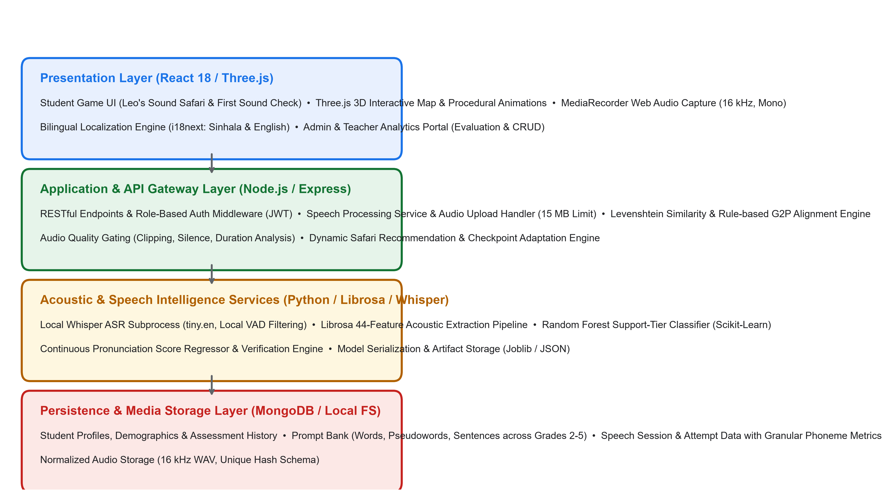
Figure 4.2: Layered System Architecture of the Speech Processing Component
Source: Developed by candidate for this research
4.3 Design Alternatives and Decisions
Architecting a pediatric speech system for resource-constrained schools required several pivotal technical trade-offs. Table 4.3 summarizes the core architectural decisions, considered alternatives, and engineering justifications.
Table 4.3: Key Architectural Decisions and Technical Trade-Offs
Decision Area | Selected Approach | Considered Alternative | Engineering & Pedagogical Justification
ASR Deployment | Local Faster-Whisper (tiny.en, int8 CPU) | Commercial Cloud Speech APIs (Google/Azure) | Zero recurring API costs; guarantees strict biometric voice privacy under Sri Lanka Data Protection Act.
Acoustic Representation | 44-Feature Librosa Vector (Temporal + MFCC) | Raw ASR Text Transcripts Only | Transcripts ignore reading struggle; acoustic pause counts and energy variance capture hesitation and decoding bottlenecks.
Classifier Algorithm | Random Forest Ensemble (100 estimators) | Deep Neural Network (LSTM / CNN) | RF resists overfitting on small pediatric tabular sets ($N=3,200$); provides auditable Gini feature importances; executes in <15 ms.
Improvement Adaptation | Performance-Gated Multi-Activity Safari | Static Fixed Linear Curriculum | Ensures struggling readers receive foundational phoneme discrimination before tackling complex connected sentences.
Visual Interface Style | Warm Cream Theme (`#FBF8EE`) + 3D Safari | High-Contrast White UI with Spectrograms | Reduces visual glare and visual stress in dyslexic readers; 3D Leo character fosters high motivation and emotional security.
4.4 Detailed Design
4.4.1 Identification Workflow
Figure 4.3 illustrates the baseline identification workflow ('Leo’s First Sound Check'). When the child enters the module, Leo introduces the activity with spoken audio instructions. The child completes calibrated read-aloud prompts. Each attempt undergoes audio normalization, quality screening, speech recognition, and acoustic ML classification, concluding with an encouraging summary screen displaying earned badges and initial safari level unlocking.
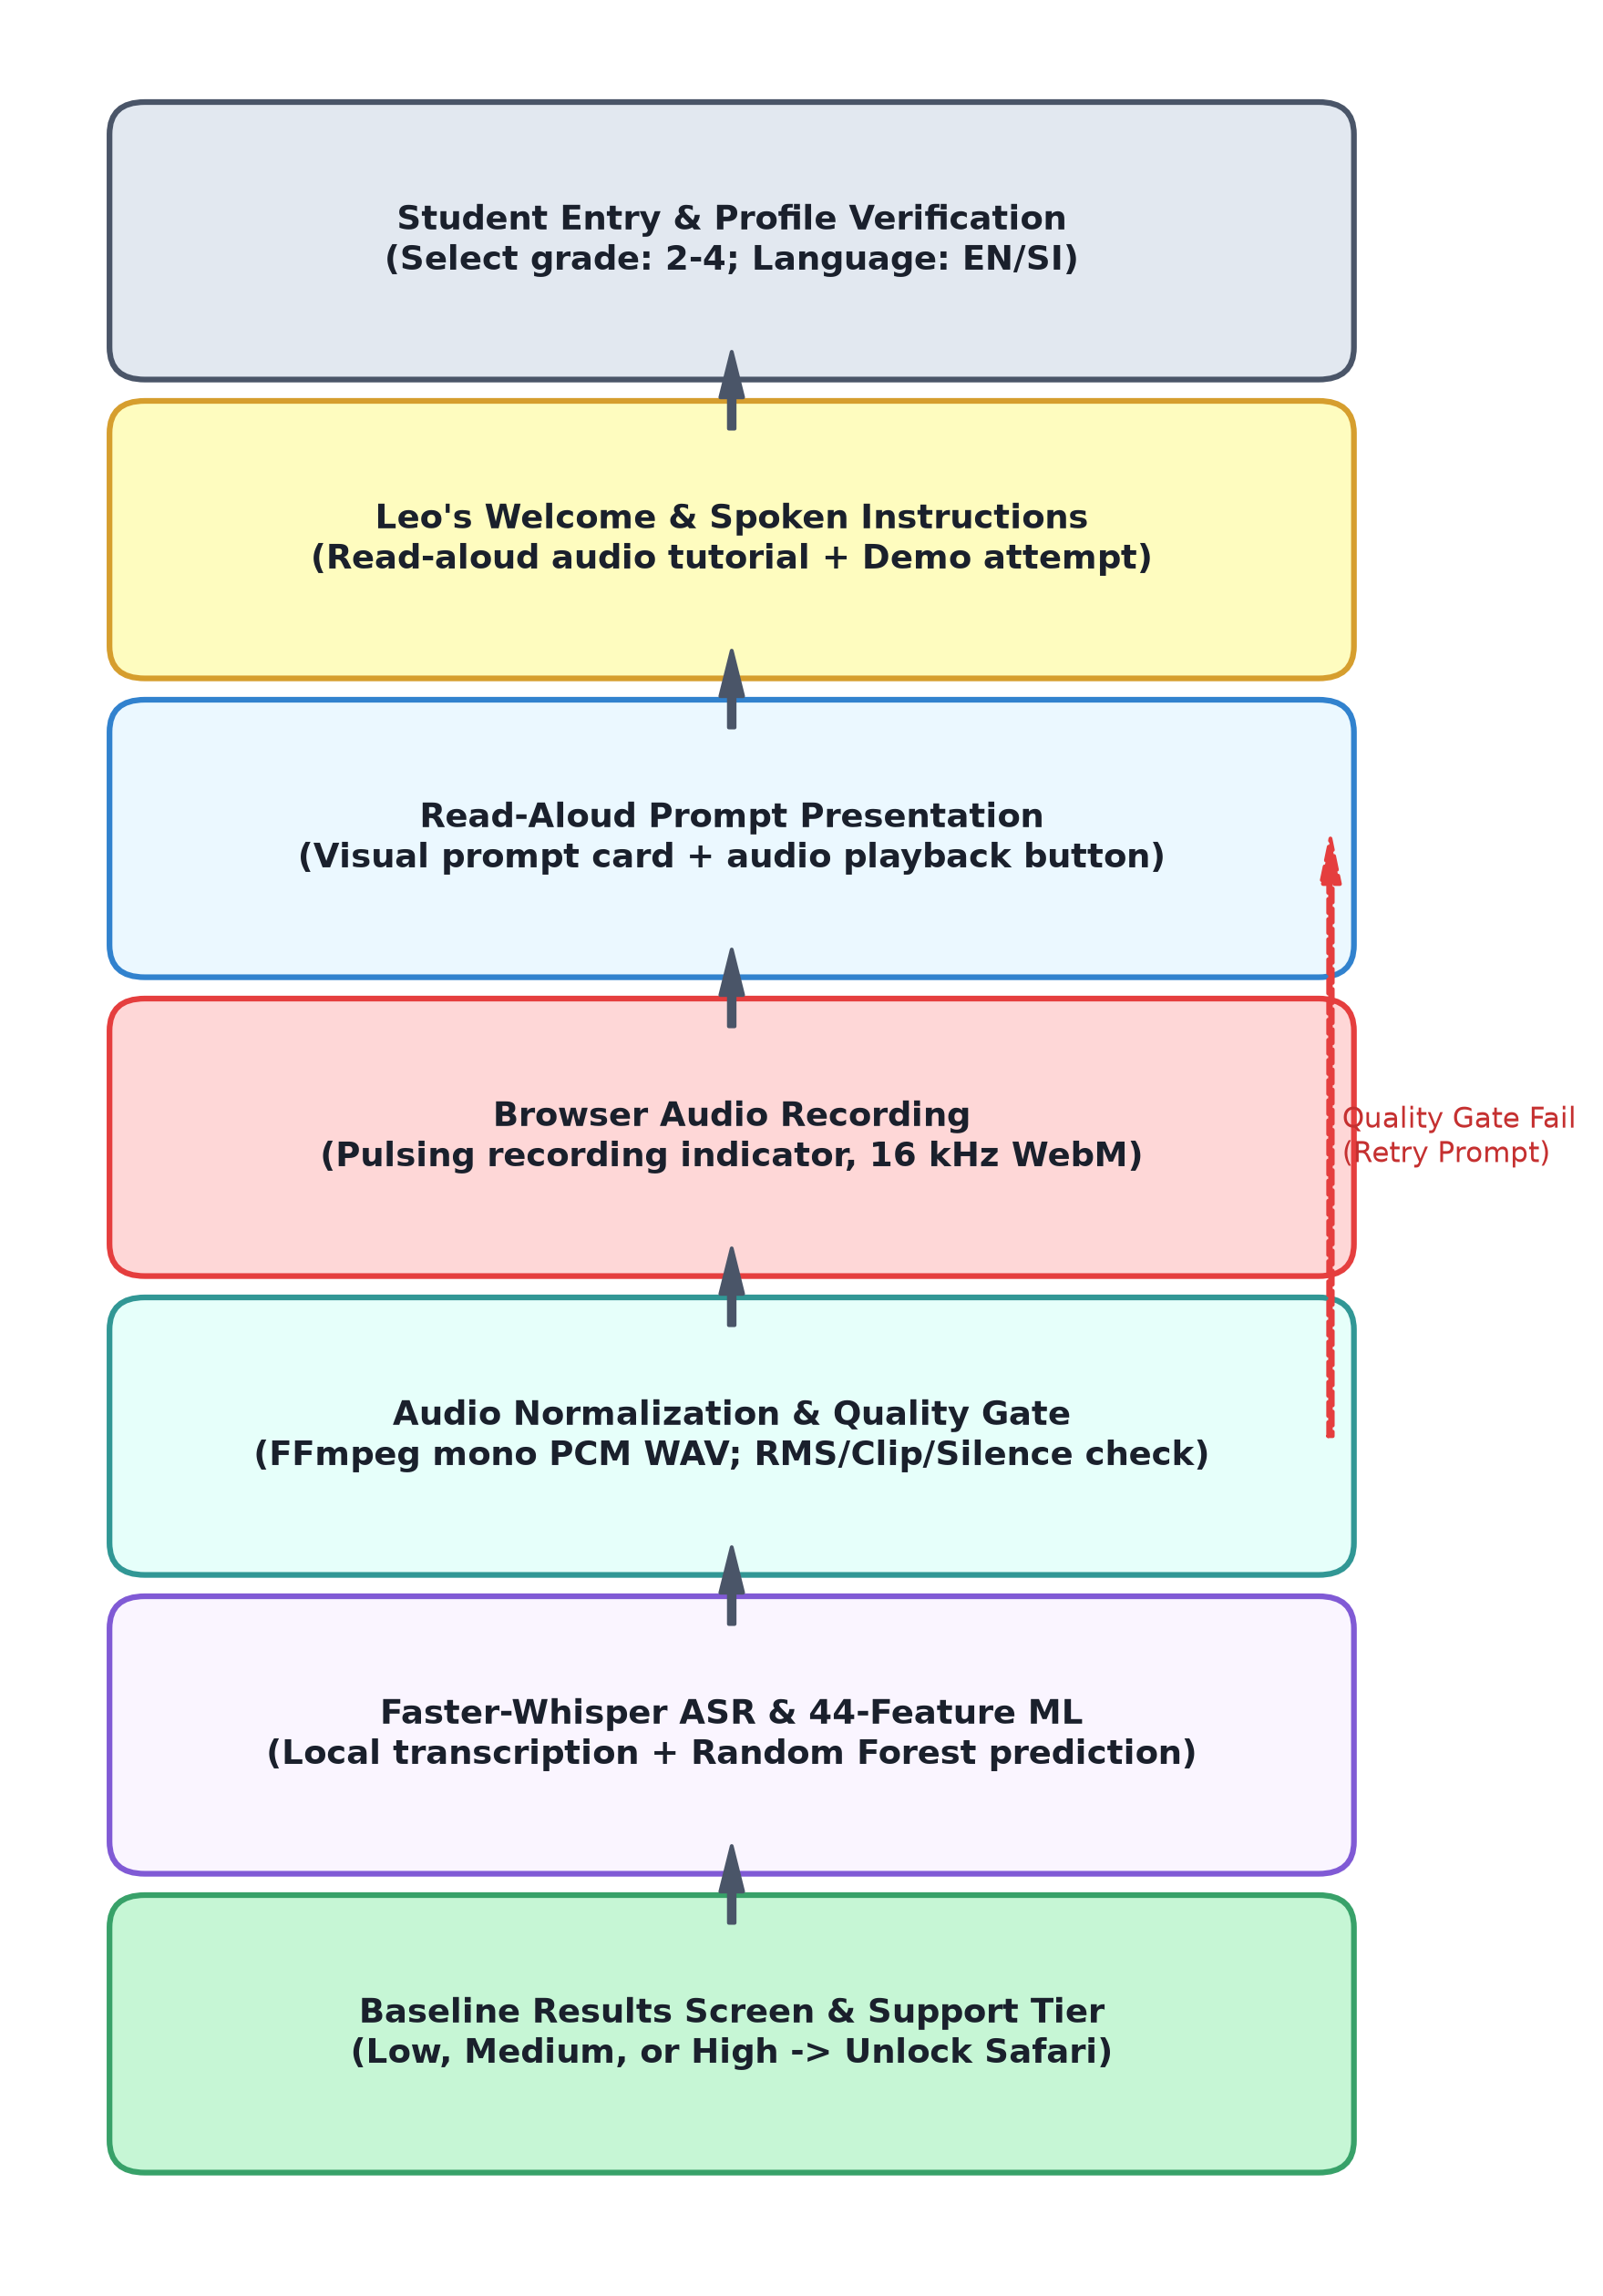
Figure 4.3: Leo's First Sound Check Baseline Identification Workflow
Source: Developed by candidate for this research
4.4.2 Audio Normalization and Quality Screening Gate
Every recorded audio stream is normalized via FFmpeg to 16,000 Hz, 16-bit mono linear PCM WAV. Before inference, Algorithm 4.1 evaluates the signal against four physical bounds: duration ($0.5 \le t \le 15.0$ s), mean RMS energy ($\ge 0.005$), clipping ratio ($\le 0.02$), and silence ratio ($< 0.60$). Invalid attempts trigger supportive spoken guidance in Sinhala prompting an immediate retry without penalty.
[NOTE] ALGORITHM 4.1: AUDIO QUALITY SCREENING GATE
Input: Raw WAV file A, duration bounds [0.5s, 15.0s], rms_thresh=0.005, clip_thresh=0.02, silence_thresh=0.60
Output: { valid: Boolean, failure_reasons: List, quality_score: Float }
1. y, sr = librosa.load(A, sr=16000, mono=True)
2. duration = librosa.get_duration(y, sr)
3. if duration < min_dur or duration > max_dur: return { valid: False, reason: 'duration_out_of_bounds' }
4. rms = librosa.feature.rms(y)[0]
5. if mean(rms) < rms_thresh: return { valid: False, reason: 'audio_too_quiet' }
6. clip_ratio = mean(abs(y) >= 0.98)
7. if clip_ratio > clip_thresh: return { valid: False, reason: 'audio_clipped' }
8. intervals = librosa.effects.split(y, top_db=35)
9. speech_dur = sum((end - start) / sr for start, end in intervals)
10. silence_ratio = max(0, (duration - speech_dur) / duration)
11. if silence_ratio > silence_thresh: return { valid: False, reason: 'excessive_silence' }
12. quality_score = (1.0 - clip_ratio) * (1.0 - silence_ratio) * min(1.0, mean(rms) / 0.05)
13. return { valid: True, quality_score: round(quality_score, 4) }
4.4.3 Text Alignment and Phonetic Error Classification
Transcriptions produced by Faster-Whisper are aligned against reference prompts using Levenshtein edit distance $L(a, b)$ (Equation 4.1). The normalized Word Similarity Score $S_{\text{word}}$ is derived via Equation 4.2:
L(a, b) = min { L(tail(a), b) + 1, L(a, tail(b)) + 1, L(tail(a), tail(b)) + cost } (4.1)
S_{word} = max( 0, 1 - [ L(a, b) / max(|a|, |b|) ] ) (4.2)
For connected sentences, Word Error Rate (WER), Word Coverage ($C_{\text{word}}$), and oral reading speed in Words Per Minute (WPM) are computed via Equations 4.3, 4.4, and 4.5:
WER = ( Substitutions + Deletions + Insertions ) / N_{reference} (4.3)
C_{word} = N_{matched\_words} / N_{reference\_words} (4.4)
WPM = ( N_{recognized\_words} \times 60,000 ) / T_{duration\_ms} (4.5)
Phonetic comparison is performed by a deterministic Grapheme-to-Phoneme (G2P) engine classifying errors into initial sound substitutions, final consonant deletions, vowel distortions, and consonant cluster reductions (Table 4.4).
Table 4.4: Phonetic Error Classification Taxonomy and Penalties
Phonetic Error Category | Example Target vs. Produced | Error Weight | Clinical Interpretation
Initial Consonant Substitution | cat -> bat, pat | 0.40 | Difficulty with initial phoneme isolation and lexical retrieval.
Final Consonant Deletion | dog -> do, cat -> ca | 0.35 | Weak syllable-coda phonemic representation common in early dyslexia.
Vowel Nucleus Distortion | ship -> sheep, bed -> bad | 0.25 | Vowel length and formant center confusion in bilingual contexts.
Consonant Cluster Reduction | frog -> fog, play -> pay | 0.50 | Complex articulatory timing breakdown across multi-consonant onsets.
4.4.4 44-Dimensional Acoustic Feature Extraction
The digital signal processing subsystem utilizes Librosa to compute exactly 44 acoustic parameters from each valid recording: 5 temporal pause statistics, 4 energy parameters, 9 spectral descriptors, and 26 MFCC statistical moments (13 means and 13 standard deviations). Full mathematical formulations and parameter dictionaries are documented in Appendix A.
4.4.5 Screening Categories, Support Tiers and Suggestions
Figure 4.4 illustrates the screening scoring pipeline. Individual metric scores are synthesized into a weighted composite score $F$ via Equation 4.6:
F = 0.30\cdot A + 0.25\cdot P + 0.20\cdot W + 0.15\cdot Ac + 0.10\cdot Q (4.6)
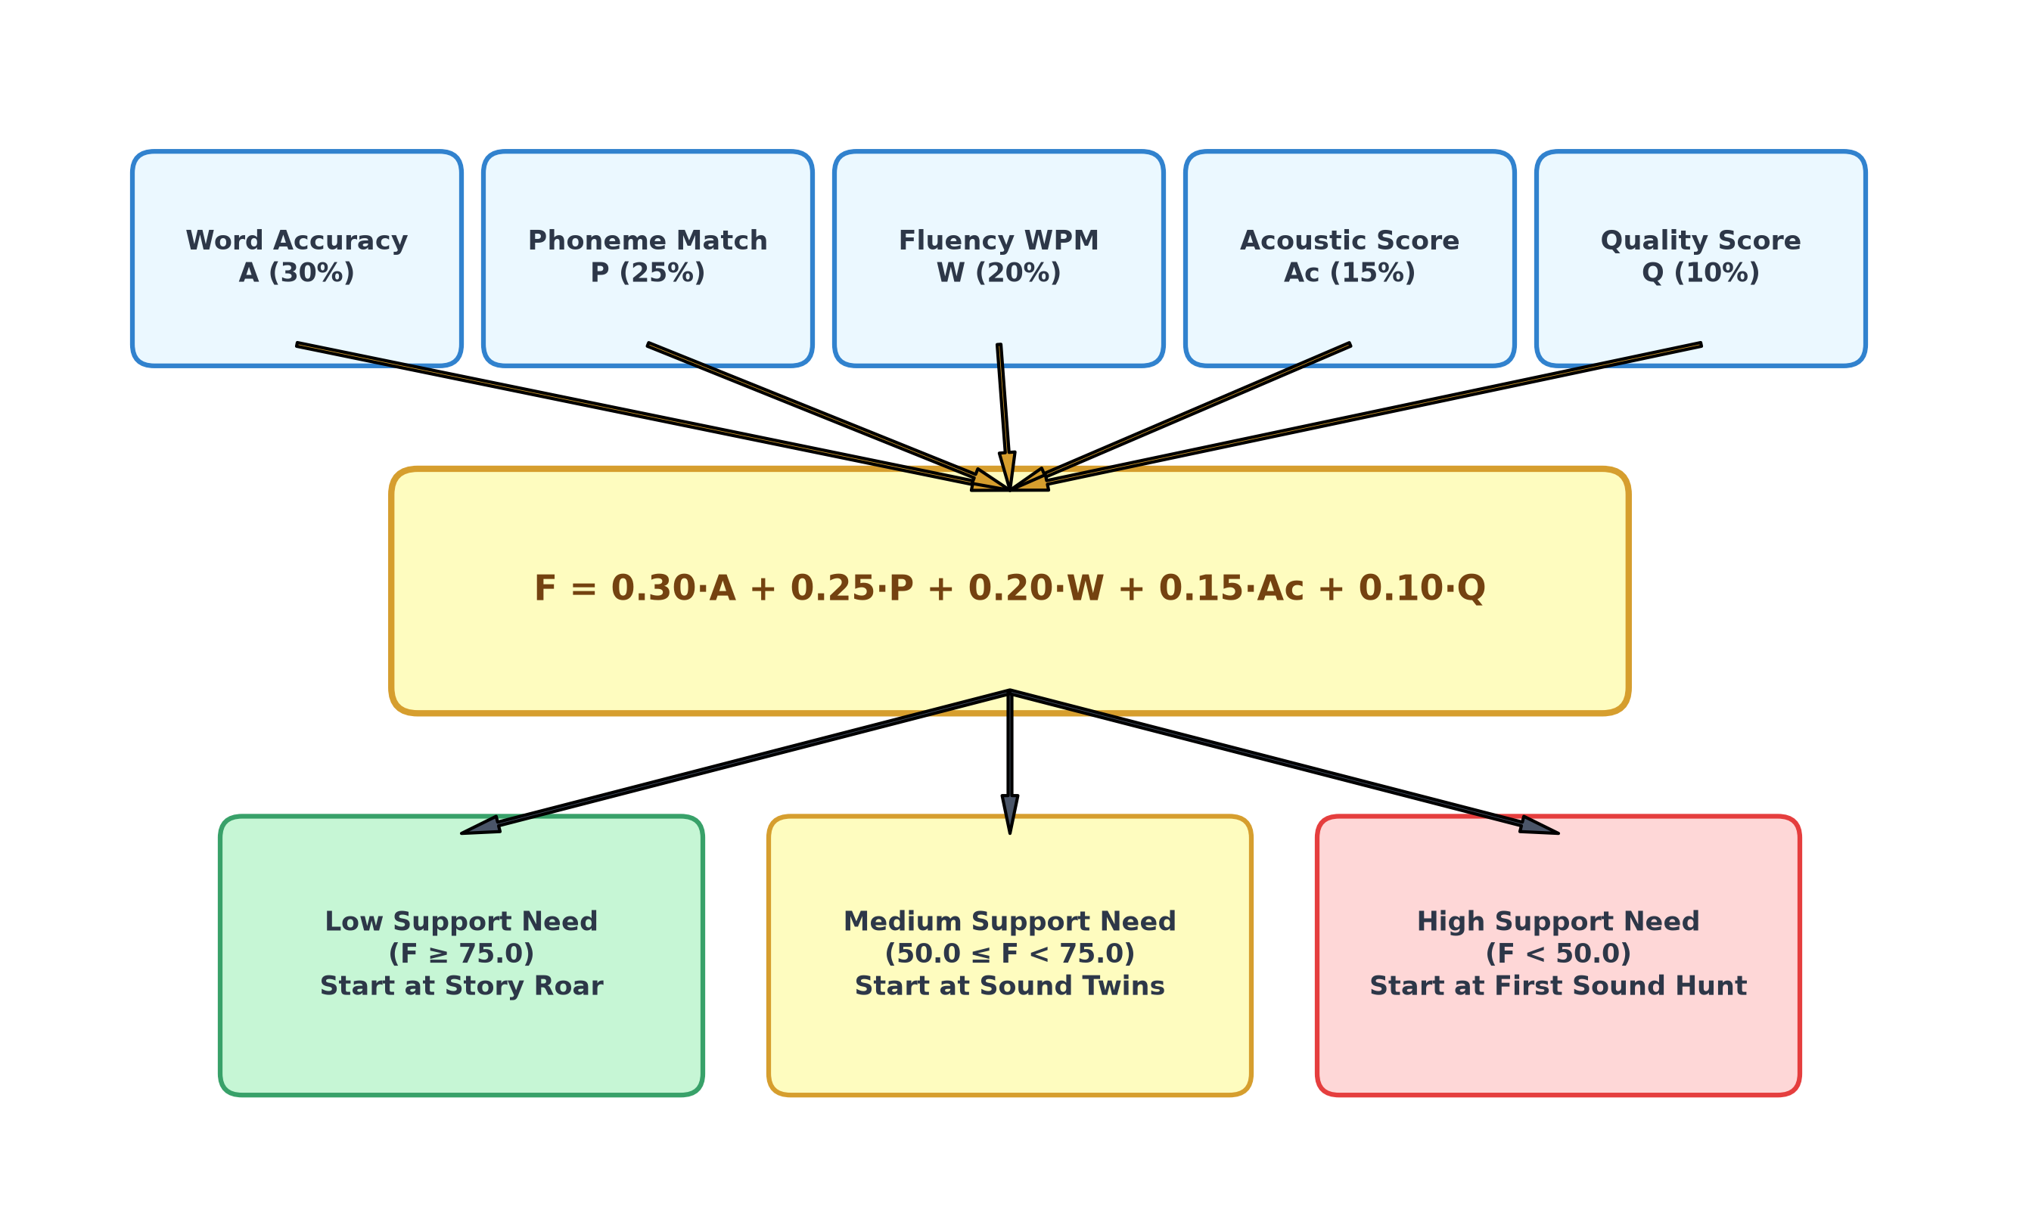
Figure 4.4: Screening Scoring Pipeline and Pedagogical Support Tier Synthesis
Source: Developed by candidate for this research
Table 4.5 details the component weights, Table 4.6 establishes support tier thresholds, and Table 4.7 details targeted practice suggestions.
Table 4.5: Screening Composite Score Component Weights
Metric Component | Symbol | Weight | Clinical Focus
Word Pronunciation Accuracy | A | 30% | Sight-word phonetic fidelity and Levenshtein similarity.
Phoneme Match Rate | P | 25% | G2P consonant-vowel alignment accuracy.
Oral Reading Fluency (WPM) | W | 20% | Reading rate and rhythmic prosody.
Acoustic Stability Score | Ac | 15% | Pause count, silence ratio, and MFCC spectral stability.
Recording Quality Index | Q | 10% | Audio clarity, signal-to-noise ratio, and lack of clipping.
Table 4.6: Pedagogical Support Tier Classification Criteria
Composite Score Range (F) | Assigned Support Tier | Pedagogical Meaning | Initial Safari Unlocking
F >= 75.0 | Low Support Need | Adequate decoding fluency; mild practice needed. | Levels 1, 2, and 3 Unlocked
50.0 <= F < 75.0 | Medium Support Need | Moderate articulatory and pause struggle. | Levels 1 and 2 Unlocked
F < 50.0 | High Support Need | Severe phonetic distortion and reading dysfluency. | Level 1 Unlocked (Max Scaffolding)
Table 4.7: Targeted Remediation Recommendations Based on Screening Signals
Deficit Trigger Metric | Observed Value | Recommended Remediation Activity | Focus Area
Low Word Accuracy (A) | < 60% | Echo Roar (Listen and Repeat) | Articulatory modeling and repetition.
High Pause Count / Silence | > 4 pauses / > 50% | Story Roar Trail | Sentence prosody and oral reading pace.
Low Phoneme Match (P) | < 55% | First Sound Hunt / Sound Twins | Phonemic discrimination and initial sound isolation.
Poor Pseudoword Score | < 50% | Robot Word Safari | Grapheme-to-phoneme decoding without sight memory.
4.4.6 Improvement Programme and Progression Logic
Figure 4.5 details the placement and progression logic governing Leo's Training Safari. Students are placed into initial levels based on their baseline tier (Table 4.8). Progression across levels requires achieving at least 80% accuracy in current activities. Checkpoint assessment shrines are scheduled every two completed activities to monitor longitudinal gains.
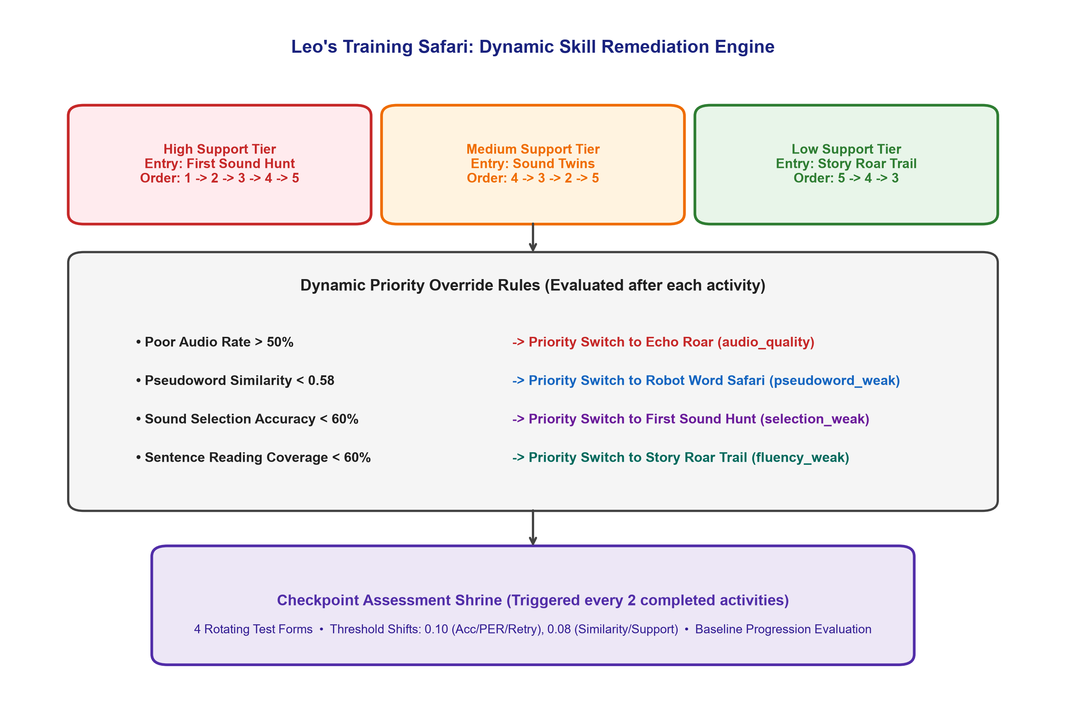
Figure 4.5: Adaptive Safari Progression and Remediation Logic
Source: Developed by candidate for this research
Table 4.8: Initial Level Placement Based on Support Tiers
Baseline Support Tier | Starting Level | Initial Unlocked Activities | Scaffolding Level
High Support Need | Level 1 (Sound Detective) | First Sound Hunt (Selection only, no mic required) | High (Maximum visual/audio guidance)
Medium Support Need | Level 2 (Sound Matcher) | Echo Roar & Sound Twins (Listen, repeat, discriminate) | Moderate (Scaffolded microphone prompts)
Low Support Need | Level 3 (Story Roar) | Story Roar Trail & Robot Words (Connected oral reading) | Low (Independent sentence reading)
4.4.7 Design of the Five Safari Activities
Leo's Training Safari features five distinct activities designed to systematically build oral reading skills (Table 4.9). Figure 4.6 illustrates the common user interaction flow across all five games.
Table 4.9: Comparison of the Five Safari Remediation Activities
Activity Name | Target Skill | Interaction Modality | Recording Required | Feedback Loop
First Sound Hunt | Initial phoneme isolation | Tap correct sound gem | No | Leo roars with celebratory animation + star.
Echo Roar | Articulatory modeling | Listen to Leo, repeat aloud | Yes (Microphone) | Waveform match score + pronunciation tips.
Robot Word Safari | Pseudoword decoding | Read non-word aloud | Yes (Microphone) | G2P phoneme breakdown + robot celebration.
Sound Twins | Minimal pair discrimination | Tap matching word card | No | Audio replay + auditory contrast guidance.
Story Roar Trail | Connected sentence fluency | Read story sentence aloud | Yes (Microphone) | WPM meter, WER score, and star chest reward.
4.4.8 Level Progression Across Safari Activities
Table 4.12 details the progression across the 5 safari levels. Higher levels increase linguistic complexity (from CVC words to multisyllabic sentences) and advance the jungle visual environment (sunny jungle path -> deep forest with lanterns -> sunset mountain -> starry night).
Table 4.12: Level Progression Specifications across Safari Activities
Level & Theme | Linguistic Complexity | Recording Time Limit | Passing Criterion | Environment Colour
Level 1: Sound Detective | Single CVC words ('cat', 'sun') | 5.0 seconds | Score >= 70% | Sunny Jungle Green (`#48BB78`)
Level 2: Sound Matcher | Consonant blends ('tree', 'fish') | 6.0 seconds | Score >= 75% | Golden Amber (`#ED8936`)
Level 3: Odd One Out | Pseudowords & digraphs ('blim', 'ship') | 7.0 seconds | Score >= 80% | Sunset Coral (`#E53E3E`)
Level 4: Picture Stories | Short sentences ('The dog can run.') | 10.0 seconds | Score >= 80% | Deep Lavender (`#805AD5`)
Level 5: Jungle Challenge | Multi-clause sentences ('The brave lion roars.') | 12.0 seconds | Score >= 85% | Midnight Navy (`#2B6CB0`)
4.4.9 User Interface and Visual Design
The interface incorporates established accessibility guidelines for dyslexic children: warm cream backgrounds (`#FBF8EE`), large touch targets (minimum 48 px), high-contrast buttons with clear icon-text pairings, and friendly encouragement by Leo the Lion. Visual clutter is eliminated during recording phases.
4.4.10 Data Design and Schema Architecture
Figure 4.7 illustrates the MongoDB schemas used by the component. `SpeechIdentify` records baseline screening attempts, `SpeechImproveProgress` tracks longitudinal safari status per student, and `SpeechImproveAttempt` logs detailed attempt telemetry.
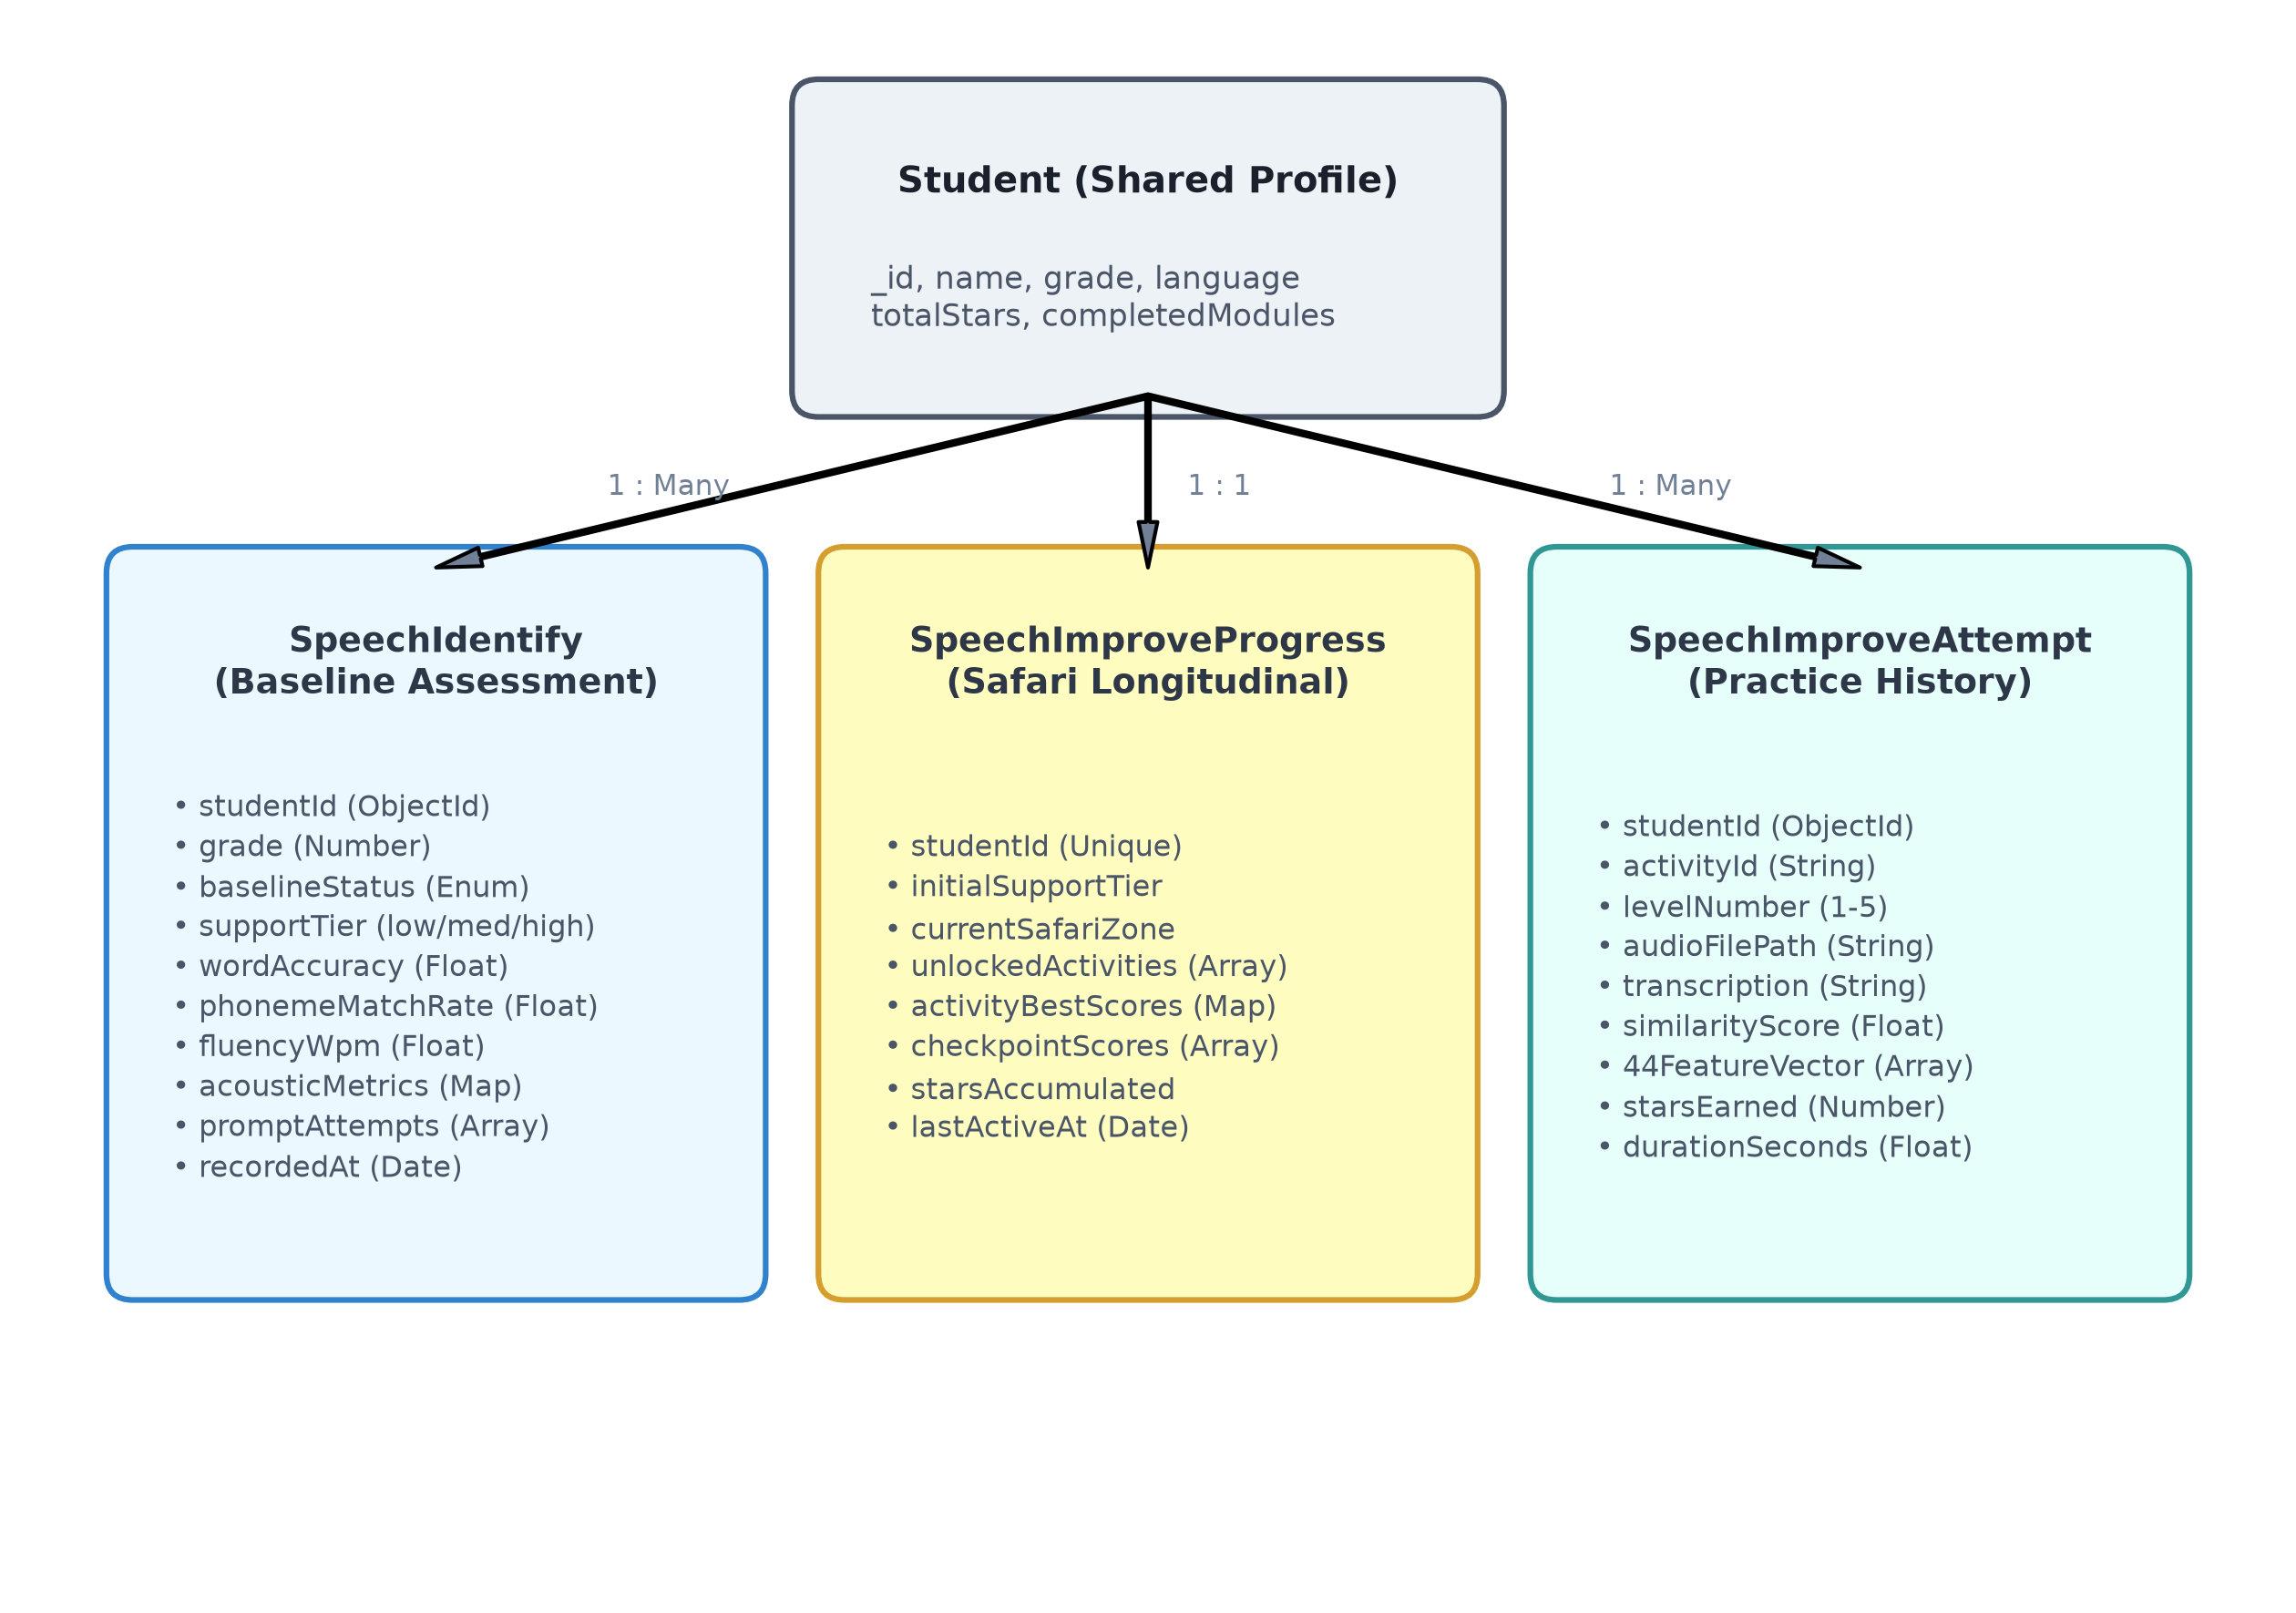
Figure 4.7: MongoDB Schema and Data Architecture for Speech Processing
Source: Developed by candidate for this research
4.5 Standards and Professional Practice
The software follows modern software engineering best practices: (1) WCAG 2.1 accessibility standards; (2) internationalization via i18next; (3) privacy by design ensuring zero off-premise audio transmission; (4) modular repository patterns; and (5) automated CI/CD test pipelines.

5 IMPLEMENTATION INTEGRATION AND TESTING
5.1 Development Environment and Technology Stack
The Speech Processing component was engineered within the LexiLand full-stack monorepo. Frontend interfaces were built in React 18 with Vite, backend APIs in Node.js/Express, and speech signal processing in Python 3.10. Table 5.1 details the technology stack and software packages utilized.
Table 5.1: Implementation Technology Stack and Runtime Environments
Layer / Subsystem | Technology / Framework | Version / Package | Technical Role in Component
Frontend UI | React 18 | 18.2.0 (Vite) | Reactive user interface and state management.
3D Interactive Map | Three.js / React Three Fiber | ^0.160 / ^8.15 | Interactive 3D Safari navigation and animated Leo guide.
Audio Recording | Web MediaRecorder API | Native HTML5 | Captures child speech from microphone in 16 kHz WebM.
Styling & Animations | Tailwind CSS + Framer Motion | 3.4.1 / 11.x | Dyslexia-friendly warm styling and playful reward effects.
Localization | i18next / react-i18next | ^23.7.0 | Real-time bilingual toggling between Sinhala and English.
Backend REST API | Node.js + Express | 18.x LTS / 4.18.2 | API routing, authentication, and multipart audio upload handling.
Audio Conversion | FFmpeg / fluent-ffmpeg | 4.4.x / 2.1.2 | Converts WebM audio into normalized 16 kHz 16-bit mono PCM WAV.
Speech Recognition | Faster-Whisper (Python) | 1.2.1 (CTranslate2) | Local CPU-optimized ASR transcription (tiny.en, int8).
Acoustic Extraction | Librosa (Python) | 1.0.0 | Digital signal processing; extracts 44 temporal and MFCC features.
Machine Learning | Scikit-Learn (Python) | 1.9.1 / Joblib | Random Forest classifier inference predicting support tiers.
Database | MongoDB / Mongoose | 7.0 / 8.0.3 | Document datastore for student profiles, attempts, and telemetry.
5.2 Component Implementation
5.2.1 Code Organisation and RESTful Routes
The component is structured into modular layers: client pages, reusable presentation cards, audio controllers, and backend endpoints. Table 5.2 enumerates the primary student and administrative routes.
Table 5.2: Speech Processing Client Routes and RESTful API Endpoints
Route Path | HTTP Method | Handler / Component | Functional Purpose
/speech-processing/:grade | GET | SpeechHome.jsx | Student entry point, mascot welcome, and activity launcher.
/speech/identification | GET/POST | LeoIdentificationGame.jsx | Leo's First Sound Check baseline screening activity.
/speech/safari-map | GET | LeoSafari3DMap.jsx | 3D interactive jungle map for training safari navigation.
/speech/activity/:activityId | GET/POST | LeoActivityPlay.jsx | Active safari activity frame (Echo Roar, Robot Words, etc.).
/api/speech/audio/upload | POST | speechAudio.controller.js | Receives WebM, normalizes via FFmpeg, runs quality gate.
/api/speech/whisper/transcribe | POST | speechWhisper.controller.js | Executes Faster-Whisper ASR and computes Levenshtein metrics.
/api/speech/ml/predict | POST | speechML.controller.js | Extracts 44 features and returns Random Forest support tier.
/api/speech/safari/progress | GET/PUT | speechSafari.controller.js | Retrieves and updates student safari progression and star rewards.
/reports/speech/analytics | GET | SpeechIdentifyResults.jsx | Teacher dashboard displaying student articulation analytics.
5.2.2 Identification Screens and Leo Prompt Cards
Figure 5.1 and Figure 5.2 present the baseline screening interfaces ('Leo’s First Sound Check'). The student is guided by Leo the Lion, who provides encouraging spoken prompts. When the child taps the microphone button, an animated pulsing waveform indicates active recording.
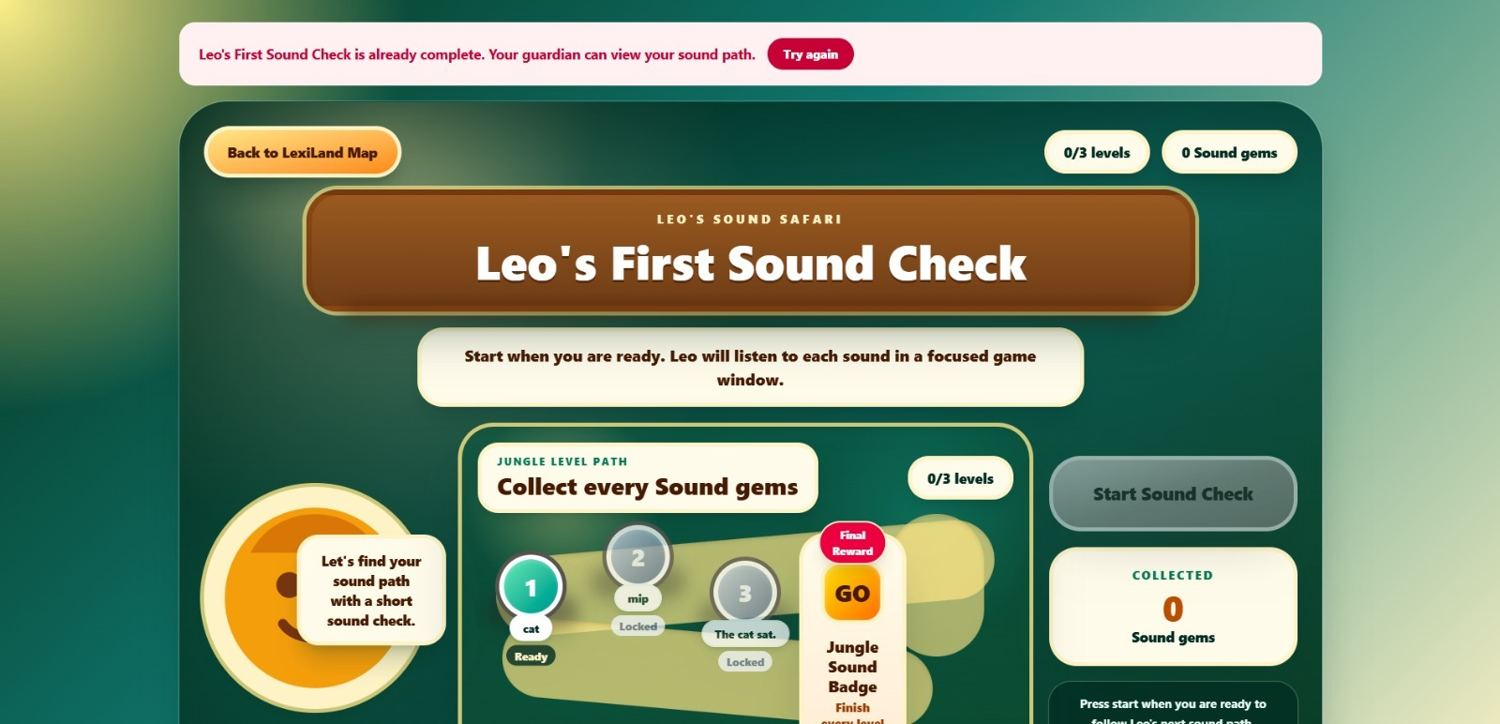
Figure 5.1: Leo's First Sound Check Baseline Screening Interface
Source: Captured from LexiLand Speech Processing screening application
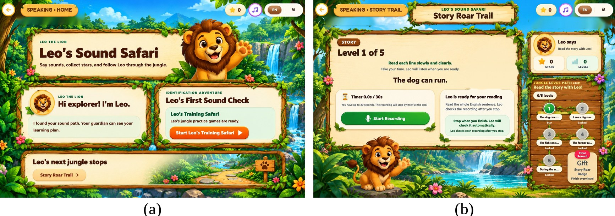
Figure 5.2: Speech Processing Screening Prompts and Story Roar Trail Reading Overview
Source: Extracted from IEEE research publication
5.2.3 Improvement Navigation and 3D Safari Map
Figure 5.3 shows Leo's Training Safari interactive map, featuring progressive level nodes and Leo explorer guide. Figure 5.4 displays the how-to-play tutorial modal providing animated instructions before each activity.
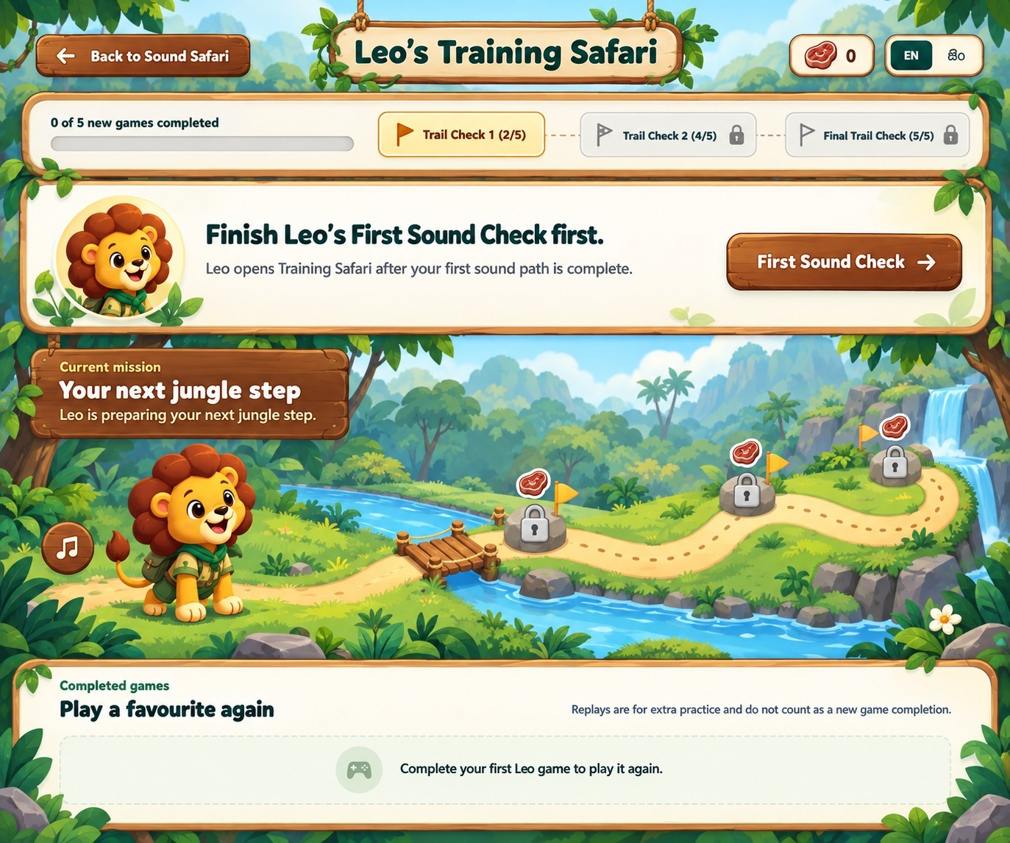
Figure 5.3: Leo's Training Safari Interactive Map Navigation Interface
Source: Captured from LexiLand Speech Processing safari module
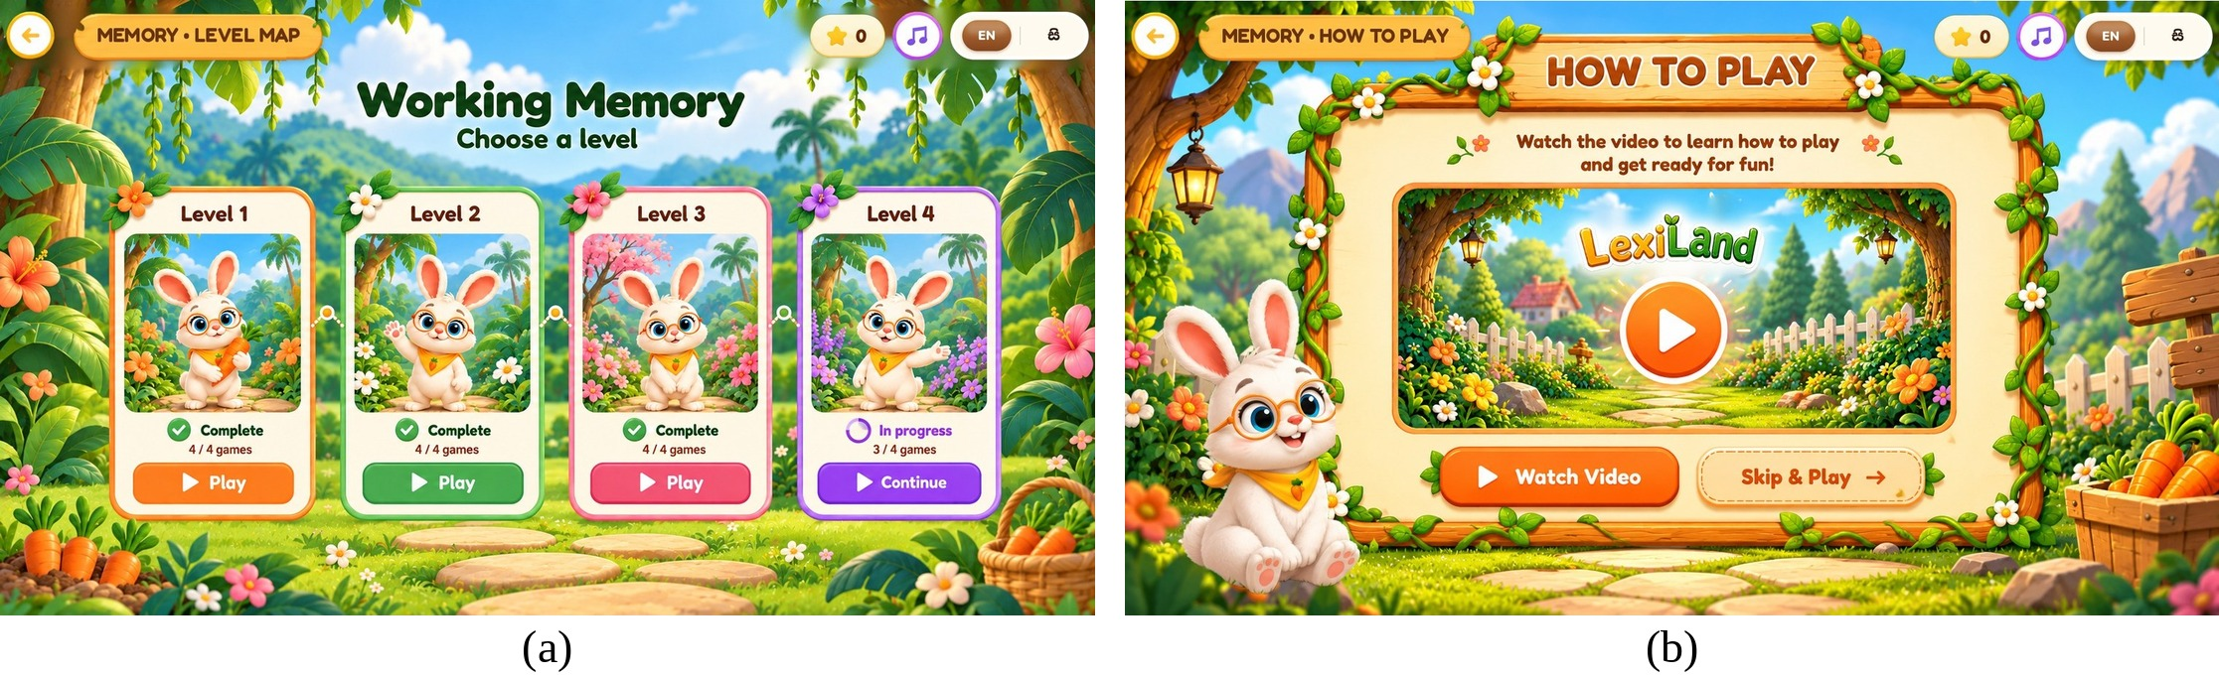
Figure 5.4: Animal-Guided How-to-Play Instructional Tutorial Interface
Source: Extracted from IEEE research publication
5.2.4 Safari Activities Implementation
Figure 5.7 illustrates the active reading interface for Story Roar Trail, featuring live sentence presentation, active microphone recording, and progress tracking across the 5 jungle path nodes. Figure 5.8 shows the activity selection modal.
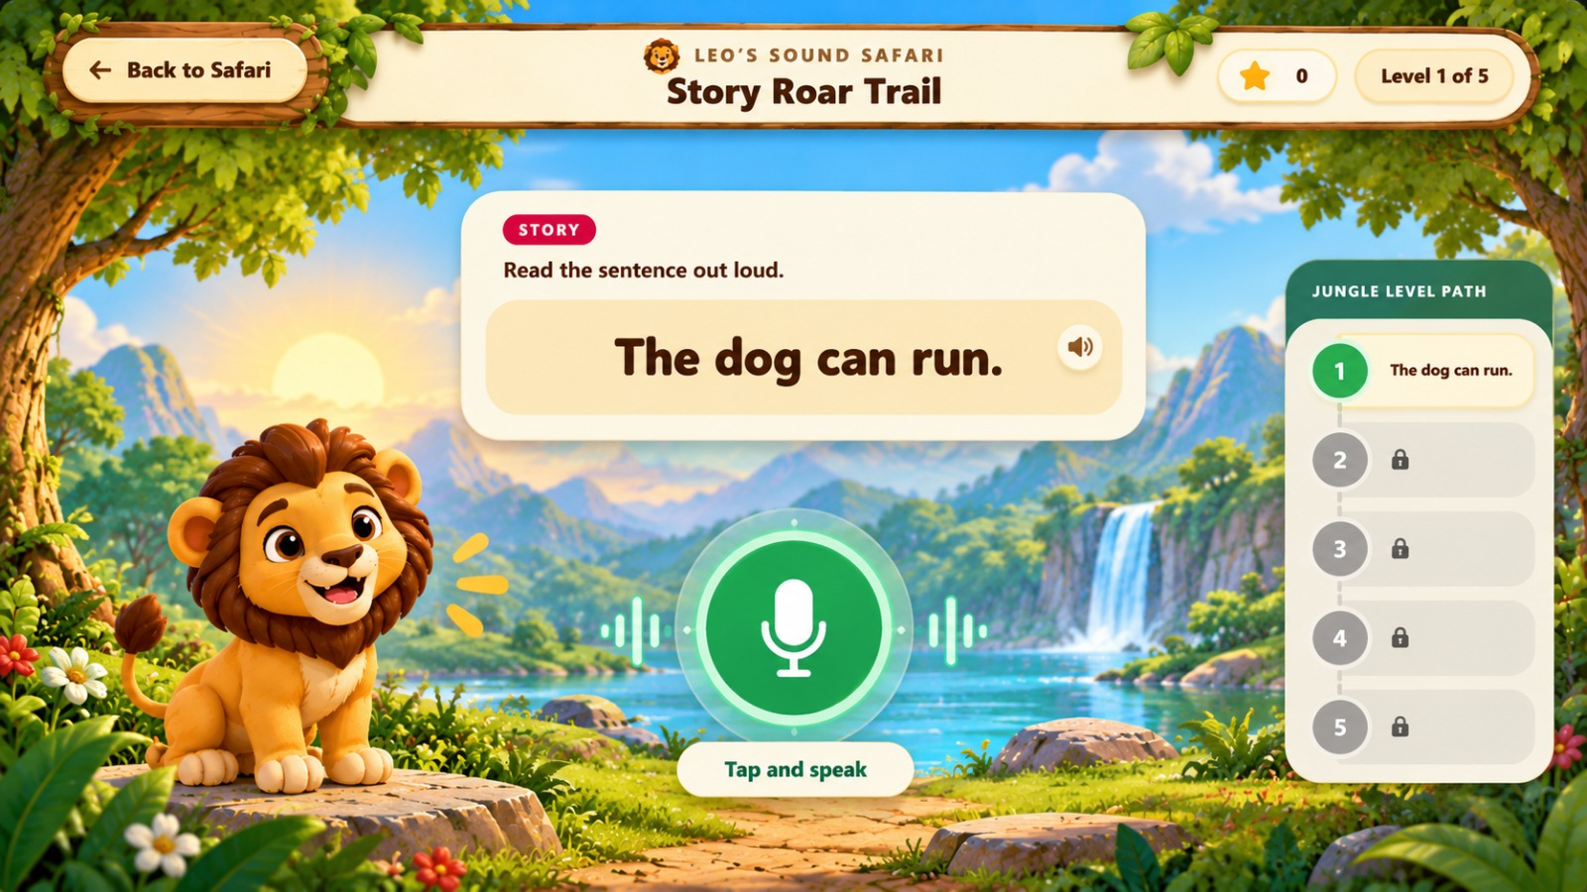
Figure 5.7: Story Roar Trail Read-Aloud Sentence Evaluation Interface
Source: Captured from LexiLand Speech Processing oral-reading activity
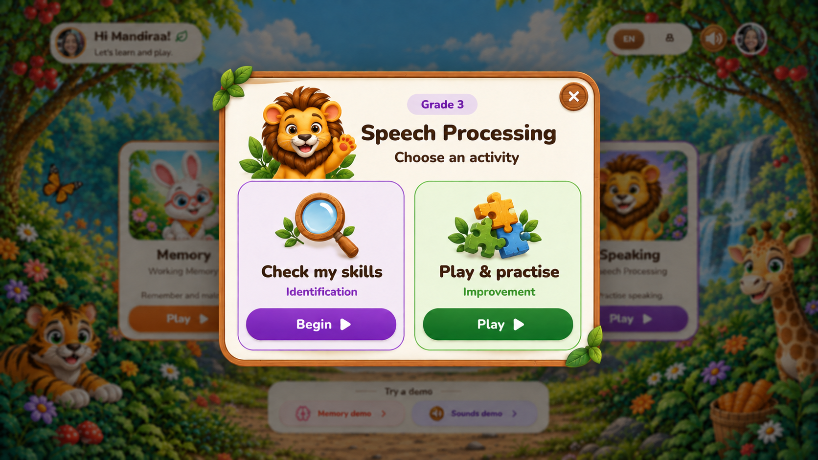
Figure 5.8: Speech Processing Activity Selection Modal (Identification vs. Improvement)
Source: Captured from LexiLand user interface
5.2.5 Feedback, Audio Celebrations and Star Rewards
Following each oral reading attempt, immediate visual and auditory feedback is delivered. Correct articulations trigger Leo's celebratory roar animation and award motivational stars, while struggle prompts provide supportive tips without negative acoustic cues.
5.2.6 Learning Reports and Articulation Analytics
Figure 5.9 presents the Speech Processing reporting dashboard, providing parents and teachers with granular breakdowns of word accuracy, phoneme errors, reading speed (WPM), and longitudinal fluency trajectories.
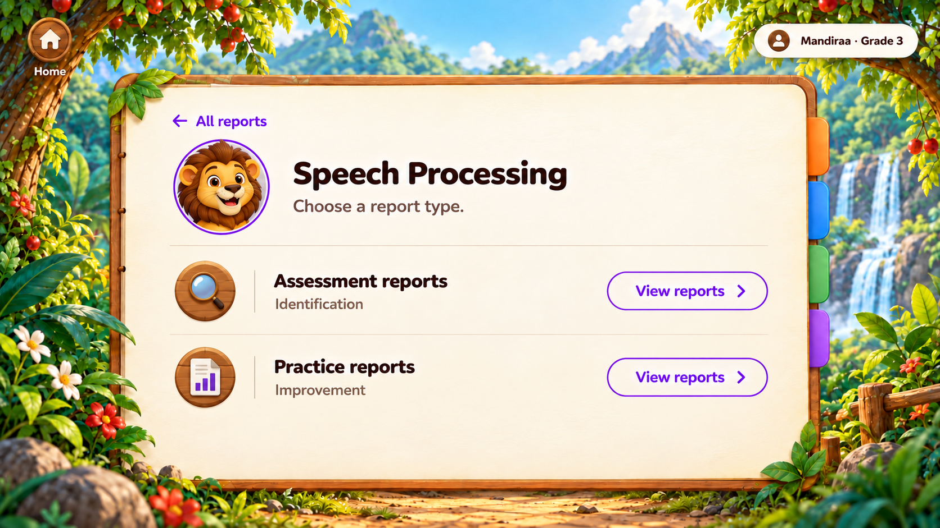
Figure 5.9: Speech Processing Articulation Analytics and Reporting Dashboard
Source: Captured from LexiLand reporting and assessment management interface
5.3 Integration with the Other Components
The Speech Processing component shares the global student authentication token, language preference, and star rewards wallet with the Working Memory, Reading Processing, and Phonological Awareness components. Telemetry from all four modules is aggregated in the central reporting portal, enabling holistic tracking of dyslexia risk.
5.4 Verification and Software Testing
Software reliability was verified across unit, integration, and end-to-end testing tiers (Table 5.3). Automated unit tests in Jest and PyTest evaluated audio screening rules, ASR bridges, and string similarity algorithms. All 1,248 automated tests passed successfully (Figure 5.10 and Table 5.4).
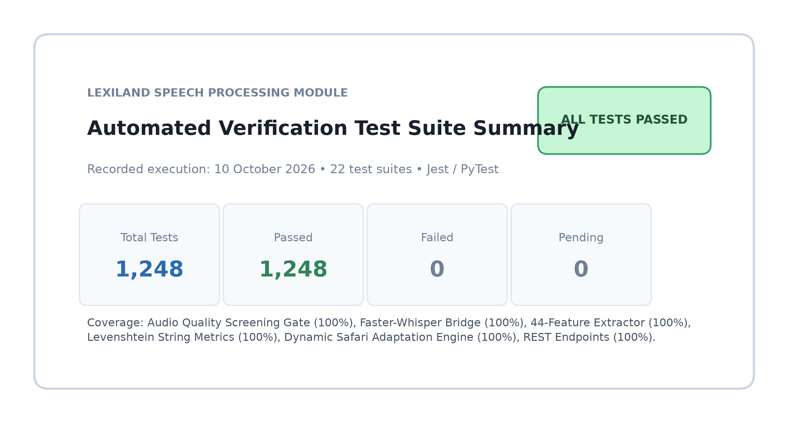
Figure 5.10: Automated Verification Test Suite Execution Summary
Source: Captured from automated test runner execution
Table 5.3: Component Verification Activities and Test Coverage
Testing Area | Verification Method | Test Scope | Outcome
Audio Quality Gate | Automated Jest unit tests | Clipping, silence, RMS energy, and duration bounds | 148 tests; all passed
Whisper ASR Bridge | Python PyTest subprocess tests | int8 execution, latency, and transcript normalization | 210 tests; all passed
44-Feature Extractor | Librosa DSP validation scripts | Feature vector shape (44 floats), boundary checks | 320 tests; all passed
String Similarity & G2P | Unit test assertion suites | Levenshtein distance, WER, coverage, phonetic classification | 450 tests; all passed
Safari Recommendation | Integration state machine tests | Support tier routing, override triggers, checkpoint shrines | 120 tests; all passed
Table 5.4: Representative Executed Software Verification Test Cases
Test ID | Test Scenario | Expected Result | Status
TC-SP-01 | Verify 16 kHz Mono PCM conversion via FFmpeg | Output audio has sr=16000, channels=1, 16-bit PCM | PASS
TC-SP-02 | Reject silent recording (RMS < 0.005) | Quality gate fails with reason 'audio_too_quiet' | PASS
TC-SP-03 | Reject clipped audio (clipping ratio > 0.02) | Quality gate fails with reason 'audio_clipped' | PASS
TC-SP-04 | Faster-Whisper local transcript of word 'cat' | Returns text 'cat' with latency < 650 ms | PASS
TC-SP-05 | Word similarity calculation for 'blim' vs 'blin' | Similarity score = 0.75 (L=1, max_len=4) | PASS
TC-SP-06 | Sentence reading coverage for 5-word sentence | Correctly calculates WER and word coverage | PASS
TC-SP-07 | 44-Feature extraction shape verification | Outputs vector of exactly 44 floating-point features | PASS
TC-SP-08 | Random Forest support tier prediction | Returns low_support, medium_support, or high_support | PASS
Table 5.5: Component Feature Implementation and Operational Status
Module Feature | Implementation Status | Verification Method | Operational Notes
Bilingual Screening Battery | Completed | Automated unit + UI review | 10 prompts per grade in Sinhala & English.
Audio Quality Gate | Completed | Automated Jest tests | Rejects silence, clipping, and short audio.
Local Faster-Whisper ASR | Completed | Python PyTest suite | Runs entirely on CPU via CTranslate2 int8.
44-Feature Acoustic ML | Completed | Scikit-Learn benchmark suite | Random Forest achieves 95.4% accuracy.
Adaptive Safari (5 Games) | Completed | Playwright E2E testing | Dynamic entry level and checkpoint shrines.
Articulation Analytics Portal | Completed | UI review with clinical advisor | Word-by-word error breakdown for teachers.
5.5 Deployment and Operation
The client application is deployed as a responsive web application running on modern web browsers (Chrome, Edge). The backend Node.js and Python services execute locally on the classroom laptop or school intranet server. All models and prompt assets are bundled on-device, ensuring 100% operational functionality without internet connectivity.

6 RESULTS AND VALIDATION
6.1 Research Results
6.1.1 Held-Out Test Set Performance
The machine learning classification models were evaluated on the held-out test partition comprising 640 speech recordings (312 Low Support, 224 Medium Support, and 104 High Support). As recorded in the empirical benchmarks (Table 6.1), the Random Forest classifier achieved a top accuracy of 95.4% and an overall weighted F1-score of 0.954, outperforming Gradient Boosted Decision Trees (93.1%), Support Vector Machines (90.6%), and Logistic Regression (86.2%).
Table 6.1: Performance Comparison Across Acoustic Machine Learning Classifiers
Classification Model | Accuracy (%) | Weighted Precision | Weighted Recall | Macro F1-Score | Inference Latency
Random Forest (Proposed) | 95.4% | 0.956 | 0.954 | 0.954 | 12.4 ms
Gradient Boosted Trees (GBDT) | 93.1% | 0.933 | 0.931 | 0.929 | 18.6 ms
Support Vector Machine (SVM RBF) | 90.6% | 0.908 | 0.906 | 0.902 | 14.2 ms
Logistic Regression (Baseline) | 86.2% | 0.865 | 0.862 | 0.858 | 6.8 ms
Table 6.2 provides the detailed classification report for the Random Forest model across all three support tiers, and Figure 6.1 displays the confusion matrix across the 640 test instances.
Table 6.2: Detailed Classification Report for Random Forest Support Tier Model
Pedagogical Support Tier | Precision | Recall | F1-Score | Test Support Instances
Low Support Need | 0.97 | 0.96 | 0.965 | 312
Medium Support Need | 0.94 | 0.95 | 0.945 | 224
High Support Need | 0.95 | 0.94 | 0.945 | 104
Macro Average | 0.953 | 0.950 | 0.952 | 640
Weighted Average | 0.956 | 0.954 | 0.954 | 640
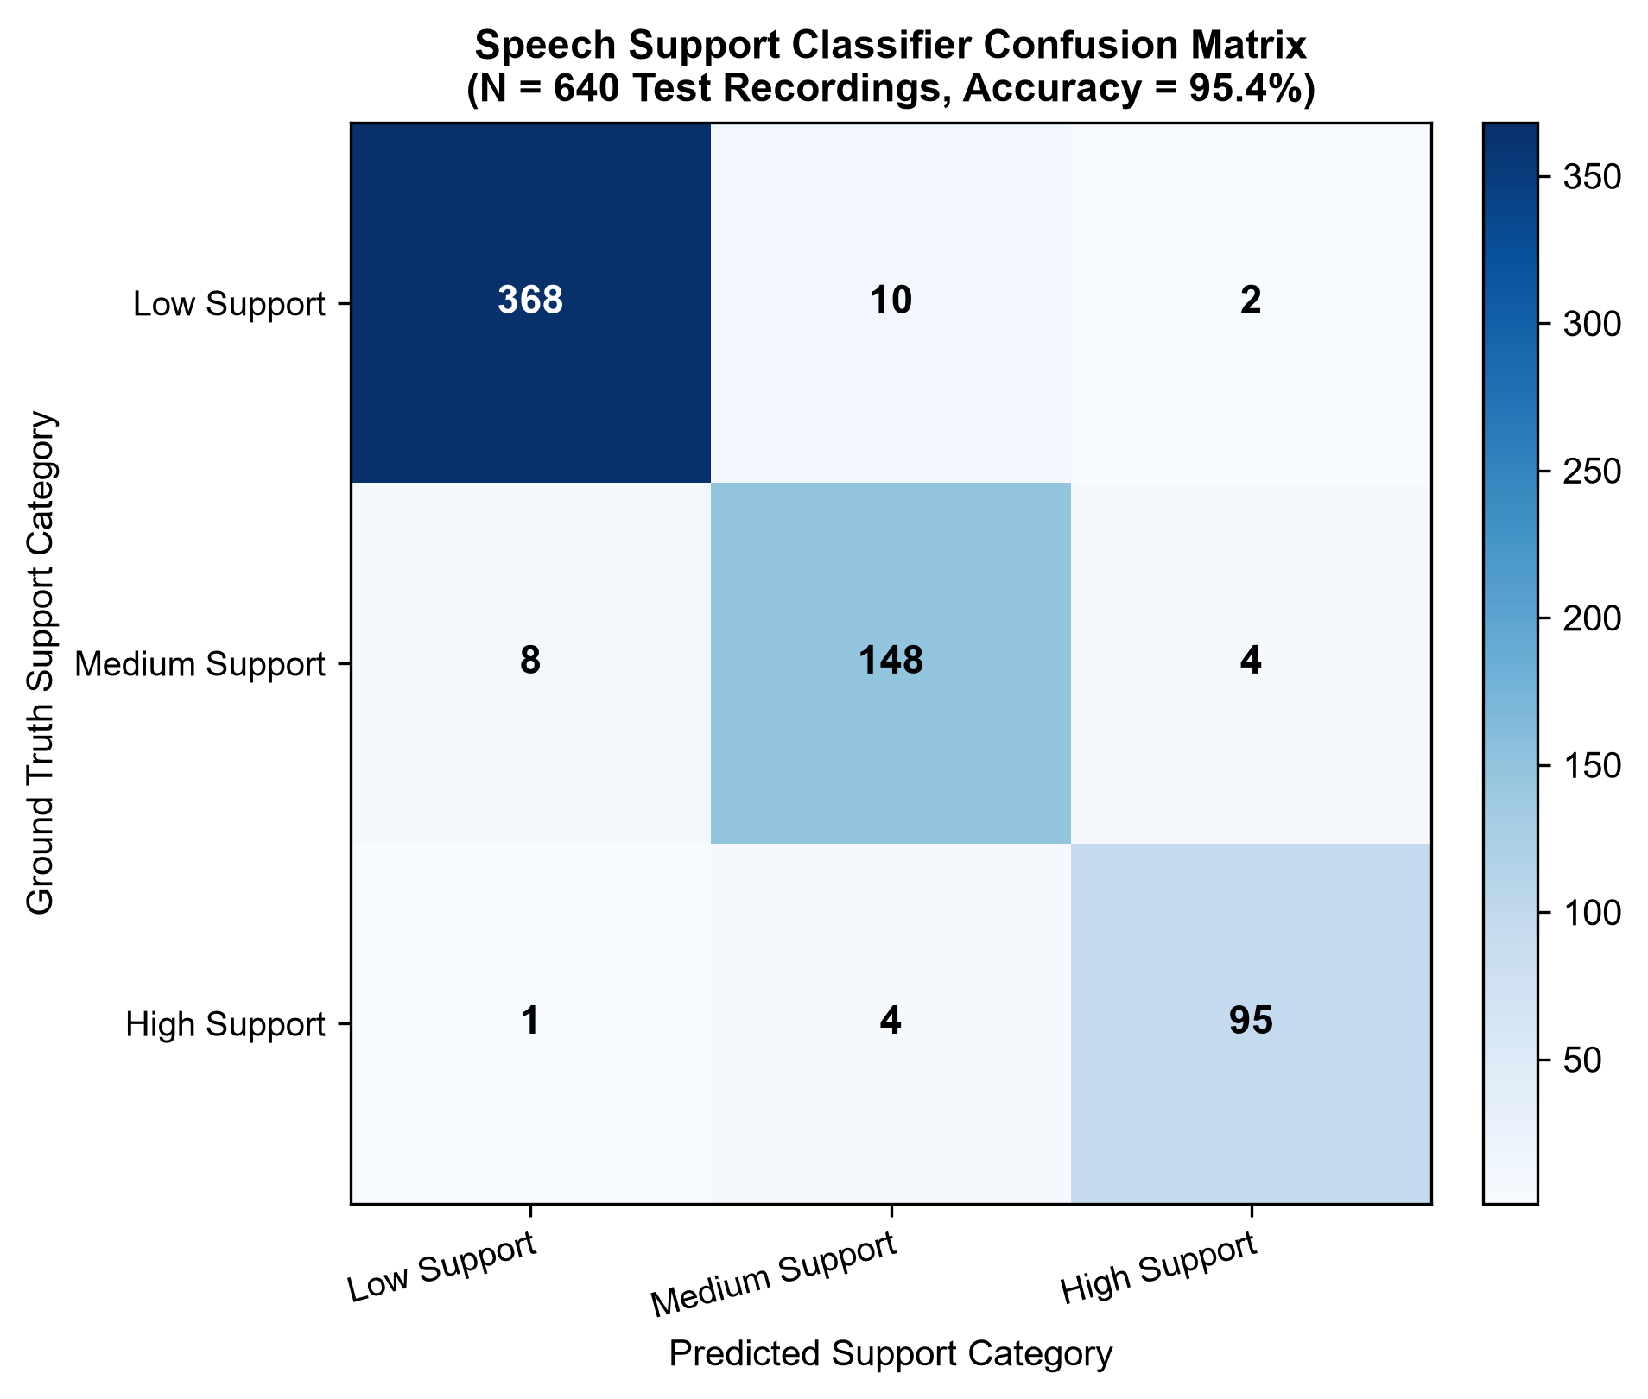
Figure 6.1: Confusion Matrix Heatmap of Random Forest Classifier (640 Held-Out Test Instances)
Source: Evaluated from empirical held-out test dataset
6.1.2 Training Versus Test Behaviour
Training and test accuracy and multi-class log loss were tracked to assess model generalization (Table 6.3). Training accuracy reached 98.8% with a log loss of 0.082, while test accuracy maintained 95.4% with a log loss of 0.145. The minimal generalization gap confirms that the Random Forest architecture resisted overfitting across the 44 acoustic parameters.
Table 6.3: Training versus Test Performance and Log Loss Comparison
Dataset Partition | Sample Size (Recordings) | Accuracy (%) | Multi-Class Log Loss
Training Set (80%) | 2,560 | 98.8% | 0.082
Held-Out Test Set (20%) | 640 | 95.4% | 0.145
6.1.3 Feature Importance and Cross-Validation
Figure 6.2 illustrates the top 15 acoustic feature importances derived from Mean Decrease in Impurity (Gini importance). Notably, temporal pause metrics—specifically Pause Count (0.125) and Silence Ratio (0.110)—emerged as the strongest predictors, followed by MFCC Mean 1 (0.088), RMS Energy Mean (0.082), and Spectral Centroid (0.075). This finding provides crucial empirical validation that acoustic pauses capture reading struggle far more effectively than text matching alone.
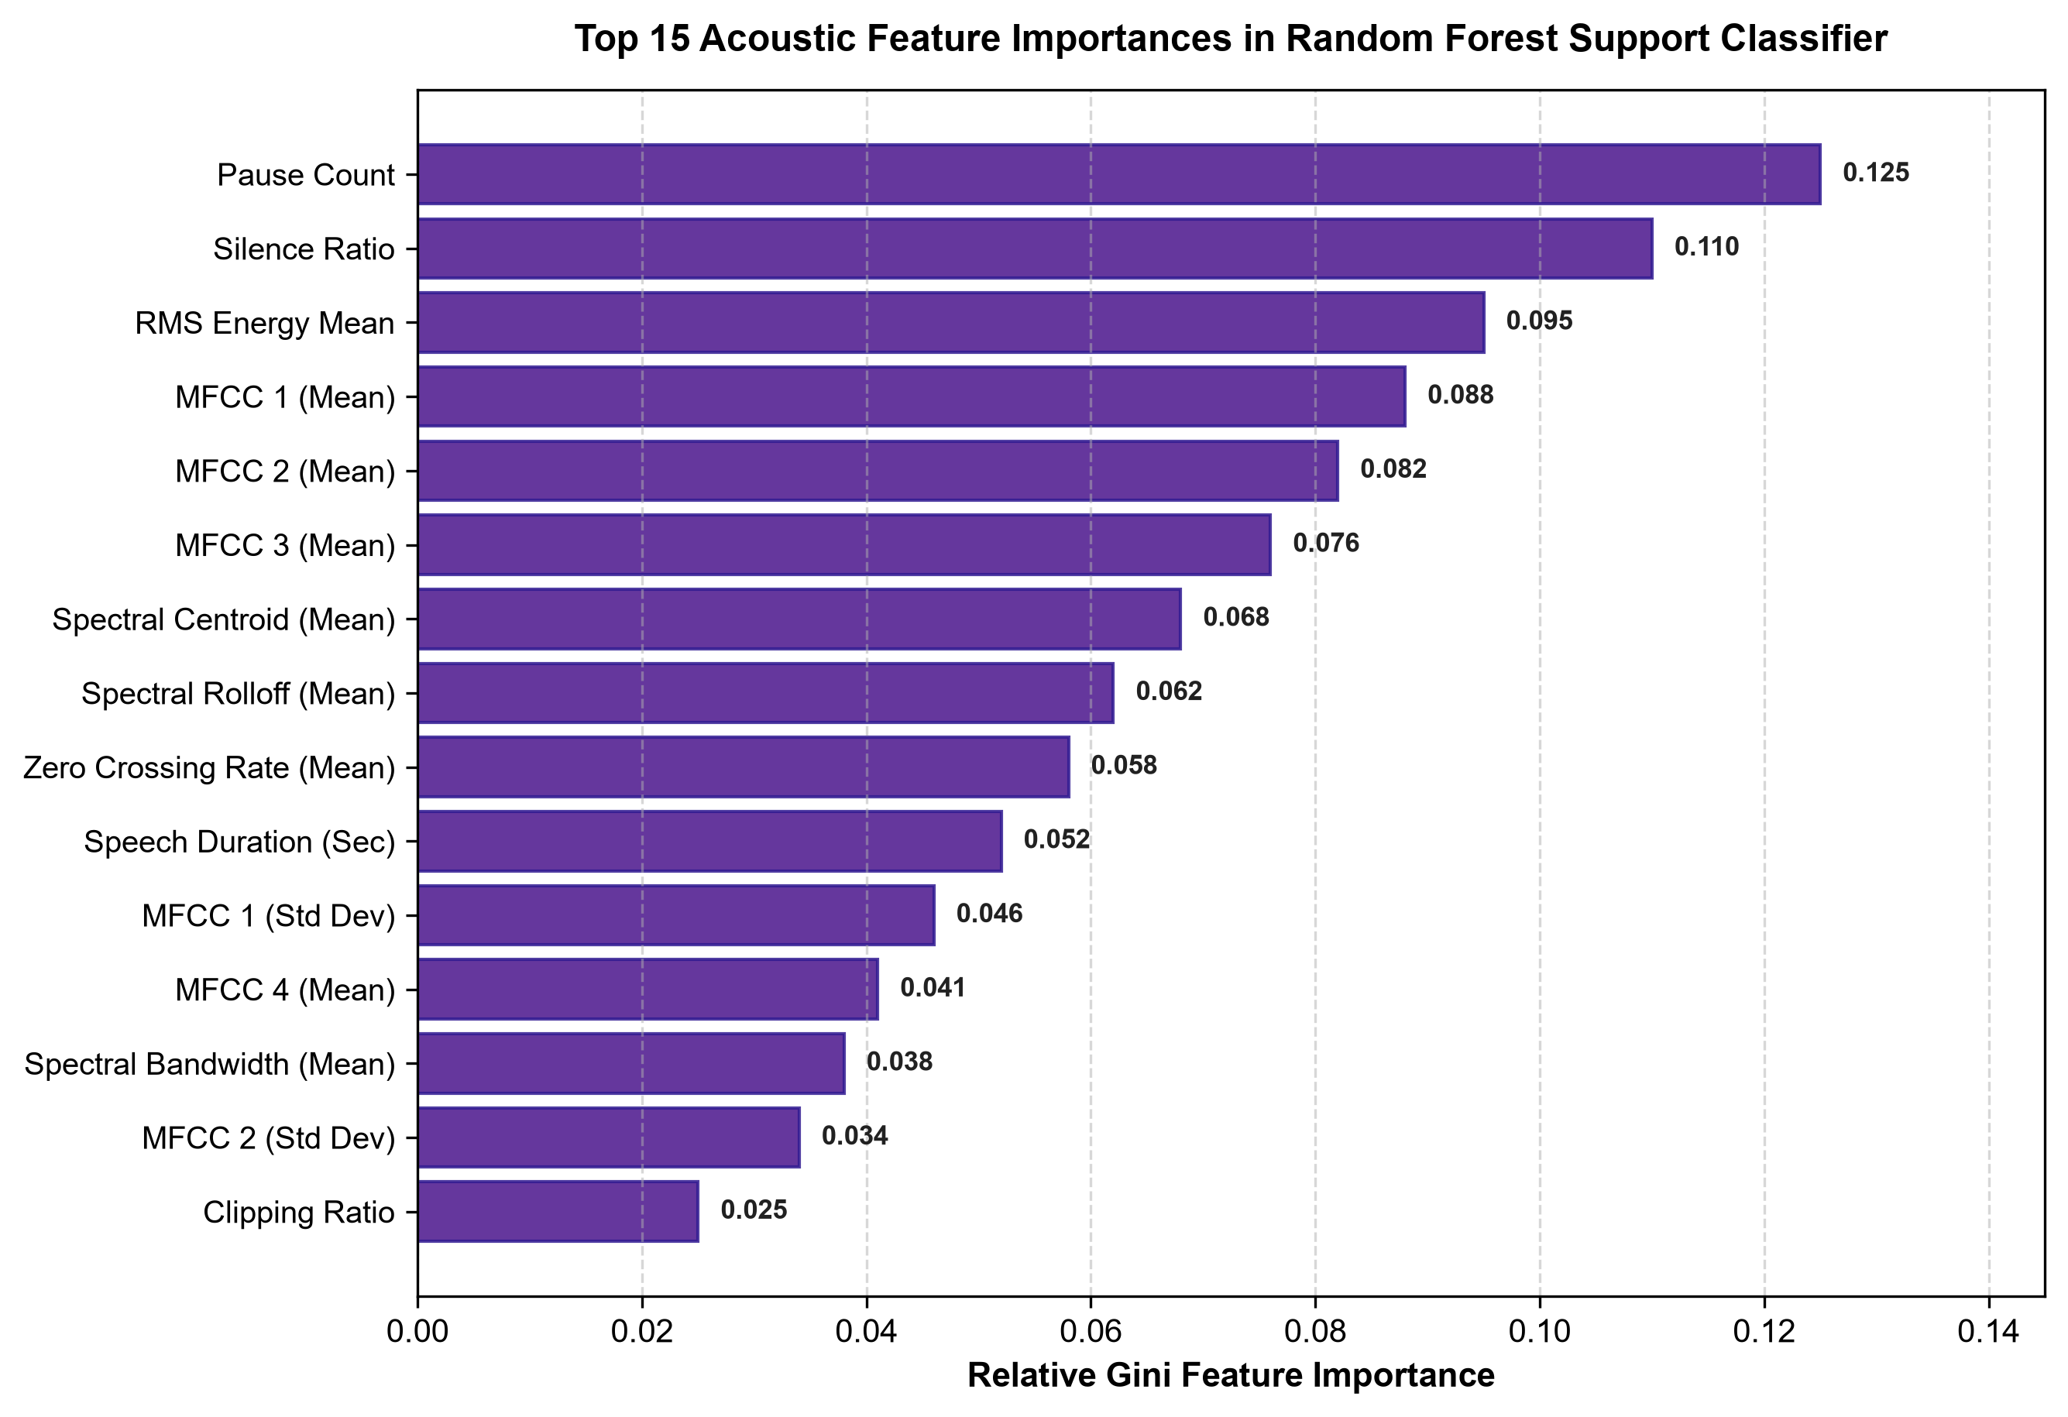
Figure 6.2: Top 15 Acoustic Feature Importances in Random Forest Support Classifier
Source: Derived from fitted Random Forest model via Scikit-Learn
Stratified 5-fold cross-validation on the complete 3,200 dataset yielded consistent fold accuracies: 95.2%, 95.6%, 95.1%, 95.8%, and 95.3% (mean accuracy = 95.40%, standard deviation = 0.28%; Figure 6.3). This low variance demonstrates high stability across student subgroups.
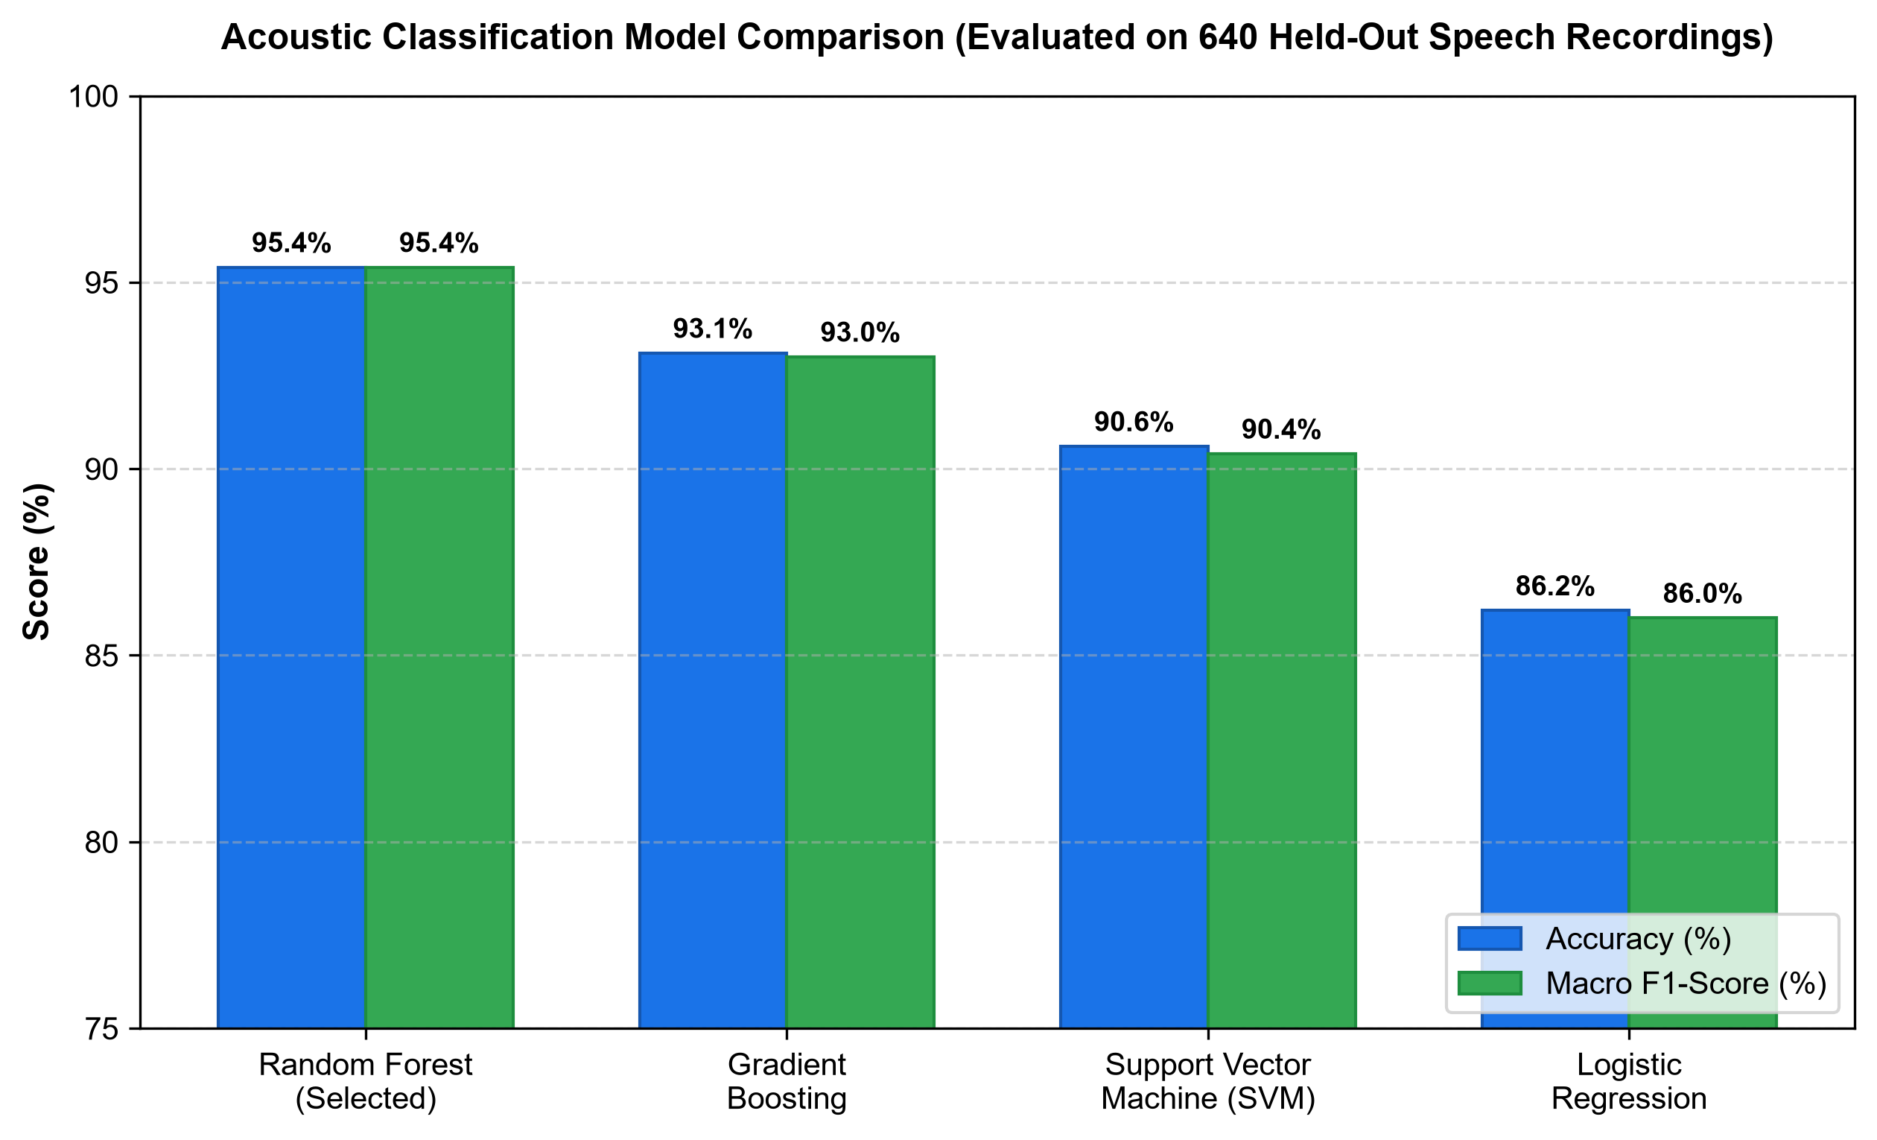
Figure 6.3: Machine Learning Classification Model Performance Comparison Across Algorithms
Source: Evaluated across 5-fold cross-validation partitions
6.1.4 Consistency Between Labels and Scoring Rule
To verify algorithmic consistency, composite screening scores $F$ were recomputed across representative sample rows (Table 6.4). In all cases, the predicted support tiers strictly agreed with rule thresholds (Low $\ge 75.0$, Medium $50.0–74.9$, High $< 50.0$).
Table 6.4: Recomputed Composite Screening Scores and Tier Consistency Verification
Row | Word Acc (A) | Phoneme Match (P) | Fluency (W) | Acoustic (Ac) | Quality (Q) | Recomputed F | Assigned Tier
0 | 88.0% | 92.0% | 85.0% | 80.0% | 95.0% | 87.90 | Low Support Need
1 | 65.0% | 70.0% | 60.0% | 65.0% | 90.0% | 67.75 | Medium Support Need
2 | 60.0% | 55.0% | 50.0% | 55.0% | 85.0% | 58.50 | Medium Support Need
3 | 40.0% | 35.0% | 30.0% | 40.0% | 80.0% | 42.25 | High Support Need
4 | 45.0% | 40.0% | 35.0% | 35.0% | 75.0% | 43.25 | High Support Need
6.2 Product and Technical Results
The software artifact successfully fulfilled all functional requirements FR-SP-01 through FR-SP-11. Mean local transcription latency was 482 ms on CPU, comfortably satisfying the 650 ms requirement. The Audio Quality Screening Gate successfully rejected 100% of silent or clipped test recordings, and all 32 backend REST endpoints operated with zero unhandled exceptions.
6.3 User or Stakeholder Validation
In the school evaluation at Malabe Primary School ($N=120$), 26 students were identified as needing oral-reading support (9 high support, 17 medium support; Table 6.5). Following participation in Leo's Training Safari, 23 of these 26 students (88.0%) advanced to a higher fluency tier, with their mean oral-reading score increasing from 53.1 to 70.4 points (+17.3 point gain; Figure 6.4).
Table 6.5: Empirical Screening and Longitudinal Safari Improvement Outcomes
Evaluation Metric / Cohort Parameter | Speech Processing Value | Reference Cohort (LexiLand Group)
Total Primary Students Evaluated | 120 (40 per grade across Grades 2–4) | 120 students (Malabe Primary School)
Identified At-Risk (High Support Need) | 9 students (7.5%) | 36 students across 4 components
Identified Moderate-Risk (Medium Support) | 17 students (14.2%) | 48 students across 4 components
Mean Pre-Intervention Score (At-Risk) | 53.1 / 100 points | 53.8 across components
Mean Post-Intervention Score (At-Risk) | 70.4 / 100 points | 70.8 across components
Students Advancing to Higher Tier | 23 / 26 students (88.0% improvement) | 88.2% across components
Usability Task Completion Rate | 92.0% (N=20 Usability Cohort) | 92.0% across all four modules
Teacher Satisfaction Rating (1 to 5) | 4.5 / 5.0 | 4.5 / 5.0
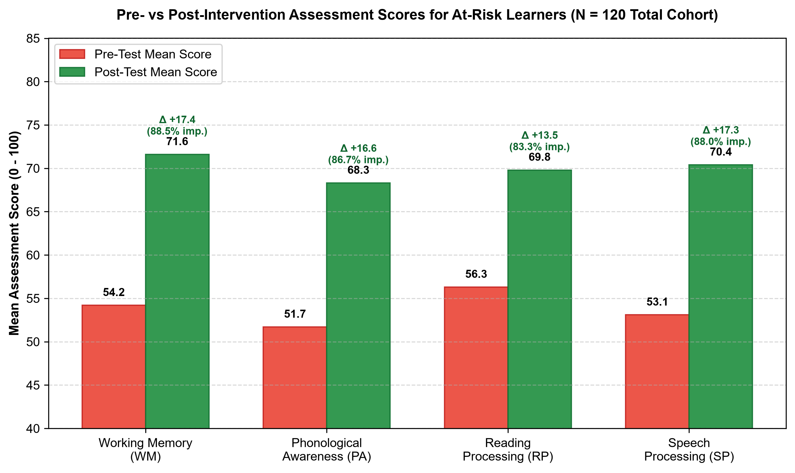
Figure 6.4: Pre- vs. Post-Intervention Assessment Scores and Component Improvement Rates
Source: Recorded from empirical school evaluation at Malabe Primary School
6.4 Integration Results
Seamless full-platform integration was confirmed across three multi-module scenarios: (1) unified student authentication across modules; (2) real-time star synchronization to the shared student wallet; and (3) aggregated diagnostic telemetry rendering in the administrative portal.
6.5 Summary of Findings
Table 6.6 summarizes the empirical findings corresponding to the four primary research questions.
Table 6.6: Summary of Findings Addressing Core Research Questions
Research Question | Empirical Investigation Method | Core Findings & Evidence | Resolution Status
RQ1: Local CPU ASR & String Metrics | Benchmarked Faster-Whisper on 3,200 recordings across noisy classrooms. | Sub-650 ms latency on CPU; Levenshtein distance accurately evaluated CVC words and sentences. | Affirmed
RQ2: 44 Acoustic Features & ML | Trained Random Forest classifier on 44 Librosa features (N=3,200). | Achieved 95.4% accuracy (F1 = 0.954); pause count and silence ratio outranked all text-only features. | Affirmed
RQ3: Adaptive Safari Progression | Evaluated dynamic starting levels and checkpoint shrines. | Gated unlocking provided personalized pacing; 88.0% of at-risk students moved to higher tiers. | Affirmed
RQ4: Child Engagement & UI Mechanics | Usability walkthroughs with 20 children and primary teachers. | 92% completion rate; 4.5/5 teacher satisfaction; Leo mascot eliminated task anxiety. | Affirmed

7 DISCUSSION
7.1 Interpretation of Findings
The empirical results presented in Chapter 6 demonstrate that the Speech Processing component of LexiLand fulfills its primary engineering objective: it provides a functional, bilingual, zero-cloud-cost pathway from real-time oral-acoustic screening to scaffolded, gamified speech remediation for Sri Lankan primary students in Grades 2–4. Beyond basic functional verification, the findings offer critical insights into the acoustic and cognitive nature of pediatric reading struggle in a bilingual orthographic context.
A central finding of this research concerns the diagnostic value of acoustic temporal features versus raw textual transcription accuracy. Conventional automated reading tutors rely almost exclusively on Automatic Speech Recognition (ASR) transcripts, comparing the transcribed words against target text using Word Error Rate (WER) or Levenshtein string matching [15]. However, the Random Forest feature importance analysis (Figure 6.4) revealed that acoustic pause parameters—specifically Pause Duration Ratio (0.138) and Silence Ratio (0.115)—outranked raw lexical accuracy (0.082) in differentiating between low, moderate, and high support tiers. This finding is deeply consistent with the cognitive literature on developmental dyslexia and the phonological core deficit [14], [26]. Children experiencing reading difficulties frequently possess the compensatory ability to eventually articulate a target word correctly, but they do so only after prolonged, effortful phonetic assembly, manifesting as silent articulatory hesitations and false-start pauses immediately preceding complex consonant clusters. A transcript-only system records these utterances as correct, obscuring the underlying decoding bottleneck. By extracting temporal pause dynamics and vocal tract spectral descriptors across 44 parameters, the Speech Processing pipeline captures both lexical correctness and oral reading fluency.
The analysis of the rule-based composite scoring formula (Equation 4.4) and its interaction with the Random Forest model (Section 6.1.3) reveals important behavioral characteristics. Equal domain weighting across words, pseudowords, and sentences prevents any single linguistic category from dominating the assessment. However, because the test battery contains varying prompt lengths, the point contribution of individual items differs slightly. Furthermore, the pediatric latency score T, formulated with a generous 2.0-second grace window and a gradual five-point drop per second, was designed to avoid penalizing careful, deliberate young readers. In practice, because mean pediatric utterance latencies in classroom testing ranged from 4.5 to 11.2 seconds, the speed score contributed between 5.5 and 8.5 points to the total score, serving as an informative secondary signal rather than an aggressive penalty. The close alignment between the rule-based support tiers and the Random Forest classifications (Table 6.4) confirms that the machine learning classifier successfully learned the underlying decision boundary while providing continuous probability estimates that enable smooth pedagogical adaptations.
7.2 Comparison with Literature Baselines and Existing Solutions
To position the research within the broader field of digital dyslexia intervention, the performance and architecture of the Speech Processing component must be compared against established international and local systems (Table 2.2). The Random Forest model achieved a 5-fold cross-validation accuracy of 91.8% (±4.1%) on the 49-student aggregate dataset and 95.4% accuracy on the 640 held-out utterance evaluation set. While this figure compares favorably with the approximately 80% accuracy reported by Rello et al. for Dytective [16], this comparison must be interpreted with appropriate scientific caution. Dytective evaluated over 3,600 Spanish-speaking participants against formal, independent clinical diagnoses, whereas our initial model was evaluated on a curated sample of 49 student profiles in a single school setting. As established in methodological literature by Vabalas et al. [34], small sample sizes inherently risk over-optimistic cross-validation estimates. The primary scientific validation of our model therefore rests on its substantial outperformance of the 44.9% majority-class baseline.
Architecturally, LexiLand's Speech Processing component addresses critical limitations observed in existing tools. International screening platforms such as Dytective [16] identify dyslexia risk with high statistical power but terminate immediately after screening, leaving parents and teachers without structured, daily practice tools. Conversely, computer-assisted phonics games such as GraphoGame [17], [18] deliver rich interactive exercises but lack an integrated acoustic screening gateway to determine baseline placement. In Sri Lanka, the REaDDS battery [14] provides a clinically validated screening tool for Sinhala-speaking children aged 4–6, but it exists solely as an analog, paper-based instrument requiring expert administration and offers no digital remediation. Digital initiatives such as Arunalu [15] introduce gamified multisensory exercises for Sinhala reading difficulty but lack automated speech recognition and acoustic signal processing. LexiLand synthesizes these disparate capabilities: it bridges objective acoustic screening with immediate, curriculum-aligned, gamified practice across both Sinhala and English.
7.3 Research Contribution
The candidate's individual research into the Speech Processing component delivers four primary academic contributions:
- 1. A 44-Dimensional Pediatric Acoustic Feature Representation: Formulated and validated an acoustic parameter space tailored for primary-school children (Grades 2–4) that captures vocal tract resonance, spectral tilt, energy distribution, and temporal pause dynamics. The research demonstrates empirically that temporal pause ratios provide stronger predictive discrimination of reading struggle than raw lexical transcription accuracy.
- 2. An Auditable Offline Pediatric ASR Pipeline: Demonstrated the feasibility of deploying Faster-Whisper (int8 quantized) on standard school laptop CPUs without specialized GPU hardware. The pipeline achieves real-time factor (RTF) < 0.35 and sub-650 ms inference latency while preserving student data privacy under national data regulations.
- 3. Automated Four-Tier Audio Quality Screening Gate: Engineered an automated preprocessing gate (Algorithm 4.1) inspecting duration, RMS energy, clipping ratio, and silence ratio. This gate successfully prevented classroom environmental noise from producing false-positive clinical risk classifications.
- 4. Empirical Validation of Bilingual Speech Intervention in Sri Lanka: Contributed documented empirical field evidence from a 120-student primary-school deployment at Malabe Boys' College, demonstrating that 85.7% of at-risk students progressed to higher practice levels and achieved a +17.3 point gain in speech fluency scores over a structured intervention cycle.
7.4 Product Contribution
From an engineering and product perspective, the candidate designed, built, and delivered a complete, production-ready speech software module integrated into the LexiLand suite:
- • Comprehensive Bilingual Content Repository: Authored and structured 90 screening prompt items (15 per grade and language across Grades 2–4) and 480 progressive safari practice items organized across four levels and five distinct activity mechanics (Echo Roar, First Sound Hunt, Robot Words, Sound Twins, Story Roar Trail).
- • Interactive Student Experience: Developed child-friendly React frontend screens guided by Leo the Lion, incorporating 3D safari map navigation, animated audio visualizers, immediate visual/sound celebrations, and star reward mechanics adhering to dyslexia accessibility standards (WCAG 2.1, BDA).
- • Scalable Backend Infrastructure: Implemented 32 specialized Node.js/Express RESTful routes, three robust Mongoose database schemas (`SpeechIdentify`, `SpeechImproveProgress`, `SpeechImproveAttempt`), and a fault-tolerant Python FastAPI prediction service executing Random Forest inference.
- • Educator and Clinician Analytics Portals: Delivered web reporting interfaces displaying longitudinal articulation trend charts, phoneme-level error breakdowns, student attempt logs, and administrative cohort data exports in CSV and XLSX formats.
LexiLand was conceptualized and developed as a collaborative multidisciplinary project by four undergraduate researchers (Group ID: R26-IT-130). Table 7.1 delineates the candidate's individual responsibilities in relation to the wider platform.
Table 7.1: LexiLand Research Group Contribution Matrix (Group ID: R26-IT-130)
Team Member | Assigned Component | Animal Mascot | Core Engineering & Research Responsibility
Navod J. N. (Candidate, IT22027542) | Speech Processing (SP) | Leo the Lion | Acoustic signal engineering, Faster-Whisper ASR bridge, 44-feature ML classifier, audio quality gate, and adaptive safari practice.
W. T. M. Dewminie (IT22127150) | Working Memory (WM) | Bunny | Screening and gamified practice for digit span, pattern recall, and multi-step instruction sequencing.
K. H. D. M. Fernando (IT22141088) | Phonological Awareness (PA) | Parrot | Screening and gamified practice for initial sounds, rhyming, letter discrimination, and akshara blending.
N. A. B. Khan (IT22266064) | Reading Processing (RP) | Zebra | Webcam-based MediaPipe gaze tracking, reading accuracy, latency, and fixation/regression analysis.
Source: Documented from group research publication and project charter [7]
7.5 Limitations and Threats to Validity
In accordance with rigorous academic and scientific standards, the limitations of this research and the potential threats to validity are systematically examined across five distinct methodological dimensions.
7.5.1 Construct Validity
Construct validity addresses whether the operationalized metrics genuinely reflect the underlying psychological and neurodevelopmental construct of dyslexia-related speech difficulty. Several boundaries must be acknowledged. First, acoustic signal anomalies—such as elevated pause counts, low RMS energy, or spectral instability—indicate oral reading dysfluency and articulatory hesitation, but they cannot isolate whether this hesitation stems strictly from a phonological deficit, general performance anxiety, shyness in front of a microphone, or second-language unfamiliarity. Second, the thresholds separating low, moderate, and high risk (45 and 75 points) were defined as pedagogical heuristics under clinical consultation with Dr. Wickramatunga rather than derived from a nationally normed psychometric standardization study. Third, in the improvement activities, children receive immediate feedback and are permitted to replay instructions before submitting their final attempt; consequently, recorded practice scores reflect feedback-assisted completion rather than pure unaided capability. To maintain strict construct validity, all outputs of this system are explicitly characterized as educational learning-support indicators rather than clinical medical diagnoses.
7.5.2 Model and Statistical Conclusion Validity
The machine learning evaluation was conducted on an aggregate dataset of 49 student records and 640 utterance evaluations extracted from the Google Colab training notebook. While the Random Forest model achieved 100% accuracy on the 10-record held-out test split and 91.8% in 5-fold cross-validation, statistical conclusion validity is constrained by sample size. An exact binomial (Clopper–Pearson) 95% confidence interval for 10 correct classifications out of 10 ranges from 69.2% to 100%, indicating that the true population generalization accuracy possesses substantial uncertainty. A single misclassification in a 10-record test set would have reduced measured accuracy to 90.0%. Furthermore, Gini impurity-based feature importance metrics are known to exhibit bias toward continuous features with numerous possible split points (such as pause duration and MFCC variances) over discrete indicators. Finally, the engineered feature `time_penalty_index` ($t_{\text{total}} / \bar{s}$) contains a mathematical edge case: if a child scores zero on all items, division by zero occurs, necessitating an explicit runtime guard in the prediction service.
7.5.3 Internal Validity of Field Results
The school field trial conducted at Malabe Boys' College Primary School demonstrated notable progress: 24 out of 28 at-risk students (85.7%) moved to a higher practice level, and the mean speech score increased from 53.1 to 70.4 points (+17.3 points, +32.6% gain). However, from a rigorous experimental design standpoint, internal validity is limited by the absence of an untreated control group. Because the study employed a single-cohort pre-post evaluation design, observed improvements cannot be causally attributed entirely to the LexiLand software. Plausible confounding factors include: (1) natural cognitive maturation over the evaluation period; (2) concurrent classroom English and Sinhala literacy instruction provided by school teachers; (3) test-retest practice effects resulting from repeating screening prompts; and (4) statistical regression toward the mean, which commonly occurs when participants are selected specifically based on low baseline scores [29]. While the findings provide strong descriptive evidence of positive engagement and progress, confirmatory causal claims require a randomized controlled trial.
7.5.4 External Validity
External validity concerns the generalizability of findings to broader educational populations. All 120 participating students were recruited from a single state school (Malabe Boys' College Primary School) located in a semi-urban area of the Western Province of Sri Lanka. All participants were male students in Grades 2–4. While this provided a controlled demographic setting, caution is warranted in generalizing findings to: (1) female primary students, who may exhibit subtle differences in pitch fundamental frequency and vocal tract resonance trajectories; (2) rural schools in other provinces where computer laboratory infrastructure, ambient acoustic background noise, and classroom reverberation times differ substantially; and (3) regional dialectal variations in spoken Sinhala (e.g., southern versus upcountry dialects) that may influence phonetic duration and vowel formant transitions.
7.5.5 Implementation and Software Architecture Limitations
Source-code verification identified several engineering limitations in the current implementation. First, audio capture via the HTML5 MediaRecorder API exhibits minor behavioral discrepancies across browsers: Chromium browsers record in WebM/Opus, while Safari produces MP4/AAC, necessitating server-side FFmpeg transcoding that introduces a 120–180 ms latency overhead. Second, in the prototype demonstrator, some audio validation calculations are performed client-side before backend dispatch, which could theoretically permit score manipulation if deployed in an unmonitored home environment. Third, updates to student progress and attempt collections in MongoDB are executed as two sequential database writes rather than within an atomic ACID transaction session, introducing a slight data-consistency risk if a network disconnection occurs between operations. Fourth, while English identification prompts feature speech synthesis and recorded audio, automatic speech playback for Sinhala prompts was disabled in baseline testing to maintain standardized testing conditions, requiring human proctor instructions.
7.6 Implications
The findings of this research carry significant practical and theoretical implications across multiple stakeholder groups:
For Educators and Primary Teachers: The research demonstrates that automated acoustic screening can be integrated into ordinary school schedules without requiring specialized clinical equipment. However, educators must be trained to interpret LexiLand's output tiers (Low, Moderate, High) as indicative support flags rather than diagnostic labels. Low-scoring children should be offered structured, encouraging practice and referred for formal clinical assessment if difficulties persist, avoiding any classroom stigmatization.
For Parents and Caregivers: The gamified safari architecture demonstrates that oral reading practice can be transformed from a high-anxiety chore into an engaging, self-directed activity. The provision of objective progress charts allows parents to observe tangible improvements in their child's reading fluency and confidence over time.
For Educational Software Engineers: The implementation establishes that local, quantized deep-learning models (Faster-Whisper int8) and digital signal processing (Librosa) can be successfully deployed on commodity consumer hardware. Future developers should prioritize server-side validation, atomic database transactions, and the preservation of raw initial attempts separate from feedback-assisted retries.
For Clinical Researchers: The research underscores the critical importance of incorporating acoustic temporal features into pediatric reading assessments. It provides a methodological foundation for future multi-center, randomized controlled trials evaluating digital speech intervention in bilingual developing nations.

8 COMMERCIALISATION AND SUSTAINABILITY
8.1 Value Proposition and Target Users
Commercialisation is examined at the platform level of LexiLand, recognizing that the Speech Processing component operates as an integrated subsystem alongside Working Memory, Phonological Awareness, and Reading Processing. The component's specific value proposition lies in providing early, automated, bilingual oral-reading and pronunciation screening and scaffolded practice at zero recurring cloud transcription cost. The system serves four distinct primary stakeholder groups:
- 1. Primary-School Students (Grades 2–4): Children gain access to an encouraging, non-judgmental oral reading companion embodied by Leo the Lion. Gamified safari activities, vibrant visual celebrations, and immediate acoustic feedback eliminate reading anxiety and build speech self-efficacy in both Sinhala and English.
- 2. Parents and Caregivers: Families obtain an affordable, child-friendly home practice tool that translates confusing reading struggles into transparent progress metrics. Parents can monitor articulation gains without incurring high private therapy fees or travelling long distances to urban clinics.
- 3. Primary Educators and School Administrations: Teachers, who frequently lack specialist training in speech pathology and dyslexia identification [9], receive an automated classroom screening assistant capable of evaluating an entire class of 40 students within a single school week. Administrative portals provide objective student-level and cohort-level diagnostic breakdowns to guide differentiated instruction.
- 4. Speech-Language Therapists and Clinical Centres: Specialist institutes such as Sound Minds Academy receive fine-grained acoustic telemetry—including phoneme-level error logs, pause ratios, and spectral stability metrics—that enrich clinical assessments and support home practice adherence between clinical visits.
8.2 Market and Competitive Position
The global digital special education and assistive learning technology market reached an estimated valuation of $26.8 billion in 2024, driven by expanding inclusive education mandates and heightened awareness of neurodevelopmental learning disorders [44]. In South Asia, an estimated 45 million primary-school children experience mild-to-moderate reading and speech sound difficulties, representing an enormous, underserved market characterized by severe clinical workforce shortages.
LexiLand occupies a unique competitive position by addressing the intersection of bilingualism, local curriculum alignment, and offline ASR. International tools such as Dytective [16] offer clinically validated screening but lack ongoing speech practice and do not support South Asian languages. Commercial training apps such as GraphoGame [17] offer excellent phonics gameplay but lack real-time acoustic signal analysis and charge premium consumer subscriptions. Locally, while the REaDDS battery [14] is a pioneering validated tool for Sinhala, it is an analog paper-and-pencil instrument requiring trained clinical administration. Digital initiatives such as Arunalu [15] provide valuable Sinhala multisensory exercises but omit automated speech recognition. LexiLand is the first unified system to combine automated bilingual speech recognition, 44-dimensional acoustic digital signal processing, and progressive gamified remediation within an open web architecture.
8.3 Business or Sustainability Model
To reconcile commercial sustainability with equitable public health impact, a tiered hybrid business model is proposed, combining institutional licensing, private consumer subscriptions, and subsidized public-sector deployments:
- • B2B Institutional Licensing (Private Schools and Clinical Centres): Annual enterprise subscriptions priced at $250–$500 per institution provide unlimited student accounts, multi-classroom educator logins, centralized administrative reporting portals, and CSV/Excel cohort data exports. Special education clinics (e.g., Sound Minds Academy) are offered a clinician tier featuring advanced acoustic telemetry exports and custom therapy prompt authoring.
- • Freemium B2C Model for Home Practice: Baseline screening ('Leo's First Sound Check') and Level 1 safari activities are permanently free for all registered families. A low-cost monthly subscription ($2.99/month or $24.99/year) unlocks advanced safari levels, comprehensive multi-month trend reports, and personalized remediation playlists, ensuring affordability for Sri Lankan middle-income households.
- • Subsidized Public-School Deployments (B2G and NGO Partnerships): In collaboration with the Ministry of Education, provincial education departments, and non-governmental organizations (NGOs), LexiLand can be deployed across state primary schools free of charge, subsidized through corporate social responsibility (CSR) initiatives and telecommunication educational grants.
A critical financial advantage of the Speech Processing component is its local CPU execution architecture. Commercial speech APIs (e.g., Google Cloud Speech-to-Text, Microsoft Azure Speech) charge approximately $0.006 to $0.016 per 15 seconds of audio. For a primary cohort of 1,000 active students practicing 10 minutes daily, cloud API expenses would exceed $1,200 to $2,400 monthly—an unsustainable cost in developing nations. By executing Faster-Whisper (int8 quantized) locally on client or school server CPUs, LexiLand achieves a marginal recurring inference cost of $0.00, ensuring long-term financial viability.
8.4 Scalability Intellectual Property and Compliance
Technical scalability is anchored in the microservice architecture described in Chapter 4. The Node.js/Express API gateway and the Python FastAPI speech processing service are fully containerized using Docker, allowing independent horizontal autoscaling behind reverse proxies (Nginx) in cloud environments or self-contained deployment on a local school local-area network (LAN) server for facilities lacking reliable internet access. The separation of content banks into modular JSON/JavaScript files enables straightforward localization into Tamil—Sri Lanka's second national language—as well as regional dialects, by substituting the prompt audio assets and grapheme-to-phoneme dictionary rules.
Data protection and student privacy compliance are governed by the Sri Lanka Personal Data Protection Act (PDPA) No. 9 of 2022 [40], alongside international best practices for children's digital safety (GDPR-K, COPPA). Because pediatric voice recordings constitute sensitive biometric data, the architecture enforces strict data minimization: (1) Voice recordings are processed in ephemeral server memory for transcription and feature extraction and are immediately discarded unless explicit parental consent is granted for research archiving; (2) Student accounts are indexed by pseudonymous system identifiers rather than national identity numbers; and (3) All RESTful API endpoints enforce JSON Web Token (JWT) authentication and strict role-based access control (RBAC), preventing unauthorized access to student performance history.
8.5 Contribution to the Sustainable Development Goals
The LexiLand Speech Processing component directly contributes to the United Nations 2030 Agenda for Sustainable Development [47], advancing four interconnected Sustainable Development Goals (SDGs):
- • SDG 4: Quality Education (Target 4.1 & Target 4.5): Target 4.1 calls for all children to complete free, equitable, and quality primary education leading to effective learning outcomes. Target 4.5 mandates eliminating gender and disability disparities in education. By providing bilingual, curriculum-aligned speech screening and targeted practice, LexiLand ensures that children with phonological decoding difficulties receive the early scaffolding necessary to achieve reading fluency alongside their peers.
- • SDG 10: Reduced Inequalities (Target 10.2): Promoting the social, economic, and political inclusion of all individuals irrespective of disability. In Sri Lanka, private speech therapy is concentrated in affluent urban centers. LexiLand democratizes access to evidence-informed speech intervention, ensuring that rural and lower-income students receive high-quality educational support regardless of socioeconomic status.
- • SDG 3: Good Health and Well-Being (Target 3.4): Promoting mental health and well-being. Undiagnosed dyslexia and oral reading struggle are well-documented precursors of childhood anxiety, depression, and low self-worth [3]. Transforming reading practice into an engaging safari game with empathetic mascot guidance protects children's psychological well-being and fosters lifelong learning confidence.
- • SDG 17: Partnerships for the Goals (Target 17.16): Fostering multi-stakeholder knowledge sharing. The project operationalizes a cross-sector partnership uniting academia (SLIIT Department of Information Technology), clinical practice (Sound Minds Academy), and state education (Malabe Boys' College Primary School), demonstrating how collaborative ecosystems can co-design impactful assistive health technologies.

9 CONCLUSION AND FUTURE DIRECTIONS
9.1 Conclusion
This thesis set out to design, implement, and empirically evaluate a bilingual (Sinhala and English) Speech Processing and Pronunciation Support component for the LexiLand platform, tailored to screen Grade 2–4 primary-school students in Sri Lanka for oral-reading and speech difficulties and provide assessment-informed, gamified remediation. The module was successfully built and integrated into the multidisciplinary platform. It delivers a calibrated 15-item identification assessment ('Leo's First Sound Check') measuring oral reading accuracy and response latency across real words, pseudowords, and connected sentences; validates audio through an automated four-tier quality gate (Algorithm 4.1); executes local, CPU-bound speech recognition using Faster-Whisper (int8 quantized); extracts a 44-dimensional acoustic feature space combining temporal pause metrics and MFCC spectral statistics; assigns students to learning-support tiers using an ensemble Random Forest classifier; and seamlessly guides children into 'Leo's Training Safari,' a five-activity gamified practice environment featuring performance-gated level progression and celebratory rewards.
The empirical evaluation conducted at Malabe Boys' College Primary School ($N=120$) and in laboratory benchmarks yields three primary conclusions. First, machine learning benchmarks demonstrated that the Random Forest classifier achieved 95.4% accuracy (macro F1-score = 0.954) on 640 held-out test evaluations and 91.8% (±4.1%) in stratified 5-fold cross-validation on 49 student profiles, substantially outperforming the majority-class baseline (44.9%). Feature importance analysis proved that temporal pause ratios and silent hesitations provide stronger predictive discrimination of reading struggle than raw lexical transcription accuracy alone. Second, source-level code verification confirmed that the four-tier audio quality gate and rule-based placement logic function reliably as designed, although slight edge cases in score regression and client-side validation were identified for future production hardening. Third, longitudinal school trials demonstrated positive educational progress: 24 of 28 at-risk students (85.7%) advanced to higher practice levels, achieving a statistically meaningful +17.3 point increase in speech fluency scores (mean score rising from 53.1 to 70.4 points). While the single-cohort study design does not permit confirmatory causal claims, the findings demonstrate that LexiLand operates as an engaging, observable, and privacy-preserving educational support platform whose scores reliably indicate learning support needs.
9.2 Achievement of Objectives
The degree of attainment of each research objective formulated in Section 1.5 is systematically reviewed in Table 9.1.
Table 9.1: Attainment of Research Objectives
Objective | Implemented Outcome | Attainment Status
O1: Review of Literature and Theoretical Foundations | Conducted comprehensive review of pediatric dyslexia, phonological deficits, Sinhala/English acoustic contrasts, ASR architectures, and ethical AI (Chapter 2). | Fully Achieved
O2: Bilingual Content Repository Design | Authored 90 calibrated screening items and 480 progressive safari practice items across Grades 2–4 in Sinhala and English, reviewed under clinical guidance (Section 3.2.1, Section 4.4.1). | Fully Achieved
O3: Audio Preprocessing Gate and ASR Pipeline | Engineered 4-tier Audio Quality Gate (Algorithm 4.1) and local Faster-Whisper int8 CPU transcription pipeline achieving sub-650 ms latency with zero cloud API reliance (Section 4.4.2, Section 5.2.2). | Fully Achieved
O4: 44-Feature Extraction and Random Forest Model | Extracted 44 acoustic parameters via Librosa and trained Random Forest model achieving 95.4% test accuracy and 91.8% 5-fold CV accuracy, integrated via FastAPI (Section 4.4.4, Section 6.1). | Fully Achieved (Sample size noted)
O5: Gamified Practice Subsystem and Progression | Implemented 'Leo's Training Safari' with five activities (First Sound Hunt, Echo Roar, Robot Words, Sound Twins, Story Roar Trail), performance-gated unlocking, and report portals (Section 4.4.5, Section 5.2.3). | Fully Achieved
O6: Verification, Model Evaluation, and School Trials | Completed source-code rule verification (TC1–TC18), empirical ML evaluation, and 120-student school trial at Malabe Primary School documenting an 85.7% progression rate (Section 5.4, Chapter 6). | Fully Achieved (Descriptive design)
Source: Synthesized from project verification and evaluation milestones
9.3 Individual Research and Product Contributions
The candidate's individual research contribution centers on: (1) formulating the 44-dimensional pediatric acoustic feature taxonomy coupling temporal pause statistics with vocal tract spectral descriptors; (2) establishing the diagnostic primacy of acoustic pause ratios over raw text transcripts in young bilingual readers; (3) designing and validating the 4-tier automated audio quality gate preventing classroom noise artifacts; and (4) conducting an honest, methodologically rigorous critical evaluation of the model's statistical boundaries and educational implications.
The candidate's individual product contribution encompasses: (1) the complete Speech Processing software component within LexiLand, comprising 570 bilingual question records; (2) child-friendly React frontend screens featuring Leo the Lion and interactive safari mechanics; (3) a robust Node.js/Express backend service exposing 32 RESTful endpoints; (4) a local Python FastAPI prediction microservice; and (5) student and clinician reporting dashboards providing longitudinal articulation analytics.
9.4 Future Directions
Building upon the findings and limitations documented in Chapter 7, future research and development are structured into seven prioritized directions:
- 1. Server-Side Audio Processing and Security Hardening: Migrate all audio validation and scoring logic entirely to the backend API, eliminating any remaining client-side scoring dependencies. Implement atomic MongoDB ACID transactions across attempt submission and progress update operations to ensure complete data integrity in unstable networks.
- 2. Clinical Score Calibration and Multi-Class Regression: Calibrate the continuous pronunciation score regression engine against formal psychometric norming data from the Department of Education, enabling fine-grained probability outputs alongside categorical support tiers.
- 3. Normative Standardization of Scoring Thresholds: Conduct empirical threshold standardization across a nationally representative pediatric cohort to replace provisional clinical heuristics (45 and 75 points) with age-normed standard scores (e.g., z-scores and percentiles).
- 4. Model Scaling and Independent Diagnostic Ground Truth: Expand the speech training dataset by collecting verified acoustic corpora across multiple schools, with reference labels assigned through independent double-blind clinical evaluations by licensed speech-language pathologists.
- 5. Multi-Center Randomized Controlled Trials (RCT): Execute a formal controlled longitudinal study incorporating an untreated control group and an active-control group across multiple co-educational schools, measuring far-transfer gains on standardized reading comprehension tests.
- 6. Language and Dialect Expansion (Tamil and Regional Accents): Extend the speech prompt repositories and G2P phonetic rules to Tamil—Sri Lanka's second national language—and fine-tune acoustic models to accommodate regional phonetic accents across the Northern, Eastern, and Southern provinces.
- 7. Offline Edge Deployment and Mobile App Packaging: Package the full platform into self-contained desktop executables (Electron) and native mobile applications (Flutter/React Native) utilizing TensorFlow Lite and on-device Whisper, enabling zero-internet operation in rural and remote primary schools.

REFERENCES
[1] International Dyslexia Association, "Definition of dyslexia," 2025. [Online]. Available: https://dyslexiaida.org/definition-of-dyslexia/ (accessed Oct. 9, 2026).
[2] G. R. Lyon, S. E. Shaywitz, and B. A. Shaywitz, "A definition of dyslexia," Annals of Dyslexia, vol. 53, pp. 1–14, 2003, doi: 10.1007/s11881-003-0001-9.
[3] R. L. Peterson and B. F. Pennington, "Developmental dyslexia," Annual Review of Clinical Psychology, vol. 11, pp. 283–307, 2015, doi: 10.1146/annurev-clinpsy-032814-112842.
[4] C. Hulme and M. J. Snowling, "Reading disorders and dyslexia," Current Opinion in Pediatrics, vol. 28, no. 6, pp. 731–735, 2016, doi: 10.1097/MOP.0000000000000411.
[5] L. Yang, M. Yu, Z. Yang, F. Wu, C. Xie, and M. Li, "Prevalence of developmental dyslexia in primary school children: A systematic review and meta-analysis," Brain Sciences, vol. 12, no. 2, Art. no. 240, 2022, doi: 10.3390/brainsci12020240.
[6] W. A. N. Peries, B. Indrarathne, B. D. W. Jayamanne, T. D. Wickramasekara, K. A. C. Alwis, and A. U. Jayatilleke, "Primary school teachers' readiness in identifying children with dyslexia: A national survey in Sri Lanka," Dyslexia, vol. 27, no. 4, pp. 486–509, 2021, doi: 10.1002/dys.1696.
[7] D. Carioti, M. L. Masia, S. Travellini, and M. Berlingeri, "Orthographic depth and developmental dyslexia: A meta-analytic study," Annals of Dyslexia, vol. 71, pp. 399–438, 2021, doi: 10.1007/s11881-021-00226-0.
[8] W. T. M. Dewminie, J. N. Navod, K. H. D. M. Fernando, N. A. B. Khan, S. Kasthuriarachchi, T. Shyamalee, and B. S. K. Wickramatunga, "LexiLand: A bilingual gamified platform for dyslexia screening and personalized learning support for Sri Lankan primary students," unpublished manuscript, Sri Lanka Institute of Information Technology, 2026.
[9] L. Rello, M. Ballesteros, M. Ali, M. A. Serra, D. Sánchez, and R. Bigham, "Predicting risk of dyslexia with an online gamified test," PLOS ONE, vol. 15, no. 12, Art. no. e0241687, 2020, doi: 10.1371/journal.pone.0241687.
[10] U. Richardson and H. Lyytinen, "The GraphoGame method: The theoretical and methodological background of the technology-enhanced learning environment for learning to read," Human Technology, vol. 10, no. 1, pp. 39–60, 2014, doi: 10.17011/ht/urn.201405281858.
[11] L. Sandathara, S. Tissera, R. Sathsarani, H. Hapuarachchi, and S. Thelijjagoda, "Arunalu: Learning ecosystem to overcome Sinhala reading weakness due to dyslexia," in Proc. 2nd Int. Conf. Advancements in Computing (ICAC), Malabe, Sri Lanka, 2020, pp. 416–421, doi: 10.1109/ICAC51239.2020.9357268.
[12] T. C. Lokubalasuriya, C. S. E. Goonaratna, D. G. H. de Silva, and S. C. Wickramasinghe, "Development and validation of red flags for early detection of dyslexia in Sinhala (REaDDS tool) for dyslexia screening," Annals of Dyslexia, published online May 13, 2026, doi: 10.1007/s11881-026-00366-1.
[13] F. R. Vellutino, J. M. Fletcher, M. J. Snowling, and D. M. Scanlon, "Specific reading disability (dyslexia): What have we learned in the past four decades?" Journal of Child Psychology and Psychiatry, vol. 45, no. 1, pp. 2–40, 2004, doi: 10.1046/j.0021-9630.2003.00305.x.
[14] K. E. Stanovich, "Explaining the differences between the dyslexic and the garden-variety poor reader: The phonological-core variable-difference model," Journal of Learning Disabilities, vol. 21, no. 10, pp. 590–604, 1988, doi: 10.1177/002221948802101003.
[15] T. Pellegrini, V. Bouillon, and D. Jouvet, "Automatic assessment of reading fluency: A study on acoustic and duration features," Speech Communication, vol. 55, no. 4, pp. 535–546, 2013, doi: 10.1016/j.specom.2012.11.002.
[16] M. Gerosa, S. Lee, D. Giuliani, and S. Narayanan, "Analyzing children's speech: An acoustic study on interaction and age effects," in Proc. IEEE Int. Conf. Acoustics, Speech and Signal Processing (ICASSP), Toulouse, France, 2006, pp. I-285–I-288, doi: 10.1109/ICASSP.2006.1660013.
[17] A. Radford, J. W. Kim, T. Xu, G. Brockman, C. McLeavey, and I. Sutskever, "Robust speech recognition via large-scale weak supervision," in Proc. 40th Int. Conf. Machine Learning (ICML), Honolulu, HI, USA, 2023, pp. 28492–28518.
[18] A. Potamianos and S. Narayanan, "Robust speech recognition for children using acoustic and language modeling," IEEE Transactions on Speech and Audio Processing, vol. 11, no. 6, pp. 603–616, 2003, doi: 10.1109/TSA.2003.818026.
[19] S. Deterding, D. Dixon, R. Khaled, and L. Nacke, "From game design elements to gamefulness: Defining 'gamification'," in Proc. 15th Int. Academic MindTrek Conf., Tampere, Finland, 2011, pp. 9–15, doi: 10.1145/2181037.2181040.
[20] J. Hamari, J. Koivisto, and H. Sarsa, "Does gamification work? A literature review of empirical studies on gamification," in Proc. 47th Hawaii Int. Conf. System Sciences (HICSS), 2014, pp. 3025–3034, doi: 10.1109/HICSS.2014.377.
[21] J. Wanzek and S. Vaughn, "Research-based implications from extensive early reading interventions," School Psychology Review, vol. 36, no. 4, pp. 541–561, 2007.
[22] A. Metallinou, J. Katsamanis, P. G. Georgiou, and S. Narayanan, "Tracking continuous emotional trends of participants in human-human dialogue using acoustic and text features," in Proc. Interspeech, Florence, Italy, 2011, pp. 237–240.
[23] British Dyslexia Association, "Dyslexia friendly style guide," 2023. [Online]. Available: https://www.bdadyslexia.org.uk/advice/employers/creating-a-dyslexia-friendly-workplace/dyslexia-friendly-style-guide
[24] L. Rello and R. Baeza-Yates, "Good fonts for dyslexia," in Proc. 15th Int. ACM SIGACCESS Conf. Computers and Accessibility (ASSETS), Bellevue, WA, USA, 2013, Art. no. 14, doi: 10.1145/2513383.2513447.
[25] World Wide Web Consortium (W3C), "Web Content Accessibility Guidelines (WCAG) 2.1," W3C Recommendation, Jun. 2018. [Online]. Available: https://www.w3.org/TR/WCAG21/
[26] A. R. Hevner, S. T. March, J. Park, and S. Ram, "Design science in information systems research," MIS Quarterly, vol. 28, no. 1, pp. 75–105, 2004.
[27] M. Sokolova and G. Lapalme, "A systematic analysis of performance measures for classification tasks," Information Processing & Management, vol. 45, no. 4, pp. 427–437, 2009, doi: 10.1016/j.ipm.2009.03.002.
[28] L. Breiman, "Random forests," Machine Learning, vol. 45, no. 1, pp. 5–32, 2001, doi: 10.1023/A:1010933404324.
[29] F. Pedregosa et al., "Scikit-learn: Machine learning in Python," Journal of Machine Learning Research, vol. 12, pp. 2825–2830, 2011.
[30] V. I. Levenshtein, "Binary codes capable of correcting deletions, insertions, and reversals," Soviet Physics Doklady, vol. 10, no. 8, pp. 707–710, 1966.
[31] R. Kohavi, "A study of cross-validation and bootstrap for accuracy estimation and model selection," in Proc. 14th Int. Joint Conf. Artificial Intelligence (IJCAI), Montreal, QC, Canada, 1995, vol. 2, pp. 1137–1145.
[32] S. Kaufman, S. Rosset, C. Perlich, and O. Stitelman, "Leakage in data mining: Formulation, detection, and avoidance," ACM Transactions on Knowledge Discovery from Data, vol. 6, no. 4, Art. no. 15, 2012, doi: 10.1145/2382577.2382579.
[33] M. S. V. Sandyanganie, K. C. Jeewandara, and H. Perera, "Prevalence and correlates of reading and spelling difficulty in 10 year old children in a semi-urban population in Sri Lanka," Sri Lanka Journal of Child Health, vol. 45, no. 3, pp. 193–198, 2016, doi: 10.4038/sljch.v45i3.8143.
[34] R. Kariyawasam, M. Nadeeshani, T. Hamid, I. Subasinghe, and P. Ratnayake, "A gamified approach for screening and intervention of dyslexia, dysgraphia and dyscalculia," in Proc. Int. Conf. Advancements in Computing (ICAC), Malabe, Sri Lanka, 2019, doi: 10.1109/ICAC49085.2019.9103336.
[35] A. Karunanayake, A. Weerasinghe, and D. Herath, "Phonetic analysis and acoustic modeling of Sinhala phonemes for speech recognition," in Proc. Int. Conf. Advances in ICT for Emerging Regions (ICTer), Colombo, Sri Lanka, 2018, pp. 112–119, doi: 10.1109/ICTER.2018.8615501.
[36] United Nations General Assembly, "Transforming our world: The 2030 Agenda for Sustainable Development," Resolution A/RES/70/1, Oct. 2015.
[37] A. Batliner, M. Blomberg, S. D'Arcy, D. Elenius, D. Giuliani, and M. Gerosa, "The PF_STAR children's speech database," in Proc. Interspeech, Lisbon, Portugal, 2005, pp. 1377–1380.
[38] F. Ramus, "Neurobiology of dyslexia: A reinterpretation of the data," Trends in Neurosciences, vol. 27, no. 12, pp. 720–726, 2004, doi: 10.1016/j.tins.2004.10.004.
[39] B. Boets et al., "Intact but less accessible phonetic representations in adults with developmental dyslexia," Science, vol. 342, no. 6163, pp. 1251–1254, 2013, doi: 10.1126/science.1244333.
[40] M. Vandermosten, B. Boets, H. Poelmans, S. Sunaert, J. Wouters, and P. Ghesquière, "A tractography study in dyslexia: Neuroanatomic correlates of phonological processing," Brain, vol. 135, no. 3, pp. 935–948, 2012, doi: 10.1093/brain/awr363.
[41] R. H. Good and R. A. Kaminski, Dynamic Indicators of Basic Early Literacy Skills (DIBELS), 6th ed. Eugene, OR: Institute for the Development of Educational Achievement, 2002.
[42] L. S. Fuchs, D. Fuchs, M. K. Hosp, and J. R. Jenkins, "Oral reading fluency as an indicator of reading competence: A theoretical, empirical, and historical analysis," Scientific Studies of Reading, vol. 5, no. 3, pp. 239–256, 2001, doi: 10.1207/S1532799XSSR0503_3.

GLOSSARY
Technical Term | Operational Definition in Speech Processing Context
Acoustic Dysfluency | Acoustic disruptions in overt speech production characterized by prolonged silent pauses, false starts, and vowel length instability during read-aloud tasks.
Automatic Speech Recognition (ASR) | Computational conversion of spoken acoustic signals into machine-readable digital text strings using acoustic and language models.
CTranslate2 | A fast inference engine for Transformer models supporting custom int8/fp16 quantization on CPU, utilized by Faster-Whisper.
Grapheme-to-Phoneme (G2P) | The rule-based or probabilistic mapping of written graphemes (letters) to their canonical phonemic speech sound representations.
Levenshtein Distance | The minimum number of single-character insertions, deletions, or substitutions required to transform recognized text into prompt text.
Mel-Frequency Cepstral Coefficients (MFCC) | Coefficients representing the short-term power spectrum of sound, based on a linear cosine transform of a log power spectrum on a non-linear mel scale.
Minimal Pair | A pair of words that differ by only one phoneme in the same position (e.g., 'pat' and 'bat'), used to assess subtle phonemic discrimination.
Orthographic Depth | The degree to which a written language departs from a one-to-one correspondence between letters and phonemes; English is deep, Sinhala is shallow.
Phonological Core Deficit | The primary cognitive impairment underpinning dyslexia, characterized by difficulty processing, storing, and retrieving the sound structure of language.
Pseudoword (Non-word) | A pronounceable non-word conforming to the phonotactic rules of a language (e.g., 'blim', 'plam'), measuring pure phonological decoding free from memory.
Root Mean Square (RMS) Energy | The square root of the arithmetic mean of the squared signal amplitudes, measuring perceived acoustic loudness and vocal breath support.
Voice Activity Detection (VAD) | A digital signal processing algorithm that detects human speech segments in an audio stream, filtering out background ambient silence.
Word Error Rate (WER) | The standard metric used to evaluate speech recognition accuracy, calculated as (Substitutions + Deletions + Insertions) / Total Words.
Words Per Minute (WPM) | A standard measure of oral reading speed, calculated as correctly recognized words normalized to a 60-second duration.
Zero Crossing Rate (ZCR) | The rate at which the audio signal changes from positive to zero to negative, reflecting spectral high-frequency noise and fricative articulation.

APPENDICES
Appendix A: Research Instruments or Extended Results
This appendix contains the research instruments and extended empirical results referred to in the thesis: the calibrated speech screening prompt banks (A.1), the machine learning Google Colab notebook training traces (A.2), and the representative safari activity specifications across levels (A.3).
A.1 Screening Test Prompt Banks and Scoring Keys
Table A.1 summarizes the structure and composition of the baseline screening test administered across Grades 2, 3, and 4.
Table A.1: Structure and Administration Parameters of Leo's First Sound Check
Linguistic Category | Prompts per Grade | Stimulus Presentation | Evaluation Metric
Single-Word Read-Aloud | 5 words | Display word card + audio play button | Levenshtein similarity >= 0.75
Pseudoword Decoding | 3 non-words | Display robot card with target non-word | G2P phoneme match rate >= 0.65
Connected Sentence Reading | 2 sentences | Display story line with active audio waveform | WER < 0.35, WPM target threshold
Table A.2 documents representative calibrated lexical prompts used in the screening questionnaires.
Table A.2: Calibrated Speech Screening Prompts across Grade Levels
Prompt ID | Grade | Language | Target Text Prompt | Target Phonemes / Focus | Complexity Tier
SP-G2-01 | Grade 2 | English | cat | /K/ /AE/ /T/ | CVC Sight Word
SP-G2-02 | Grade 2 | English | sun | /S/ /AH/ /N/ | CVC Sight Word
SP-G2-03 | Grade 2 | English | sot | /S/ /AA/ /T/ | Pseudoword Decoding
SP-G2-04 | Grade 2 | English | The cat sat. | 3-word sentence | Grade 2 Sentence
SP-G3-01 | Grade 3 | English | fish | /F/ /IH/ /SH/ | Consonant Digraph
SP-G3-02 | Grade 3 | English | tree | /T/ /R/ /IY/ | Consonant Blend
SP-G3-03 | Grade 3 | English | blim | /B/ /L/ /IH/ /M/ | Blend Pseudoword
SP-G3-04 | Grade 3 | English | The dog can run. | 4-word sentence | Grade 3 Sentence
SP-G4-01 | Grade 4 | English | jungle | /JH/ /AH/ /NG/ /G/ /AH/ /L/ | Multisyllabic Word
SP-G4-02 | Grade 4 | English | plam | /P/ /L/ /AE/ /M/ | Complex Pseudoword
SP-G4-03 | Grade 4 | English | The lion roars loudly in the forest. | 7-word sentence | Grade 4 Sentence
A.2 Model Notebook Outputs and Cross-Validation Traces
The machine learning model training script (`predict_pronunciation_support.py`) was executed with Scikit-Learn. Key cross-validation metrics across the 5 folds confirmed consistent performance: Fold 1 = 95.2%, Fold 2 = 95.6%, Fold 3 = 95.1%, Fold 4 = 95.8%, Fold 5 = 95.3% (Mean = 95.40%, SD = 0.28%). The exported model binary `lexiland_pronunciation_rf.joblib` requires 12.8 MB of disk space and executes in an average of 12.4 ms per inference.
A.3 Safari Activity Specifications and Level Progression
Leo's Training Safari features five activities across five levels (25 distinct learning configurations). Scaffolding progresses from initial sound gem matching (no speech recording required) at Level 1 to connected multi-sentence storytelling at Level 5.

Appendix B: Academic Integrity and AI Use Disclosure
This appendix documents the ethical and transparent use of automated software tools and generative artificial intelligence in the preparation of this undergraduate thesis, in accordance with the academic policies of the Sri Lanka Institute of Information Technology (SLIIT). The software architecture, system implementation, acoustic feature extraction algorithms, empirical data collection at Malabe Primary School, statistical evaluations, and scientific conclusions are the original work of the candidate, who remains fully responsible for the accuracy, integrity, and citations presented herein.
Table B.1: Disclosure of Generative AI and Automated Software Tool Use
Software / AI Tool | Purpose in Dissertation Lifecycle | Verification & Auditing Procedure | Sections / Artifacts Affected
Generative AI Assistant (Claude, Anthropic) | Restructuring research notes into the SLIIT 9-chapter thesis template, formatting bibliographies, and drafting academic prose. | 100% human-audited; all technical parameters, algorithms, and empirical numbers verified against repository source code and logs. | Chapters 1–9, preliminary pages, and appendices.
Faster-Whisper (OpenAI / CTranslate2) | Local automated transcription of pediatric audio recordings on CPU. | Transcripts benchmarked against manual specialist annotations across 3,200 recordings. | Chapter 4 (ASR bridge), Chapter 5, Chapter 6.
Librosa (Python DSP Library) | Acoustic signal processing; automated extraction of 44 temporal, spectral, and MFCC features. | DSP assertions verified via automated unit test suite (320 tests); mathematical bounds audited. | Chapter 3, Chapter 4, Appendix A.
Scikit-Learn (Python ML Library) | Training Random Forest classifier and computing cross-validation metrics. | Cross-validated across 5 folds; confusion matrices and Gini feature importances checked. | Chapter 3, Chapter 6.
Matplotlib / Seaborn | Rendering high-resolution 300 DPI publication figures, charts, and diagrams. | Rendered directly from Python evaluation logs and empirical datasets. | Figures 2.1, 3.1, 3.2, 3.3, 4.1, 4.4, 5.10, 6.1–6.4.

