# Acknowledgement

Things do not happen overnight, I was able to complete the project because of the supports, guidance and efforts. So, I want to express my gratitude to all the supporters who supported me throughout the project and every effort has turned fruitfully into the completion of this project. It is possible only due to the supervision and supporters. So I’m extremely thankful to them.

Special gratitude goes to my respective teacher Mr. Kiran Rana for providing me the opportunities and giving his supports and guidance which made me possible in the completion of the project. I’m grateful to him for helping for the software analysis, design, implementation, testing and deployment.

I’m also extremely thankful and grateful to get the supports, efforts and guidance from all the staffs of Softwarica College of IT and E-Commerce that made me possible to complete the project successfully.

Last but not least, I am heartily thankful to the Lamb of God, my family and friends who gave the full supports and understand me unconditionally.

# Abstract

The product available in the stock is difficult task to manage for the business activities. As the stock management plays the vital role to run the business activities effectively and smoothly. The digital world has influence the most of the area. Likewise, with the help of technology it makes easier to manage the stock in the blink of eye.

To manage the stock, there people can visit the website and can insert, edit and delete the stock that are available in their warehouse. It helps to save the time as well as the cost. It makes easier to manage the stock.

This project helps to keep the record of stocks as it is the web based application. Not only for the business activities but also for the shops people can manage their stocks. This project includes all the requirements like use cases and its description, system architecture, model use, design, implementation as well as the testing. To do the web based application I use the PHP CodeIgniter to design the software.

Contents

Acknowledgement 1

Abstract 1

List of figure 5

Chapter 1 6

Introduction 6

Background of the system 7

Justification 7

Aims 7

Objectives 7

Overview of project design 8

Chapter 2 10

Analysis 10

Introduction to Analysis 11

Need for Analysis 11

Object Oriented Analysis 11

Pitfalls of my project 11

Merits of my project 11

Requirement 12

Functional requirements 12

Non-functional 13

Requirement prioritization 14

NLA 15

Initial class diagram 16

Use case diagram 17

Justification 17

Architecture 18

Chapter 3 20

Design 20

Dynamic Modeling 21

Structural Modeling 28

Database Modeling 31

Chapter 4 36

Implementation 36

Programming language used 37

Chapter 5 38

Testing 38

Black box testing 39

Unit testing 49

Chapter 6 51

Other project issues 51

Risk management 52

Configuration management 54

Scheduling/Gantt chart 56

Future work 58

User manual 59

Limitation 67

Chapter 7 68

Conclusion 68

Chapter 8 70

References and bibliography 70

Chapter 9 72

Appendix 72

Code Snippets 73

List of tables 76

Database 76

Controllers\Auth.php 77

Controllers\Dashboard.php 78

Controllers\Orders.php 79

Controllers\Products.php 88

Models\Model_auth.php 93

Models\Model_orders.php 94

Models\Model_products.php 99

Views\dashboard.php 101

Views\login.php 102

Views\orders\create.php 104

Views\orders\edit.php 115

Views\orders\index.php 127

Views\templates\footer.php 131

Views\templates\header.php 132

Views\templates\header_menu.php 134

Views\templates\side_menubar.php 135

# List of figure

Figure 1: initial class diagram 14

Figure 2: use case diagram of stock management system 15

Figure 3: three tier architecture 17

Figure 4: activity diagram of login 20

Figure 5: activity diagram of product 21

Figure 6: activity diagram of selling the product 22

Figure 7: sequence diagram of login system of stock management system 23

Figure 8: sequence diagram after entering the main page of the system 24

Figure 9: sequence diagram of adding the product 25

Figure 10: final class diagram of stock management system 27

Figure 11: context diagram 28

Figure 12: Er diagram of the stock management system 29

Figure 13: login form of stock management system 31

Figure 14: dashboard of the stock management system 32

Figure 15: add the brand 33

Figure 16: add the category 34

Figure 17: category form of stock management system 34

Figure 18: brand form of stock management system 35

Figure 19: adding product form 36

Figure 20: add the order 37

Figure 21: testing valid email and password 51

Figure 22: testing passed of email and password 52

Figure 23: risks management 55

Figure 24: configuration management in github 56

Figure 25: configuration management 58

Figure 26: schedule of the project 59

Figure 27: Gantt chart of the project 60

# Chapter 9

## Appendix

### Code Snippets

#### Source code directory structure

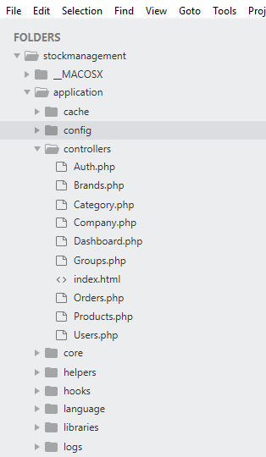

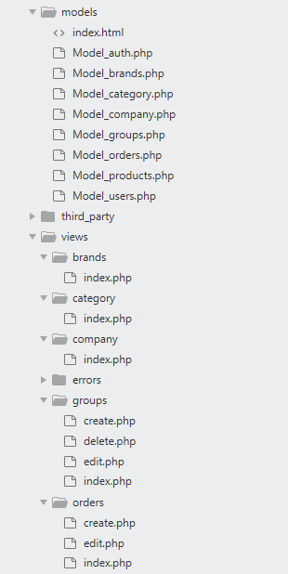

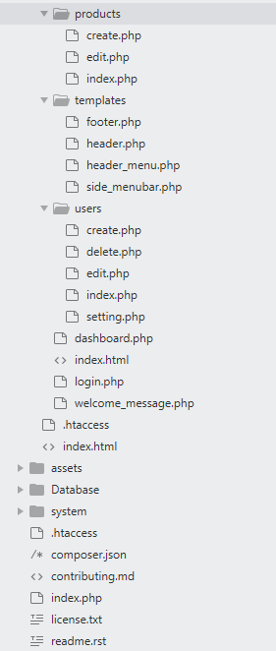

### List of tables

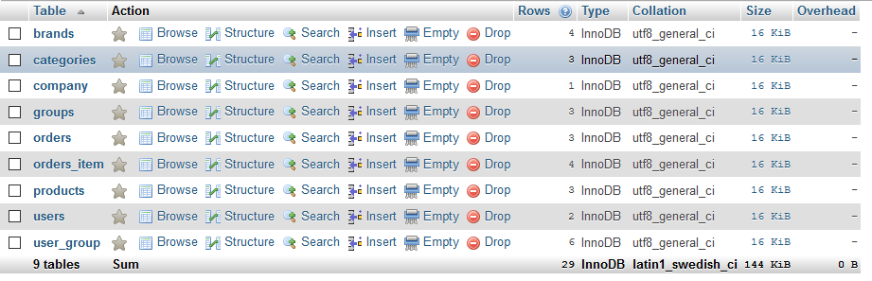

### Database

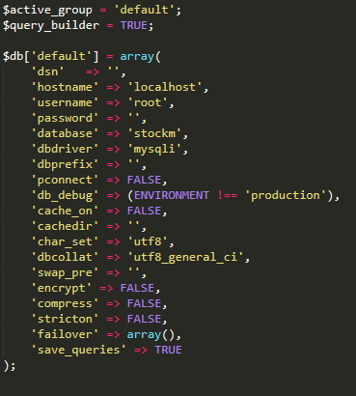

### Controllers\Auth.php

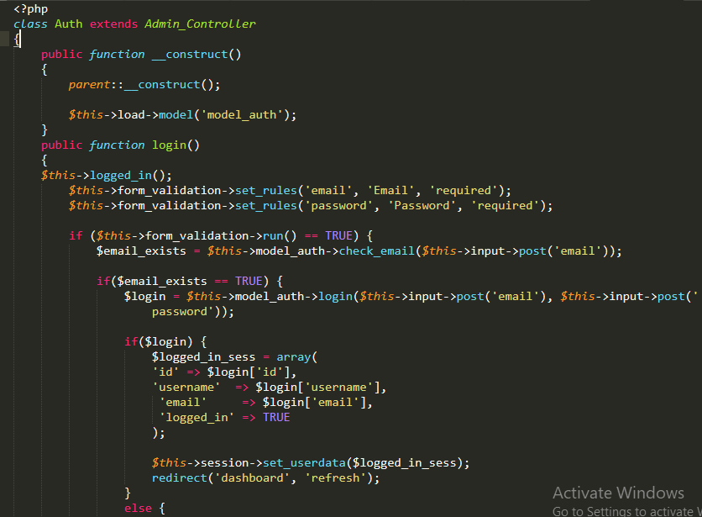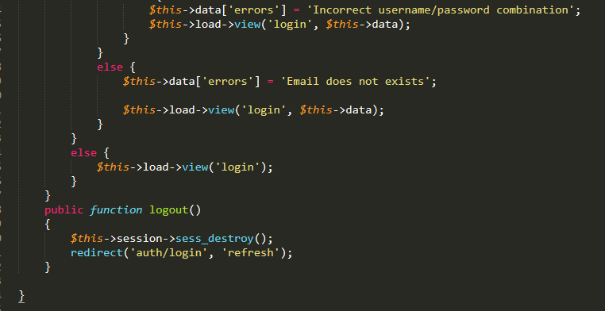

### Controllers\Dashboard.php

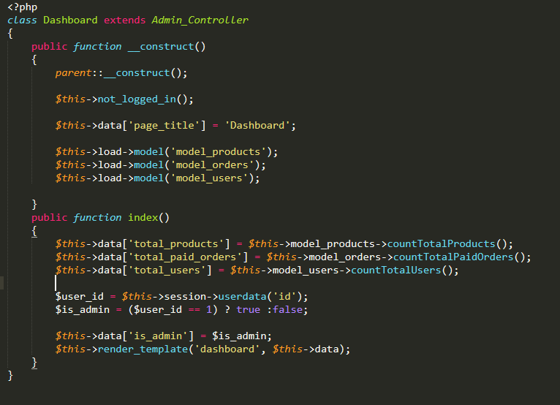

### Controllers\Orders.php

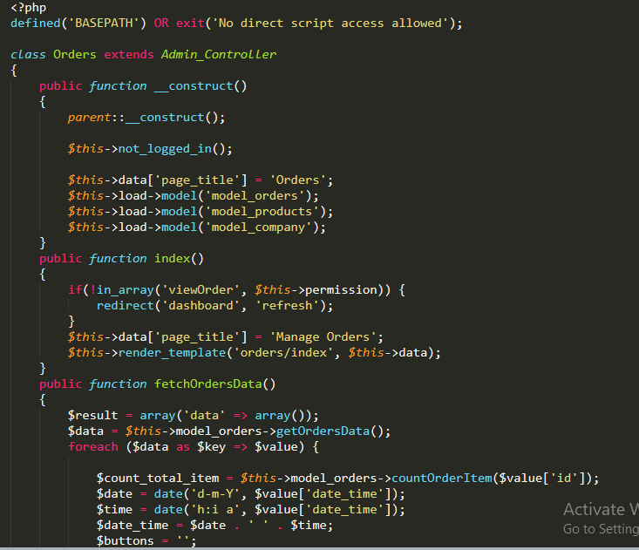

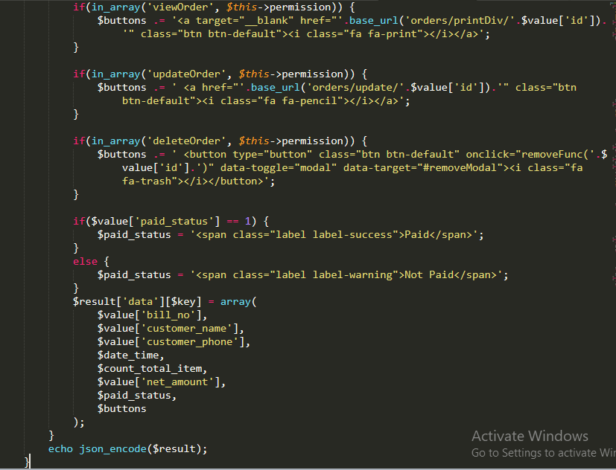

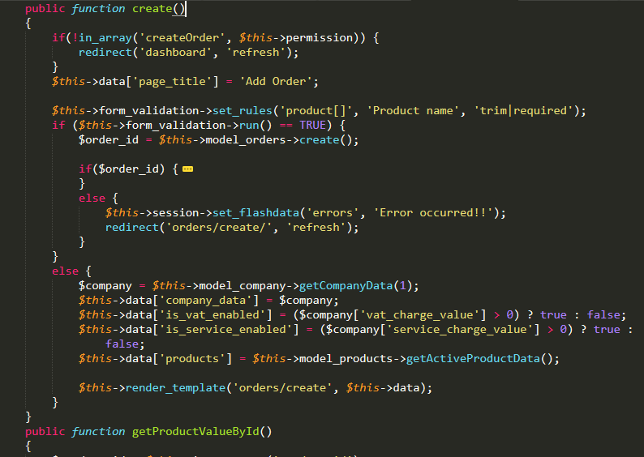

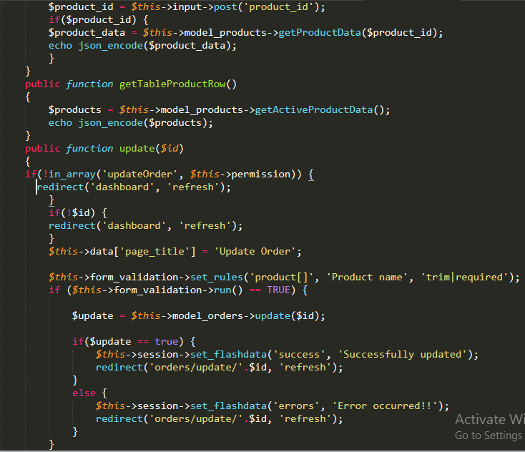

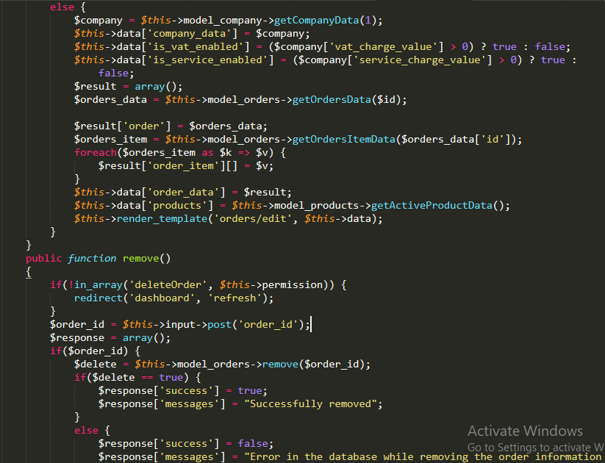

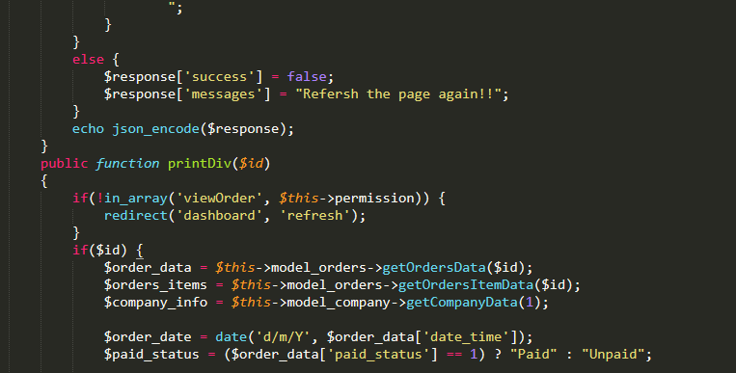

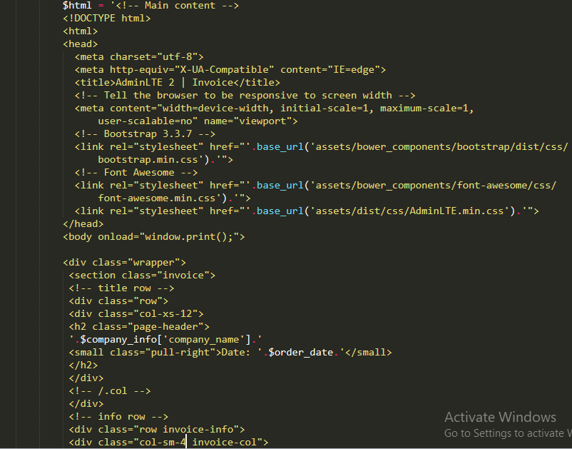

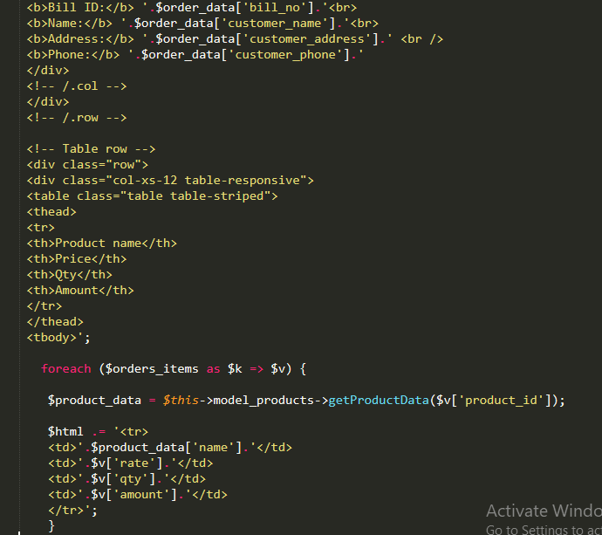

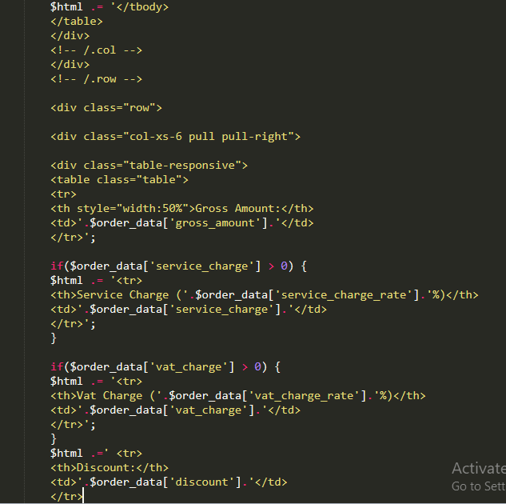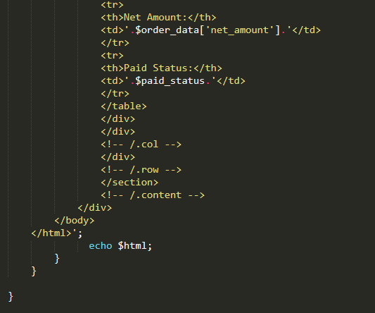

### Controllers\Products.php

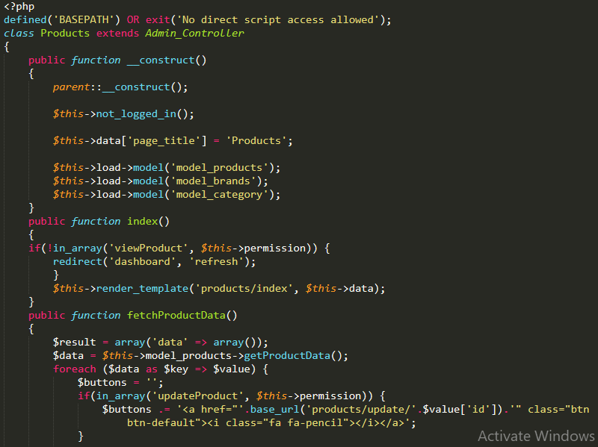

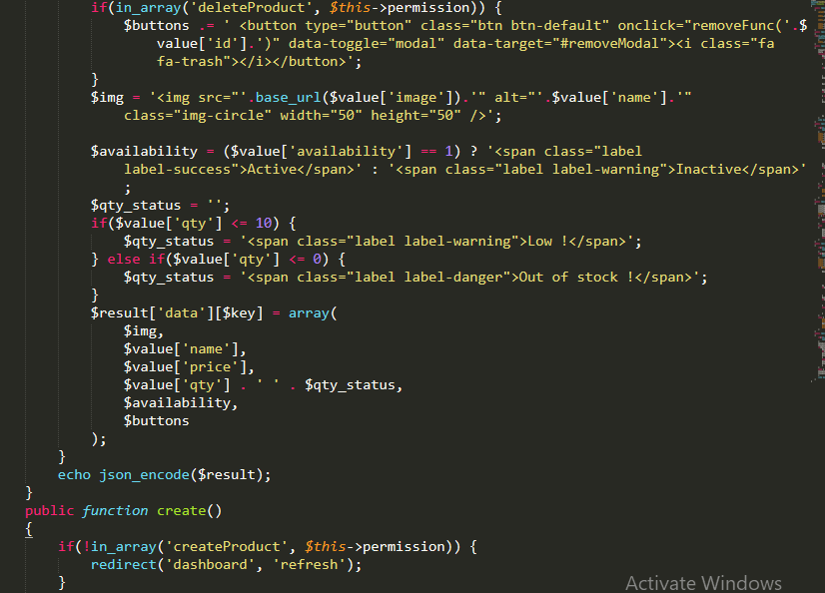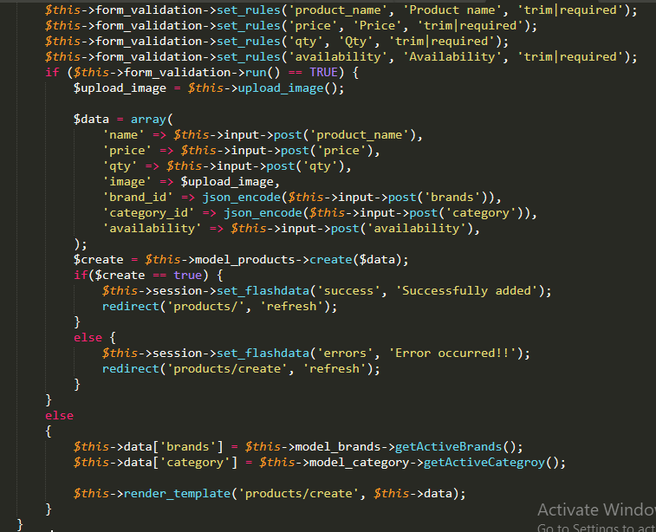

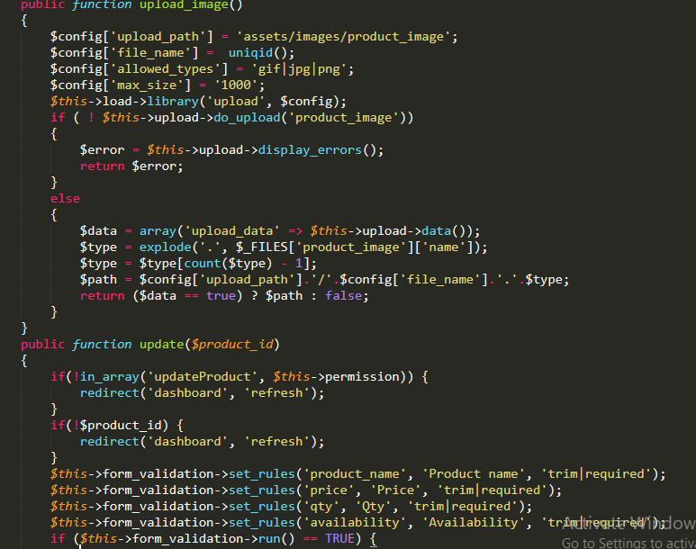

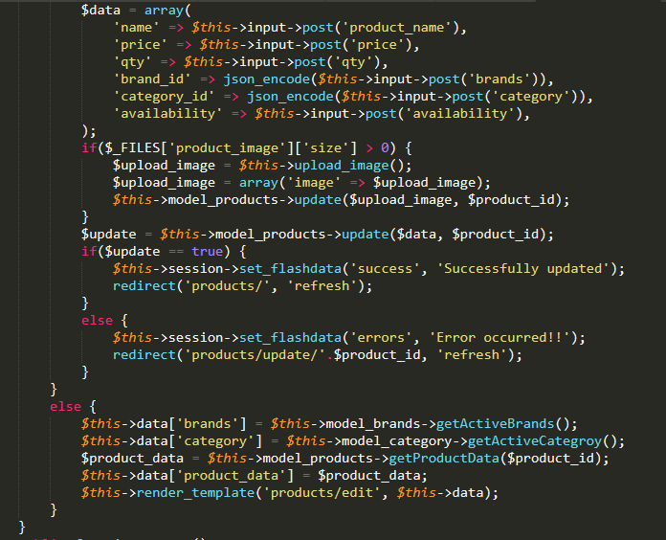

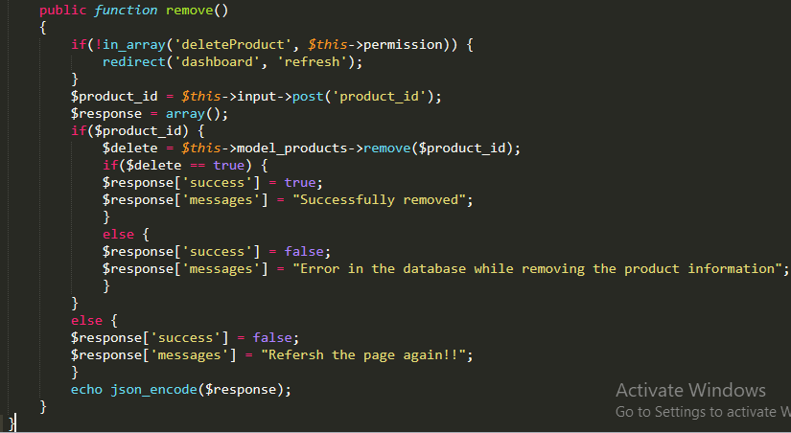

### Models\Model_auth.php

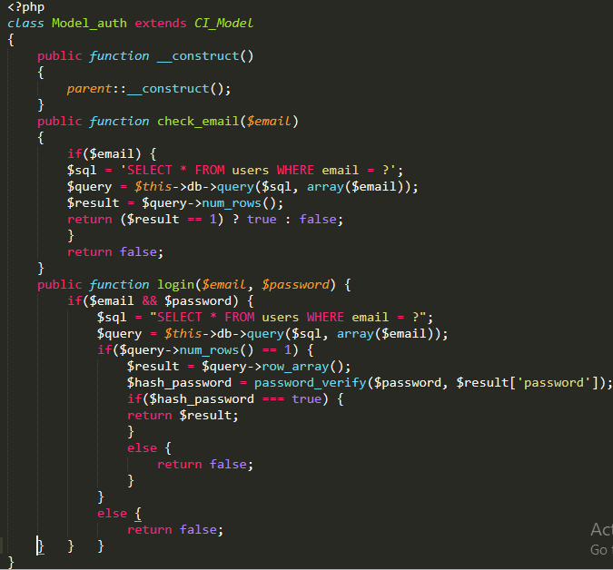

### Models\Model_orders.php

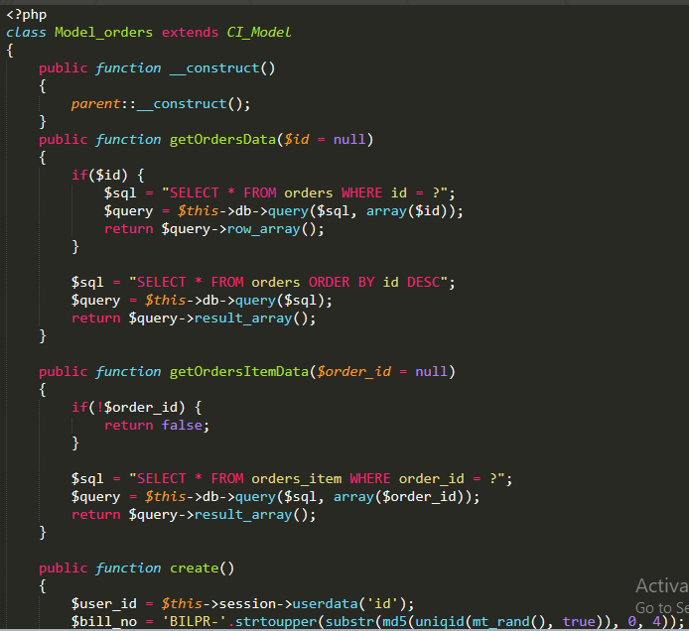

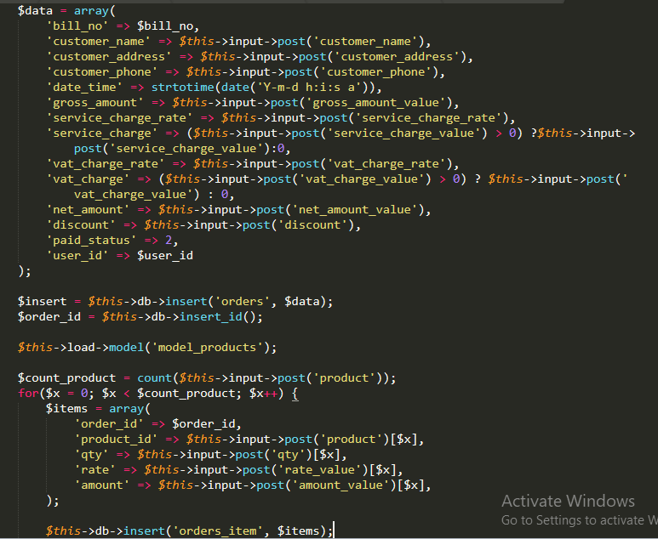

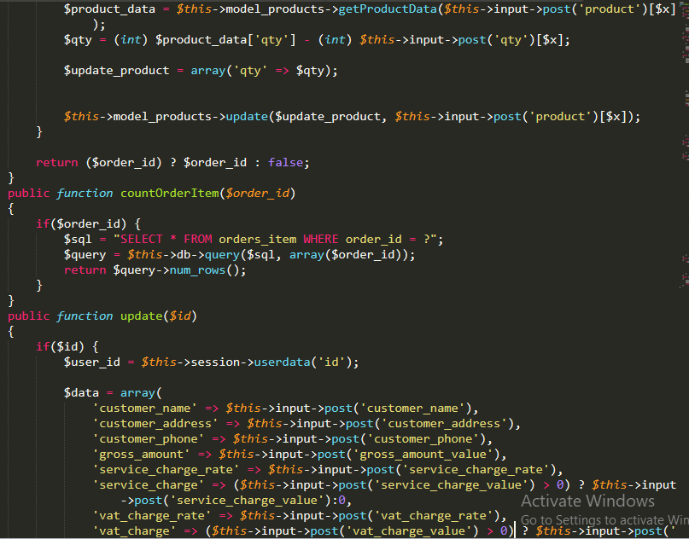

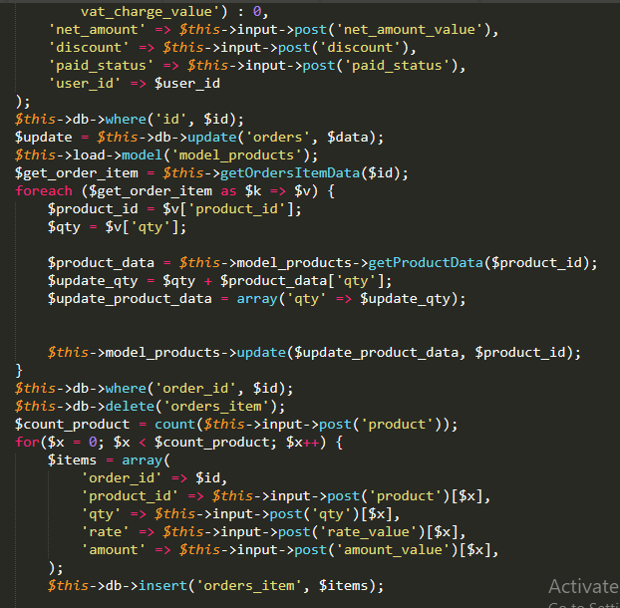

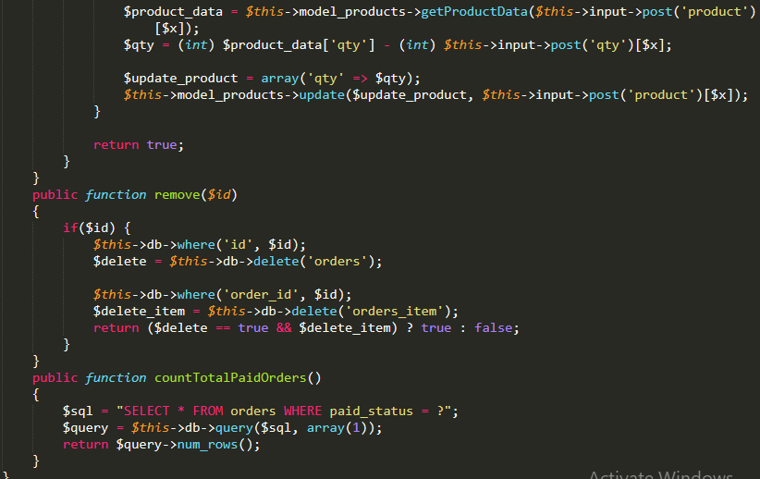

### Models\Model_products.php

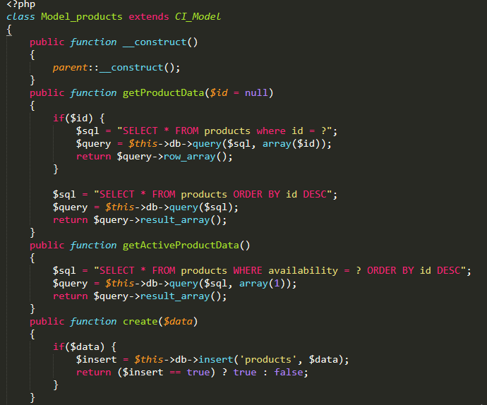

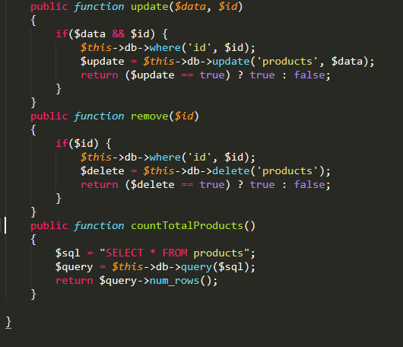

### Views\dashboard.php

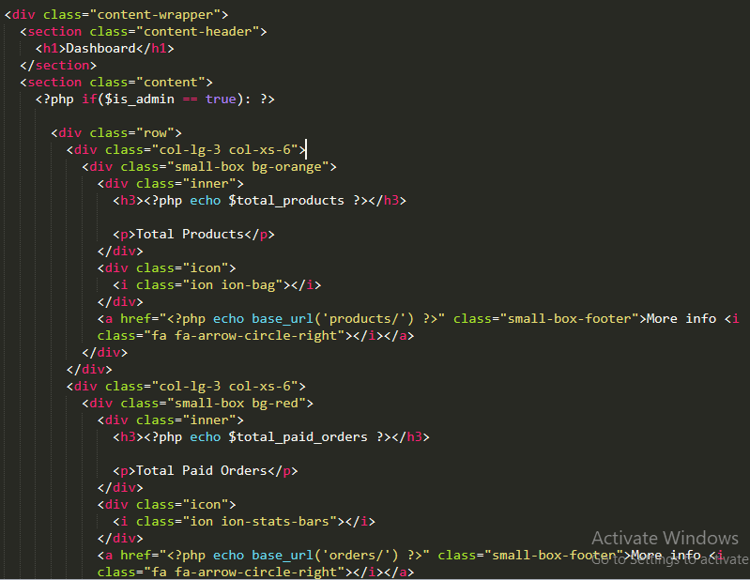

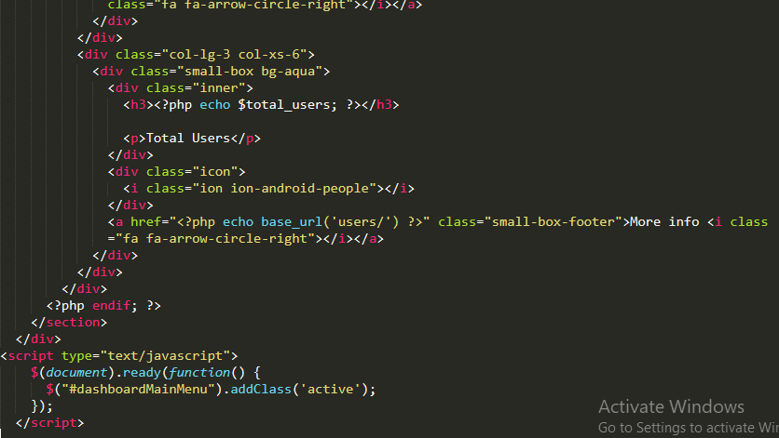

### Views\login.php

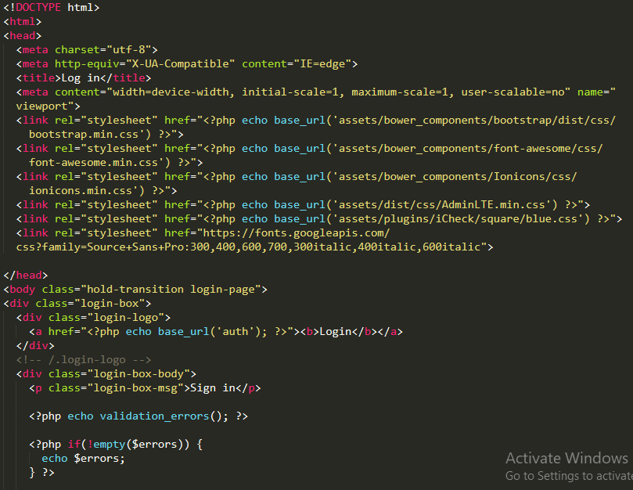

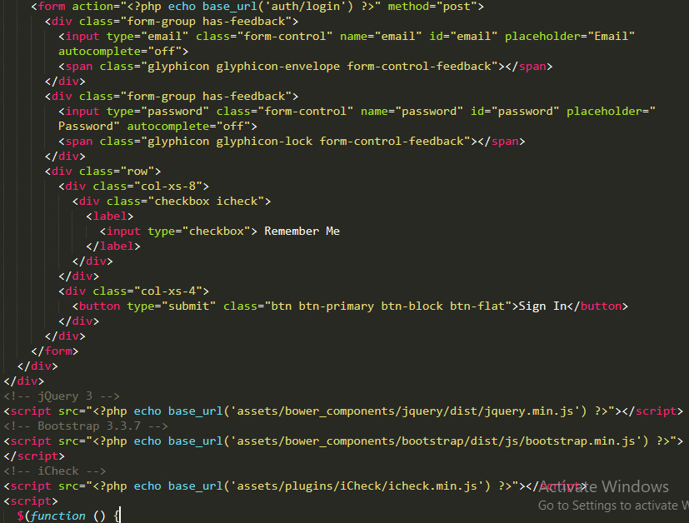

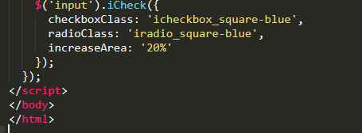

### Views\orders\create.php

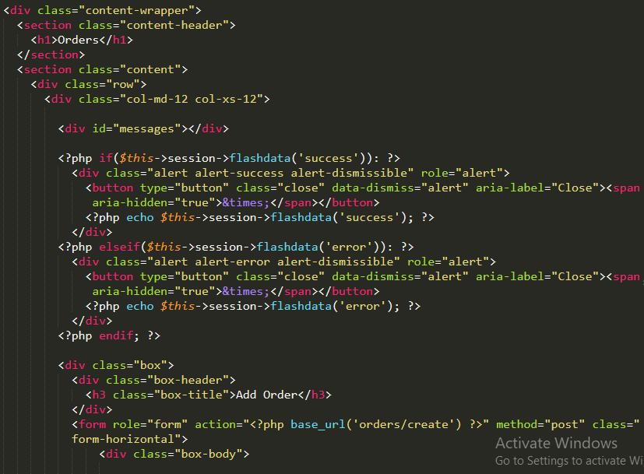

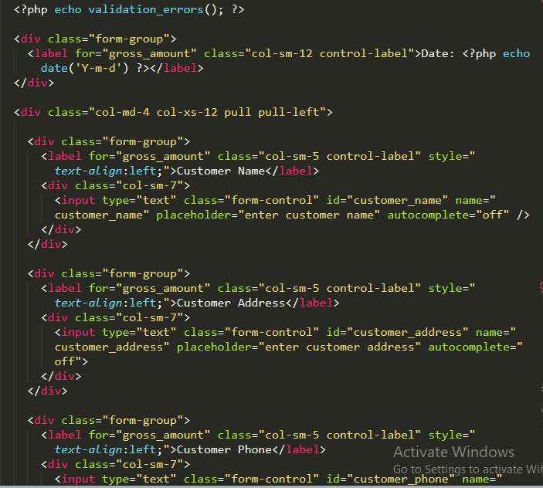

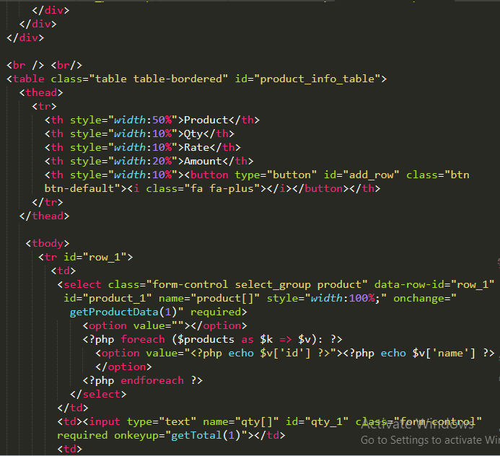

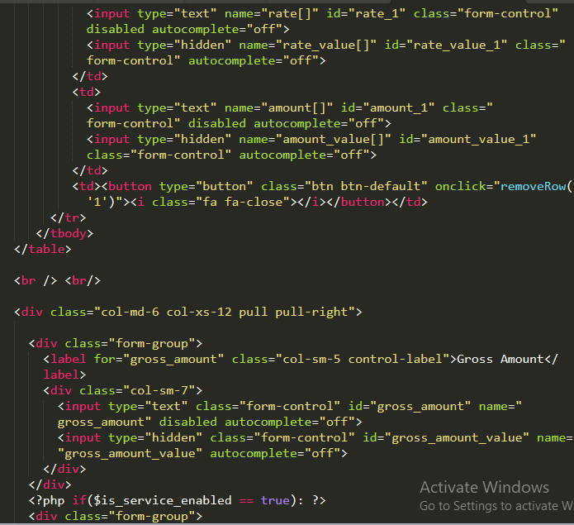

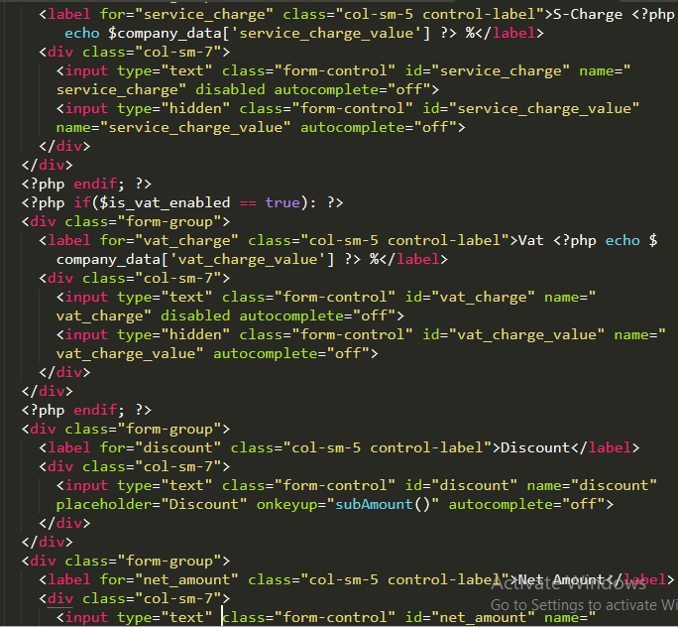

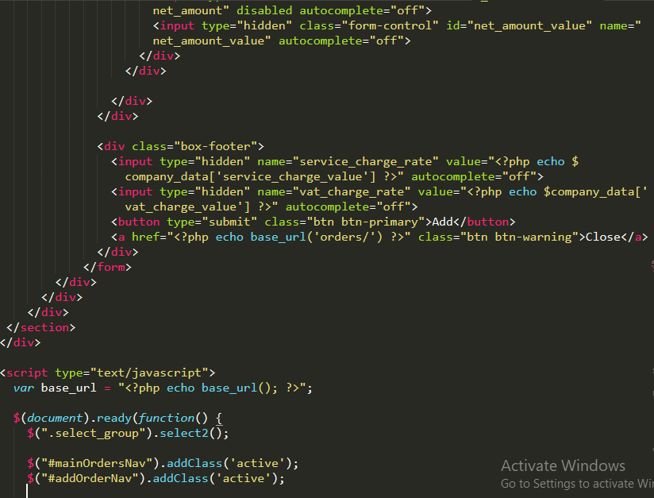

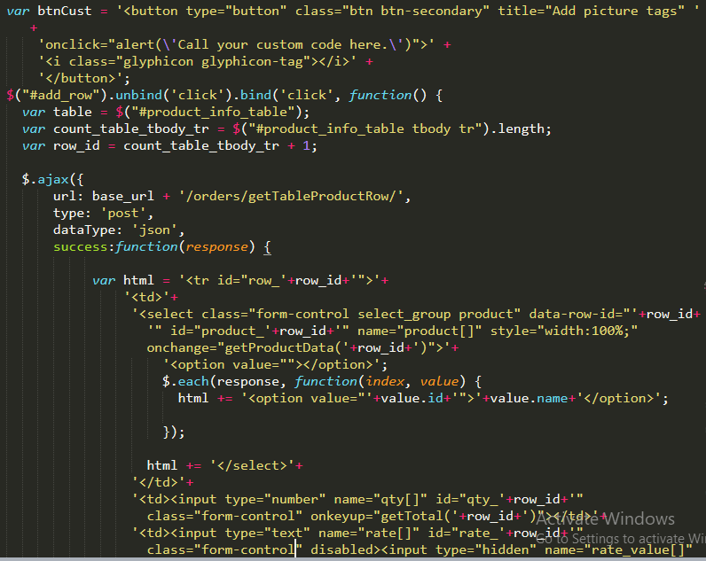

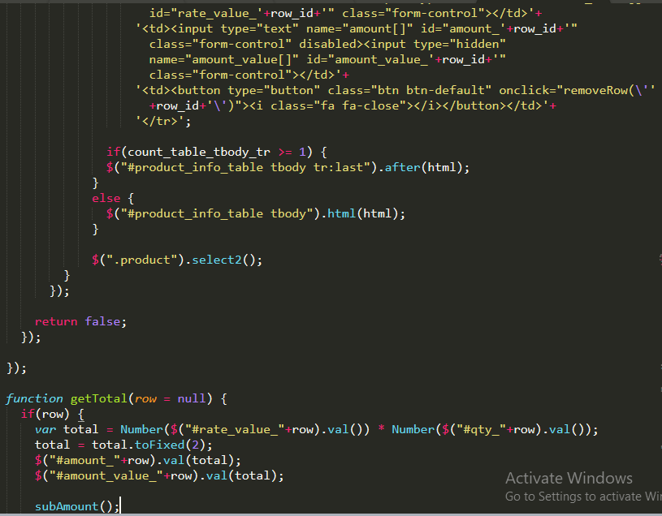

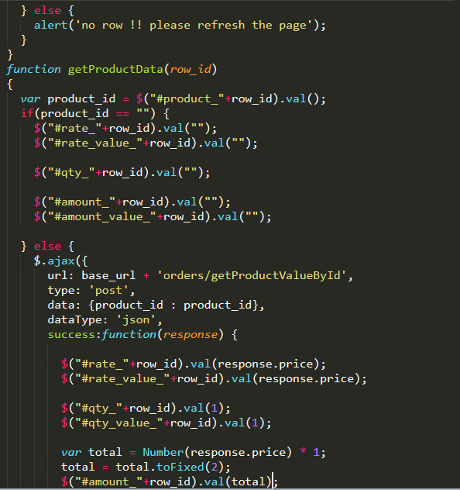

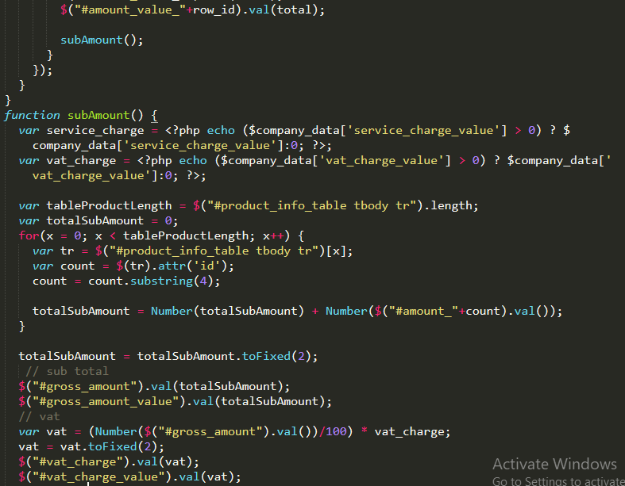

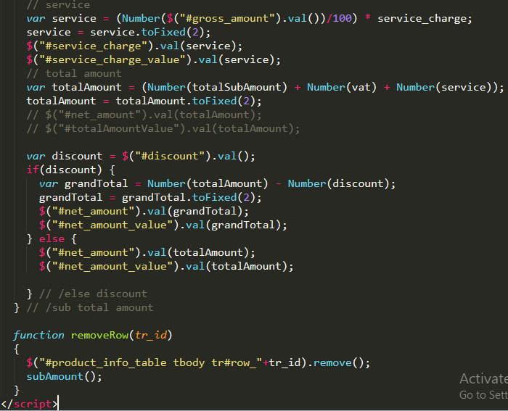

### Views\orders\edit.php

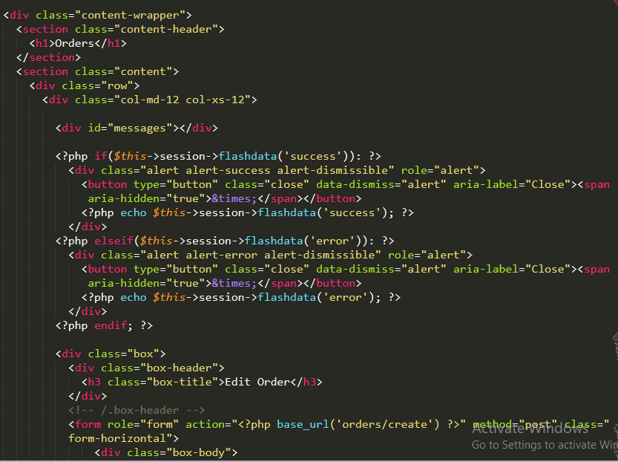

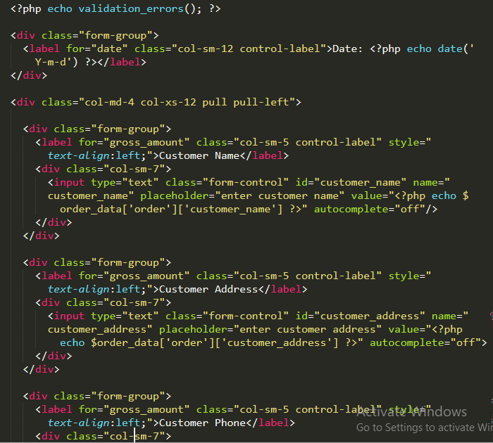

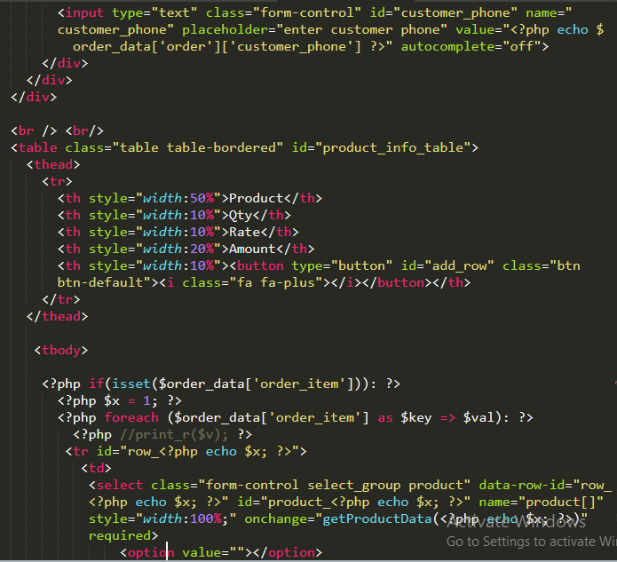

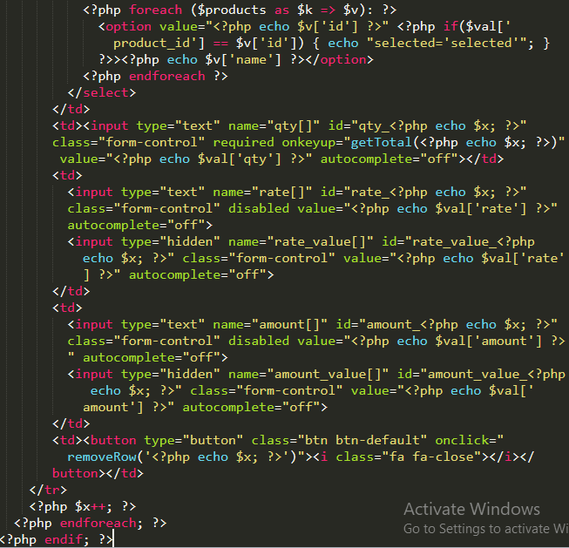

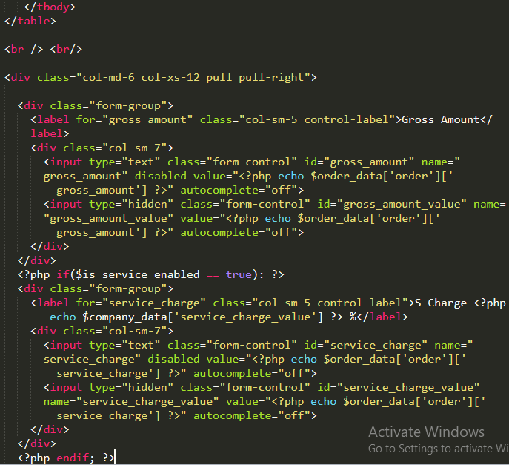

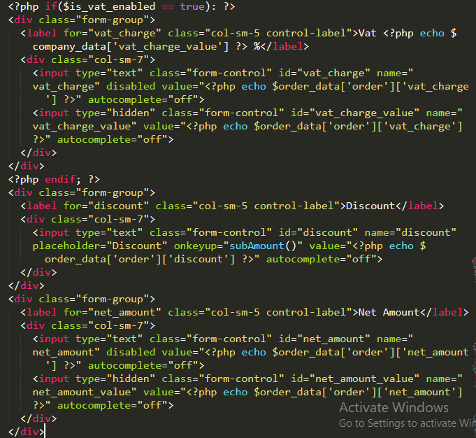

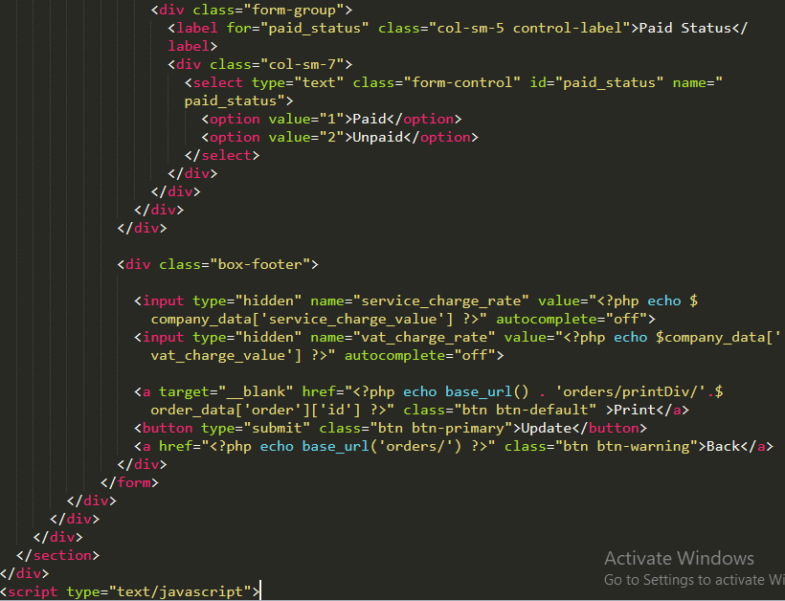

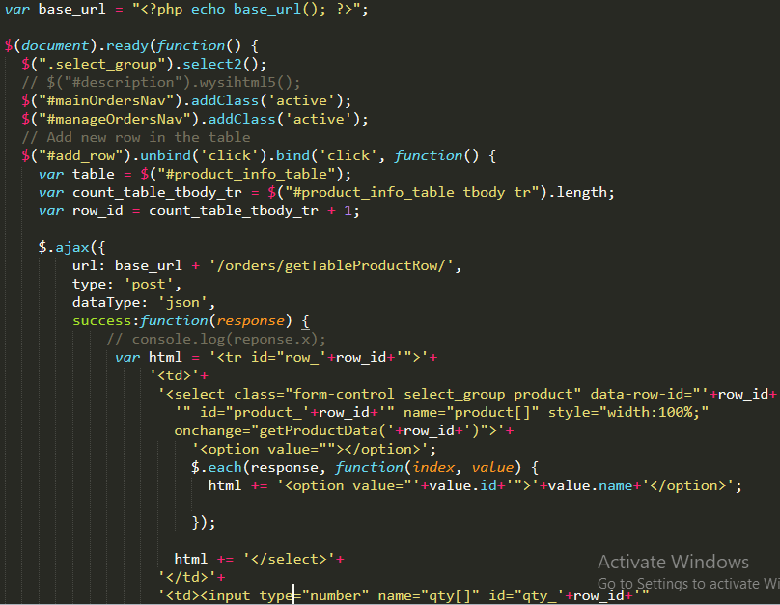

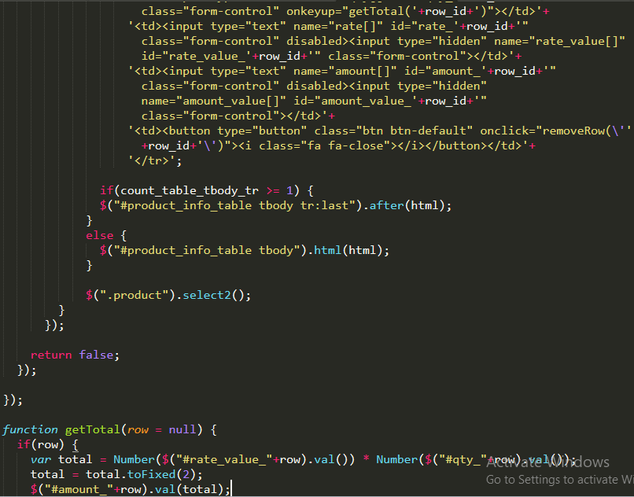

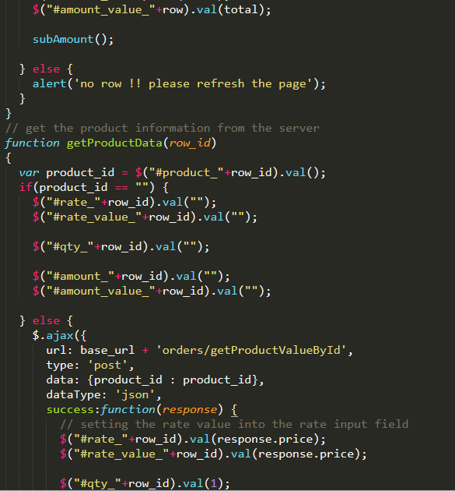

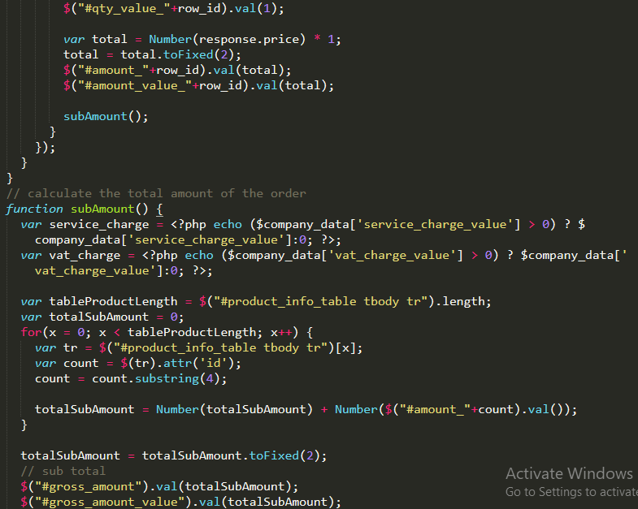

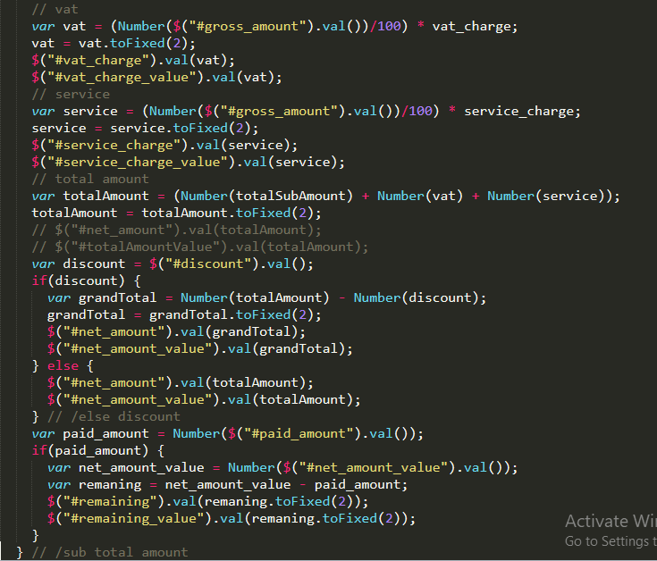

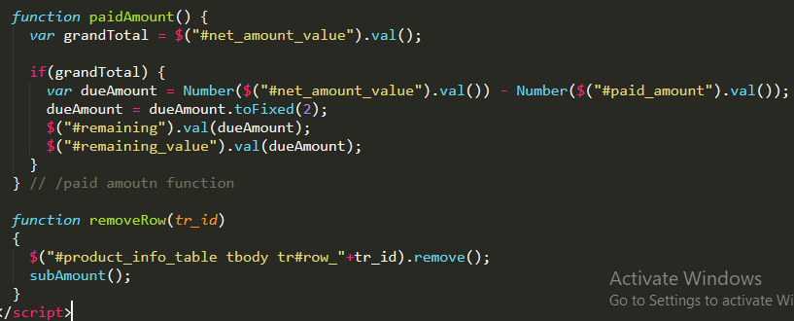

### Views\orders\index.php

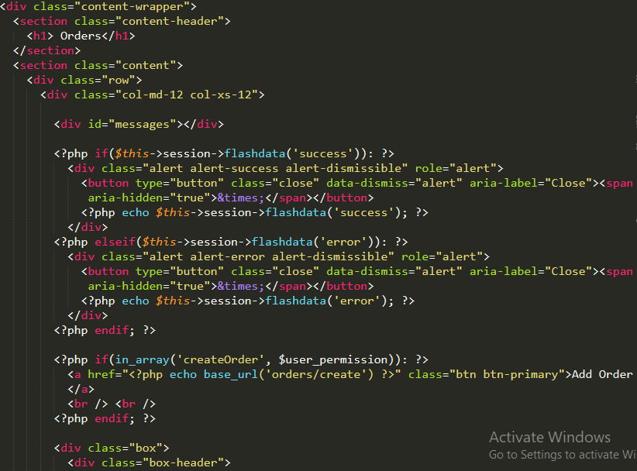

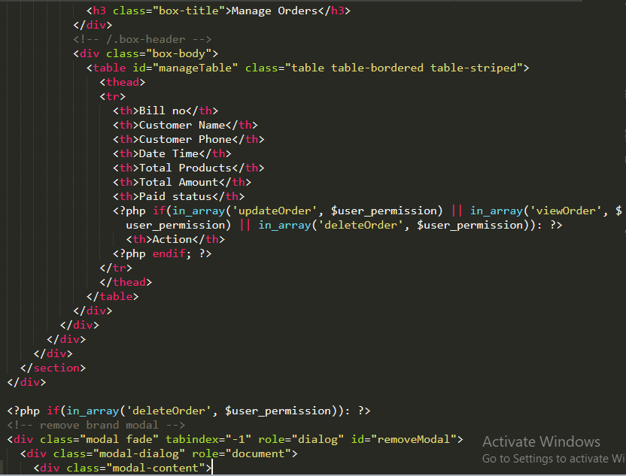

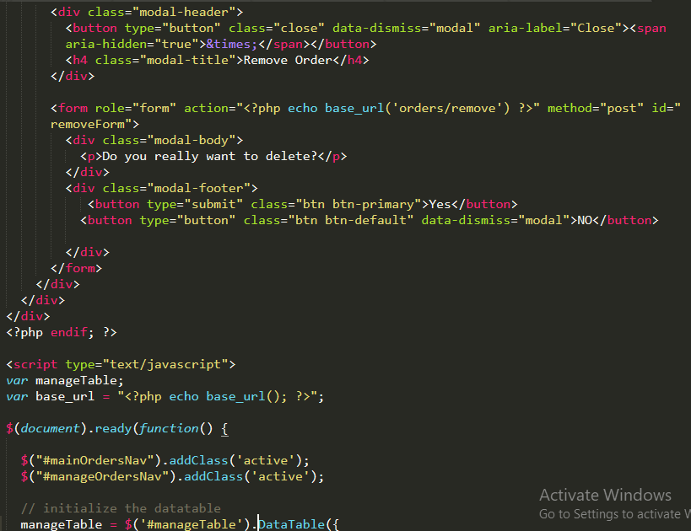

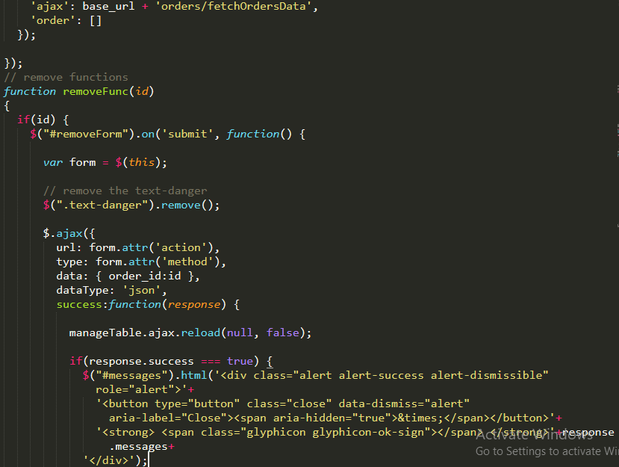

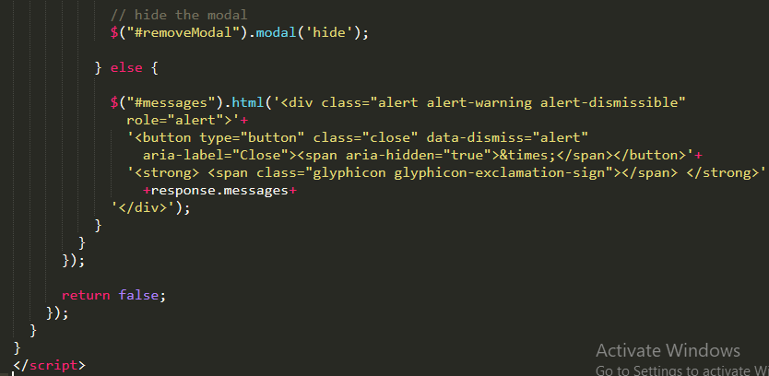

### Views\templates\footer.php

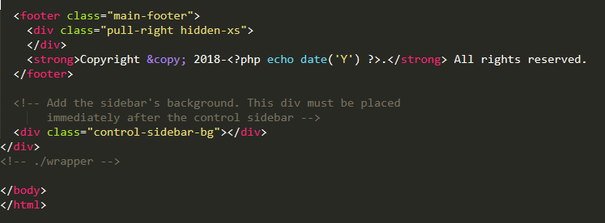

### Views\templates\header.php

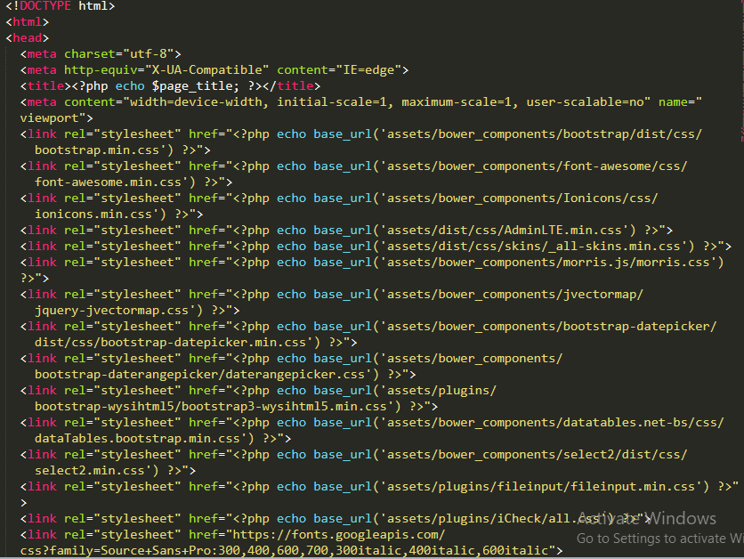

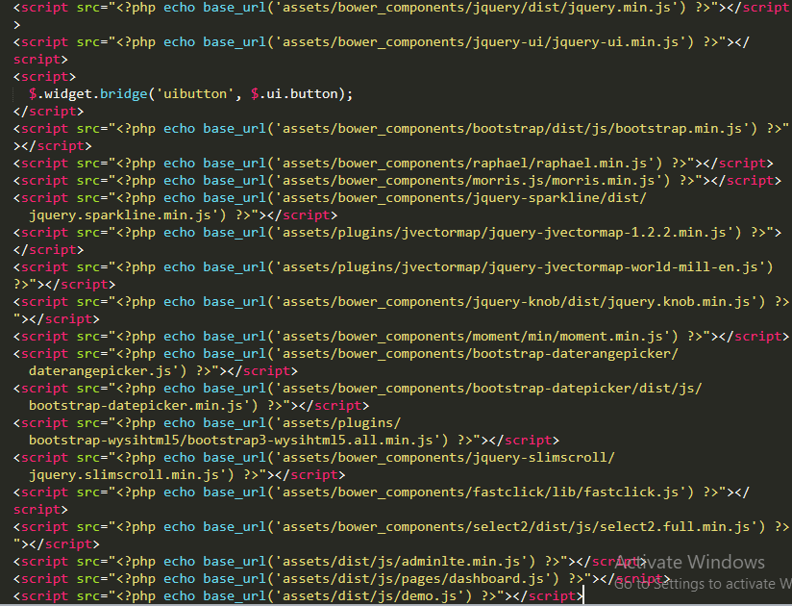

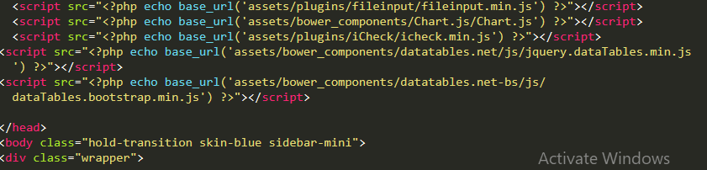

### Views\templates\header_menu.php

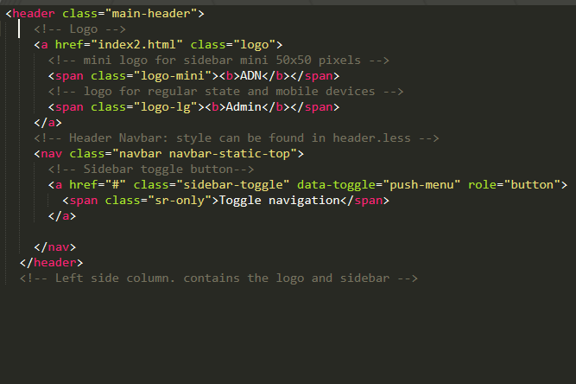

### Views\templates\side_menubar.php

