Acknowledgement

Abstract

Chapter 1

Introduction

Background of the system

Aims

Objectives

Chapter 2

Analysis

Requirement

Function and non function

Use case diagram

It is the simple diagram which includes system, actor, use case and relationships. It represents the interaction of the user with the system and shows the relationships between the actor and the use cases. It helps to decrease the confusion as it gives clear information about the actor and their relationships with the use cases of the system.

Justification

Use case diagram is very helpful to develop and design the system as it provides the clarity. Following are the reasons to choose the use case diagram for the system:

* Mainly it provides way to communicate complex ideas in a fairly basic way.
* It helps to easily understand the system as have proven an excellent bridge between software developers and end users.
* It helps to provide the function requirement of the system.
* It provides the easiness to understand the how system works and who are involve in the system
* It helps to decrease the problems that can occur in the future.

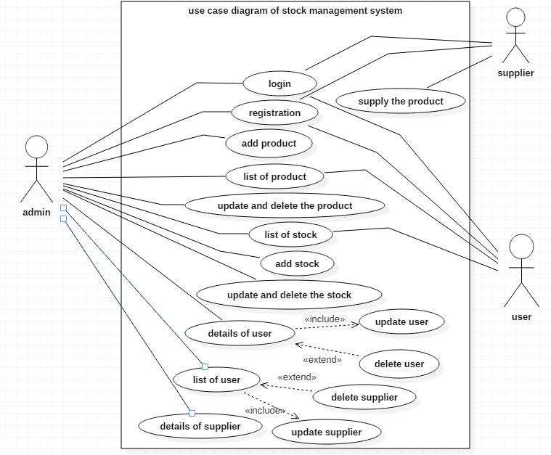

Fig1: use case diagram of stock management system

Here, in this use case diagram there are three actor admin, supplier and staff. Firstly the all three actors can login and register in the system. The inside works is handle by the admin like insert, update and delete of product, stock, staff and supplier. The staff can manage the product and stock available in the system. In this system the update should be done which is compulsory and the delete is in the hand of admin. If admin wants to delete then they can but don’t want to delete then also it is fine. The supplier do the work of supply of the product.

Architecture

3-tier system architecture

Initial class diagram

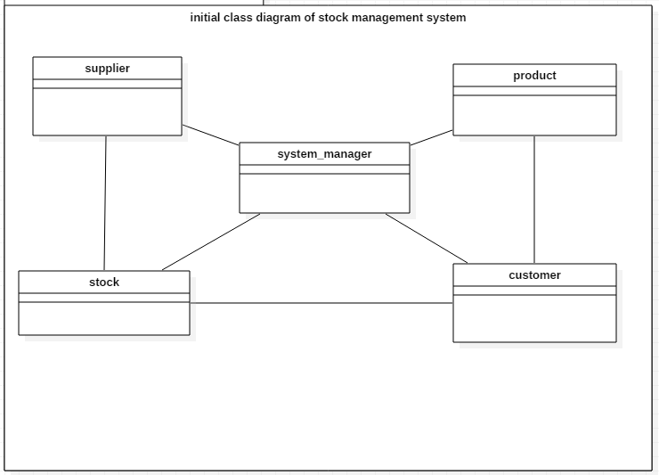

Fig2: initial class diagram

Er-diagram

It is the visual representation of the design which shows the relationships between the entities which is stored in the database. It provides simple way to understand the system and its work as it provides the details of the relationship of entity.

Justification

Following are the reasons to select the er-diagram for the system:

* Firstly it is highly flexible as it easily delivers the other relationships from the already existing ones.
* It is easy to understand as it acts as the blueprint for the database.
* It decreases the complication which can arise during the development.
* It provides the effective communication between the entities.
* It is very simple to understand.

Er-diagram of stock management system

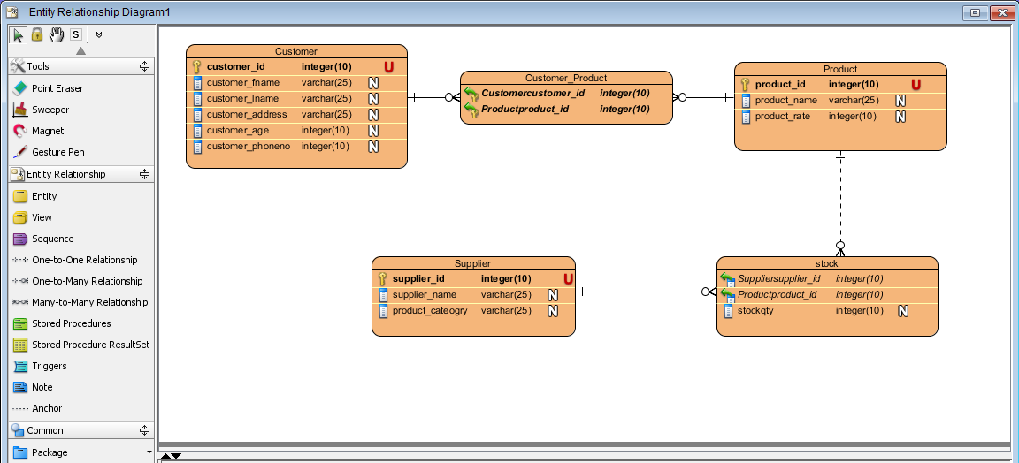

Fig3: er-diagram of stock management system

Final er-diagram of stock management system

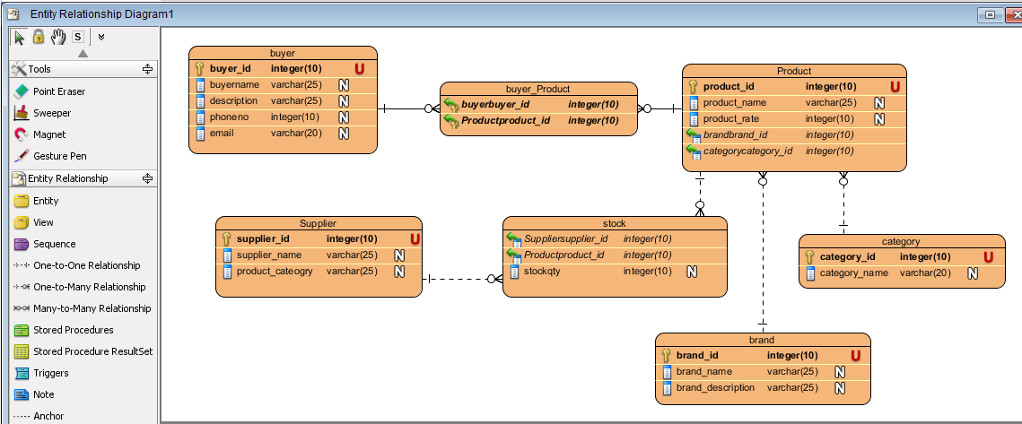

Function and nonfunction

Fig4: function and nonfunction (MoSCoW)

|  |  |  |
| --- | --- | --- |
| F/NF | Requirement | MoSCoW |
| NF(R1) | Login | M |
| NF(R2) | Registration | M |
| F(R3) | Add product | M |
| NF(R4) | List of product | M |
| F(R5) | Add stock | M |
| NF(R6) | List of stock | M |
| F(R7) | Add user | M |
| F(R8) | List of user | M |
| F(R9) | Add supplier | M |
| F(R10) | List of supplier | S |
| F(R11) | Update the customer | S |
| F(R12) | Update the product | S |
| F(R13) | Delete the supplier | C |
| F(R14) | Delete the users | C |
| F(R15) | Delete the product | C |

UI diagram of stock management system

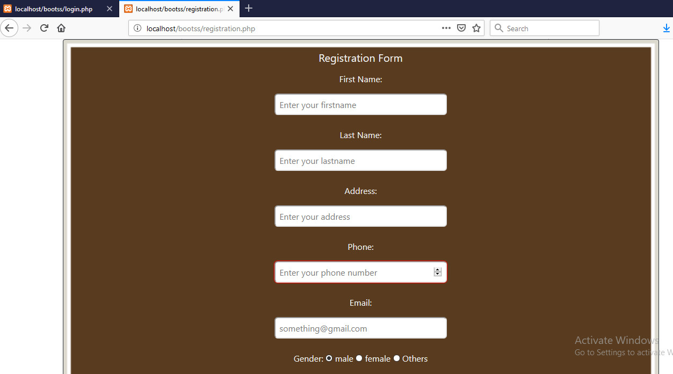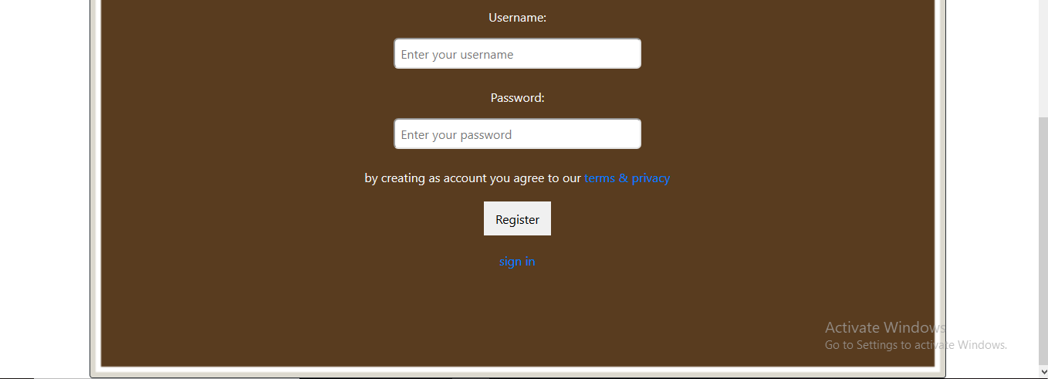

Fig5: registration form

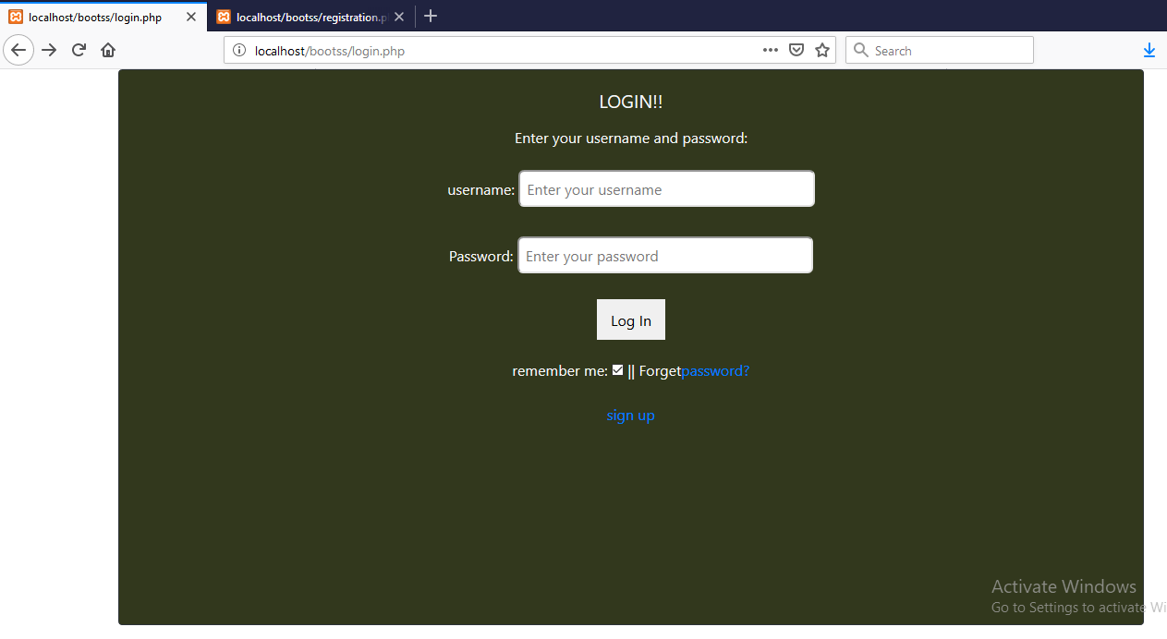

Fig4: login form

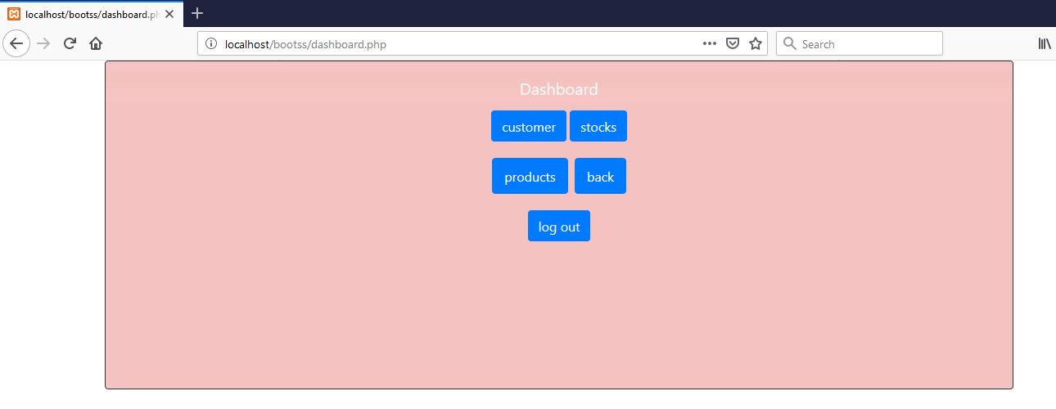

Fig: dashboard

Chapter 3

Design

Class diagram

It is the graphical representation which is made up of different classes and relationship between them in the object oriented system. In the class diagram, the attributes and operation forms the complete class. It is use while systems design and development.

Justification

Class diagram provides the simple and effective way to design the system. So, I have also chosen the class diagram to design the system. Following are the reason to choose the class diagram.

* It provides the information about how the system is structured or design.
* It contains the relevant structural relations and data type.
* It provides the overall sketch of the system.
* It is flexible as it gives the clear structure of system.
* It is also mostly used diagram to design the system.

The class diagram of stock management system is given down below:

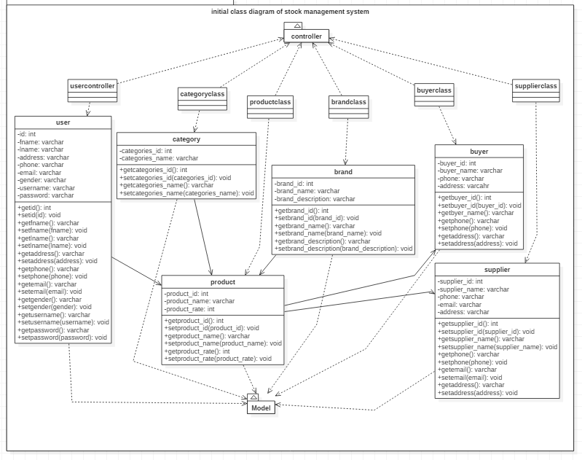

Fig1: class diagram of stock management system

Here, the classes that are involved in the class diagram are user, product, category, brand, buyer and supplier. Here the adminuser login inside the system and manage the product. It manages the category and brand of the product. The buyer can buy the product and the supplier supply the product to the buyer. The class diagram is made in the MVC pattern as shown in the figure above. In this class diagram, there is the attributes of classes and its operation are also given as well as the connection of classes.

Activity diagram

It is one of the important diagrams in UML that describe the dynamic aspect of the system. It is the diagram which is similar to flow chart that represents the flow from one activity to another activity. It is the behavioral UML diagram.

Justification

Activity diagrams are the user friendly diagrams which help to the flow of activity of the system. It shows the how the system behaves. So, following are the reasons to select the activity diagram:

* It provides the actual work flow behavior of the system.
* It describes the actual state of activities of a system by showing all the sequence of activities performed.
* It is use for analyzing a use case by describing what actions need to take place and when they should occur.
* It provides the easiness to understand the work flow of the system.
* It is mostly use diagram as it is user friendly.

The activity diagram of stock management system is given down below:

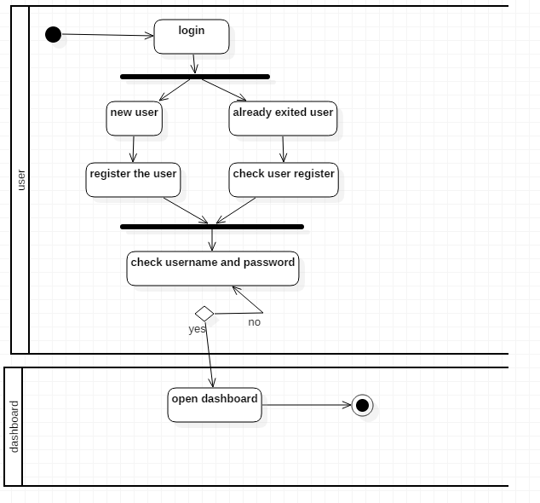

Fig1: activity diagram of login

The given activity diagram is of login system where the user can login. If it’s new user, then can register and login. If already exited then enter the email and password. In case of entering the right email and password, open the dashboard not then check the email and password.

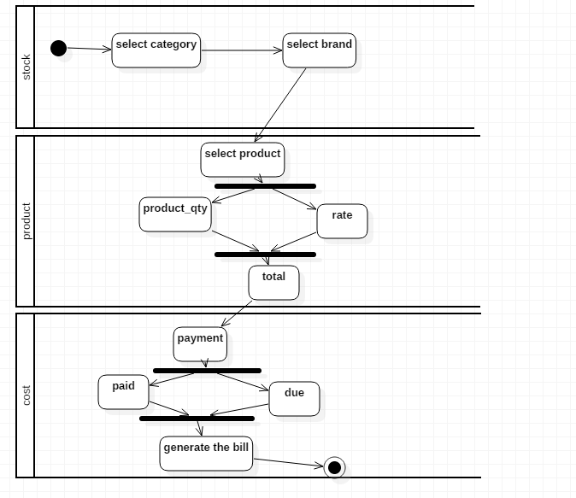

Fig2: activity diagram of stock

Here, the admin can select the category, brand and product. They can calculate the amount of the product. Also they can generate the payment bill of that product and print it out.

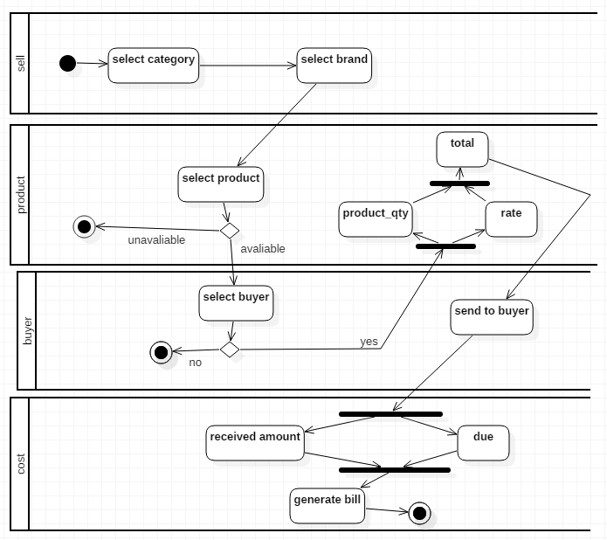

Fig3: activity diagram of selling the product

To provide the product to the buyer, select the category and brand of product. Check whether the product is available or not. If it’s available, then calculate the amount of the product. After calculation generate the bill for that product.

Sequence diagram

Chapter 4

Implementation

References

<https://www.tutorialspoint.com>

<https://www.laravel-vuejs.com>

<https://www.lucidchart.com>

<https://www.quora.com>

<http://benefitof.net>