The Report

- REQUIREMENTS AND SPECIFICATIONS
Website objective
The objective of the website is to promote MJ Made, a small-scale (home based) bakery that offers assorted baked goods and packages. It will aim to inform customers about the operating hours, contact information, view the available menu, learn more about the business and allow them to explore other services including orders and delivery. Each element will be carefully crafted to ensure it reflects the quality and charm of the bakery, making it an inviting space for customers to explore. To support efficient content management, a system will be developed that allows easy addition, modification, and removal of product listings and descriptions (T, et al., 2024)
Target audience
The target audience includes individuals, students, working class and the general public interested in purchasing various baked goods.
Demographics
- Age: persons aged 18 and over
- Location: primarily located in Gaborone
- Occupation: no specification
- Customers looking to indulge in a variety of warm, home-made delicacies.
Technical Aptitude
Website design should be fluid and agile in order to cater to different people. The objective is to make sure that website is interactive and simple to enhance customer experience. The target is moderate internet users with a basic understanding of website browsing, the use of different devices and social media as users will be expected to navigate a standard website with hypertext linking. The design of the website will be user-friendly, which will allow users to easily browse and navigate between pages.
Type of Website
The website will be a combination of e-commerce, promotive and informative. It will be designed to provide information about the business, the products and services offered, location and contact details. The goal of the website is to advertise as well as market the business to potential customers. It will also focus on ensuring user satisfaction and usability, with an option to give feedback, make queries and offer support. The website will include online orders, with an option for delivery or pick-up as preferred by the customer.
Client requirements
According to (Go-Globe, 2024) it is important to keep your website purposeful and person-friendly by getting remarks often and keeping up with the latest web layout fine practices. Navigation will be intuitive, allowing users to explore the bakery’s offerings effortlessly. The responsive design will ensure compatibility across various devices and screen sizes, making the website accessible to a wide audience, whether on a desktop, tablet, or mobile phone (T, et al., 2024). Other common client requirements include engaging content, high quality visuals, accessibility and speed of operations/ response time. The website will aim to incorporate all these features to improve customer interaction.
Feasibility Study
Technical feasibility
Technical feasibility is the evaluation of the prospective implementation and development of a proposed product or project from a technical point of view. It considers the alignment of the product design with the available resources, technology, and overall capabilities of the primary team and organization (Glossary, 2023). Since this is an individual (school) assignment, each student is expected to impose the technical skills needed for this project. The skills required for the creation of this website are the knowledge and execution of HTML, CSS and JavaScript. They are considered primary skills in the development of the website, they are performed on Visual Studio Code which is a free text-editor. The other applications include GitHub Pages, Canva and various web browsers, of which offer free versions as well. This is essential because the school project is not funded. Therefore, the overall technical feasibility is high.
Schedule feasibility
According to, (Usmani, 2024), in a schedule feasibility study, management analyses whether the proposed endeavour has any time constraints and whether they can complete the proposal within the given duration. They analyse the proposal’s practicality and achievability within a given timeline. The duration of this project runs from the 10th of March until 20th May 2026. This is a lengthy time period that allows students to complete the project seamlessly.

- INFORMATION DESIGN AND TAXONOMY
The website construction will be simple with easy organization and classification of information. It will consist of a navigation tab (menu) that will be available on all pages comprised of:
- Home – the main page containing company logo, navigation tab and search bar
- Menu – will showcase the offers, descriptions, pricing and different packages available
- About – a brief description of the company; owner, background, motivation and credibility
- Gallery – high quality images that showcase products on offer
- Contact – email, contact numbers and location information
- Additional services – placing an order online; pick-up / delivery

MJ Made Site Map
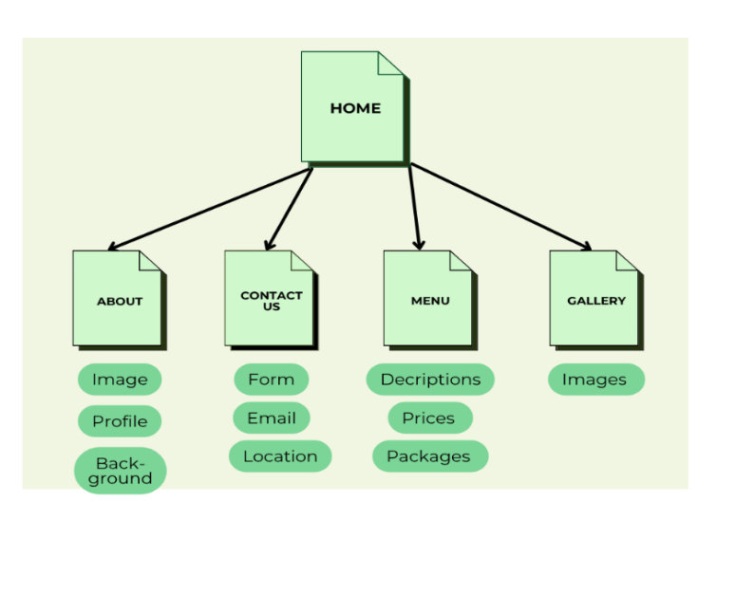

Users will be able to explore in between pages without needing to return to the home page because this feature will be available on all pages

- PAGE TEMPLATE DESIGN
The wireframe is used to offer a visual view of how the webpage content will be structured.

The main (home) page

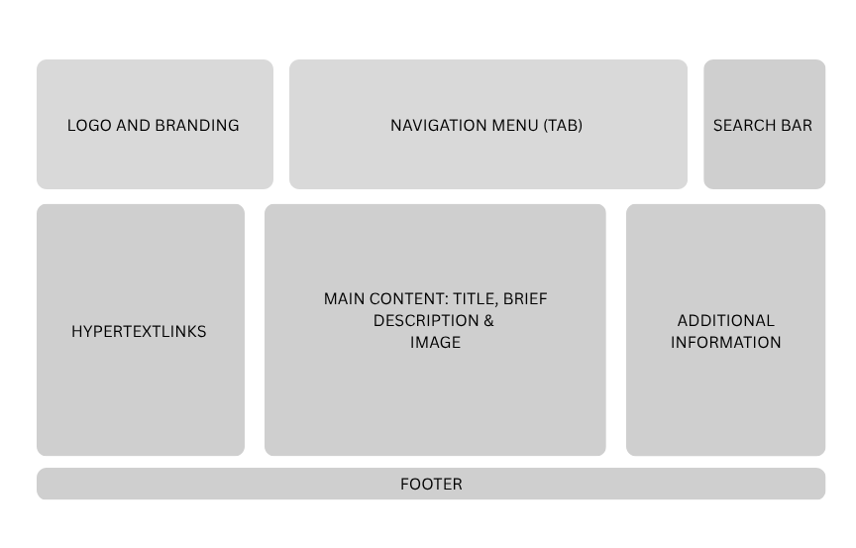
The contact page

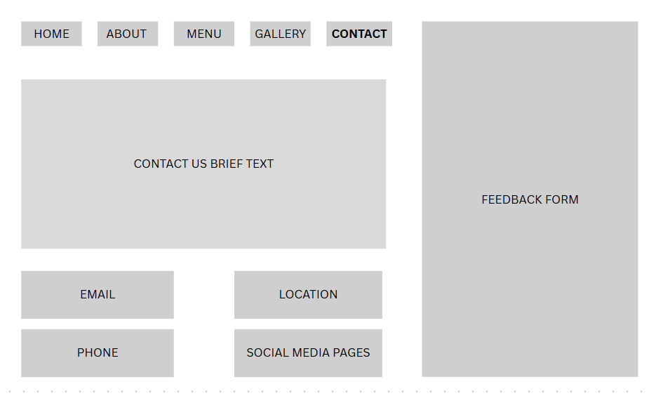

The about page

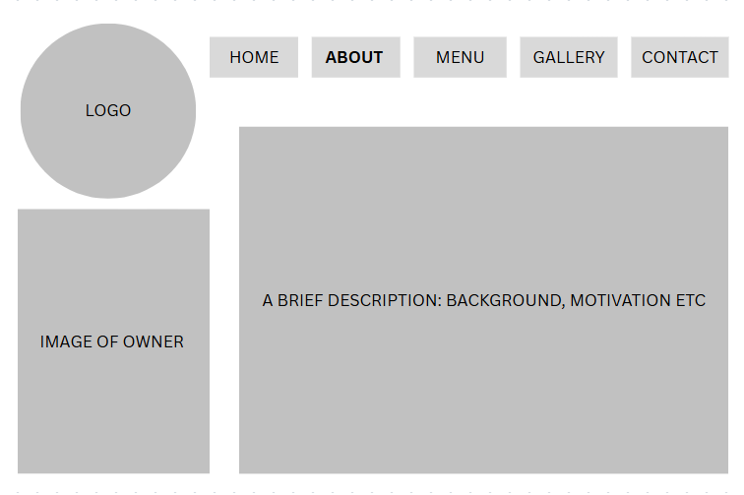

- TECHNICAL BRIEF
The creation of a website requires technical tools such as JavaScript to create interactivity, HTML to provide structure, CSS to enhance the appearance of the website and the use of GitHub Pages for deployment. Visual Studio Code will be utilised as a development environment because it is free and offers versatile features. Additionally, web browser testing requires the use of commonly used browsers such as Google Chrome, Apple Safari and Microsoft Edge. The aim is to test the functionality of the website using these web browsers. Canva is a great tool for visual design and creation; it may be used to design some elements such as the wireframe.

References
- Glossary, C., 2023. Chisel Glossary. [Online]
Available at: https://chisellabs.com/glossary/what-is-technical-feasibility/
[Accessed 22 March 2026].
- Go-Globe, 2024. Web Design Principles for a Customer-Friendly Website. [Online]
Available at: https://www.go-globe.com/web-design-principles-for-a-customer-friendly-website/
[Accessed 20 March 2026].
- T, S., Rajest, S. & Rajan, R., 2024. Design and Development of an Online Bakery Website for Enhanced Customer Experience. CENTRAL ASIAN JOURNAL OF MATHEMATICAL THEORY AND COMPUTER SCIENCES, V(5).
- Usmani, F., 2024. PM Study Circle. [Online]
Available at: https://pmstudycircle.com/schedule-feasibility/
[Accessed 22 March 2026].

