
FACULTY
OF
INFORMATION
AND
COMMUNICATION TECHNOLOGY
NATIONAL DIPLOMA: COMPUTER SYSTEMS ENGINEERING
PROJECT DESIGN III: PJD 301B
DESIGN DOCUMENTATION
PROJECT TITLE: Smart Registration System for Exam Venue Access based on Face Recognition
LECTURER NAME: Muwanguzi Mark Ntume and Chunling Du
STUDENT NAME: OD MAKOTI
STUDENT NUMBER: 240493870
EMAIL ADDRESS: 240493870@tut4life.ac.za
CONTACT NUMBER: 0711960247
SUBMISSION DATE: [Insert submission date]

TABLE OF CONTENTS
TABLE OF CONTENTS 2
Introduction 3
Systems Overview 3
Design Considerations 4
Assumptions and Dependencies 4
Related Software and Hardware 4
End-user Characteristics 5
General Constraints 5
Goals and Guidelines 5
Development Methods 6
Architectural Strategies 6
System Architecture 7
Subsystem Architecture 8
Detailed System Design 8
Face Recognition Engine 8
Register Database Manager 9
ESP32 Firmware Controller 10
Email Notification Dispatcher 10
Register Database Schema 11
Functional Flow 12
Function 1: Face Scan & Eligibility Verification 12
Process Flow Table – Face Scan & Eligibility Verification 13
Status Flow Table – Face Scan & Eligibility Verification 13
Function 2: Access Decision, Register Logging & Email Notification 13
Process Flow Table – Access Decision, Register Logging & Email Notification 14
Status Flow Table – Access Decision, Register Logging & Email Notification 14
Conclusion 15
Glossary 15
Bibliography 16

Introduction
This design documentation describes the technical design of the Smart Registration System for Exam Venue Access based on Face Recognition, a biometric access-control terminal developed for Tshwane University of Technology under module PJD 301B. Where the previously submitted proposal defined what the system must achieve, this document defines how the system is constructed — the hardware and software architecture, the design decisions taken, the database that forms the student qualification and attendance register, and the detailed behaviour of each system function.
Purpose of this document: to present a complete and traceable design solution for the system, covering the system overview, design considerations, assumptions and dependencies, architectural strategies, detailed component design, the register database schema, and the functional flow of each core process. It gives the developer, evaluator, and any future maintainer a single reference that explains why the system is structured the way it is, not only what it does.
Scope of this document: the document covers the design of the check-in terminal (ESP32 subsystem), the host-side face recognition and decision-making application, the SQLite register database that records student qualification and attendance status, and the email notification module. It does not repeat the full requirements analysis or budget already presented in the project proposal, and it excludes design detail for features stated as out of scope in the proposal (automatic proximity sensing, physical door/turnstile actuation, and cloud multi-region database synchronisation).
Intended audience: the module lecturers and evaluators assessing this Project Design III submission, the student developer (as an implementation reference during the build and testing phases), and any future TUT student who extends or maintains the system.

Systems Overview
The Smart Registration System is a hybrid hardware-software solution that automates identity verification, exam-eligibility checking, and attendance registration at an exam venue entrance. It combines a low-cost embedded terminal built around an ESP32 microcontroller with a host-side Python application that performs facial recognition, eligibility decisioning, database record-keeping, and email notification.
On the hardware side, the terminal exposes only two physical controls to the student — an ON/OFF power switch and a “START SCANNING” push button — together with a 16x2 I2C LCD screen, red/green status LEDs, and an active buzzer for immediate audio-visual feedback. On the software side, a Python application running on a host PC captures a frame from a USB webcam when scanning is triggered, extracts a 128-dimensional facial encoding using OpenCV and dlib, and compares it against pre-enrolled student encodings stored in a local SQLite database.
Critically, that same SQLite database is designed to function as the system's register: it does not merely store a face template per student, it maintains, per module and per exam session, whether a student is qualified to write, and it logs every scan attempt with a timestamped attendance outcome. This means the database is simultaneously (1) the biometric identity store, (2) the authoritative qualification register per module, and (3) the attendance register per exam session — giving academic staff a single, queryable source of truth for “who was qualified and who actually attended.” The system therefore functions as a queue-reducing, paperless replacement for manual roster-checking at the exam hall door, while producing a verifiable digital record that can be exported or audited after the exam.

Design Considerations
Before a complete design solution could be devised, the following issues had to be identified and resolved:
- Identity assurance versus false rejection: a strict facial-matching threshold reduces impersonation risk but raises the chance of a legitimate student being rejected; the design must balance the Euclidean-distance matching threshold to keep both risks acceptably low.
- Register accuracy and integrity: because the database now doubles as the official qualification and attendance register, every write to the attendance_log table must be atomic and timestamped so that no scan event can be lost, duplicated, or logged against the wrong exam session.
- Offline reliability: the terminal must continue to grant/deny access and log attendance even if the campus network or SMTP server is temporarily unavailable, since exam access cannot depend on internet connectivity.
- Real-time performance: the complete scan-to-decision cycle must complete in under two seconds so that entrance queues keep moving, which constrains the facial-encoding algorithm and the database query design.
- Low-cost hardware limitations: the ESP32 and supporting peripherals were selected to stay within a strict sub-R900 budget, which limits on-device processing and pushes the computationally expensive face-recognition workload to the host PC rather than the microcontroller.
- Data privacy of biometric data: facial encodings and personal student data are sensitive information and must be stored locally rather than transmitted to third-party services, and access to the database must be restricted to authorised invigilation staff.
- Human factors for non-technical invigilators: the terminal must be usable by exam invigilators with no technical training, so all feedback is communicated through simple LCD text, colour-coded LEDs, and distinct buzzer patterns rather than technical error codes.

Assumptions and Dependencies
This section describes the assumptions and dependencies regarding the software and hardware used in the project, and their intended use.

Related Software and Hardware
- Host PC running Python 3 with OpenCV (opencv-python), the face_recognition/dlib library, sqlite3, smtplib, and PySerial installed.
- ESP32 development board running C++ firmware written in the Arduino IDE, communicating with the host over USB Serial at 115200 baud.
- USB HD webcam (or ESP32-CAM module) positioned at the check-in desk for facial image capture.
- Peripheral hardware: 16x2 I2C LCD, red/green LED indicators, active buzzer, momentary push button, and ON/OFF rocker switch, wired as described in the Architectural Strategies section.
- SQLite database file (exam_system.db) stored locally on the host PC, assumed to reside on the same machine that runs the Python application (no external database server is used).
- An outgoing SMTP mail account/server is assumed to be available for the email dispatch module; if unreachable, the system depends on local logging as a fallback record of the access decision.

End-user Characteristics
- Students: assumed to have no technical training; their only required interaction is pressing the “START SCANNING” button and facing the camera. They are assumed to already be pre-enrolled in the students table with a captured facial encoding.
- Exam invigilators/administrators: assumed to have basic computer literacy sufficient to power on the host PC, launch the Python application, and read the LCD/terminal output; they are not expected to write SQL queries directly, though they may later query the register through a simple reporting script or exported view.
- Possible/probable future changes in functionality: additional roles (e.g., a departmental administrator who marks students qualified/not qualified ahead of the exam) may be added in later iterations without changing the core scanning workflow.

General Constraints
- Hardware/software environment: limited to a single host PC and a single ESP32 terminal per venue in this prototype phase; multi-terminal synchronisation is out of scope.
- End-user environment: the terminal is deployed at a single entrance point per exam venue, under supervision of an invigilator, with mains or USB power available.
- Availability/volatility of resources: campus Wi-Fi/internet availability cannot be guaranteed at all times, so the email notification step must not block or delay the access decision or the attendance log write.
- Requirements from the specification: the total hardware cost may not exceed the approved budget of R860.00–R900.00 as stated in the project proposal, which constrains the choice of processing hardware and sensors.

Goals and Guidelines
The following goals and guiding principles dominate the design of the system's software:
- KISS principle (“Keep it simple”): the terminal exposes only two physical controls and three possible outcome states, minimising the chance of user error and keeping the firmware logic small and verifiable. This is desirable because the terminal will be operated by non-technical invigilators under time pressure during exams.
- Emphasis on speed over exhaustive processing: the facial-matching algorithm favours a fast, pre-computed 128-D vector comparison over more exhaustive (and slower) deep-learning re-inference on every scan, because entrance throughput (under two seconds per student) is a stated project objective.
- Register accuracy over convenience: whenever there is a conflict between simplifying the software and guaranteeing an accurate attendance/qualification record, the design favours accuracy — for example, the attendance_log write happens before the (less critical) email dispatch, so a slow or failed email can never cause a missed register entry.
- Affordability: every hardware and design choice is evaluated against the sub-R900 budget constraint stated in the proposal, favouring widely-available, low-cost components (ESP32, I2C LCD, basic LEDs/buzzer) over specialised commercial biometric hardware.
- Consistency of feedback “feel”: LED colour, buzzer pattern, and LCD text are always changed together for a given outcome, so the three feedback channels never contradict one another.

Development Methods
An iterative and incremental development approach (an Agile-influenced prototyping method) was adopted for this project, rather than a strict Waterfall approach. A Waterfall method was considered but rejected because the system spans two tightly-coupled domains — embedded firmware and computer-vision software — whose integration issues (serial communication timing, camera lighting conditions, encoding accuracy) are difficult to predict fully upfront and are best discovered through short build-test-refine cycles.
The chosen method breaks development into the five phases already defined in the project timetable: (1) planning and hardware procurement, (2) host-side software development, (3) hardware wiring and firmware development, (4) integration and testing, and (5) packaging and final evaluation. Each phase produces a working increment that is tested before the next phase begins — for example, the facial-recognition matching logic is validated against the SQLite register in isolation (Phase 2) before it is wired to the physical button-and-LCD feedback loop (Phase 3), which in turn is tested before the email dispatch and full attendance-logging pipeline is verified end-to-end (Phase 4). This reduces the risk of discovering a fundamental design flaw only at final integration.

Architectural Strategies
The following key design decisions and strategies affect the overall organisation of the system:
- Edge/host split architecture: computationally expensive facial recognition (OpenCV/dlib) runs on the host PC rather than the ESP32, because the ESP32's limited RAM and clock speed cannot run deep-learning inference within budget; the ESP32 is instead responsible only for physical I/O (button, LCD, LEDs, buzzer), communicating decisions over a lightweight USB Serial protocol.
- Choice of SQLite for the register: SQLite was chosen over a client-server database (e.g., MySQL/PostgreSQL) because the terminal must operate as a standalone, offline-capable unit with no dedicated database server; SQLite is serverless, transactional (ACID-compliant), and ships as part of the Python standard library, which keeps the solution inside the zero-cost software budget while still providing reliable relational storage for the qualification and attendance register.
- Single source of truth for register data: rather than storing attendance status as a flag on the students table, attendance is modelled as its own attendance_log table (a fact table) referencing students and exam_sessions. This design decision means the register can hold a complete history of every scan across every module and session for a student, instead of only the most recent result, and directly satisfies the requirement that the system show who has qualified for a module and whether they attended that specific exam.
- USB Serial communication protocol: a simple text-command protocol (ALLOWED / LATER / DENIED) is used between host and ESP32 at 115200 baud, chosen for its simplicity, debuggability, and negligible latency compared with the 2-second throughput target.
- Error detection and recovery: if the SMTP email dispatch fails (e.g., no network), the exception is caught and logged locally without blocking or rolling back the attendance_log write, since the register entry is the authoritative record and email is a secondary confirmation channel.
- Memory management: each captured video frame is processed and discarded immediately after encoding extraction; no raw images are persisted to the database, only the derived 128-D numeric encoding, which keeps storage requirements small and reduces biometric data-privacy exposure.
- Concurrency: the prototype assumes one scan is processed at a time per terminal (a single-threaded scan-decide-log-notify pipeline), which is sufficient for a single entrance point; the email dispatch step, however, is designed to run asynchronously so that it does not delay the next student's scan.

System Architecture
At the top level, the system is decomposed into four collaborating subsystems, shown in Figure 1: the Check-in Terminal (ESP32 subsystem), the Host Processing Unit (Python application), the Register Database, and the Email Dispatch Module. The Check-in Terminal is responsible for capturing the student's physical trigger action and presenting the final decision through LCD/LED/buzzer feedback. The Host Processing Unit owns the computer-vision pipeline and the eligibility decision logic, and mediates all access to the Register Database. The Register Database persists student, module, session, qualification and attendance data. The Email Dispatch Module is a downstream consumer of the decision result and only sends a confirmation email; it never determines access on its own.
This decomposition was chosen (over, for example, placing the decision logic on the ESP32 itself) because it keeps the resource-hungry facial-recognition workload off the constrained microcontroller, and it keeps the register centralised in one authoritative database rather than duplicated across devices.
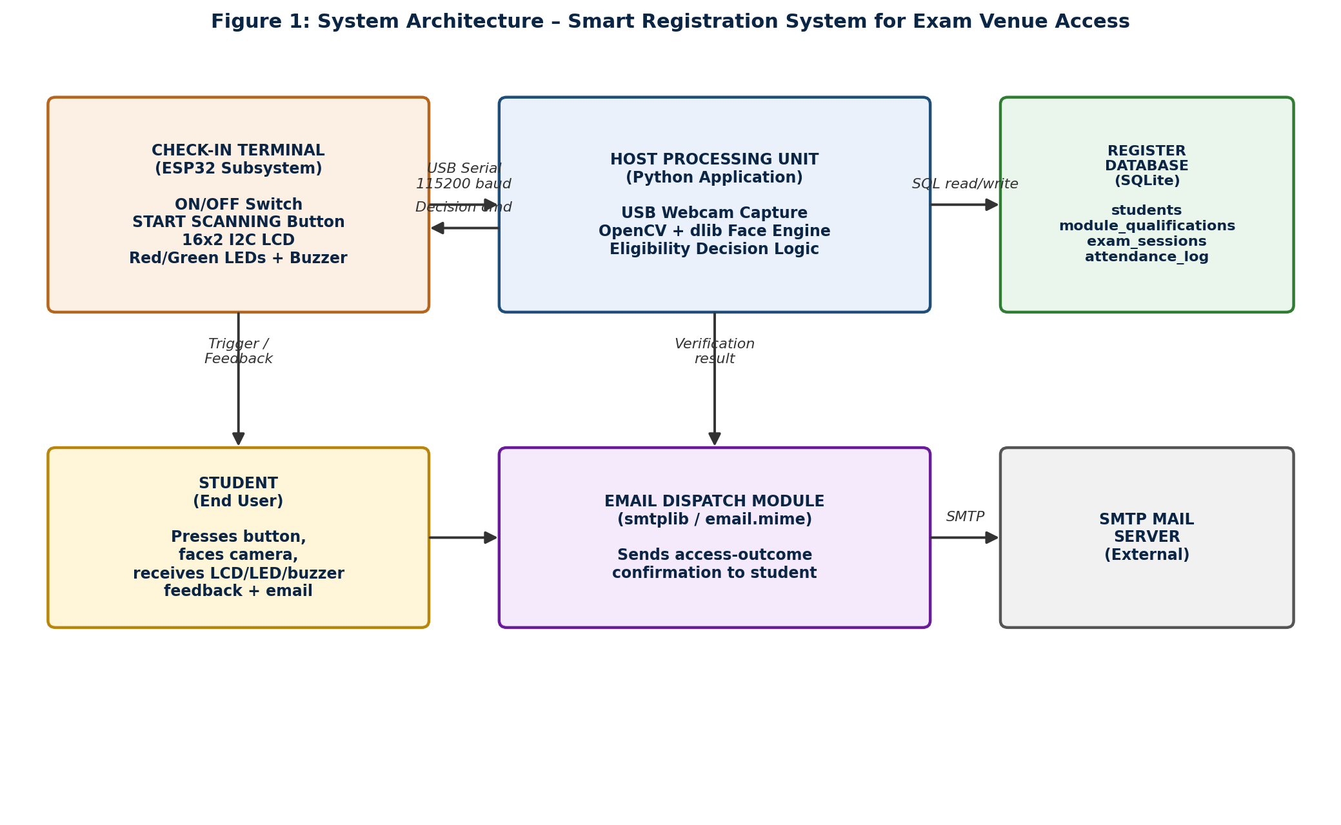
Figure 1: System Architecture – Smart Registration System for Exam Venue Access

Subsystem Architecture
Check-in Terminal (ESP32 subsystem): handles the ON/OFF power state, debounces the “START SCANNING” push button, listens on USB Serial for a decision command, and drives the LCD, LEDs and buzzer accordingly. It has no direct database access.
Host Processing Unit (Python application): subdivided into a Capture module (OpenCV frame grab), a Recognition module (dlib 128-D encoding and Euclidean-distance matching), and a Decision module (queries the register to resolve qualification and time-slot eligibility, then issues the outcome).
Register Database (SQLite): subdivided into the identity store (students), the qualification register (module_qualifications, modules), the scheduling store (exam_sessions) and the attendance register (attendance_log) — detailed fully in the Detailed System Design section below.
Email Dispatch Module: a thin subsystem that formats and sends a confirmation message once it receives an outcome from the Decision module; it is decoupled from the Register Database and cannot modify attendance records.

Detailed System Design
This section provides a detailed description of the key software components identified in the System Architecture, and introduces the Register Database schema in full, in direct response to the requirement that the system maintain a database acting as a register of which students are qualified for a module and whether they attended the exam.

Face Recognition Engine
Classification: Software module (Python package) within the Host Processing Unit.
Definition: Converts a captured video frame into a 128-dimensional facial encoding and matches it against pre-enrolled student encodings held in the Register Database.
Responsibilities: Capture a frame from the USB webcam on trigger; detect and align the face; extract the 128-D encoding using dlib's ResNet-based model; compute the Euclidean distance to each stored encoding and return the closest match below the acceptance threshold, or “no match.”
Constraints: Must return a result within roughly one second to keep the total scan-to-decision cycle under two seconds; must operate under variable desk lighting; requires an unobstructed frontal face view.
Composition: capture.py (frame acquisition), encode.py (128-D vector extraction), match.py (distance comparison against the students table).
Resources: USB webcam, CPU cycles on the host PC, in-memory frame buffer (released immediately after processing).
Processing: On trigger: grab frame → detect face → extract encoding → query stored encodings → compute distances → return best match or “unrecognised.”
Interface/Exports: recognise_face(frame) -> student_id | None, exposed to the Decision module.

Register Database Manager
Classification: Software module (Python data-access layer) wrapping the SQLite register database.
Definition: The authoritative store of student identity, per-module qualification status, exam session schedules, and per-session attendance outcomes; functions as the digital register that replaces the manual paper roster.
Responsibilities: Provide lookup of a student's qualification status for the module associated with the current exam session; provide the current/next exam_sessions time slot for eligibility checking; persist a new attendance_log entry for every scan attempt (successful or not); expose read functions so staff can later query “who was qualified and who attended” for a given module or session.
Constraints: All writes to attendance_log must be atomic (a scan event must never be partially recorded); the database file resides locally on the host PC only, and access is restricted to the application process running under invigilator supervision.
Composition: students, modules, module_qualifications, exam_sessions, and attendance_log tables (see Figure 2 for the full schema and relationships).
Resources: SQLite engine (Python standard-library sqlite3), local disk storage for the exam_system.db file.
Processing: On each scan: (1) look up student_id from the Face Recognition Engine result, (2) join module_qualifications and exam_sessions to resolve eligibility for the current module/session, (3) insert one row into attendance_log recording the resulting access_status and a boolean attended flag, (4) commit the transaction.
Interface/Exports: get_qualification(student_id, module_code), get_current_session(venue_id), log_attendance(student_id, session_id, status, attended) — exposed to the Decision module and to any future reporting script.

ESP32 Firmware Controller
Classification: Embedded firmware component (C++/Arduino Core) running on the ESP32 microcontroller.
Definition: Bridges physical student interaction and physical feedback hardware to the host application via USB Serial.
Responsibilities: Debounce and detect the “START SCANNING” button press and forward a trigger byte to the host; listen for an incoming decision command (ALLOWED / LATER / DENIED) and drive the 16x2 LCD, the red/green LEDs and the buzzer to match; manage system power state via the ON/OFF rocker switch.
Constraints: Must debounce the push button to avoid duplicate triggers; must respond to an incoming serial command within a few hundred milliseconds so the overall feedback feels instantaneous; constrained to the GPIO pins defined in the wiring design (button on GPIO 15 with internal pull-up, I2C LCD on GPIO 21/22 SDA/SCL, LEDs on GPIO 12/14).
Composition: main firmware loop, button debounce handler, serial command parser, LCD display driver, LED/buzzer feedback handler.
Resources: ESP32 GPIO pins, I2C bus, onboard timers for debounce and buzzer timing.
Processing: Continuously poll button state and serial buffer → on button press, send TRIGGER → on receiving a decision command, update LCD text, set LED colour, and sound the buzzer pattern associated with that status.
Interface/Exports: Serial protocol: outbound `TRIGGER\n`; inbound `ALLOWED\n` | `LATER\n` | `DENIED\n`, consumed by the host Python application via PySerial.

Email Notification Dispatcher
Classification: Software module (Python) within the Host Processing Unit, using smtplib and email.mime.
Definition: Sends an automated confirmation email to the student's registered address stating the outcome of their access attempt.
Responsibilities: Compose a message appropriate to the access_status returned by the Decision module (“Access Granted,” “Access Denied – Come back later,” or “Access Denied – Not Qualified”) and send it via SMTP to <student_id>@tut4life.ac.za.
Constraints: Must not block or delay the attendance_log write or the next student's scan; must fail gracefully (log the error locally) if the SMTP server or network is unavailable, rather than raising an unhandled exception.
Composition: compose_message.py (message templating), send_mail.py (SMTP session handling and error capture).
Resources: Outgoing SMTP server/account, network connectivity (best-effort, not guaranteed).
Processing: Receive access_status and student email from the Decision module → select the matching message template → open an SMTP session → send → catch and log any delivery failure without affecting the register.
Interface/Exports: send_confirmation(student_email, access_status) — called asynchronously by the Decision module after the register entry has already been committed.

Register Database Schema
In direct response to the requirement that the system maintain a database that acts as a register showing which students are qualified for a module and whether they attended the exam, the schema below (Figure 2) separates qualification (eligibility to write) from attendance (whether the student actually presented at the venue and was granted or denied access). This separation allows staff to query, for any module, the list of qualified students, and independently, for any exam session, the list of students who attended, were turned away for arriving at the wrong time, or were denied for not being qualified.
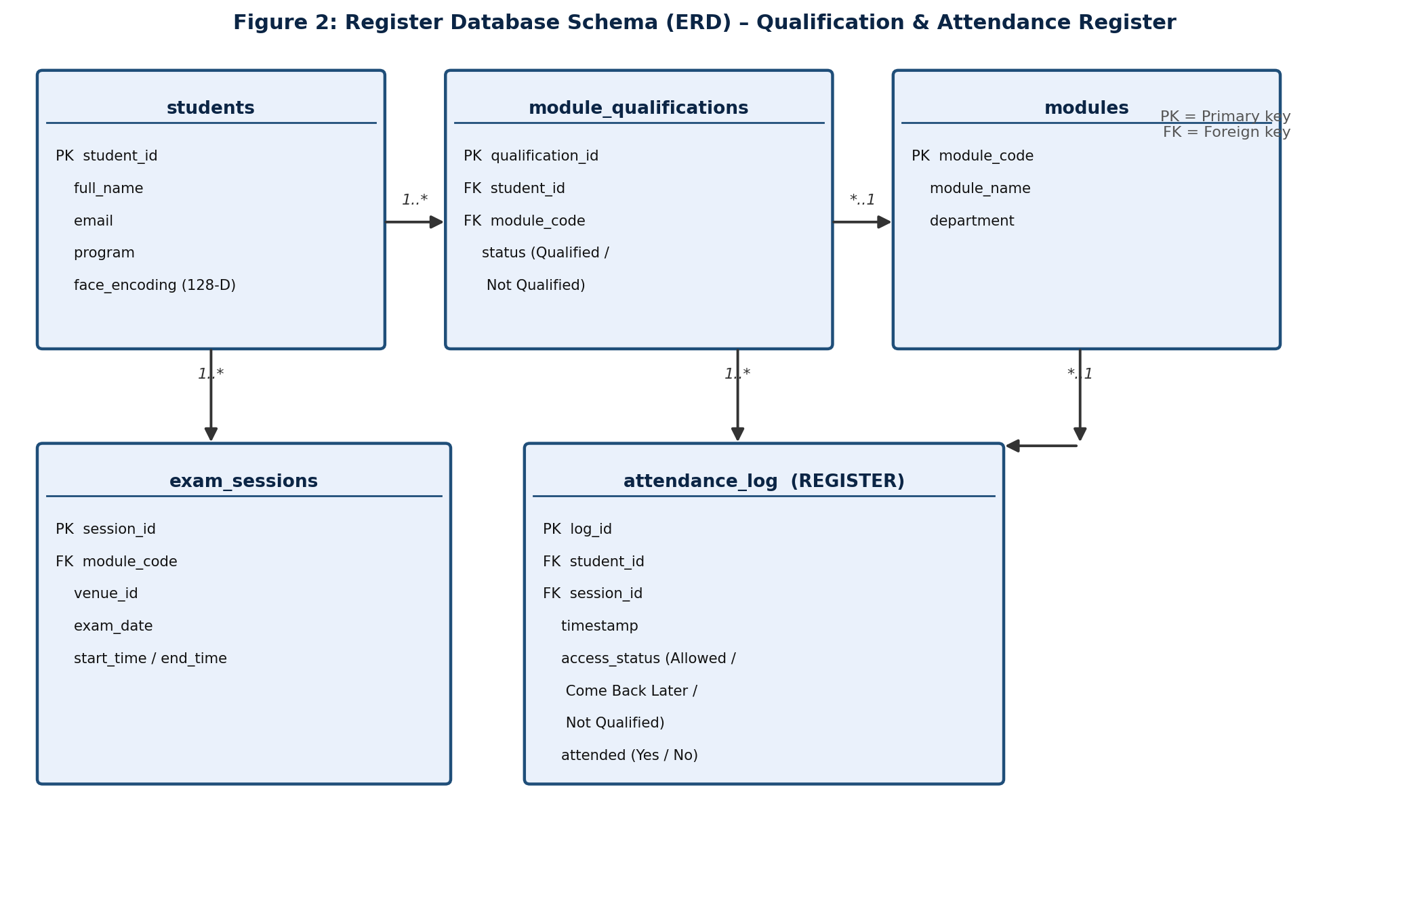
Figure 2: Register Database Schema (ERD) – Qualification & Attendance Register
Table | Key Fields & Purpose | Acts as
students | student_id (PK), full_name, email, program, face_encoding — the enrolled biometric identity store. | Identity register
modules | module_code (PK), module_name, department — the catalogue of examinable modules. | Module catalogue
module_qualifications | qualification_id (PK), student_id (FK), module_code (FK), status (Qualified / Not Qualified) — records whether a student is cleared to write a given module. | Qualification register
exam_sessions | session_id (PK), module_code (FK), venue_id, exam_date, start_time, end_time — the timetable of scheduled exams per module. | Session schedule
attendance_log | log_id (PK), student_id (FK), session_id (FK), timestamp, access_status (Allowed / Come Back Later / Not Qualified), attended (Yes/No) — one row per scan attempt. | Attendance register

Functional Flow
This section provides a detailed description of the system's two core functions. Each function is accompanied by an activity diagram, a process flow table, and a status flow table, as required.

Function 1: Face Scan & Eligibility Verification
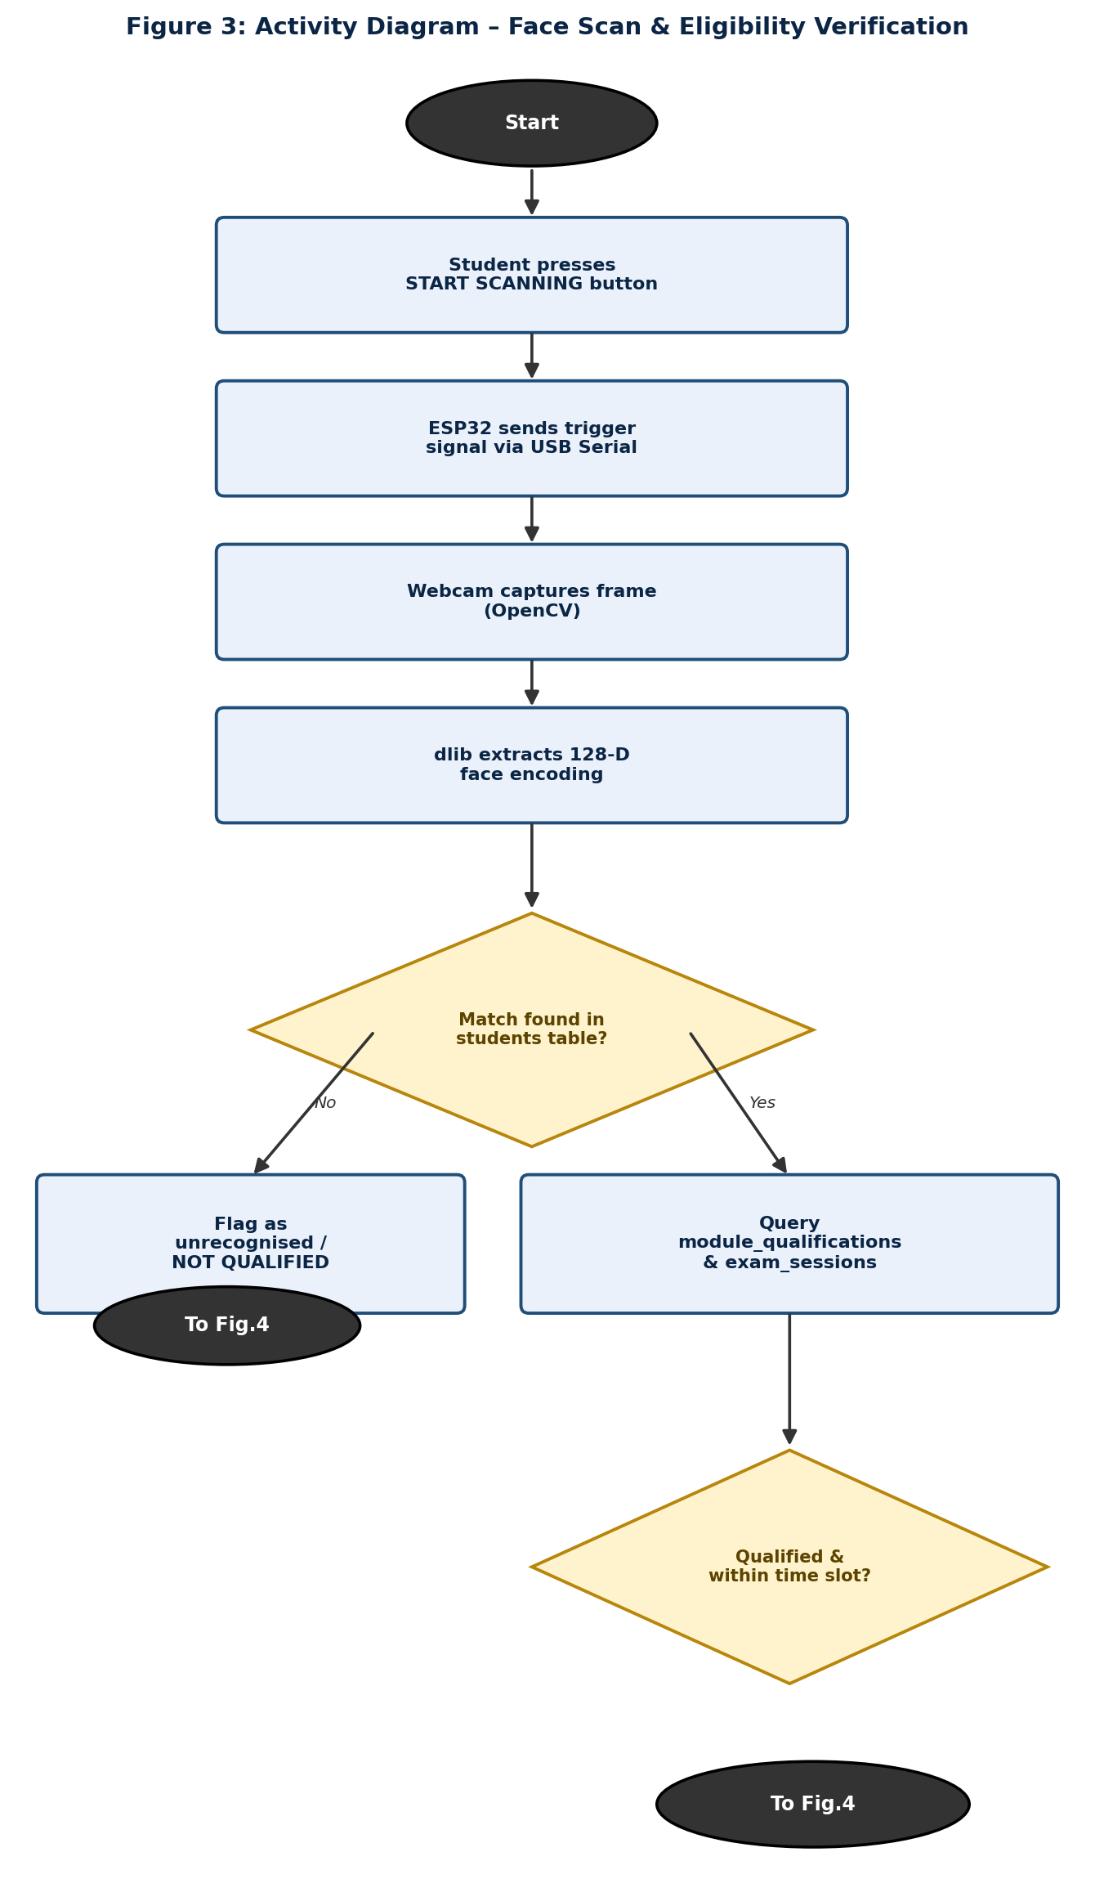
Figure 3: Activity Diagram – Face Scan & Eligibility Verification

Process Flow Table – Face Scan & Eligibility Verification
Step | Process | Description
1 | Trigger scan | Student presses the “START SCANNING” button; the ESP32 debounces the input and sends a TRIGGER command to the host over USB Serial.
2 | Capture frame | The host application grabs a single frame from the USB webcam using OpenCV.
3 | Extract encoding | dlib detects the face in the frame and extracts a 128-dimensional facial encoding.
4 | Match identity | The encoding is compared (Euclidean distance) against every stored encoding in the students table; the closest match under the acceptance threshold is returned, otherwise the scan is flagged unrecognised.
5 | Resolve eligibility | If a student is identified, the Register Database Manager queries module_qualifications and exam_sessions to determine whether that student is qualified for the module linked to the current session and whether the current time falls within the scheduled slot.

Status Flow Table – Face Scan & Eligibility Verification
Status | Description
Unrecognised | No stored encoding matched within the acceptance threshold; the student cannot be identified and the attempt is treated as Not Qualified.
Identified – Qualified & in slot | The student was matched, their module_qualifications status is Qualified, and the current time is within the session's scheduled start/end time — proceeds to the Allowed outcome.
Identified – Qualified, wrong slot | The student was matched and is Qualified, but the current time falls outside their scheduled session — proceeds to the Come Back Later outcome.
Identified – Not Qualified | The student was matched but their module_qualifications status is Not Qualified (e.g., registration or academic hold) — proceeds to the Not Qualified outcome.

Function 2: Access Decision, Register Logging & Email Notification
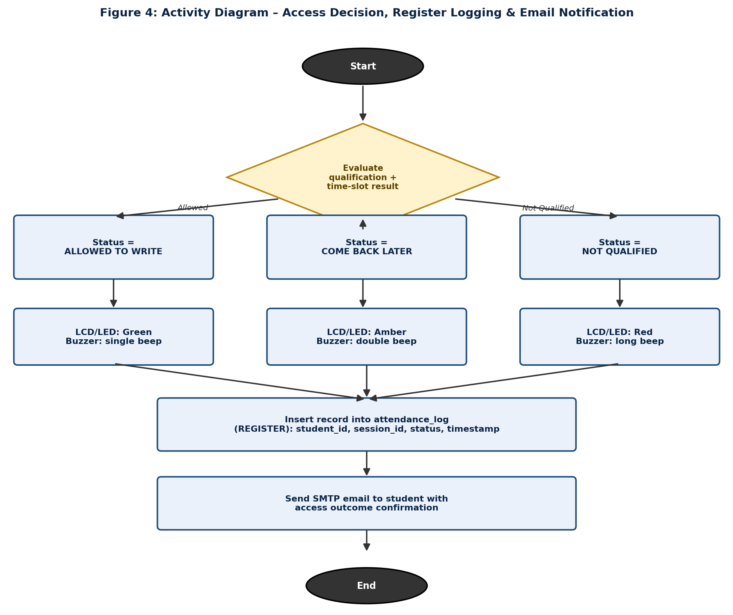
Figure 4: Activity Diagram – Access Decision, Register Logging & Email Notification

Process Flow Table – Access Decision, Register Logging & Email Notification
Step | Process | Description
1 | Determine outcome | The Decision module converts the eligibility result from Function 1 into one of three access_status values: Allowed to Write, Come Back Later, or Not Qualified.
2 | Drive terminal feedback | The status is sent to the ESP32 over USB Serial; the ESP32 updates the LCD text, sets the LED colour, and sounds the matching buzzer pattern.
3 | Write register entry | The Register Database Manager inserts a new row into attendance_log containing the student_id, session_id, access_status, an attended flag, and a timestamp — this is the permanent register record.
4 | Dispatch email | The Email Notification Dispatcher composes and sends a confirmation email to the student's registered address, asynchronously, so that it never delays the next student's scan.
5 | Ready for next scan | The terminal returns to standby, awaiting the next “START SCANNING” button press.

Status Flow Table – Access Decision, Register Logging & Email Notification
Status | Description
Allowed to Write | LCD shows “ALLOWED TO WRITE”, green LED and single beep; attendance_log records attended = Yes; confirmation email states access was granted.
Come Back Later | LCD shows “COME BACK LATER”, amber LED and double beep; attendance_log records attended = No with the reason (wrong time slot); email advises the correct session time.
Not Qualified | LCD shows “NOT QUALIFIED”, red LED and long beep; attendance_log records attended = No with reason Not Qualified; email states access was denied due to qualification status.

Conclusion
This design documentation has presented the complete technical design of the Smart Registration System for Exam Venue Access, extending the original proposal with a detailed architecture, component design, and — in direct response to the module lecturer's feedback — a fully specified register database. The register separates qualification (module_qualifications) from attendance (attendance_log), giving the institution a single, queryable digital source of truth for which students are qualified to write a given module and whether they in fact attended the corresponding exam session. The edge/host architectural split keeps the low-cost ESP32 terminal simple and responsive while placing the facial-recognition workload and the authoritative register on the host PC, meeting the project's goals of affordability, speed, and register accuracy within the approved sub-R900 hardware budget.

Glossary
Term | Definition
128-D encoding | A 128-dimensional numeric vector representation of a face, produced by a deep-learning model, used for biometric comparison.
Attendance register | The attendance_log table; the record of every scan attempt, its outcome, and whether the student attended.
Debounce | A firmware technique to prevent a single physical button press from being registered as multiple presses.
dlib | An open-source C++/Python library providing machine-learning tools, including the facial-encoding model used in this project.
ERD | Entity-Relationship Diagram; a diagram showing database tables and the relationships between them.
ESP32 | A low-cost microcontroller with built-in Wi-Fi/Bluetooth, used here purely for peripheral I/O control.
Euclidean distance | A mathematical measure of the straight-line distance between two encoding vectors, used to judge how closely two faces match.
I2C | Inter-Integrated Circuit; a two-wire serial communication protocol used here to connect the LCD to the ESP32.
OpenCV | Open Source Computer Vision Library; used for camera frame capture and image processing.
Qualification register | The module_qualifications table; the record of whether each student is cleared to write a specific module.
SMTP | Simple Mail Transfer Protocol; the protocol used to send the automated confirmation emails.
SQLite | A lightweight, serverless, file-based relational database engine used to implement the register.

Bibliography
- Espressif Systems, ESP32 Technical Reference Manual. [Online].
- A. Rosebrock, Deep Learning for Computer Vision with Python. PyImageSearch, 2017.
- Python Software Foundation, “sqlite3 — DB-API 2.0 interface for SQLite databases,” Python Documentation, 2026.
- Python Software Foundation, “smtplib — SMTP protocol client,” Python Documentation, 2026.
- G. Bradski and A. Kaehler, Learning OpenCV: Computer Vision with the OpenCV Library. O'Reilly Media, 2008.
- D. E. King, “Dlib-ml: A Machine Learning Toolkit,” Journal of Machine Learning Research, vol. 10, pp. 1755–1758, 2009.
- A. K. Jain, A. Ross, and K. Nandakumar, Introduction to Biometrics. Springer Science & Business Media, 2011.
- P. Liechti, “pySerial Documentation,” 2026.
- COMMUNICA.CO.ZA — electronic component supplier catalogue.

