Problem

Solution
Method
Null hypothesis | All means are equal
Alternative hypothesis | Not all means are equal
Significance level | α = 0.05
Equal variances were assumed for the analysis.

Factor Information
Factor | Levels | Values
Circuit Type | 4 | A, B, C, D

Analysis of Variance
Source | DF | Adj SS | Adj MS | F-Value | P-Value
Circuit Type | 3 | 12102 | 4033.9 | 22.18 | 0.000
Error | 16 | 2910 | 181.9
Total | 19 | 15012

Model Summary
S | R-sq | R-sq(adj) | R-sq(pred)
13.4870 | 80.61% | 76.98% | 69.71%

Means
Circuit  Type | N | Mean | StDev | 95% CI
A | 5 | 19.20 | 7.79 | (6.41, 31.99)
B | 5 | 70.00 | 11.02 | (57.21, 82.79)
C | 5 | 36.20 | 11.17 | (23.41, 48.99)
D | 5 | 79.80 | 20.51 | (67.01, 92.59)
Pooled StDev = 13.4870

Tukey Pairwise Comparisons
Grouping Information Using the Tukey Method and 95% Confidence
Circuit  Type | N | Mean | Grouping
D | 5 | 79.80 | A
B | 5 | 70.00 | A
C | 5 | 36.20 |  | B
A | 5 | 19.20 |  | B
Means that do not share a letter are significantly different.

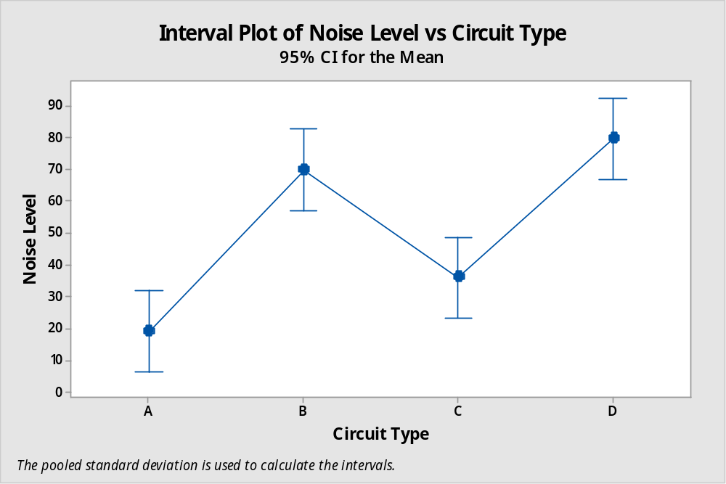

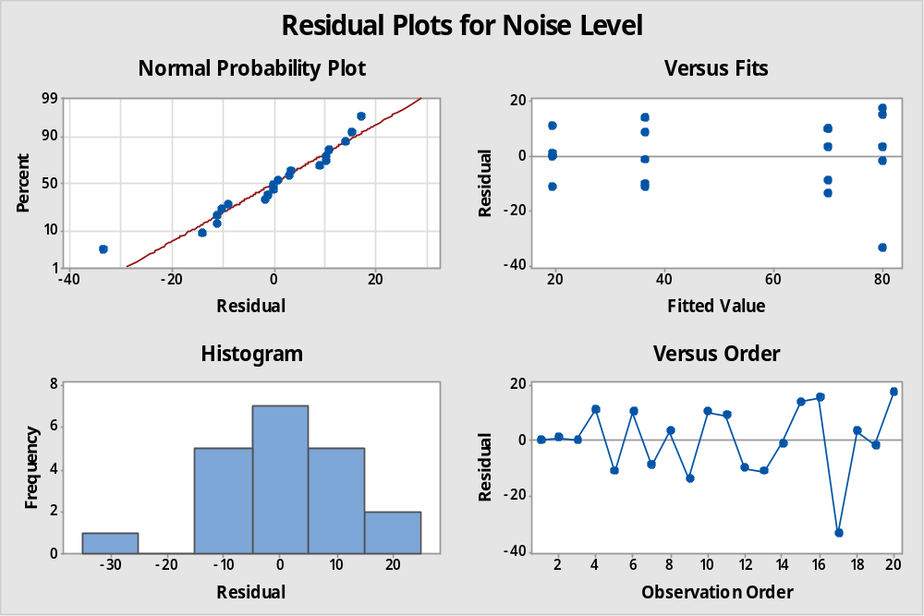

Conclusion
- In ANOVA table, the p-value = 0.000 < α = 0.05, we reject the null hypothesis that mean noise level is same for all type of digital circuit.
- The lowest average noise level is of circuit type A (19.20) and highest average noise level is of circuit type D (79.80)
- Tukey’s procedure shows that circuit type D and B shows similar performance and it is in group A. Similarly, circuit type A and C shows similar performance and they are put into group B. Hence, there are two clusters identified, first cluster (A and C) showing low average noise level and second cluster (B and D) showing high average noise level.
- Error distribution is skewed and having some extreme observations.
- Assumption of equal variation is not met.
- Errors are not related to each other as shown by the graph of error vs observation order.

