**Output:**

Alert:

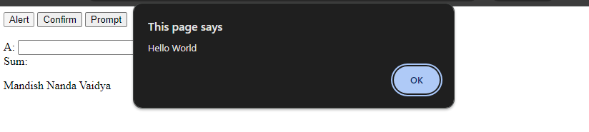Confirm: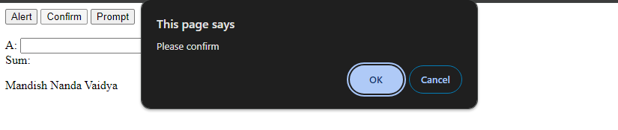Prompt: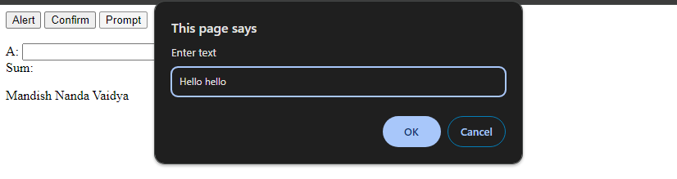

Assignment operation and variable declaration: