
Tribhuvan University
Institute of Science and Technology

Project Report on
InfoDigest – Text Summarizer

Submitted to:
Department of Bachelor of Science in Computer Science and Information Technology (BSc.CSIT)
National College of Computer Studies

In partial fulfillment of the requirement for the degree of Bachelor of Science in Computer Science and Information Technology (BSc.CSIT)

Submitted by:
Mandish Nanda Vaidya [28872/078]
Regd. No.: 5-2-551-76-2021

Under the supervision of
Mr. Yuba Raj Devkota

August, 2025

NATIONAL COLLEGE OF COMPUTER STUDIES
TRIBHUVAN UNIVERSITY

SUPERVISOR’S RECOMMENDATION

I hereby recommend that this project, prepared under my supervision entitled “InfoDigest – Text Summarizer”, a platform that performs extractive and abstractive summarization, by Mandish Nanda Vaidya in partial fulfillment of the requirements for the degree of Bachelor of Science in Computer Science and Information Technology (BSc.CSIT) is processed for the evaluation.

…………………………..
Mr. Yuba Raj Devkota
Project Supervisor
National College of Computer Studies
Paknajol, Kathmandu

CERTIFICATE OF APPROVAL

ACKNOWLEDGEMENT

The successful completion of my final year project owes much to the invaluable support and guidance extended by my project supervisors. I express my deepest gratitude to Mr. Yuba Raj Devkota, my project supervisor, whose dedicated guidance and mentorship have been instrumental throughout my journey. I am equally grateful to Mr. Jagdish Bhatta from Tribhuvan University for providing us with a comprehensive project overview and direction.
I would like to express my heartfelt thanks to the National College of Computer Studies (NCCS) for providing me with an exceptional platform to pursue and develop this project. Under the guidance of Mr. Yuba Raj Devkota, and the NCCS team, I have significantly deepened my understanding of AI and ML algorithms, as well as various components associated with the development of this system.
I am profoundly grateful for the unwavering support and encouragement I received throughout this academic endeavor. The NCCS administration, faculty members, and technical staff have been exceptional in providing the resources and environment conducive to my research and development. The collective contribution of my friends and communities has not only enhanced the quality of my project but also enriched my learning experience, making this journey truly memorable and worthwhile.

ABSTRACT

InfoDigest is an AI-powered web application designed to combat information overload by intelligently condensing large volumes of text from scientific and research documents. Leveraging both extractive and abstractive techniques, the system automatically generates coherent summaries from various document formats, including .docx, .txt, and .pdf. Beyond its core summarization capabilities, the platform integrates essential text analysis metrics such as word count and keyword extraction.
The system features a user-friendly interface and a robust authentication framework that differentiates between standard users and administrators. Authenticated users can access their summary history and provide feedback, while administrators manage users and view overall system analytics. This integrated approach streamlines the research workflow, making academic information more accessible and digestible for a wide range of users.

KEYWORDS: Extractive summarization, Abstractive summarization, Document summarization, Natural Language Processing, Text rank, LongT5

TABLE OF CONTENTS

SUPERVISOR’S RECOMMENDATION i
CERTIFICATE OF APPROVAL ii
ACKNOWLEDGEMENT iii
ABSTRACT iv
LIST OF ABBREVIATIONS vii
LIST OF FIGURES viii
LIST OF TABLES ix
CHAPTER 1: INTRODUCTION 1
1.1 Introduction 1
1.2 Problem Statement 1
1.3 Objectives 2
1.4 Scope and Limitation 2
1.4.1. Scope 2
1.4.2. Limitations 2
1.5 Development Methodology 3
1.6 Report Organization 4
CHAPTER 2: BACKGROUND STUDY AND LITERATURE REVIEW 5
2.1 Background Study 5
2.2 Literature Review 5
CHAPTER 3: SYSTEM ANALYSIS 8
3.1 System Analysis 8
3.1.1 Requirement Analysis 8
3.1.2 Feasibility Analysis 10
3.1.3 Analysis 11
CHAPTER 4: SYSTEM DESIGN 17
4.1 Design 17
4.1.1 Refinement of Class, Object, State, Sequence and Activity diagrams 17
4.1.2 Component diagrams 21
4.1.3 Deployment diagrams 22
4.2 Algorithm Details 22
4.2.1 Extractive Summarization 22
4.2.2 Abstractive algorithm 25
CHAPTER 5: IMPLEMENTATION AND TESTING 29
5.1 Implementation 29
5.1.1. Tools Used 29
5.1.2. Implementation Details of Modules 29
5.2. Testing 41
5.2.1. Test Cases for Unit Testing 41
5.2.2. Test Cases for System Testing 44
5.3. Result Analysis 46
CHAPTER 6: CONCLUSION AND FUTURE RECOMMENDATIONS 49
6.1. Conclusion 49
6.2. Future Recommendations 49
REFERENCES 50
APPENDICES 51

LIST OF ABBREVIATIONS

AI Artificial Intelligence
API Application Programming Interface
BART Bidirectional and Auto-Regressive Transformers
BLEU Bilingual Evaluation Understudy
CNN Convolutional Neural Network
GPT Generative Pre-trained Transformer
GPU Graphics Processing Unit
IDE Integrated Development Environment
LSA Latent Semantic Analysis
LSTM Long Short-Term Memory
MERN MongoDB, Express, React, Node.js
ML Machine Learning
NLP Natural Language Processing
PDF Portable Document Format
RAG Retrieval-Augmented Generation
ROGUE Recall-Oriented Understudy for Gisting Evaluation
RNN Recurrent Neural Network
Seq2Seq Sequence to Sequence
SVD Singular Value Decomposition
TF-IDF Term Frequency - Inverse Document Frequency
T5 Text-to-Text Transfer Transformer
UI User Interface

LIST OF FIGURES

Figure 1.1: Incremental Development 3
Figure 3.1: Use case diagram 9
Figure 3.2: Class diagram 12
Figure 3.3: Object diagram 13
Figure 3.4: State diagram 14
Figure 3.5: Sequence diagram 15
Figure 3.6: Activity diagram 16
Figure 4.1: Refined class diagram 17
Figure 4.2: Refined object diagram 18
Figure 4.3: Refined state diagram 19
Figure 4.4: Refined activity diagram 20
Figure 4.5: Component diagram 21
Figure 4.6: Deployment diagram 22
Figure 4.3: T5 Encoder-Decoder structure 27
Figure 5.1: Vocabulary IDF values 32
Figure 5.2: TF-IDF values after L2 normalization 32
Figure 5.3: Cosine similarity matrix 33
Figure 5.4: Sentence similarity 34
Figure 5.5: Page rank algorithm 34
Figure 5.6: Extractive summary result 35
Figure 5.7: Training arguments of abstractive summarization 36
Figure 5.8: Training process 37
Figure 5.9: Abstractive summary result 37
Figure 5.10: Registration module 38
Figure 5.11: Login module 38
Figure 5.12: User profile module 39
Figure 5.13: User history 39
Figure 5.14: Manage user module 40
Figure 5.15: Analytics module - 1 40
Figure 5.16: Analytics module - 2 41

LIST OF TABLES

Table 5.1: Unit testing for login module 42
Table 5.2: Unit testing for summarizer module 43
Table 5.3: System testing 44

INTRODUCTION

1.1 Introduction
InfoDigest is an AI-powered web application designed to combat information overload, particularly within the scientific and research communities. The platform intelligently condenses large volumes of text from various sources, including research papers, into concise and understandable summaries.
At its core, InfoDigest leverages advanced AI to provide text summarization using both extractive and abstractive approaches. It also supports document summarization for formats like .docx, .txt, and .pdf. To enhance the user experience, the system includes a simple user interface, text analysis tools (like keyword extraction), and a robust user authentication system. Logged-in users can manage their history of summaries and provide feedback, while administrators have access to user management and system analytics. InfoDigest is a powerful tool for streamlining research and knowledge management.

1.2 Problem Statement
In today's digital world, we're all dealing with a ton of information, especially in science and research. This "information overload" is a big problem. Researchers, students, and professionals have to read a lot of long, complicated documents, which takes a lot of time and energy. This slows down their work, makes it harder to review research, and can even slow down new discoveries.
The trouble is most tools for summarizing text aren't good enough. They can't handle the tricky, technical language in academic papers. Many of them are also missing key features, like different ways to summarize text, detailed analysis, and ways for users to manage their work.
So, there's a real need for a better, AI-powered website. This website would not only accurately summarize scientific papers but also offer a full set of tools to manage information more easily. It would include features that focus on the user, like a way to give feedback, and tools for admins to manage everything. The goal is to make the research process smoother and make complex information easier for everyone to access.

1.3 Objectives
The objectives of InfoDigest project are as follows:
- To develop an AI-powered text summarization solution, using Python for intelligent model creation and deploying a MERN-based web interface for users to access and condense textual content and file input into concise summaries.
- To utilize Artificial Intelligence and Machine Learning algorithms, specifically focusing on Natural Language Processing (NLP) methodologies for extractive and abstractive summarization, to enable InfoDigest to intelligently process and condense text.

1.4 Scope and Limitation

1.4.1. Scope
The scope of InfoDigest are as follows:
- The system will generate summaries from various text sources, including direct text input and uploaded documents in .docx, .txt, and .pdf formats and support both extractive and abstractive summarization techniques.
- The application will provide basic text analysis metrics, such as word count and keyword extraction, to give users a quick overview of their content.
- A simple, clean, and easy-to-navigate interface will be a core part of the design, ensuring a smooth user experience.
- The system will include a login and authentication system to manage user access. It will have two distinct user roles: a standard user and an administrator.
- Logged-in users will have the ability to view a history of their past summaries.
- The system will provide a mechanism for users to submit feedback on the quality of the generated summaries, which will be used to improve the AI models over time.
- The admin role will have access to a dashboard to manage users and gain insights into the overall system usage. This will include analytics related to the number of summaries generated and user activity.

1.4.2. Limitations
The limitations of InfoDigest are as follows:
- Initial development will focus solely on English language text summarization. Support for other languages is outside the current scope.
- Advanced NLP features such as sentiment analysis, named entity, topic modeling, or question-answering are not included.
- The project is limited to processing static textual content and cannot sumarize live audio or video feeds.

1.5 Development Methodology
For InfoDigest, an incremental development approach is used. This means that instead of building the entire app at once, the system is developed in small, working parts, or "increments," with each new version adding more features to the last. This allows delivery of basic, working product early and add more functionality over time. The development process consists of the following increments:
- The first increment will focus on the most important part: the core summarization engine, which will handle basic text input.
- Then, the second increment will add user authentication, user history, and a simple user interface. This provides a functional app that users can start using and gives valuable feedback.
- The third phase will expand the summarization capability to handle .docx, .txt, and .pdf files, along with adding text analysis tools and a user feedback mechanism.
- Finally, the last increment will focus on the administrative side, building the admin dashboard for user management and system analytics.
This phased approach is ideal because it allows a working product to be delivered to users faster, incorporates their feedback at each stage, and handles any problems early on, ensuring the app truly meets their needs.

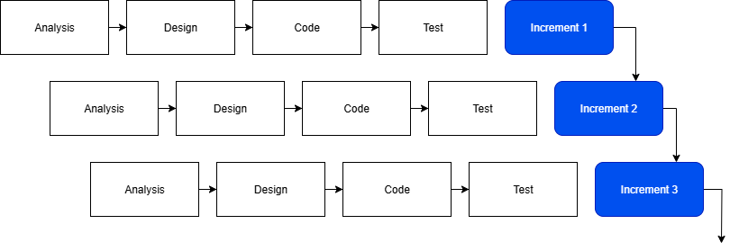
Figure 1.1: Incremental Development

1.6 Report Organization
Chapter 1: Introduction
Introduces the project, its goals, methodology, and scope.

Chapter 2: Background Study and Literature Review
Presents background theories, concepts, and previous works related to project.

Chapter 3: System Design and Architecture
Describes the overall structure of the system, including architectural components, data flow, and user role interactions.

Chapter 4: System Implementation
Provides implementation details such as the tools, programming languages, frameworks used, integration of algorithm, and includes relevant system interface screenshots.

Chapter 5: Results and Evaluation
Discusses the output of the model, evaluates its performance using accuracy and other metrics, and analyzes how well the system meets its objectives.

Chapter 6: Conclusion and Future Enhancements
Concludes the project by summarizing key achievements and outlines potential improvements and additional features for future development.

BACKGROUND STUDY AND LITERATURE REVIEW

2.1 Background Study
Grammarly's summarization tool, integrated within its comprehensive AI writing platform, provides users with the capability to distill lengthy documents, articles, or notes into concise overviews. This feature leverages artificial intelligence to identify and extract the most critical information, presenting it in a digestible format that aids quick comprehension and efficient information retrieval, complementing Grammarly's core grammar and style correction services [1].
QuillBot's summarizer stands as a prominent feature alongside its renowned paraphrasing capabilities, offering users a versatile tool to condense text effectively. It allows flexible summarization, enabling users to choose between extracting key sentences or generating a paragraph summary, and provides control over the output length, making it highly adaptable for various academic, professional, or personal comprehension needs [2].
Scribbr's text summarizer is specifically tailored to assist students and researchers in navigating academic literature by quickly extracting the core arguments and essential information from scholarly articles, essays, or research papers. This tool focuses on providing a rapid understanding of complex academic texts, helping users to efficiently identify main points and key findings without needing to read the entire document [3].
Summarizer.org offers a direct and user-friendly online tool dedicated solely to text summarization, providing a straightforward solution for condensing any given text. It primarily employs extractive summarization techniques, allowing users to paste content and quickly generate a shorter version, often with options to specify the desired summary length by sentence count or percentage, serving as a quick utility for basic text condensation [4].

2.2 Literature Review
Hybrid Extractive-Abstractive Summarization with Retrieval-Augmented Generation proposes a novel method that fuses extractive and abstractive approaches using a Retrieval-Augmented Generation (RAG) framework. The method first retrieves salient sentences from the source document using extractive strategies, which are then passed to a pretrained transformer (e.g., BART or T5) to generate coherent summaries. This hybrid structure leverages the factual grounding of extractive summaries and the fluency of abstractive models. It is particularly effective in handling long-form and multi-document summarization tasks, and enhances factual accuracy, content coverage, and linguistic naturalness [5].
The paper “Attention Is All You Need” introduced the Transformer architecture, a breakthrough model for sequence-to-sequence tasks that replaced recurrence and convolution entirely with self-attention mechanisms. The Transformer uses an encoder–decoder structure, where each layer is built from multi-head self-attention, position-wise feed-forward networks, residual connections, and layer normalization. To capture word order without recurrence, the model incorporates positional encoding. This design allows for efficient parallelization, drastically reducing training time while better modeling long-range dependencies compared to RNNs and CNNs. On benchmarks like WMT 2014 machine translation (English–German, English–French), Transformers achieved state-of-the-art results, demonstrating both higher accuracy and scalability. The paper’s impact has been immense: it laid the foundation for modern large language models such as BERT, GPT, and T5, extended beyond NLP into computer vision, speech, and multimodal AI, and fundamentally shifted the research paradigm—establishing attention as the dominant framework in deep learning [6].
Automatic Text Summarization with Machine Learning: An Overview by Luis Fred offers a conceptual introduction to a range of summarization methods, categorized into extractive and abstractive approaches. The article outlines classical extractive techniques like TF-IDF, clustering, TextRank, and LSA, before transitioning into neural network-based summarization. It briefly introduces Seq2Seq models, transformers, and pretrained models such as BERT and GPT. While not academically peer-reviewed, it provides valuable insights into how machine learning and deep learning have shaped the evolution of automatic summarization [7].
Evaluation of Extractive and Abstractive Approaches for Text Summarization offers a comprehensive comparison of classical and modern summarization methods. The paper evaluates TextRank, Luhn's algorithm, and TF-IDF-based extractive methods alongside T5, PEGASUS, and BART abstractive models. The authors assess these models based on ROUGE, BLEU, and readability scores, concluding that while extractive techniques are computationally cheaper and interpretable, abstractive models outperform them in linguistic fluency and semantic depth. The paper also suggests hybrid methods as a potential solution to combine the strengths of both paradigms [8].
Text Summarization using Deep Learning: A Study on Automatic Summarization reviews modern deep learning techniques applied to automatic summarization. The paper emphasizes encoder-decoder frameworks, including RNNs, LSTMs, and transformers, with a strong focus on models like BART, GPT, and T5. It discusses model training strategies, including fine-tuning on domain-specific datasets and the use of reinforcement learning to optimize summary quality. The study highlights the benefits of deep learning in generating coherent, context-aware, and human-like summaries while acknowledging the need for substantial computational resources [9].
Text Summarization Using Latent Semantic Analysis presents one of the earliest and most cited methods for unsupervised extractive summarization. The method constructs a term-sentence matrix from the input text and applies Singular Value Decomposition (SVD) to uncover latent semantic structures. Sentences are then selected based on their relevance to the dominant latent concepts. This ensures semantic richness and diversity in the resulting summary, even though the approach is purely statistical and not context aware. LSA remains a popular baseline due to its unsupervised nature and effectiveness in low-data environments [10].

SYSTEM ANALYSIS

3.1 System Analysis

3.1.1 Requirement Analysis

3.1.1.1 Functional Requirement
The functional requirements of InfoDigest are as follows:
- Text Summarization: The system must generate summaries from various text sources like input text and uploaded files to produce summarized content. Summarization can be produced by either extractive approach or abstractive approach.
- Document Summarization: The system must summarize text from uploaded documents (.docx, .txt, .pdf).
- User Interface: The system provides a simple and easy to navigate interface with suitable designing.
- Text Analysis: The system must provide text analyzer metrics (word count, key word extraction, etc.).
- User Feedback: The system allows logged in users to send feedback on the summary generated.
- User History: The user can view their history which displays the information related to the generated summaries.
- User Authentication: The user needs to login to access certain features. The user can be either a normal user or an admin.
- Admin Functionalities: The admin has the ability to manage users and obtain overall analytics of the system.
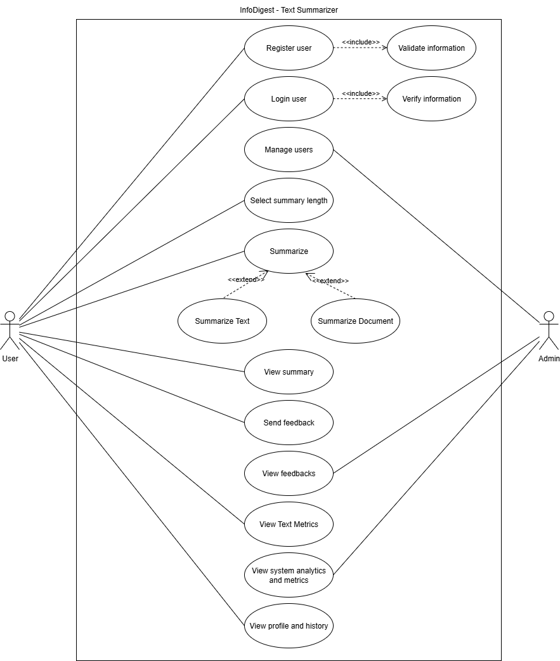
Figure 3.1: Use case diagram
This diagram illustrates how a user interacts with the InfoDigest system. The user can perform several actions: summarize text or documents by adjusting the summary length and send feedback and view text metrics. The user can also register and log in as an optional feature so that the user can store the summarization history along with their metrics. Similarly, the admin can manage users and view the user’s feedback and view overall analytics and metrics of the system.

Non-Functional Requirement
The non-functional requirements of InfoDigest are as follows:
- Performance: The system must generate summaries within an acceptable time frame and must be reasonably fast and accurate.
- Usability: The system must have a user-friendly interface that is easy to navigate and understand.
- Reliability: The system must be robust and handle errors gracefully.
- Security: The system must protect user data and ensure privacy.
- Maintainability: The system must be designed for easy maintenance and updates.

3.1.2 Feasibility Analysis

Technical feasibility
The provided text describes the technical feasibility of the InfoDigest project, highlighting its core components and architecture. The project is considered feasible because it uses a robust hybrid summarization system, combining an abstractive model (LongT5 fine-tuned with PyTorch on the arXiv dataset) with extractive methods (TF-IDF, Cosine Similarity, TextRank using NLTK). The system is deployed using a scalable FastAPI backend and a user-friendly MERN stack frontend. The use of OpenCV and PyTorch further enhances their capability, making the project a viable and well-architected solution.
Minimum requirements for technical feasibility include:
- Proficiency in Python, NLP/ML, JavaScript, React, Express.js, Node.js, FastAPI and database management (MongoDB)
- Access to a machine with sufficient computational resources for model development and training (GPU recommended for complex models)
- A development environment capable of supporting the chosen technologies and integration workflows.

Operational feasibility
InfoDigest is operationally feasible due to its intuitive, web-based interface and use of standard AI/ML and web technologies, which significantly simplify its integration into existing workflows and ultimately reduce user overhead. Furthermore, the reliance on established Artificial Intelligence, Machine Learning, and web technologies means that the underlying infrastructure benefits from robust community support, extensive documentation, and a readily available pool of expertise for development, deployment, and ongoing maintenance. Additionally, the project's defined scope is a critical factor, as it precisely outlines what will and will not be included, preventing feature creeping and thereby minimizing the initial operational burdens associated with a more complex system.

Economic feasibility
From an academic perspective, the InfoDigest project is economically feasible because it efficiently uses the student's time and effort to achieve valuable educational outcomes. The project's potential benefits, including enhanced skills, a stronger portfolio, and possible research opportunities, outweigh the primary costs of the student's time. Careful planning, efficient resource allocation, and a focus on delivering a functional application are key to maximizing these academic gains.
Also, given that most of the technologies used in the project are freely available and cost effective, this application is financially viable.

Schedule feasibility
The InfoDigest project's schedule is feasible within a reasonable timeframe. This is supported by its defined scope, allowing focus by including feasible features. The project's modular components permit parallel development, and it will leverage existing resources to complete the project on time.

3.1.3 Analysis
InfoDigest project is developed using a object oriented approach. The object-oriented approach is a programming paradigm that structures software design around objects, rather than functions or logic. The detailed analysis of the project is displayed below:

Object modelling
Object modeling is a way to design a software system by viewing it as a collection of interacting objects. This approach focuses on defining the objects within the system, their data (attributes), and their behaviors (methods). The goal is to create a model that mirrors the real-world problem, making the system easier to understand, design, and maintain.
- Class diagram
A Class Diagram is a core part of object modeling. It is a static, high-level blueprint that shows the system's structure. It depicts the different classes and the relationships between them, such as inheritance, association, and aggregation. Each class is represented by a box showing its name, attributes, and methods. It provides a visual representation of the overall design and architecture of the software.

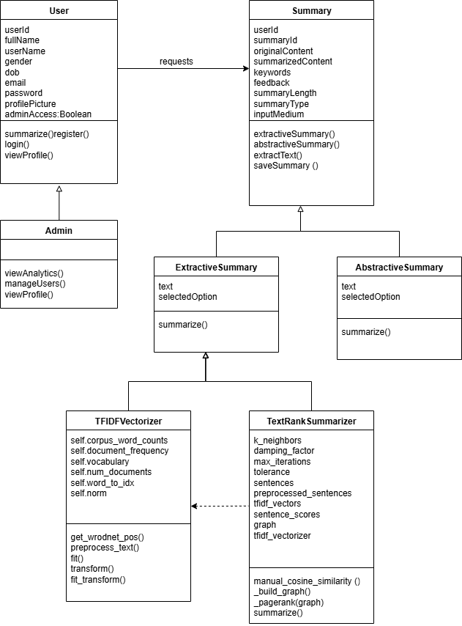
Figure 3.2: Class diagram

- Object diagram
An Object Diagram is a specific snapshot of the system at a particular moment in time. While a Class Diagram shows the general structure, an Object Diagram shows concrete instances of those classes (the objects themselves). It displays the objects, their specific attribute values, and the links between them. This diagram is useful for demonstrating a specific scenario or for testing if the class structure can support the intended interactions.
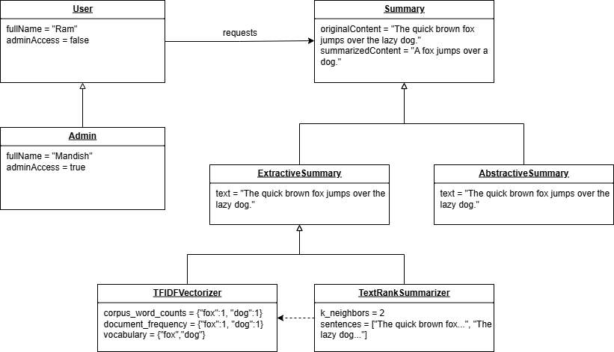
Figure 3.3: Object diagram

Dynamic modelling
Dynamic modeling describes the behavior of a system over time. It focuses on how the system's objects interact with each other and change their states in response to events.
- State diagram
A state diagram, also known as a state machine diagram, is a behavioral diagram that shows the different states an object can have and the events that cause a transition from one state to another.
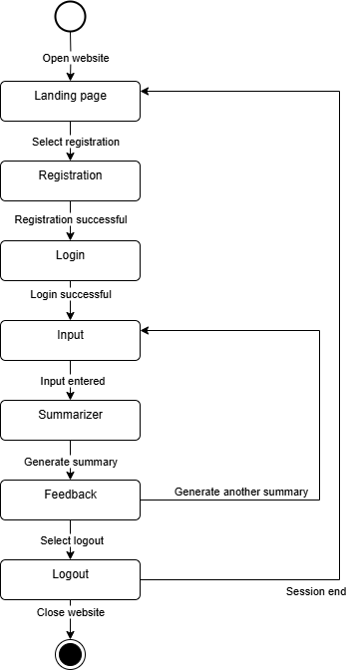
Figure 3.4: State diagram

- Sequence diagram
A sequence diagram is a type of interaction diagram that shows how processes and objects interact with each other in a sequential manner. It depicts the chronological order of a series of messages exchanged between different objects or actors to perform a specific task.
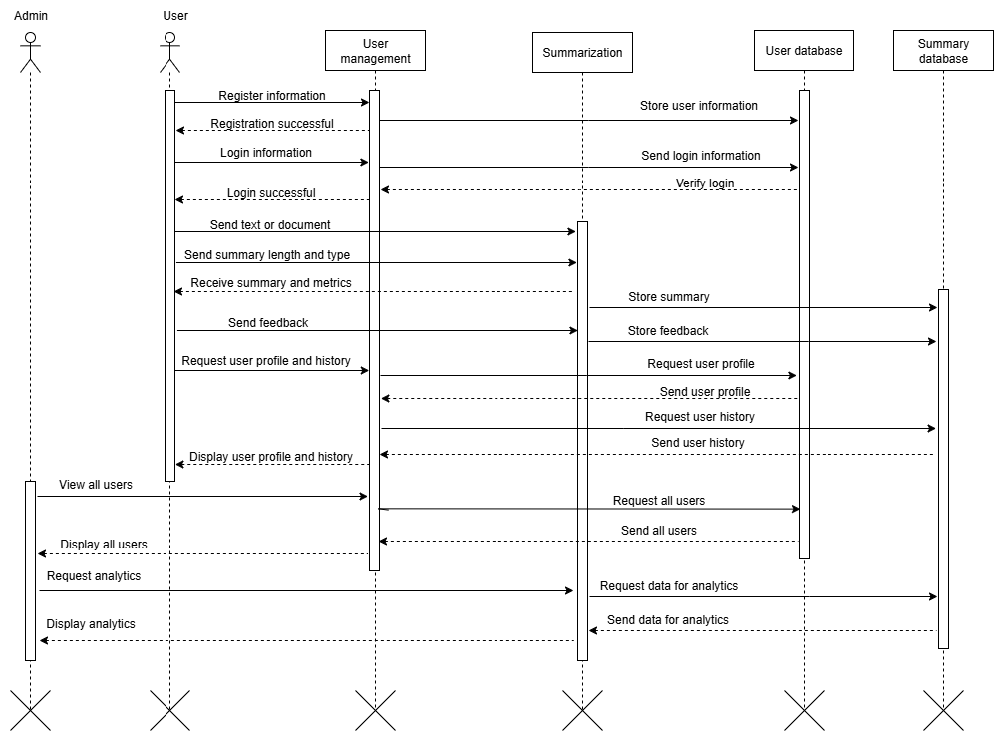
Figure 3.5: Sequence diagram
The figure demonstrates the distinct workflows for a standard user and an administrator, from initial authentication to core functionalities. The diagram shows how a user can register, log in, submit text for summarization, and access their history, while also detailing how an administrator can manage users and request system-wide analytics, all through a series of sequential messages between the user interface and various backend services like user management, summarization, and their respective databases.

3.1.3.3 Process modelling
Process modeling is the graphical representation of a business process or workflow, used to analyze and improve how work is done within an organization. It provides a common language for stakeholders to understand a sequence of activities, events, and decisions, making it easier to identify inefficiencies and opportunities for automation.
- Activity diagram
An activity diagram is a behavioral diagram that shows the flow of control from one activity to another. It models the step-by-step workflow of a system, representing the sequence of actions, decisions, and parallel processes.
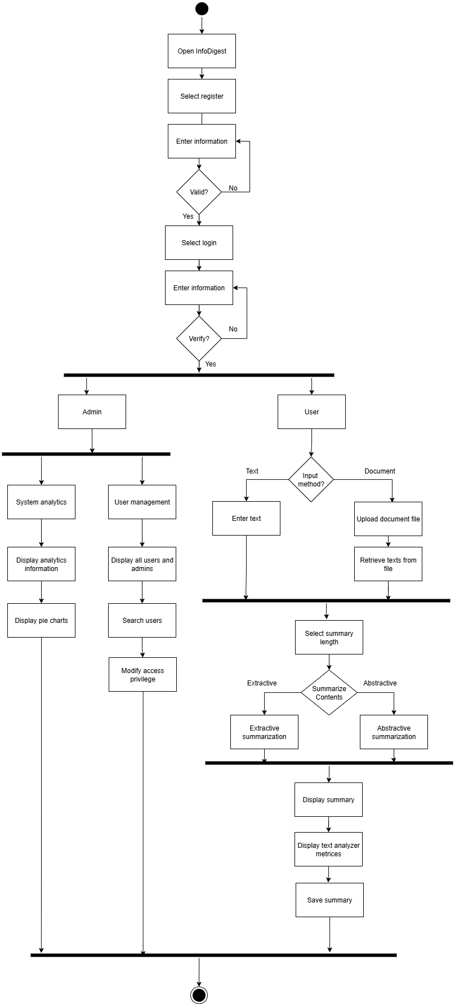
Figure 3.6: Activity diagram

SYSTEM DESIGN

4.1 Design
InfoDigest project is developed using object-oriented approach. It emphasizes modularity, reusability, and flexibility by representing real-world entities as objects, each containing data and methods. The detailed design of the project is displayed below:

4.1.1 Refinement of Class, Object, State, Sequence and Activity diagrams
- Class diagram
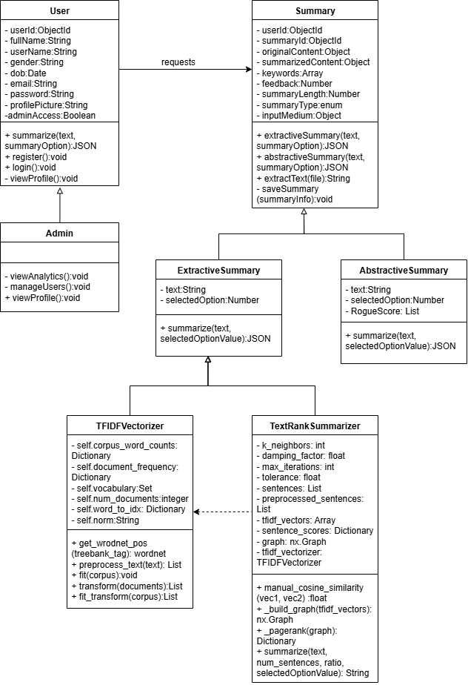
Figure 4.1: Refined class diagram
This class diagram in figure f4.1 shows a text summarization system where users request summaries and admins manage the system. The Summary class handles storing content, generating summaries, and saving results. Summarization is done through ExtractiveSummary (using TextRankSummarizer and TFIDFVectorizer) or AbstractiveSummary. The TextRankSummarizer builds graphs and applies PageRank, while TFIDFVectorizer preprocesses and vectorizes text. Overall, it illustrates how user data, summary generation, and algorithms connect to deliver summaries.

- Object diagram
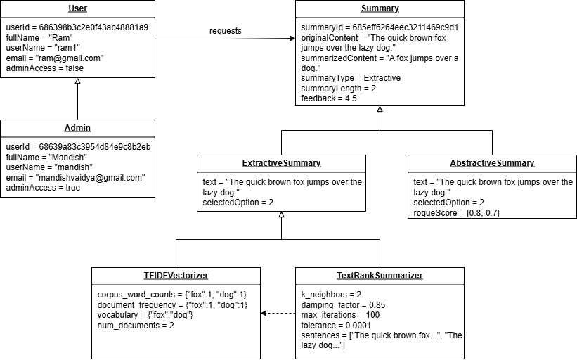
Figure 4.2: Refined object diagram
This object diagram in figure 4.2 shows a runtime snapshot of the summarization system. Here, a User (Ram) requests a summary, which is represented by a Summary object containing original content, summarized output, type, length, and feedback. An Admin (Mandish) exists with elevated access rights. The Summary is linked to an ExtractiveSummary that processes the text using the TextRankSummarizer, which in turn relies on a TFIDFVectorizer for vectorization. The diagram also includes an AbstractiveSummary object with text, option, and ROUGE score values. Overall, it demonstrates how actual objects interact at runtime to generate summaries from user input.
- State diagram
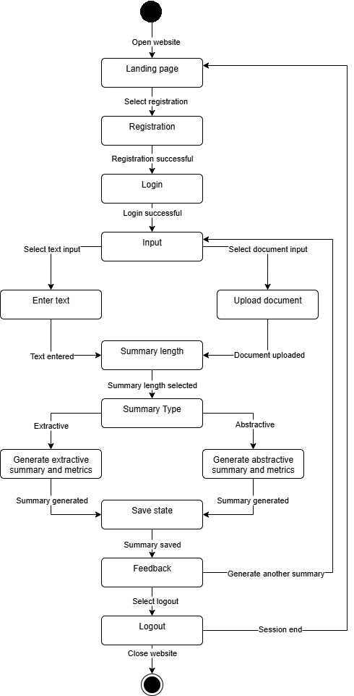
Figure 4.3: Refined state diagram
The image in figure 4.3 shows a State Diagram that outlines the user flow of InfoDigest. The process begins when a user opens the website, leading to a landing page where they can choose to either register or log in. After successful authentication, the user is directed to the input section, where they can either type in text or upload a document. The system then prompts the user to select the desired summary length and type (either extractive or abstractive). Once the summary is generated, the user can save the result, provide feedback, or choose to create another summary, which returns them to the input screen. The process concludes when the user selects to log out or ends their session, which leads to closing the website.
- Activity diagram
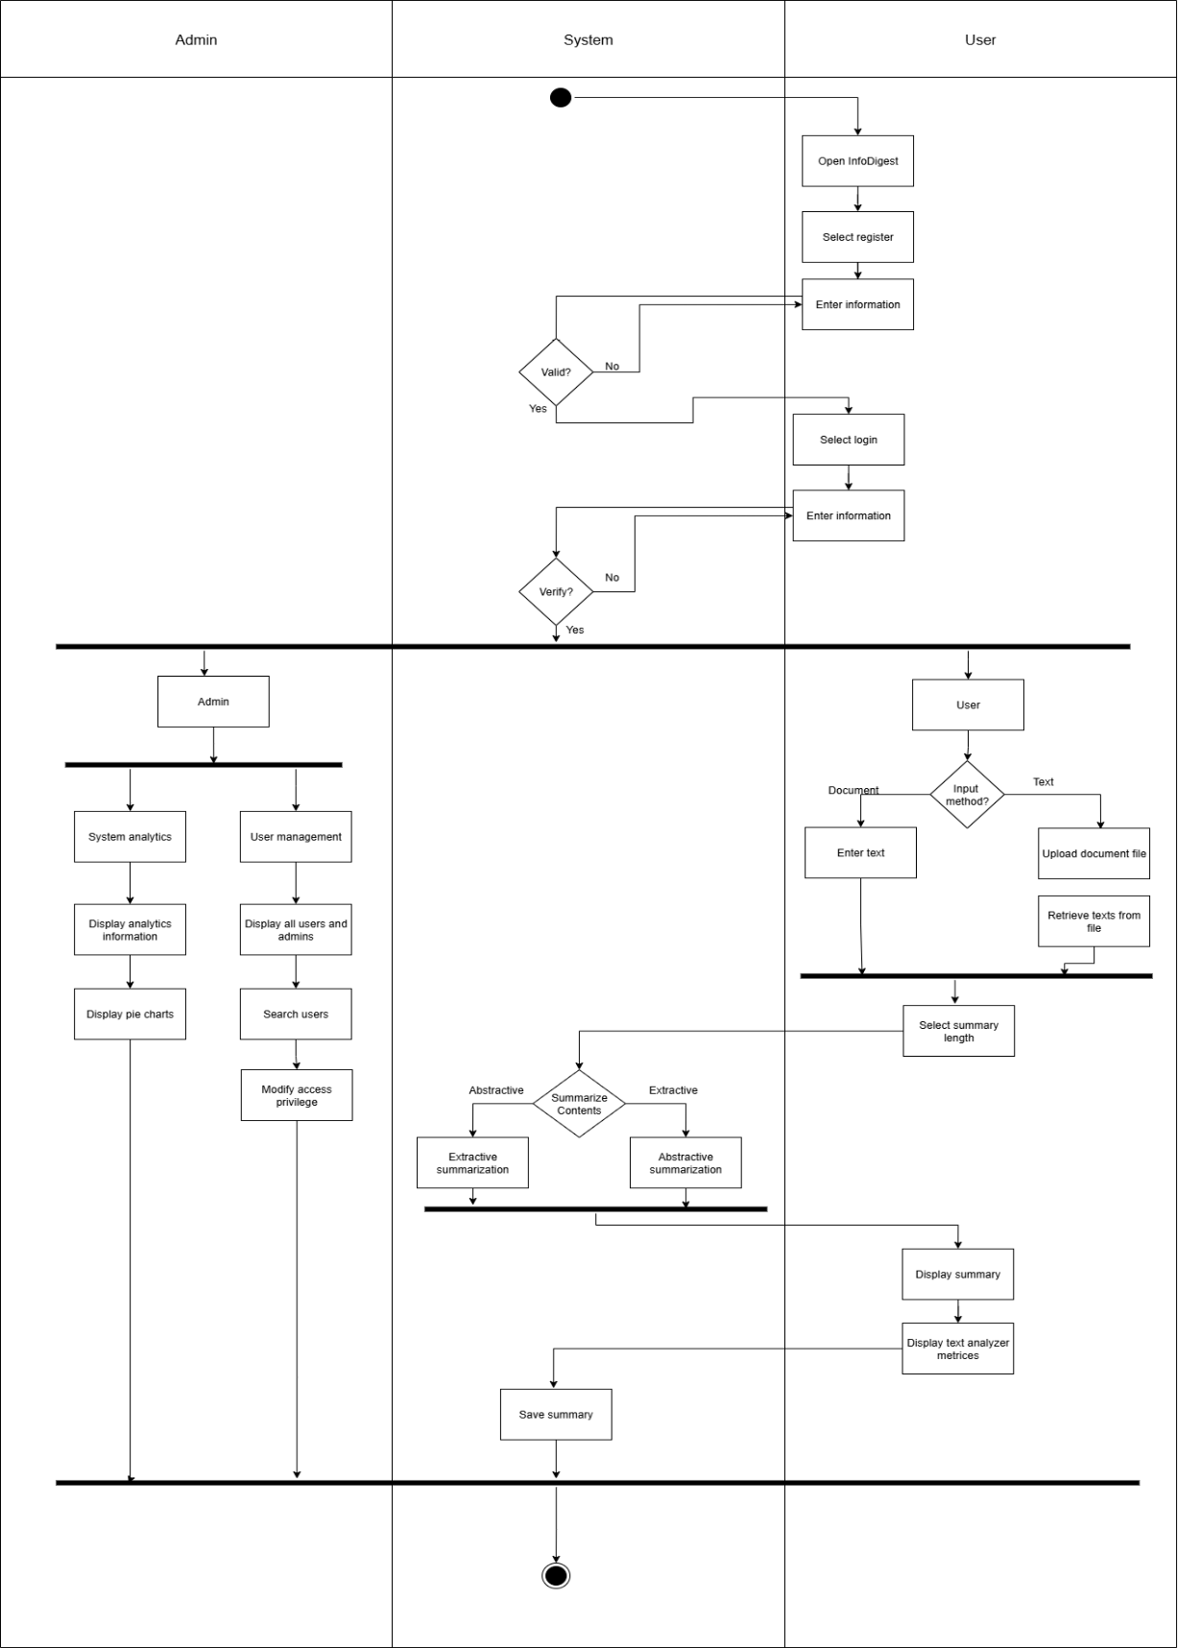
Figure 4.4: Refined activity diagram
The image in 4.4 is an activity diagram for the InfoDigest application. It begins with the user registration and login process. After successful authentication, the flow diverges based on the user type: Admin or a regular User. The User path details the process of either inputting text or uploading a document, selecting a summarization method (extractive or abstractive), and then viewing and saving the generated summary. The admin path outlines separate functionalities for managing user accounts and viewing system analytics, which are displayed in the form of metrics or pie charts. This diagram visually maps out the entire operational workflow of the application.

4.1.2 Component diagrams
A component diagram is used to illustrate the high-level architecture of a system, showing how the major components are organized and how they depend on each other. It provides a static view of the system's modular structure.
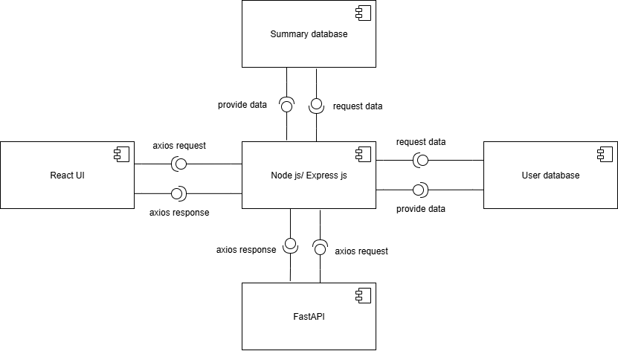
Figure 4.5: Component diagram
The image in 4.5 represents a component diagram for InfoDigest. At its center is the Node.js/Express.js backend, acting as the main hub that communicates with all other components. The React UI frontend sends and receives requests and responses from the backend using Axios. The FastAPI service, which handles complex summarization and analysis tasks, also communicates with the central backend via Axios. Finally, the two separate databases, User database and Summary database, are shown, with the main backend requesting and providing data to each to manage user information and store generated summaries respectively.

4.1.3 Deployment diagrams
A deployment diagram illustrates the physical architecture of a system, showing how the different software components are deployed across various hardware nodes and the connections between them. It provides a view of the physical environment where the system will run.
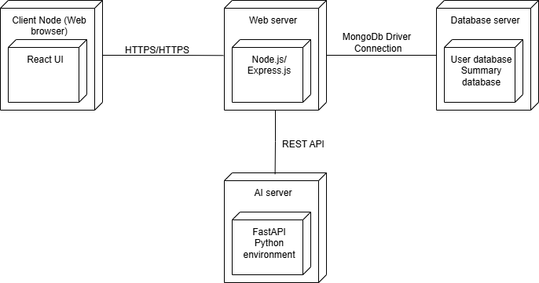
Figure 4.6: Deployment diagram
The figure in 4.6 is a deployment diagram for InfoDigest. It shows a client node representing the user's browser, where the React UI is deployed. This client communicates via HTTPS with a Web server, which hosts the Node.js/Express.js backend. This central backend then communicates with an AI server that hosts the FastAPI service via a REST API. Additionally, the backend connects to a Database server to interact with both the User database and Summary database via a MongoDB Driver Connection.

4.2 Algorithm Details
The algorithm details for the InfoDigest project are as follows:

4.2.1 Extractive Summarization
Extractive summarization is a technique where a summary is generated by selecting significant sentences or phrases directly from the original document. Unlike abstractive summarization, it does not generate new text but rather extracts existing content. This approach relies on identifying the most important parts of a text based on various linguistic and statistical features.

- Term Frequency-Inverse Document Frequency (TF-IDF)
TF-IDF is a numerical statistic that reflects how important a word is to a document in a collection or corpus. It is often used as a weighting factor in information retrieval and text mining.
The Term Frequency (TF) measures how frequently a term appears in a document:
$$TF(t,d)=\frac{Number of times term t appears in document d}{Total number of terms in document d}$$
The Inverse Document Frequency (IDF) measures how important a term is:
$$IDF(t,D)=log⁡\left(\frac{Total number of documents N}{Number of documents with term t in them​}\right)$$
Finally, TF-IDF is calculated as the product of TF and IDF:
TF-IDF(t, d, D) = TF(t, d) × IDF(t, D)
Higher TF-IDF scores indicate higher importance of a word in a specific document relative to the entire corpus. This metric can be used to assign scores to words within sentences, which then contribute to the overall importance score of a sentence.

- Cosine Similarity
Cosine similarity is a measure of similarity between two non-zero vectors of an inner product space. It measures the cosine of the angle between them. If the vectors are normalized to unit length, the dot product is the cosine similarity. For text summarization, sentences are often represented as vectors (e.g., using TF-IDF weights or word embeddings), and cosine similarity is used to find how similar two sentences are.
The formula for cosine similarity between two vectors A and B is:
$$similairty\left(A, B\right)= \frac{A . B}{\left|\left|A\right|\right| . |\left|B\right||}= \frac{\sum_{i=1}^{n}{A_{i}B_{i}}}{\sqrt{\sum_{i=1}^{n}{A_{i}^{2}}}\sqrt{\sum_{i=1}^{n}{B_{i}^{2}}}}$$
Where Ai​ and Bi​ are components of vector A and B respectively. A value of 1 means the vectors are identical, 0 means they are orthogonal (no similarity), and -1 means they are diametrically opposed. In summarization, this helps identify redundant sentences or group similar sentences together.

- K-Nearest Neighbors (K-Neighbors) for Graph Construction
While k-neighbors is typically a classification algorithm, its concept can be adapted to build a graph for text summarization algorithms like TextRank. In this context, each sentence in the document is a node in the graph. The edges between sentences are determined by their similarity (e.g., using cosine similarity).
To build the graph using a k-neighbors approach for TextRank:
- Each sentence is converted into a numerical vector using TF-IDF weights of its words.
- The cosine similarity between every pair of sentence vectors is calculated.
- For each sentence (node), identify its k most similar sentences based on the cosine similarity scores. An edge is drawn between the current sentence node and its k nearest neighbors. The weight of this edge can be the cosine similarity score itself. The value of k can be determined dynamically based on the total number of sentences in the input text:
- for texts with up to 15 sentences, k is 2
- for texts between 16 and 100 sentences, k is 5
- for texts with over 100 sentences, k is 10.
This creates a weighted graph where nodes are sentences and edges represent their similarity. The correct value of k is not fixed and should be altered as per the desired output.
This graph structure is crucial for algorithms like TextRank, as it models the relationships and interconnections between sentences in the document.

- TextRank Algorithm
TextRank is a graph-based ranking algorithm for text processing, inspired by Google's PageRank algorithm. It identifies the most important sentences in a text based on their "connectivity" within the graph of sentences.
The steps for TextRank are:
- The input text is divided into sentences, and each sentence is tokenized and preprocessed (e.g., stop word removal, stemming/lemmatization, part-of-speech tagging).
- Each sentence is represented as a node in a graph G=(V,E), where V is the set of vertices (sentences) and E is the set of edges between them.
- Edges are drawn between two sentences if their similarity score (e.g., cosine similarity based on shared words or TF-IDF vectors) exceeds a certain threshold, or by using a k-neighbors approach as described above. The edges are weighted by their similarity scores.
- The algorithm iteratively calculates a score for each sentence, similar to how PageRank scores web pages. The score of a sentence depends on the scores of the sentences it is connected to, and the weights of those connections. The TextRank score S(Vi​) for a vertex (sentence) Vi​ is given by:
$$S\left(V_{i}\right)=\left(1-d\right)+d × \sum_{V_{j}∈\ln{(V_{i})}}{\frac{w_{ji}}{\sum_{V_{k}∈Out\left(V_{j}\right)}{w_{jk}}}S(V_{j})}$$
Where:
- d is the damping factor (typically set to 0.85), which represents the probability of jumping to a random vertex.
- In(Vi​) is the set of vertices that point to Vi​ (sentences similar to Vi​).
- Out(Vj​) is the set of vertices that Vj​ points to (sentences that Vj​ is similar to).
- wji​ is the weight of the edge from Vj​ to Vi​ (e.g., their cosine similarity).
This process is iterated until the scores converge.
Once the scores for all sentences are stable, the sentences are ranked in descending order of their TextRank scores. The top-ranked sentences, up to a desired length or word count, are then selected to form the extractive summary, usually maintaining their original order within the document for coherence.

4.2.2 Abstractive algorithm
An abstractive summarization algorithm generates a summary by creating new sentences and phrases that capture the main ideas of the source text, rather than simply extracting existing sentences. This process requires a deep understanding of the source material.
The LongT5 transformer model is a type of abstractive summarization algorithm designed to handle very long documents, a common limitation for many transformer models. It is built upon the T5 (Text-to-Text Transfer Transformer) architecture but incorporates a local-global attention mechanism. This allows the model to process long sequences of text efficiently without a significant performance drop. Essentially, it can pay attention to all parts of a long document, enabling it to synthesize information from various sections to create a cohesive summary.
By using either local or transient-global attention, the model can scale to process input sequences of up to 16,384 tokens, a major leap from the typical 512-token limit of many transformer models.
- T5 framework
The T5 (Text-to-Text Transfer Transformer) framework is a unified model that handles a wide range of NLP tasks by treating every problem as a text-to-text task. This means that for any given input, the model's output is always a string of text. This approach simplifies the architecture and allows the same model, with the same training process, to be used for different tasks like summarization, question answering, translation, and classification.
- Translation: “translate English to German: How are you?” → “Wie geht es dir?”
- Summarization: “summarize: The article discusses climate change impacts…” → “Climate change affects ecosystems.”
- Classification: “sst2 sentence: The movie was great. label:” → “positive”

- Encoder–Decoder Structure of LongT5
The LongT5 model is an extension of the T5 framework, and it retains the core encoder-decoder structure while making a crucial modification to handle extremely long sequences of text.
The T5 framework treats text summarization as a text-to-text problem, using a standard encoder-decoder transformer architecture. This unified approach simplifies the process, as the same model and code can be applied to many different NLP tasks simply by changing the input format.
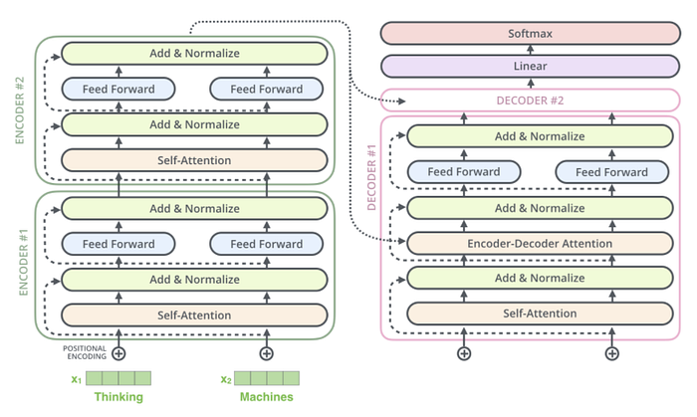
Figure 4.7: T5 Encoder-Decoder structure
The LongT5 model consists of two main parts:
- Encoder: The encoder's job is to read the entire input document and create a compressed, contextual representation. In standard T5, this is done with a full self-attention mechanism, which has a quadratic computational cost. LongT5 addresses this by replacing the standard attention with a more efficient, hybrid mechanism that scales linearly with input length. This mechanism uses a combination of two techniques:
  - Local Attention: Each token only attends to a fixed window of tokens around it (e.g., 128 tokens to the left and 128 to the right). This is computationally efficient and captures the local context well. This approach restricts attention to a fixed window of tokens around each token (e.g., 127 tokens to the left and right). The complexity is linear with respect to the input sequence length (l) and the window size (r), or O(l×r). Since r is a constant, this scales as O(l), a major efficiency improvement over the quadratic O(l2) of standard attention.
  - Transient-Global Attention: To prevent the model from losing the "big picture," certain key tokens are designated as "global" tokens. These global tokens attend to all tokens in the sequence, and all other tokens attend to them. This creates a bottleneck that forces the model to distill global context into a few representations, which the decoder can then access. The complexity of this mechanism is O(l(r+l/k)), where k is the block size used to create the global tokens. This also offers a significant efficiency gain over standard attention for long sequences.
This hybrid approach allows the LongT5 encoder to process long documents without the memory and computational burden of full attention.
- Decoder: The decoder's structure is largely similar to the standard T5 decoder. The decoder generates the summary based on the encoder's representation. It uses masked self-attention to generate the summary word by word and cross-attention to link its output to the encoder's understanding of the source document. This streamlined process allows LongT5 to deliver state-of-the-art results on long-form summarization tasks while being computationally practical. It uses two types of attention:
  - Decoder Self-Attention: This is a masked attention mechanism that ensures the decoder can only "see" the tokens it has already generated. This allows for sequential text generation.
  - Encoder-Decoder Cross-Attention: This is the crucial link between the encoder and decoder. The decoder uses this mechanism to "query" the encoder's output, essentially asking "Which parts of the original document are most relevant to what I'm generating right now?". This allows the decoder to produce a summary that is semantically aligned with the source text, even as it creates new phrases and sentences. The LongT5 decoder can use a standard cross-attention mechanism because the output summary is typically much shorter than the input document, so the quadratic scaling issue is not a concern here.
The decoder hidden states are projected to the vocabulary with a softmax layer. The probability of a summary sequence y = (y1, …, ym) given the input document x is:
$$P\left(y | x\right)= \prod_{t=1}^{m}{P(y_{t}|y_{<t},x)}$$
This ensures that the summary is both fluent (depending on past tokens) and faithful (depending on input).

IMPLEMENTATION AND TESTING

5.1 Implementation

5.1.1. Tools Used
The different tools and software used in the project are as follows:
- Platform: Windows
- Front end: React
- Back end: Express.js, FastAPI
- Database: MongoDB
- IDE: VS Code
- API Testing: Postman
- Model creation: Python, Jupyter Notebook
- Dataset: ccdv/arxiv-summarization, CNN/DailyMail
- Environment Management: Anaconda
- GPU: NVIDIA GeForce RTX 3060
- Diagraming tool: Draw io

5.1.2. Implementation Details of Modules
The modules of InfoDigest are as follows:

Module 1: Extractive Summarization
The extractive summarization is used to select the highest valued sentence from among the original corpus. The code for extractive summarization is written in python so, it is integrated in the MERN project using FastAPI to create API of the python functions.
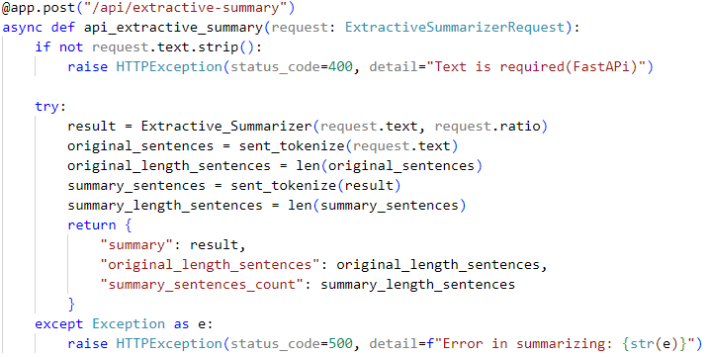
The FastAPI backend of “/api/extractive-summary” receives text and ratio as input which is used to perform extractive summary. It consists of the following imports:
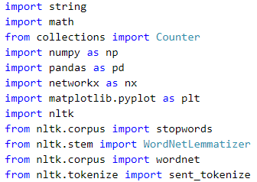

The Extractive_Summarizer consists of 2 main classes:
- TFIDFVectorizer
This function is used to calculate the TF-IDF vectors of the given input. The key components for a TF-IDF calculation system. self.corpus_word_counts will store the frequency of each word within individual documents, while self.document_frequency tracks how many different documents contain a particular word. self.vocabulary will hold all unique words encountered across the entire collection of documents, and self.num_documents will count the total number of documents processed. self.word_to_idx creates a numerical mapping for each unique word, and self.norm likely indicates the type of normalization to be applied to the calculated TF-IDF scores.
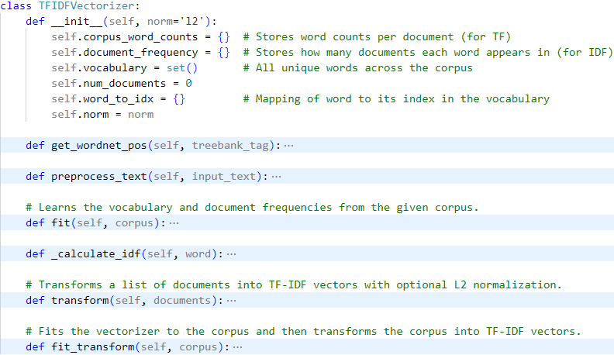
Here, the get_wordnet_pos function maps part-of-speech tags to WordNet's format, crucial for accurate lemmatization. The preprocess_text method cleans text by converting to lowercase, removing punctuation and stopwords, and performing lemmatization (reducing words to their base form) for consistent word representation.
The fit method is responsible for "learning" from a given corpus of documents. It iterates through each document, preprocesses it, and populates self.vocabulary (all unique words), self.document_frequency (how many documents each word appears in), and self.corpus_word_counts (word counts per document). It also establishes a word_to_idx mapping for vector representation.
The _calculate_idf method computes the Inverse Document Frequency for a given word using a "smooth IDF" variant, which helps prevent division by zero for words not present in the training corpus.
Finally, the transform method converts new documents (or the original corpus) into numerical TF-IDF vectors. For each document, it calculates the Term Frequency (TF) of each word (how often a word appears in that document) and combines it with the pre-calculated IDF to produce the TF-IDF score. Optionally, it applies L2 normalization to these vectors, which can be useful for downstream machine learning tasks. The fit_transform method conveniently combines the fit and transform steps.
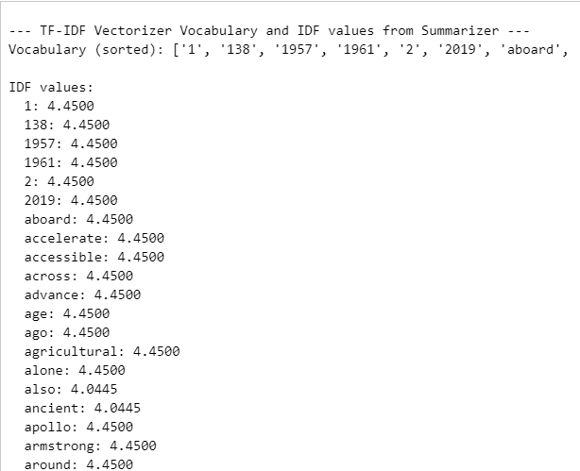
Figure 5.1: Vocabulary IDF values
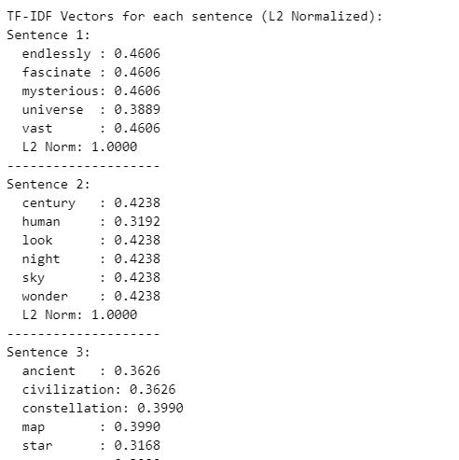
Figure 5.2: TF-IDF values after L2 normalization
- TextRankSummarizer
The TextRankSummarizer class is used to enforce the TextRank algorithm to identify the most valued sentence among the corpus. The TextRankSummarizer's constructor sets up the core parameters for its summarization process, including k_neighbors to define graph connectivity, damping_factor and max_iterations for the PageRank algorithm's behavior, and tolerance for convergence. It also initializes internal data structures to store sentences, their processed forms, TF-IDF representations, calculated PageRank scores, and the similarity graph, along with an instance of TFIDFVectorizer for text numericalization.
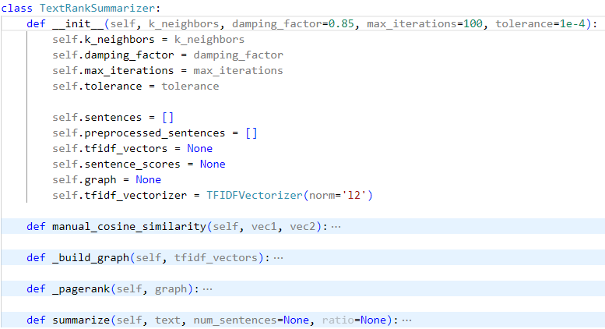
The manual_cosine_similarity function calculates the cosine similarity, a common metric in NLP, between two input vectors. It computes the dot product of the vectors and divides by the product of their magnitudes, returning 0.0 if either vector is a zero vector to prevent division by zero errors, thus providing a numerical measure of their semantic resemblance.
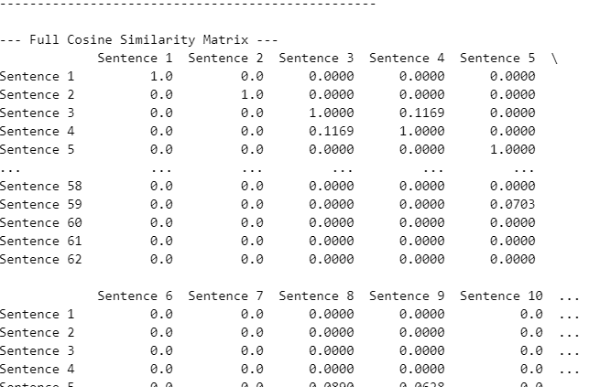
Figure 5.3: Cosine similarity matrix
The private helper function _build_graph is crucial for constructing the sentence similarity graph, the core of the TextRank algorithm. It first computes a pairwise cosine similarity matrix between all sentence TF-IDF vectors. Then, based on the k_neighbors parameter, it identifies and connects the top-K most similar sentences with weighted edges in a NetworkX graph, visually enhanced with debugging prints and Matplotlib visualizations.
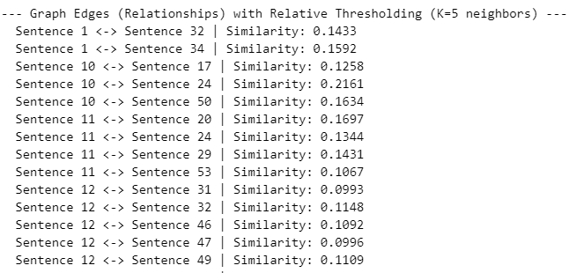
Figure 5.4: Sentence similarity
The private helper function _pagerank implements a customized PageRank algorithm, central to determining sentence importance. It iteratively calculates a "score" for each sentence (node) in the graph, where scores propagate based on neighbor importance and edge weights, driven by a damping_factor. The process continues until scores converge or a maximum iteration limit is reached, ultimately identifying the most central and relevant sentences.
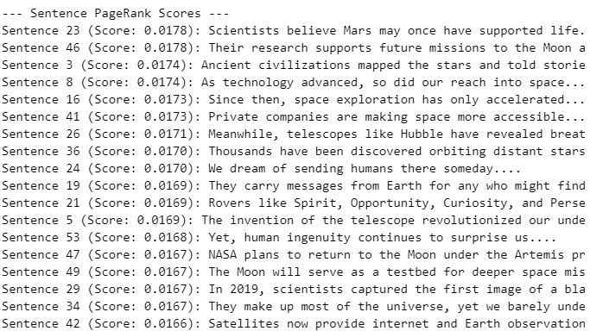
Figure 5.5: Page rank algorithm
The summarize function is the main orchestrator for text summarization. It tokenizes the input text into sentences, converts them into TF-IDF vectors using the internal tfidf_vectorizer, and then constructs the sentence similarity graph via _build_graph. Subsequently, it applies _pagerank to score sentence importance. Finally, it sorts sentences by their scores and extracts the top-ranked ones to form the summary, either by a specified number of sentences or a ratio of the original text length.
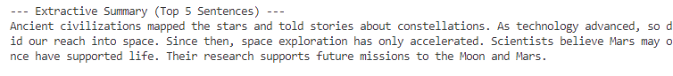
Figure 5.6: Extractive summary result

Module 2: Abstractive summarization
The abstractive summarization module consists of a robust process for fine-tuning a LongT5 model to perform abstractive summarization. The first key step involves the intelligent management of model checkpoints. The code is designed to automatically detect and load the most recent checkpoint from the results directory, which is crucial for resuming training from a previous state without starting over. This allows for long-running training sessions to be robust against interruptions. The notebook then loads the ccdv/arxiv-summarization dataset, which contains academic papers and their abstracts, and a custom preprocess_function prepares the data for the model by tokenizing and formatting the text. The articles and abstracts are truncated to specific lengths to fit the model's input requirements.

Sample:
Article: additive models @xcite provide an important family of models for semiparametric regression or classification . some reasons for the success of additive models are their increased flexibility when compared to linear or generalized linear models and their increased interpretability when compared to fully nonparametric models .
it is well - known that good estimators in additive models are in general less prone to the curse of high dimensionality than good estimators in fully nonparametric models…

Summary: additive models play an important role in semiparametric statistics .
this paper gives learning rates for regularized kernel based methods for additive models .
these learning rates compare favourably in particular in high dimensions to recent results on optimal learning rates for purely nonparametric regularized kernel based quantile regression using the gaussian radial basis function kernel , provided the assumption of an additive model is valid…

Following the data preparation, the notebook sets up the training environment. It loads the LongT5ForConditionalGeneration model and its corresponding tokenizer from the identified checkpoint. The TrainingArguments class from the transformers library is used to define key parameters for the training loop, such as the output directory, evaluation and saving strategies, learning rate, batch sizes, and the number of training epochs.
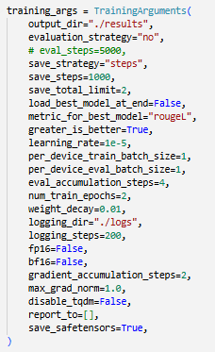
Figure 5.7: Training arguments of abstractive summarization
Notably, a custom callback, ClipNanGradientsCallback, is implemented to prevent gradient explosion, a common issue in deep learning that can destabilize training. This callback ensures that the gradients are clipped to a maximum norm of 1.0, promoting stable and reliable training. The Trainer object is then instantiated with the model, training arguments, datasets, and a data collator, which handles padding and batching of the tokenized data.
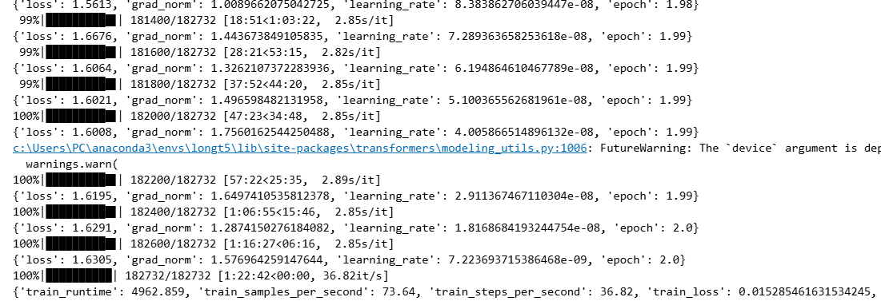
Figure 5.8: Training process
The result of fine tuning LongT5 model after 2 epochs on arxiv dataset is as follows:
TrainOutput(global_step=182732, training_loss=0.015285461631534245, metrics={'train_runtime': 4962.859, 'train_samples_per_second': 73.64, 'train_steps_per_second': 36.82, 'total_flos': 2.002116063264768e+18, 'train_loss': 0.015285461631534245, 'epoch': 1.999994527534709})
Finally, the notebook includes sections for generating and evaluating summaries. A dedicated function is provided to compute ROUGE scores, which are a standard metric for evaluating summarization models. The rouge_scorer from the rouge_score library is used to compare the generated summaries against the human-written reference abstracts. This quantitative evaluation, along with a qualitative example of a generated summary, provides a clear measure of the model's performance. The entire notebook forms a complete and self-contained workflow, demonstrating best practices for fine-tuning a large language model on a specific task.
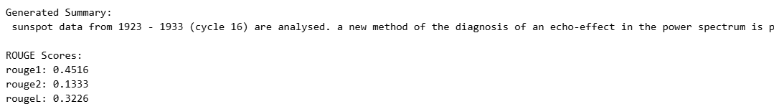
Figure 5.9: Abstractive summary result

Module 3: Registration
This module allows the user to register to the system so that they can have a personalized feel and have access to their user history. This module consists of entering user information, which the system validates so that there is no conflict of information based on username and email address.
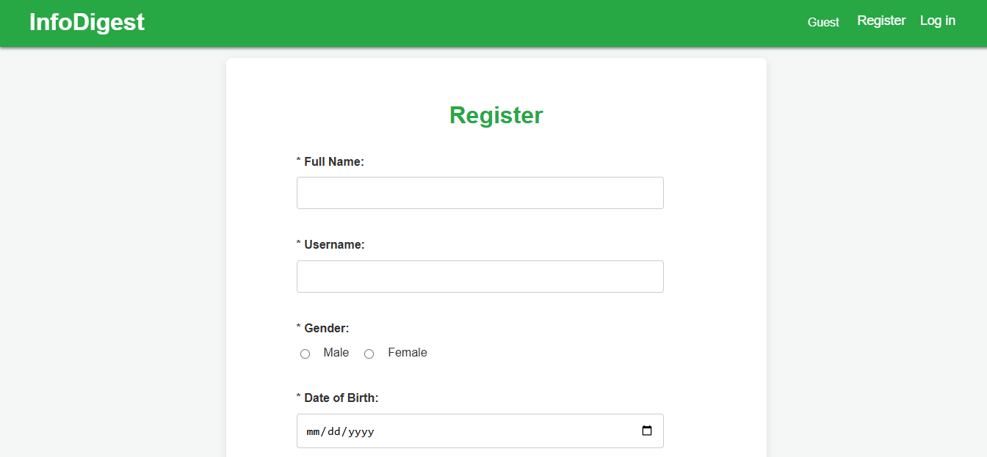
Figure 5.10: Registration module

Module 4: Login
This module allows the user to log in to the system to have access to their personal history and save activity in the system. This module consists of entering user information and password, which is verified by the system and authenticates the user.

Figure 5.11: Login module

Module 5: User profile
This module allows the user to access their profile which consists of their user information and their history of all the summary actions performed. A user can only access user profile of themselves. An admin can access user profile of any user in the system.
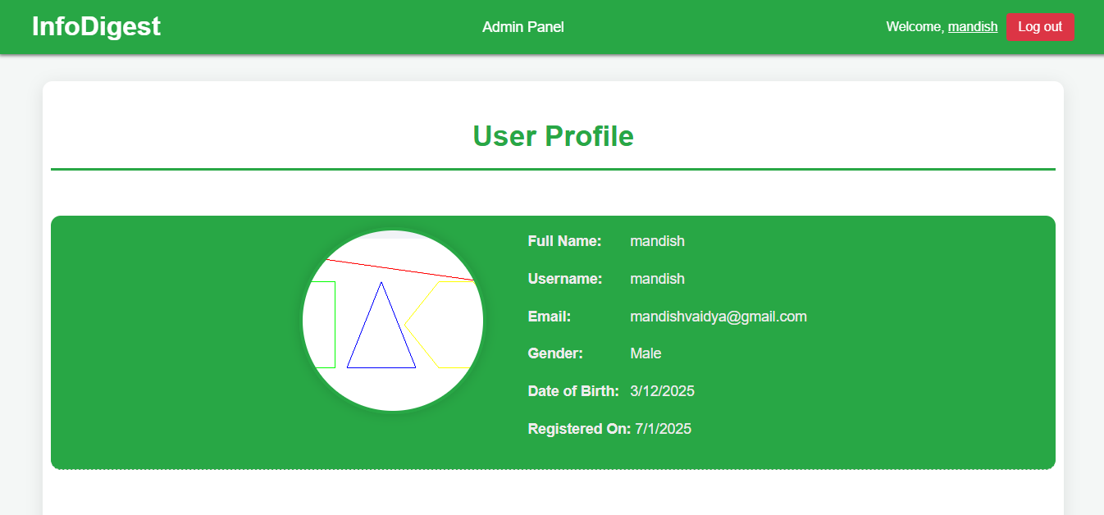
Figure 5.12: User profile module
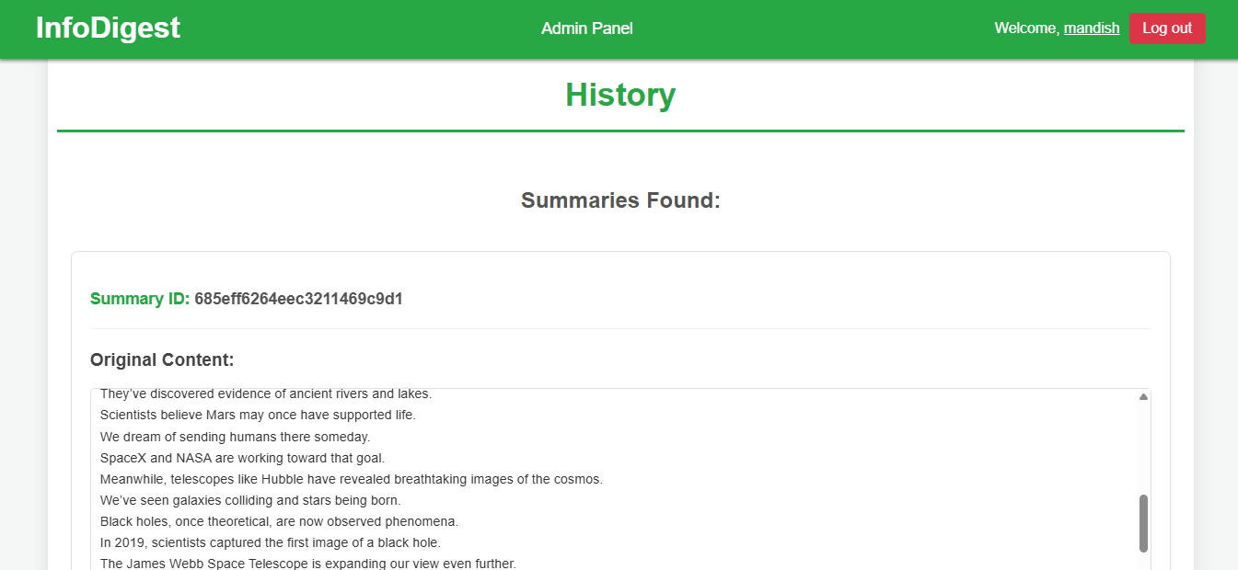
Figure 5.13: User history

Module 6: Manage users
This module is unique to only the admin of the system. This module allows the admin to view all the existing users and existing admins of the system. It also allows the admin to modify access privileges which can be set to normal user or admin. The current admin cannot modify access privileges of themselves.

Figure 5.14: Manage user module

Module 7: Analytics
This module is unique to only the admin of the system. This module allows the admin to view all the analytics of the system. It displays statistical information along with pie charts to visualize and summarize the information related to the system and its activities.
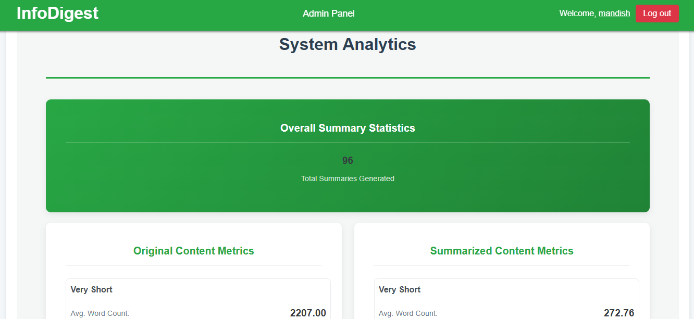
Figure 5.15: Analytics module - 1
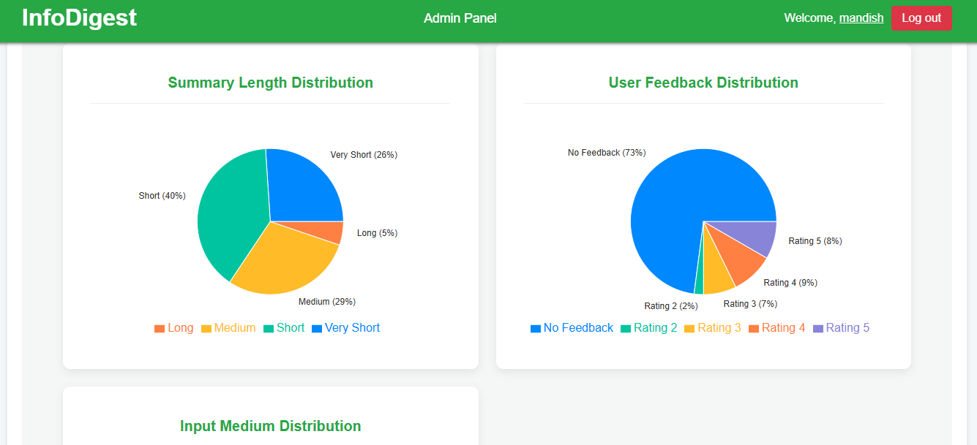
Figure 5.16: Analytics module - 2

5.2. Testing

5.2.1. Test Cases for Unit Testing
Unit testing is a software development process where the smallest testable parts of an application, called units, are individually and independently analyzed for proper operation. The primary purpose is to validate that each unit of the software performs as designed and to quickly detect bugs early in the development cycle.
Test scenario: To check if login module is working correctly.

Table 5.1: Unit testing for login module
TestID | Test steps | Test data | Expected result | Actual result | Status
UT11 | Enter valid username and password. Then press login button. | username: “mandish”  password: “mandish123” | The user should log in successfully and be redirected to the summarizer page. | The user logs in successfully and is redirected to the summarizer page. | Pass
UT12 | Enter invalid username and password. Then press login button. | username: “ramShyam”  password: “ram123” | “User not found” error message should be displayed. | “User not found” error message is displayed. | Pass
UT13 | Enter valid username and invalid password. Then press login button. | username: “mandish”  password: “123456M” | “Incorrect password” error message should be displayed. | “Incorrect password” error message is displayed. | Pass
UT14 | Do not enter anything. Then press login button. | username: “”  password: “” | “Username is required” and “Password is required” error message should be displayed. | “Username is required” and “Password is required” error message is displayed. | Pass

Test scenario: To check if summarizer module is working correctly.

Table 5.2: Unit testing for summarizer module
TestID | Test steps | Test data | Expected result | Actual result | Status
UT21 | Enter a long sentence for text input type. Then press summarize button. | text: “InfoDigest is an AI-powered web application designed…” | The summary and its metrics should be displayed. | The summary and its metrics are displayed. | Pass
UT22 | Do not enter anything. Then press summarize button. | text: “” | “Error: Please enter some text first.” error message should be displayed. | “Error: Please enter some text first.” error message is displayed. | Pass
UT23 | Enter a long sentence for text input and short summary length. Then press summarize button. | text: “InfoDigest is an AI-powered web application…”  summary length: “short” | A short summary and its metrics should be displayed. | A short summary and its metrics are displayed. | Pass
UT24 | Select file input. Upload document. Then press summarize button. | file: “final.docx” | The summary and its metrics should be displayed. | The summary and its metrics are displayed. | Pass

5.2.2. Test Cases for System Testing
System testing is a type of software testing that is conducted on a complete, integrated system to evaluate the system's compliance with its specified requirements. The purpose of this testing is to validate the end-to-end functionality of the application in an environment that is as close to production as possible.

Table 5.3: System testing
TestID | Test steps | Test data | Expected result | Actual result | Status
ST1 | Enter a long sentence for text input type. Then press summarize button. | text: “InfoDigest is an AI-powered web application designed…”  summaryType: “extractive” | The extractive summary and its metrics should be displayed. | The extractive summary and its metrics are displayed. | Pass
ST2 | Enter a long sentence for text input type. Then press summarize button. | text: “InfoDigest is an AI-powered web application designed…”  summaryType: “abstractive” | The abstractive summary and its metrics should be displayed. | The abstractive summary and its metrics are displayed. | Pass
ST3 | Select file input. Upload document. Then press summarize button. | file: “final.docx” | The summary and its metrics should be displayed. | The summary and its metrics are displayed. | Pass
ST4 | Enter valid username and password. Then press login button. | username: “mandish”  password: “mandish123” | The user should log in successfully and be redirected to the summarizer page. | The user logs in successfully and is redirected to the summarizer page. | Pass
ST5 | After summarization, select a feedback option. Then press submit feedback button. | option: 4 | “Summary feedback updated successfully!” pop up should be displayed. | “Summary feedback updated successfully!” pop up is displayed. | Pass
ST6 | Open user profile by clicking on username on status bar. | username: “mandish” | The user profile of the current user should be displayed. | The user profile of the current user is displayed. | Pass

5.3. Result Analysis
Result analysis for InfoDigest, would involve a systematic evaluation of the effectiveness of both extractive and abstractive summarization methods. This analysis compares the quality, coherence, and accuracy of the summaries generated by each approach.

5.3.1 Extractive Summarization Analysis:
We evaluated the extractive summarization system on a subset of 200 documents from the CNN/DailyMail (3.0.0) test set. The system achieved the following ROUGE F1 scores:
- ROUGE-1: 0.2803
- ROUGE-2: 0.0903
- ROUGE-L: 0.1876
These metrics provide an indication of how closely the generated summaries overlap with human-written reference highlights. ROUGE-1 captures unigram overlap, measuring basic word coverage. ROUGE-2 considers bigram overlap, reflecting the preservation of short phrases and local coherence. ROUGE-L evaluates the longest common subsequence, which reflects sentence-level structure and ordering similarity.

For context, we compare our results against well-known baselines:
Lead-3 Baseline (reported):
- ROUGE-1 ≈ 0.40–0.43
- ROUGE-2 ≈ 0.17–0.20
- ROUGE-L ≈ 0.36
TextRank (reported in prior work):
- ROUGE-1 ≈ 0.30–0.33
- ROUGE-2 ≈ 0.11–0.13
- ROUGE-L ≈ 0.25–0.28

Interpretation
The system’s performance is below the Lead-3 baseline, which is a strong heuristic for news summarization since the most important information often appears in the first three sentences of articles. Compared to published TextRank baselines, the system’s scores are slightly lower across all metrics. Specifically, the ROUGE-1 and ROUGE-2 scores are close to but below the expected range, while ROUGE-L is noticeably lower. This suggests that while the system can capture some relevant content, it struggles to consistently align with the reference summaries in terms of structure and sentence selection.
Overall, the evaluation shows that the extractive summarization system produces reasonable results but does not yet match the performance of strong baselines such as Lead-3 or standard TextRank implementations.

5.3.2 Abstractive Summarization Analysis:
We evaluated the LongT5 model on a subset of 100 documents from the arXiv test set. The evaluation used ROUGE metrics to measure the overlap between generated summaries and the reference abstracts. The system achieved the following average ROUGE F1 scores:
- ROUGE-1: 0.4118
- ROUGE-2: 0.1619
- ROUGE-L: 0.2431
These metrics reflect different aspects of summary quality. ROUGE-1 captures unigram overlap, indicating basic content coverage. ROUGE-2 measures bigram overlap, assessing the model’s ability to preserve short phrases and fluency. ROUGE-L evaluates the longest common subsequence, reflecting structural and sentence-level similarity to the reference.

For abstractive summarization on scientific articles (arXiv dataset), the reported baselines typically achieve:
- ROUGE-1: 0.41–0.44
- ROUGE-2: 0.15–0.18
- ROUGE-L: 0.24–0.26

Our model’s performance aligns well with these ranges, indicating that it generates summaries that capture the essential content and structure of scientific abstracts. The ROUGE-1 score of 0.4118 shows that a substantial portion of key terms and concepts is preserved. ROUGE-2 (0.1619) reflects the model’s ability to maintain coherent phrase-level content, while ROUGE-L (0.2431) suggests moderate preservation of sentence-level structure.

Interpretation
The results demonstrate that the LongT5 model effectively generates abstractive summaries that are informative and reasonably faithful to the reference abstracts. The ROUGE scores indicate that the model captures the main points of each scientific paper while maintaining coherence and grammatical correctness. Some loss in ROUGE-L relative to ROUGE-1 suggests minor differences in sentence structure between the generated and reference summaries, which is expected in abstractive summarization.
Overall, the LongT5 model shows strong performance for abstractive summarization of long scientific documents. The results are consistent with published benchmarks and demonstrate the model’s ability to produce concise and informative abstracts. Future improvements could include fine-tuning on domain-specific subsets, increasing beam search size for better content coverage, or experimenting with length constraints to optimize summary conciseness.

CONCLUSION AND FUTURE RECOMMENDATIONS

6.1. Conclusion
InfoDigest is a powerful web application that effectively tackles the problem of information overload in research and scientific fields. By using advanced AI to create concise summaries of large texts ranging from research papers to standard documents, it makes information more manageable. The system's ability to create both extractive and abstractive summaries is built on a strong foundation, often powered by state-of-the-art models like LongT5.
More than just a summarizer, InfoDigest offers a complete solution with a simple interface, secure user login, and features like keyword extraction and a history of past summaries. This makes it a comprehensive tool for knowledge management. Its well-designed structure also makes it easy to integrate future upgrades, such as RAG models, to further improve the quality of its summaries. Ultimately, InfoDigest is a valuable tool that not only automates a tedious process but also helps researchers more quickly access and use key information.

6.2. Future Recommendations
Looking ahead, the future development of InfoDigest should focus on evolving it from a powerful summarization tool into a more comprehensive and intelligent research assistant. A key recommendation is to integrate a Retrieval-Augmented Generation (RAG) system to enhance summary quality by cross-referencing and enriching the generated content with external, authoritative data. This would allow the platform to produce more factual and contextually rich summaries. Furthermore, the summarization models could be fine-tuned on domain-specific datasets (e.g., medical, legal, or financial) to improve accuracy and relevance for specialized users. To expand its utility, InfoDigest should also pursue integrations with major research databases like PubMed or arXiv, enabling direct summarization of scholarly articles without the need for manual file uploads. Finally, incorporating advanced features such as collaborative annotation and a personalized "research feed" could transform InfoDigest into a central hub for knowledge management, empowering researchers with a tool that not only processes information but also facilitates discovery and collaboration.

REFERENCES

[1] | Grammarly, "Grammarly AI Writing Tools," [Online]. Available: https://www.grammarly.com/ai/ai-writing-tools/summarizing-tool. [Accessed 20 May 2024].
[2] | QuillBot, "QuillBot," [Online]. Available: https://quillbot.com/summarize. [Accessed 20 May 2024].
[3] | Scribbr, "Scribbr," [Online]. Available: https://www.scribbr.com/text-summarizer/. [Accessed 20 May 2024].
[4] | Summarizer.org, "Summarizer.org," [Online]. Available: https://www.summarizer.org/. [Accessed 20 May 2024].
[5] | T. Cao, H. Lee and Y. Choi, "Hybrid Extractive-Abstractive Summarization with Retrieval-Augmented Generation," 2023.
[6] | A. Vaswani, N. Shazeer, N. Parmar, J. Uszkoreit, L. Jones, A. N. Gomez, Ł. Kaiser and I. Polosukhin, "Attention Is All You Need," in Advances in Neural Information Processing Systems (NeurIPS), 2017.
[7] | L. Fred, "Automatic Text Summarization with Machine Learning: An Overview," 2021. [Online]. Available: https://medium.com/luisfredgs/automatic-text-summarization-with-machine-learning-an-overview-68ded5717a25.
[8] | B. Sharma, A. Choudhary, M. Ahmad and S. Kharel, "Evaluation of Extractive and Abstractive Approaches for Text Summarization," Engineering Proceedings, vol. 59, no. 1, p. 194, 2023.
[9] | M. Anwar, R. Raj and K. Yadav, "Text Summarization using Deep Learning: A Study on Automatic Summarization," 2024. [Online]. Available: https://www.researchgate.net/publication/388159354_Text_Summarization_using_Deep_Learning_A_Study_on_Automatic_Summarization.
[10] | Y. Gong and X. Liu, "Text summarization using Latent Semantic Analysis," 2001.

APPENDICES

Landing page:
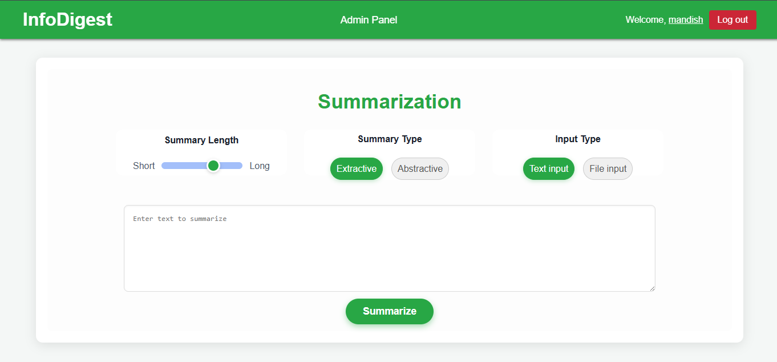

File input type:
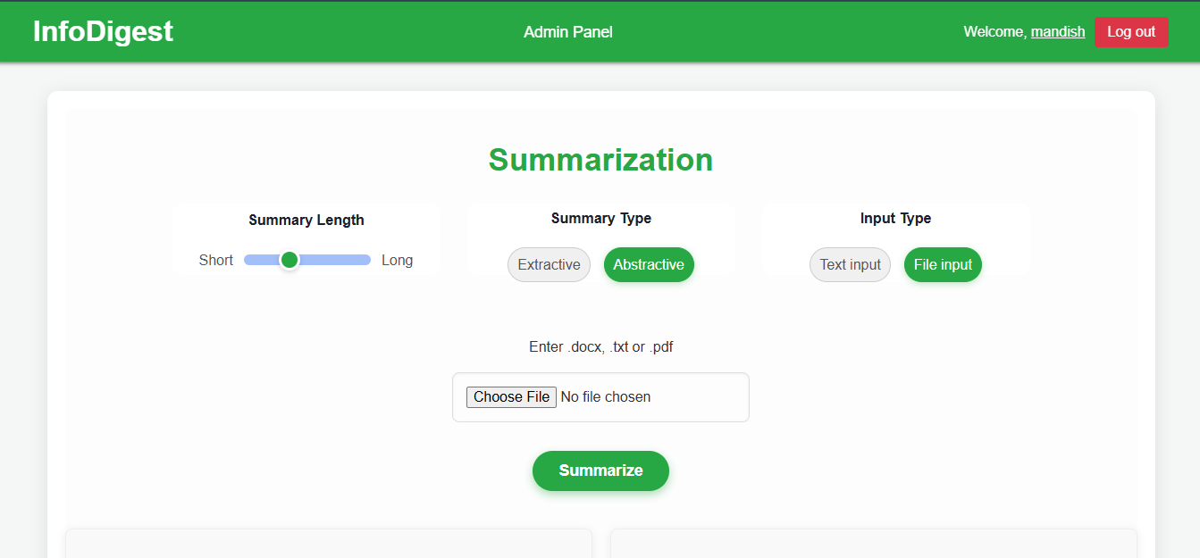

Summary: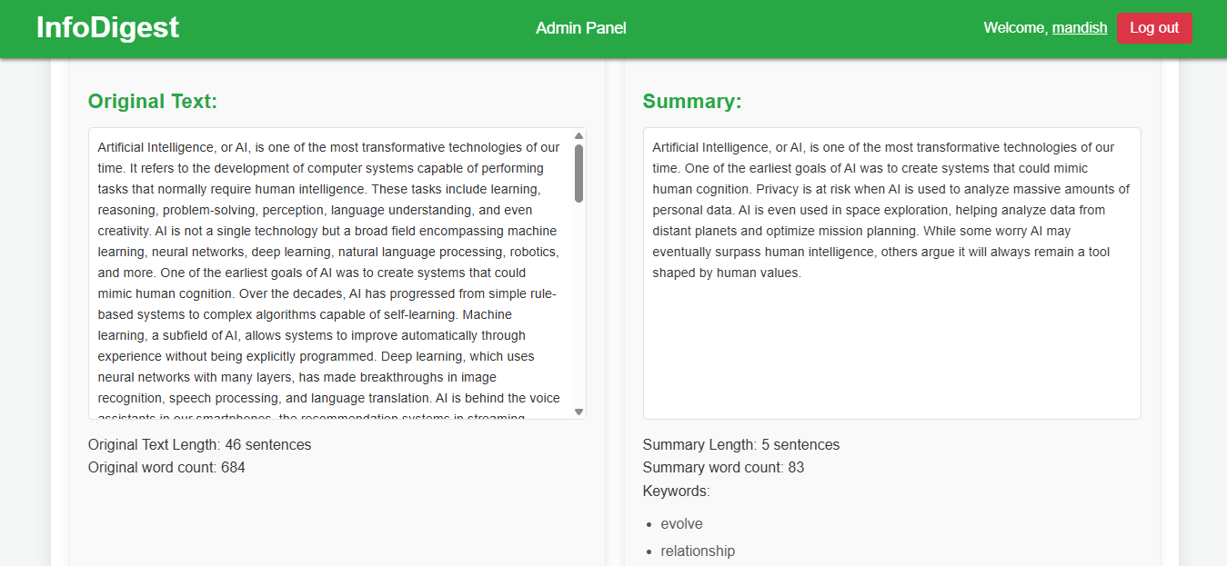

Summary stored message:
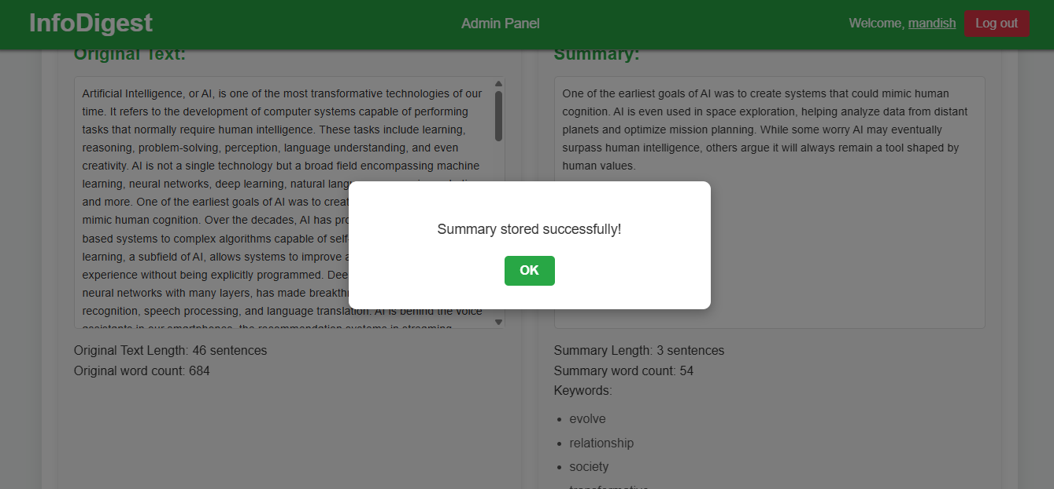

Feedback section:

Feedback update message:


User access modifier: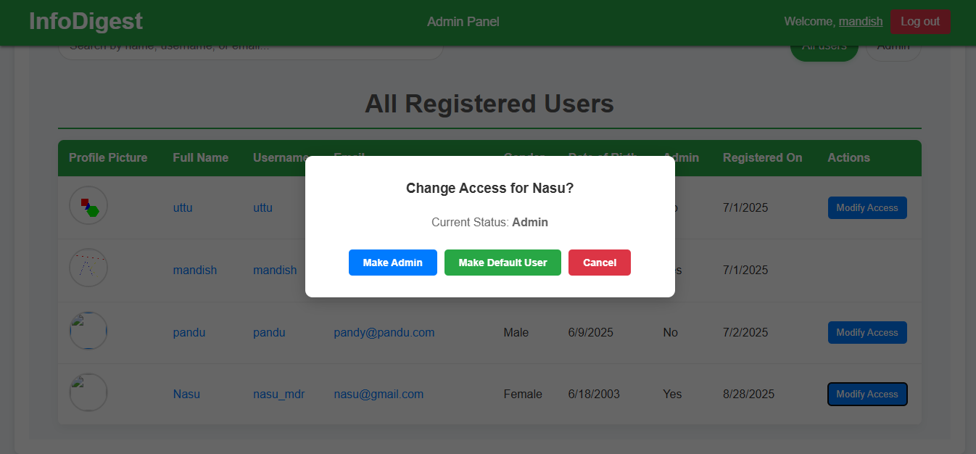

Registered admins:

