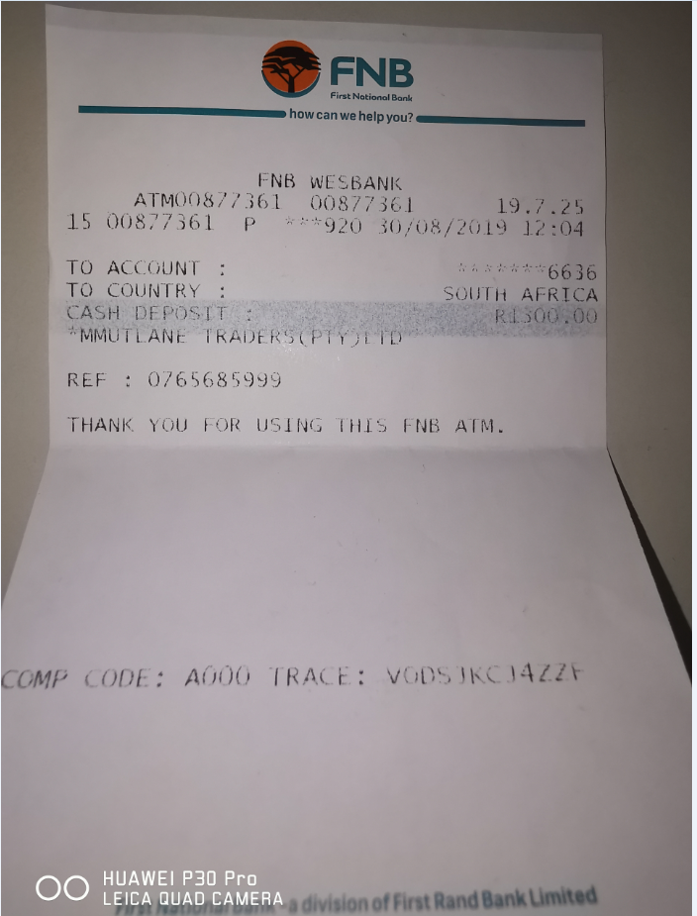

CURRICULUM VITAE

PHILLIP MANDLA MTOMBENI

PERSONAL PARTICULARS

SURNAME | Mtombeni
FIRST NAME | Phillip Mandla
COMMONLY KNOWN AS | Mandla
CONTACT DETAILS | +27 827230343, 0765685999, 0765444098 or 0733607334
E-MAIL ADDRESS | pmmtombeni@gmail.com
PHYSICAL ADDRESS | 37 CarlsWald Manor,8TH ROAD,CARLWALD,MIDRAND 1682
LANGUAGES | PROFICIENCY | SPEAK | READ | WRITE
LANGUAGES | ENGLISH | GOOD | GOOD | GOOD
LANGUAGES | AFRIKAANS | GOOD | GOOD | GOOD
LANGUAGES | SESOTHO | GOOD | GOOD | GOOD
LANGUAGES | SETSWANA | GOOD | GOOD | GOOD
LANGUAGES | ZULU | GOOD | GOOD | GOOD
LANGUAGES | XHOSA | GOOD | GOOD | GOOD

QUALIFICATIONS

QUALIFICATION | INSTITUTION | YEAR
Postgraduate Diploma in Business Management or Honours | Regenesys Business School | 2015
Matric | Thuto Tiro Comprehensive School | 1998

SUMMARY OF SKILLS

1. Training Only
2. Limited Practical Experience
3. Thorough Practical Experience
4. Extensive Practical Experience

INTERPERSONAL SKILLS / REPORTING | LEVEL
Documentation | 4
Communication  - Within Team  - With Clients / Users  - With Management | 4
Client Relationship  - Formal  - Informal | 4
Resolve Issues | 4
Knowledge Transfer | 4
User Support | 4

OPERATING SYSTEMS | LEVEL
Windows XP | 4
Windows 98 | 4
Windows 2000 | 4
Windows 8 | 4

NETWORKING | LEVEL
LAN | 3
WAN | 2
TCP/IP | 2
SMTP | 3

Referee 1:
Name: | Tumedi Madihlaba
Relationship: | he is my mentor
Telephone Number: | 0713895994 or 0116326932
E-mail address: | tbmadihlaba@gmail.com

Referee 2:
Name: | Ms Tsholofelo Maeko
Relationship: | She is my mentor
Telephone Number: | 0827230343
E-mail address: | tsholos.maeko@gmail.com

Referee 3:
Name: | Matikita Mphahlele
Relationship: | He is my mentor
Telephone Number: | 0828625958 0116322606
E-mail address: | matikita02@gmail.com or matikitam@gmail.com


