**An Entire MBA in 1 Course**

**Squarespace.com**

**Sharkvitualreality.com**

**Process**

**Methodology**

**Systems**

**1 Marketing plan emailing list,regularly,follow up, CRM**

**NBNBNBNBNB**

**Notning else will matter if you don’t get customers :FOCUS NUMBER 1**

**2Allience building: list key members,insuranece broker: WHO NEEDS TO BE ON MY TEAM, make them part of the buniness plan**

**3Crisis Planning Eskom load shedding,disaster recovery,new competitor**

**4 Key documenting storage**

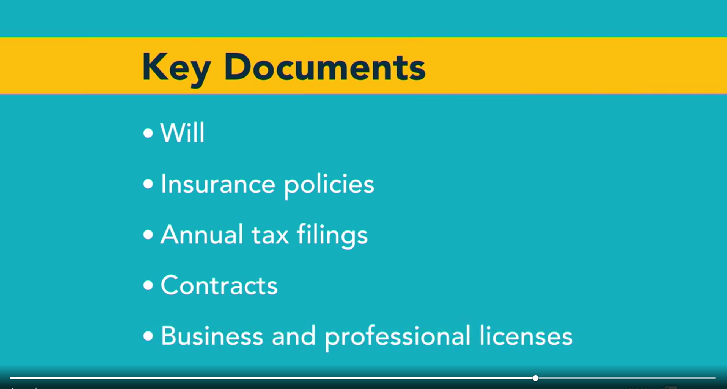

**5 Exit plan**

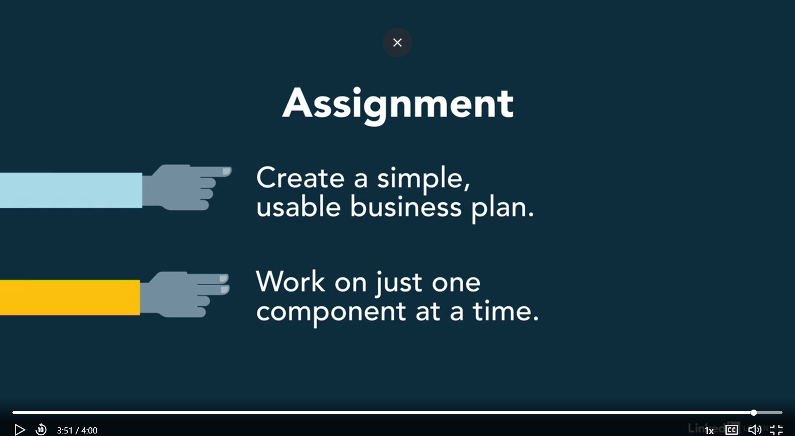

**10.2.1 ENTREPRENEURSHIP CAPSTONE PROJECT [100]**

Entrepreneurship is defined as a process of launching, developing and running a new business. It begins as a small venture and continues to grow into a large corporate firm. Traditionally, an entrepreneur is someone who takes a lot of risks to reap rewards for the services or products that are offered.

**You are required to draw up a comprehensive strategic plan (Business Plan) for an entrepreneurial venture that you have identified.**

The project report must have the following components:

1. A description of the organisation, including the mission and long term objectives.

2. A description of the industry in which the organisation operates including a competitive analysis and identification of key success factors.

3. A detailed SWOT analysis for the organisation.

4. Identification of and evaluation of potential growth strategies.

5. A detailed business plan

The project will be assessed in terms of the following allocation:

