SCHOOL OF INFORMATION TECHNOLOGY

MASTER OF INFORMATION TECHNOLOGY



GROUP ASSIGNMENT

COVER PAGE

|  |  |
| --- | --- |
| **Student Number** | **Name of Students (in alphabetical order)** |
| 28458207 | Ayong Kenneth |
| 13268831 | Kingenga Mandiangu .E. |
| 13090012 | Makura Sheunesu .M. |
| 15327494 | Mokoena Jacqueline .S. |
| 15309666 | Mvundla Zenzo |
| 23250195 | Ramatsetse Miclass |
| 14434662 | Zingwe Lloyd |
|  |  |
| Contact email address | MakuraSM@tuks.co.za |
| Contact telephone number | 0846062447 |

|  |  |  |
| --- | --- | --- |
| Name of Module | | Digital Economy |
| Module Code | | MIT 851 |
| Name of Lecturer(s) | | Prof Ian Strydom and Mr Louw Labuschagne |
| Date of Submission | | 16 October 2015 |
| Declaration: | *I declare that this assignment, submitted by our group, is the group’s own work and that we have referenced all the sources that we have used.* | |
| Signature of Leader | |  |

|  |  |
| --- | --- |
| Date received |  |
| Signature of Administrator |  |

|  |  |
| --- | --- |
| Mark |  |
| Date |  |
| Signature of Lecturer |  |



BabySittersOnTheGo Pvt Ltd

Business Plan

Table of Contents

1. Introduction 1

2. Purpose 1

3. Executive summary 1

4. Business description 1

4.1. Industry Analysis 1

4.2. Background Information 3

4.2.1. Basic Company information 3

4.2.2. Management Structure 3

4.3. Business Processes 3

4.3.1 Baby sitters booking 3

4.3.2 Hiring process 4

4.4. Vision 4

4.5. Mission 5

4.6. Business Goals 5

4.6.1 Short term goals 5

4.6.2. Long term goals 5

5. Marketing plan 5

5.1. Customer Identification 5

5.2. Customer needs 5

6. Competitor analysis 6

6.1. Competitor Description 6

6.2. Competitive advantage 8

7. Advertising plan 8

7.1. Pricing Strategy and Policy 9

7.2. Delivery and Payment 9

8. Research & Development 9

8.1. Transport 9

8.2. Technology: 9

8.3. Future developments 10

9. Risk Management 10

10. Financials 12

11. Timeline 12

12. Site evaluation plans 1

Introduction

BabySittersOnTheGo pvt ltd is an established Gauteng based child-care e-business organisation that provides trained and experienced baby sitters on demand in Gauteng thereby sharing the parenting duties with the parents. BabySittersOnTheGo will be providing Gauteng parents with baby sitters upon request. The baby sisters provided will be well trained, proficient in English, have experience and be background checked.

Purpose

The purpose of this business plan is to provide a proposal for the suggested e-business that is BabySitterOnTheGo. The business plan will outline the mission, objectives and strategies to be used in implementing the proposed e-commerce.

Executive summary

Business description

* 1. Industry Analysis

The schedule constraints brought about by the modern family systems has created a massive opportunity for the business of caring for kids. A number of factors collectively contribute to this phenomenon. Statistics South Africa published statistical release P0305 called recorded live births 2014. The document presents information on recorded live births in South Africa between 1994 and 2014. The release indicates that the number of births that occurs yearly is always above 800 000. Of these births, Gauteng has the highest number relative to other provinces. This scenario suggests that the child care industry is on an upward growth trend.

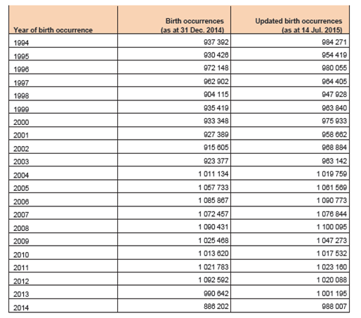

**Table1:** Birth occurrences by year of birth and reference period, South Africa 1994 – 2014 ( Source? Shiva)

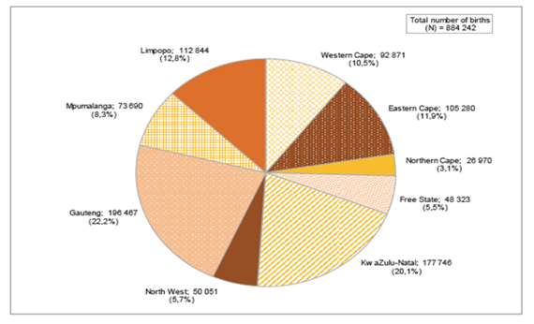

Birth occurrences by province of birth registration, South Africa for 2014 ( source?)

The childcare industry in South Africa is mainly coordinated by agencies. These agencies facilitate the link between the baby sitters and the parents. The agency’s role usually ends after linking the baby sitters with the parents.

Other players in the child care service industry are the pre-school institutions where parents enrol their kids to a specific institution where the kids attend on a daily basis. Such institutions have defined working hours which do not permit them to operate round the clock.

These two types of child-care business listed above have shortcomings such as the unavailability of permanent sitters. This means these child-caring institutions are not always available when parents need help with their children.

Baby sitters on the go provides the perfect solution to the problems above. It aims to provide qualified babysitters to parents whenever needed for as long as is required.. The services will be provided to parents in Gauteng who need safe and professional baby-sitters.

* 1. Background Information
     1. Basic Company information

BabySittersOnTheGo Pvt Ltd is an established Gauteng based child-care organisation that provides trained and experienced baby sitters on demand in Gauteng thereby sharing the parenting duties with the parents. The time taken by parents away from their homes can only be enjoyable if parents are assured that their children are taken good care of. The organisation provides professional service in the childcare industry and provides a broad range of contract terms for its customers whether it be permanent, temporary or fixed term basis. As a credible agency, we are extremely selective over who we recruit, ensuring that we entrust only the best and most deserving. For peace of mind, you can be assured that the BabySittersOnTheGo Baby sitters have been fully vetted and background checked.

BabySittersOnTheGo provide child care services for children from the age of 0 according to the specific needs of children and their respective families.

In contrast with the other competitor businesses such as the ones already listed in the section under industry description, BabySittersOnTheGo is an online business that extensively utilises online technology infrastructure in the baby sitters booking and hiring process.

* + 1. Management Structure

**T**he organogram

* 1. Business Processes
     1. Baby sitters booking

**B**abySittersOnTheGo tries to reduce all kind of face to face meetings that delay the booking process by focusing on extensive use of online technology infrastructure. All the steps involved in the baby sitters booking process are discussed below:

**Step 1:** The parents access the [www.babysittersonthego.co.za](http://www.babysittersonthego.co.za/) web site where they *browse* the profiles of baby sitters which consist of pictures, names, experience, qualification and availability. If the parents find the baby sitters that interest them, they can move to the next step.

**Step 2**: The parent *registers* by filling in a form that requests their personal information as well as their references.

**Step 3:** After registration, the parents can then log in to the site where they can *select* the baby sitters they are interested in. If the parent is interested in more than one baby sitter, they can compare them before their final decision.

**Step 4:** The parent can then choose the payment method that is suitable for them based on the payment methods available which are credit card or EFT payment. The payment is calculated based on the number of children the baby sitters is going to take care of, the duration the baby sitter is requested to work and the transportation fee in case the parent has selected to pay us for that service.

**Step 5**: Once the payment reflects to us or a proof of payment is sent by the parent, the baby sitters will be transported either by ourselves or by the parents based on the transportation method chosen.

* + 1. Hiring process

To ensure that our business provides quality child care services, our baby sitters go through well-defined rigorous selection process. The steps are discussed below:

**Step 1:** Baby sitters willing to work with us contact us via our website where they fill in the form requesting their personal information. They can also upload further supporting documents such as a certified copy of the first aid training certificate or video highlighting basic details about themselves.

**Step 2:** BabySittersOnTheGo will then proceed with screening where we use *Reference Check* to verify if the baby sitters are truly what they claim they are. This process consists of checking the ID, citizenship, employment history, criminal record, credit record, medical clearance and sex offender check.

**Step 3:** Face to face interviews will be conducted after successful reference check.

**Step4:** Successful candidates will be selected based on the conditions stated below.

* Healthy medical report
* Positive Reference check
* English literacy
* Minimum age of 18

Candidates who are approved but lack first aid training will be sent for training to Super Baby sitters based on our partnership agreement with Super Baby sitters. Super Baby sitters is a South African based childcare organisation that provides first aid training for Baby sitters. The candidate will then be listed on the website once the training has been completed successfully.

* 1. Vision

Our vision is to become the leading service provider of professional childcare services to all modern South African parents.

* 1. Mission

At BabySittersOnTheGo, we seek to provide professionally trained, experienced and reliable baby sitters on a timely basis. We believe that each child’s needs are different therefore we aim to adapt our services to the requests of specific childcare needs.

* 1. Business Goals
     1. Short term goals
* Provide high quality child care services in Gauteng, 24/7
* Provide flexible childcare services while taking into consideration the unique dynamics of each family
  + 1. Long term goals
* Extend our services from provincial to national.
* Become South Africa’s number one online leader childcare services

Marketing plan

* 1. Customer Identification

Our customers are parents of children from 0 years from Gauteng province. They will be mainly working parents (married and single) with household income levels ranging from R20 000 upwards. We are targeting at least 500 per month.

* 1. Customer needs

The customer needs have been ascertained by way of a survey.

How our company solves their problem: information that will help customers with decision making

Indicate price range for Baby sitters. Are we cheap or expensive. We are within market rate but with better flexibility.

Quality aspects – Type of training we provide (Institution we are using)

* Reference Checks
* Are we the only company who offers this service/Competition?
* Baby sitters experience. Mainly students with 1 year experience
* Easy payment method
* Experienced, trained, reliable and professional Baby sitters.
* Available on time and all the time.

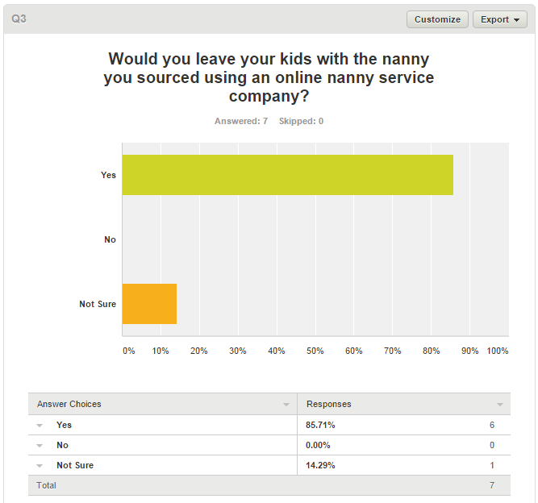

Competitor analysis

* 1. Competitor Description

The Competitive Analysis table below compares our company with our two most important competitors. In the first column are key competitive factors.

|  |  |  |  |  |
| --- | --- | --- | --- | --- |
| **Factor** | **BabySittersOnTheGo** | **Domestic Guardians** | **SuperBaby sitters** | **SA Nanny** |
| Products | Baby sitters on demand | Permanent Nanny placement | Permanent Nanny placement | Nanny on Demand |
| Price | R27 per hour | Monthly rate of R3000pm | Monthly rate from R2500 with a R750 placement fee and R250 every month there after | R25ph and R750 per week |
| Quality | Trained, professional with background checked Baby sitters | Provide training in childmind, housekeeping and first aid/CPR and life skills | No police checks done | Trained and make use of students with drivers licence |
| Selection | Rigorous selection process that includes a medical clearance, ref check, english literacy, 18 years older | 25 yrs or older, contactable references. Pre interview grooming and assessments | 25 yrs or older, contactable references. Pre interview grooming and assessments | Use mainly students who a traced back to their schools |
| Service | Customer does everything online. Enquiry, booking, and payment | Customers enter their details online and are contacted by a babysitter | Offers a cleaning/ironing service as well as a childcare service | Day and shift services of nanny and other services |
| Reliability | Readily available Baby sitters available on our 24/7 websites |  |  | A lot of Baby sitters in our database |
| Stability | Registered and contracted trained Baby sitters in our books | Work history of nanny checked and if bad behaviour a replacement is provided the next morning | Work history of nanny checked and if bad behaviour a replacement is provided the next | A large pool of students needing extra cash on an adhoc basis |
| Expertise | Partnership with accredited training providers to regularly train and refresh our Baby sitters | Provide training and Baby sitters have 3 yrs experience | Provide training and Baby sitters have 3 yrs experience | Trained on various courses and matriculated |
| Company Reputation | Still starting hence little reputation | Since 2008 | Since 2005 | Been in existence for over 10 years |
| Location | Online and covers all of Gauteng province | All of Gauteng | Cape Town and surroundings | In Johannesburg and surroundings |
| Sales Method | Online payment only | Offers an “hourly coupon” service, | EFT or credit card Payment before service | EFT or credit card Payment before service |
| Credit Policies | Payment before service | Payment after service | Payment before service | Payment before service |

* 1. Competitive advantage

We differentiate ourselves by allowing the customer to choose the kind of babysitter they want in their homes. Customers are also able to directly reserve a babysitter online any time of the day, without having to search through numerous Curriculum Vitae’s and await a response.

Advertising plan

Advertising is the ultimate way to communicate effectively to potential customers about the services we offer in order for them to make informed decisions. To this end, the suite of advertising tools in the organisation’s toolkit includes some of the following:

Advertising Portfolio

Print

Broadcast

Covert

Outdoor

1. **Print advertising**

The daily papers and magazines are very prominent methods of promoting for distinctive organizations everywhere throughout the world. Utilizing the print media, BabysittersonTheGo can likewise advance our services through handouts and fliers.

1. **Social Media advertising –** Our business intends to use social media platforms like Facebook, Twitter, Instagram, google+ and WhatsApp, YouTube.

1. **Outdoor advertising**

Outdoor advertising utilizes diverse apparatus to increase customer consideration. The billboards, Kiosks, and occasions or events are a compelling approach to pass on the organization's message. The billboards will be available in selected places around the city but we will ensure that the substance of the message ought to be such that it draws on the customers' consideration. The kiosks serve as information outlets for the general population as well. As such, as an organisation, we strongly believe that outdoor advertising is a compelling advertising instrument.

1. **Pricing**

Our rate is set per hour of service to enable flexibility for our customers and employees. The average market rate is R27 ph. As a small business, having the lowest price is not a good policy as large competitors can under-price us anyway. Our price policy has considered average prices and we shall compete on quality of service.

* 1. Pricing Strategy and Policy
* Our pricing strategy fit with what was revealed in our competitive analysis.
* Our price is competitive and our customers will have flexibility in paying per hour as they demand the service and how much money they have to spend.
* Flexibility in our total cost of service is our competitive factor. Customers’ decision to use our services will be based mostly on price flexibility.
* No credit facilities will be provided, only prepaid services.
  1. Delivery and Payment

Research & Development

Babysitting services are in high demand in South Africa, this can be substantiated by the survey contacted (<https://www.surveymonkey.com/r/2CTKGR7>) and figure [] shows the results of the survey. Most of the baby-sitting businesses that currently exist in South Africa are not technologically advanced , that is, they are still operating in an old traditional model of only running business from own home [U2] or office based. South Africa is poised on the brink of a digital revolution. Recent research carried out by consultancy World Wide Worx shows that the Internet economy contributes two percent to South Africa's gross domestic product (GDP). BabySittersOnTheGo aims to take full advantage of current digital economy by performing a wide range of commercial activities by means of a website that can connect trading partners (baby sitters and parents). According to Price Waterhouse Coopers (2013), the rapid evolution of the digital era is providing opportunities for businesses to be more profitable and centre on the needs of the customer. Our aim is to disrupt the traditional business models of organisations in the childcare industry by offering advanced and efficient service trading model using the following digital elements described in this section.

* 1. Transport

According to Mail and Guardian (2013), South Africa is in a desperate need of a viable and sustainable public transport network. Our custodians of this business BabySittersOnTheGo are Baby sitters babysitters spread in the Gauteng area. It has been observed that on a daily basis, there are approximately 15-million commuters and this which consists of 60 to 70% of the commuting public and workforce. Because our customers are most likely geographically scatted and majority of the babysitters do not have cars, transportation has been identified as an issue. Our customers (baby sitters and parents) might not be able to reach each other swiftly. We will need to attract both Baby sitters and parents to our service and our market analysis indicates that our service will most likely do better in an affluent area. This will be capped by partnering with Uber services to transport Baby sitters to and from areas where there is no reliable public transport service. Uber can connect our baby sitters with a driver in minutes therefore saving time.

* 1. Technology:

Most of the existing South African babysitting businesses do not have websites or the websites are too basic and static. Another element on few existing website is the lack of adhering to effective web design principles, thus tend to perform poorly and have sub-optimal Google Analytics metrics. Our website will use SSL (Secure Sockets Layer), the standard security technology for establishing an encrypted link between a web server and a browser. For payment, we will use PayFast, which is a payments processing service for South Africans and South African websites. It enables easy, secure and instant transfer of money from online buyers to sellers.

* 1. Future developments

We are planning to add a mobile application development project once our company is up and running. Ten years ago, the term mobile applications meant very little to the general population. Today, there seems to be a mobile application to do just about anything, thus we cannot afford not having a mobile application. The South African legislative environment is constantly changing - often before business has become completely comfortable with its obligations under the preceding legislation; a challenge for any company director. BabySittersOnTheGo deals with personal information which consists of babysitters and parent information. In this premise, we will be in the look-up for compliance of our website and company with Protection of Personal Information (PoPI) legislature which is a law that regulates the use of personal information in South Africa.

Risk Management

Risk Management: Potential risks which could pose a threat to our company

Table 1: Risk Matrix

|  |  |  |
| --- | --- | --- |
| **Category** | **Risk** | **Mitigation** |
| Babysitters | 1. Baby sitters not having sufficient training to deliver a professional service as advertised | 1. We will enter into a partnership with Super Baby sitters to provide accredited training to all Baby sitters in our books as well as refresher courses on an adhoc basis |
| 2. Babysitters may breach their non-solicitation contract by providing our customers with their personal details directly leading to private communication and bypassing our business next time their services are required | 2. Non solicitation contracts will be signed with both baby sitters and customers and we will have a company lawyer to ensure compensation in case of breach |
| 3. Scarcity of readily available trained, competent and trusted Baby sitters | 3. Marketing will be done to increase our employee base and attract all potential Baby sitters by providing good rates. Students will be targeted as potential Baby sitters. |
| Market | 4 High marketing costs to increase brand awareness | 4. Extensive market research will enable us to market to our target customers hence minimise costs |
| 5. Competition exists in a variety of forms within the childcare services market. | 5. We will regularly analyse our competitors in order to stay ahead of them |
| 6. Our advertising message may not reach our target market. | 6. We would advertise on the Internet frequented by working parents, in magazines for mothers, and local newspapers within busy neighbourhoods |
| 7. Low brand recognition | 7. Good branding from the start of our marketing campaigns |
| 8. Consumer not accepting concept | 8. Awareness of the benefits of the concept through our marketing strategy |
| Customers | 9. Parents requiring childcare services may already have a regular nanny and therefore may ignore us as a possibility. | 9. Awareness of the benefits of the concept as a cheaper alternative to a permanent nanny through our marketing strategy |
| 10. Customers not trusting our Baby sitters due to the fact that we are new to the market | 10. Awareness of the brand and concept through our marketing strategy |
| Legal and Compliance | 11. Compliance with regulatory authorities that can be omitted due to lack of knowledge of a regulation | 11. Research all regulatory authorities within this category of business before start up for example Protection of Personal Information (PoPI) |
| 12. It can be difficult to ensure that all legal formalities are not breached. Baby sitters will gain access to our customers’ private space, and may breach their contract of protecting customers’ privacy, and a possible lawsuit. | 12. Sign non-disclosure agreements with all Baby sitters |
| Technology and Operations | 13. Website being unavailable due to connectivity, slowness, and virus attack or system error may cause a loss in potential or existing customers. | 13. An adhoc IT support technician will be available to support and maintain the website |
| 14. Over reliance on Uber as a means of transporting Baby sitters to customers residences can be too optimistic as Uber does not operate in all areas | 14. At the start the directors will make their personal cars available in case Uber is not available |
| Implementation | 16. Scheduled time to market not met | 16. We will have a detailed schedule of activities towards start up. |

Financials

Timeline

Conclusive figures can be put in after the guys doing the financials are done with them. If the dates are fine then i can just quickly draw up a gantt chart

|  |  |  |  |  |  |  |  |
| --- | --- | --- | --- | --- | --- | --- | --- |
| **Task (code)** | **Time (Days)** | **Responsibility** | **Prerequisites** | **Start Date** | **End Date** | **Projected Budget (ZAR)** | **Remarks** |
| Business Proposal (T1) | 14 |  |  | 01-08-15 | 14-08-15 |  | This is an organisation’s formal statement stipulating goals and reasons to embark on a new endeavour. |
| Lobbying for funds (T2) | 28 |  | T1 | 15-08-15 | 11-09-15 |  | This involves looking for funding to either start a new establishment or extend a currently existing front. |
| Implementation Planning (T3) | 14 | Project Manager  Project Sponsor | T2 | 12-09-15 | 25-09-15 |  | This happens after the funding is acquired and statement of the business plan can now be executed. |
| Website development (T4) | 30 | Website development contractor | T3 | 26-09-15 | 25-10-15 |  | This task involves the development of the website and testing its functionality. |
| Setting up office (T5) | 36 | External contractor | T3 | 26-09-15 | 31-10-15 |  | Opening a physical office that will be used by the company administrator and also for screening all the interested Baby sitters. |
| Marketing and Sales campaigns (T6) | 30 | Marketing team | T3 | 26-09-15 | Ongoing |  | Making use of various advertising techniques in order to enroll as many Baby sitters as possible. |
| Pre-screening and assessing Baby sitters (T7) | 5 | Administrator | T5 | 20-10-15 | 31-10-15 |  | This task involves conducting background checks for the potential Baby sitters. |
| Uploading qualified Baby sitters (T8) | 2 | Administrator | T7 | 01-11-15 | 02-11-15 |  | This is when you upload the profiles of the qualified Baby sitters onto the finished website so that they can be viewed by potential employers. |
| Administration and Maintenance (T9) | 2 | Administrator | T4, T5, T6, T7, T8 | 20-10-15 | Ongoing |  | This is a continuous process of maintaining the day to day operations of the establishment. |
| TOTAL |  |  |  |  |  |  |  |

Site evaluation plans

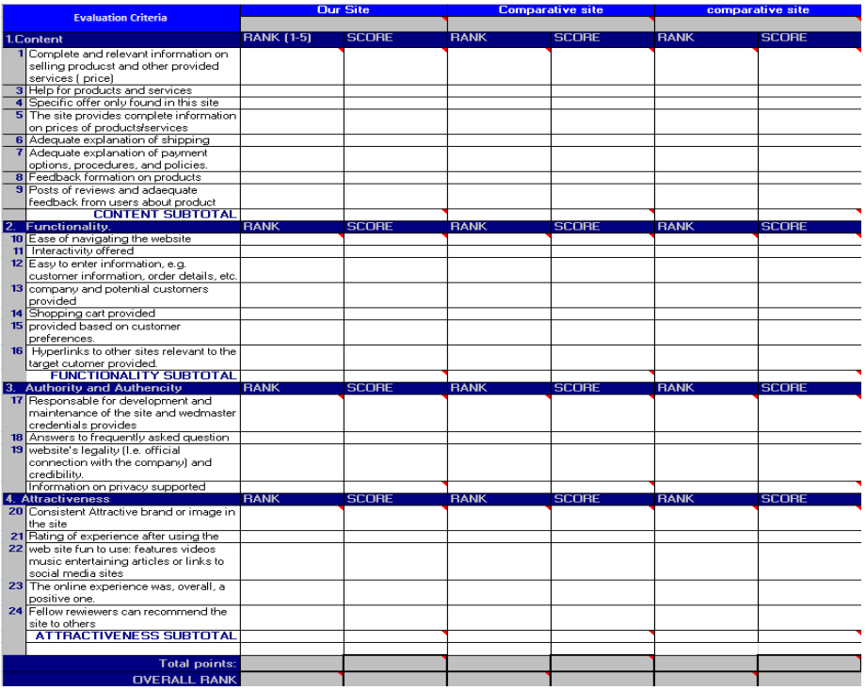The evaluation of the site will be done based on a multiple aspects of the web site. Since there is a multitude of evaluation criteria some of them will be used. For the sake of subjectivity, an evaluation sheet is made available for an evaluation by ourselves and some fellow evaluators.

Conclusion

The business plan presented a specification on what BabySittersOnTheGo e-business’ direction and what it intends to be with time. The business plan will serve as a one of the guidelines to get the business off the ground making use of the mission and vision objectives. It is important that reviews of the business plan be done in a specified period of time inorder to evaluate on its effectiveness.