

Research Project Management software e.g Open Source

UP MIT Student 2016

**Student Name: Leeto Modutoane**

**Student Number: 16081928**

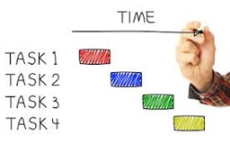

Project Management documentation

Senior Systems Analyst

Information Technology Project Management, by Kathy Schwalbe, 7th

Edition

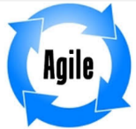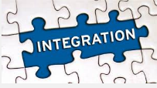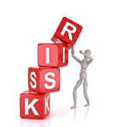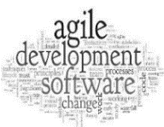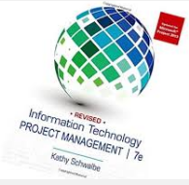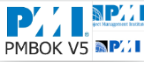  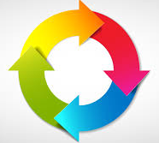 L.E Modutoane

Apply Agile Methods creatively

Research managing Integration in projects Management

Research Risk Management

Research managing distributed project teams Management

(Human Resource Management) Determine, how to keep the team happy & Motivated

Apply Project Management Methodologies creatively e.g Dashboards

PM – Project Management

IT – Information Technology

Cohen, D., Lindvall, M., & Costa, P. (2003). Agile software development. DACS SOAR Report, (11)

**Intends to Contributee**

Innovation in PM

PM frameworks, tools and techniques

Project, Portfolio and Program management

**Intends to Learn**

Project Cost, Time and Quality Management

Outsourcing Contract Management

Project Life Cycle

Awie Leonard, Rennie Naidoo

Project Integration Management

Through MIT 852

IT Project Management